**Environmental impact of steel and concrete as building materials**

**Jan Bujnak**

University of Zilina, Univerzitna 1, 01026 Zilina, Slovakia, [jan.bujnak@fstav.uniza.sk](mailto:jan.bujnak@fstav.uniza.sk)

Abstract

Energy consumption, harmful air emission and natural resource depletion as three environmental concerns are investigated on the prestressed concrete and to equal extend on steel - concrete composite highway bridges. The main results presented in the paper validate clearly advantage of steel as structural material particularly from the point of view of sustainable development.

1. Introduction

The construction industry is generally dominated by the use of steel or concrete as building materials. Differences in cost, availability, structural performance properties are the obvious decision-making criteria used by designer to choose the most suitable structural materials for the building type. Actually, there is a growing concern over the environmental impacts created by the built environment. Several analyses methods are utilized in conjunction with the study of industrial ecology and environmental management. Life cycle assessment allows for direct comparison between two materials by ensuring the context of comparisons is sound. Using this evaluation, the mass of raw material into an operation are quantified and proportioned as to their amounts in either the finished product or in a waste stream. As a result, the portion of the raw materials released into the air can be quantified. However, an appropriate mass balance is a difficult task as there are typically many different raw material inputs into a facility, making the process very complex.

The quality of the ambient air is an issue that is a common denominator among all people, based on the simple fact that to live everyone must breathe. Despite this fact, air quality is an issue that has been historically ignored. However, this approach to air quality is changing rapidly as no aspect of the environment has recently received greater attention than that of air pollution and its effects on our well-being. Air pollution is the release of various compounds into the atmosphere. Estimation of emissions from a source is a process which involves the qualification and quantification of pollutants. To begin the process of estimation of emissions, the source must be reviewed to determine its size and nature. This includes the quantification of all raw material inputs, production steps, and release points to qualify what types of emissions might possibly exist. After the source has been reviewed and the potential emissions qualified, the process of assessing the quantities of pollutants that are or can be emitted can begin. Particularly, dioxide carbon emission is at the front position of environmental policy issues due to the effects of global warming and emerging climate changes appearing from the end of the previous century. Other hazardous emissions from steel and concrete are not given in detail, even though their obviously harmful acidification potential. Building industry is a large consumer of energy. The embodied energy used during construction processes and pre-used phase is just investigated, even if the operational energy consumption required to operate and maintain a structure far outweighs. The enormous consumption rate of raw materials in construction industry poses major environmental challenges because of limited available natural resources. Their extraction and use have significant impact on the environment. The resource depletion associated with both materials can be compared and potential solutions of the critical processes suggested based on the presented investigation.

2. Highway bridges as evaluated objects

Two similar parallel continuous ***composite plate-girder*** highway bridges have two end spans of 32,0 m and intermediate ones of 40,0 m extending over twenty-three spans (Figure 1). The superstructure of every one bridge 984,0 m long is 11,5 m wide. The roadways have a width of 19,1 to 22,2 m. Two contrary circular bents of road on the bridge have radius of 1000 m and 2150 m with intermediate transit curves. Figure 2 shows a typical bridge cross-section consisting of the concrete deck and only two built-up plate girder I-section axially 6,6 m spaced. The steel plate composite girders were selected for each bridge having an even slender web construction depth of 2050 mm.

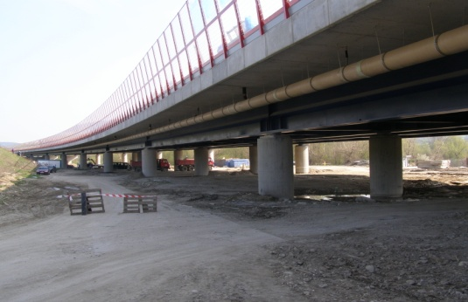

**Figure 1.** Composite bridge structure **Figure 2.** Typical cross-section

Transverse intermediate stiffeners welded to both sides of the web were placed in the fifth of spans for meeting slenderness requirements and allowing webs to develop shear capacity. The longitudinal angle stiffeners welded to one side of the web, located at distance of 400 mm from inner surface of the compression flange should increased bending resistance by preventing local buckling. The variable area of flanges was used to save material where the bending moment would be smaller or larger in a span. The top flange that acts with the concrete deck is of the constant 500 mm width and proportioned by varying thickness from 30 to 50 mm. The cover plates 550 mm large and 30 to 50 mm thick are added to the bottom flanges 600 mm width, and from 50 to 150 mm thick for increasing the flexural strength of cross-sections. Low-alloy structural carbon steel S355J2 and S355K2 grades have been used for steel bridge structural parts Cross frames consisting of angels diagonals and horizontal channels and acting as a truss provide lateral stability of the girder bridge and distribute vertical loads. Their spacing 6,6 m is compatible with transverse stiffeners. End cross frames and diaphragms at piers and abutment are provided to transmit lateral loads to the bearing. Reinforce concrete with 28-days compressive strength 37 N.mm-2 was used in slab construction 300mm thick with parabolic haunches at girders. Shear stud connectors ∅ 22/150 from steel grade S235J2 at the interface between the concrete slab and structural steel should ensure a full composite action.

Both precast ***prestressed concrete*** follow-up bridges 785 m long have two equal end spans of 36 m length and intermediary spans from 36,33 to 38, 8 m. The superstructure is 11.5 m wide with eight pretensioned I-beams from C45/55 concrete class with the structural depth 1, 90 m. The web thickness was chosen to be 200 mm and width of both upper and lower flanges was 800 mm (Figure 4). The center-to-center distance between adjacent girders, totally eight ones in the cross-section was 1,9 m. Concrete deck slab 200 mm thick from C30/37 concrete class attached by shear connection to the girders provide composite action. Cast in place cross-girders at intermediary pier supports, after hardening can interconnect adjacent spans and provide longitudinal continuous bridge behaviour. Entirely 28 multistraight prestressing tendons, LS 15,5/1800 MPa were situated in girder flanges. Supplementary four cables in deck slab were required for continuity reasons. The elevation view of the concrete bridge is shown in Figure 3.

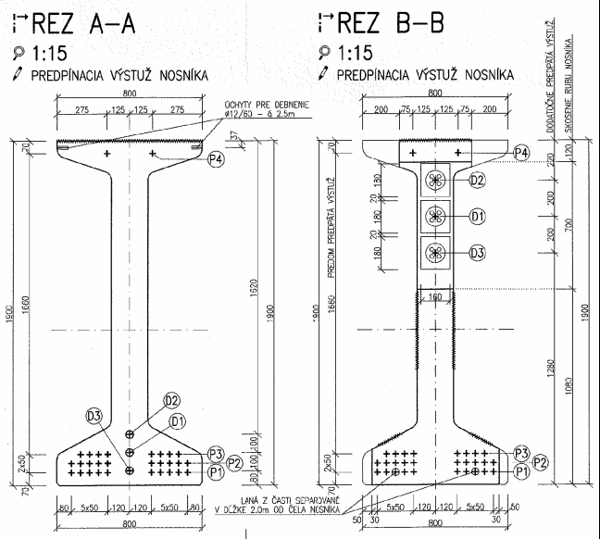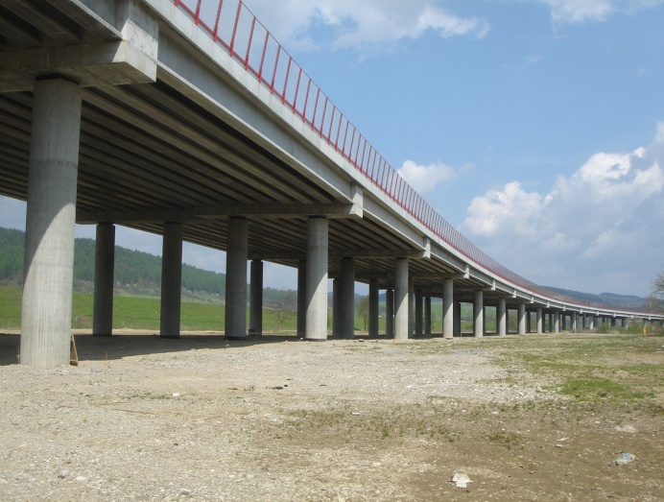

**Figure 3**. Concrete part of bridge structure **Figure 4.** Typical beam shape

Manuscripts must be typed single spaced using 10 point characters and be formatted for A4 size paper (297x210 mm). Only Arial fonts are accepted for the text. Section and subsection titles are typed in Arial font using 12 point characters. Page should have top margins of 3.5 cm; left, right and bottom margins of 3.0 cm. The text must fall within a frame of 23.2 cm x 15.0 cm centered on a 29.7 cm x 21.0 cm page. Paragraphs are separated by a single line space and with no indentation. The text of the papers is written in one column and justified. The maximum length of your paper should be 5,000 words (Maximum 8 pages) if you are using text only.

3. Process flow

**3.1 Steel construction**

Iron is actually produced in mini-mills using electric arc furnace turning a mixture of iron scrap and small input of virgin iron into structural steel. As electrodes are used to melt the scrap mix, the process is very energy intensive. The liquid iron is ladled, the sulphur and oxygen are removed and metal alloys added. Structural steels are usually produced by rolling steel cast from the steelmaking process after reheating it to the austenizing range above 850°C. Rolling consists of passing the steel through a series of rolls that form the cast steel into the shape and thickness required. A very wide range of shapes and sizes are currently rolled or available. The properties of steel largely result from the influence of microstructure and grain size though other factors such as non-metallic inclusions are also important. The grain size is strongly influenced by the cooling rate, to a lesser extent by other aspects of heat treatment and by the presence of small quantities of elements such as niobium, vanadium and aluminum. Thus, the production of steel and steel products involves heat and the effects of heating and cooling throughout. The chemical composition of steel is largely determined when the steel is liquid but for a given chemical content the structure is largely determined by the rate at which it is cooled and may be altered by subsequent reheating and cooling under controlled conditions. Carbon steels are largely composed of iron with up to 1.7% carbon, but the addition of relatively small quantities of other elements greatly influences its behavior and properties. For structural purposes it is desirable that steel be ductile and weldable, and consequently most structural carbon steels are mild steel with carbon in the range 0.15 to 0.29% and may include small quantities of manganese, silicon and copper. The proper production of steel structures is a complex process involving making the steel, processing it into useful products, fabricating these products into useful assemblies or structures by cutting, drilling and fitting, and erecting and assembling these components, assemblies, and structures into buildings or bridges. It is important to analyze processes because they can have a major effect on the investigated environmental impact of a steel structure, but they normally do not specify or need details of precisely how the steel is produced, rolled or formed. Presently, welding is perhaps the most important process used in the fabrication and erection of structural steelwork. It is used very extensively to join components to make up members and to join members into assemblies and structures. Welding used and done well helps in the production of very safe and efficient structures because welding consists of essentially joining steel component to steel component with steel that is intimately united to both. Corrosion of steel takes place by a complex electro-chemical reaction between the steel and oxygen that is facilitated by the presence of moisture. Structural requires additional protection and the usual methods are paint systems or galvanizing.

**3.2 Concrete production**

The Portland cement, water, stone, and sand as traditional basic constituents have increased in modern concrete form to include both chemical and mineral admixtures. These admixtures have been in use for decades, first in special circumstances, but have now been incorporated in more and more general applications for their technical and at times economic benefits in either or both fresh and hardened properties of concrete. Raw materials for manufacturing Portland cement consist of basically calcareous and siliceous material, extracted from quarries, blended and crushed into a powder. The mixture is heated to a high temperature within a rotating kiln to produce a complex group of chemicals, collectively called cement clinker. Clinker production process is the most energy intensive portion of the process with temperatures reaching over 1800 0C. Because of this cement accounts for 94% energy used to produce concrete, but represents only 12% of the volume. The pyro-processing also accounts for a large amount of CO2 as a by-product of calcinations, which occurs in the kiln at roughly 900 0C. Cement may be marketed in bags. For ready-mixed concrete production, bulk delivery by cement tankers and pumped into plant silos is the most common practice. Supplementary mineral admixtures commonly used in blended cement are fly ash, granulated blast furnace slag and silica fume besides natural pozzolans. The aggregates in concrete are grouped according to their sizes into fine and coarse aggregates. It is common to refer to fine aggregate as sand and coarse aggregate as stone. Traditionally, aggregates are derived from natural sources in the form of river gravel or crushed rocks and river sand. Fine aggregate produced by crushing rocks to sand sizes is referred as manufactured sand. Aggregates derived from special synthetic processes or as a by-product of other processes are also available. Water is needed for the hydration of cement but not all is used up for this purpose. Part of this added water is to provide workability during mixing and for placing. This latter usage can be reduced by the introduction of chemical plasticizers. Where it is possible, potable water is used. Other sources may contain impurities that introduce undesirable effects on properties of fresh and hardened concrete. Unlike mineral admixtures, which may be introduced as blended cements, chemical admixtures are typically added during the mixing process of concrete production. This admixture is used for entraining air into concrete to increase its frost resistance. The use of accelerating admixtures is common during cold-weather concreting, as the rate of hydration of cement is decreased by lower temperatures. Their function is to increase the rate of hydration, thereby speeding up the setting time and early strength development. Water reducing and retarding admixtures are adsorbed onto the surface of cement particles when added to the mixture. This induces a charge on to the cement particles thereby preventing their flocculation. The water so released improves the workability and the increase in surface of cement particles available for early hydration.

4. Main results of environmental analyses

Considering previously listed unit and sub-unit processes and analyzing life cycles, the input and output data relevant to the three investigated environmental impacts have been derived. This data collection was the longest and the most resource intensive component of the methodology. The set of results for concrete and steel bridge construction process flows can provide in this manner the targeted environmental impacts. The common study results illustrate that steel and concrete bridge structures have similar impacts on the environment from the point of view of three examined area. The comparison in Figure 5 proves that for each environmental impact area the results are of the same order of magnitude. The largest difference is in the resource depletion with a difference of 65%.

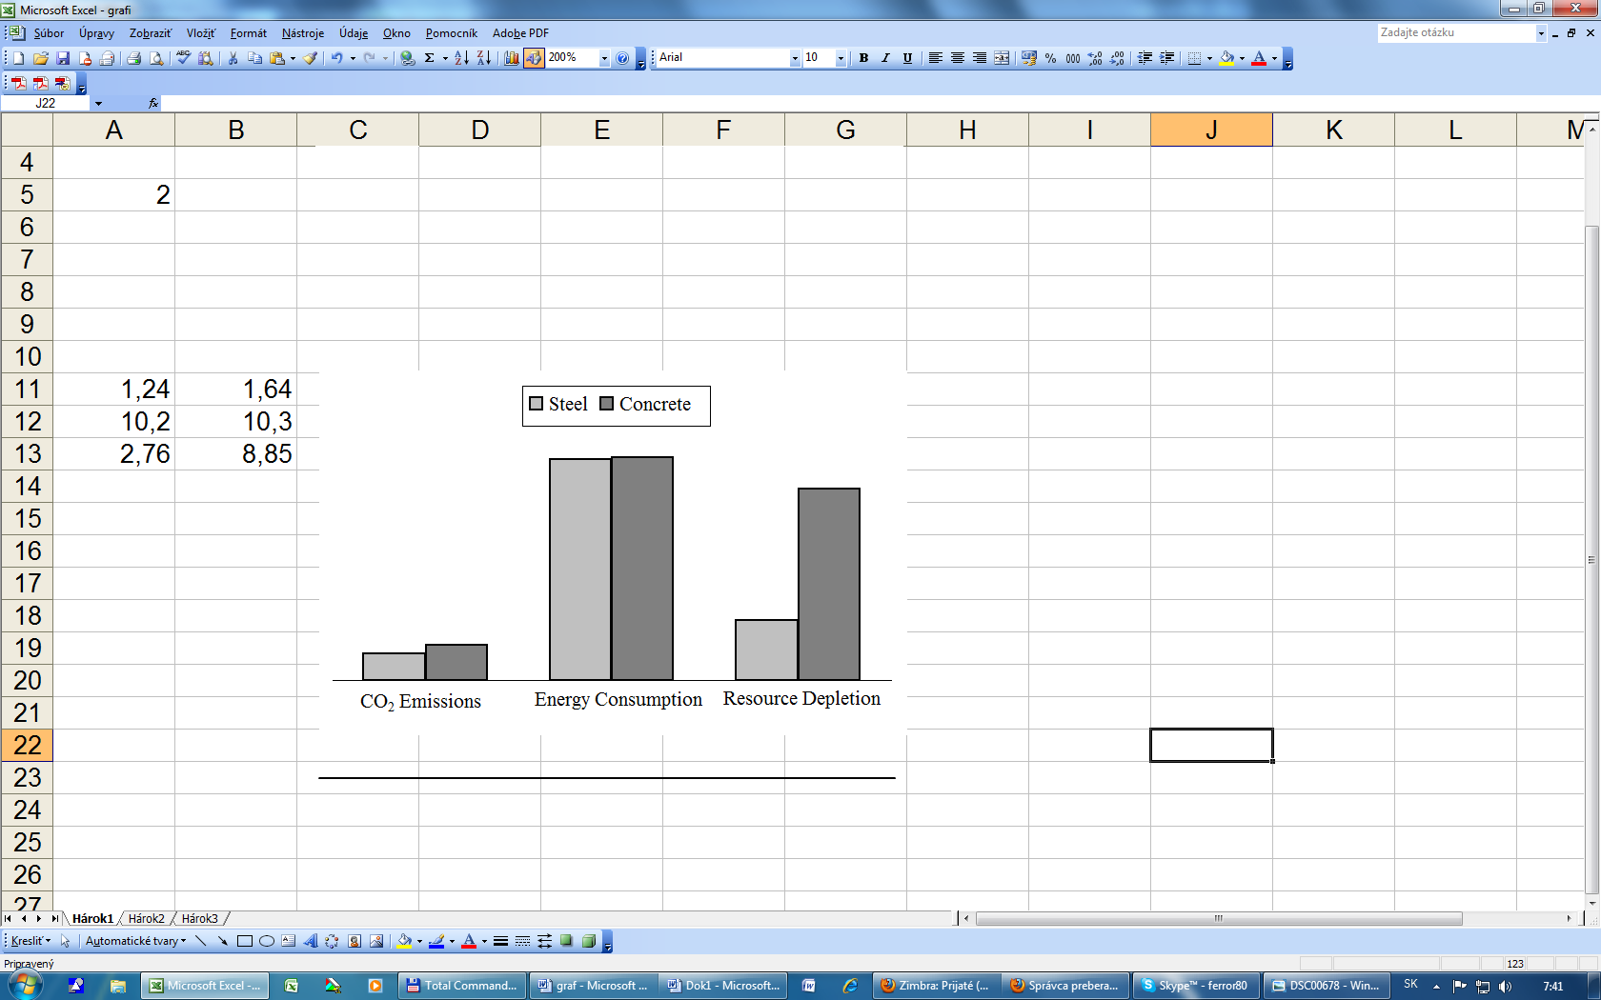

in kg/m2

in tons/m

in MJ/m

145

147

238

3,12

9,42

194

**Figure 5.** General review of global outcomes

The more detail comparisons can evaluate ***energy consumption*** for all production facilities, transportation assets and construction site demands across overall process flow of steel and concrete. The percentage breakdown for energy consumption for composite steel and concrete bridge structure is shown in Figure 6. The fabrications of steel beams appear to be the most energy intensive portion of overall steel process flow. It demands of 63% of the total energy requirements when compared against the other four product systems associated with steel process flow, especially construction (10%), steel bridge structure fabrication (8%), connection production (3%), and concrete deck pouring (16%). The total energy consumption by concrete bridge unit production is shown in Figure 7. The prestressed beam fabrication process accounts for nearly half (56%) of total energy requirements when compared against reinforcement bars (31%), construction (12%) and formwork (1%).

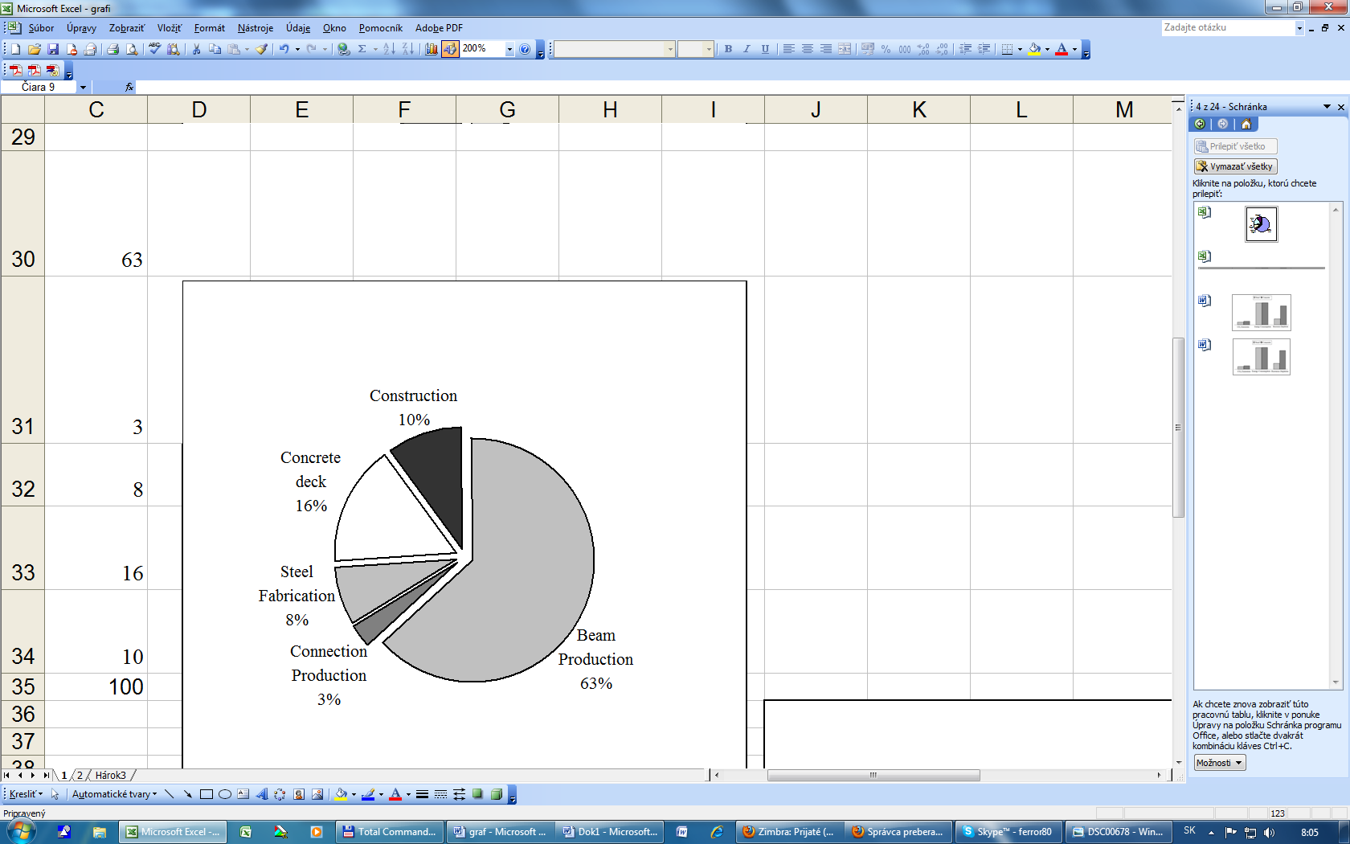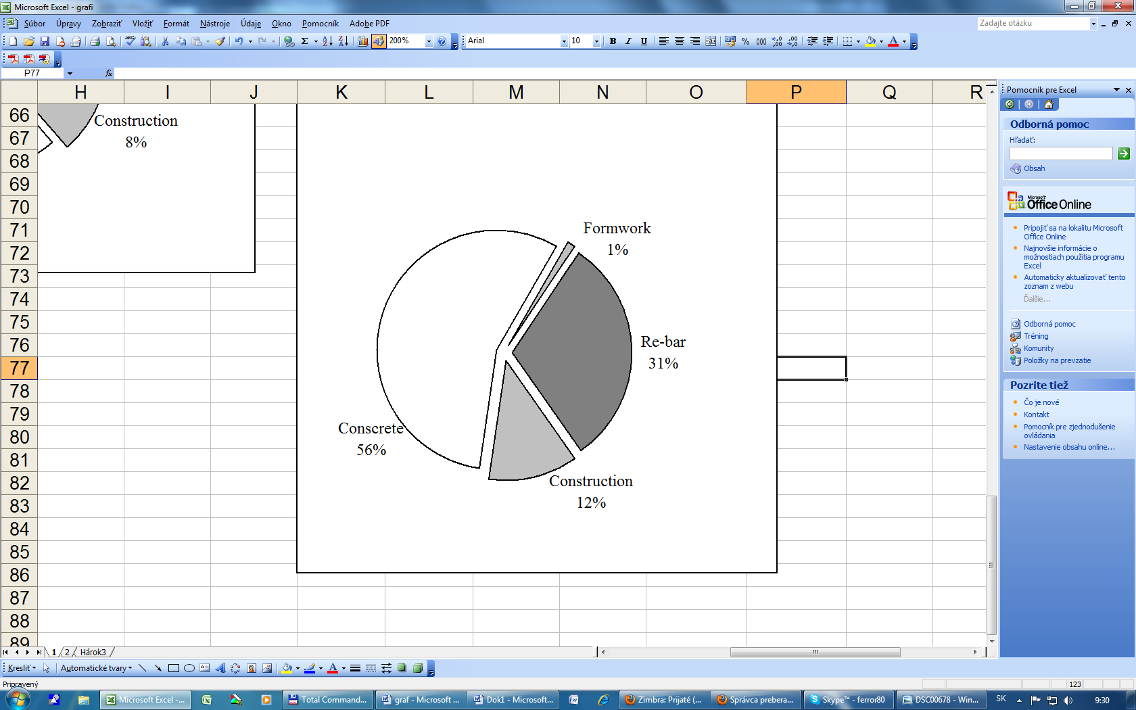

**Figure 6.** Energy consumption by composite **Figure 7.** Energy consumption by steel and

concrete bridge structure concrete bridge structure

The raw data results in Figure 5 indicate that concrete has a 30% greater impact on dioxide carbon ***emissions*** CO2but both are on the same order of magnitude. The dioxide carbon is in almost all processes, directly from chemicals reactions or through burning of fossil fuels for kiln heating and to provide the electricity to power production processes. The process of calcinations emits also CO2 as a byproduct of chemical reaction. It is then common to suppose that concrete would have greater impact on emissions than steel. A range of emissions by main production processes is illustrated in Figure 8. The primary contributors to total emissions for composite steel concrete bridge are steel structural parts manufacture at 56% and concrete deck production at 27%. These two main product processes account for nearly 83% of total CO2emissions.

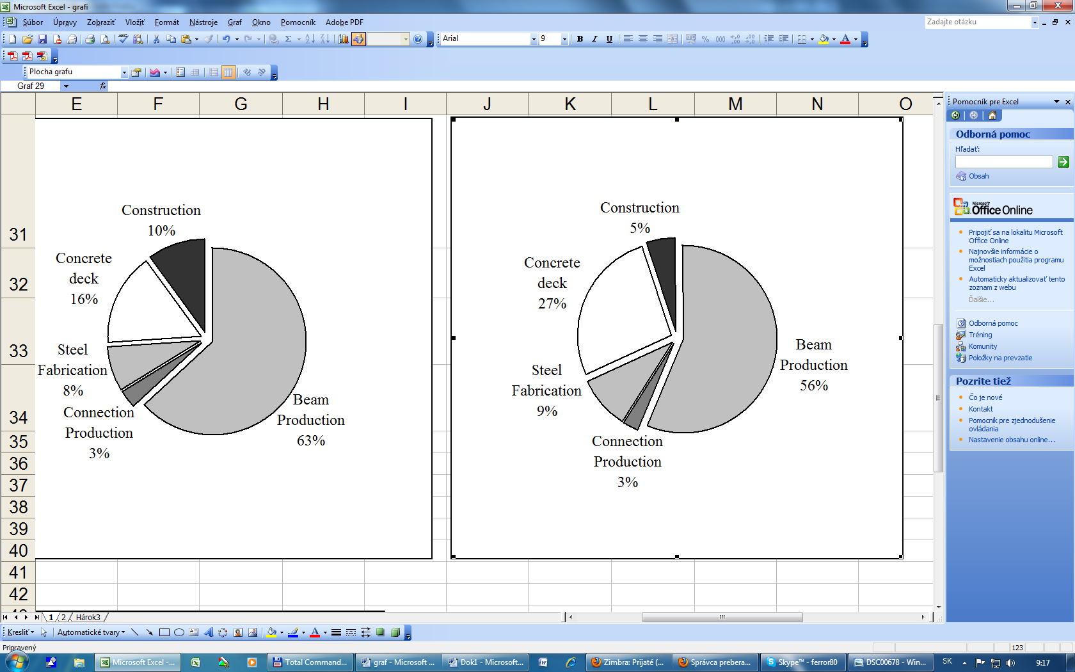 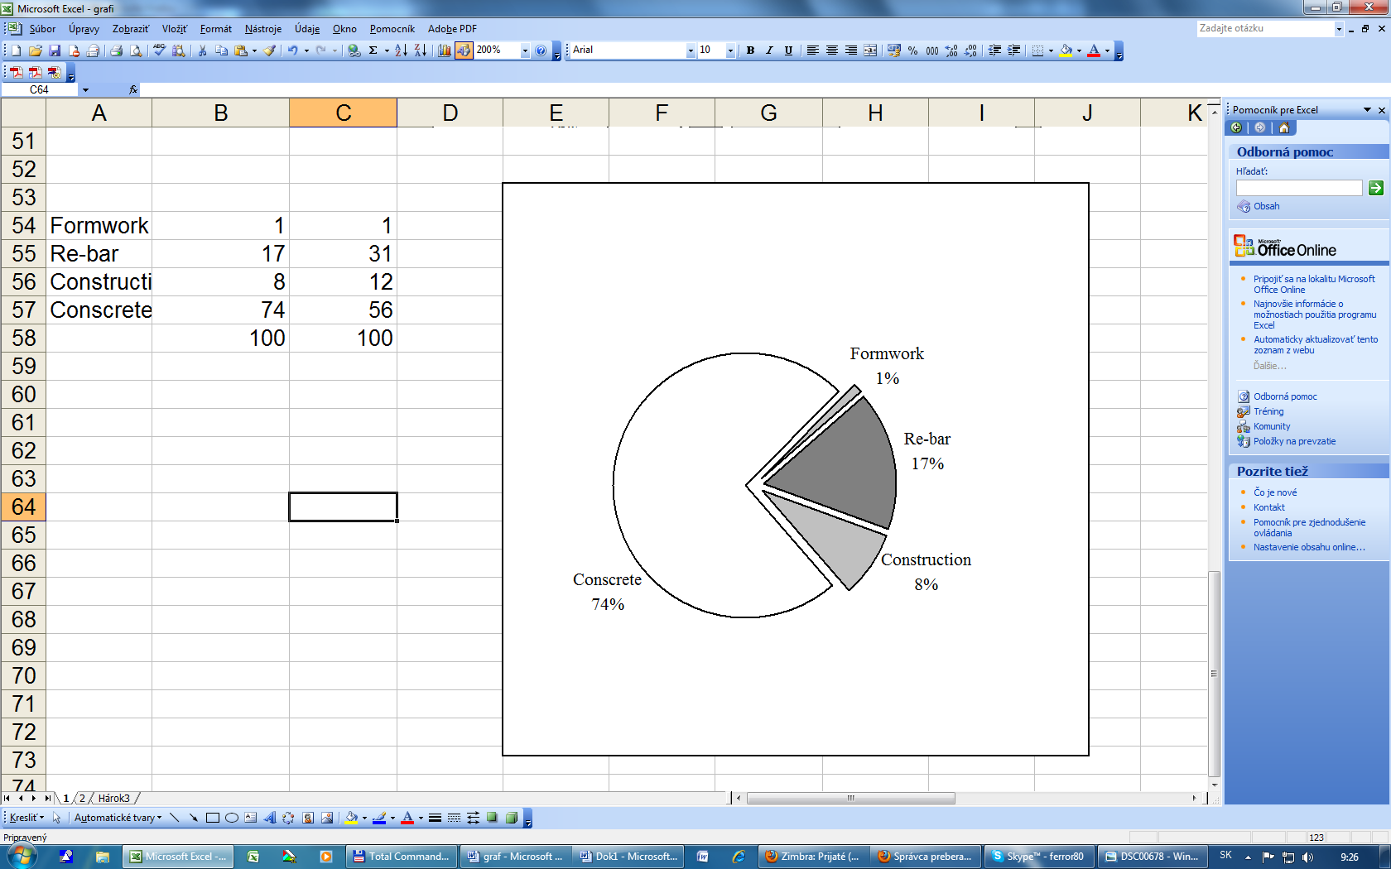

**Figure 8.** Air emission comparisons for **Figure 9.** Air emission comparisons for concrete and steel bridge concrete bridge

A record of emissions for concrete bridge production processes is given in Figure 9. The primary emitter is production of concrete at roughly 74%. Analysing the individual unit processes of the concrete manufacture, it can be found that the production of cement accounts for 94%, with only 6% emissions produced by transportation and electricity to operate cement production facilities (Figure 10). For reducing emissions related to concrete, decreasing amount of cement in the mixture ratio is effective solution. The admixture like mill scale or fly ash may replace partially Portland cement required by obvious concrete mix ratios.

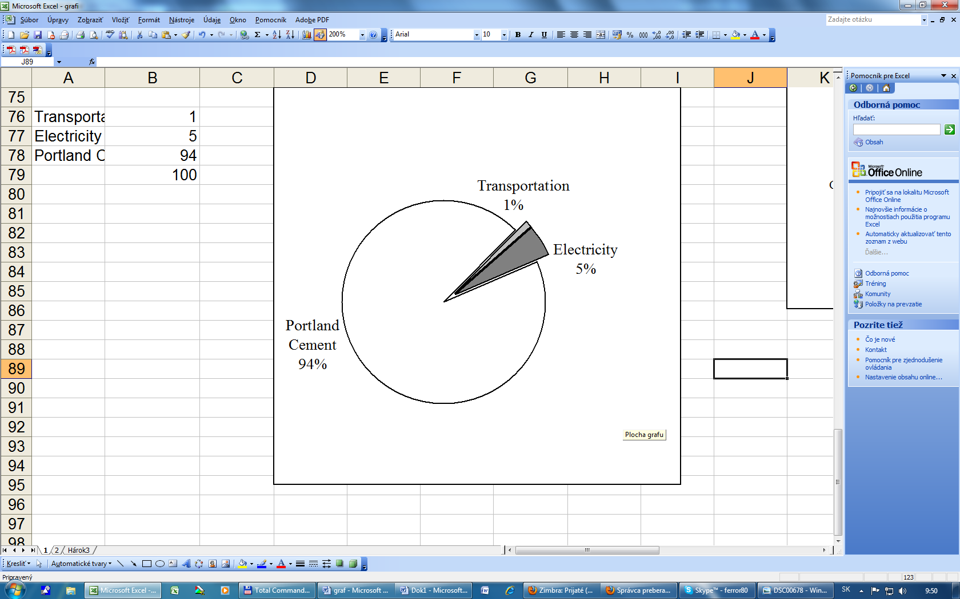 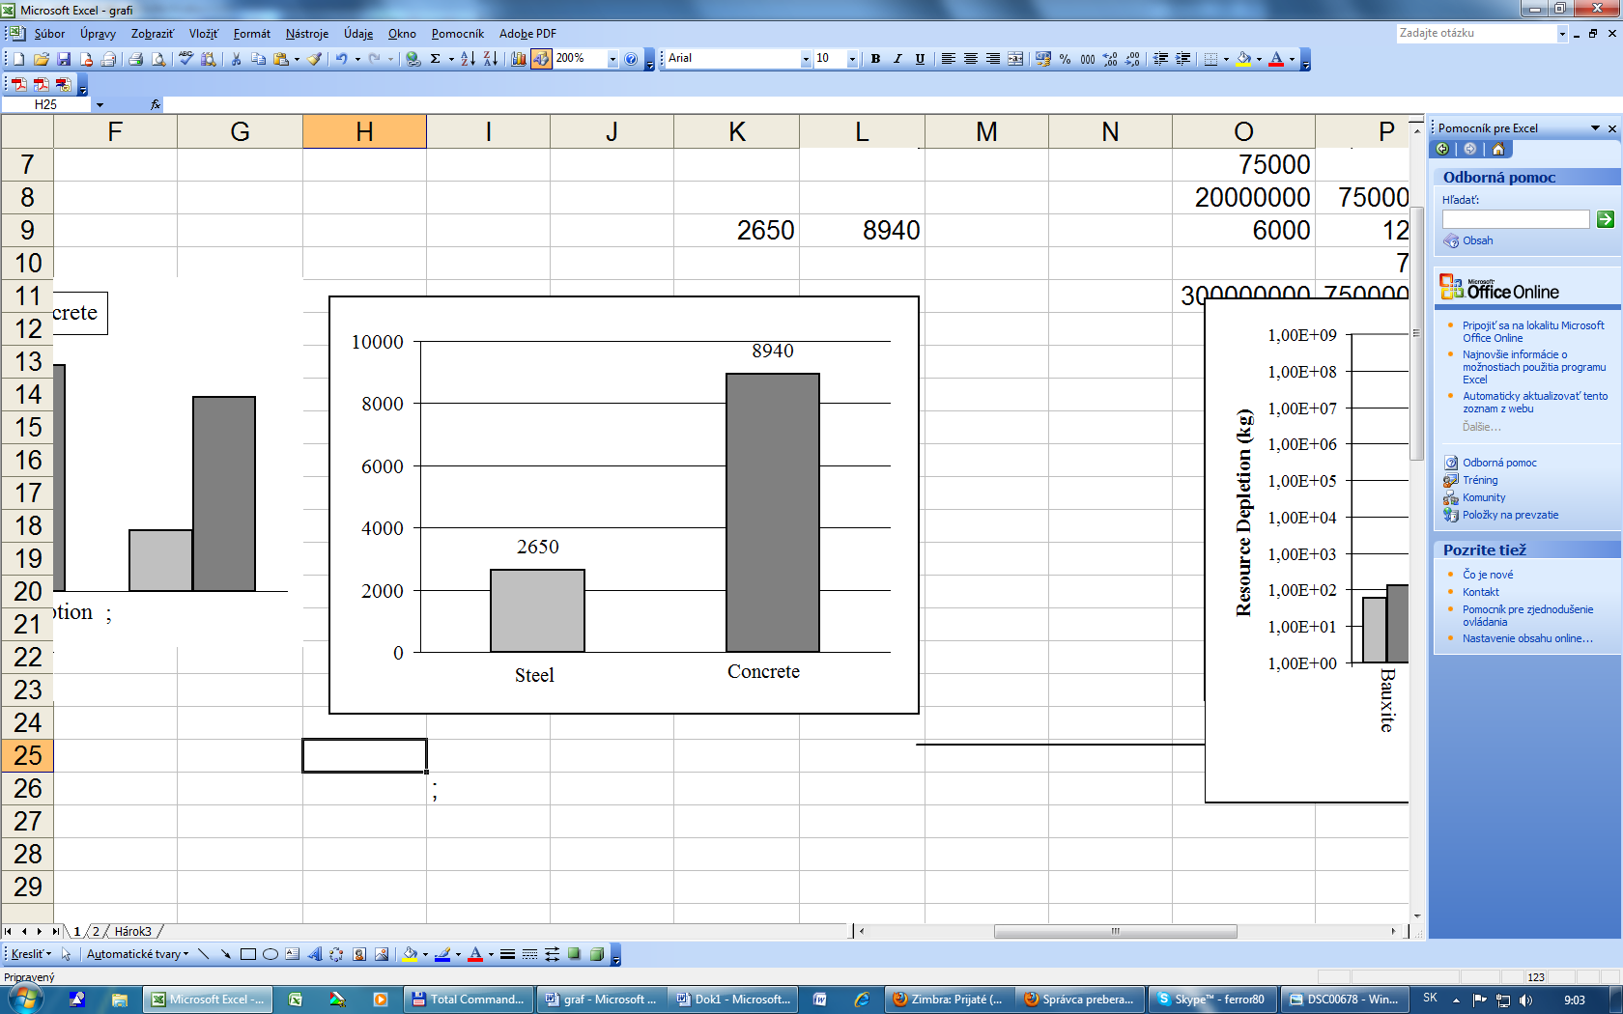

in kg/m

**Figure 10*.*** *Air emission comparisons* **Figure 11.** *Emission comparison*

*for concrete manufacture*

The primary ***natural raw resources*** measured in the individual production processes of the respective material flows are bauxite, clay, gravel, gypsum, iron ore, limestone and sand (Figure 12). The water and wood were considered as renewable material types. While other materials are required for concrete and steel structures manufacture, only these nine were considered as the main inputs. Concrete, when used as a building material, has four times the impact on material depletion compared to steel as shown in Figure 11. Concrete and steel have major impact on the limited natural resources. However, it is important to note that building of bridges required also a similar amount of water. This impact is not insignificant, too.

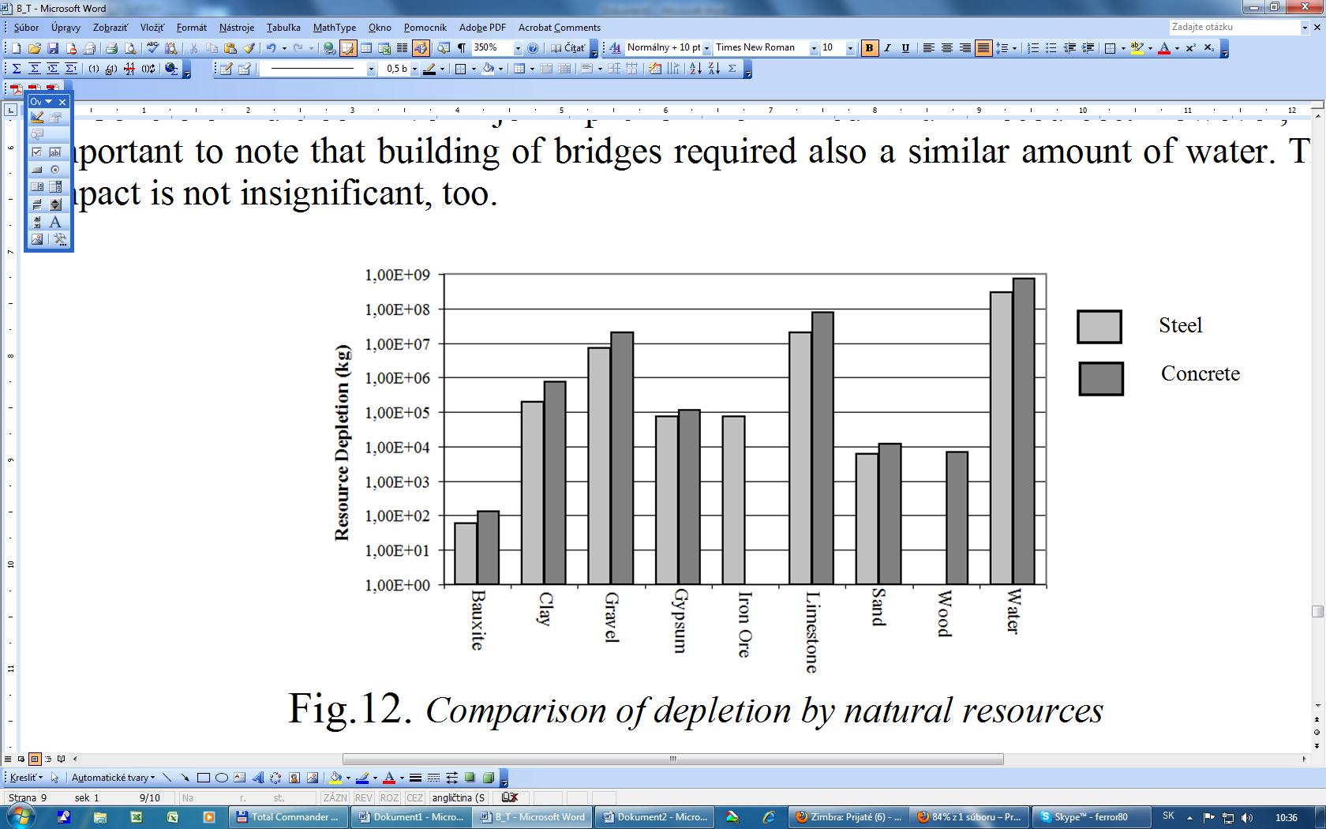

**Figure 12.** Comparison of depletion by natural resources

**5. Concluding remarks**

The results of study presented in the paper are based on bridge design data and material inventory. Several assumptions used on product processes can influence accuracy, but in most cases are equivalent between the two materials. For the most part thus, they do not impact the intended comparison. Each construction project is unique and no two projects are executed in the same way. To solve this issue, the most widely used method was applied in the evaluation, as obvious in these conditions. The evaluation illustrated that steel has less or equivalent requirements of concrete in all investigated area. But both materials have significant impact on the global environment. The constructions using steel or concrete would continue to dominate the building industry. The local conditions or market changes can modify in the future our assessment inputs. It is better to avoid of assigning strictly, which material is better, especially in energy consumption or emission, due to only a slide impact margin.

6. Acknowledgements

The paper presents results of the research activities supported by the Slovak Research and Development Agency under the contract No. SUSPP-0005-07 and by the Slovak Grant Agency, grant No. 1/0311/09.

References

1. Bujnak J. (201I). Environmental impact of steel and concrete as building materials on the global environment, *Proceedings of post gradual course on Building efficiency,* Novi Pazar, Serbia, 14 and 15 February, pp.02-34
2. Moravcik M., Dreveny I.,Kotes P., Kotula P., (2010). First experience with MDP 38 M girders application for highway bridge, *Proceedings of concrete days conference 2010,*  Bratislava, Slovakia, 29 and 30 November, Editor University of Zilina, p. 154-159.
3. Vican J., Odrobinak J., (2009). Behaviour analysis of composite motorway bridge during proof-load test, *Proceedings of the 5th International conference „Concrete and Concrete Structures*“, Zilina, Slovakia, 15 and 16 October, Editor University of Zilina, 2009, ISBN 978-80-554-0100-3, pp. 401-408.
4. Vican J., Odrobinak J., Gocál J., Hlinka R., (2007). Design of bridge over the river Vah in Trencin. The XXXIII meeting of specialist for steel structures, *Proceedings of the conference on Steel, composite and timber structures and bridges*, Oscadnica, Slovakia, 3,4 and 5 October, Editor GEORG, ISBN 978-80-969161-5-3, pp 171-176.
5. Bjorklund T., Jonsson A., Tillman A.M., (1996).LCA of building frame structures: Environmental impact over the life cycle of concrete and steel frames, Technical Environmental Planning Report, Goteborg, Sweden, Chalmers University of Technology.
6. Guggemos A., Horvath A., (2001). Comparison pf Environmental Effects of Steel and Concrete-Framed Buildings, *Journal of Infrastructure Systems,* p.93-101.
7. Jumila S., Horvath A., (2003) Life-Cycle Environmental Effects of an Office Building, *Journal of Infrastructure Systems,* p.157-166.