The present and the desired future of Hungarian engineering education from the perspective of the Hungarian Chamber of Engineers

J. Mecsi
Hungarian Chamber of Engineers, Budapest and University of Pécs, Hungary
jmecsi@gmail.com

Abstract
In Hungary, there are many debated issues in higher education, about the newly introduced Bologna system, about its problems and about the questions of state regulation of higher education issues.
These problems became more and more actual, that there is a new law to be adopted on the regulation of higher education. For making this law several professional organizations expressed their opinion.
The Hungarian Chamber of Engineers, as the determinant of engineering profession, the provider of design, expert and technical licences, is interested in maintaining the quality of higher education, the improvement of its quality.
This article gives an overview of the technical issues raised in relation to higher education, proposals formulated by the Bologna-based education to improve quality.
1. The number of students in higher education

According to statistical data 5,000 students were admitted to universities and colleges of engineering annually between 1985 and 1989. Out of the 5,000 students 3,800 (76%) graduated successfully.
What are the data for the present day, 20 years later? Between 2003 and 2010 9,000 students were admitted annually on average. Of the 9,000 students 3,600 (40%) graduated successfully. Shall we admit that it was a mistake to promote mass education?

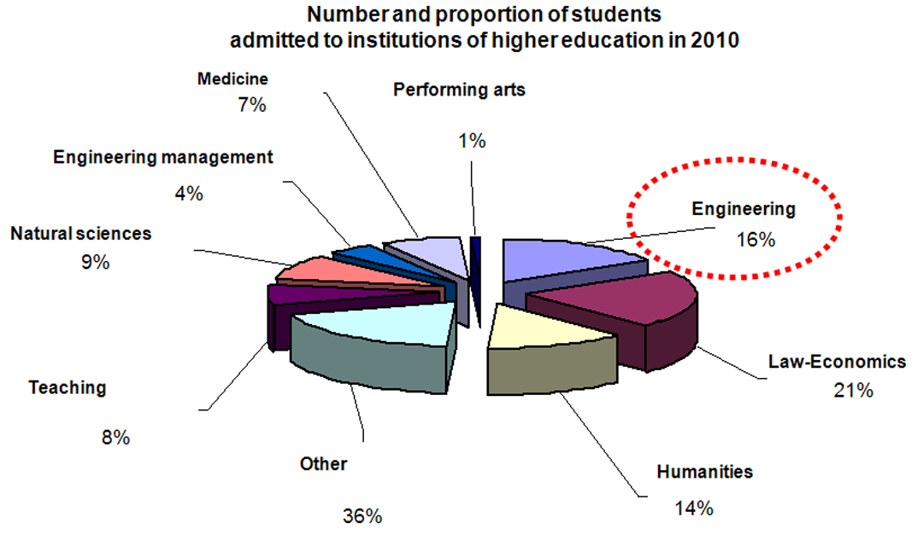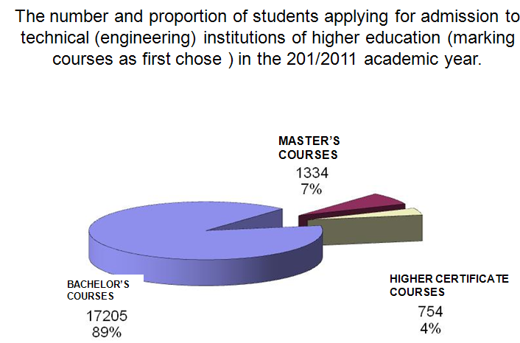

Figure 1. Number and proportion of students admitted to institutions of higher education, and the number and proportion of students applying for admission to technical (engineering) institutions of higher education (marking courses as first chose ) in the 2010/2011 academic year.

The government declared its intention to increase radically the number of students in engineering. This objective is meant to be achieved through administrative measurements. However, there are no sufficient candidates who meet the strict requirements. The problem is the motivation of the young candidates and our experiences demonstrate that the selection method requires careful consideration.
On the other hand, the education should make the profession more attractive. With the mass-education the number of graduates have not increased, but at the same time the level of the education was influenced negatively by the fact that the same number of teachers had to deal with more students at the same time. (The number of teachers did not exceed, and in some cases decreased.) Engineering as a profession requires more work compared to other education in humanities for example.

Figure 1 shows the share of students in engineering which is 20% of the whole , however the rate of the graduates is much less favorable.

2. What are the most important tasks?

- Students’ motivation to be strengthened;
- Finding the right balance in the engineering curriculum;
- Strengthening the relationship and the cooperation of practising engineers and educational institutions;

Introducing into engineering role models, and promoting engineering careers may boost students’ motivation.

The mentality of young people in Hungary, and maybe in other European countries has changed. If there is an easier way provided for the students they may choose it instead of facing difficulties thus learning lessons. It would be necessary to prescribe unified requirements for the basic formation and do not let the students avoid more challenging problem solving. It is important for the students to have a favourable affinity towards the subjects they learn. Accordingly, the teaching and methodological issues are increasingly come to the fore, the motivation to strengthen the external conditions, and a fresh approach to education that at the start of the studies the students may feel that the knowledge they acquire will be useful.
Rewarding the students’ performance is expected to happen “right now”, instead of offering reward in the near future for accomplishments.

3. Less is more
Instead of imparting knowledge in traditional education we emphasise the acquirement of certain skills. The former approach in the information age is misleading. No matter how hard the students try to digest the incredible amount of information they should learn, instead of acquiring real knowledge they only prepare for exams using their short term memory skills.

It is much easier for the instructor to present an established subject matter and to assess the reproduction of that subject matter by students than to develop a programme, which is aimed at skills development, to create practical tasks through which students’ development can be assessed, to assist them in finding solutions to these tasks and then to evaluate the students’ work. The former has its well established routines, while methods of the latter are not deeply founded yet.
A wide circle of knowledge and education can lead to versatile skilled people who can bring their skills into other areas, who thrive easier, and hence will be satisfied.

4. The technical characteristics of higher education
The technical higher education should be to ensure the preparation of students for the roles of problem solving (design, construction manager, technologist, programmer, employed abroad) and for both the more executive role (calculator, technician, administrator, administrative-role).
Researchers should be those of problem-solving type of graduates. From the executive type of students can be also a good researcher if he/she receives an impetus for deepening his/her knowledge and can do creative work in certain situations.
We consider the necessity of restricting the choice of subject choice and the circle of compulsory subjects. We also think necessary to make restrictions to subjects which should be finished within a certain term.
We recommend that a range of optional subjects (both professional and of human nature), a can be studied by a certain number of students according their ability and of interest to choose, but should be limited (the minimum number and range of choice items).
The degree of technical ability of working elements (the executive and problem-solving profile is set to different levels and degrees):
• physical (lexical) knowledge (among other things, material and product names);
• exploratory ability and fragmentation of the disciplines;
• special (industry-specific) basic skills (mathematics - statistics, informatics - Physics - Mechanics, Strength of materials, dynamics, etc - the chemical processes - corrosion, aging, etc - geometry, descriptive geometry, kinematics, etc -) to use knowledge roots, and fundamental relationships within the framework, assumptions, derivation;
• practising processes (methods of calculation - Programs -), including the use of self-critical computing;
• Knowledge of standards and conventions;
• artist skills and effective presentation skills (presentation and discussion of suitability)
Education to use this knowledge together in a proportionate and targeted by preparation must be provided.
Education should provide these knowledge together with the preparation for the application in real life in proportion and targeted.
We see proportion should be increased for practicing time. It is a great danger if students only get a superficial knowledge.
We see the targetedness in that, that for the problem-solving type of students the knowledge of standards and overall used methods should give less importance, however they should be capable the contents behind the rules and for the capability of modernization (making new calculations and prescriptions etc.)

5. The engineering mentality
It is important to teach complex approaches rather than to be lost in details. So many subjects to learn can obscure the real connections and people tent to rely on computer even without giving another thought to the dimensions they calculate. The availability of information through the internet and computer programmes may suggest reliability and do not imply for verification.

Contrary to the previous practice the following points should be emphasized:

- project-oriented training. It means solving practical tasks which deals with the problems in full correlation emphasizing certain details / those serving the development of skill most/.
It is favourable in technical fields because it gives greater motivation to students so that they can use the acquired knowledge too.

- the market; it requires new competences from graduates. These competences preferably trend towards skills and more comprehensive knowledge. These are The use of computers, communication skills including the command of languages, the capability for team work, project approach, economic knowledge, etc.

- the proportion of practical knowledge must be strenghtened.

Naturally it raises difficulties for a professor / lecturer to work out the development of skills and life-like exercises aiming at the measurement of their development, to help solve them, to appraise their quality rather than present the knowledge having been systematized for a long time and check the reproduction of this knowledge. The latter has established methods, while checking the adaptation, skills and improvement is still immature.
6. Students’ community in the learning process
The individual study is focused on obtaining credits while studying together in a small group may have several advantages. Discussions within the group can deepen knowledge, and can keep students within the group and not letting them drop out of the courses. The teacher may rely on the more active members of the group who may pass on the instructions. Solving engineering tasks requires mostly group activity. Having more problems to be solved in groups may foster engineering education. Nowadays it becomes more and more common to form small engineering offices with small number of members. It is very important to have good skills in cooperation and being active in learning from each other.

7. Examination and certification
The testing system of the students has the illusion of objectivity, however the experiences are disappointing as regards the problem solving skills of the graduated engineers. The oral examination as a supplement to written examinations may be more adequate means of examination.
The new regulation on higher education requires that the credits shall reflect the acquired knowledge (and not the number of hours attended). The students’ exam results should not be the basis for calculating the subsidy for the educational institution.
8. Instructors
The complexity of the strengths in educating-forming engineers is provided by the relationship of research and practice. These different activities enrich each other, they do are not in hierarchy.
The engineering instructor doesn’t necessarily have to make new discoveries according to the scientific measurement or justify the new knowledge, but with having the solid knowledge and its structure can make new products and can organize tasks to do.

Summary
This article gives an overview of the difficulties in the engineering higher education, and makes proposals in order to improve quality. The huge difference between the number of students entering and graduating from universities or colleges urges for solution. Not only the selection method requires careful consideration, but the education itself should make the profession more attractive. The motivation of the students should be strengthened by promoting engineering careers. For this aim it is evitable to foster the relationship and cooperation of practising engineers and educational institutions. Finding the right balance in the engineering curriculum is one of the most important tasks nowadays.

