Experimental investigation of solar photovoltaic- thermal (PVT) energy conversion systems for production of heat and power
¹David A. G. Redpath, 1Jonathon Palmer, 1Philip D. Dalzell, ¹Thomas A. Kattakayam, ¹Christopher Tierney, ²Harjit Singh, ¹David R. McIlveen-Wright¹, and ¹Neil J. Hewitt¹
¹Centre for Sustainable Technologies, University of Ulster at Jordanstown, Newtownabbey, Co. Antrim, N. Ireland BT37 OQB

² Faculty of Engineering, Kingston University, Roehampton Vale, London SW15 3DW, UK, h.singh@kingston.ac.uk

* Corresponding author. Telephone +44 2890368240, Fax +44 2890368239, email: d.redpath@ulster.ac.uk

Abstract
Two solar photovoltaic-thermal (PVT) energy conversion systems are described and their performance tested under laboratory conditions. One of these PVT collectors was a simple Flat Plate (FP-PVT) design, with headers and risers for heat removal the other a fixed linear axis Compound Parabolic Concentrating solar PVT (CPC-PVT) energy conversion system with a heat-pipe for removal of solar gain. Both had a low iron glass cover for high transmissivity of solar radiation, and polycrystalline silicon solar photovoltaic cells adhered to the absorber.
Heat loss coefficient for the FP-PVT collector was measured as 4.1W/m²/K and 3.5W/m²/K for the CPC-PVT solar collector. These solar collectors were tested under steady state conditions using the solar simulator facility at the University of Ulster’s Centre for Sustainable Technologies. The FP-PVT and the CPC-PVT had a combined efficiency of 66.8% and 53.4% respectively producing both heat and power.

1. Introduction
The Stern Report [1] has highlighted the rationale for the deployment of low carbon technologies to stabilise global greenhouse gas emissions at 550 ppm CO₂eq [2]. Buildings account for around half of the UK’s total carbon emissions [3] and the usage patterns of these is directly related to energy consumption. In the first quarter of 2010 domestic and services sectors were responsible for 50% of total energy consumption within the UK [4]. In 2007, the UK government set a target to gradually improve the energy efficiency and carbon performance of buildings to achieve a zero carbon emission level for new homes by 2016 [5]. Further, the UK government intends to set zero carbon targets for new non domestic buildings by 2019 [6]. These standards are expected to assist the UK government significantly in reducing CO₂ emissions from buildings and to achieve the 2050 target of an 80% reduction in carbon emissions compared to the 1990 baseline as set in the Climate Change Act 2008 [7]. Typically solar energy conversion technologies are used to generate sustainable thermal or electric power. For example solar water heaters convert incident solar radiation into thermal energy, which is typically utilised, for domestic, commercial or industrial purposes (photo thermal conversion); solar photovoltaics generate electricity (photovoltaic conversion) a hybrid of these technologies is known as a solar photovoltaic-thermal (PVT) collector. PVT solar systems combine photovoltaic (PV) and solar thermal components into one unit with a simultaneous provision of electric power and heat. It was reported by Zondag et al (2002) that hybrid PVT systems are more efficienct than conventional solar thermal or solar photovoltaic collectors per unit area [8]. Similarly to solar PV and solar thermal, PVT collectors can either have a planar or a concentrating geometry and theoretically any PV material such as crystalline, polycrystalline, amorphous-silicon or non-silicon thin-film cells could be incorporated within a PVT collector. The electrical conversion efficiency of PV cells decreases significantly with a rise in their temperature above standard operating conditions, therefore, cooling these is essential if the electrical conversion efficiency is to be maintained. The additional benefit is that low grade thermal energy is also generated from the same area. Open circuit voltage and the short circuit current are the most sensitive parameters to the rise in temperature especially in the case of silicon cells. To avoid long term damage to silicon cells their temperature should be kept below 60 °C. Thus such systems as described in this paper would be ideal for preheating purposes and could be joined with other solar collector technologies such as evacuated tube solar water Heaters which are commercially available if higher outlet temperatures are required forming a solar cascade system. The rationale for the development of PVT systems is that in recent years the cost of silicon solar cells has fallen rapidly and improvements in efficiencies have also been realised, during the same time period the cost of solar thermal systems has remained relatively static and efficiencies have remained steady. If both technologies (photovoltaic and thermal) are combined then both cost and space saving’s would be the result. This paper describes the fabrication of two PVT systems; one of these was based on the simple flat plate solar water heater design (FP-PVT) the other was a novel design of solar PVT collector incorporating Compound Parabolic Concentrating (CPC) collector with a heat-pipe for removing solar gain from the absorber plate (CPC -PVT). The CPC -PVT solar collector developed in-house used heat-pipe technology to remove excess heat from the solar cells maintaining their efficiency as they warm up. A heat-pipe based system was chosen as previous research has reported that these are more effective in transient climates such as the UK [9]. Planar PVT systems have been studied extensively experimentally and numerically [10-14]. Different absorber geometries were investigated and a spiral flow design reported to have the highest combined thermal-PV efficiency of 62% [13]. A planar PVT system with rectangular channel absorber geometry achieved a combined efficiency of 65% [14]. The total output energy of a CPVT system depends on the solar energy input, ambient temperature, wind speed, the operating temperature of the PV cells and substrate and the heat extraction mode. Design decisions were made based on the concentrator type, coolant type & target thermal to electrical yield ratio and the solar fraction for optimizing the operation of these systems. Building integrated systems also have further requirements of light weight and compatibility with the architectural details of the building elements but this design consideration is outside the realm of this paper. Cooling of the PV cells can be achieved by circulating a suitable fluid, for example water, air, or a refrigerant (heat-pipe) and the heat carried away by the cooling fluid can be used for space and/or water heating. Up to a concentration ratio (C_{R}) of 10 the cooling scheme for the solar cells can either be active or passive, but for the systems with C_{R}>10 cooling has to be achieved using some active or forced circulation of the cooling fluid. Passive cooling of linear concentrators, CPC or V-trough, is complex and difficult to achieve due to a large area over which the PV cells are placed and so the active cooling is required. Design of absorber substrate to maximise the amount of heat transferred to the cooling medium (typically water or air) is a prime requirement [15]. Clearly, the best cooling scheme that will yield the highest conversion, electrical as well as thermal, efficiencies is yet to be identified. Low concentration PV systems, linear Fresnel non-imaging systems (lens or mirror based) and CPCs with planar reflectors, are more viable for building integration allowing more light to travel into the building interiors than the high concentration ones whilst using absorption materials opaque to visible light. If static these can be placed at any location on the buildings, but in that case a very limited concentration ratio, C_{R} ≤2.5, is achievable. Within the options for concentrators devices, parabolic concentrators [17], Fresnel reflectors [16], compact linear Fresnel reflectors [27], V-trough reflectors [28] and CPCs [20, 29, 30] have been studied but still the best combination of solar concentrator type, cooling scheme and the PV cell type to yield maximum conversion efficiency for a range of geographical locations including the UK has yet to be experimentally determined.
2. Methodology
To investigate the performance of solar PVT systems two solar photovoltaic thermal collectors were fabricated, assembled and installed alongside a commercial PV module. The first PVT system had reflective concentrators with a concentration ratio of 1.8, a heat-pipe from a proprietary evacuated tube solar collector for heat removal, and the whole system was incorporated within Styrofoam for lightness and to ensure excellent thermal performance by minimising heat losses (k=0.04Wm⁻¹K⁻¹). The second PVT system was constructed in a similar fashion to a flat plat collector (Duffie and Beckman, 2006) using copper sheet and tubes for the absorber plate

Figure 2.1 shows a schematic diagram of the CPC -PVT, figure 2.2 a photograph of the FP-PVT under construction.

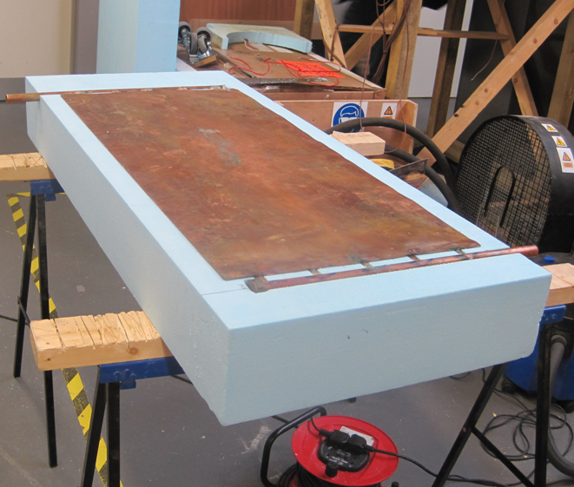
Copper absorber plate
Header and Risers
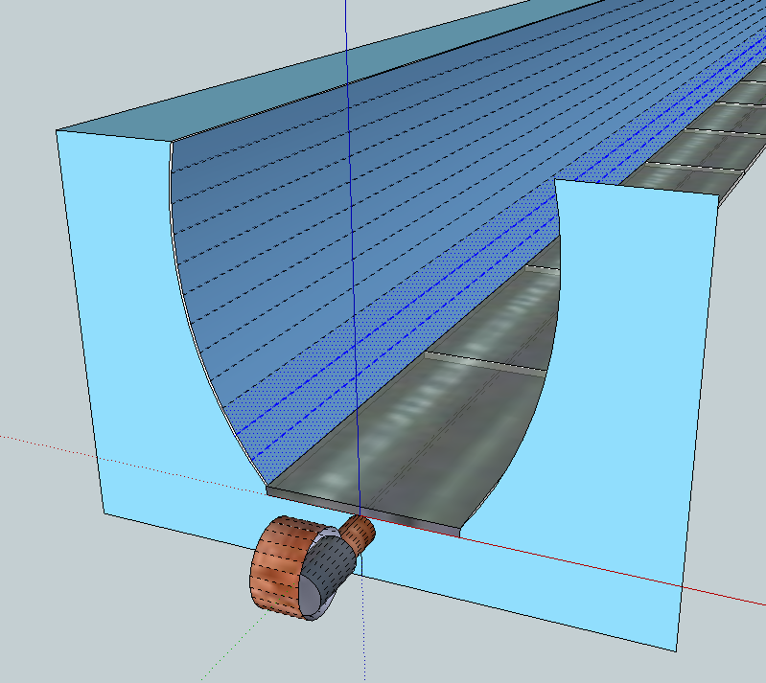
Copper Absorber plate
CPC profile
Heat pipe

Figure 2.1 CPC -PVT Figure 2.2 FP-PVT under construction

Polycrystalline solar cells with a short circuit current of 3.6A, an open circuit voltage of 0.555V and a maximum power output (W_{p}) of 1.8W, were adhered to the absobers using a thermally conductive but electrically insulating thiixotropic adhesive with a thermal conductivity of 1.58W.m⁻¹K⁻¹, (ACC silicones AS1607, 2011). Figure 2.3 shows a photograph of the CPC -PVT with the solar cells adhered to the absorber. Incident solar radiation was measured to an accuracy of 2% using a Kipp and Zonen pyranometer model CMP6, temperature measurements were made at the collector inlets, collector outlets, and the ambient using class A platinum resistance thermometers (accuracy±0.06°C). Temperature measurements of the absorber plates, solar cells, rear of the PV module and the risers were taken using t-type thermocouples.

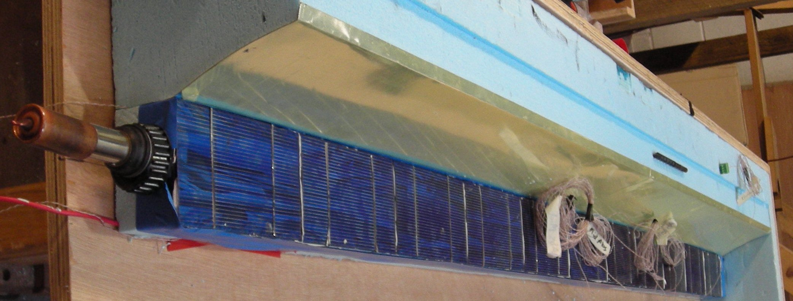
Solar Cells
Thermocouples
Condenser
CPC reflector

Figure 2.3 Side view of CPC-HP-PVT

Voltage and current for all three solar collectors were measured using a multi-channel logger and calibrated using a fluke multi-meter, and all values were recorded every minute. The flow rate across each collector was the only parameter not recorded by the multichannel logger this was measured at half hourly intervals using a graduated cylinder (±1ml) and a stop watch (±0.1s), three readings were taken, the mean mass flow rate and the time of measurement recorded. The collector water inlet temperature was maintained using a Julabo bath (Julabo.com, 2011), which can control temperatures to within ±0.03°C. The operating and test conditions outlined in [23] for testing under a solar simulator were adhered to. The thermal output and efficiency of the two PVT collectors was calculated using equation 2.1 and equation 2.2 [24], respectively.

$Q_{u}=mC_{p}\left(T_{o}−T_{i}\right)$ {2.1}
$η_{i}=\frac{mC_{p}\left(T_{o}−T_{i}\right)}{A_{c}G_{T}}$
{2.2}

The electrical output of the FP-PVT, the CPC -PVT and the solar PV module was calculated using equation 2.3 where P is the electrical output (W), I is the measured current (A) and V is the measured voltage (V). The electrical conversion efficiency of the two systems was calculated using equation 2.4, where A_{c} is the area of the collector aperture and G_{T} the incident solar radiation (W/m²) on aperture.

{2.3}
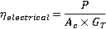 {2.4}
The total instantaneous output of both PVT collectors was calculated by adding the thermal and electrical output and the overall efficiency calculated using equation 2.5.

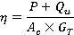 {2.5}
The response of the collectors to a step change in radiation was determined as follows; both collectors were allowed to reach a steady operating state i.e. the outlet temperature varied by no more than 0.05°C/minute, the collector was then covered until the temperature difference across it was zero i.e. no energy was being generated and then removed and the time recorded for the collector outlet temperature (T_{o}) to reach 63.2% of its original value before the cover was removed.
3. Results

Figure 3.1 is a photograph of the three collectors being tested under the solar simulator, table 3.1 is a summary of the experimental results.

PV module
CPC-HP-PVT
FP-PVT
Pyranometer
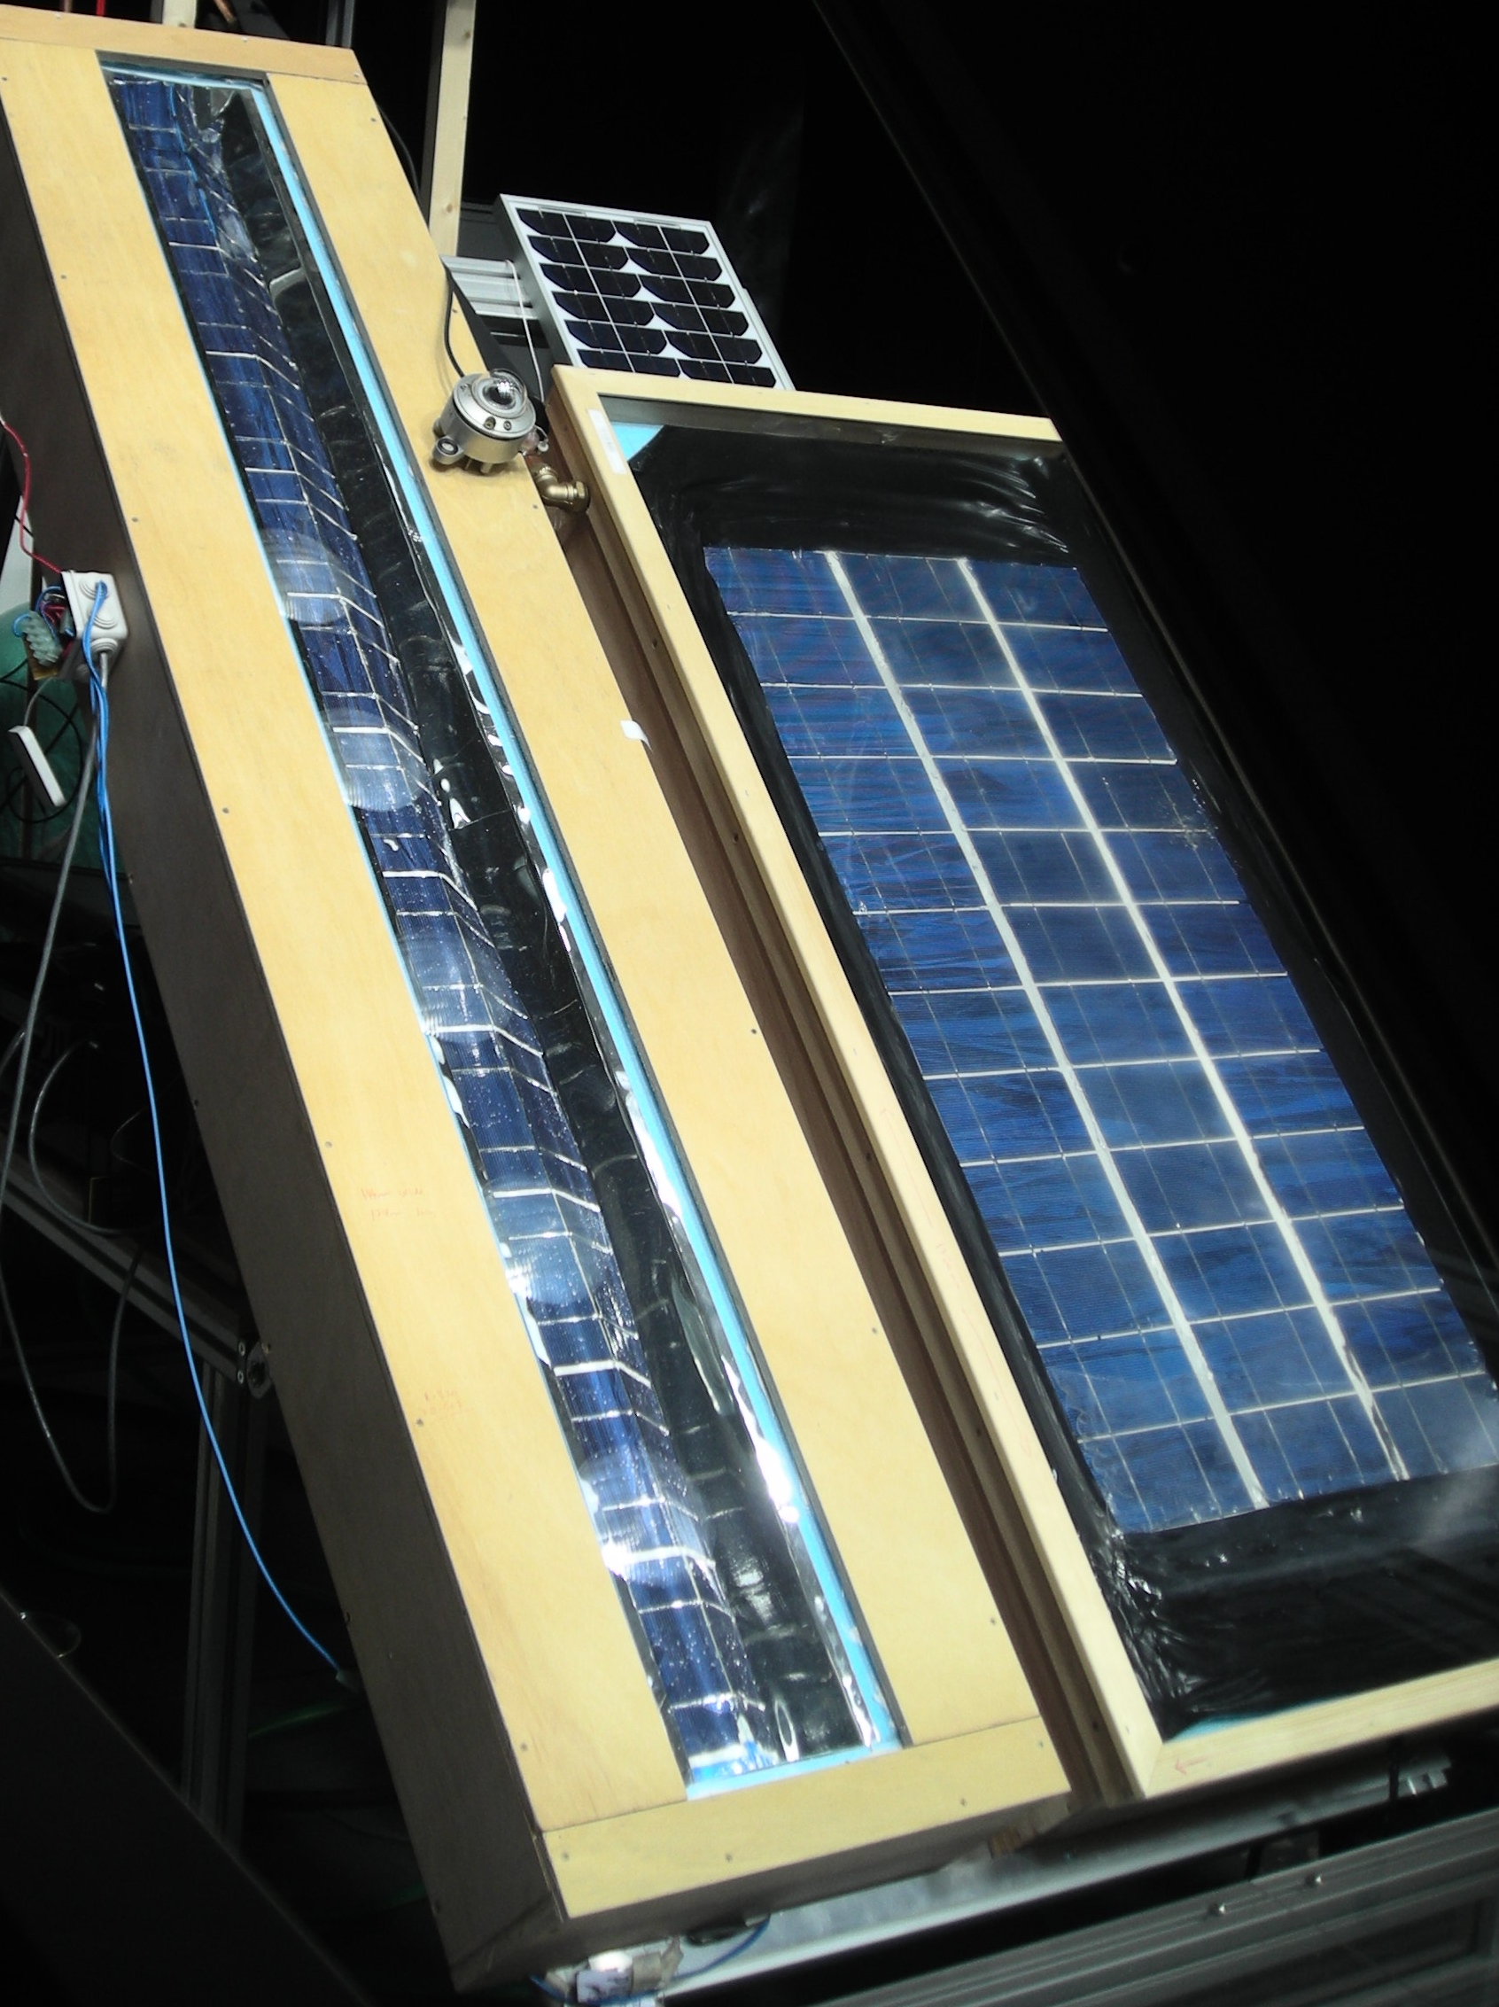

Table 3.1 Results Summary
System | FP-PVT | CPC- PVT | PV
Parameter
A_{c} (m²) | 0.45 | 0.25 | 0.12
Mean efficiency | 0.67 | 0.54 | 0.07
F_{R} | 0.64 | 0.48 | NA
F_{R}U_{L} (W m⁻² K⁻¹ ) | 4.10 | 3.62 | NA

Figure 3.1 Experimental set up.

The mean thermal efficiency of the FP-PVT and the CPC -PVT collector was calculated using equation 2.2 as 59.4% and 54.0% respectively for inlet temperatures (T_{i}) ranging from 22.8°C to 39.6°C. The thermal efficiencies of both collectors were plotted as a function of (T_{i}-T_{a}/G_{T}) with the heat removal factor F_{R} taken as the intercept of the y-axis and the gradient of the line of best fit (collector heat loss coefficient, F_{R}U_{L}), as shown in figure 3.2. The heat removal factor and the collector heat loss coefficient for the CPC-PVT was calculated as 0.473 and 2.29W m⁻² K⁻¹ respectively. The FP-PVT collector had a higher heat removal factor and collector loss coefficient calculated as 0.638 and 4.10 W m⁻² K⁻¹ respectively.

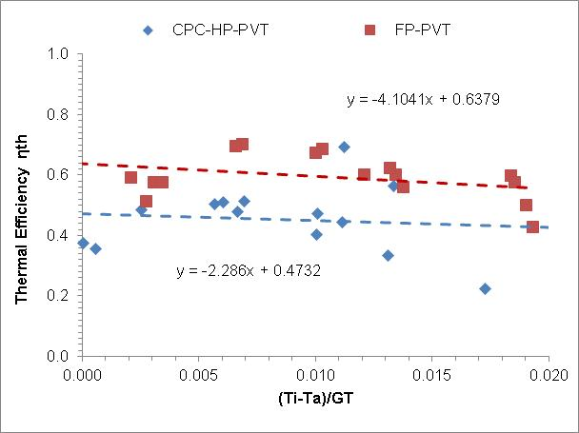

Figure 3.2 CPC-HP-PVT and FP-PVT thermal efficiencies

The electrical efficiencies of both collectors under the same conditions as those in figure 3.2 are shown in figure 3.3. From figure 3.3 it can be seen that as the temperature difference between the collector inlet and ambient increases the electrical conversion efficiency of both systems decreased. The maximum electrical conversion efficiency of the CPC -PVT and the FP-PVTwas measured as 9.5% and 7.9% respectively this was 2.5% and 0.9% higher than the PV module used as a control

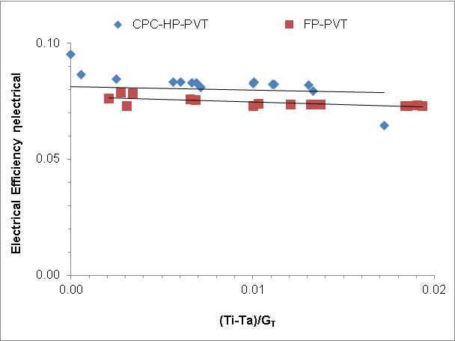

Figure 3.3 CPC -PVT and FP-PVT electrical efficiencies

From figure 3.3 it is observed that these values occurred when the inlet temperature of the collector was operating at or near the ambient temperature. Figures 3.4 and 3.5 show the response time of the CPC-PVT and the FP-PVT respectively to a step change in radiation as outlined in section 2

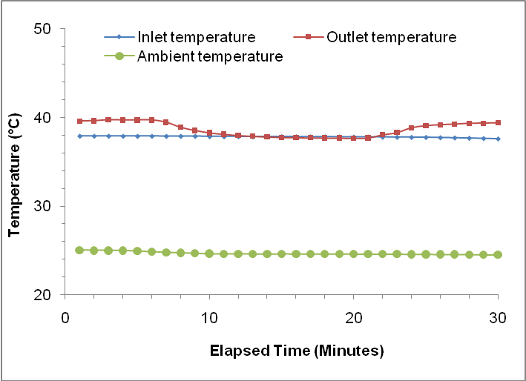
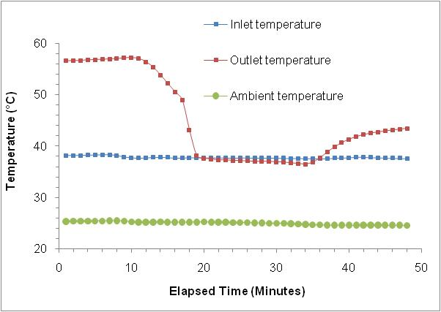

Figure 3.4 CPC-PVT Figure 3.5 FP-PVT

From figure 3.4 it is seen that the response time of the CPC -PVT to a step change in radiation is much faster in comparison to that of the FP-PVT which can be observed in figure 3.5. Within 7 minutes of the aperture cover being removed the outlet temperature of the CPC-PVT had recovered its original value and steady operating conditions were resumed. It took more than an hour for steady state conditions to be resumed in the case of FP-PVT.

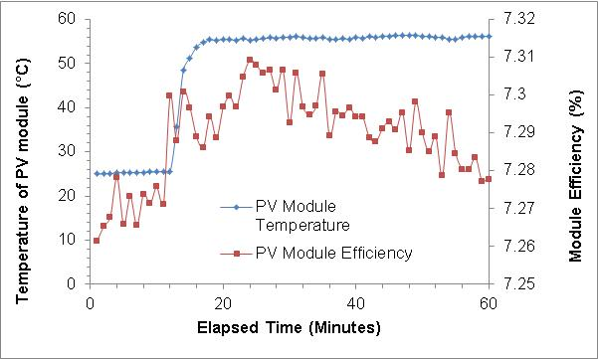

Figure 3.6 Temperature and efficiency of control PV module
Figure 3.6 shows the measured temperature and efficiency of the small PV module which demonstrates that the electrical and thermal efficiency of solar energy conversion from PV modules could be improved by removal of excess heat. It was observed that the efficiency of the PV module was reduced as the temperature increased, as shown in figures 3.4 and 3.5 this excess energy could be used to generate low grade heat.
4. Discussion
As shown by the results presented in section 3 the CPC -PVT had a lower thermal efficiency than the FP- PVT with a heat removal factor of 0.488 compared to 0.638. The mean electrical conversion efficiency was 7.8% which was 0.4% higher than the value obtained for the FP-PVT and the highest value of 9.5%was 1.6% higher than the FP-PVT system. The advantages of using a heat-pipe absorber for transient climatic conditions was observed from the step change in radiation which simulates the overhead passing of a large cloud. It was experimentally demonstrated that the CPC -PVT system responded much more rapidly than the FP-PVT system which took a lot longer to cool down and heat up suggesting that in such conditions the CPC- PVT would be a more appropriate choice agreeing with the research published by Hull (1987).

5. Acknowledgements

The authors would like to acknowledge the help from the technical support staff of the University of Ulster.
References
1. N. Stern, (2006). The Economics of Climate Change: The Stern Review, Cambridge University Press, Cambridge. Available at: http://www.hmtreasury.gov.uk/independent_reviews/stern_review_economics_climate_change/stern_review_report.cfm, (Accessed 8 February 2007).
2. IPCC.2007.: Climate Change 2007: Synthesis Report. Contribution of Working Groups I, II and III to the Fourth Assessment Report of the Intergovernmental Panel on Climate Change [Core Writing Team, Pachauri, R.K and Reisinger, A. (eds.)]. IPCC, Geneva, Switzerland,
3. Department of Trade and Industry. 2007. Meeting the Energy Challenge A White paper on Energy Available from: http://www.berr.gov.uk/files/file39387.pdf [Accessed 12.05.2010]
4. Department of Energy and Climate Change. 2010. Energy Trends - June 2010.
5. Department for Communities and Local Government. 2007. Building a Greener Future: policy statement. Available from: http://www.communities. gov.uk/documents/planning and building/pdf/building-greener.pdf [Accessed 01.07.2010]
6. Department for communities and local Government. 2009. Zero carbon for new non domestic buildings consultation policy options. Available from: http// www.Communities.gov.uk /documents/planningandbuilding/pdf/13991110.pdf. (Accessed 17th April 2011)
7. Climate Change Act. 2008. Crown copyright. Available from: http://www.opsi.gov.uk/acts/acts2008/pdf/ukpga20080027_en.pdf 2008 [Accessed 19.06.2010]
8. H.A. Zondag, D.W. DE VRIES, W.G.J. Van Helden, R.J.C. Van Zolingen. (2002). The thermal and electrical yield of a PV-Thermal Collector, Solar Energy, Volume, Volume 72, Issue 2, pp.113-128
9. Hull J R, 1987, Comparison of heat transfer in solar collectors with heat pipe versus flow through absorbers, Journal of Solar Energy Engineering, Volume 109, pp.253-258
10. T.T. Chow, Performance analysis of photovoltaic-thermal collector by explicit dynamic model, Solar Energy 75 (2003), pp. 143–152.
11. S.A. Kalogirou and Y. Tripanagnostopoulos, Hybrid PV/T solar systems for domestic hot water and electricity production, Energy Conversion and Management 47 (2006), pp. 3368–3382.
12. Y.B. Assoa, C. Menezo, G. Fraisse, R. Yezou and J. Brau, Study of a new concept of photovoltaic-thermal hybrid collector, Solar Energy 81 (9) (2007), pp. 1132–1143.
13. A. Ibrahim, M.Y. Othman, M.H. Ruslan, M.A. Alghoul, M. Yahya and A. Zaharim et al., Performance of photovoltaic thermal collector (PVT) with different absorbers design, WSEAS Transactions on Environment and Development 5 (2009), pp. 321–330.
14. T.T. Chow, J. Ji and W. He, Photovoltaic-thermal collector system for domestic application, Journal of Solar Energy Engineering 129 (2007), pp. 205–209.
15. R. Zakharchenko, L. Licea-Jimenez, S.A. Perez-Garcia, P. Vorobiev, U. Dehesa-Carrasco and J.F. Perez-Robles et al., Photovoltaic solar panel for a hybrid PV/thermal system, Solar Energy Materials and Solar Cells 82 (2004), pp. 253–261
16. R. Pujol, V. Marínez, A. Moià and H. Schweiger, Analysis of stationary Fresnel like linear concentrator with tracking absorber, 13th Solar Paces symposium (2006).
17. M.E.A. Alfegi, K. Sopian, M.Y.H. Othman and B.B. Yatim, Transient mathematical model of both side single pass photovoltaic thermal air collector, ARPN Journal of Engineering and Applied Sciences 2 (2007), pp. 22–26.
18 D. Mills, 2004, Advances in solar thermal electricity technology, Solar Energy, volume 76 pp..19-31.
19. N. Fraidenraich, Design procedure of V-trough cavities for photovoltaic systems, Progress in Photovoltaics: Research and Applications 6 (1998), pp. 43–54
20. M. Hernandez, R. Mohedano, F. Munoz, A. Sanz, P. Benitez and J.C. Miñano, New static concentrator for bifacial photovoltaic solar cells, 16th European photovoltaic solar energy conference (2000).
21. H.P. Garg and R.S. Adhikari, Performance analysis of a hybrid photovoltaic thermal (PVT) collector with integrated CPC troughs, International Journal of Energy Research 23 (1999), pp. 1295–1304
22. G. Vokas, N. Christandonis and F. Skittides, Hybrid photovoltaic-thermal systems for domestic heating and cooling—a theoretical approach, Solar Energy 80 (2006), pp. 607–615.
23. J. Duffie J and W. Beckman, 2006, Solar engineering of thermal processes, John Wiley and sons, New Jersey, USA, 3rd edition
24. ACC silicones, 2011, Technical Data Sheet AS1607, available at: http://www.acc-silicones.com/content/products/as1607.ashx
25. Julabo 2011, Julabo : the temperature control company, available at: http://www.julabo.de/session_uk.asp, accessed 17th may 2011

26. BS EN12975-2:2006, Thermal solar systems and components. Solar collectors: Test methods, BSI, UK,

