Developing a low cost E-learning Framework for Engineering Courses in Developing Countries

¹ Shakeel A. Khoja, ² Qurban A. Memon
Faculty of Computer Science, Institute of Business Administration, Karachi, Pakistan
e-mail:¹ skhoja@iba.edu.pk
EE Department, UAE University, United Arab Emirates, e-mail:² qurban.memon@uaeu.ac.ae

Abstract
Teaching Engineering courses at graduate and post graduate level has always been expensive. Infrastructure cost that includes establishment of laboratories, libraries, establishment of degree programs, and accreditations is considerably high as compared to traditional general science or arts courses. Similarly maintenance cost is also on the higher side, which includes arranging qualified faculty members, access to digital libraries, lab usage, teaching resources, etc. This makes E-learning a natural choice for policy makers in the developing countries as a medium to impart engineering education; however making laboratory science courses accessible to distance or online learners require eliminating certain barriers. These barriers include managing laboratory based courses, selection of simulators and virtual experiments, provision of ‘to-do’ take home assignments, role of online tutor and ensuring reliability of the evaluations being conducted. The proposed framework deals with above issues using Problem Based Learning (PBL) methodology for transferring knowledge. An open source Learning Management System is used to store course contents, lab manuals, course works, lab assignments and references. A Virtual Classroom is used to provide synchronous communication between instructor and student, while QTI standards are used for ensuring authenticity of evaluations. The proposed framework is developed using open source web servers and software, where tutors and learners are required to register themselves in a course. A profile is also stored for every user.
Keywords; E-learning, Problem Based Learning, Engineering Education, Learning Management System

- Introduction
It is an established fact that nearly half a century ago, Japanese changed the masses concept of utility by their “low cost at an acceptable quality” theory [1]. Nowadays this theory is considered as the foundation for the success of popularization of many areas, such as manufacturing, health and education. This fact has also initiated the need of new models and frameworks to provide access and reasonable quality to masses. Professional education at graduate level such as medicine and engineering is also facing the same issue and a number of education models primarily based on distance education and e-learning have been proposed [2..6]. Learning is no longer considered as a process transferring and distributing knowledge to the students. It is now viewed as a transformational process whereby students acquire facts, principles, and theories as conceptual tools for reasoning and problem solving in meaningful contexts. The role of teacher has been modified from traditional pedagogical (intellectual) to facilitator, manager and social [7], who not only provides knowledge and guidance, but also helps students in finding the right learning artifact for them from various known and unknown internet forums. From the technological perspective, internet is playing an important role for such student based learning.
The objective of this paper is to develop an e-learning framework that will be used by teachers and knowledge providers of various engineering universities of Pakistan, to organize the course contents including laboratory experiments, for distance learning through existing infrastructure, experience, needs, and later on reorganizing it if necessary, depending upon the performance of students, by adapting evaluation techniques, such as diagnostic, formative and summative. The approach to organize the lecture contents is based on the adaptive learning theory. Finally a good amount of emphasis is given on evaluation procedures that the tutor can adopt to evaluate the students, in order to provide these students course contents, based on their learning curve.
Learning styles and learning mechanisms are changing rapidly. Learners yield rapid learning through new technologies through electronic and web media. The trend of education has largely shifted towards the web based learning environment with ever-increasing popularity of the Internet. More and more web based learning sites, VLEs (Virtual Learning Environments) and LMSs (Learning Management Systems) are becoming common, providing various mediums of interaction amongst tutors and learners. The most commonly used mediums are passive posting of study material, Internet chat and email. A number of software and learning systems have been developed using these technologies, such as Blackboard, Moodle, Sakai, etc., whereas the usage of Web2.0 technologies (RSS, social bookmarking, blogs, etc.) and mobile learning are also picking up the pace [8]. New developments in learning science and technology provide opportunities to create well-designed meaningful learning environments for diverse learners. With the increasing use of a variety of approaches in learning in the information age, learners are moving away from wanting to be taught mostly in lectures to problem or case based learning, where they learn through experience and problem solving. Today, learners expect on-demand, specific instruction with good support services. The delivery of information and learning through a web based instructional systems could be done by using text and media. To provide true replica of real world learning, systems should also provide reference sections of the topics that are being offered on those management systems, which could be in the form of hypermedia. But still it lacks the learning through behaviors i.e. the learning with the help of gestures and face-to-face question and answer sessions. To overcome this, web based systems use virtual meeting sessions (Cisco WebEx, Dimdim, etc.) and group forums.
Course contents are developed on the theory of constructivism. Constructivists propose that the construction for new knowledge starts from one’s observations of events through past experiences. Hence, learning is the integration of new knowledge and behaviors into a framework and subsequently recalling relevant events in the appropriate situation. This theory is also applied in our educational framework. Course Content created, transfer of knowledge, arrangements of laboratory work and evaluations are carried out as per the standards laid out by ABET and Pakistan Engineering Council.
2. Conceptual Framework Development
In this section, we discuss background environment where such an online system is to be deployed. In order to assess it, we focus on main component – learning (aka distance learning) infrastructure. It seems appropriate to consider typical learning infrastructure of a developing country, where constraints are relatively high and thus include many of the possible difficulties faced by an interested subscriber.
The backbone of this framework is an open source LMS (Sakai, Moodle, Elgg, etc.,) that will be used to create repositories of all the engineering courses being taught. This system will be a central system, supported by all the engineering universities, where specialist teachers are encouraged to submit their course material. The Higher Education Commission (HEC), Government of Pakistan is an ideal place to host such repository. HEC being responsible for providing curriculum guidelines to private and public universities of Pakistan, will also be in a position to implement and monitor major expansions in quality education through this framework, thus improving quality control standards of the courses being imparted in different universities, and creating some sort of uniformity between them. A PBL pedagogy process is suggested through which course content are provided as per students need and performance. Instructors are also trained to develop assignments that are based on a case study or a real life problem, for which students are assessed on the basis of the questions like why, how what, etc. In this way a student can be graded and ranked, which in turn provide the feedback to student for future improvements and challenges.
Telecommunication Infrastructure is a major bottle neck in a developing country to employ such systems. Rural areas usually have relatively weaker infrastructure as compared to urban areas. Awareness to VLEs and LMSs is another issue that we foresee in rural areas. Based on these facts, it is understood that learning modes and their dynamics are to be devised carefully so that reasonable number of students is provided online access to general administrative/academic information and specific supporting course material. Such a system will be required to provide varying degrees of access for student’s maintained confidence into the system. Under this concept, the framework to be devised is suggested to support following learning modes:
a) Offline teaching material with archived learning components (audio, video, flash and independent executable files) to be downloaded
b) Offline teaching material with email and group/forum support
c) Offline teaching material with online facilitator (chat support)
d) Online teaching material with online facilitator (virtual class room support)
It should be re-emphasized here that teaching mode varies in degree of quality delivery from offline to online mode for accessing the teaching material. This is what it seems to be prevalent within such a scenario providing availability cost versus quality. In other words, the services to be provided to students depend upon the availability of necessary infrastructure at their premises. Considering the different modes of teaching mentioned as above, the various services could be offered through such framework are online teaching (web camera sessions), chatting, interactive white boards, interactive classrooms and discussions for online teaching, course repository including curriculum, lecture presentations, tutorials, videos, quizzes, reading material and course announcements are provided in the offline teaching mode. Further, if we look closer at services versus modes of teaching, the e-frame work to be devised for such a flexible and a wide range platform needs to have internal and external sub-systems. The internal and external sub-systems can be considered as equivalent to registered and un-registered students respectively. Both of these sub-systems of e-framework are to be developed and supported by an online education system within such a typical telecom infrastructure. In other words, it can provide a generic e-learning system supporting all possible scenarios. Such an e-framework is proposed as shown in Figure 1, describing activity versus access. The horizontal dimensions of the framework represent activity: information, interaction, collaboration, collocation, and transaction. The vertical ones represent access: internal and external. On the vertical side, the external dimension is open courseware, global chats and general management. The internal dimension is focused on registered students, who along with access to ‘external entities’, can also participate in various other academic activities, including class participation and assessments, as shown in Figure1.

Figure1. E-learning Framework providing access at Internal and External levels
2.1 Learning through Constructivism
Students decide what they need to learn by setting personal learning goals. Students construct for themselves meaningful knowledge as a result of their own activities and interaction with others [9]. Learning strategies include library research, problem and case-based learning, solving assignments and projects, group work, discussions, and fieldwork. On the contrary, classroom teaching is a stimulus to the student’s real learning that mostly takes place outside formal classes. Further unstructured (Constructivism) classes with individualized activities, much discussion and optional attendance will provide more chances of learning then traditional class room methods. Students engage actively with the subject matter and transform new information into a form that makes personal sense to them and connects with prior knowledge. Students are placed immediately into a realistic context with specific coaching provided as needed [10].
The constructivist model is learner-centered. The student must control the pace of learning. The teacher acts as a moderator who facilitates the process of learning. Students learn better when they are allowed to discover things by themselves rather than being told what to learn. Variations of the constructionist theory include the collaborative theory of learning, and the cognitive information-processing model of learning. Constructionist-based theories are very popular and have triggered a paradigm shift in the education process towards a student-centered learning approach. This means that there should be some contact between the teacher and the student for the achievement of learning and ability outcomes of a subject. A leaner builds his/her knowledge by building up a knowledge base according to a sequence that suits his/her learning process. Hence every learner has a different experience of learning. A learner can acquire knowledge from social interaction (social-constructivism) with others [11]. According to different theories of learning [10], it could be summarized that the ability to learn is the result of some sort of input and then constructing the meaning from it. Learning consists both of constructing meaning and constructing systems of meaning [12]. There could be many factors involved the process of learning of learner e.g. language, environment and the medium of communications.
Figure2. Adaptive Learning methodology

2.2 Modern Style of Learning
Learning is the integration of new knowledge/ behaviors into a framework and subsequently recalling what is relevant in the appropriate situation. To understand learning we must consider how new information is received and the stage through which new information is processed as it progresses from immediate sensory experience to long-term storage. It is also important to understand how novices and experts organize, analyze, or encode, and then retrieve necessary information. Teaching consists of organizing, planning, delivering and evaluating the content of the subject area. Figure 2 shows the basic elements and their relation in an adaptive learning environment. An instructor hosts subject contents on a course website, which are delivered to students based on certain feedback and performance. If the student has managed to read/pass previous modules in his course roadmap successfully, then the system will allow him to access the new material, otherwise the student will be required to clear the previous modules through web based assessment system, providing performance feedback to the teacher. Learning is contingent upon perception. It improves concept formation- the essential element of human thought. Learning is benefited by memory and is achieved through thoughtfulness and critical thinking [12]. This framework suggests that students should learn at their own pace, rather than following a particular timetable, which in some cases may not be the right choice.
Teaching may best be defined as the organization of learning. So the problem of successful teaching is to organize learning for authentic results. Teaching may be thought of as the establishment of a situation in which it is hoped and believed that effective learning will take place. This situation is complicated and made up of many parts, such as the requirement of a learner, facilities (stated place, time of meeting, books, aids, etc.), orderly and understood procedures, rules for grading and finally an organizer who brings these parts to a complete form– in other words a teacher. Teaching is the organization of learning. Thus it follows that a teacher is essentially an organizer. The task of any organizer is to enable a group and the individuals in it to function effectively together for the achievement of a common purpose [13].
Feedback or evaluations are mostly conducted through web-based assessment procedures available in a VLE. A number of online and office tools are available in such systems, ranging from MCQs to open ended questions. The Web-based informal assessment represents a cognitive behaviour modification technique designed to help students develop goal setting behaviour, planning and self-monitoring and provides the opportunity for students to master the concepts. For example, students can regulate and monitor their own learning throughout the course in a sequential and constructive fashion as they respond to the questions and receive on-going feedback [14]. Students in a course are mostly assessed on the basis of the question like why, how what, etc. In this way a student can be graded and ranked, which gives in turn student a feedback for future improvements and challenges. There are various modes in which a student can be assessed, such as written exam and quizzes, viva voce, projects, lab reports, thesis, dissertation, self-assessment, peer assessment and many more.
2.3 Problem Based Learning
PBL is a constructivist teaching method, also known as student-centered pedagogy, in which students learn about a subject in the context of complex, multifaceted, and realistic problems. It utilizes student groups to identify what they already know and what they should be learning, but each group member is also responsible for independent research. Further, instructor scaffolding is considerably less direct in problem-based learning than in other constructivist models such as anchored instruction. Students are allowed to struggle and induct their own mental model of course concepts with only occasional "life-lines" from the instructor when concept processing falls off-track. Problem-based learning is most similar to case-based instruction, but in its purest form, PBL is more open-ended [15].

Figure3: Student Centered Model for Adaptive Learning
The above sections provided details of the different aspect of education. In this section, we are presenting a framework for E-learning which will aid in developing a prototype and online sites incorporating multimedia tools such as audio, video and graphics, along with the above mentioned aspects of education. Figure 3 depicts the basic elements or our model. This is a student centered model and the teacher’s job along with providing education, is to tune certain parameters, through student’s feedback, to describe what next should be provided to the student.
PBL teaching method places responsibility on students for managing their own, learning while the teacher guides them and manages their learning environment. Students are given tasks and opportunities, information resources and support, and encouraged to construct their own knowledge structure which is guided through feedback and revision. Learning strategies include library research, problem and case-based learning, doing assignments and projects, group work, discussions, and fieldwork. Classroom teaching is a stimulus to the student's real learning that mostly takes place outside formal classes.
2.4 Feedback Annotations
Teachers uploading their teaching material on LMS are encouraged to define feedback annotations as well. These annotations [16] are used for creating small assessment and feedback points through which the teacher receives students’ feedback, and are part of feedback log as shown in figure 2. These annotations act as metadata to student grading and can be used for cumulating overall assessment in a course. These annotations are also used by students when they want to tag, bookmark, search, link, or highlight the part of the learning material. These annotations can later be used to develop community folksonomy, in order to rate a part of a learning component by the student community. Similar technique is also used for virtual labs that are discussed in section 3 of this paper.

2.5 Implementing Difficulty Index
The proposed framework would be developed on the basis of both the constructivism theory and PBL. For the case study, Basic Electrical Engineering courses are inspected. The course contents are developed on a wider assessment difficulty index of easy, moderate and difficult (to be decided by the tutor). For example, topics in which electrostatic and magnetic fields, their properties, and basic circuits are discussed could be placed in easy difficulty index category. Topics which discuss radiation, electrical energy transmission and power transformer could be placed in the moderate difficulty index. Finally, difficult index covers topics which are dependent on some other subjects e.g. transmission networks, instruments and measurements, etc. The difficulty index would be different for each course according to targeted audience and would be decided by tutor by allocating less points for topics that lie in the easy level, average points for moderate level and maximum points for topics difficult index level (a linear mechanism). Each topic taught would increase learner’s knowledge points by a predefined increment. If a learner’s knowledge points match or come closer the tutor defined outcome points of the course, a student would be considered to have good problem solving skills. If no one or only few come closer to outcome points, the tutor can reorganize the course contents in the difficulty index to achieve the expected outcomes.
3. Applying PBL to Engineering Laboratories
Engineering laboratories are real challenge to distance learning. Laboratory experience is most important component of Engineering Education. Such education is provided face to face in a traditional environment and instructors’ expertise is considered crucial for knowledge delivery. A number of virtual simulators and internet based test-beds have also been introduced to conduct most of the engineering experiments, especially in the field of Electrical, Electronics and Computer Systems [17, 18]. However it has been shown in recent Internet based remote and virtual laboratory studies, effective learning could only be achieved by approaches combining theoretical courses with laboratory works which could be repeated as many times as the learners wish [19]. It can be argued that face to face training could have limitations both at the trainer end and at the student end. Among the limitations at the trainer end, the requirement for more knowledge, lack of training skills, high maintenance cost, and supporting staff are some to highlight, whereas at the student end, restricted schedules, provision of consumables, availability of laboratory equipment in working order and that trainer would not be able to repeat experiment as many times as the student wish. Therefore remote or virtual laboratories have a good opportunity to appear as better alternatives for staff and students.
Virtual laboratories with aided annotations, are very helpful not only to provide feedback as required by PBL strategy, but are also helpful in indexing different steps of a lab practical, to provide synchronized text caption and guided information, to identify which topics that need further clarification from the pattern of learners and to provide feedback on students’ performance. Annotations can also be used to provide hyperlinks to videos and other recordings on web such as YouTube, where demonstration videos can be uploaded for further training. The suggested framework also features development of an interactive lab manual that can be effectively used by students to carry out step by step instructions from the system while conducting an experiment. An instructor can develop this manual using LMS in the same fashion as a quiz is developed, whereas a student after completing his lab experiment will submit his readings, which are evaluated by the system and results are generated instantly. In this manner, students are encouraged to use virtual labs using PBL through LMS. For advanced experiments, where physical apparatus is required, the Universities are encouraged with existing infrastructure to allow students to use their labs, whereas training material is to be provided by proposed framework.
4. Implementation
The framework suggested site is developed using open source web servers and software. Tutors (authors of course) and learners are required to register themselves in a course. A profile is stored for every user. Along with, data fields are provided for storing pre-requirements, learning abilities, domain knowledge, prior training and feedback received. For interactive chats, we have developed customized software, where the registered students can login in particular class rooms. In the profile, student thumbnail pictures of the students are also provided. As shown in figure 4, the primary server is s a combination of remote server, streaming server, content management server and database server. Remote server handles communication between primary and other parts of main system. Streaming sever is used for live transmitting and on demand video. Content management server deals with asynchronous learning. Features provided by primary server are: discussion list, live and relayed streaming, online quizzes, student messaging, course notices, course material repository, discussion forum, blogging, FAQs, peer critique, coursework submission system and engineering laboratory module.
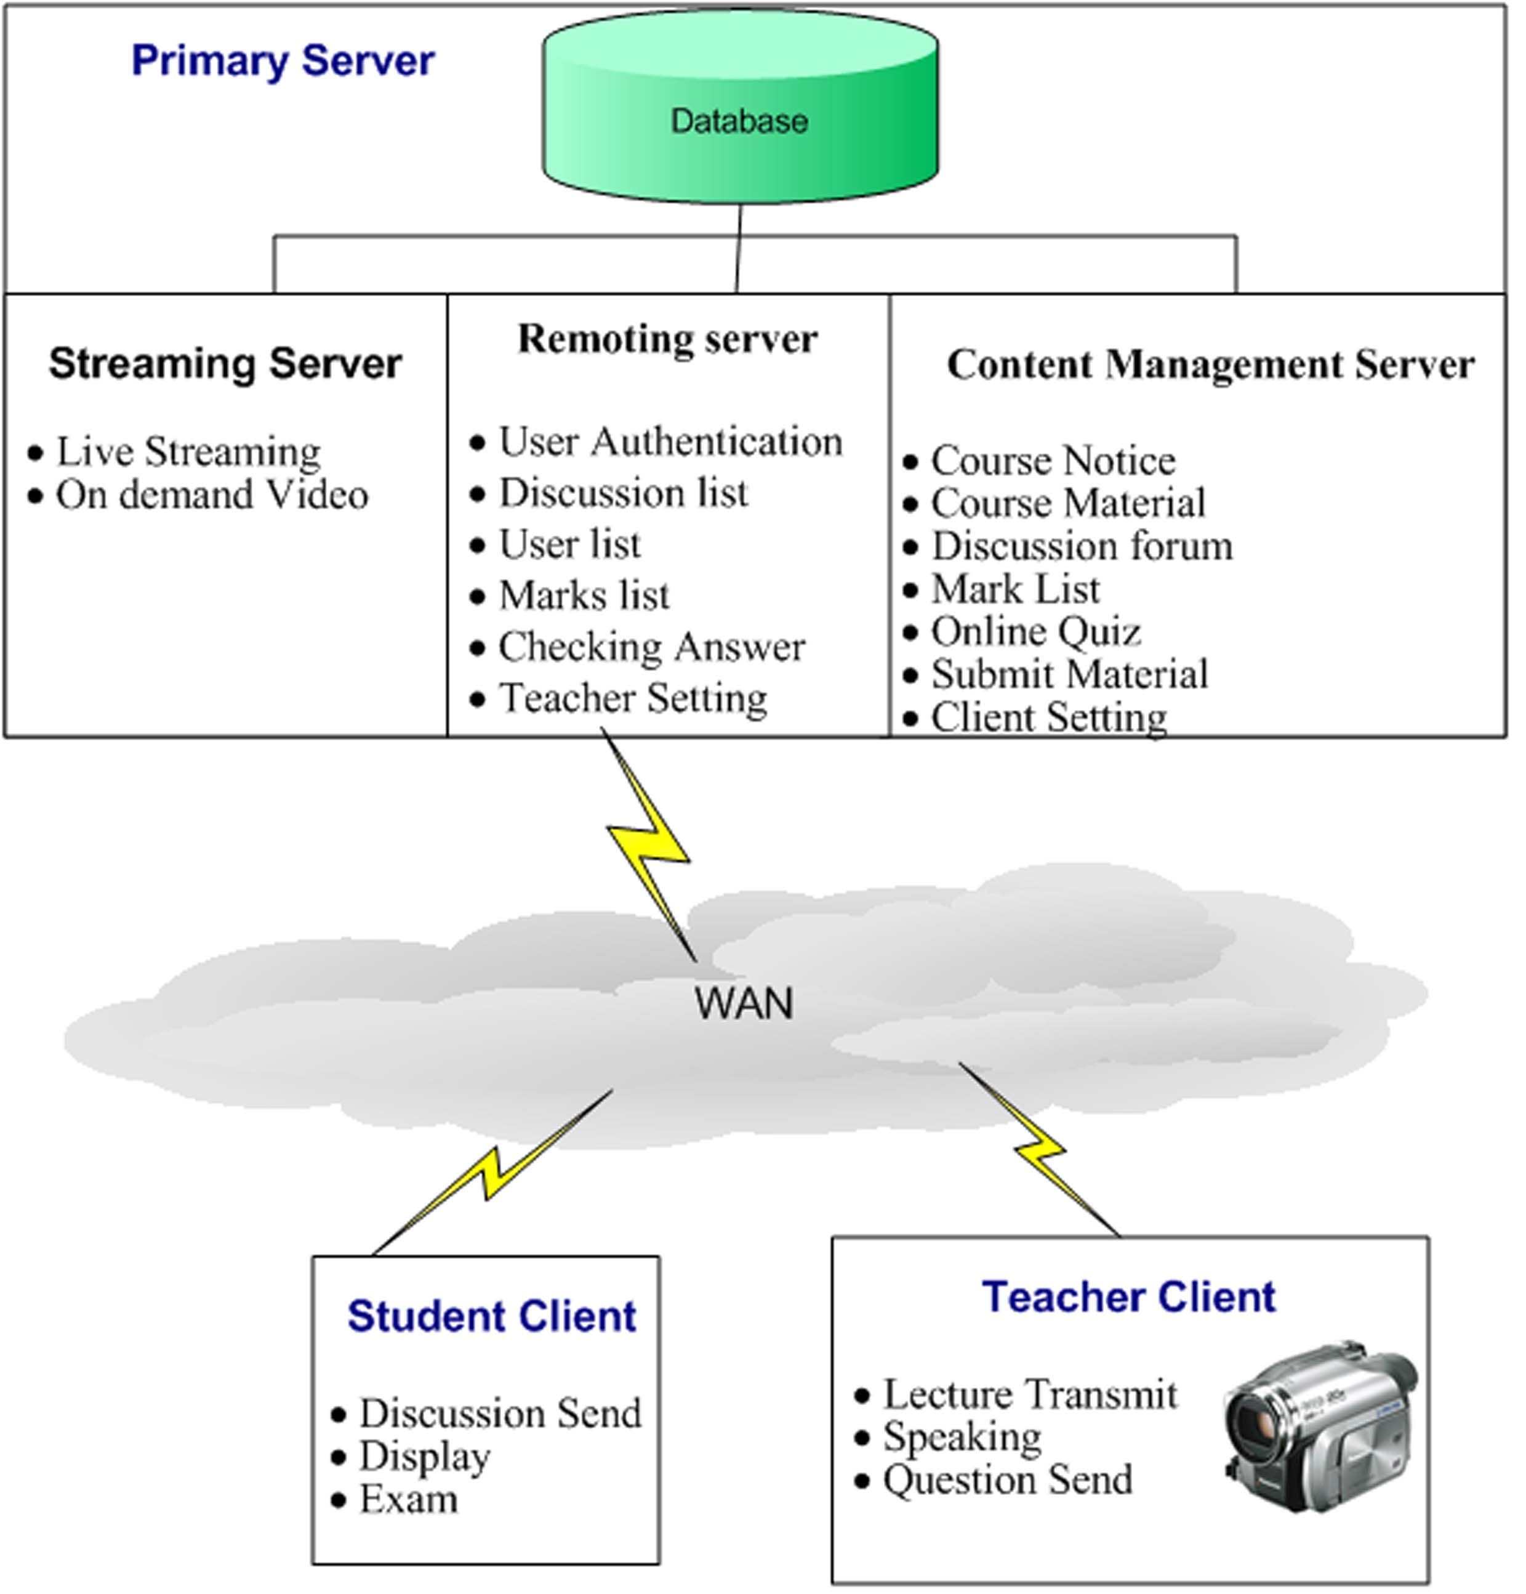
Figure 4: Main system Architecture
The instructor module is similar to student client module but has added functions of class control, video transmission, screen capture transmission, and question reply function. Instructor is responsible for organizing subject materials according to the topic and the sub-topics in a particular manner. Lectures and lab sessions are cross-referenced using hyperlinks on to other web pages and related YouTube videos. Sub-topics fall in the categories of explanations, examples, questions and references. It is the responsibility of the tutor to develop and maintain the formula for PBL difficult indexing, by using the above mentioned entities, to decide whether a student is allowed to proceed further. The development and study of this formula is beyond the scope of this paper. Currently in the proposed framework, we have adopted linear incremental method for modifying difficulty index.
Each course on the site is created on the basis of course title. Followed by a topic, and sub-topics in a particular index of difficulty, learners can navigate a topic using links on a page for its sub-topic. Each link clicked increases student’s points for directed unsupervised activity. If a page is clicked from its sub-topic it will not constitute to the points of a student. Once the learner has finished reading through the topic, he/she can check his/her skills by appearing in a quiz. The scored marks in the quiz are added to already scored-points through navigation of pages. This way, students’ performance is checked by comparing their old scores with the current ones.
At the end of the course a tutor can calculate the average of students’ performance, which in turn will be matched with his expected points for each difficulty index. If there is any difference found then the tutor can change the criteria of difficulty index.

5. Conclusion
An open source low cost E-learning Framework for Engineering Courses in Developing Countries is proposed. It is shown that Engineering education which is considered very expensive and is restricted to selected ones, could be diversified through its teaching pedagogies and can be made low cost by using Internet technology. This framework not only helps in providing learning material and instructional guidelines to a student, but if federated, can also help in maintaining curriculum standards and quality parameters of public and private universities of the country.
References
- Smith Jim, “Japan - Myth or miracle? Japan and the battle for Europe”, The TQM Magazine, Emerald Group, Bedford West Yorkshire, Apr 1993 Vol. 5 Iss. 2, pp. 47-51
- Barry Donald Willis, Distance education: Strategies and tools, Educational Technology Publications, Inc.: Englewood Cliffs, N. J., January 1994
- Aktan, B.; Bohus, C.A.; Crowl, L.A.; Shor, M.H, “Distance learning applied to control engineering laboratories”, IEEE Transaction on Education, Vol. 39, Issue 3, pp. 320 – 326.
- Bissell, C.; Endean, M., “Meeting the Growing Demand for Engineers and Their Educators: The Potential for Open and Distance Learning”, 2007 IEEE International Summit, Munich Germany, 9-11 Nov. 2007.
- Wu Chun; Yuan Ling; Wang Mei-ge, “An improved education technique for distance learning, 2010 International Conference On Computer and Communication Technologies in Agriculture Engineering (CCTAE), Chengdu, China, 10-12 June 2010.
- Khoja, S. and Sana, F, “A low cost interactive distance learning solution” in 6th Annual IEEE/ACIS International Conference on Computer and Information Science (ICIS 2007), Melbourne, Australia, 11-13 July, 2007.
- Zane L. Berge, Ph.D, “The Role of the Online Instructor/Facilitator”, http://www.emoderators.com/moderators/teach_online.html, viewed on Nov 25, 2010.
- Ebner, M.: E-learning2.0 = e-Learning 1.0 + Web 2.0?, Second International Conference on Availability, Reliability and Security, 2007(ARES 2007), pp. 1235 - 1239, (2007).
- Montgomery S.M.:, Addressing Diverse Learning Styles Through the Use of Multimedia, ASEE/IEEE Frontiers in Education Conference, (1995).
- Bill Pelz, C.A.S:, My three principles of effective online pedagogy, Journal of Asynchronous Learning Networks (JALN) Volume 8, Issue 3 (2004).
- Zhi-Feng Liu, E., Sunny S. J., Lin, Chiu, C., and Yuan S.: Web Based Peer Review: The learner as both Adapter and Reviewer, IEEE Transactions of Education, Vol 44, No. 3, Page(s). 246-251 (2001).
- Fardouly N.: “Learner-Centered Teaching Strategies”, in Principles of Instructional Design and Adult Learning Series, The University of New South Wales, Australia, September 1998. http://www.fbe.unsw.edu.au/learning/instructionaldesign/strategies.htm (1998)
- Hein, G.E.: Constructivist Learning Theory, International Committee of Museum Educators Conference (CECA), Jerusalem Israel, pp.15--22 (1991)
- Buriak,P., McNurlen, B., and Harper,J.: Systems Model for Learning, in ASEE/IEEE Frontiers in Education 95 Conference, Atlanta, USA, (1995)
- Ashcroft, K. and Foreman-Peck, L.: Managing Teaching and Learning in Further and Higher Education. Routledge, London: The Falmer Press, (1994)
- Lightbody P., Newton D., “Annotations Apache Struts 2 Documentation”, http://struts.apache.org/2.0.14/docs/annotations.html, viewed on 29 Nov 2010.
- Michael Karweit, “Virtual Laboratory”, http://www.jhu.edu/virtlab/virtlab.html, viewed on Nov 24, 2010
- Nedic, Z., Machotka, J., Nafalski, A., “Remote laboratories versus virtual and real laboratories” in 33rd Annual Conference on (2003 FIE) Frontiers in Education, Boulder, USA, 5-8 Nov 2003.
- Wulf. W.A. “How shall we satisfy long-term educational needs of engineers?” Proceedings of the IEEE, volume 88, Issue 4, pp. 593-596.

