The Center for Ecohydraulics Research Mountain StreamLab – a facility for collaborative research and education

¹Ralph Budwig and ²Peter Goodwin
Center for Ecohydraulics Research, University of Idaho Boise Campus, Boise, Idaho, USA, rbudwig@uidaho.edu ¹ ;pgoodwin@uidaho.edu ²

Abstract
The University of Idaho (UI), Center for Ecohydraulics Research (CER), Mountain StreamLab (MSL) features a large-scale sediment flume to allow fundamental and applied research of processes in mountain streams with a unique combination of scale, instrumentation, and computer-control. The goal of the MSL is to create a multi-user facility to allow a broad community of researchers and students to benefit from this unique, complex, and expensive laboratory. This paper describes the capabilities of the facility and accompanying instrumentation; as well as efforts to provide enhanced distance access through a suite of web based functions. The MSL hosted ten projects in 2010. Two of these projects are highlighted as examples in this paper – this first is a basic study that relates to sediment transport in mountain streams and the second examines how probe disturbances may lead to scour of a channel bottom.
1. Introduction
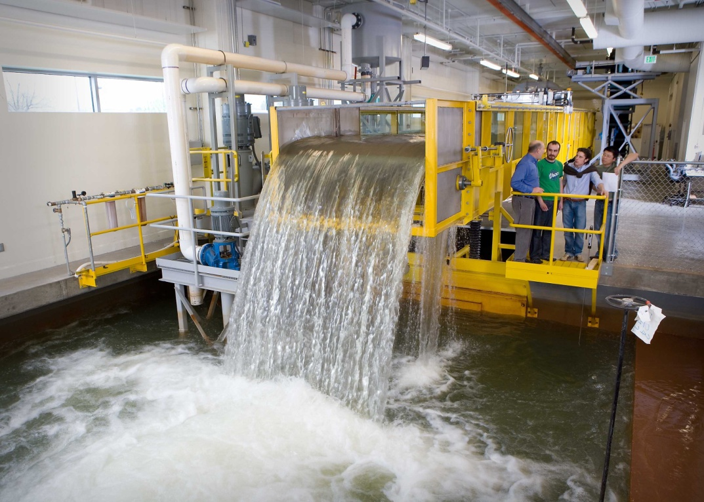
The University of Idaho (UI), Center for Ecohydraulics Research (CER), Mountain StreamLab (MSL) features a large-scale sediment flume to allow fundamental and applied research of processes in mountain streams with a unique combination of scale, instrumentation, and computer-control. The MSL, built in 2004, was carefully designed to fill a current void in laboratory facilities to study the interaction of sediment and turbulence and to overcome many of the problems associated with laboratory scaling. A combination of operational features makes this facility unique. The flume is 20m long, 2m wide, and 1.2m deep and includes a slope variable up to 10%. Flow rates may be set manually or by a computer interface, with the low flow system providing metered volume flow rates between 0.6 and 60 liters/second (0.021 to 2.1 CFS) and the high flow rate system providing metered volume flow rates between 60 and 850 liters/second (2.1 to 30 CFS). The flume is equipped with a custom designed, computer controlled instrumentation platform and can simultaneously measure multiple processes, such as bedform response to varying hydrographs. In addition, tri-modal sediment size distributions can be fed into the flume at high transport rates. After passing through the flume, the sediment is collected into a sediment weighing drum at the downstream end of the flume. This provides a continuous reading of the overall bedload transport rate. More technical detail on the MSL is provided in Section 2.
Figure 1. The CER high gradient sediment flume.

The goal of the MSL is to create a multi-user facility to allow a broad community of researchers and students to benefit from this unique, complex, and expensive laboratory. They are able to observe experiments in real-time though a recently implemented web based lab-cam system. Additional web based applications to facilitate collaboration are in the planning stages and are described in Section 2.

Broad and collaborative access to this unique facility will contribute to advances in geomorphology research, particularly in emerging themes such as ecohydraulics that span several disciplines of science and engineering. Examples of recent MSL project topics include: sediment transport in mountain streams, physical modeling of a salmon redd, sediment flux through a pool-riffle stream configurations, modeling of building stability when subjected to glacial lake outburst flooding, and physical modeling of sediment transport though a river diversion. More details on selected studies are provided in Section 3.
2. Laboratory Description
2.1 Description of the MSL
Figure 2. The MSL floor plan.
Tilting Sediment Flume
Catch Basin
3 meters (10 feet)
Pumps
Head Tank
Tailgate
Entrance to Sediment Trap

Model Basin Area
Control Room
Sediment Conveyors
Hoppers
Sediment Receptacle
Rollup Door to Shop
Rollup Door to Loading Area
The MSL is located at the Boise branch campus of the University of Idaho, on the first floor of the Idaho Water Center, where water-related agencies and graduate education programs are collocated. The MSL features a large scale, tilting-sediment flume and has a 186 square meter (2000 square foot) model basin area adjacent to the flume (Figure 2). The flume is 20 meters long, with a width of 2m and a depth of 1.2m. The maximum slope of the flume is 10%. Water is pumped from a 242,000 liter catch basin to the flume or to the modeling basing area directly for high flow rate applications or through a head tank for low flow rate applications. Magnetic flow meters are used to measure volume flow rate. The low flow system provides metered volume flow rates between 0.6 and 60 liters/second (0.021 to 2.1 CFS) and the high flow rate system provides metered volume flow rates between 60 and 850 liters/second (2.1 to 30 CFS). Flow rates may be set manually or by a computer interface. The flume sediment system is designed to feed sand and river rock in an open circuit (non-recirculating) mode. Sediment is stored in three sediment hoppers, so that up to three sizes of sediment can be delivered simultaneously, each at calibrated mass flow rates. The sediment feeding system can handle grain sizes from 0.5 mm to 40 mm. Larger cobbles may be manually loaded into the flume. An overhead crane that follows the length of the flume and the model basin area is used to move bulk bags of sediment for loading the hoppers as well as for manual placement into the flume. After passing through the flume, the sediment is collected into a sediment weighing drum at the downstream end of the flume. This provides a continuous reading of the overall bedload transport rate. The weighing drum, when full, dumps sediment into a holding tank. The sediment is augured from the holding tank into a slurry pump intake tube and then pumped to a receptacle in the alley that is adjacent to the MSL. A water return pump then draws water from the top of the receptacle and returns it to the flume catch basin. The sediment that collects in the receptacle is periodically transported to a local gravel yard, where it is reprocessed and sold for commercial applications.

The model basin area adjacent to the flume provides ample space for a variety of hydraulic and ecohydraulic physical models. Water can be supplied to this part of the laboratory from either the head tank or the variable speed pumps and is discharged into the catch basin after exiting the model.

The flume is equipped with a custom-designed, computer-controlled instrumentation platform that can move a measuring probe to any prescribed x, y, and z location or sequence of locations along the length, width, and depth of the flume. The platform has an on-board computer to host measuring instruments and custom software to record measured data along with the location at which it was measured. Major instrumentation in the MSL includes:
- A stereoscopic particle image velocimetry (PIV) system with megapixel resolution and 15 Hz frame rate. High end visualization software processes and displays PIV results.
- A high-speed (up to 50 kHz sampling rate), high accuracy (better than 0.1 mm) charge-coupled device (CCD), laser displacement sensor is mounted on the instrumentation platform and can be used to scan water surface profiles and sediment bed profiles.
- A custom eight channel ultrasonic sediment bed profiling system provides real-time bed profiling through a water column.
- An acoustic Doppler velocimeter (ADV) system that provides down-looking and side–looking capabilities.
- A Dual-frequency Identification Sonar (DIDSON) acoustic digital movie camera acquires planar images of underwater objects and boundary features. The DIDSON can function even with a water column that is loaded with suspended sediment and is optically opaque. The flume in the MSL has floor and side ports to mount the DIDSON.
- A high speed camera system to capture sediment motion
The MSL is adjacent to a design and fabrication facility. The fabrication equipment is available for model fabrication and for fabrication of custom instrumentation for the MSL.

2.2 Technology to facilitate collaboration
A web-based lab-cam system was installed in 2010 and is now operational. The system allows for real-time viewing of experiments by streaming video with off-site control of pan, tilt, and zoom of the lab-cams. Collaborators have full access to the lab-cams through a standard Internet browser. Two additional web based applications to facilitate collaboration are in the planning stages. The first will collect MSL data streams and to display them on a web-based interface. Local and distance users will have web access to real-time snapshots of data streams as well as ability to download complete data sets for post-processing. The second will be a large data management facility where experimental data may be stored and retrieved via the web-based interface. This will be especially useful for large data sets such as those associated with PIV or the water column or laser scan bed topography.
3. Examples of Recent Projects
The MSL has been used by research by faculty from regional and national universities as well as by northwest divisions of agencies including the U.S. Forest Service, U.S. Geological Survey, and the U.S. Bureau of Reclamation (Table 1). In addition, we have significant collaboration with other universities and research communities, including a MOU that articulates the MSL a part of the NSF National Center for Earth Surface Dynamics (NCED) and a part of the St Anthony Falls Laboratory (SAFL). CER has a global network of collaborators located in Europe, Asia, and South America. We partner with the Center for Patagonia Ecosystem Research (Chile) and are advisors to the European Union-Latin America Center for the Environment (Chile). Table 1 presents a list of projects that were conducted in 2010.
Table 1. MSL Projects in 2010
Name and Affiliation | Research Topic, Sponsor, and Status
Elowyn Yager, Ph.D. (CER) | CER Keystone class project, February, 2010
Ms. Heidi Schott (CER)  Elowyn Yager, Ph.D.  Joel Johnson, Ph.D.  U. Texas at Austin | Sediment transport in mountain streams, funded by NSF Career Award #0847799. March & April, 2010, with additional work planned for 2011
Ralph Budwig, Ph.D. | Transformation of the stream laboratory into a distance-use facility for collaborative research and education, Idaho EPSCoR equipment grant, May to August, 2010
Ms. Holly Bentz, USFS  Wolfgang Kampke, Karlsruher Institut für Technologie (KIT)  Ralph Budwig, Ph.D. | Physical modeling of modified culvert flow to aid fish passage, U.S.Forest Service, June, 2010
Mr. Joe Wagenbrenner (WSU)  U.S. Forest Service | Physical modeling of hill slope erosion and in-channel treatments, USFS, July, 2010
Ms. Natalie Spencer  University of London | Physical modeling of ram-dirt building stability when subjected to glacial lake outburst flooding, July, 2010
Mr. Sagar Neupane (CER)  Ms. Lauren Perrault (CER)  Ms. Heidi Schott (CER) | Follow-up to CER Keystone class project on sediment erosion in a gravel stream bed with alternating rows of large cobbles, October, 2010
Mr. Todd Buxton (UI)  Alex Fremier, Ph.D. (UI)  Elowyn Yager, Ph.D. | Proof of concept experiments for physical modeling of a salmon redd, October, 2010
Ms. Sharon Parkinson, USBR  Mr. Neal Bradshaw (CER)  Peter Goodwin, Ph.D.  Diego Caamano, Ph.D., Universidad de Concepción  Ralph Budwig, Ph.D. | Sediment flux through pools, U.S. Bureau of Reclamation, November and December of 2010
Harindra Fernando, Ph.D., U. Notre Dame  Peter Goodwin, Ph.D.  Ralph Budwig, Ph.D.  Mr. Neal Bradshaw | Preliminary physical modeling of river diversions, December 2010

More detailed summaries of two current and MSL projects are below.
3.1 Sediment transport in mountain streams (Yager and Schott, UI; Johnson, UT-Austin) In mountainous drainage basins, steep channels (gradients of 3-20%) occupy the majority of the total channel length. The volume and grain sizes of sediment supplied from steep channels and hillslopes influence the success of downstream river restoration projects. The aquatic habitat and water quality in restored sites are partially controlled by the magnitude and grain-size distribution of the sediment supply. Accurate predictions of sediment flux in steep streams are needed before the potential success of many restoration sites can be determined. In addition, we cannot answer fundamental geomorphologic questions without knowledge of sediment transport in steep headwater streams.

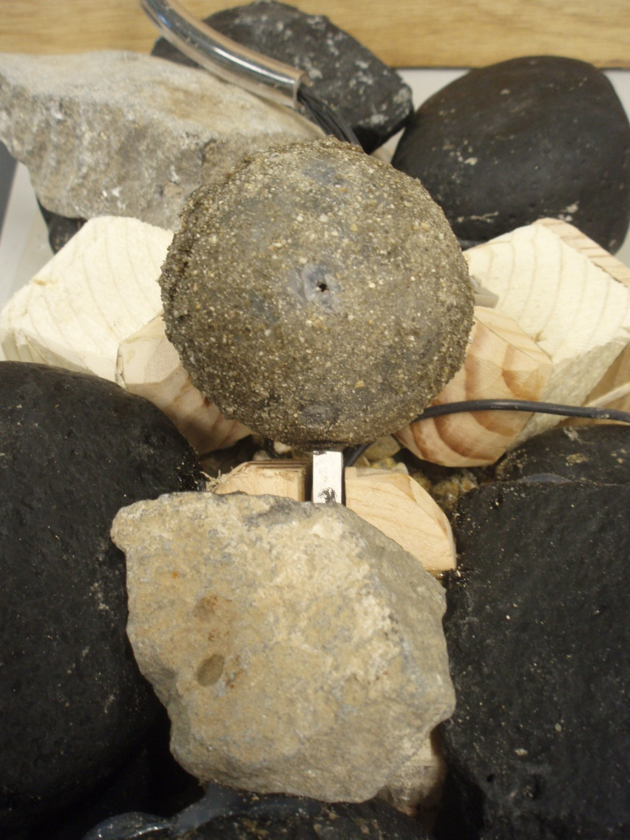
Most sediment transport equations are based on empirical fits to data measured at the reach-scale and therefore do not include the mechanics of grain motion. Furthermore, traditional bedload transport equations derived for low-gradient channels typically over-predict sediment flux in steep, rough streams by several orders of magnitude (e.g. Bathurst et al., 1987; Rickenmann, 1997; D’Agostino and Lenzi, 1999). Most streams, particularly steep channels, have relatively wide grain-size distributions that are divided into distinct spatial patches with narrower grain-size distributions. Relatively little field work has been conducted on sediment patches (e.g. Paola and Seal, 1995; Lisle, 1995; Dietrich et al., 2005), and no theory currently exists to explain the location, grain size distributions, sediment transport rates and stability of sediment patches. Use of a reach-averaged grain size and shear stress in streams with patches can cause sediment flux predictions to be incorrect by orders of magnitude. Furthermore, the use of time-averaged flow measurements in unsteady or nonuniform environments, which are typical of steep streams, to predict sediment motion have been unsuccessful (e.g. Nelson et al., 1995; Sumer et al., 2003). The turbulent parameters (velocity intensities, pressure variations, etc.) directly responsible for sediment transport are also relatively uncertain (e.g. Kalinske, 1943; Nelson et al., 1995; Papanicolaou et al., 2001; Schmeeckle et al., 2007) and very few measurements have been made for the range of flow conditions found in steep streams (Papanicolaou et al., 2002). Yager therefore hypothesized that bedload transport equations for steep, rough streams need to include 1) the range of turbulence and grain properties that control the initiation of grain motion 2) the spatial variability in stresses and bedload transport rates on patches, and 3) the effects of temporal and spatial variations in sediment supply.
Figure 3. The test grain.

Flume experiments in the MSL are being used to further the understanding of the complex interactions between sediment transport, bed grain sizes, flow turbulence and channel roughness on initiation of grain motion. To measure local conditions, a mobile test grain was constructed that measured pressures at specific points around the grain. The 50 mm diameter test grain is shown in Figure 3. The test grain has seven surface pressure ports each connected to a pressure transducer inside the test grain. These pressure transducers were sampled at frequency of 1000 hz.

The test grain was placed on a fixed bed, so the pocket geometry was constant throughout all experiments. The contact points of the test grain on the bed were three force sensors that measured force fluctuations of the test grain. The sampling rate for these sensors was also 1000 hz.

Particle Imaging Velocimetry (PIV) was used to measure the 3D velocity field in a streamwise slice of the water column over the diametral plane of the test grain. Pressure, force, and PIV measurements were simultaneously collected during the initiation of motion of the test grain.

For brevity – we show only force transducer signals in this paper. Figure 4 shows the outputs of the three force sensors the mobile grain was placed upon. The time immediately before the signals flat-line are the point when the particle moved. The white signal is the upstream force sensor, and the pink and blue signals are the downstream left and right respectively. The most notable observation of these outputs is the range of force fluctuations is greater at the lower slope than at the higher slope. This suggests that the particle can endure greater force at the lower slopes before it rotates out of its pocket. This does make sense in that less of the particle’s weight is in the downstream direction at lower slopes.

3.2 Probe disturbances and potential scour (Budwig; Chris Hocut, Notre Dame U.) Measurement probes that penetrate the free surface of a river or an open channel are often used to measure flow conditions, water quality or bed topography. These probes interact with the flow causing disturbances, which alter the flow and may also locally scour the sediment bed, whereby velocity fluctuations and vorticity cause the sediment particles close to the tip of the probe to erode and be transported downstream. Example probes include underwater cameras, ultrasonic depth probes, acoustic Doppler current profilers (ADCP), acoustic Doppler velocimeters (ADV), and water quality probes.

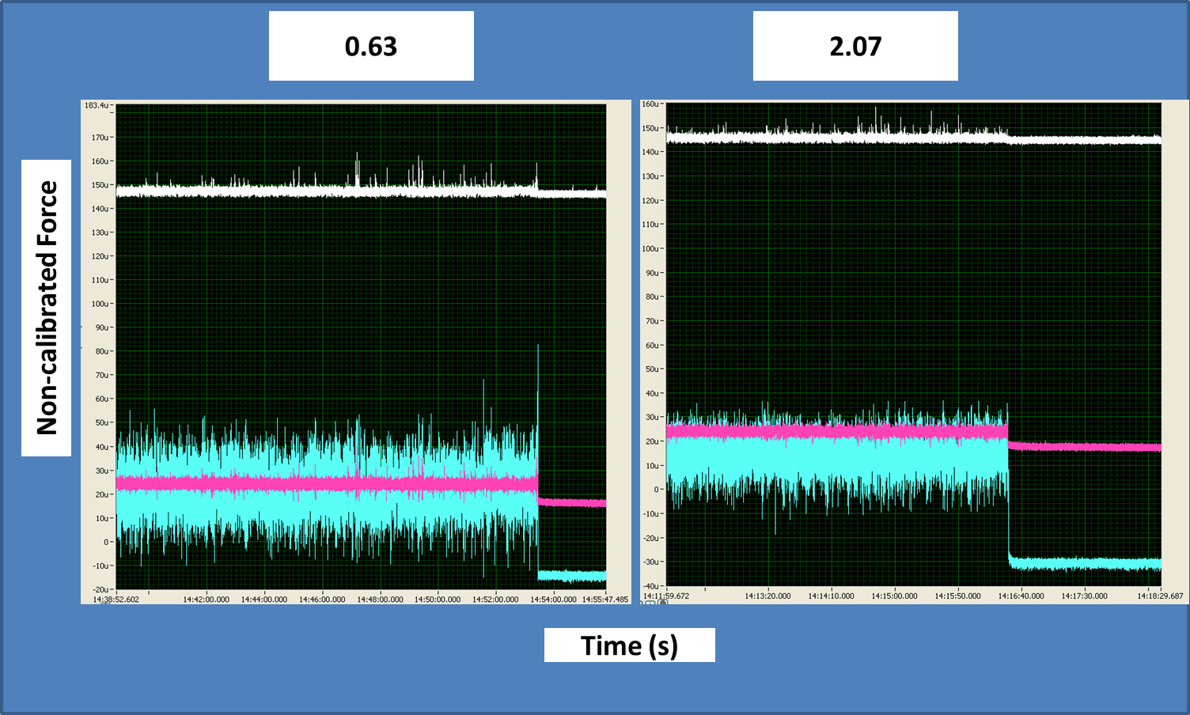
Figure 4. Force sensor outputs for slopes of 0.63% and 2.07%

The authors are aware of four previous studies of the flow around bluff bodies that were not in contact with wall of an open channel. Krampa-Morlu and Balachandar (2001) measured the wake velocity of a flat plate in an open channel suspended above the channel bottom. A “wall jet” like flow interacted with the wake flow behind the plate. The velocity profiles in the immediate wake were distorted and in the form of an S shape showing a significant deviation from the approaching freestream velocity profile. Snyder and Castro (1999) found a downward flow disturbance induced by an ADV transducer probe in a tow tank. The vertical velocity was always negative and had a value of approximately 2% of the horizontal speed. Rusello et al. (2006) compared the flow disturbance of a Sontek MicroADV and a Nortek Vectrino ADV in a flume. The MicroADV showed substantial deflection of the flow near the central transducer. Muste et al. (2010) investigated the flow disturbance of an ADCP in a flume. The flow velocity decreased and directed downwards as it approached the upstream side of the ADCP. The velocity then increased as the flow passed under the ADCP and decreased downstream in the wake. The flow disturbance extended up to half of the depth of the flow.

The present study experimentally investigated open channel flow disturbance due to a suspended circular cylinder that penetrated the free surface. A circular cylinder was selected (rather than a particular probe configuration) as a paradigm problem to yield fundamental physical understanding of the disturbance flow field. The cylinder penetration depth that caused interaction with the channel bottom was also investigated. This present study is an extension of the study of disturbances caused by probes that penetrated the free surface of an open channel when the cylinder was 7D (17.8cm) above the channel bottom performed by Sanders et al. (2009).

The experimental configuration is shown in Figure 5. The distance between the tip of the cylinder and the channel bottom was varied. The cylinder diameter was fixed at 2.54 cm. In this paper, for brevity, we will only shown a limited set of results for when the cylinder tip was D/2 (1.3cm) above the channel bottom.

Figure 6 shows the PIV generated vector field for the open channel flow with the cylinder D/2 (1.3cm) above the bottom. The turbulent wake was present directly downstream of the cylinder. The wake started below the cylinder and propagated upwards to the top of the FOV as it moved downstream. It can also be seen that that the disturbance from the cylinder extends to the channel bottom just downstream of the tip of the cylinder.
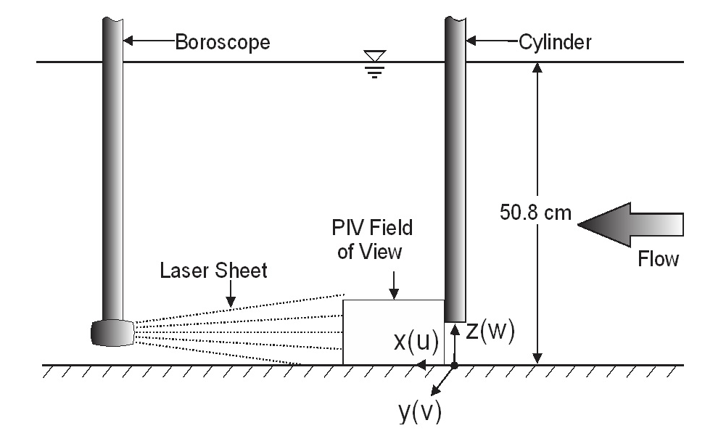
Figure 7 shows an image of the scour hole and dune created by the presence of the cylinder D/2 (1.3cm) above a sand bed. This cylinder location was the farthest tested distance above the sand bed which caused scour. Figure 8 shows the surface plot and contour plot of the sand bed after thirty minutes of flow as measured by the CCD laser sensor. The maximum height of the dune was 0.39cm above the sand surface and the maximum depth of the scour hole was 0.09cm below the sand surface. The x-distance between the maximum height of the dune and the maximum depth of the scour hole was 3.69cm. The width of the scour hole was 5.5cm and the width of the dune was 8cm. The distance from the cylinder center line to the maximum scour hole depth and maximum dune height was -0.96cm and 2.7cm, respectively.
Figure 5. Location of PIV field of view.

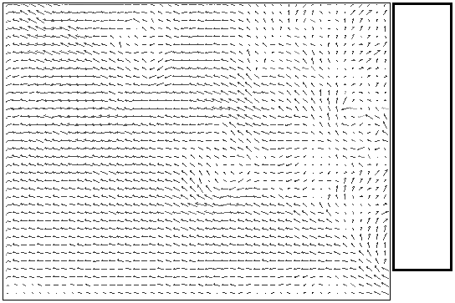
Figure 6. Vector field with tip of cylinder D/2 above channel bottom. Flow is from right to left.

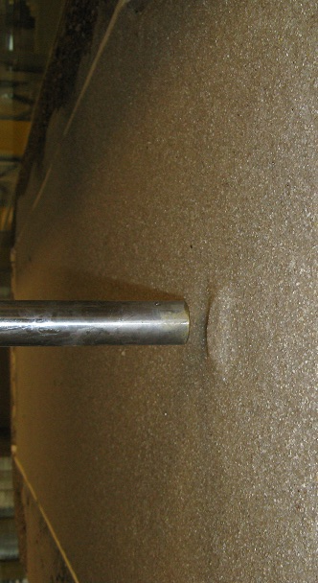

Figure 7. Image of score dune and hole. Cylinder is D/2 above the channel bottom.
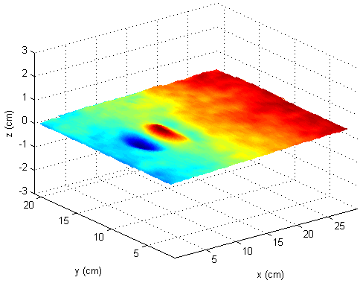
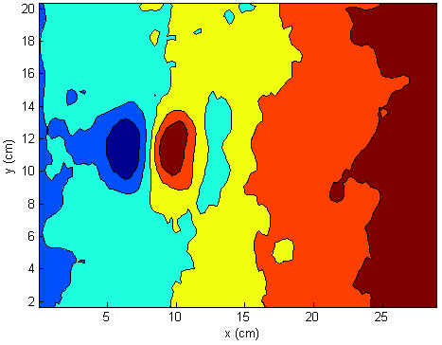
Figure 8. Surface and contour plots with the cylinder D/2 above sand. The Δz between each color in contour plot represents 0.8mm of depth. Flow is from left to right.
4. Concluding Remarks
The ten projects hosted in 2010 have demonstrated capability and accessibility for collaborative projects in the MSL. Broad and collaborative access to this unique facility will contribute to advances in geomorphology research, particularly in emerging themes such as ecohydraulics that span several disciplines of science and engineering. Additional instrumentation as well as web based applications are in the planning stages, with the goal to further facilitate collaborative research and education.
5. Acknowledgements
The authors would like to acknowledge the funding and support from the Murdock Charitable Trust for the purchase and commissioning of instrumentation and the sediment trap system. The purchase and installation of the labcam system was supported by NSF award number EPS-0814387 from the NSF Idaho EPSCoR Program and by the National Science Foundation. Additional financial support for monitoring and research was provided by Congressional Award: Fund for the Improvement of Postsecondary Education (FIPSE). (Award No. P116Z010107: Hydroinformatics Computing Center at the University of Idaho)
References
- J. C. Bathurst, W. H. Graf, and H. H. Cao, “Bed load discharge equations for steep mountain rivers,” in Sediment Transport in Gravel-bed Rivers, C.R.Thorne et al. (eds.), Wiley, 1987, pp. 453-477.
- D. Rickenmann, “Sediment transport in Swiss torrents,” Earth Surf. Processes Landforms, Vol. 22, 1987, pp. 937-951.
- V. D’Agostino and M. A. Lenzi, “Bedload transport in the instrumented catchment of the Rio Cordon Part II: Analysis of the bedload rate,” Catena, Vol. 36, 1999, pp. 191-204.
- C. Paola and R. Seal, “Grain size patchiness as a cause of selective deposition and downstream fining,” Water Resour. Res., Vol. 31, 1995, pp. 1395-1407.
- T. E. Lisle, “Particle size variations between bed load and bed material in natural gravel bed rivers,” Water Resour. Res., Vol. 31, 1995, pp. 1107-1118.
- W. E. Dietrich, P. A. Nelson, E. Yager, J. G. Venditti, M. P. Lamb, and L. Collins, “Sediment patches, sediment supply, and channel morphology,” in River Coastal and Estuarine Morphodynamics, G. Parker and M.H. Garcia (eds.), Taylor and Francis, 2005, pp. 79-90.
- J. M. Nelson, R. L. Shreve, S. R. McLean, and T. G. Drake, “Role of near-bed turbulence structure in bed load transport and bed form mechanics,” Water Resour. Res., Vol. 3, 1995, pp. 2071-2086.
- B. M. Sumer, L. H. C. Chua, N.-S. Cheng, and J. Fredsøe, “The influence of turbulence on bedload sediment transport,” J. Hydraul. Eng., Vol. 129, No. 8, 2003, pp. 585–596.
- A. Kalinske, “The role of turbulence in river hydraulics,” Bull.Univ. Iowa Studies Eng., Vol. 27, 1943, pp. 266–279.
- A. Papanicolaou, P. Diplas, C. Dancey, and M. Balakrishnan, “Surface roughness effects in near-bed turbulence: Implications to sediment entrainment,” J. Eng. Mech., Vol. 127, No. 3, 2001, pp. 211–218.
- M. W. Schmeeckle, J. M. Nelson and R. L. Shreve, “Forces on stationary particles in near-bed turbulent flows,” J. Geophysical Res., Vol. 112, 2007, F02003, doi:10.1029/2006JF000536.
- A. N. Papanicolaou, P. Diplas, N. Evaggelopolos and S. Fotopoulus, “Stochastic incipient motion criterion for spheres under various bed packing conditions,” J. Hydraul. Eng. ASCE, 2002, doi: 10.1061/(ASCE)0733-9429(2002)128:4(369).
- F. N. Krampa-Morlu and R. Balachandar , “A study on flow past a suspended bluff object in an open channel,” Can J Civil Eng, Vol. 28, 2001, pp. 547-554.
- W. H. Snyder and I. P. Castro, “Acoustic Doppler velocimeter evaluation in a stratified towing tank,” J Hydraulic Eng, Vol. 125, 1999, pp. 595-603.
- P. J. Rusello, A. Lohrmann, E. Siegel, and T. Maddux, “Improvements in acoustic Doppler velocimetery,” Proceedings of the 7th International Conference on Hydroscience and Engineering (ICHE-2006), September 10 – 13, 2006, Philadelphia, USA
- M. Muste, D. Kim, and J. A. González-Castro, “Near-transducer errors in ADCP measurements: experimental findings,” J Hydraulic Eng, Vol. 136, 2010, pp. 275-289.
- N. Sanders, R. Budwig, and E. Yager, “Disturbances caused by probes that penetrate through the water surface of an open channel flow,” Proceeding of the 33rd IAHR Congress, August 9-14, 2009, Vancouver, Canada.

