A Web Based Learning Design Tool

¹F.B. Bruno, ²T.L.K. Silva, ³R.P. Silva, ⁴F.G. Teixeira
Universidade Federal do Rio Grande do Sul, Porto Alegre, Brazil
fernando.bruno@ufrgs.br¹;
tania.koltermann@ufrgs.br²;
regio@ufrgs.br³;
fabiogt@ufrgs.br⁴;

Abstract
The use of learning objects can facilitate the process of production and delivering of educational material and their reuse and re-contextualization in different scenarios – such process is due to the current development stage of Information and Communication Technologies (ICTs), which allow easy access to products and services related to them. ICTs combined with instructional design theories, lead to the emergence of new generations of distance learning, which add educational content to web based services. From this combination rises a hybrid mode of education, which combines tools for face-to-face and distance learning (Blended Learning).
This paper proposes a web-based tool that enables the development and provision of learning designs and its reuse and re-contextualization as generative learning objects, aimed at developing educational materials.
In this tool, the learning designs work as structures built on XML, based on concept maps, which act as an interaction layer between the learning objects, organizing the content to be available.

1. Introduction
The current development stage of Information and Communication Technologies (ICTs) enables easy access to products and services related to them - computers and mobile devices (phones, tablets), applications and telecommunication networks. The educational field is, for some time, using such technologies for developing and distributing educational material [1].

This development allows the emergence of new generations of Distance Learning (DL), which are characterized by the media used in the delivery of educational material [2] – starting with the submission of handouts and books by postal service, through distribution of CD-ROMs, reaching virtual environments for teaching and learning (Learning Management Systems – LMSs).

ICTs has also provided the emergence of a hybrid mode of instruction that gathers face-to-face and distance learning tools, known as blended learning [3].

However, the design and production of digital learning materials, even considering the appropriate use of authoring languages, require large investments in human and financial resources – which encouraged the development of a strategy that leads its development based on concepts of Object Orientation (OO) brought from the software engineering field. The learning material build around this strategy is known as Learning Objects [4].

Learning objects represent a new approach in producing and distributing educational material. Among its main properties are the ability of combination of various objects to give rise to new objects, the possibility of reuse and optimization of resources used in its preparation and distribution - properties inherited from the OO paradigm, which highly values de creation of components (objects) that can be reused [5].

The taxonomy of learning object types, proposed by Wiley [5], classifies them according to their complexity and functionality in five different types: Fundamental, Combined-closed, Combined-open, Generative-presentation and Generative-instructional.

The first three types are related specifically to the content. The last two contain abstract strategies that are independent from the contents.

According to Boyle; Leeder and Chase [6], the key concept of generative-instructional learning objects is to separate the deep structure from the surface structure of the learning object. This deep structure is supported by a concept known as learning design. The concept of generative learning object separates the learning design from its surface instantiation. The surface learning object is then viewed as a particular realization of the underlying learning design [6].

According to Weller [7], if the educational experience can be thought as an action that comprises two distinct components, namely content and pedagogy, then content-based learning objects represent the instructional content, while the leaning design (the generative-instructional type) addresses the pedagogical strategies.

Despite its relatively recent appearance in connection with e-learning, this concept of designing for learning is far from being a new idea. In a traditional face-to-face context, many teachers make consciously, or not, learning design decisions every time they prepare a teaching session [8].

Although they are not innovative ideas in education, the central ideas behind the concept of learning design represent new possibilities for increasing the quality and variety within the Distance and Blended Learning context [8].
2. Learning Objects
The term "learning object" was chosen by the Learning Technology Standards Committee (LTSC) of the Institute of Electrical and Electronics Engineers (IEEE) [9] to describe the minor instructional components, consisting of any material, digital or not (multimedia material, instructional content, learning objectives, computational tools, people, organizations, events), which is used in a technology-based learning process (learning management systems, interactive learning environments, collaborative learning environments) [10].

A narrower concept was adopted by Wiley [5], which considers the object of learning "any digital resource that can be reused to support learning" These resources are delivered through the network, on demand and may have different granularities: from small (videos, images, text) to large (lectures, lessons, courses).

The concept of learning object, according to Wiley [5], is based on the paradigm of Object Oriented of the Software Engineering field. For the same author, the term "learning object" is not universally employed and different terms are found in the literature, such as "knowledge object", "instructional component", “pedagogical document”, “educational software component”, “online learning materials” and simply “resource”.
2.1 Taxonomy of learning objects types
Learning objects can be classified in various ways, according to the instructional theory to which it belongs, but Wiley [5] proposed a taxonomy of object types compatible with various instructional design theories, improving the chances of implementation. This taxonomy classifies them according to their complexity and functionality in five different types (some types were renamed in a later work [11], as shown below):

- Fundamental (formerly single-type): the simpler type. It is the category of smaller granularity in the taxonomy and contains a small fraction of knowledge. – for example, an image file, a simple text, a 3D model.

- Combined-closed (formerly combined-intact): a set of objects gathered for a specific purpose – for example, text with illustrations.

- Combined-open (formerly combined-modifiable): a set of objects assembled on demand for a specific purpose – for example, a web page with various media resources (animations, images, text, videos).

- Generative-presentation: an object that contains presentation strategies of the object combinations.

- Generative-instructional: a content-independent object that contains abstract pedagogical strategies, combining other objects and evaluating the student interactions with these combinations.

According to Singh [12], the combined object types should take the student to a particular learning objective, and through feedback, to evaluate its performance over the goal (Figure 1).

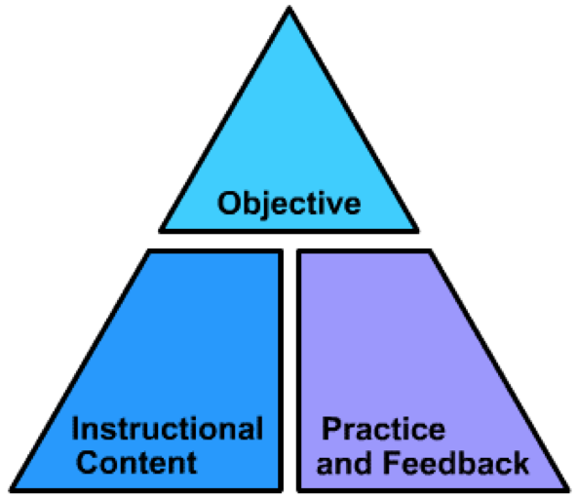
Figure 1: Key elements of a learning object [12]
2.2 Learning Objects in HyperCAL online
HyperCAL online is an education support system, used by the Department of Design and Graphic Expression, of the Federal University of Rio Grande do Sul, in undergraduate courses in Engineering, Architecture and Design and Design graduate. HyperCAL online has a trial module available to experimental registration and retrieval of learning objects, developed and implemented by Silva [10].

Wiley's taxonomy [5], presented in Section 2.1, was adopted for the production of learning objects in this trial module, covering only the fundamental and combined object types [10].

The development of combined objects is guided by concept maps that represent structures of courses, enabling the construction of learning objects of different granularity from the semantic relationship established between them (Figure 2). For the development of combined objects, the fundamental objects that will be part of the composition must be registered in advance – the composition is then generated dynamically in XML (eXtensible Markup Language) [13] and stored in the HyperCAL online database [10].

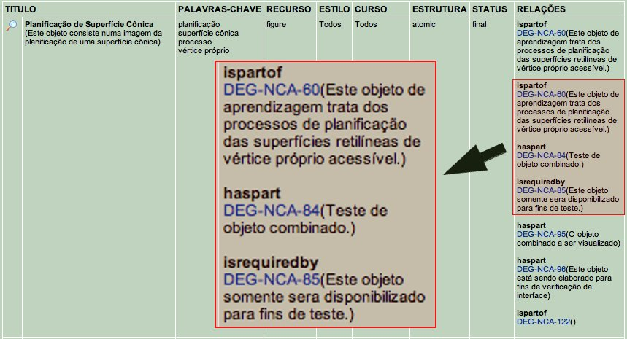
Figure 2: Example of semantic relationship between objects [10]

The XML standard was chosen because it is a language that offers greater ease of use, besides its high compatibility with various systems can be modeled and interpreted by various programming languages – among them, PHP (PHP Hypertext Preprocessor), which was used in the development of HyperCAL online.

The search and retrieval of objects stored in the database is a problem of information architecture. Such objects must be available and shared efficiently, based on a clear and consistent information system, so they are stored with their metadata. Metadata information is necessary for indexing and searching, corresponding to a complete description of the learning object [10].

As the metadata information is retrieved through search engines or used by a learning management system (LMS), the stored object can compose learning units. Silva's work [10] used the Learning Object Metadata (LOM) specification, proposed by the IEEE [9] which proposes attributes organized into categories to make the metadata structure. In addition to the attributes recommended by the LOM specification, were added information concerning the undergraduate course that is intended, and characteristics of learning style.

When the learning object is prompted by an agent, the system will search through the information available, the elements of this object, and how it should be presented. The presentation is achieved by processing XML files in HTML (HyperText Markup Language), using XSLT style sheets (eXtensible Stylesheet Language Transformations), which organize the content of the object and returns a web page [10]. The final result can be viewed in Figure 3.

The methodology developed to design the combined objects takes the declared semantic relationships in the concept map of the course through adequate vocabulary for indexing metadata. And with the aid of information contained in the metadata of fundamental and/or combined learning objects, it is possible to organize and build the structure of the combined object according to an XML file [10].

The prototype available in HyperCAL online does not offer the generative learning object type. Such objects act as an interaction layers that provides teaching strategies, establishing relationships between other objects (creating and providing a logical sequence and devices that monitor the process) between the agents of the process (learners, instructors) and between objects and agents (activities, assessments) [1].

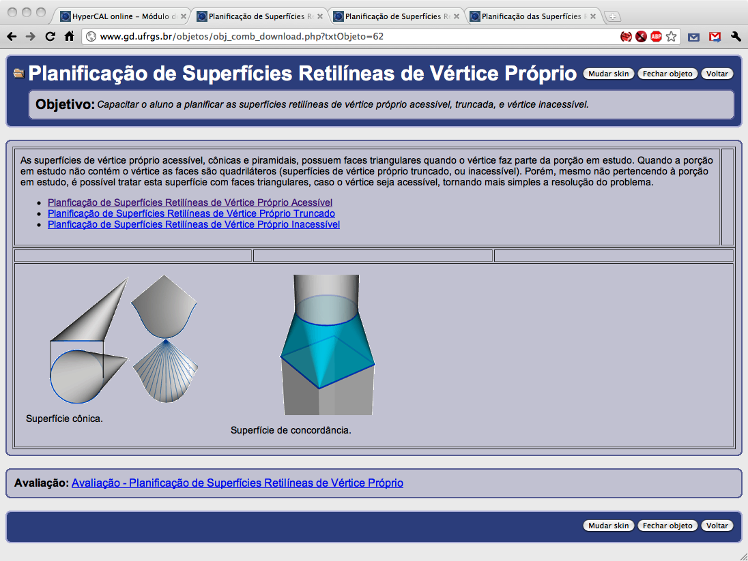
Figure 3: Example of a combined object in HyperCAL online [10]
2.3 Generative-Instructional Learning Objects
The taxonomy of Wiley [5] (section 2.1), points to the generative objects as the category of higher complexity of the learning objects. This category is independent of presentation strategies, being used as a structure that organizes the other types of objects, and assessing the learner's interactions with these combinations. These objects support the instantiation of abstract instructional strategies and have high level of reusability [6].

For the generative object to be truly adaptable, the underlying structure must be separated from content, so the process of producing an object generative is thus one of deconstruction, by disaggregating the contents from the core structure [14].

The challenge in making a generative object is to develop an architecture that represents the pedagogical standard behind the learning object - supported by the learning design – and that support its representation in a variety of instantiations [6].
3. Learning Design
According to Koper [15], every learning practice has an underlying learning design that is more generic than the practice itself, as an independent structure. Thus, a learning design can be reused many times creating different courses. The structure of a learning design can be expressed as a script, like rules to be applied in a given situation [15]:

If {learning situation S (and value V)}
Then {use learning design method M (with probability P)}

Such rules can be classified into three categories:

- those derived from instructional design theory, where knowledge is shaped by theories that consist of a set of design principles;

- those derived from examples and best practices in teaching;

- those derived from patterns in best practices, representing an intermediary category between theories and best practices.

To encourage the use of a language and a common vocabulary and make the learning design information a language compatible with computers, IMS Global Learning Consortium has developed, based on the Educational Modeling Language (EML) of the Open University of the Netherlands, the IMS Learning Design Specification (IMS-LD) [16], composed of three main documents (Best Practice Guide, Binding Information and Information Model), and XSD schemas (W3C, 2004) for validation of XML files [17].

According to the Best Practices Guide, the development of Learning Design for a unit of learning can be described as follows [1]:

- analyze the problem of education as a specific case study, creating a scenario that describes the learning objectives and tasks or activities, establishing the basic order of events that can be captured in a narrative form;

- express such narrative description in an UML (Unified Modeling Language) activity diagram, which is used as support for the creation of the XML document that implements the IMS-LD;

- create the actual content (educational resources) through a content package that incorporates the learning design.

The IMS-LD specification provides a framework for the development of learning designs from a vocabulary that covers much of the instructional actions. According to Britain [8], the concept of learning design is much broader, and is not fully represented in the specification. However, the IMS-LD [5] is the result of an effort to standardize, through an open technical documentation, the modeling process of teaching strategies [17].

Figure 4 shows the basic structure of the element <learning-design> according the IMS-LD [16].
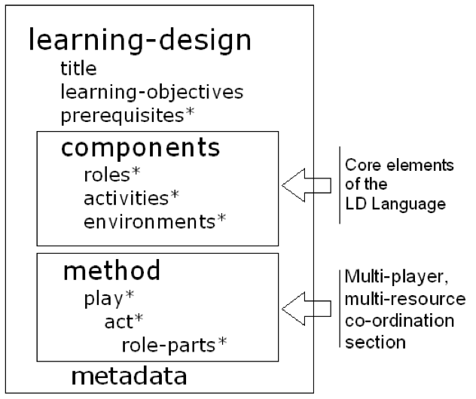
Figure 4: The <learning-design> element [17]
3.1 Learning Design Approach in Learning Objects
Learning objects are resources of great interest and importance to the learning design. Through evaluation and review of software tools related to learning design, Britain [8] does some distinctions: As the IMS-LD provides a complete and thorough framework, exploring the possibilities of applications within the learning space, this framework presents only one of several possible realizations of the concept of learning design and there are other possible ways to model this concept that are not implemented in IMS-LD [1]. Britain [8] also seeks to differentiate the learning design as a concept broader than the term related to the IMS-LD specification.

Another aspect addressed by Britain [8], is the organization and presentation of activities and resources needed to support learning. This planning can be viewed as a sequencing rule that will serve as a tool for learning design. This organization can be given by a sequential or branched workflow, allowing the use of different routes [1].

In the point of view of the teacher, this approach has two advantages. Provides a framework for teachers to think in a more complex and creative way about how they design and structure activities for different students or groups of students. And the learning design can be distributed and shared among many teachers and / or archived for reuse. Thereunto, a pattern or design must be described in a sufficient abstraction level to allow its generalization, keeping its pedagogical value [1].

According to Britain [8], instructional design in distance education has focused predominantly on learning objects as an essential entity within a course or program of course. However, the learning design focuses on learning activities. Good and well structured contents are important to create good quality courses, as well as tasks, activities and interactions that occur among the participating agents.
3.2 Learning Design Tools
The IMS-LD specification served as basis for some computer implementations of learning design in the construction of generative learning objects. Among them are:

- RELOAD Project (Reusable eLearning Object Authoring & Delivering), from Bolton University [18] (figure 5);

Figure 5: RELOAD Editor [18]
- ReCourse Learning Design Editor, from TENCompetence Foundation (figure 6) [19];

Figure 6: ReCourse Learning Design Editor [19]

- GLO Maker, from the Centre for Excellence in Teaching and Learning in Reusable Learning Objects (CETL-RLO) (figure 7) [20].

Figure 7: Generative Learning Object (GLO) Maker [20]

All of these tools, despite being very useful, free and multi-platform, were not designed to work directly on the web – they must be downloaded and installed on a computer – which reduces the possibility of reusability, because the objects created are not stored in a centralized repository, but in the computer of who produced them.
4. A Web Application Model
From the technological base available in the HyperCAL online system, it is possible to adopt another interaction layer, representing teaching strategies, through the inclusion of generative learning objects.

For the development of Units of Learning (UOL) – a term used to define an instructional component (course, lecture, lesson) – based on the concept of learning design, there should be a distinction between the unit itself, and its delivery to different groups of learners. The IMS-LD provides a rating system to describe these units. One of the requirements that must comply with the learning design is the possibility of reproduction and repetition of such unity, reaching different system agents [21]. Once created, the learning unit can be retrieved and delivered many times.

At its core, the IMS-LD describes the interactions between users in different roles, and between users and the system. Such interactions can be captured in the form of properties and declared in the object itself [22].

The implementation of a UOL consists in customizing the contents to the user, as needed (figure 8).
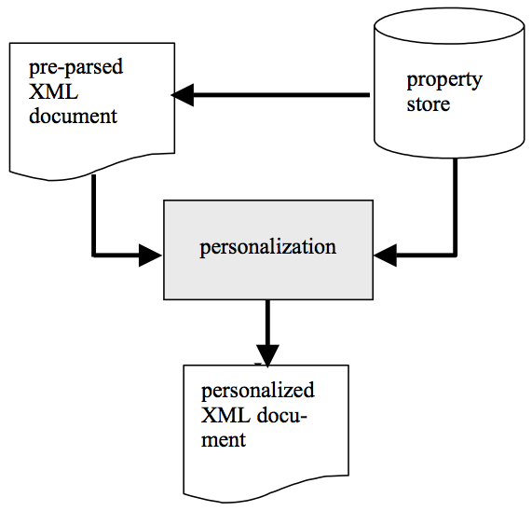
Figure 8: Personalization and delivering of learning objects [22]

The proposed application extends the functionality of HyperCAL online, taking advantage of its structure and tools, such as registration module of objects and their metadata, as shown in figure 9.

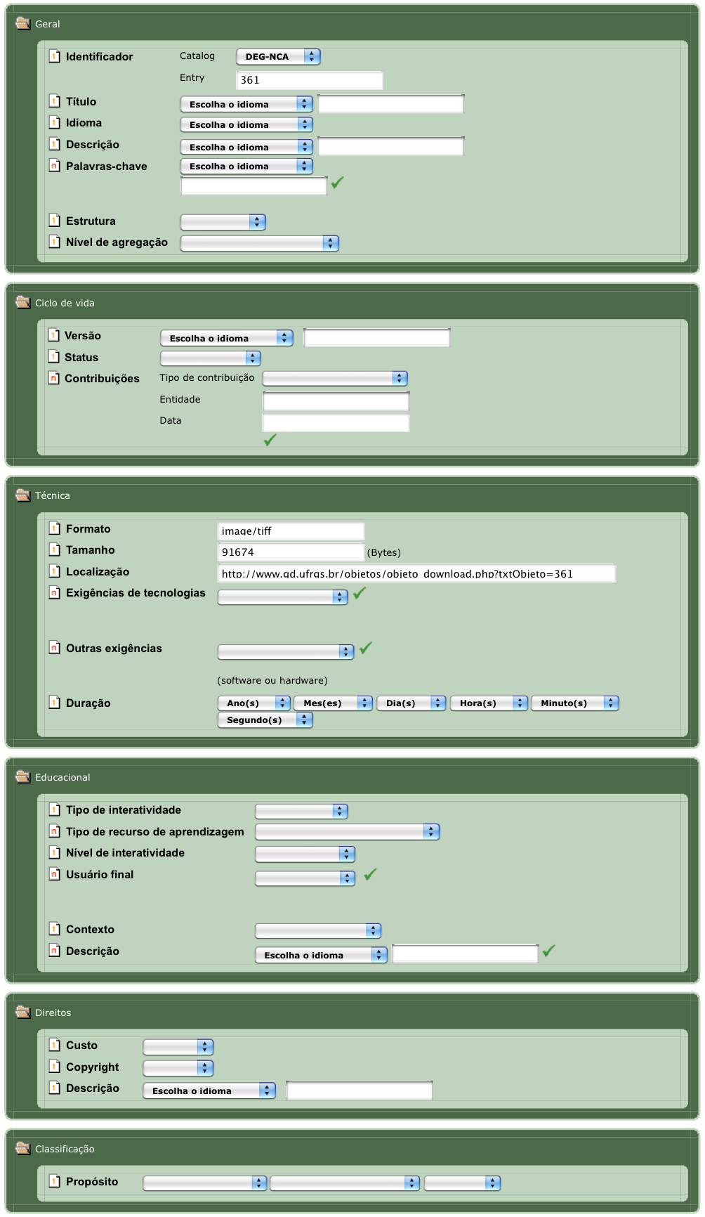
Figure 9: Metadata registration in HyperCAL online [10]
The vocabulary used to add the new category of objects is provided by the LOM [4] and the language used in the generation of XML files is that presented by the IMS-LD specification [16] which, although not representing all aspects of learning design, as pointed out by Britain [8], provides a broad basis for computer implementation, as seen in the examples of section 3.2.
5. Conclusion
Based on the design of learning objects proposed by Silva [10] which considers the Wiley’s taxonomy of fundamental and combined objects [5], adding a new layer of interaction between objects, corresponding to objects that contains the learning designs, will create complete instructional units, providing not only the content but also an activity workflow, establishing the roles that each agent must play.

The creation of objects follows the same generative model used in combined objects through the automatic generation of XML files, using a graphical interface that runs on a web browser.

The adoption of this new layer will provide greater adaptability, because at the time of request, the object instance is created with the needs and learning style of the apprentice, carrying the information of this and being presented in a customized way.

Generative objects also allow its update, which can contribute to creating more qualified objects, which are improved as they are used.

The choice of the web as a platform for production and management of learning objects comes as a solution for storage and sharing. The use of objects is justified when its reusability is facilitated – what is possible in a client-server environment, where information is centralized and available anywhere in the network.

The technological development brought by this new extension of HyperCAL online will enable the adopting of the concept of learning design in all forms of education. The results from this model will serve as a basis for other developers to implement features of generative objects and learning design in other virtual environments of teaching and learning.
References

- T. L. K. Silva, R. P. Silva, F. G. Teixeira, and F. B. Bruno, “Objetos de Aprendizagem Generativos no Ensino de Projeto de Produto,” Proceedings of International Congress of Design Research, Bauru, 2009.
- J. C. Taylor, “Fifth generation distance education,” 2001. [Online]. Available: http://eprints.usq.edu.au/136/. [Accessed: 14-Jul-2009].
- R. T. Osguthorpe and C. R. Graham, “Blended Learning Environmens: Definitions and Directions,” Quarterly Review of Distance Education, vol. 4, no. 3, 2003, pp. 227-233.
- M.-C. J. M. Fabre, F. Tamusiunas, and L. M. R. Tarouco, “Reusabilidade de objetos educacionais,” Revista Novas Tecnologias na Educação, vol. 1, no. 1, 2003.
- D. A. Wiley, “Learning object design and sequencing theory,” Thesis, Brigham Young University, 2000.
- T. Boyle, D. Leeder, and H. Chase, “To boldly GLO–towards the next generation of learning objects,” Proceedings of the Panel session at E-Learn 2004, pp. 1–5, 2004.
- M. Weller, “Learning objects, learning design, and adoption through succession,” Journal of Computing in Higher Education, vol. 19, no. 1, Sep. 2007, pp. 26-47.
- S. Britain, “A review of learning design: concept, specifications and tools,” A report for the JISC Elearning Pedagogy Programme, 2004.
- L. T. S. C. (LTSC) IEEE, “Draft Standard for Learning Object Metadata (IEEE 1484.12.1-2002),” Jul-2002. [Online]. Available: http://ltsc.ieee.org/wg12/files/LOM_1484_12_1_v1_Final_Draft.pdf. [Accessed: 06-Apr-2011].
- T. L. K. Silva, “Produção Flexível de Materiais Educacionais Personalizados: O Caso da Geometria Descritiva,” Thesis, Universidade Federal de Santa Catarina, 2005.
- D. A. Wiley, “The Instructional Use of Learning Objects (Online Version).” [Online]. Available: http://reusability.org/read/. [Accessed: 09-Jul-2009].
- H. Singh, “Introduction to Learning Objects,” [Online]. Available: http://www.elearningforum.com/meetings/2001/july/Singh.pdf. [Accessed: 15-Jul-2009].
- W3C, “XML Schema,” 2004. [Online]. Available: http://www.w3.org/standards/xml/schema. [Accessed: 07-Apr-2011].
- R. Morales, D. Leeder, and T. Boyle, “A Case in the Design of Generative Learning Objects (GLO): Applied Statistical Methods GLOs,” Proceedings of World Conference on Educational Multimedia, Hypermidia and Telecommunications, 2005, p. 302--310.
- R. Koper, “An Introduction to Learning Design,” in Learning Design, R. Koper and C. Tattersall, (Eds.) Berlin/Heidelberg: Springer-Verlag, 2005, Chap. 1, pp. 3-20.
- IMS, “IMS GLC :Learning Design Specification,” 2003. [Online]. Available: http://www.imsglobal.org/learningdesign/. [Accessed: 07-Apr-2011].
- B. Olivier and C. Tattersall, “The Learning Design Specification,” in Learning Design, R. Koper and C. Tattersall, (Eds.) Berlin/Heidelberg: Springer-Verlag, 2005, Chap. 2, pp. 21-40.
- RELOAD, “RELOAD Project”, 2008. [Online]. Available: http://www.reload.ac.uk/. [Accessed: 19-May-2011].
- TENCompetence, “ReCourse Learning Design Editor,” 2010. [Online]. Available: http://tencompetence-project.bolton.ac.uk/ldauthor/. [Accessed: 19-May-2011].
- RLO-CETL, “GLO Maker,” 2009. [Online]. Available: http://www.glomaker.org/. [Accessed: 19-May-2011].
- C. Tattersall, H. Vogten, and R. Koper, “An Architecture for the Delivery of E-learning Courses,” in Learning Design, R. Koper and C. Tattersall, (Eds.) Berlin/Heidelberg: Springer-Verlag, 2005, Chap. 4, pp. 63-73.
- H. Vogten, R. Koper, H. Martens, and C. Tattersall, “An Architecture for Learning Design Engines,” in Learning Design, R. Koper and C. Tattersall, (Eds.) Berlin/Heidelberg: Springer-Verlag, 2005, Chap. 5, pp. 75-90.

