Tracking Control System of the Modeling Yard

¹R. Pavlas
VSB – Technical University of Ostrava, Ostrava - Poruba, Czech Republic, roman.pavlas@vsb.cz¹

Abstract
This article is focused on description of four ways of tracking control on the modeling yard. The yard is situated in the laboratory of Department of control systems and instrumentation. Control system was continuously developed by the help of students. First step was connecting the particular model's objects to input/output devices of the PLC control system and creating of the basic programs. Next steps were design and creating of the hand control panel, creating of display views in InTouch software, design and creating of digital control panel and digitalization of locomotives. For every new created hardware and software control components were developed program modules (for PLC). Model yard is in present fully operable.

1. Introduction
The model yard (Fig. 1) is made-up from components for railways of sizes TT (exactly TT12) that means we work with the model in scale 1:120 with a track gauge 12 millimeters. The model consists of series of the functional components (switches, markers – signaling devices, a bar, etc.), but also from many decorative components (trees, buildings, a tunnel, etc.). The yard is divided into several sections. The complex is placed into a protective case, which protects it from damage.

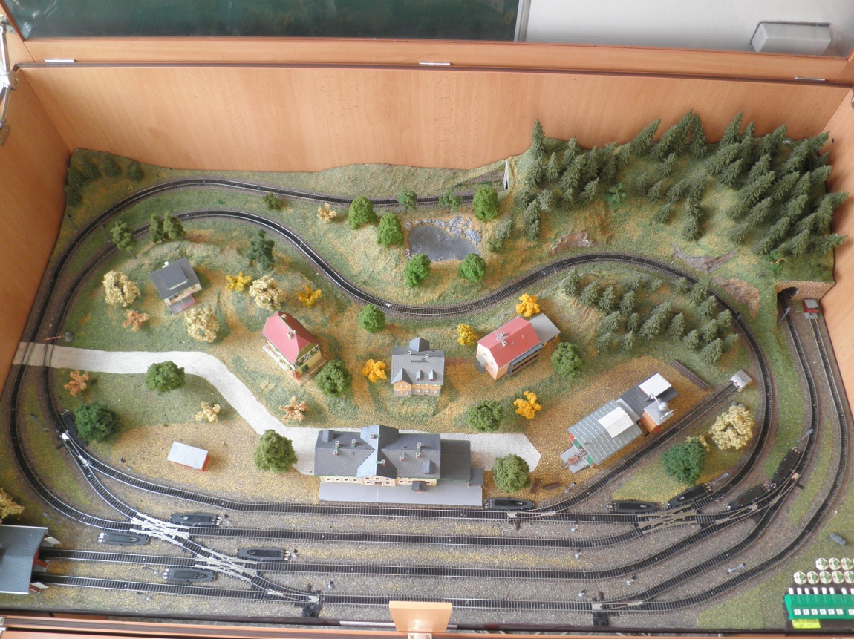
Figure 1 The model yard
2. The model yard description
2.1 Basic Terminology
In the article there are used special words using in the railway's terminology:

Wide track – is the track section between two adjoining stations or among stations and a station track at the tram-stop or the platform. The boarder between the wide track and the station is a gateway marker. A track on the wide track is called a railroad track.

Station track – each track in the station is called the station track. The station tracks are divided in traffic tracks, handling tracks and tracks for exceptional purposes (e.g. catching, averting).

The railway-station – it is haulage with a track division and given extent of offering transit services. The railway-station on the model is created from 4 station tracks (Fig. 2). It deals with the main train tracks (track N. 1 and track N.2), a ranging track, being used for a pushing away vans and driving vehicles (track N. 3), and a station track with a connection on a trailer (track N. 4).

Locomotive depot – it presents a building, in which blind tracks lead further (so-called dead-end siding tracks) and in this depot they are ended by a bumper. In our model they are presented by a track with mark 1s and a track marked like 3a, these tracks are continuation of the main track N. 1 and ranging track N. 3.

Railway trailer - this track is used for the own operator’s needs or for the other enterprisers and for pushing away of the train sets. On the model there is a dead-end siding track marked as 4a and it was produced by extension of station track N. 4.

Lay-by track - is extended part of the ranging track N. 3 and it is used for laying-by of the vans, driving vehicles or of the whole train sets for the trailer. On the model it is marked as 3b.

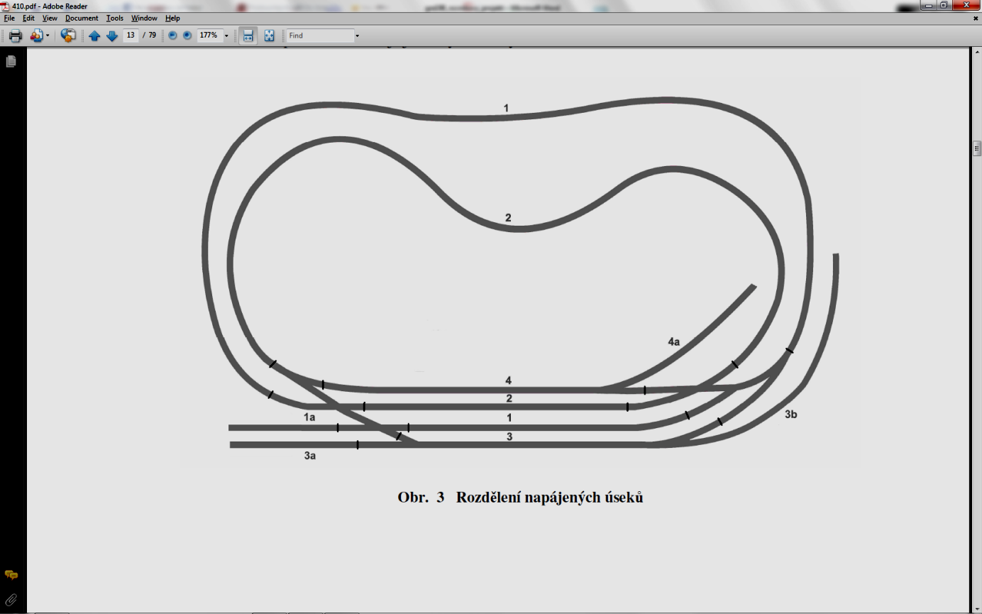
Figure 2 Diagram of the model yard with marked tracks

2.2 Description of the railway elements and their wiring
The model railway is presented by two circuits (outer and inner) and a railway-station, which links these two circuits. Outer one is called as a railroad track N .1 and it is connected on station track N. 1. Inner track is called track N. 2 and it is connected on the station track N. 2. Then the railway-station is formed by 4 station tracks, a railway's trailer and a locomotive depot. The signs of all railways’ tracks are shown in the pictures. The signs arise from regulations; according to them they are designed [1]. On the model there is a quantity of preventive and electric elements used (points, semaphores, etc.).

3. Control methods of the model yard
The model yard can be controlled by several ways. It makes it possible to many laboratory tasks can by applied. The ways of the control system of the traffic on the model yard:

- By the help of PLC AC800M from ABB company.
- By the help of the hand control panel.
- By the help of SCADA/HMI InTouch system.
- By the help of the digital control.
3.1 The control system by the help of PLC AC800M
PLC AC800M is a modular industrial computer compounded of several single modules. Thanks to that the control platform can be adapted for using in the widest spectrum. Platform PLC AC800M used in the model yard consists of following modules (Fig. 3):

a) Processor module AC800M type PM860.

b) Communication extension ProfiBus CI854A.

c) Module CI830 for interface I/O cards to bus bar ProfiBus.

d) Input module DI801.

e) Check out module DO801.

f) Power supply SD821.

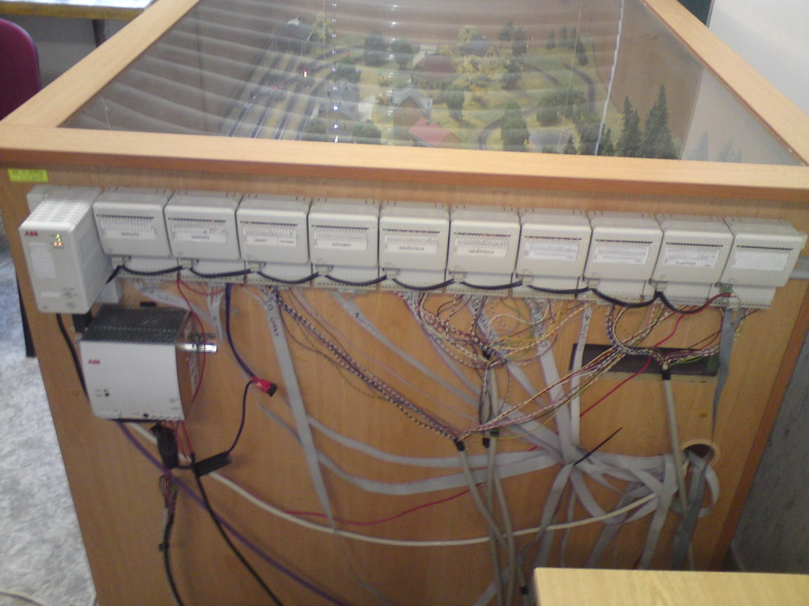
Figure 3 Components of PLC on the model yard

The used system for control of the model yard does not make it possible to operate directly into the yard. For installing of other control elements there are not enough free inputs in PLC. That is why the control program is constructed to be controlled alone depending on its state. Starting and stopping is operated by hand [2].
The program is designed for rides of two train sets, their points of departures are station tracks N. 1 and N. 2. Designed program directs the operation on three different train railways. The first route begins in the station on the station track N. 1. After program’s starting-up the train set starts to ride clockwise. It continues on railroad track N. 2 and it returns into the station on station track N. 4.
The second train track begins in the station on the station track N.2. The train set continues on railroad track N. 1 and it finishes in the station on station track N. 1. The third route begins in the station on station track N. 4. The train set continues clockwise to the railroad track N. 2 and it rides to its finish in the station on the station track N. 1. After arrival to the last train route the program sets up into the starting position that means the opening of the first train route.

3.2 The control system by the help of the hand control panel
The panel (Fig. 4) contains buttons, levers and LED diodes. By the help of the buttons and the levers each rail stage is controlled. LED diodes are useful as a visual control component, if the section is active, the diode at its button switches-on. If the operator presses an arbitrary button on the hand control panel, it will reach to the setting of variables pressing of a given button [3].

Figure 4 Hand control panel

A boot timer is installed there, so the button could not be pressed repeatedly at his holding, and this boot timer can unplug it. If there are pressed two buttons of two sections simultaneously, setting of the points will start to work and after their setting we can see licensing sign on the marker and the train starts to go.
The train sets can stop in the yard only in the station or on the wide track in front of the entrance marker. To be able for the train to go out from the station, the button of the station, from which the train will depart, has to be pressed, and then also the button of the given track, on which has the train to drive. After the train route the train stops till before the entrance marker, which let the train drive into the station. To be possible for the train set to drive into the station, a button of the track, on which the train is located, must be switched on, and also the button of the stage, on which the train set has to go.

3.3 The control of operation by the help of SCADA/HMI system
The main window of the application (Fig. 5) is created by three parts, which give us the information about the state on the model yard [4].
Upside part has a rather informative function, but it contains also a button start/stop and a switch for choosing of a mode. Then we can find there information about a state of communication between program InTouch and PLC. In case of a problem with variables it gives also information about a number of mistaken I/O variables. The other information relates to login and of course there is also a date and a time.
The middle part shows the model railway itself. Then on the left side we can see the window for choosing of a train routes for the both trains and a button letting us to show or hide additional information like a state of the semaphore for retrace, information about a train on busy stages, visualization of sensors and displaying of power supply of the tracks.
The folds make the lower part of the window; they are able to switch among the windows and the button for login and logout. The main window of application shows the model yard with its all operated elements, like e.g. signals, points and power supply of the sections.

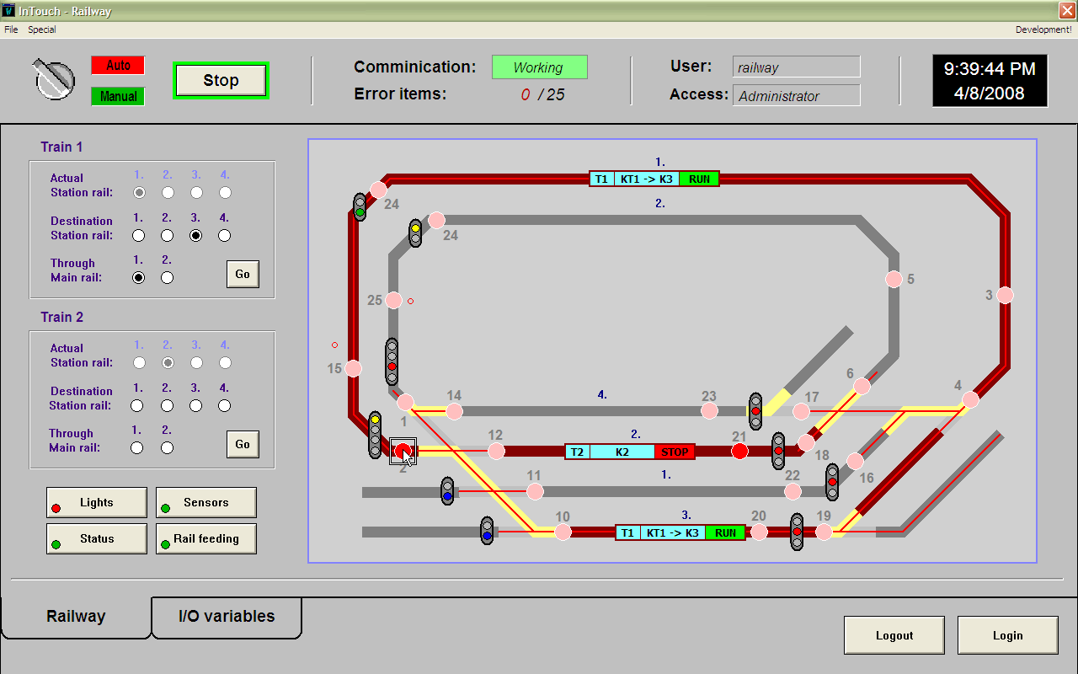
Figure 5 InTouch – Runtime mode

On the picture we can note also other information, which applies to currently busy sections (section of the tracks engrained in red). On busy stages there are informative blocks shown, informing about a number, a route and a state of a train, which is going in given part of the route at the moment. (E.g. Informative block of a wide track 1 announces that the train n. 1 is riding there and its actual position is on the track between the wide track 1 and the station track 3. The informative block of the station track 2 then informs about the train n. 2, which is standing on this track.).
On the screen we can see now that one train is standing on the station track 2 and the second is preparing to pass the station track 3 to the wide track 1. The signaling of the departure marker is showing to it a signal „go".

3. 4 The system of operating by the help of digital control
Another milestone in a railway's clay-modeling branch was the using of a digital control. The digital control caused that the locomotives are able to behave on any sections of the yard unconditionally. Until the locomotives were controlled by the help of operating of the power supplied sections of the yard, the engine of a locomotive was linked directly with the power supply in the given section and behaved according to a polarity and size of voltage in it.
At the digital control the tracks are supplied by constant voltage, in which the control signal is modulated. Every locomotive processes this signal and works according to the instruction given to the locomotive with the right address.
The mentioned technology is used for a manual control of the model yard. However for the realization of the given task it is needed to extend this technology to be able to link the digital operating with PLC [5].
The whole modification of the technology consists in modification of the drivers HUGO 4. The modifications consist in making a bridge across switches and thereby the direct linking of connection of one-chip ATMEL with one-chip PIC. This solving was chosen because of impossibility to obtain a tenet bus bar LOCONET. Each of till eight handlers communicates by the help of bus bar I2C control unit that is operated by the help of I/O signals from the control PLC (Fig. 6).
For the safe operation and mainly for protection of each part of the set, the components were placed into the plastic protective box. This box is produced from the standard plastic main electric box.

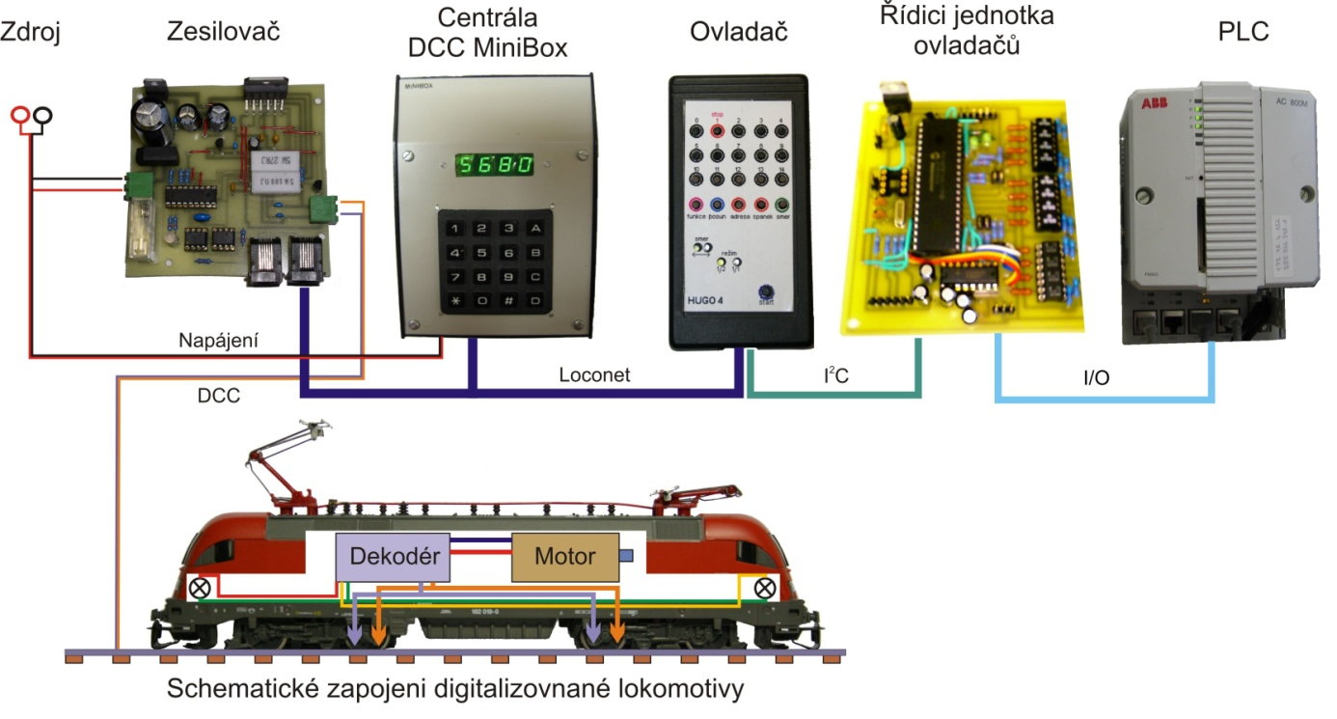
Figure 6 The modified technology of the digital control

In the box there are single components of the digital set the way. Each part is fixed to the bottom, or to the lid box, pertinently plug into the connectors (drivers). On the upside of the box programming track is set to be possible locomotive, which can be pre-set and tested, to lie up. On the ends of the rail there are install stops to prevent a locomotive to go out of the track and its fall. On the back of the box there is a set of connectors. These connectors are useful for connection of single circumferences.
4. Acknowledgements
The presented results were obtained during the completion of a Student Grant with student participation, supported by the Czech Ministry of Education, Youth and Sports and with financial support of project INGO/LA09024 – Prestigious Representation of Czech Republic in iNEER Organization.

References
- P. Stachiv, “The traffic control of the railway model,” Diploma thesis, Ostrava: VSB-Technical University of Ostrava, 2006, 67 p., head of thesis R. Pavlas.
- T. Habernal, “Laboratory tasks about the tracking control of a railway model,” Bachelor thesis, Ostrava: VSB-Technical University of Ostrava, 2006, 56 p., head of thesis R. Pavlas.
- O. Unger, “Operation control laboratory tasks for a railway model,” Bachelor thesis, Ostrava: VSB-Technical University of Ostrava, 2008, 40 p., head of thesis R. Pavlas.
- H. Kývala, “Tracking control for a railway model,” Diploma thesis, Ostrava: VSB-Technical University of Ostrava, 2008, 76 p., head of thesis R. Pavlas.
- M. Kubín, “Digital control of a railway model,” Diploma thesis, Ostrava: VSB-Technical University of Ostrava, 2009, 70 p., head of thesis R. Pavlas.

