A Comprehensive Approach to Tackle the Lack of English Language Skills of Engineering Students

¹Jose M. Camara, ²Ana M. Lara, ³Alfredo Jimenez

¹Higher Polytechnic School, University of Burgos, SPAIN
checam@ubu.es
²Higher Polytechnic School, University of Burgos, SPAIN
amlara@ubu.es
³Faculty of Economics, University of Burgos, SPAIN
ajimenez@ubu.es

Abstract
It is widely assumed that Spanish students lack from sufficient English language skills. This is particularly alarming in the engineering environment, where this language is used on a daily basis. There exist a number of different programs and activities traditionally employed to address this problem. In our School of Engineering, these initiatives have been promoted too late in time. This has forced us to be more innovative and to avail of the most recent available programs. Budget reductions in the last few years have restricted the range of each and every initiative deployed thus increasing our commitment on the quest for new forms enhancing our students’ command of English language. Special agreements with foreign Universities and enterprises intended to promote the mobility of our students, have become the flagship of our internationalization program. The latest: the creation of a group of innovation on education integrated by a number of lecturers and devoted to the introduction of English language in the teaching of regular courses. In this work we will provide a review of all these initiatives paying special attention to the procedures associated to the implementation of courses in English. It is not a new activity within the Spanish higher education system. On the contrary, several universities have started a number of courses especially in the last decade. In our university, this experience has been taken into account in order to provide adequate procedures and sufficient support to lecturers. Regardless the budget restriction that we are currently suffering, the goal is to ensure a high level of quality on the courses and continuous support for the lecturers. The creation of a working group on innovation on education demonstrates a high level of commitment among the lecturers along with a valuable tool to share experiences and improve results. Through this initiative we expect, not only enhance our students’ command of the English language, but also increase the number of foreign incoming students and the number and range of countries where they come from.

1. Introduction
Several studies and surveys [libros blancos, studio UVA] have pointed out that, according to graduates and employers, one of the flaws of Spanish engineering students’ training is their low level of foreign languages, English language in particular. Unlike other European countries, Spanish educational system does not provide students who finish secondary school a sufficient command of English language. This situation is hard to offset at the University. Engineering degrees are not intended to include a significant amount of training on languages. Nevertheless, there exist several initiatives and programs that can be helpful to improve the situation. Notwithstanding, some of them require a level of English higher than average, thus compelling interested students to provide themselves external training.
The Higher Polytechnic School of Burgos hasn’t been an exception in this scenario. On the contrary, the awareness of this pitfall arose particularly late. By that time, as depicted in [CUIEET2009], some of the most attractive programs were almost closed for newcomers. Some urgent and creative measures had to be taken, postponing in time more conventional ones. In previous works [CUIEET2010][INTED2010] some of these innovative initiatives have been described.
As long as we have acquired more experience on the management of international programs, some traditional opportunities have been revealed possible as well. Erasmus agreements with English speaking countries, apparently impossible to extend to new partners, have been achieved. The latest initiative and also the core of this article is the establishment of courses given in English.
The rest of the paper is structured as follows: section 2 will describe previous works related to the same topic. Section 3 will provide an overview of current and previous initiatives in our School. In section 4 we outline the challenges associated to the courses given in a foreign language and also the procedures followed to ensure the highest possible level of quality on them. Finally, conclusions and future trends are presented in section 5.

2. Related Work
The lack of a good command of English language is not exclusive to Spanish students. On the contrary, many other countries have the same problems. Therefore a wide variety of experiences have been carried out worldwide. Some of them are not meant to serve as English learning tools but, obviously, they eventually take that role as well.
The importance of international programs and the issues associated to the use of English language in them were sorted out in [Hercog2007]. The benefits listed in this work are not only related to the language but also to some other important skills. This author also addresses the issue of international programs’ management in [Hercog2008], thus setting up the basis of how important internationalization is and how difficult it is to manage it properly.
In spite of the difficulties, not only regular programs, but also many interesting innovative experiences can be found and taken as very good examples of how to tackle the English language issue. In [Rosendahl2008] it is described how students from different countries can collaborate to carry out a project in common. Surprisingly, the work is done in a non-stop manner passing on the work worldwide, 24 hours a day. More focused on the language itself, in [Rynearson2010] an innovative role named “bridge engineer” is presented. This engineer is intended to become a bridge between different cultures and languages, in order to facilitate the completion of an international project. In [Taylor2009] the creation of an international network of universities and the annual event that becomes its central activity are depicted.
Teaching in English in countries where this language is not official has also been addressed in literature. It becomes an issue in countries where the average level of English is low as it occurs in Spain [Ballester2004]. In [Gregersen2009] the implementation of a course given in English language in Denmark is described. A very comprehensive approach is presented tackling aspects like pedagogy, methodology, monitoring, evaluation and teachers’ training, thus providing a good foundation to the construction of high quality courses.
3. Review of Initiatives at the Higher Polytechnic School
Conventional internationalization programs, such as the Erasmus one, are very helpful for English learning purposes when established with English speaking countries. As stated before, in our case, access to agreements with those countries were almost closed by the time our internationalization program started. Being that the scenario some other options had to be explored.
The first action taken was to establish agreements with non-English speaking countries offering courses in English. Scandinavian countries became our first target. Nevertheless, we soon exhausted possibilities in this direction. The United States was the next step. Bilateral agreements with American universities are hard to obtain and, once arranged, they are very demanding in terms of the level of English required to the students and also the way to prove it. In fact, courses taken and degrees obtained within the European context are not valid for most American universities. In many cases they require certain marks obtained at either TOEFL or IELTS exams. Theses exams are not accessible anywhere at any time, so the students have to adjust their plans to take them. They are also costly and valid only for two years. Moreover, a proportional compensation is usually required by the partner university, and bearing in mind the higher cost of tuition fees in the US, this is hard to afford for Spanish universities. Putting these two initiatives together, we still had a long way to go.
A more innovative initiative arose when we realized that European students were being admitted at Scottish universities granted by Scottish government so no tuition fees had to be paid. As presented in [CUIEET2010] we proposed a bilateral agreement to one these universities (Edinburgh Napier University) so, without any additional commitment from them, we were able to provide academic recognition to those of our outgoing students joining them. As long as this University offered a number of degrees closely related to most of ours, the problem seemed to be solved. However, emerging budget constraints from the Scottish government soon limited the range of this solution.
Alongside the previous initiative, a new extremely convenient opportunity arose. Within the new Erasmus program 2007-2013, a brand new line was introduced: internships in foreign enterprises. Since this possibility turned up, we have been increasing the number of positions for our students. Currently, although there are not many, finding adequately prepared students has become the bottleneck. Notwithstanding, budget cuts once again, appear as a major threat to the development of this initiative.
Finally, our University has come up with the decision to promote the creation of courses taught in English to be included within official degrees. This is an action intended to address a number of objectives. The improvement of our student’s level of English is a major and very straight one but there are others. Offering courses given in English may help our university to become more attractive to foreign students thus contributing to increase the number of incoming students which, in the case of the Polytechnic School, presents a clear imbalance. It will also facilitate the establishment of new bilateral programs thus increasing the number of opportunities for our students.
4. The Challenge of Teaching in a Foreign Language
As stated before, the latest initiative on this internationalization process has been the establishment of precise regulations to offer courses in English and, as a consequence, the kick off of some subjects given in this language. In this section we will describe both the foundations of the program and the outcome of some early experiences.

In order to make this initiative compatible with the current dire economic situation, only optional subjects were offered in English. Thus, it would not be necessary to duplicate the number of groups to provide both English and Spanish teaching. In addition, those students who do not want to attend lessons in English can choose other available optional subjects. This is undoubtedly a constraint that notably reduces the range of courses to join the program although, on the other hand, an extra recognition of 50% is received by the lecturers during the first two years of teaching. It is meant to compensate the additional effort of the preparation and teaching of the course in a foreign language. Whether or not this compensation is enough to promote the participation of lectures is a discussion that will be addressed in the Conclusions section.

Lecturers are required to prove a sufficient command of the English language prior being authorized to offer the course to the students. Also a certain level of English, although not as high as the one for lecturers, is required for the students. Apart from external courses and examinations available, the University has set up internal procedures for training and assessing the level of English and other languages as well.

In [Gregersen2009], it is stated that teaching in a foreign language is a major challenge. In addition to an adequate command of the language, a specific training is recommended for the lecturers involved in the program in order to ensure a sufficient level of quality. In our case, a number of training resources have been offered to the lecturers. Under the supervision of an expert English professor, the staff has access to training courses intended to improve pronunciation and published material for self training. Lecturers are also encouraged to suggest personalized training activities to address their own particular difficulties.

We would also like to highlight that, in addition to all the resources made available by the University, the pioneer professors offering lessons in English have organized themselves. We have constituted a formal workgroup with several different objectives:
- To organize further training activities in order to continue with the enhancement of the teaching quality.
- To share experiences and provide feedback among the participants.
- To expose the achievements of our initiative so its strengths and advantages can be replicated by other groups of professors.
- To obtain external funding in order to be able to accomplish new activities in the future.

Once the regulations about the organization of this initiative have been officially released, some teaching has started in English. Nevertheless, a few previous experiences had been put into practice by a few enthusiastic lecturers before the regulation was formally adopted. From all this work done, some early results can be exposed.
4.1 Case Study: Management Courses
In spite of the lack of regulation, the lecturer in charge of Management courses at the degree of Computer Science, became aware of the concepts of flexibility and mobility associated with the “Bologna process” along with the principles of the Declaration of Graz [], which states that “The development of European universities is based on a set of core values: equity and access; research and scholarship in all disciplines as an integral part of higher education; high academic quality; cultural and linguistic diversity”. According to these foundations, the lecturer decided to give students the possibility of taking the subjects in English. This decision has generated a valuable experience for later initiatives carried out under the new University regulations and for the regulations themselves. In Table 1, the number of registered students in the management subjects in presented. Academic year 2010-2011 is within the rule of the new regulations.

Table 1: Historical Registration in Bilingual Teaching in Computer Science. University of Burgos.
Source: Own elaboration.
TOPIC REGISTRATION | ACADEMIC YEAR
 | 2006-2007 | 2007-2008 | 2010-2011
Computer Managed Production | 7 | 14
Human Resources Management |  |  | 14
Knowledge Management |  |  | 10

What can be inferred from the figures is that the students have been rather timid at the time they had to make the decision of matriculating in these courses. People in Spain, has historically experienced enormous difficulties to learn and be fluent in foreign language. Our students are not an exception and it is not surprising the lack of students in some cases. Although relatively successful in the first two years, the program presents a blank during the years 2008/09 and 2009/10 due to the difficulties in organizing these courses without an official regulative framework. It is important to highlight that, given the lack of regulations, the Computer Managed Production course was simultaneously given in Spanish as well. Interestingly, when the course was finally reintroduced in the last season, the number of students registering for these courses sharply increased. Apparently, the economic crisis of the last years has strongly influenced the perception that students have of the importance of foreign languages. As a matter of fact, latest news report soaring opportunities for Spanish engineers abroad. This has triggered their interest for languages, mainly English and German. Again, it is important to make clear that Human Resources Management (HHRR) and Knowledge Management (KM) are both optional subjects that, according to the recently implemented University regulations, are offered only in English. Therefore, in these cases, we can easily compare the success of the subjects given in English with the same ones in Spanish in the previous years.
- The number of students who chose HHRR in year 10-11 was 25. That shows a significant reduction after being offered in English.
- On the other hand, KM was not given in 10-11 in Spanish due to the lack of interested students.
These results seem to be contradictory. Whereas HHRR has apparently been negatively affected by the shift of language, the same modification has rescued KM from ostracism.
Students from HHRR have been asked to answer two questions in order to monitor their contentment with the experience:
- Has it been profitable to register for this subject?
- Do you consider this innovative educational initiative as a necessary skill for your future?
Their answers are depicted in . Results of KM are not available by the time this article was written because this course belongs to the second semester of the season. The analysis of the results reveals that:
- 64% of the students give the maximum mark to their decision of taking this course; the remaining 36% mark it with 4 out of 5. This is incredibly cheerful taking into account that it’s been the first time this course has been given in English.
- Their assessment of the impact that this experience will have in their professional future is also very positive. All but three mark it above 4.

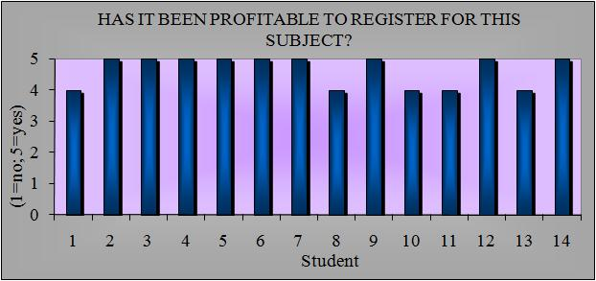
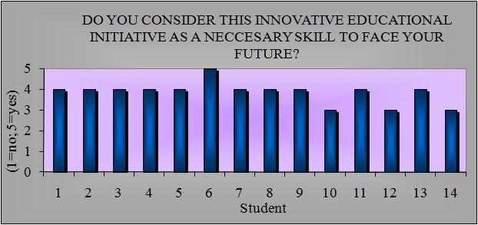

Figure 1: Students’ answers. Source: Own elaboration

In addition to the students’ opinions, the lecturer has focused her attention in two facts:
- Around 20% of the students do not usually attend classes in Spanish courses, whereas all the students included in the course given in English have regularly attended the lectures.
- According to Figure 2, that compares academic results obtained at the Computer Managed Production within the same season, students belonging to the group in English have obtain far better grades than their counterparts studying in Spanish.
Based on these results, a subjective analysis can be proposed:
- Students who decide to matriculate in courses given in a foreign language are more committed with hard work and discipline, not only on aspects concerning the language, but also with new ways of learning and preparation of the exams.
- Their motifs are related to the quality of their curriculum as a whole and its connection with market demands.
- Undoubtedly, they show high levels of motivation which positively affects attending rates and final results.
- They are willing to enrich their technical learning with more specific capabilities such as the English language.

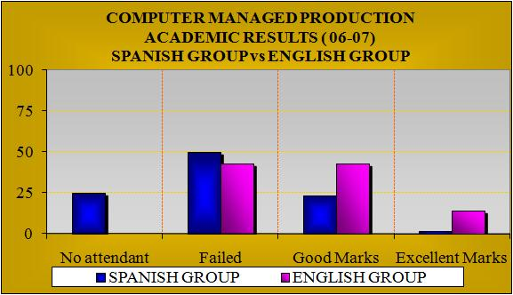
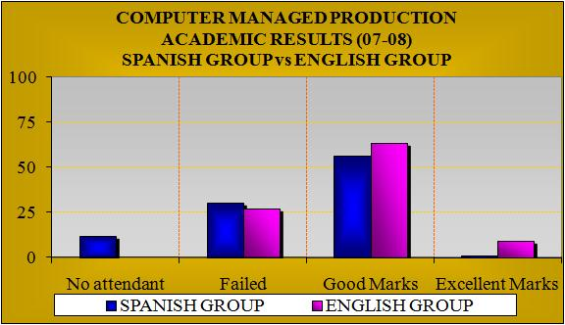

Figure 2: Academic results in bilingual courses.
Source: Own elaboration

5. Conclusions and Future Trends
After a period of unregulated initiatives, in which the lecturers interested in offering the possibility of taking their subjects in English had to make an extra effort to give the same subject in Spanish and English alongside, there is a brand new internal regulation that tries to compensate this effort adequately. In addition, it is meant to serve as a guarantee of quality for this teaching. According to previous experiences in other universities and countries, depicted in sections 2 and 4, we are in a good position to achieve high levels of quality in our teaching as long as proper training and material resources are deployed to support the lecturer’s work. On the other hand, and according to the number of courses that have successfully started in the current season and the number of lecturers involved, it can be stated that the budget constraints negatively affect this activity in two ways:
- The academic compensation (50% extra recognition) received by the lecturers seems to be not enough to offset the amount of work to be done.
- Optional subjects are probably not the best option for a successful kick off. Students have a broad variety of options to choose from, which results in a lower number of students per subject. In spite of the difficulties associated to language, optional subjects are less likely to be successful than the mandatory ones.
It has to be acknowledged that the regulations are very recent. It is obvious that latter experience will provide us with a better understanding to suggest even more accurate modifications intended to improve results. Nevertheless, in addition to the improvement of this framework, some innovative initiatives can be put into practice. For the time being, the availability of subjects in English depends on the lecturer’s initiative. The lecturer has to decide whether or not to offer the subject in English without any hint of its foreseeable success. It would be useful to have some information about students’ preferences in this sense, not only from regular Spanish students, but also from exchange students from partner Universities. This could be achieved by means of a survey distributed among our students and also those foreign ones who apply for a place in our University. Other options, such as custom made courses for foreign groups could be explored as well.

References
1. A. B. Author, & C. D. Author. (2000). Title of the article, The Journal, Volume, pp.110-120,
The list of references should be ordered alphabetically according to the first author surname.
[NOTE: Begin typing References on this line, listing them in sequence in the order cited in the paper. Use the following individual formats for journal papers, books, chapters in books etc., but do not include these headings or bunch your references under any of these headings]
[Format for citation for JOURNAL PAPERS:]
- R. Duffell, “Toward the Environment and Sustainability Ethic in Engineering Education and Practice,” Journal of Professional Issues in Engineering Education and Practice, Vol. 124, No. 3, 1998, pp. 78-90.
- S. H. Bokhari, “Partitioning Problems in Parallel, Pipelined, and Distributed Computing,” IEEE Transactions on Computers, Vol. 37, No. 1, January 1988.
[Format for citation for BOOKS:]
- G. T. A. Kovacs, Micromachined Transducers Sourcebook, McGraw-Hill, New York, 1998, pp. 95-97.
- W. Aung, et al. (ed.), Engineering Education and Research – 2001: A Chronicle of Worldwide Innovations, iNEER, Arlington, VA, 2002.

[Format for citation for CHAPTERS IN BOOKS:]
- I. Verner, and D. Ahlgren, "Robot Contests Framework for International Cooperation in Engineering Education,” Innovations 2003: World Innovations in Engineering Education and Research, W. Aung, et al. (eds.), iNEER, Arlington, VA, 2003, Chap. 24, pp. 237-245.
[Format for citation for papers in CONFERENCE PROCEEDINGS:]
- H. Jerez, C. Abdullah, C. Christodoulou, J. V. Reenen and R. Jordan, “Wireless Enabling Education and Research Activities,” Proceedings of 2003 International Conference on Engineering Education, ICEE-2003, Paper No. 3301, Valencia, Spain, 2003.
- B. H. Byer, and E. Tam, “Addressing New Directions of Globalization, Environmental Management Systems and Sustainable Development in the Curriculum,” Proceedings of 12th Canadian Conf. on Engineering Education, Victoria, B.C., 2001, pp. 313-317.
[Format for citing REPORTS:]
8. Chi-Fu Den, “Final Report of First Phase National Telecommunications Program (NTP),” NTP Office, National Science Council (NSC), Taiwan, September 2003.

Please be informed that regarding the extra reviewing and copyright agreement
Once your paper has been peer-reviewed and accepted, before final publication of papers the transfer of copyright agreement must be signed by all authors and returned to iNEER and ICEE-2011. Session Chairs may be asked to comment on papers and may suggest some changes, for example, to make it clearer to readers, or addresses other issues considered very important to be aware of.

Thank you for your cooperation in complying with these instructions.

In the Spanish case, the most common English level tests are those from the Spanish Official School of Languages and from University of Cambridge.

