A Web-Based Benchmarking Information System Developed as a Student Project

¹Radim Farana, ²Marek Babiuch, ³Jana Jezikova, ⁴Martin Rajski
Faculty of Mechanical Engineering, VSB – Technical University of Ostrava, Czech Republic, radim.farana@vsb.cz ¹;
Dept. of Control Systems and Instrumentation, Faculty of Mechanical Engineering, VSB – Technical University of Ostrava, Czech Republic marek.babiuch@vsb.cz ²
jana.jezikova.st1@vsb.cz ³, martin.rajski.st@vsb.cz ³

Abstract
This contribution presents the positive results obtained at the Faculty of Mechanical Engineering, VŠB – Technical University of Ostrava, Czech Republic, with the Quality Management System, which was certified in the year 2005. The next step that was done was to apply the system Total Quality Management (Excellence System), according to the EFQM Excellence Model in the year 2006. The benchmark project, implemented with many technical faculties from the Czech Republic and Slovak Republic, as one of important steps for improving faculty management, is also presented in the paper.

This contribution presents the web based information system, developed as a student project, its structure and methods, which was oriented on obtaining a universal environment for building different benchmarking projects for separate use. The project definition allows the defining of a list of filled in parameters in a very easy form to define the computed output statements. This statement could be presented in a suitable graphical form, typically in time-dependent charts.

1. Self-assessment process
The Faculty of Mechanical Engineering joined a project focused on applying the Quality Management System at VSB – Technical University of Ostrava at the end of the year 2004 in concurrence with the pilot application of QMS at the Faculty of Electrical Engineering and Computer Science, which was the first faculty in the whole Czech Republic with a functioning QMS system. At the end of the successful certification of the QMS system at the Faculty of Mechanical Engineering in May 2005, it was clear that it would be a long way to fully implement all management instruments, especially those used by all faculty members at all management levels need a lot of work. The university management system is different from a typical company management system. The obtained results from the faculty QMS system have been very interesting also for all other technical faculties. The main goals were presented at the International Conference on Engineering Education 2006 [4], 2007 [5], 2008 [6], 2009 [7] , 2010 [8] and as a part of the faculty Excellence System (best practices) [17]. It was very satisfying when representatives of two other technical faculties from the Czech Republic asked for cooperation meetings to transfer our results to their faculties. How important the quality assurance in higher education is, especially in the European Union, is described in many papers, presented at previous ICEE conferences [2, 10, 15]. The use of quality management systems in higher education is more and more common, as is described in more and more papers, like [9, 12, 13, 14].
We were looking for other forms for developing the faculty management system, together with expanding standard QMS instruments, such as processes risk analysis based on FMEA (Failure Mode and Effects Analysis), SWOT (Strengths, Weaknesses, Opportunities, and Threats) analysis as a background for significant decisions, the consistent utilization of preventive and corrective measures. The QMS model based on ISO 9000 norms is oriented on suppliers and customers, but the university is complicated and depends on its academic staff, that is we have to focus at least also on our employees. Then we were looking for some more complex system, which can describe the university management system more complexly. Since we were from the beginning oriented on industrial standards, it is not surprising that we choose the system Total Quality Management based on EFQM (European Foundations for Quality Management) Excellence Model [3]. An important aspect of the model is the detailed self-assessment methodology, usable for a faculty or university [11], which is compulsory in the Czech Republic for all state universities, according to the University Act.

Many analyses were done during the self-assessment process and more than fifty interesting faculty performance and efficiency indicators were found. Ten of them were selected as the basis for benchmarking projects with other technical faculties from the Czech Republic and other European Union countries. Ten main criteria were chosen to compare the efficiency of the faculty management system:
1. Number of students in bachelor and master study programmes calculated according to teacher.
2. Number of students in doctoral study programmes calculated according to the number of associate professors and professors.
3. Length of external study stays per student (for stays longer than one month).
4. Success of students from the first bachelor class in percentage (for the first, second and third year of study) and percentage of students finishing study in the standard length of time.
5. Financial volume of research projects (without follow-up activities) according to academic employee.
6. Financial volume of follow-up activities per academic employee.
7. Percentage of associate professors and professors from the total number of all counted teachers.
8. 8.1 Average age of professors.
8.2 Average age of associate professors.
8.3 Average age of assistant professors.
9. Investment pro-rata from the Ministry of Education, Youth and Sports calculated according to teacher.
10. Number of R&D results calculated according to a teacher (special system for the Czech Republic only).

Since the obtained results of the benchmarking project, first put into effect in the year 2007, were very fruitful, participating faculties decided that we would repeat this analysis in the following years. When the main problem, identified during the data collection phase, was in representative data acquisition and the in the correct computation or relative indexes, we decided to develop universal information support, usable for more benchmarking projects.

2. Student projects
Student projects are a standard teaching method that have been used for long time in subjects like Databases, Information Systems and many other. One project is usually dealt with by a team of three or four students. The main problem is that students do not have effective knowledge from this area and the main goal of this project is to learn more about solving a problem. It is almost impossible to connect these projects in solving some concrete problems for industrial partners. Another problem is the price of the newest hardware and software. In this case we have good experience in collaboration with some hardware and software producers, who give or loan us their equipment for our laboratories.

Much better (and more complicated) are the long-term projects, done during a longer time by a student team supervised by the teacher. There is a very good possibility to learn more about teamwork, team management and collaboration. A few of these projects are developed at our Department. Many of them are oriented on creating and updating information systems, provided by our Department, like the presented benchmarking information system. This information system has been developed as a student’s project during completion of the diploma thesis.

3. System database
The first analytical output was based on the index definition. Practically all indexes are relative, and some data are totals of typical source data, like the sum of bachelor and master students. The index definition was defined:

$I_{x}=\frac{\sum_{i=1}^{4}{C_{i}}}{\sum_{j=1}^{6}{J_{j}}}$ (1)

where: I_{x} – x-th index, C_{i} – particular data in the numerator, J_{j} – particular data in the denominator.

The equation (1) is the basis of the developed information system data structure, see Figure 1. The needed data for index definition are stored in tables:
Tab_Nazev_Vypoctu: index name
Tab_Ukazatel: name of filled in data part
Tab_Vypocet: index calculation definition

The data filled for every project by each participating faculty are available in table Tab_vstup and counted index values in table Tab_vystup. This solution, including automatic index counting system, is serviceable for presenting easy and fast charts.

4. Client Application
The client application for data acquisition, participant management and final result presentation have been developed in the ASP.NET environment, for example see Figure 2 for a list of faculties participating in the project. As an example of the system output, see Figure 3 including the number of students per teacher. As you can see, it is possible for project participants to fill in only partial data and/or data for selected years. This character of the developed system is very important especially during the data collection process to see all available data immediately after their insertion.

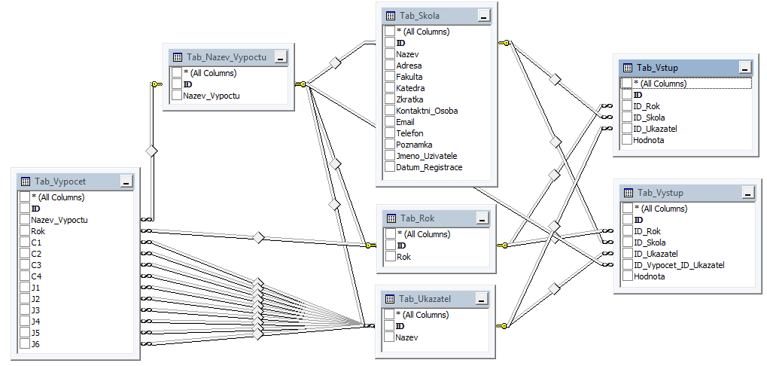

Figure 1: Data structure of developed information system.

Figure 2: Web based client application example.

Figure 3: Examples of benchmarking project results.

5. Conclusions
Orientation on the system Total Quality Management has extended this methodology by using more new possibilities. A great number of opportunities for improvement were identified in the benchmarking project which was done and the presented information systems help very much to put the process into effect. It is a great contribution to faculty management´s orientation on the complex quality system and I am expecting that the university will not be a closed system anymore. Just the opposite, the university must very actively accept the changes of the external environment. The university must especially observe, analyze, find out new solutions, apply adequate changes in structure and management, and above all observe and verify the influence of our decisions. One of the principal features of the EFQM Excellence Model is the possibility of comparing the achieved results with other participants in the Quality Award Program for the Czech Republic which includes industrial companies - it means our partners and also some very important customers. Of course, we were very happy when we were declared the winner of the Czech Republic Quality Award for the year 2007 [16].

4. Acknowledgements
The presented results were obtained during the completion of a Student Grant with student participation, supported by the Czech Ministry of Education, Youth and Sports and with financial support of project INGO/LA09024 – Prestigious Representation of Czech Republic in iNEER Organization.

References
1 CSJ 2007. Benchmarking codex (in Czech) [on-line]. ]. 2002 [cit. 2011-05-01], available on Internet <URL: http://www.benchmarking.cz/kodex.asp>.
2 Edwards1, M.E., Tovar Caro, E. and Sánchez-Ruiz, L.M. Strengths and obstacles for quality assurance in the European Higher Education Area: The Spanish case, International Conference on Engineering Education, Seoul, Korea, 2009. pp. 18 – 22. ISSN 1562-3580. ISBN 978-89-963027-1-1.
3 EFQM. European Foundation for Quality Management web portal [on-line]. 2006 [cit. 2011-05-01], available on Internet: <URL: http://www.efqm.org/>
4 Farana, Radim. Quality Management System at the University. International Conference on Engineering Education and Research “Global Education Interlink”, Puerto Rico, USA, 2006, Volume R2F, pp. 1 – 4. ISSN 1562-3580.
5. Farana, R. The Excellence System Application in Higher Education, International Conference on Engineering Education, Coimbra, Portugal, 2007. 6. pp. ISSN 1562-3580. ISBN 978-972-8055-14-1.
6. Farana, R. The Total Quality Management System Application to the Faculty Management System Improvement, International Conference on Engineering Education, Pécs, Hungary, 2008. 9. pp. ISSN 1562-3580. ISBN 978-963-7298-20-2.
7. Farana, R. & Smutná, J. Approaches For Quality Assurance In The Higher Education, International Conference on Engineering Education, Seoul, Korea, 2009. pp. 9 – 16. ISSN 1562-3580. ISBN 978-89-963027-1-1.
8. Farana, R., Raiski, M. & Ježíková, J. Web Based Enterprise Performance Appraisal Information System, International Conference on Engineering Education, Gliwice, Poland, 2010. 6. pp. ISSN 1562-3580.
9 In-sook Kim, Jeong-Woo Choi. A Conceptual Model of Decision Support System for Continuous Quality Improvement of Engineering Educational Program, International Conference on Engineering Education, Seoul, Korea, 2009. pp. 11 – 14. ISSN 1562-3580. ISBN 978-89-963027-1-1.
10 Konio. J. Quality Assurance at Higher Education Institutes: The Role of Educational Initiatives, International Conference on Engineering Education, Pécs, Hungary, 2008. 9. pp. ISSN 1562-3580. ISBN 978-963-7298-20-2.
11 Nenadál, Jaroslav. Advantages and weaknesses of self-assessment and proposed gross progress of university self-assessment process (in Czech) AULA, year 12, special number, 2004, s. 24-40. ISSN 1210-6658.
12 Noordin, N. K. , Jaafar, M. S., Mohd Noor, M. J. M. , Wagiran, R., Aziz, A. A. and Osman, M. R. Incorporating Quality Management System in the Implementation of OBE at Faculty of Engineering, UPM, International Conference on Engineering Education, Pécs, Hungary, 2008. 9. pp. ISSN 1562-3580. ISBN 978-963-7298-20-2.
13 Olaru, M. and Sandru, I. M.D. On the use of quality management system processes related performance indicators within higher education, International Conference on Engineering Education, Pécs, Hungary, 2008. 4. pp. ISSN 1562-3580. ISBN 978-963-7298-20-2.
14 Riley, S., McPhail, A., Bishop, G., Campbell, B. and Shrestha, S. Quality Management of First Year Teaching – An Initiative in the School of Engineering, University of Western Sydney, International Conference on Engineering Education, Pécs, Hungary, 2008. 8. pp. ISSN 1562-3580. ISBN 978-963-7298-20-2.
15 Ruiz Reyes, N., Vera Candeas, P., Cañadas, F., Reche P. and García Galán, S. Accreditation and Quality Assurance of Engineering Education Programs in the European Higher Education Area, International Conference on Engineering Education, Pécs, Hungary, 2008. 10. pp. ISSN 1562-3580. ISBN 978-963-7298-20-2.
16 SCJ. List of Czech Republic National Quality Award winners (in Czech) [on-line]. Web page [cit.: 2010-03-08]. Available on Internet <URL: http://www.scj-cr.cz/data/prehled_firem_95-07.pdf >.
17 Smutná, J. & Farana, R. Understanding the Quality Concept in the Higher Education, Acta Montanistica Slovaca, Košice, Slovak Republic, 2010, Vol. 15. pp. 54-57. ISSN 1335-1788.

