The Value of Short Term Study Abroad in Civil Engineering

¹Sinéad C. Mac Namara. Presenting Author, ²Samuel P. Clemence Coauthor
Syracuse University, Syracuse, USA, scmacnam@syr.edu¹;
Syracuse University, Syracuse, USA, spclemen@syr.edu²

Abstract
Engineering students, by virtue of their demanding curricula, do not participate in semester abroad programs or year abroad programs as often as their colleagues in the humanities. Short-term study abroad programs over spring break or a portion of the summer break are often a more realistic option. The Civil and Environmental Engineering program at Syracuse University has facilitated a number of such programs in recent years (some in collaboration with other departments such as history or architecture). The short-term study-abroad programs have included Venice, Rome, Mexico City, and Dubai. The study described here is an attempt to examine those programs, the impacts on student’s perceptions of their discipline, and the impacts on student’s educational trajectory and later career choices. The study further aims to establish the characteristics of the programs that produce positive outcomes, with the ultimate aim of reproducing some of the positive impacts of study abroad in the classroom environment. This is especially important for students both nationally and internationally, for whom such programs are out of reach financially.

1. Introduction
Syracuse University has a long tradition of international education. The first group of SU students studied abroad in China in 1919. The School now has seven overseas centers and facilitates programs in a further 20 counties. Almost half the students who take part in SU program internationally are from other institutions. The programs offered are a mixture of semester long and short-term programs and almost half of all Syracuse students participate in study abroad.

In the College of Engineering, however, the rigorous curriculum and high number of required courses, and lack of foreign language skills often prevent students from taking part in semester-long study abroad. This is consistent with national trends in engineering education. Approximately 16% of all American undergraduate students who study abroad students are from the STEM disciplines, but STEM students make up 26% of the overall undergraduate population. The Department of Civil and Environmental Engineering has offered a series of short-term study abroad opportunities in recent years including Venice, Rome, Mexico City, and Dubai, and the majority of study abroad activity in the department is through these programs.

“The Aqueducts of Ancient Rome” is the title of an honors seminar open to any university honors student but taught by a civil engineering faculty member that includes a spring break study abroad trip to Italy. The students in this course come primarily from civil and environmental engineering. The course uses the aqueducts as a vehicle to learn about life in the Roman Empire. Students are exposed to the role of infrastructure in economic and military power as well as the innovative technical skills of the ancient Romans. Through engineering they were able to support a quality of life that would be unmatched for centuries after the demise of their regime. The similarity of the engineering solutions employed (without any knowledge of advanced mathematics) to modern day designs is striking and inspiring.

“Leonardo da Vinci: Artist and Engineer” is an interdisciplinary spring break program that is taught by a Civil Engineering faculty member and a Fine Arts faculty member. The goal of the course is to study the influence of Leonardo on engineering and art throughout the ages. The course consists of three parts; the first half of the course is comprised of lectures on da Vinci’s art and engineering—given jointly by the fine arts and civil engineering faculty member. The second part is a ten-day trip to Florence, Venice, Milan, Paris and Amboise to examine da Vinci’s art and engineering on site. The third part consists of project presentations by student teams on some aspect of da Vinci’s art or engineering. The class consists of approximately 10 engineering students and ten liberal arts students. The department has been successful in securing funds at the university level to support scholarships to defray the cost of participating in this very popular program. The Dean of Engineering and Dean of Arts and Sciences contribute $10,000 each to assist financially needy students to participate in the program. The engineering and liberal arts students find that the course has a transformative effect on their understanding of art, science and engineering.

The Department of Civil and Environmental Engineering in collaboration with an alumni industry partner the Dubai Contracting Company (DCC) sponsors a 3-credit five-week internship program for six departmental students in Dubai, UAE (for which students pay only the tuition). DCC provides the entire support including travel, housing, office space and a stipend of $1000 for each student. This course provides exposure to the realities and complexities of a leading construction firm in the UAE. The students experience jobsite training in construction of large-scale projects and learn about the business practice and social culture of the Middle East. This course is limited to six civil engineering students and is always over subscribed. Generally students with the highest academic standing and good extra-curricular service records are selected to take part.

The most recent addition to the department’s offerings is a cross listed architecture/civil engineering spring break program to Mexico City entitled: Myth, Mechanics and Modernity. The itinerary includes the structural feats that are the Aztec cities of Teotihuacán and Tenochtitlan and the Mezzo-American Xochicalco. The early colonial construction of Mexico City also offers an opportunity to see the blend of construction and structural techniques native to the indigenous population with those of the immigrant stonemasons from Europe. Further European influence came in the form of the exiled engineers and architects that came from Spain in the wake of that country’s civil war. A major focus of the trip were the shell structures of Felix Candela which are of considerable interest to architects and engineers alike, combining as they do a remarkable command of complex shell geometries with a concern for aesthetics, form and experience.
2. Background
The 2009 findings of the “Study Abroad for Global Engagement Project” by the University of Minnesota-Twin Cities in the US established that study abroad increased student’s subsequent global engagement and impacted their later educational and career choices. The study found that these effects were long term, and further that the length of the study abroad experience did not greatly influence the positive outcomes.
Engineering education researchers have identified a host of advantages to study abroad for engineering students. Trout et al argue that the education of a well-rounded engineer grows increasingly more complex, that it is necessary to give students the capacity to understand “engineering solutions in a global, economic, environmental and societal context” and that international experiences contribute to this “global competency”. Talley et al also make the case that a wide range of educational experiences is necessary for American engineering graduates to be equipped with the vital creative problem solving skills that they will need in the field, and that studying abroad can help fulfil this need. They further assert that broader college experiences make for graduates better prepared to succeed in and contribute to a diverse workplace. This study also found modest correlation between engineering programs with study abroad options and higher program rankings. Spodek et al contend that study abroad:
“can significantly improve the set of skills new engineers bring to their fields, in the process improving their career opportunities and better meeting the demands of the job market”
and in doing so represents a tested and reliable method for meeting ABET and industry needs. Downey adds that the advantages of study abroad go far beyond increased competitiveness for American engineering graduates. International programs offer the opportunity for both students and faculty to critically examine the typical modes of teaching and learning in American engineering education, and to extend their understanding of the centrality of non-technical influences on engineering practice. Supporting this view is a five year study from Bucknell University of a series of short summer programs that provides assessment data in support of the claim that such courses:
“provide a learning environment…in which students develop intellectual maturity, personal conviction and strength of character, informed by a deep understanding of different cultures and diverse perspectives.”
Barriers to study abroad by engineering students are also much discussed in the literature. Talley et al note that engineering students are underrepresented in study abroad in large part due to curricular rigidity and that short-term programs and alternative abroad experiences such as Engineers without Borders are the most realistic option to focus on to improve engineering participation. Language barriers, limited mobility of students and faculty, and heterogeneity in pedagogical approach and grading practices, are identified by Borri et al as primary barriers. They suggest that European models for international education might provide direction for the global engineering education community. ERASMUS- SOCRATES is a long established EU program for transnational exchange for students and faculty at all levels, TEMPUS is a similar program established for eastern-European and former Soviet Union countries, and LEONARDO DA VINCI finances internships for engineering students across Europe. Sailsbury et al identify a matrix of complex socio-economic, cultural, and academic factors that inhibit minority students from participating in study abroad in the same numbers as non-minority students. These factors and the relative size of their influence on student decisions vary between minority groups, but unsurprisingly financial aid (and the form in which it is provided) emerges as the primary barrier.
3. Faculty Observations
Members of the faculty who have lead the programs report various aspects of the courses that lead to positive student and faculty outcomes. As anyone who has ever taken a class on a field trip or a child to the zoo knows: nothing beats the real thing. The level of student engagement with engineering principles when presented through the lens of a real, full-scale machine/structure/object they can see, touch, climb on, sketch, photograph is much higher than that seen in a classroom presented with a dry textbook example. Textbook examples likewise strip away all the messy complexity of real projects that today’s students so desperately need exposure to in their education if they are to be equipped for the engineering problems of the 21st century. Syracuse University’s Civil and Environmental Engineering programs have also been designed with an emphasis on innovative transformative engineering design. They don’t go see any old bridge, they see an aqueduct designed thousands of years ago, the construction of which was a heroic engineering feat in itself, still standing despite long outliving its “design life”. They can walk up and grab the 1.5 inch thick edge of a Candela shell and look at the 140 ft span it covers. They explore the rapidly changing landscape of an emerging power in the Middle East where the tallest building in the world (by a considerable margin) has just been completed. These experiences have the capacity to engage students in their discipline in tremendously fruitful ways, whether influencing choices for senior design projects, providing the impetus for graduate study, or informing career goals.

The impact of the cultural exchange that occurs on these programs has two aspects. Students are forced to confront differences in their daily norms (as any traveler is) and these confrontations provide the opportunity for personal growth. For many American students study abroad is their first trip outside the US and as such has a powerful impact. Deviations from norms in engineering and engineering education that are encountered while abroad are also instructive for students. Certain subjects are taught with an in-built set of assumptions (that pertain to codes and practice in the US) that the students are unaware of until confronted with a different approach. These moments are instructive and can serve to solidify core engineering knowledge and teach students to question assumptions in the design process.

Several of the department’s programs (as described above) are interdisciplinary and faculty report that this has contributed to their success. In learning about another discipline’s goals and values, students are forced to articulate their own discipline’s goals and values. They also come into contact with the many non-technical influences that pervade engineering practice. These are valuable lessons for a student engineer to contextualize their disciplinary knowledge.

Positive impacts are not limited to student participants. Although often viewed as thankless undertaking (that takes away from primary research goals) the work required to organize and run a short-term study abroad program can pay off for faculty in opportunities to pursue new research areas and develop new teaching materials. For some engineering faculty who teach very large courses the opportunity to work more intensively with a smaller group of students is also a refreshing change
4. Student Survey Data
In order to begin to study the effect of study abroad on student outcomes a survey was administered to the whole student body of the Department of Civl and Environmental Engineering. There were a total of 62 responses, which represents 21% percent of the total student body. The respondents are divided into three groups: those that have participated in short-term study abroad, those that are participating in short-term study abroad this coming summer, and those that have not (yet) studied abroad and have no immediate plans to do so.

The responses from the students who have participated in short-term study abroad offered by the Department of Civil and Environmental Engineering are presented in Figure 1. There is general agreement that study abroad improved their overall education, almost 80% agree or strongly agree. Furthermore, over 50% of respondents agree that the program improved their civil engineering education. It should also be noted that this is no explicit disagreement with either of these suggestions. There is considerable support (over 60% agree or strongly agree) for the idea that civil engineering study abroad positively affected later coursework. Longer-term effects were also noted; with over 50% of students claiming that short term study abroad had an impact on later career and educational decisions (note most of the students in this sample are currently finishing their third or fourth year of a four year program and are thus actively engaged in making such decisions). There was least agreement (under 40%) for the suggestion that the program positively impacted student’s knowledge about the civil engineering industry, although there was also no explicit disagreement. The different programs offered engage with contemporary civil engineering practice in quite different ways, so this result is perhaps not unexpected. As part of the survey students were also given an opportunity to expand on their responses, discuss why they had chosen to study abroad, and tell us anything that had surprised them. In regard to impact on later education responses included:

“It gave me a way of relating my coursework to real-life applications”

“I grasped a better understanding of how Roman aqueducts worked and gained a more "physical sense" how they played a part in Roman water supply system.”

Responses that concerned impact on later career choices included:

“Studied abroad in Dubai, led me to believe that I would work in the contracting business rather than engineering industry.”

“I was able to interact with people from different disciplines and clarify what type of courses I wanted to take and what my goals were.”

“It was harder abroad, and I saw people who truly wanted to be engineers, here it’s easier and half the people do it for money. It was the culture associated with engineering, and my personal goals that affected my later career decisions”

When asked what was the most surprising thing they learned some responses focused on the interdisciplinary and intercultural aspects of the programs, and others on the opportunity to experience the applied nature of engineering:

“ The impact of cultural differences on engineering”

“I learned a lot about architecture students... They're pretty cool.”

“The precision and man power that must have been provided to create aqueducts.”

“Implementing your theory concepts in practical.”

Figure 1: Responses from Students who have taken part in Civil Engineering Short Term Study Abroad (n=14).

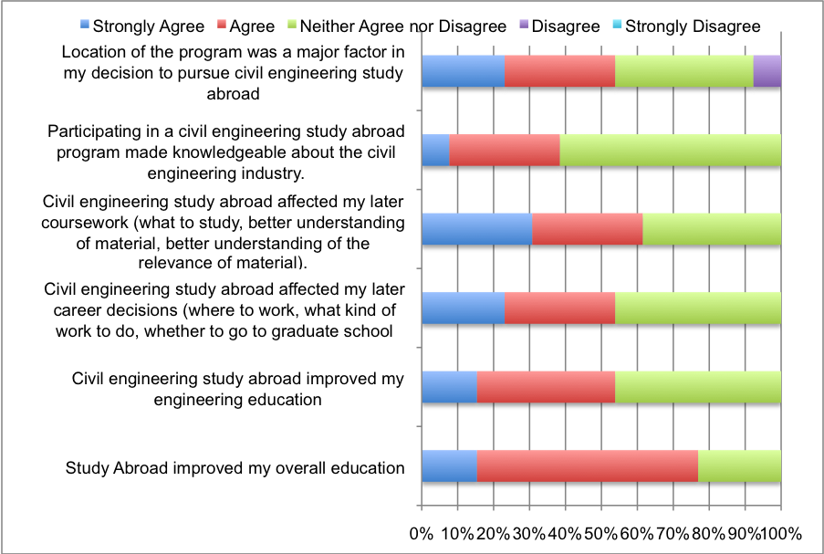

The responses from the students who are participating this coming summer in short-term study abroad offered by the Department of Civil Engineering are presented in Figure 2. The sample size for this group is too small for any analysis, but is presented here in the interests of completeness.

Figure 2: Responses from Students who are participating in Civil Engineering Short Term Study Abroad this coming summer (n=4).
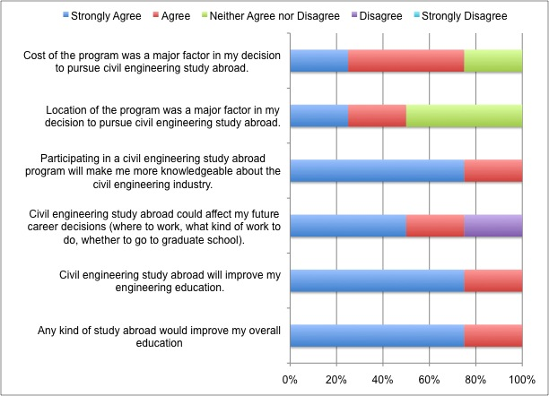

The responses from the students who are have not participated in short-term study abroad offered by the Department of Civil Engineering are presented in Figure 3. This is the largest group in the study with 44 respondents. This group includes second years that would not yet have been eligible for some of the programs, and third and fourth years that either did not apply for the programs or applied and were unsuccessful.

There is marked enthusiasm for study abroad amongst this group. Approximately 90% of this group believes that participating in civil engineering study abroad would make them more knowledgeable about the civil engineering industry and could affect their future career decisions about graduate study or type of job to pursue. Further, 80% of the respondents posit that any kind of study abroad would likely improve their overall education and that civil engineering study abroad would improve their disciplinary education. With these results in mind it is not surprising that over 80% are interested in participating in any study abroad opportunity and almost 70% in a civil engineering study abroad program. Two important caveats to note: location of the abroad program is important to approximately 85% of students (this result requires further study) and cost is a major factor. For 70% of students cost could prevent them taking part and for 95% cost would be a major factor in the decision to enrol or not. This group was also offered an opportunity to add any comments that they might have about short-term study abroad. The responses showed good awareness of and interest in the currently offered programs:

“I am interested in the Leonardo da Vinci program offered, I plan looking into the program for next spring break.”

“I was very interested and wanted to be a part of the Leonardo da Vinci course offered as an avid artist and engineering student.”

“I have heard great things, especially about the Dubai program. I hope to take part in it someday.”

Desire for increased offering and concerns about cost, schedule constraints and engineering applicability were also expressed:

“I believe study abroad programs could expose you to different types of engineering environments and problems. This would help you become more adaptive against other engineering problems or situations you may face in the future.”

“Would love to see more options for short term and even semesters abroad to different locations.”

“I would have been interested in being part of any engineer study abroad internship or experience through the engineering college however the personal cost of approx $4000 was too much for me as I am only able to afford the college price as it is now”

“Not sure if it would be able to fit in schedule”

“It seems like a very interesting opportunity that has many cultural benefits, but few practical -Engineering- specific benefits. The experience of studying abroad, however, cannot have a value placed on it.”

Figure 3: Responses from Civil Engineering Students who have not yet participated in study abroad (n= 44).

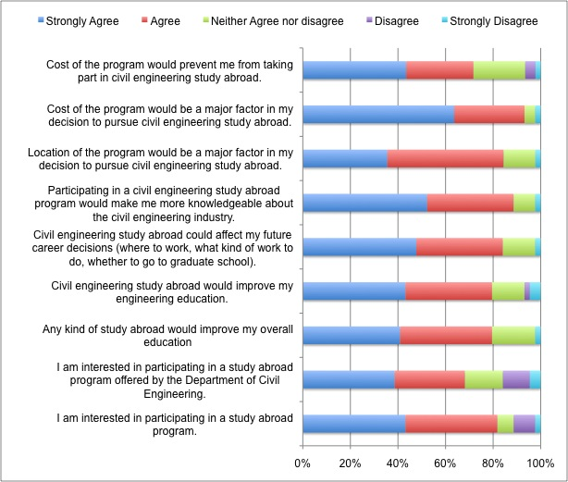

4. Conclusions and Further Work
Although the sample size involved is small, it is clear that there is strong support on the part of the student body for study abroad opportunities. Other studies support the idea that short-term study abroad represents an impactful while realistic option for engineering students. Amongst the students who have participated in the department’s short-term abroad programs there is broad agreement that the experience positively impacted their education (both disciplinary and general) and that longer term impacts on both future learning and career decisions were manifest. Amongst students who have not (yet) participated in the department’s short-term abroad programs there is enthusiasm to take part and willingness to view the programs as transformative in terms of education and career. Those students also express concerns about cost as a barrier to participation.

The Department of Civil and Environmental Engineering at SU continues to evolve the short-term study abroad programs offered to its students. The results of this study further reinforce our commitment to this pedagogical endeavor. Further, we will continue to find ways to structure programs to maximize student involvement, particularly in regards to financial aid.

Further study is necessary to identify the aspects of short-term study abroad that are most positively impactful. It is to be hoped that some of the primary strategies (such as teaching using case studies of real buildings and projects, perhaps by way of doing more local field trips) might be deployed on the home campus to equal effect.

Acknowledgments
The authors whish to thank Jon Booth of SU Abroad and the Faculty of the Department of Civil and Environmental Engineering for their assistance in the preparation of this paper.

References

. P.C. Bhandari. “Promoting Study Abroad in Science and Technology Fields” IIE Study Abroad White Papers, Institute of International Education, Vol. 5, No. 5, 2009.
- Karen Fischer “Short Study-Abroad Trips Can Have Lasting Effect, Research Suggests” The Chronicle of Higher Education, February 20th 2009.
- K. Trout, J. Stewart and G. Scales, “Overcoming the Current Challenges of Promoting and Enhancing International Options within Engineering,” Proceedings of 2010 American Association for Engineering Education Annual Conference and Exposition, ASEE-2010, Paper No. 407, Louisville, KY, USA, 2010.
- K. Talley, C. Hovell and J. Stith, “Study Abroad to See the World and Become a Better Engineer” Proceedings of 2010 American Association for Engineering Education Annual Conference and Exposition, ASEE-2010, Paper No. 388, Louisville, KY, USA, 2010.
- S. R. Spodek, L. Gerhardt and D. J. Mook, “Study Abroad: Impact on Engineering Careers,” Proceedings of 2003 American Association for Engineering Education Annual Conference and Exposition, ASEE-2003, Paper No. 2320, Nashville, TN, USA, 2003.
- S. R. Spodek, L. Gerhardt and D. J. Mook, “Study Abroad: Impact on Engineering Careers,” Proceedings of 2003 American Association for Engineering Education Annual Conference and Exposition, ASEE-2003, Paper No. 2320, Nashville, TN, USA, 2003.
- G. Downey, “What is Global Engineering Education For?” Proceedings of 2010 American Association for Engineering Education Annual Conference and Exposition, ASEE-2010, Paper No. 1277, Louisville, KY, USA, 2010.
- J. Evans, E. Jablonski, K. Buffinton and R. McGinnis, “Five Years of Short-Term Study Abroad Programs: Engineering in a Global and Societal Context” Proceedings of 2010 American Association for Engineering Education Annual Conference and Exposition, ASEE-2010, Paper No. 1277, Louisville, KY, USA, 2010.
- K. Talley, C. Hovell and J. Stith, “Study Abroad to See the World and Become a Better Engineer” Proceedings of 2010 American Association for Engineering Education Annual Conference and Exposition, ASEE-2010, Paper No. 388, Louisville, KY, USA, 2010.
- C. Borri, E. Guberti and J. Melisa, “International Dimension in Engineering Education” European Journal of Engineering Education, Vol. 32, No. 6, 2007, pp. 627-637.
- M. H. Sailbury, M. B. Paulsen and E. T. Pascarella, “Why Do All the Study Abroad Students Look Alike? Applying an Integrated Student Choice Model to Explore Differences in the Factors that Influence White and Minority Students’ Intent to Study Abroad” Research in Higher Education, Vol. 52, 2011, pp. 123-150.

