Telling Tales: Enhancing the Perception of Engineering

Cliodhna McCormac*, Pagona Papakonstantinou and James Davis

School of Engineering, University of Ulster, Jordanstown, Co. Antrim, BT37 0QB, UK
*T: +44 (0) 28 903 68018, E: c.mccormac1@ulster.ac.uk

Abstract

The progress of an EPSRC project designed to engage school pupils in designing art works to accompany a series of modern day fables that emphasize the significance of Engineering to everyday life and to provide a glimpse of what may emerge in the future is described. Central to this is the creation of a multi level story line which has value beyond the mere curiosity and thus the resulting narrative and embedded contextual material would be designed to be capable of integration within components of the Science, Technology, Engineering and Mathematics (STEM) curricula. The project’s remit is to distribute the tales in the form of a series of booklets to schools within Northern Ireland to evaluate the pre and post intervention response in relation to raising the profile of Engineering.

Introduction

The perception of Engineering as a profession has suffered greatly in recent years in relation to recruits to university courses but the loss of esteem within the public arena is, by far, the more worrisome as this typically feeds the career aspirations of the former. While it was once traditionally associated with large scale structures, the increasingly harsh economic climate has seen the sustained erosion of the industrial base and it would appear that there are few, home grown, engineering feats of sufficient iconic status with which to capture the imagination. This is certainly a false assumption given the tremendous advances that have occurred across the Engineering sector but it is one whose effects are exacerbated by historical comparison and highlights a desperate need to increase the visibility of “Modern Engineering”. It can be argued that tangibility is a key piece of the puzzle that has been lost as Engineering has moved, at least in Northern Ireland, quite literally from the Titanic to ever smaller scales and, while vital to the emerging needs of high technology manufacturing, can be highly obtuse even to those with a scientific background.

There is, however, a second issue. Even if the miracles of Nano-engineering, a highly topical example, were rendered in a form that provides a final picture readily comprehensible to the average person – would they be willing to look and to expend the time needed to comprehend the significance of the information? There is an implicit danger that, in an age characterised by information overload, the effectiveness of conventional, passive dissemination processes will be severely debilitated/diminished and the message subsequently lost to all but those already within the ranks of the converted. This clearly defeats the purpose of true public engagement. It is therefore the aim of the proposed project, to assess a more covert approach to capturing the attention of those to whom Engineering is regarded, at best, with considerable apathy.

The aim of the present presentation is to outline the strategies being taken with the School of Engineering at Ulster to create a more integrated approach that aims to generate a much more sustainable profile for Engineering across local, regional and national audiences. The secondary objective is to highlight how such processes could be transferred and hopefully adopted across different faculties such that a more coherent international perspective could be fostered that together raises – essentially recaptures - the profile of Engineering as a high value profession.

Booklet Rationale

The heart of the strategy relies on engaging school pupils. Rather than passively supply them with yet more literature – the innovative step is to directly involve the pupils (our prospective audience and future recruitment pool), through outreach, in the preparation of the literature. The approach was to enable them to design art works that would be incorporated into a booklet. However, in contrast to the conventional literature, we set out to rediscover the art of story telling in which the human dimension of Engineering is explored and the concepts and indeed the significance of the design and construction process is put in true context. The intention is to create a series of modern day fables that emphasize the significance of Engineering to everyday life and to provide a glimpse of what may emerge in the future. Central to this is the creation of a multi level story line which has value beyond the mere curiosity and thus the resulting narrative. Embedded within the story would be material capable of integration within components of the Science, Technology, Engineering and Mathematics (STEM) curricula. Thus the booklet could serve as a curricula revision tool for the students in their forthcoming studies and could be readily adopted by school teachers. The booklet would therefore have a life far beyond that of conventional brochure literature.

Methodology and Pedagogical Basis

The core remit relies on the applicants adapting the Jonathan Swift tales of Gulliver’s voyage to Lilliput and Brobdingnag as the fictional foundation upon which to present the research being conducted within the School of Engineering. The reason for embedding the Engineering within a fictional background has multiple advantages. We can all remember the fairytales we were told in our youth. Many are constantly reinforced in the media whether through plays, movies or television. They are familiar and our intention is to adapt some of these such that when they are recalled in subsequent life – there would be a possibility of retrieving aspects of the Engineering that they learned through reading the booklet. It is hoped that through emotional engagement with the human elements of the story, there would be a more holistic retention of the ethos of Engineering which would engender positive memories for future recall.

Storytelling was an important, if not vital, stage in our development, representing the logical progression from the cave painting and was the springboard through which societal norms were introduced to the young [1,2]. This oral tradition arguably represented the very introduction to the real world where tales would be told to inform and aid the survival of the community and these methods are still practiced in present day aboriginal societies where the legacy is passed from one generation to the next. There are still faint resonances of this approach in modern societies where fairytales and fables are recounted in bedtime stories. While their present day form is almost invariably used to entertain, this is a largely superficial deployment of a pedagogical vehicle whose historical purpose was predominantly to inform and influence. Engagement with the central narrative was exploited as an emotional hook through which to embed the central message within the mind of the child and thus enhance retention [1]. It is easy to recall the stories of our youth – while the exact details may have been lost to an aging memory - the nuances and core message contained within them are liable to be as clear as when they were first heard [2,3]. In a preliminary survey of 153 undergraduate engineers to assess their literary background – over 90% nominated at least 5 fairy tales/ rhymes as within the top ten story lines that they could recall – the most popular being Humpty Dumpty. Emotional engagement is a key hook and the tragedy of the poor egg certainly has age old resonances. Therein lies the crux of our argument for the use of storytelling as a means of enhancing present day appreciation of Engineering as a positive occupation and potential career.

A substantial knowledge base on the use of emotional engagement has arisen in recent years and the key psychological fundamentals that mediate such processes have long been recognised. A central theme in the fable approach is the empathic melding of the reader with the experience of the central character such that the trials and tribulations are shared. It can be a form of personal, mental, role play in which experiential learning is achieved indirectly and is critical to the present argument as it represents deep learning of a message [2]. Engineering is, in contrast to the academic disciplines, the storyteller’s ideal realm in that it contains all of the key ingredients (principally the presence of large challenges, danger and overcoming the seemingly impossible) necessary for the construction of stories that can capture the interest of the reader [2,4,5]. The variety of storyline is dependent only on the imagination of the teller and it is capable of being moulded in an inexhaustible number of ways that can serve to emphasize specifics or generalities and can be tailored to any context. Rather than presenting isolated data or facts – it offers a means of delivering the theme in a holistic and reflective approach that is more amenable to being embedded within deep memory [6,7]. There is an additional advantage in that it can tap into the imagination in a way that conventional lecture material often fails to achieve and facilitates learning of the bigger picture (or in our case the ethos/process) rather than imparting isolated facts about Engineering [2,4,5]. Some of the main merits highlighted in Figure 1.

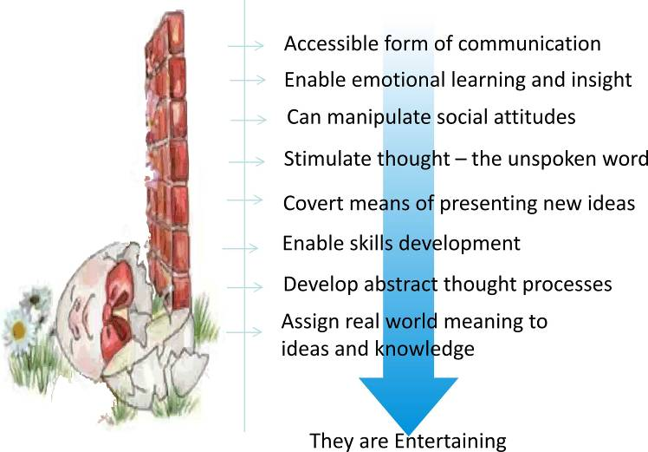
There is little doubt as to the flexibility of the story approach but the crucial question is how to deliver it effectively. Can it be readily adopted across different faculty and what degree of expertise is needed for its implementation? The components of storytelling rest upon the empirically tested foundations of educational psychology [2] but, ultimately, their collation, integration and expression is more art than science and it is clear that the best stories require the addition of what can seem to be an intangible creative element. This could at first glance appear to relegate the strategy to those with a literary background who have nurtured a talent for writing but, while the possession of the latter is certainly advantageous, its absence is not a reason for exclusion. There is an almost innate human perception of what a story is and what it should contain (beginning, middle and end; a challenge and, ideally, a resolution) and while the performance may be variable – everyone is capable of delivering it [2,3]. Providing there is sufficient feedback – the story can be optimised to the appropriate reader level.

It is important to note that the process of storytelling need not be restricted to the lecturer. Storytelling has long been a critical component of medical practice – employed by students and staff irrespective of educational or creative background to share experiences and develop professional competencies [8]. The discussion and review of case histories, consultations and consideration of clinical scenarios are a matter of routine professional development and each embodies a degree of storytelling. It is easy to envisage how a similar format could, in principle, be applied equally well to broad based engineering practice where postgraduates can be involved in an effort to improve their communication skills – as indeed is the intent in the proposed project.
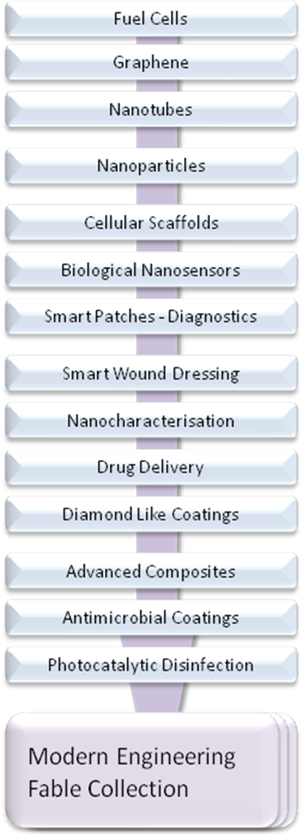
Implementation and Outcomes

It is proposed that the fables would take aspects of the Engineering research being undertaken and weave them into a coherent plot capable of engaging, on a first level, a young audience – typically 11-13 year old. This sets the baseline for accessibility and transferability across all demographics. Surreptitiously embedded within the text or accompanying figures will be a modicum of more complex Engineering and Technology concepts though still residing within the bounds of lay terminology. The latter provides an avenue through which the tale can be adopted within the secondary school science curricula. The main remit however is to convey the challenge and benefits that can accrue from Engineering and thereby strengthen the profile of the profession. As such, the fable approach provides a single vehicle through which to reach many different cohorts. The research base at Ulster provides a large number of “modern” Engineering opportunities which can be incorporated within the narrative. Some of the topics that would be exploited are highlighted in Figure 2.
Figure 2. Engineering Topics
As indicated previously, the main limitation lies not in the story itself, nor the supporting artwork, but rather in its uptake by the public. A multi-threaded strategy is therefore proposed to aid both the compilation of the material (Figure 3) but also its transmission to the home or visitor centre and therein access a much more public arena. The participation of the pupils in the preparation of the artwork supplementing the story is crucial as this fosters greater engagement in the subject being illustrated but also serves to stimulate interest in the final published fable collection. The artwork would be used as a homework based assessment tool within the existing school curricula and, as such, ensures participation but also encourages higher quality submissions. Each participating school would be given a “commission” with the process seeking to effectively mimic the contractual work undertaken by commercial artists. The commission itself serves to illustrate a particular component of the narrative. The reward for completion in this case is not monetary but academic in terms of credits relating to their assessment but with an added incentive that those of sufficient quality would be used in the final fable collection print run.
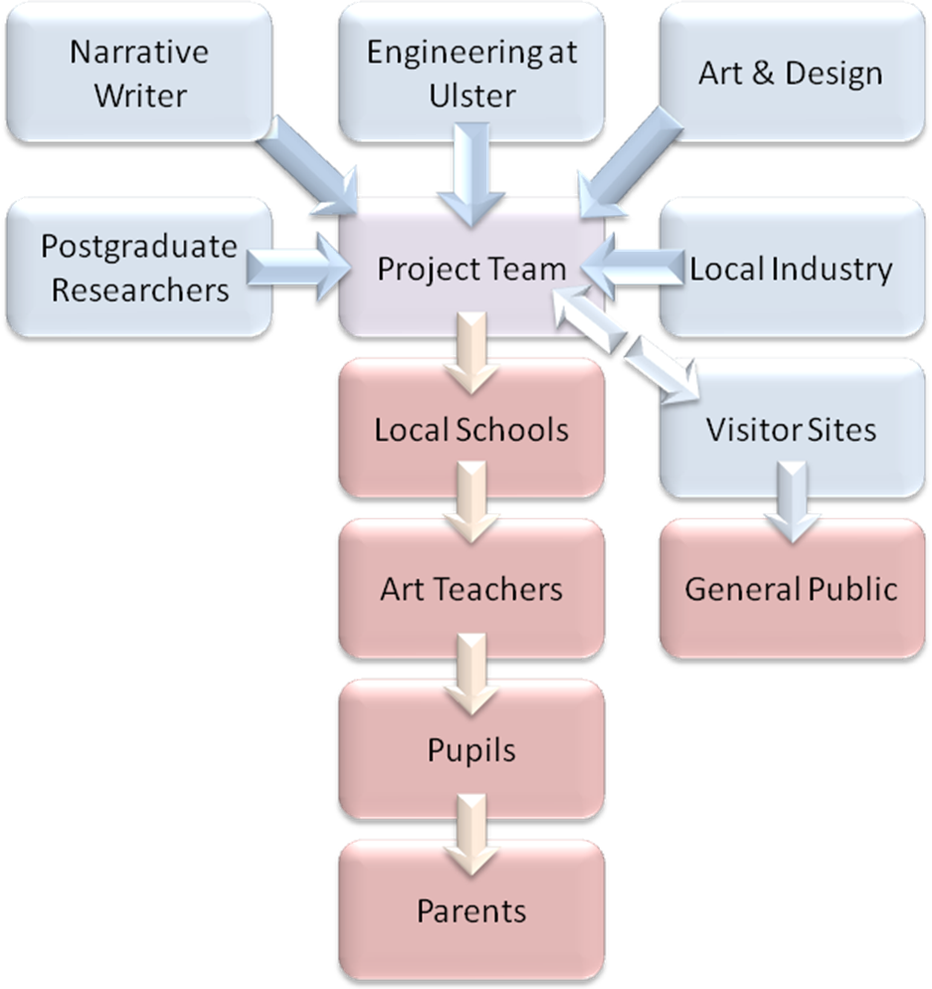
Among the advantages of this approach, there is a competitive edge to the preparation of the illustration and, more importantly, the homework based assignment serves as a conduit for the dissemination of key Engineering achievements out with the classroom, thereby potentially raising the visibility of the subject and profession and stimulating discussion within the home. A secondary bonus is also apparent in that the successful completion of the commission will require an appreciation, at least to some extent, of the underlying concepts referred to in the narrative. It should also be noted that in targeting an artistic contribution, the project has the potential to reach an audience that may hitherto have had little regard for the traditional STEM subjects, thus reaching the disaffected rather than the converted.
Figure 3. Project programme

Project Partners and Target Audience

Preliminary discussions were held with a number of Northern Ireland schools (primary and secondary) and with industry (regional and national) within Northern Ireland to consider the mechanics of the project in terms of integrating the artwork assignment into the existing curricula and the criteria necessary to ensure that the resulting booklet would be of value for pupils – both at primary and secondary level - and the necessary literary style and typical science content. These would act as the advisory panel when constructing the actual narrative. It was anticipated that the pilot project would engage 20 schools (10 primary, 10 secondary) as partners in the first instance. This would give a total participation audience of approximately 2,600 pupils (600 primary and 2000 secondary). The project would release 6000 booklets which, assuming a total return to the home, would generate a readership audience of approx 18,000 (based on 2 parent / 1 child). The latter, however, could clearly be far larger depending on the movement of the booklet through the extended family network and an assessment of such transferability will be a core objective of the project.

An important point to note and a key feature of the project is that a booklet would be produced that will be attractive, have direct and identifiable local interest and will have an accessibility (through the resonance with Swift’s work) that appeals across a spectrum of age ranges – all of which have the potential to stimulate curiosity [2,4,5]. It is easy to envisage that the booklet will have a lifespan far greater than a leaflet, an event or other activity and the residence time within the home and transfer between family members within the home could be priceless. As such, the audience figures postulated above, in many respects, represent the minimum but there is clear potential for a far greater and sustained influence.

Conclusions

Storytelling was historically the principal method of disseminating messages about the wider world and how it works and is embodied in the subtext of tales by Aesop and the Grimm brothers and recounted through countless generations. It is important to realise the story is pivotal to making the facts that we wish to convey much more accessible and thereby improve their later recall. This is due primarily to the fact that the underlying story is responsible for capturing the imagination of the listener or reader. In recent times, the narrative that once held our attention has been significantly eroded and replaced with a distillate of hard facts, calculation and process for solving problems – the human dimension is often dismissed as being superfluous to the exam/assessment process as students search through the ever expanding shelves of crib notes. These do little to aid long term memory. As such, the significance of Engineering can be eroded – indeed sacrificed in many respects and the enthusiasm for the subject tragically lost. The status of the profession will suffer as a consequence as the student searches for an alternative career. The strategies outlined above demonstrate a versatile method through which to counter the apathy at a grass roots level. The intention is to foster a more proactive attitude which can pervade the student response to the subject in later years and hopefully the underlying human dimension and societal challenges that Engineering is attempting to meet are reinforced. The case study presented highlights how it can be delivered in a holistic manner that is complementary to existing promotional methods. Most importantly, it provides an inherently transferable method for engagement and reinforcement of the message that contrasts the traditional delivery of such material and thus should enable a greater retention of the key tenets and enable transfer to a wide audience. It is hoped that at the very least the booklets stimulate discussion and therein enhance the esteem in which Engineering should be held – ultimately leading to the revitalization of interest and recruitment.

Acknowledgements

The authors thank the EPSRC for funding the project through their Partnerships for Public Engagement Programme.

References

1 G. Anderson, (2000), “Fairytale in the Ancient World”, Routledge, London

2 J. Moon, (2010), “Using Story in Higher Education and Professional Development”, Routledge, London

3 M. Gillard, (1996) “Story Teller, Story Teacher”, Stenhouse Publishers, Maine.

4 E.K. Diekhof, H.E. Kipshagen, P. Falkai, P. Dechent, J. Baudewig and O. Gruber,(2011) “The power of imagination — How anticipatory mental imagery alters perceptual processing of fearful facial expressions”, NeuroImage, 54, 1703-1714

5 M.J. Shank, (2006), “Teacher storytelling: A means for creating and learning within a collaborative space”, Teaching and Teacher Education, 22, 711-721

6 C.M. Roebers and W. Schneider (2005) “The strategic regulation of children’s memory performance and suggestibility”, Journal of Experimental Child Psychology, 91, 24-44

7 D.R. Shaffer (1989) “Developmental Psychology (Childhood and adolescence)”, 6th edition, Wadsworth

8 J.A. Sakalya, (2002), “Literary Pedagogy in Nursing: A Theory Based Perspective”, Journal of Nursing Education, 41, 386-392

