Acceptance of Innovative Technical of Teaching and Learning

Osvaldo Shigueru Nakao Brazil1, Hernani Luiz Brinatti Brazil 2, José Aquiles Baesso Grimoni Brazil 3
1 Dept. of Structural Engineering and Geotechnical, Polytechnic School, University of São Paulo, Brazilm, osvaldo.nakao@poli.usp.br 1
2 Dept of Naval and Oceanic Engineering, Polytechnic School, University of São Paulo,Brazil,hlbrinat@usp.br 2
3 Dept of Electric Energy and Automation Engineering, Polytechnic School, University of São Paulo, Brazil,aquiles@pea.usp.br 3

Abstract
The Escola Politécnica of the University of São Paulo (Brazil) implemented a curriculum reform in 1999, with the purpose to meet curriculum guidelines specified by Brazil Ministry of Education. These guidelines define the set of skills that an engineer must have. Thus, in order to provide that the 750 freshmen students at Polytechnic School of University of Sao Paulo acquire knowledge and develop skills and attitudes related to these competencies, it was decided to implement a new methodology for engineering design, incorporating strategies to teaching and learning in Introduction to Engineering course.
The students are taught an engineering desigh method by developing an engineering project. It seeks to establish the habit of formulating problems starting from the needs assessment and proposal and choose of solutions alternatives and maintaining constraints from well-defined criteria.
The discipline also aimed at allowing the student to develop certain skills and attitudes, such as teamwork, written and oral communication, social and environmental awareness, ethical judgment and stance.
Once the desired learning outcomes are identified, the apropriate teaching methods should be selected and students’ activities are defined. A large range of mechanisms, involving peer assessment (competitions between groups) and assessment for other students (competition between classes), projects evaluation by class teachers and the final projects by a panel of teachers.
The experience developed in the years of existence of the subject reveals that the development of a thematic project has helped students to appreciate the technical issues and help the students to understand the mission of engineering. Even without advanced technical knowledge, students have presented classical solutions and sometimes innovative ideas for proposed projects. In addition, there has been a significant correlation between students' understanding about the importance of discipline and its evaluation on the teacher's class. In contrast, there is a difficulty of some students to work with unconventional methods of assessment as used in this discipline. The paper addresses mainly these two issues based on evaluation of the students' responses to a specifically prepared questionnaire.

- Introduction

This paper deals with the analysis of the students evaluation of a discipline offered in the first semester of the engineering course at the Polytechnic School (EPUSP). It refers to Introduction to Engineering (IE), which was implemented in 1999 in order to meet the demand of the new curriculum guidelines for the engineering school. The discipline introduced new learning techniques in the engineering school and acted as a pilot for other experiences in the undergraduate course. The methodology used in Introdution to Engineering, described by Barreiro et al(2003), Montefusco (2004) and Nakao and Brinati (2007) was the precursory one in the adoption of new mechanisms to evaluate the student’s learning in EPUSP.
The teachers’ team of IE, which is composed by 24 members each semester, has been trying to improve the teaching plan along these 12 years period. Once some imperfection is identified, alternative measures are proposed for student activities and criteria of learning evaluation. Therefore the teaching team believes that there is a good consistency between the desired learning outcomes and the effective results of students learning. However, it is important to know how the students appreciate the discipline in its different aspects, mainly because IE has basic features very distinct from those of other first semester disciplines. For instance, the students’ learning evaluation in these disciplines is essentially based on the grades given by professors for quizzes and homework, while in Introduction to Engineering (IE) the evaluation procedure covers a large range of mechanisms including even peer evaluation. The means selected to get the student evaluation about the discipline is to handout a specially prepared questionnaire in the last semester class.
In the following it is presented initially some basic considerations about the student evaluation procedure and its effects on the process of the habilitation choice in the school. Afterwards it is presented a short description of IE teaching plan and mechanisms of learning evaluation. Then it is presented the questionnaire submitted to the students for the discipline evaluation. Finally the questionnaire answers for two selected periods are presented and discussed.

- Influence of Student Performance on Career Selection

When the curriculum reform was implemented in EPUSP in 1999, it was defined a gradual process of career selection along the first four semesters. The grades given to the students in each discipline of these semesters have a great importance because they are used to classify the students in the gradual process of habilitation selection. In 2008 it was introduced some changes in the procedure of career selection, but the students still have to compete for some habilitation based on their averaged grades in the subjects undertaken in the two firs semesters.
The grades are also used in other opportunities, as in the selection of candidates for scholarships or interchange students program, which usually takes as a decision criterion the student performance.
In order to provide equal opportunity in these competitions, it is specified a common class schedule for the first year disciplines, and a specified standard for the didactic material and a homogeneous evaluation of the students’ learning.
In the particular case of Introduction to Engineering, in which the students are divided in 24 classes of 32 elements, the discipline activities are carefully discussed and planned to provide the required uniformity. In spite of the student heterogeneity and their different needs, there is a concern for the uniformity of teachers’ actions. It must be very carefully considered the ambiguity between classes and lessons homogenization (in such way the students competition for selecting the desired habilitation should the most fairly possible) and the respect of student individuality (in order that the learning process could be optimized). Even an administrative procedure of distributing the 750 students in 12 or 24 classes should take into account this question.
Since the final grade of the student in the discipline depends, even partially, of a competition among three classrooms, it is necessary that the students are randomly distributed by the classes to provide a fair competition. Otherwise, if in an extreme case there is a class composed by the best classified students, this class would have a relevant advantage in the competition. Furthermore, other pedagogical reasons recommend that the classes are conveniently balanced.
The 750 students that enrolled in the EPUSP are divided in 24 classes. Since part of the evaluation process contemplates a competition among classes, there has been concern about an even distribution of students’ potential in the different classes
- IE Guidelines

In order to understand the content of the evaluation questionnaire submitted to the students it is important to synthesize the main IE features. As it was pointed out by Nakao and Brinati (2007) there is a logical chain relating the discipline objectives to the discipline activities and the corresponding procedures used to evaluate the effective learning achieved by the students. This basic consideration was used to define the teaching plan for IE.
As its main goal, it is decided that the students should learn an engineering design method by developing an engineering project. They are taught that the method comprises a given set of processes: identification of the needs and expectations, definition of the problem, formulation of alternative solutions, imposition of evaluation criteria, selection and implementation of the best solution.
The discipline activities are, therefore, concentrated on the development of a thematic project in a different scenario for each three classrooms. The students are required to work, organized in teams, on a class project divided into two phases along the semester. The themes chosen for the project have been deliberately polemical and citizenship-driven, such as: management of solid waste and reduction of waste disposal; electrical energy savings in commercial and residential buildings, reduction of water consumption in these buildings., and improvement of urban trans portation systems.
After an initial trial with a simple project, the students are introduced to the engineering theme selected for that semester. The teacher presents the main aspects related to the general problem and specifies to his students the particular scenario that they will have to deal in their project. The teacher also provides the basic bibliography for the selected theme. The additional references should be obtained by the students.
The students are asked to analyze the whole problem and to split it in four relevant subprojects. The students are then divided in eight groups, two of each working in the same subproject. Each group should organize their activities, which start by defining what data they need in order to get a comprehensive knowledge of the problem. Afterwards, they will search this information in the bibliography and sites, as well in a field survey. They should start this work in the classroom, with the supervision of their teacher, and before leaving the classroom they should program the activities along the week.
The students are stimulated to look after other professors and experts to get a better understanding of the project they are carrying on. Some students may eventually visit sector firms to collect additional data. The idea is that the students may start to build a professional network, which can be helpful in the future.
The discipline also aims at the development of the students’ attitudes and skills, such as teamwork, planning, programming, controlling, written and oral communication, creation of alternatives and decision criteria, economic, social and environmental awareness, and ethical judgment and stance. The discipline activities along the semester will be used to stimulate these skills and attitudes and to evaluate how the students incorporate them in their practice.
IE activities involve lectures and class discussions, teamwork, and inter-group and inter-classes competitions intermediated by a professor. The groups have to prepare two partial project reports and also present them orally to be evaluated by the class and the professor.
The reports are analyzed by the professor with the purpose to check the quality of the project developed by the group, checking out the student comprehension of the engineering design methodology, as well the student’s skill in written communication.
The grade given to the group report is subject to discussion of the group members, which should negotiate the grade division according to each individual contribution. In this activity the students are stimulated to exercise ethycal judgement.
Since 2003, a normalization procedure has been adopted in Introduction to Engineering to define the grades given to the project reports, in order to take into account the different evaluation criteria of the professors
At the end of the semester the class prepares a final report that integrates and consolidates the contribution of the different groups.
The groups have to present their partial project to the whole class evaluation in a competition way. The students, which were previously instruted about oral communication techniques, are evaluated by their classmates on this specific skill but mainly on the quality of the project.
At the end of the semester there is a competiiton between three partners classes, which present their project to the students of three other partners classes and a professors’ committee.
The IE team, composed by the coordinator and 24 professors have regular weekly meetings in which the students’ accomplishment in the different aspects is analyzed. It is possible, therefore, to take in real time the required measures to correct the discipline course. The professors are stimulated to discuss with the students along the semester the learning process and the mechanisms used for its evaluation, and to give them the necessary feedback in order to improve the student’s performance.

4. Discipline Assesment

The teaching and learning procedures are permanently questioned about their effectiveness and efficiency by teachers and pertinent committees, even in informal discussions. The recording of the right decisions as well as of the mistakes along a semester allows to make a diagnosis of the selected techniques and to make the required feedback. The question that arises is how and when to make this recording. How can be computed the extra class student activities? Are the work demands in one discipline much different from others? It is possible to find out the students perception about their learning as well as about the adequacy and motivation of the themes selected for the discipline project, and about the teacher performance and evaluation criteria?
In Introduction to Engineering it was decided to collect the answers to those questions through a questionnaire delivered to the students in the last semester class. The analysis of these data allows the identification of eventual problems.

The questionnaire inquiries items that are relevant to the quality of teaching and learning process in the student perception, envolving, in the present version, six aspects: understanding of engineering subjects, development of skills and attitudes, the work performed along the semester, the professor performance, the evaluation mechanisms and aglobal appraisal of the discipline. In the first years a slightly different questionnaire was used. Each aspect is divided in a given number of items, as described below.
- Understanding of engineering: identify needs and wishes; define the problem; formulate alternatives; find the best alternative.
- Development of skills and attitudes: teamwork; planning, programming and controlling; writing and oral communication; creating alternatives and decisin criteria; taking economical, social and enveronmental aspects in consideratiom; judging and negotiating abilities.
- Work developed in the semester: motivation of the thematic project; change in the understanding of theme of the project after working on it; comprehension of an engineering project base on the development of the thematic project; ability to work in a embracing thematic project.
- Professor performance: enlightment of discipline objectives; orientation in classroom; global evaluation of the teacher.
- Mechanisms of students’ learning evaluation: motivation to the development of oral communication and teamwork skills; contribution to enhancement of work; appraisal of evaluation of students by their classmates; evaluation of the intergroup competition.
- The discipline as a whole: contribution for the student formation as an engineer; overall evaluation of the discipline.
The students may express their satisfaction on each item in 5 different ways: very good, good, regular, bad an d very bad.

4.1 Discipline Assesment in 2001 and 2002

The project theme adopted in 2001 and 2002 was electrical energy. The students’ motivation was very high due to the blackout that had occurred in Brazil in May 2001. The students have to deal with the problem of reducing the consumption of electrical energy in different scenarios.
The evaluation questionnaire was applied by the professors in 2001, but only 91 copies were turned back. The very low level of response was probably because the questionnaire was applied, without previous announcement, in the last class. Even with this small sample, it was possible to check the accomplishment level with the development of the discipline.
The answers related to the contribution of Introduction to Engineering to the understanding of engineering showed that the best result, in the terms of “good” and “very good”, was obtained for the aspect “definition of the problem” (Nakao, 2005), with around 90%.

The formulation of alternatives and the selection of the best solution were the only ones were the sudents, even in a low percentage, give a bad answer. In general, the contribution of IE to the understang of engineering was good or very good for 80% of the students, which menas that one of the discipline goals was met.
In terms of the development of specific skills and attitudes, the answers obtained indicate that the IE contribution was good or very good for 80 % of the students. The level “good” was dominant for: the development of teamwork skill, planning, programming and controlling skills, writing and oral communication abilities, formulation of alternatives and decision criteria. The contribution was considered very good only for taking in consideration economical, social and environmental aspects in engineering projects.
The percentage of the answers with the concept good and very good indicatet that the theme selected for the discipline project was motivating and appropriate. The grade very good was the most selected by the students.
In the evaluation of the professor performance, the predominant answer was to the concept very good. The amount of the students that evaluate their teacher performance as regular and bad was around 10 %. Most of the teachers were engineering professionals with a large experience, and certainly this profile had contributed to the evaluation results.
The answers given to the aspects related to the mechanisms used to evaluate the students’ learning showed a relevant distribution of the concepts very bad, bad and regular, indicating that this was the great problem of the discipline. In the traditional way of evaluation, in which the professor is responsible for it, by means of quizzes, the students do not contest so severely the grades received. It shows that, in general,one tends to accept the judgement made by a authority or hierarchy superior element, but does not accept well a peer evalaution. There is also the effect of comments made by earlier classes about arrangements made in the partners class competition, which indicate that the desired student maturity for an ethycal judgement was not obtained neither by the discipline methodology nor bt the professor interaction.
It was found out that the students appreciate well the discipline, since more than 80 % gave the concept good or very good in terms of its contribution to the understanding of engineerig work and in the overall evaluation of discipline.
The analysis of the comments presented in the questionnaires of the students enrolled in the IE in 2001 showed that there was a decrease of the complaints presented by the students of the two previous years. The authors believe that this was due to the modifications introduced in the discipline as the results of the observations made by students and teachers.
There were many comments about the extra classroom work the students must spend in the distinct activities related to development of the tematic project. In response to this comment, from 2003 on, the discipline got 1 credit work in addition to the 3 classroom credits.
The students expressed complaints about the heterogeneity of procedures applied by the professors in the evaluation of the project reports. Tese complaints were analyzed and a new procedure was introduced in 2003; the grades given to the reports normalized in order that the average grade of the reports is the same for all the classes.
In 2002 the questionnaire was ansewered by 320 students. The contribution of the discipline to the understanding of engineerig was considerd as good or very good by 70 % of the students. In comparison with 2001 there was a decrease in the level of approval and there appear answers with the concept very bad.
The answers to the questionnaire indicated that the contribution of IE to the development of teamwork and writing and oral communication was considered good and very good by 75% of the students. For the other desired skills and attitudes - planning, programming and controlling; creating alternatives and decisin criteria; taking economical, social and enveronmental aspects in consideratiom – the prcentage of good and very good was around 70 %. There was a decrease of these percentages in comparison to the rsults obtained in 2001.
The answers given by the students to the motivation of the thematic project indicated a lower level in comparison to 2001. Although the theme was the same, the visibility given by the media in 2001 to the energetic blackout made the students give a better concept to the theme. There is certainly a correlation between what is of public domain and the student motivation.
This fact arises a question.Is this type of correlation that drives the interest of the students for a specific engineering habilitation?
In 2002 there was also a dominance of the concept very good in the evaluation of the professor performance. Howevwer, the percentage of the students that evaluate the classified the performance as regular, bad and very bad was twice as high as in 2001.
Once again the worse grades were given to the mechanisms of learning evaluation, expressing that this aspect is the main discipline problem. The percentages of the bad and very bad concepts increased much in comparison to 2001.
There is an understanding that the evaluation process should be natural and that all the persons will be work as leaders or under some leadership, and therefore they will have to evaluate or to be evaluated. However, since the student judgment in the competitions was subjective, and further away of the right or wrong evaluation that one is used to, there was some insecurity relatively to the fairness of the results.
It was noticed that the students got a good impression of the discipline, since more than 70 % gave the good and very good concepts to the contribution for the student formation as an engineer, and more than 60 % gave the good and very good concepts for the discipline as a whole.

4.2 Discipline Assesment in 2008

The project theme adopted in 2008 was again energy, but in a more embracing form. The students have to deal with the problem of decreasing the energy consumption in different types of commercial buildings.
As it can be seen from Figure 1, the students’ evaluation about the questions related to the understanding of engineering indicate that the IE contribution was good or very good for more than 70 % of the students.
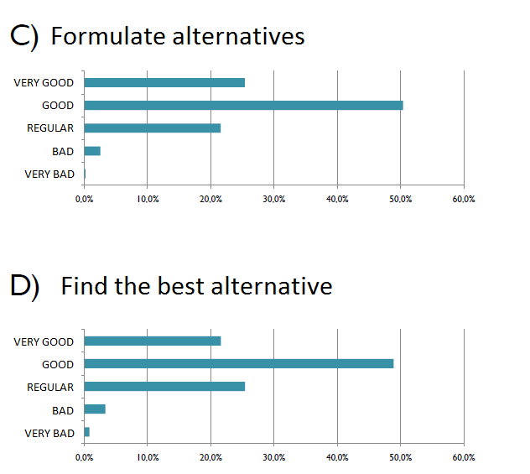
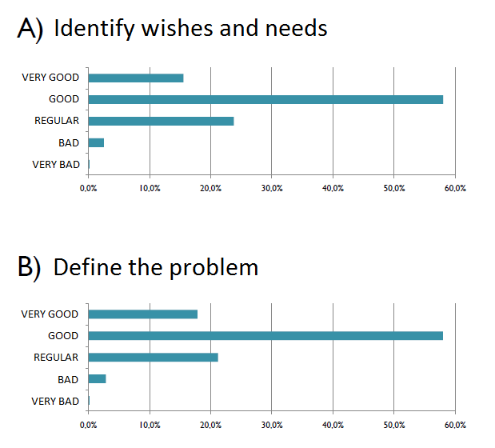

Figure 1 Understanding of engineering

The students’ evaluation about the contribution of the discipline to the development of specific skills and attitudes is presented in Figure 2. It is seen that the IE contribution was good or very good for more than 70 % for teamwork skill, formulation of alternatives and decision criteria and taking in consideration economical, social and environmental aspects in engineering projects. These results are quite similar to those ones obtained in 2001 – 2002.
In the remaining abilities and attitudes - planning, programming and controlling, writing and oral communication, and judging and negotiating – the percentages of good and very good were lower, but always greater than 50 %.
The students’ evaluation about the work developed in the semester is presented in Figure 3. The better evaluation, more than 70 % of good and very good concepts, was given to the comprehension of an engineering project based on the development of the thematic project. This is the main discipline goal. The motivation aroused by the theme did not have the same level of good and very good.

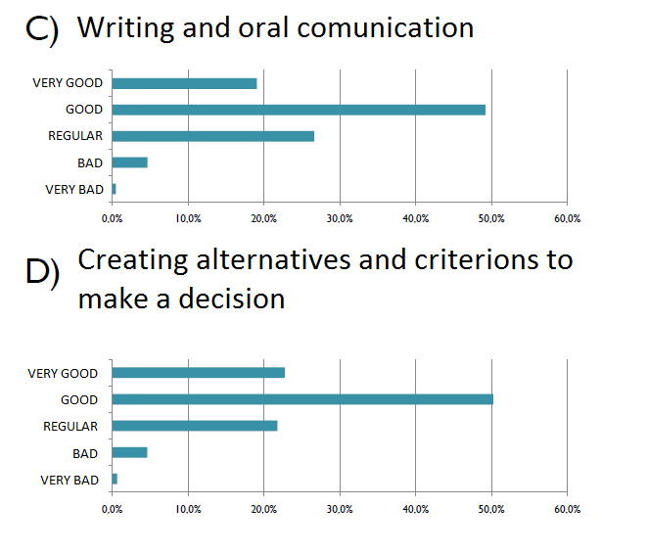
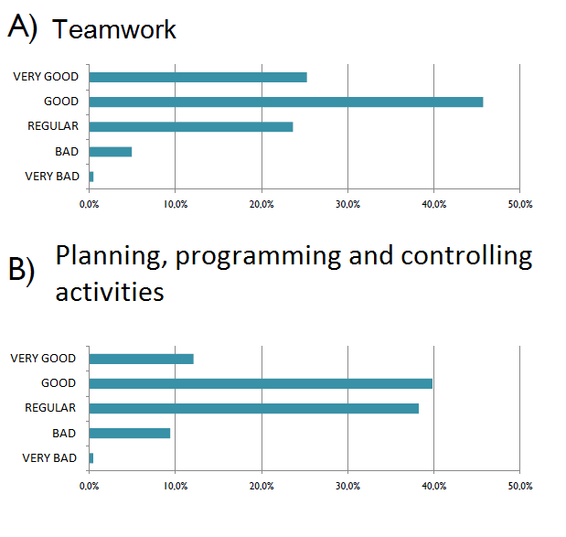

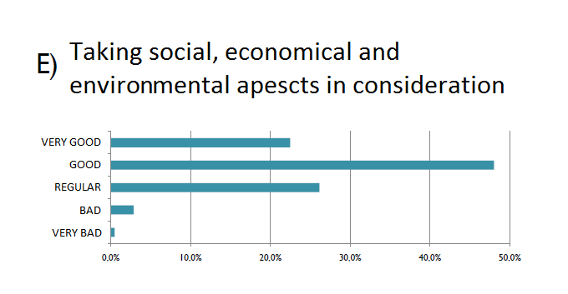
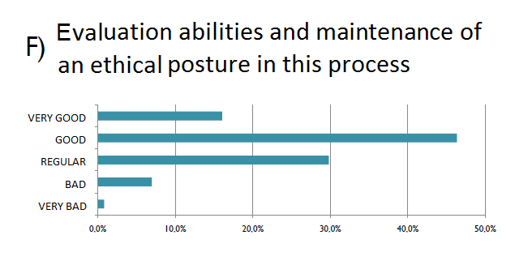

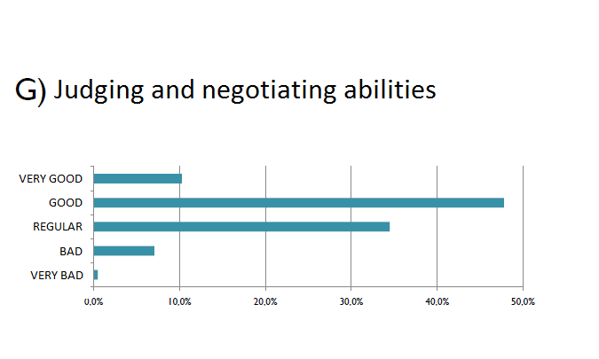

Figure 2 Development of skills and attitudes

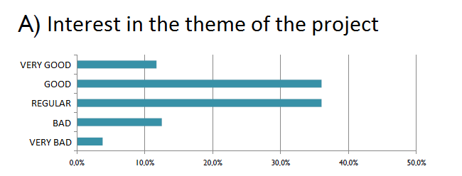
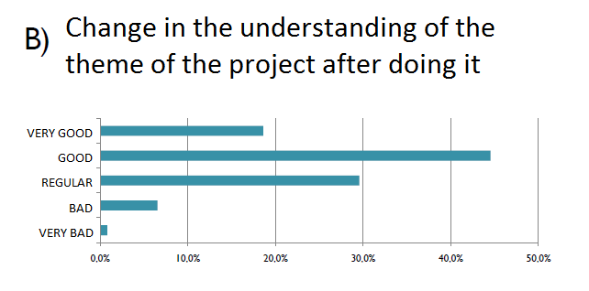
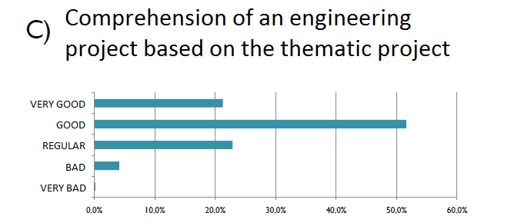
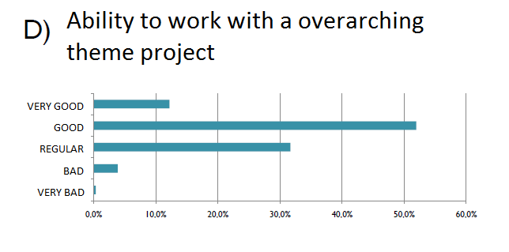
Figure 3. Work developed in the semester

In 2008, like in the previous years, the teachers’ performance was well appraised by the students. The professor participation in making clear the discipline objectives and in supervising the classroom work got a percentage of good and very good concepts above 70 % and the global performance the correspondent amount is around 80 %.
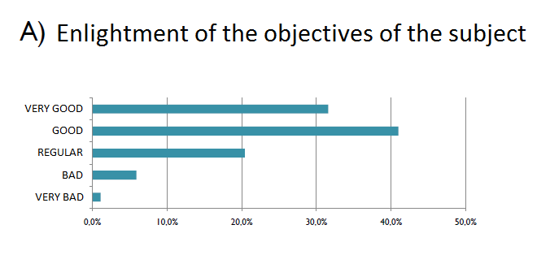
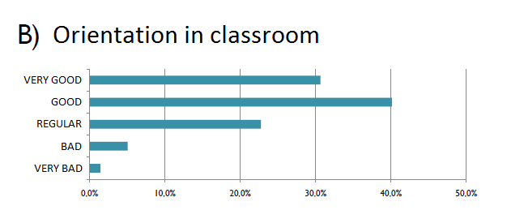
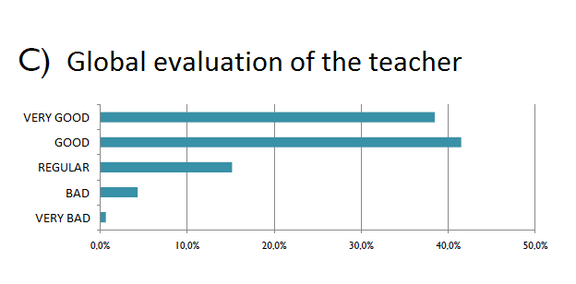

Figure 4 - Professor performance
Considering the mechanisms of students’ learning evaluation, the answers are not better than those obtained in the previous years. The concept very good has a smaller percentage than the regular one for all the items. Specifically, the evaluation of the students by their classmates and the competition intergroup got a percentage of bad and very bad concepts higher than 15 %.
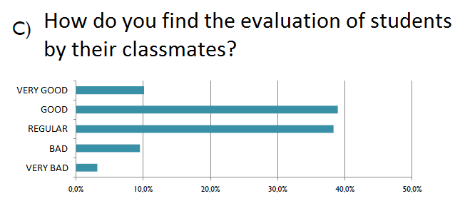
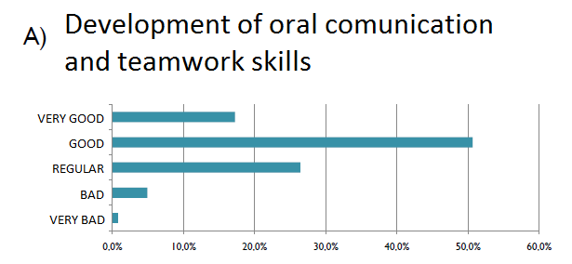
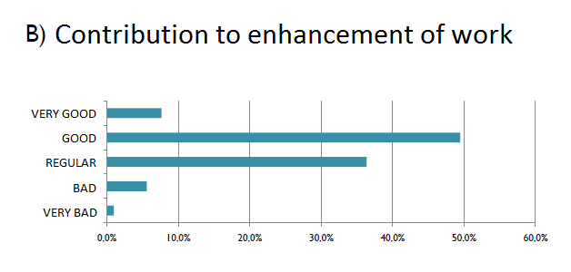
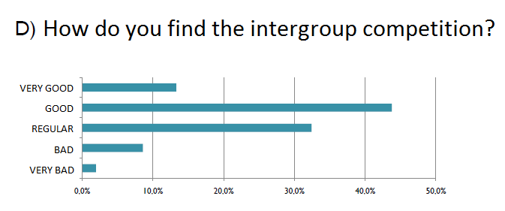
Figure 5 - Mechanisms of students’ learning evaluation

The answers given by the students relatively to the global evaluation of the discipline indicate a good appraisal, since more than 70 % of the students gave the concept good or very good for the contribution for the student formation as an engineer, and more than 60 % gave the concept good or very good in the overall evaluation of the discipline.

5. Conclusions
It is important that the rejection that some youngsters have demonstrated relatively to the engineering (Becker, 2001) could be overcome by offering in the first academic year a discipline which shows to the youngster and to his (her) family the creative, challenging and captivating work of an engineer by the development of a project that is very meaningful to the society.

According to Williams (2002), which is studying with the American leaderships the two most significant changes in the education field, the answers obtained pointed out that the most important ones are the engineering design, the emphasis in an efficient learning process, informatics, a generalist curriculum and the evaluation process.

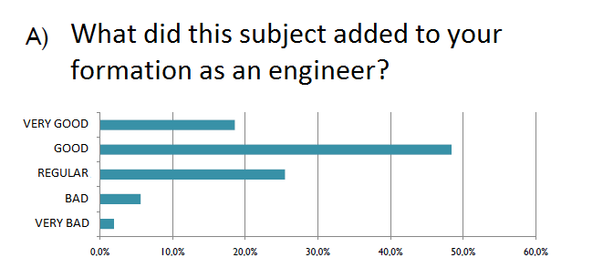
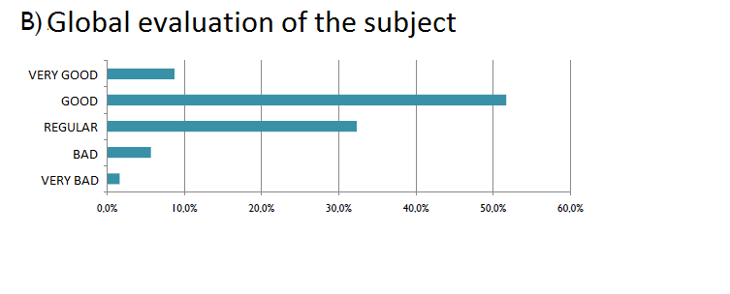

Figure 6 -The discipline as a whole

The use of questionnaires as the assessment of subjects is a tool that allows clearly from the tabulation and analysis of data collected to draw a clear profile of students' views on discipline, on the teaching practice and the actual students performance and involvement.
The paper showed what are the positives and negatives Introduction to Engineering course points, through the analysis of evaluation questionnaires implemented in several years of offering.
Introduction to Engineering is a discipline linked to training on the method of engineering design, and then it requires a greater effort and attention on students' understanding and organization of the various steps involved including research and data organization. The procedures are different in other disciplines that the student attends in the first year of the Polytechnic School of USP.
The discomfort ratings by and peers evaluation and also in the teacher evaluating the reports might be linked to the fact that this generation had their achievements celebrated very differently from previous generations that in many of the successes were only fulfilled obligations.
By analysis of the questionnaires for 2001, 2002 and 2008, concluded that the discipline has done its job and that the students recognize their value formation.

References
- BARREIRO, A. C. M., NAKAO, O. S., NASCIMENTO, O. R. Avaliando na área de ciências exatas: duas experiências. In: FELTRAN, R. C. DE S., BARREIRO, A. C. M., BARREIRO J. C. (Org.) Experiências em avaliação na universidade. Taubaté: Cabral Editora e Livraria universitária, 2003.´
- MONTEFUSCO, R. Disciplina Introdução à Engenharia: análise e avaliação. 2004. Dissertação (Mestrado) – Escola Politécnica, Universidade de São Paulo. São Paulo, 2004.
- NAKAO, O. S. BRINATI, H. L. Evaluation processes in tune with new personal and professional perpectives, ICEE 2007, Coimbra.
- WILLIAMS, J. M. The Engineering Portfolio: Communication, Reflection, and Student Learning Outcomes Assessment. International Journal of Engineering Education, v. 18, nº. 2, pp. 199- 207, 2002.
- BECKER, F. S. Why don’t young people want to become engineers? Rational reasons for disappointing decisions – European Journal of Engineering Education- vol 35, n. 4, August 2010, p. 349-366.

