Detecting Bone Tissue Changes by Textural Analysis in 3D CT Image Data

¹J. Jan, M. Malinsky, R. Peter
²P. Ourednicek
Dept. of Biomedical Eng. FEEC, Brno University of Technology, Brno, Czech Rep. jan@feec.vutbr.cz, xmalin09@stud.feec.vutbr.cz, xpeter12@stud.feec.vutbr.cz ¹
Philips Nederland, The Netherlands, petr.ourednicek@philips.com ²

Abstract
The paper describes the initial stage of a project, oriented towards support of diagnosis of tumorous diseases in bones, particularly in spine. The regular X-ray computed tomography examinations of patients provide time series of 3D image data sets, which are to be analysed. Primary task is the detection of the diseased areas based on the local density and texture. In the second phase, these areas are evaluated with respect to size and shape, and particularly the time development is followed enabling to assess the disease development during a treatment.

From the methodological point of view, after obtaining the image data with segmented individual vertebrae, the vertebra volumes are individually examined by several 2D (and potentially also 3D) texture analysis methods that have proved to be capable of detecting the tumorous bone tissue. In the second phase, the corresponding vertebrae in the consecutive data sets are 3D registered and the diseased areas compared, this way providing the information on the time development of the illness. A computer programme has been designed and implemented that enables both the described automatic analysis and the comparison with the medical expert decisions on the tissue character utilising the same image data. This allows the assessment of the efficiency of the automatic procedures that are expected to be comparable or even more sensitive and specific than the manual evaluation by even an experienced radiologist, besides saving the medical expert time substantially.

The project is a part of the dissertation work of a team of two doctoral students.

1. Introduction
The bone tissue changes are one of the signs that enable to follow quantitatively the development of some cancerous illnesses and to assess the influence of the cure. However, these changes are tiny and therefore, even when using the modern computer-tomography (CT) equipment, difficult to detect and evaluate by visual inspection, which is moreover tedious and time consuming for the medical experts. It is therefore needed to develop a computer- assisted method that, using the modern image analysis methods, would fulfill the two following requirements:
- It is necessary to discover and segment the bone areas of changed structure, both more and less dense than normal. This way, three-dimensional ill areas are detected that can be assessed quantitatively, i.e. by determination of their volume, evaluation of shape etc.
- The other task is to follow the time development of the diseased areas by comparison of data from different time instants, e.g. from CT examinations repeated after weeks or months.

The first task requires careful choice of texture analysis methods that would be sufficiently sensitive and specific to the image data characteristics particular for the diseased areas. In the first period of the project, only characteristics based on local intensity (CT density) were used; an example of the results in a vertebra 2D slice is on Fig. 1. Presently further texture based methods are added, providing more features of comparable importance to the diagnosis; these are expected, when suitably weighted and combined into feature vectors and classified by a suitable parser, to increase both the sensitivity and specificity. The results of the individual methods are appraised by the cooperating radiologist and considered rather successful; however, it is supposed that after combining the individual criteria in the described manner, the detection will be improved substantially.

A B
Fig. 1 A – 2D slice from a 3D set of CT data describing a partly diseased vertebra, B – coloured diseased higher (red) and lower (blue) density areas as detected by the density based method of segmentation

The second task is based on advanced methods of flexible (piecewise nonlinear) 3D image data registration that enable the required comparison of the analysed areas in time series of the CT examinations. This is an area, where the previous experience with demanding 3D image-registration based analysis [4], [5] has been be used.

There are several published papers dealing with the problems of spine tumour segmentation and development, e.g. [1], [2], [3].

2. Methods and results
  - Image material
The analysed image data were provided by the IRST Institute, Meldola (Italy) in frame of cooperation coordinated by the Philips Nederland. The used CT system was Brilliance iCT Philips-F0728C3 providing the 3D data of the following parameters: helical scanning (protocol COLONNA OSSO/Spine) , slice thickness 0.670, spacing between slides 0.335, rows 768, columns 786. So far, only a few data sets are available. This is why the results must still be considered initial. More consistent series of data are expected in future. The data have been segmented into individual vertebrae by the Philips Research Group in Hamburg according to [15].
As there is no database of respectively classified vertebrae CT data available, building of such a database has been started. So far, a single vertebra data consisting of 60 slices (786x786 pixels) has been classified by a medical expert using a specially designed programme that enables to colorize manually the areas considered by the expert as diseased (red – higher density, blue – lower density areas than the average tissue considered healthy). An example of 12 slices of this database is in Fig. 2.
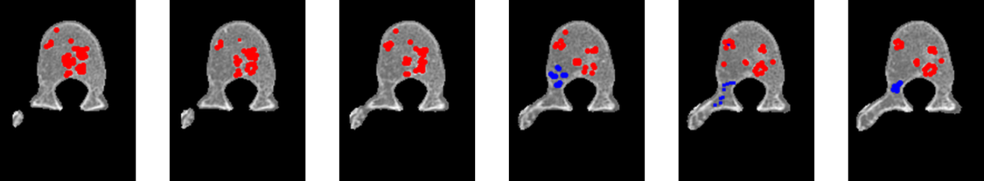
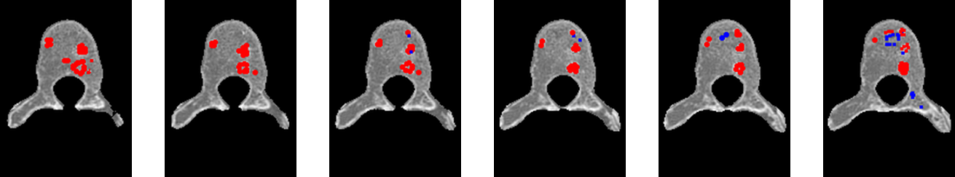
Fig. 2 Example of 12 slices from our database of vertebrae with diseased areas manually indicated by a medical expert. This database is serving as a ground-truth standard for assessing the automatic detection
It is supposed that the database wil grow in future thus becoming a reliable tool for evaluating the sensitivity and specificity of individual detection methods and their combinations. However, as the manual indication is rather difficult, uncertain with a large interpersonal variability and also time consuming, this will require a concerted effort of at least several radiologists to provide a sufficiently large and reliable classified set.
  - Methods
When manually evaluating the diseased areas, the medical experts take into account primarily the local density of the areas but also their shape (even in 3D relations) and – when available – also the time development, thus increasing the detection reliability by utilising their experience. The considered automatic methods cannot take these aspects easily into account and must so far rely only on the local properties of the image data. On the other hand, the textural analysis can reflect even tiny, barely visible features – not only the density but also the textures differring from the texture of the healthy bone tissue.

So far, three below described methods proved relevant and are used for detecting the diseased areas, while the texture analysis using the Local Binary Pattern (LBP) method did not show good results in detection and has been abandoned. The conceptually simplest successful method is the intensity-based region growing that starts from seeds determined manually or automatically using complex criteria. Both the region growing and seed finding use the sophisticated threshold determination methods based on local moments and entropy [6], [7].

The second texture analysis method is based on modelling the texture by Markov Random Fields (MRF) describing spatial interaction of neighbouring pixels, followed by consequential classification of the obtained MRF features using a Bayesian classifier [8], [9], [10]. The initial parameters of the probability distributions as needed for the classifier were determined using the maximum-entropy and moments threshold-determining approach [6], [7] for diseased areas while for the healthy tissue they were estimated and set up manually. During the learning process, these parameters are optimised with a positive effect to the classification, as visible from Fig. 3. The MRF approach seems promising.

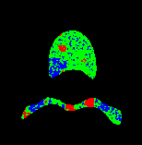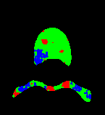
Fig. 3 Classification of diseased areas (red, blue) by the MRF method before (left) and after optimisation (right) of classifier parameters; green – healthy tissue. Only segmented vertebra volume is depicted.

The last so far used texture analysis approach was based on co-occurrence matrices (COM) as described in [11], [12], [13], consequently classified by the learning K-nearest neighbour method [14]. From the co-occurrence matrices, ten Haralick features were calculated for each matrix thus providing a set of features to be classified. Out of these features, two (variance of sums of squares and variance of differences) proved relevant, clearly indicating the areas of interest (Fig. 4).

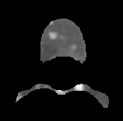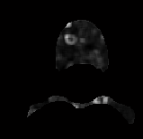
Fig. 4 Parametric maps depicting the most relevant features derived via the COM approach (left – variance of sums, right – variance of differences)
  - First results
Presently, the available results provided on 2D slices show that all three described methods provide qualitatively comparable results as the detection of the areas of interest concerns, as can be seen on example in Fig. 5.

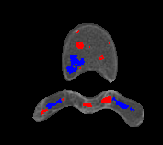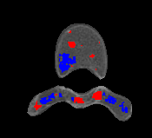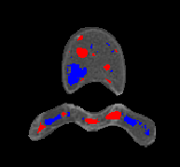
Fig. 5 Example of comparison of results of diseased areas detection by the three different methods (from left: intensity based region growing, Markov random field model based method, co-occurence matrices based method)

Besides the ill areas detection, also initial analysis of the time series of image data has been performed, providing e.g. the difference images between temporally neighbouring images, as in Fig. 6. Here, the differences among low-density areas and among high-density areas are separated in two images to enable easier diagnostic assessment. This analysis requires careful registration of the vertebra volumes from both acquisitions, should the results be reliable.

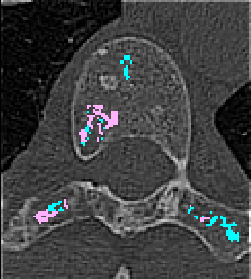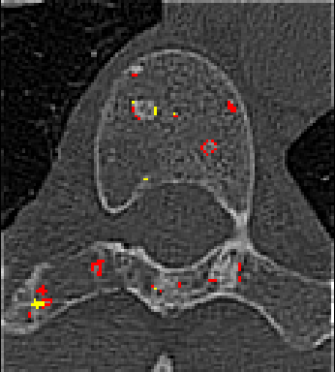
Fig. 6 Difference images between two temporally successive spatially identical slices of the same vertebra volume showing the increase (red, pink) and decrease (yellow, bluish) differences of the low-density (left) and high-density (right) lesions

4. Conclusions
A methodology under development, enabling to detect and evaluate the diseased areas in the backbone tissue, namely the lower- and higher-density areas that are also distinguished by hardly visible but digitally detectable texture differences, has been described. Three concrete methods have been shown to work satisfactorily for the detection of lesions on 2D slices of the 3D volume data. So far, only qualitative method assessment is possible due to a low amount of the available CT data. A quantitative mutual comparison of the individual approaches as well as an assessment with respect to expert medical image analysis should be based on a statistics utilising rich set of preliminarily manually evaluated images, formed of consistent time series of data acquisition that are not available yet. This is an aim for future research.

The paper summarizes the present state of the project which is still in its initial phase, though already showing the potential of the chosen approaches. The next steps will be formulating the feature vectors from the weighted available textural features and implementing a suitable artificial-intelligence based automatic classifier of the tissue character thus improving further the reliability of the diseased area detection. No less important is the second phase of the analysis that, based on precise volume registration, allows to produce reliable series of difference data describing the temporal development of the lesions. The first results in this direction have also been shown.

Acknowledgements
The project is supported by Philips Nederland, who recognizes the importance of the advanced applied research for the successful study of doctoral students. The infrastructure and technical support has been provided by the national research centre DAR (Data, Algorithms and Decission making) project no. 1M0572 and has been also partially supported by the research frame no. MS 0021630513, both sponsored by the Ministry of Education, Czech Republic. The cooperation with the IRST Institute, Meldola (Italy) who provided the CT image data is acknowledged, as well as the cooperation with the Philips Research group Hamburg, who provided the preliminary segmentation of the CT data.

References
- Yao, J., OConnor, S.D., Summers, R.M. (2007): Computer Aided Detection of Lytic Bone Metastases in the Spine using Routine CT Images, ISBI 2007. 4th IEEE Int. Symp. On Biomedical Imaging: From Nano to Macro, 2007., pp. 512-515, doi: 10.1109/ ISBI. 2007. 356901
- Hardisty, M., Gordon, L., Agarwal, P., Skrinskas, T., Whyne, C. (2007): Quantitative characterization of metastatic disease in the spine. Part I. Semiautomated segmentation using atlas-based deformable registration and the level set method. Medical Physics. Vol. 34 (2007), 7, doi:10.1118/1.2746498 (8 pp.)
- Hardisty, M., Gordon, L., Agarwal, P., Skrinskas, T., Whyne, C. (2007): Quantitative characterization of metastatic disease in the spine. Part II. Histogram based analyses. Medical Physics, Vol. 34 (2007), 8, pp. 3279-85, 2007
- OUŘEDNÍČEK, P.; JAN, J.; MALÍNSKÝ, M.; PETER, R. (2010): Piece-wise rigid registration as a way to improvement of CT angiographic image data. El. proc. ECR 2010 Vienna, 2010 (id 18271), EPOS TM, 2010, 10.1594/ecr2010/C-3057, 20pp.
- JAN, J., MALINSKY, M., PETER, R., OUREDNICEK, P. (2010).: Improved Disparity Based Image Processing in 3D CT Subtractive Angiography. Proc. 32nd Int. Conf. IEEE-EMBC, Buenos Aires 2010, CD issue, IEEE 2010, FrA04.1, ISBN 978-1-4244-4124-2
- P.K. Sahoo, S. Soltani, K.C. Wong, Y.C. Chen (1988): A Survey of Thresholding Techniques, Computer Vision, Graphics, and Image Processing, Vol. 41 (1988), pp.233-260.
- W. Tsai: Moment-preserving thresholding: a new approach (1985), Computer Vision, Graphics, and Image Processing, vol. 29 (1985), pp. 377-393.
- Berthod, M., Kato, Z., Yu,S., Zerubia, J. (1996): Bayesian image classification using Markov random fields, Image and Vision Computing, Vol. 14 (1996), no. 4, pp. 285-295
- Stolkin, R., Hodgetts, M., Greig, A., Gilby,J (2007).: Extended-Markov Random Fields for Predictive Image Segmentation, Proc. Int. Conf. on Advances in Pattern Recognition 2007, 6 pp.
- Tuceryan, M., Jain, A.K. (1993): Texture analysis. In Handbook of pattern recognition & computer vision, C. H. Chen, L. F. Pau, and P. S. P. Wang (Eds.). World Scientific Publishing Co., Inc., River Edge, NJ, USA, pp. 235-276.
- FENG, D. D.(2008): Biomedical information technology. Elsevier/Academic Press 2008, 525 pp, ISBN 0-12-373583-1
- JAN, J. (2006): Medical Image Analysis, Reconstruction and Restoration, Concepts and Methods. CRC Taylor and Francis NY 2006, pp. 607-614
- Y. Rui, T. S. Huang, and S. - F. Chang (1997): Image retrieval: Past, present, and future. Proc. Int. Symp. Multimedia Inform. , Taipei, Taiwan, 1997
- Nabney, I. T.: NETLAB (2002): Algorithms for pattern recognition. Springer NY 2002, ISBN:1-85233-440-1
- T. Klinder, J. Ostermann, M. Ehmb, A. Franz, R. Kneser, C. Lorenz (2009): Automated model-based vertebra detection, identification, and segmentation in CT images. J. Med. Im. Analysis (Elsevier), Vol.13 (2009), pp.471-482

