The ADOK Project - Automation Technology and German in an Online Course

Claudia Daems
Language Services, Tampere University of Applied Sciences, Tampere, Finland, claudia.daems@tamk.fi

Abstract
In this project called ADOK: Automatisierung und Deutsch im Online-Kurs (= Automation engineering and German in an online course) - running from 1.10.2009 till 30.9.2012 - teachers of automation work together with teachers of German as a foreign language to develop a curriculum and material for an inter-disciplinary course for automation technique, namely control systems that are programmable from memory (PLC), and German as a foreign language. This material will be available on the Moodle platform. When the project is finished every college can use this course for free. Besides these teachers, coming from the following colleges: FH Tampere-Finland (coordinating partner), HS Reutlingen-Germany, TU Ostrava-Slovakia and TH Tallinn-Estonia, three firms cooperate in this project: T;mi Eichstädt (German as a foreign language), Hinterwaelt (graphic design) and InPunkto Software (programming).

The course simulates an international project starting with an order for a steering mechanism for traffic lights and going up to its initial operation. The students are divided into international teams which act both as orderer/buyer and supplier respectively. Each team of buyers has to order a specific steering mechanism for the traffic light. In order to be able to do so the students have to acquaint themselves with the programming language called Step 7, a software package for PLC of the SIMATIC group developed by Siemens. The communication between buyer and supplier takes place in German. Today many students are not so well grounded in German. Their level of the language being no higher than A2 (European reference frame) the written communication in this project is done with the help of a computer based module. Based on the “Seven-seven-method” the students also learn to understand specialized texts in German (for instance the Siemens hornbook).

The planning phase and the development phase have already been completed. In these phases the educational objective was defined and the concept of the course was made up. Two test modules with elaborate material were made and tested with students of all colleges involved in the project. At this very moment the project group is working on the production of the other eight modules. All partner colleges will start testing the course with the new material at the beginning of 2012.

1. Introduction
This paper contains a presentation of an Erasmus project from the LLP program. It is called: ADOK - which is a shortened form for Automation Technology and German as an Online Course.
Partners from four countries – Finland, Germany, Estonia, and the Czech Republic – decided to develop an interdisciplinary curriculum for a course which is named “Automatisierung und Deutsch im Online-Kurs” after the project´s name. In fact two completely different disciplines are connected: control technology on the one hand and language learning (in this case German) on the other hand.

The project began on October 1st 2009 and will be completed on September 30th 2012. The first two work packages “Planning” and “Development” are completed already and the project group is now working on the other work packages. A first draft of the course will be completed by the end of this year which will then be tested in a pilot course. In the course the students will acquire the basics of control technology through the example of a traffic light system and apply this knowledge in an international project. For this purpose, international teams will be formed that will act as either purchaser or vendor. They will have the task of programming a variant of the traffic light system. German will be the project language. The students will therefore acquire the following skills in the foreign language: written and oral communication in German, understanding of technical texts (automation technology) and presentation of the product (traffic light system). A particular challenge is that the students will have only elementary knowledge in both areas. Therefore the project consortium must find new ways of transmitting knowledge.

In the following pages first follows a description of the reasons and the needs that lead to the start of this particular project, the targets that are envisaged and the way of working towards them. In the next paragraph is given more detailed information about this project: information about the main contents of the course and its target groups and a presentation of the different partners and a description of their respective tasks. In a third and a fourth part the learning objectives will be defined and the step by step construction of the course plan explained. This will be followed by a description of the actual course (the final product) and its use in the class room, the laboratory at different institutions and at the student’s home. This chapter finishes with a short overview of the work that has already been done, the remaining work and perspectives as to the testing and use of the final product.

2. How the project started
In the ADOK (Automatisierung und Deutsch im Online-Kurs or: Automation Technology and German as an Online Course]) project, an interdisciplinary online course is being developed in automation technology and German as a foreign language. This means that two totally different subject areas are linked in the course, one of them technical (programmable-logic control (PLC) systems) and the other a foreign language (German). The new element in this project is that the foreign language is no longer just a teaching medium but has equal status as a learning objective along with the knowledge of PLC systems.

First automation technology was chosen because it plays a relevant and strategic part in all industries. The choice of the language was motivated by the fact that today there are fewer and fewer specialists who can understand and speak German although Germany is a (for some “the”) major trading partner of countries such as Finland, Estonia and the Czech Republic. Many other countries find it interesting to do business with Europe’s leading economical power and may sometimes experience the need to speak the language better. With our course we intend to close this gap and train engineers in both programming and German. These were the main reasons for setting up this project with the financial support of the EU.

3. Description of the project
In the project we produce a curriculum and materials for an interdisciplinary course entitled “Automatisierung und Deutsch im Online-Kurs” which, as told before, combines problem-based instruction in control technology with activity-based learning of German.

Figure 1: Logo of the course

The use of computer technology enables learners to become quickly acquainted with a foreign language. For the test phase of the project, students, and possibly instructors too, will travel to a partner institution of higher education.

The target groups for this course are engineering students studying for a bachelor degree at European institutions of higher education and employees of companies in technical industries, who can use the material in continuing training. For students, the course can be used both as a technical course in combination with the learning of German or as a German course focusing on the specific language of control technology. They can use it, moreover, as a preparatory course for a period of study abroad. In this way, it also supports student mobility. After the project has been completed the course and the accompanying teaching material will be accessible on the Internet and available free of charge under www.adok-projekt.eu The course also contributes to the promotion of a European Higher Education Area.

Coordinator of the project is the Tampere University of Applied Sciences (TAMK). Two instructors – one from each field: automation technology and German as a Second Language – are participating in the project. Universities from Germany, Estonia and the Czech Republic are partners in the project: Reutlingen University (RTU), Tallinna Tehnikakõrgkool University of Applied Sciences (TTK) and Technical University of Ostrava (VSB). Each institution is represented by respectively one German instructor and one automation technology instructor. All four universities tested the material in work package 2 with their own students (September and October 2010). In order to get around the time problem (the fall semester starts at different dates at different universities), the testing of the pilot course is scheduled for the spring semester of 2012. By that time project teams with participants from all four institutions will be formed.

Our other partners are: the firm of Ulrike Eichstädt, an experienced teacher of German at the Goethe Institute Finland in Helsinki; further on a graphic designer from HINTERWAELT GRAFIKDESIGN and a programmer from In Punkto Softwareentwicklung, both from Germany.

Siemens Oy and Metso Automation Oy, both from Finland, are supporting the project as associated partners. We received, for example, permission to use authentic material as the basis for the development of instructional material.

4. Learning Objectives

4.1 Learning Objectives for Programmable Logic Controller (PLC)
The students who attend this course will acquire the basic knowledge of PLC-systems.
They will be acquainted with methods for the systematic solution of automation tasks, especially with the aid of the following description media: Block diagram, program flowchart, structogram, state diagram (task→algorithm).
They will also learn to handle the documentation and the programming of projects which include machine control. That means that after completing the course they will be able to handle the following descriptive media for PLC programs: Ladder diagram (LD), function block diagram (FBD) or function diagram (FD) with STEP 7, statement list (STL) and graphic programming (S7-HiGraph), (algorithm→program).
Moreover they will learn to design solutions for simple automation tasks by using a PLC application and develop and test simple programs with STEP 7 (develop a project, write and test a program)

4.2 Learning Objectives for German as a Foreign Language

Students with only little knowledge of German (A2) will learn to read and understand technical texts through appropriate reading strategies. They will also acquire relevant terminology and learn to write emails and to fill out forms relevant to the particular project.
They will have to produce texts with the aid of text components (set phrases) and gain the necessary communication skills and the ability to solve problems in an international environment. Finally they will acquaint themselves with communication skills to handle tasks in automation projects in German.

5. Course structure
5.1 General

The curriculum for the course consists of classroom instruction, laboratory work and online instruction using the learning platform Moodle. Special material for the Moodle course is being developed by a group of teachers. The entire course will be available at no cost to any interested group and can be downloaded from the project website: www.adok-projekt.eu after completion of the project

The course consists of an introduction and 10 modules.
The introduction is basically in the native language of the students but it is accompanied by a simple German version. Furthermore a motivating picture or graphic and a short course description (aim, range, structure) can be found here.
5.2 Modules
Module 1: Getting to know each other
Here students introduce themselves and international teams are built. All participants are acquainted with the requirements and procedures. The different project phases are presented starting with a definition of the project and a description of its implementations.

Module 2: Technical Introduction I
In this module students are introduced in PLC (hardware, equipment). They are introduced into the basic concepts of automation technology, construction assembly and the function of the automation devices (for example: SIMATIC 300). The students also master some reading strategies and learn to recognize and understand characteristic structures of the German language. They work with authentic technical texts in German.

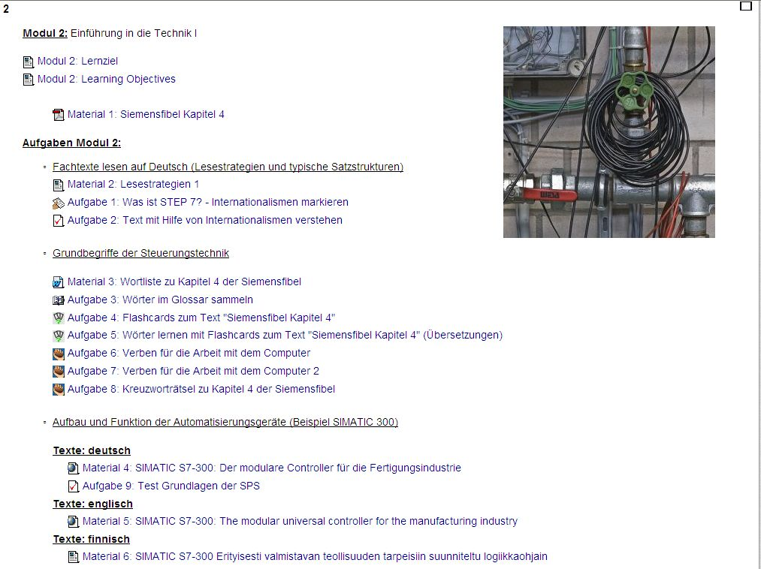

Figure 2: Module 2 of the test course

In work package 2 “Development” we developed special exercises for reading comprehension and the acquisition of a reading strategy, exercises for communication as well as active learning tasks. With students from the four universities we tested which exercises and learning activities are particularly effective and give satisfaction.

Module 3: Technical Introduction II
This module contains an introduction into Software – programming. The students read more technical texts in German (the stress lies on developing reading strategies and recognising characteristic structures). They also start making exercises in the Lab.

Module 4: Visualization of software and hardware
In this phase of the project the students are confronted with a Demo of the programming of traffic lights (step by step). Examples come from the SIMATIC-Fibel.

Module 5: Start of the project
The students get a description of their task: Program a traffic light.
Problem statement: the customer orders programming for a traffic light system. The order is in German.

Module 6: Project communication I
The students learn to place an order and actually do so. They take part in a virtual project meeting (Net meeting). The students learn to have an eye for the intercultural aspects of business life, to recognise differences and act accordingly.

Module 7: Project communication II
In this module the students have to present their solution to the customer who can ask for possible changes. Again the student will be confronted with intercultural aspects.

Module 8: End of the project
Project hand-over including testing, implementation and start up.
The students once more are confronted with the characteristic communication in this specific situation. They also have to write a protocol.

Parallel to Modules 5-8: Work in the lab = Programming: Variation of one of the demo cases

Module 9: Company visits

Module 10: Intercultural aspects and reading strategies
It includes some more information on intercultural aspects of business life and exercises on reading strategies.

6. Conclusion
A lot of work has already been done. First a test module was written and tested with the students. In the meantime the learning aims were defined and refined and an overall structure devised. Other members of the group collected authentic material and cleared copyrights. At the same time the project website was made ready by the programmer. By now the work on the five first modules has been completed and we have good hopes that the remaining modules will be ready by the end of this year. That would mean that teachers and students could start with the pilot course at the beginning of next year which will of course reveal shortcomings and mistakes. But there will be time enough to make improvements as the final date for the EU-report is September 2012. By then a teacher’s guide will also be ready.

When this project is ready it is not meant to disappear in a drawer. On the contrary, the course that results from it is going to be used in several educational institutions and is hopefully only the first of a set of similar courses. Indeed, the language must not be German, it could be any language. The programming of a traffic light is only one example of many tasks of the same kind the future engineer has to carry out. Perhaps here you found inspiration for your own project.

7. Acknowledgements
This project has been funded with support from the European Commission. This publication reflects the views only of the author, and the Commission cannot be held responsible for any use which may be made of the information contained therein.

References
1. www.adok-project.eu

- Hufeisen, Britta, Marx, Nicole (Hrsg.), EuroComGerm - Die sieben Siebe: Germanische Sprachen lesen lernen, Shaker Verlag, Aachen 2007
- Marjatta Huhta, Language and Communication for Professional Purpose - Needs Analysis Methods in Industry and Business and their Yield to Stakeholders, Dissertation, Helsinki, 18.1.2010

