Supporting and enhancing learning with a virtual learning environment: Mathematics in the Level 3 Engineering Diploma and beyond

¹S. Lee, ²R. Browne
Mathematics in Education and Industry, Trowbridge, UK, Stephen.lee@mei.org.uk¹;
Mathematics in Education and Industry, Trowbridge, UK, Richard.browne@mei.org.uk²

Abstract
A new system of Diplomas for 14-19 year olds was introduced in England for first teaching in September 2008. This included the Level 3 Engineering Diploma, which contains compulsory, and optional, mathematics components. The qualification, a blend of academic and work-orientated learning, was intended to enable students to continue their studies in Higher Education or to move into employment. Students who have studied this qualification will now be entering universities, predominantly to study Engineering.

Mathematics in Education and Industry (MEI) is a small, independent, charitable UK curriculum development body, which is committed to improving mathematics education for all. MEI has a wealth of experience in creating material to support the teaching and learning of mathematics. MEI material is predominantly located online in a Moodle based Virtual Learning Environment (VLE), which students and tutors access remotely. MEI currently has over 30,000 registered users on its site. Over 2000 schools/colleges, across England, also have free access to the site (having registered with the Further Mathematics Support Programme, a Department for Education initiative managed by MEI).

MEI has developed material to support the mathematics in the Level 3 Engineering diploma. Material includes text-based pages, interactive resources, video and multiple-choice assessments. It is clear that such content is also appropriate for many other users, including those in universities and in employment. This paper will detail the content, structure and pedagogy of the MEI resources. It will also discuss how these can be used as a tool for supporting and enhancing learning, including enhancing student engagement and the use of automated assessments. Ultimately, the project can be seen as contributing to inspiring the next generation of engineers.

1. Background
When new qualifications and courses are created there is an underlying need for provision of supporting information and materials. This is paramount to enable those tasked with the job of teaching the qualification to be adequately prepared.

This paper considers the pedagogy behind a Virtual Learning Environment (VLE), constructed by Mathematics in Education and Industry (MEI), to provide support for the teaching of a new qualification, the Level 3 Engineering Diploma. It will consider the individual aspects of the environment and discuss its transferability to higher education.
Background information about the new Diplomas and about VLEs is given, before the methodology used to create the MEI VLE is detailed. Benefits, evidence of success and issues are discussed, and reflections are made.
1.1 Diplomas
The Diploma qualifications for 14 to 19 year olds were first taught in academic year 2008/09. It is therefore worth giving a little background as this will set them in context within the UK educational system and allow them to be compared to equivalent qualifications taken outside of the UK.

The Diplomas offer a blend of classroom work and practical experience. The Foundation Diploma is equivalent to five GCSEs (The usual qualification taken by 16 year olds) at grades D – G; the Higher Diploma is equivalent to seven GCSEs at grades A* - C; and the Advanced (also known as Level 3) Diploma is equivalent to 3.5 A Levels (the most common qualification taken by 18 year olds)..

Diplomas consist of three curriculum parts:
- Principal learning, the learning related to the title of the particular diploma
- Generic learning, which consists of functional skills and a project
- Additional specialist learning (ASL), which may be chosen freely from an extensive catalogue

In the year in which Diplomas were first introduced there were five lines of learning available (Construction and the built environment, Creative and media, Engineering, IT, and Society, health and development). From September 2009 consortia of schools and colleges offered diplomas in a further five lines of learning (bringing the total to ten) and by 2011 14 lines of learning were available. Of those published to date, only the Advanced Engineering Diploma has a mathematics unit as a compulsory part of its principal learning. This unit is called ‘Mathematical Techniques and Applications for Engineers’ (MTA) and is rated at 60 guided learning hours, the same size as a single unit of an A Level that is divided into six units. It should be noted that many experts have suggested that the MTA unit is significantly larger than a single unit of A Level Mathematics.

The Advanced Diplomas include 360 guided learning hours of additional specialist learning. This is the size of an A Level. For the Advanced Engineering Diploma, a purpose-designed mathematics ASL unit has been accredited. Its title is ‘Mathematics for Engineering’ and it is rated at 180 guided learning hours, the same size as an AS Level qualification (half the size of an A Level qualification), although the unit does have a considerable amount of material, and appears to be larger than a typical AS in mathematics. Further information can be seen at: http://www.engineeringdiploma.com/

This paper details the work in constructing resources for the MTA unit and it is therefore appropriate to provide an outline of the mathematics that is in the unit. Sample schemes of work and lesson plans, by the Awarding Body OCR, can be seen at: http://www.ocr.org.uk/download/sm/ocr_36442_sm_diploma_unit_f563_sow.doc
OCR’s overview is:
This unit will be externally assessed by a two-hour written examination paper. In Section A there will be fifteen short answer questions and in Section B eight long answer questions. The learner is expected to answer all Section A questions and choose three questions from Section B.
It is intended that learners will develop knowledge and understanding of:
- Algebra
- Geometry and Trigonometry
- Calculus
- Statistics
From this knowledge and understanding of the theory will come the development of the ability to solve problems in the context of engineering. This unit has not only been written to ensure success in the Diploma in Engineering but as preparation for the exciting world of engineering which lies ahead of the learner.

It is clear that these mathematical topics are fundamental ones for many courses, so the support provided for this unit has a high potential for transferability to other courses.
1.2 Virtual Learning Environments
In the last decade there has been a tremendous development in technology. One such advance is that of the VLE, which, although having been in existence for much longer, has, in this period, become more widely used. Schools/colleges, universities and industrial companies alike have all found VLEs met some of their particular needs.

In 2003 Becta led the way in considering VLEs in the school environment (see: http://partners.becta.org.uk/index.php?section=rh&rid=13640). For higher education, Sharpe et al (2006), in their publication The undergraduate experience of blended e-learning: a review of UK literature and practice, detailed the expansion of VLEs “The uptake of VLEs by HEIs has been undertaken in a short period from 7% of HEIs in 1997, 81% in 2001, 86% in 2003 and 95% in 2005.”

In the specific area of interest, i.e. mathematics for engineers, a seminal paper was presented by Hibberd et al (2005), which explained:

“Mathematical Electronic Learning Environment in Engineering and Science (MELEES) is a web-based Environment developed to support students from Schools outside of Mathematical Sciences who take mathematics modules as one part of their course. The provision is based on a Virtual Learning Environment (VLE) supplied by WebCT which can be readily configured to individual student cohorts and incorporates a number of tools to manage and display teaching and learning materials, interactive elements such as tests (quizzes) and tracking of student usage. It also has significant capabilities to provide communication with students.”

Another important aspect of the context that we now briefly consider is the importance of mathematics for students at the transition to university engineering courses.
1.3 Mathematical preparedness of students embarking on undergraduate engineering courses
There has been a large amount of literature on this subject in recent years. Hicks (2007) at a conference on ‘Attracting the best students of mathematics into engineering’ stated that “The mathematical preparation of students entering university to read engineering is increasingly critical.” This reflects over a decade of reports on the lack of preparedness in mathematics of students going on to study engineering degrees, see for example Measuring the mathematics problem, Hawkes and Savage (2000), Mathematics in the university education of engineers, Kent and Noss (2003), Newton’s Mechanics: Who needs it?, Savage and Stripp (2008).

In the UK there is currently a concerted effort to manage this situation via the establishment of a national STEM Centre (http://www.nationalstemcentre.org.uk/) and a national Higher Education STEM Programme (http://www.hestem.ac.uk).

2. Methodology
In this section the specific detail of the MEI VLE, for the MTA unit will be given. This will focus on the construction rather than the exact mathematical materials contained therein.

From the initial login page all users are required to sign into the VLE using an individual username and password. They then find themselves on their ‘homepage’, which lists the units that they have has access to along with some other general functional items, which includes: Latest news bulletin, a calendar, upcoming events and messages. A drop-down menu bar along the top of the site provides links to profile settings, help menus and error reporting facilities.

Figure 1: Unit level view in VLE.
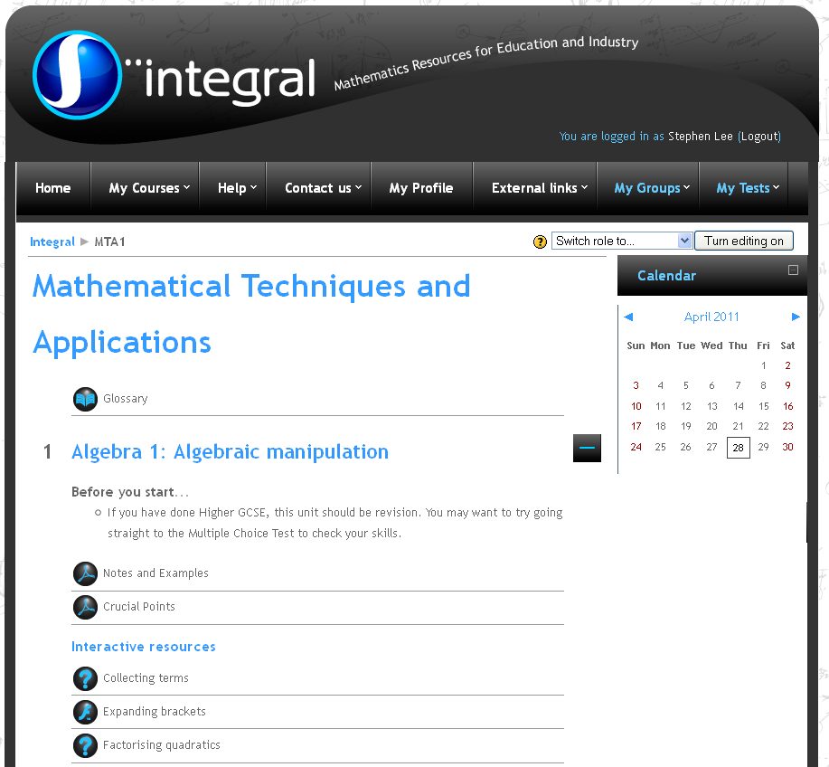

When a user selects a unit they then can access the specific material. Figure 1 shows this initial view of a unit (figure 1 is of the actual MTA unit). Again, the general items can be seen to include the calendar, but now the top menu bar has two additional items, a link to the ‘groups’ that the user is in, and also to their ‘tests’.

These options available to the individual user can be changed on a class by class or global site basis. There are more options which can be enabled, such as blogs and forums.

With respect to the construction of the materials – within the MTA unit there are 18 sections, each of which has a common format. This includes:
- ‘Before you start’ text
- Notes and examples document
- Crucial points document
- Interactive/active learning/other resources (where appropriate)
- Section test
- Topic assessment (one per topic, which may be made up of 1, 2, 3 or more sections)
- ‘Now you have finished’ text

Figure 2 shows this in practice with a screenshot of one of the sections from the MTA course (Note that each of the resources sections below contains more that two links but they have been truncated in the image, the better to indicate the construction of an individual section.).

Figure 2: Types of resources available in each section.
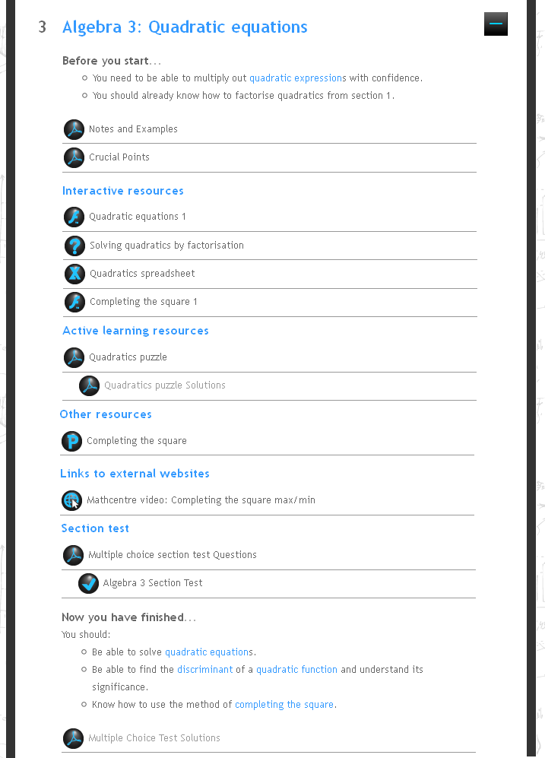

Note that the light blue text (e.g. ‘quadratic equation’ in the first bullet point) is for expressions which are linked to the glossary, i.e. clicking on these brings up a new internet browser tab/window for the user which has in it the glossary definition. Also the lighter (grey) text (e.g. ‘Quadratic puzzle solutions’ under ‘Active learning resources’) links are only available to tutors and/or students who have been given additional permissions as they include solutions.

The small icons next to each resource give indication of its type. Within the VLE there are many different types, which include: PDFs, Word documents, PowerPoints, Spreadsheets, Flash files, Geogebra files, JavaScript interactive questions, videos and hyperlinks to external resources (as appropriate). This multiple representation, as detailed by Crisan (2004), is one of the main ways in which ICT can be used to aid students’ understanding.

A further important feature is that the VLE provides a powerful management tool, which allows both student tracking facilities and the ability to edit individual aspects. Students can also see how they perform in tests, on a question by question basis (on section tests).

At the time of this paper, you will be able to view a sample of the online resources, by navigating to integralmaths.org and using: username – mei-fp1guest, password – Guest.

3. Benefits, Evidence of Success and Issues
The MTA course is just one of over 100 different courses that are in the MEI VLE, many of which are of a near identical construction to the MTA course. It therefore seems sensible to discuss the performance of the VLE in the wider context of the collection of courses available.
3.1 Benefits and Evidence of Success
Firstly, our development of the VLE is very much aligned to Stiles (2000), who stated:

This view leads to an approach to course design which is output driven and focuses on the learning process and the effect it has on the learner, rather than an input led view which focuses on a body of content and its absorption by the learner. This approach can be summarised as:
- Identify Learning Outcomes
- Design Learning Opportunities - What can a learner do which will demonstrate that one or more Learning Outcomes have been met?
- Apply Deconstruction
- Consider Group or Individual Learning
- Identify or Create Resources - Theory, External Resources, Hints and Internal Resources

It is easy to see, when comparing the above list with the details in Figures 1 and 2, where this alignment lies. That is to clearly give indication of what should be known, what is to be learnt and a way in which this can be done, i.e. via resources and mechanisms like messaging and being part of a group, and a way to assess this (here in real time and which can be automatically marked).

It is clear, from feedback received (see Button et al (2008)) that even the basic elements, i.e. Notes and examples and crucial points PDFs, are valued by students and teachers alike as they offer something over and above what is available from a textbook, which is the usual method of supporting their learning and teaching. Furthermore, there is clear support for, and interest in, the various interactive/active learning resources found in the VLE. As Hoyles (2008) commented “ICT has the potential to offer visual, dynamic connectivity with real-time interactions” and this is evident through such resources.

Also in Button et al (2008), feedback from a survey of students and teachers on the MEI VLE showed that 82% of students and 90% of teachers indicated that the multiple choice tests/chapter assessments were good or excellent. These formative assessments form a key part of the learner experience. A further key point, established through the same feedback evaluation, was that virtually all students and teachers (92% and 95% respectively) cited it as being important or very important that the resources were tailored to the units that they are learning/teaching in order for them to be encouraged to use the resources. This makes it clear that, at this level, generic resources are not as effective in encouraging users to engage with them as are tailored resources.

Such a point is supported by Golden et al (2006, 2007). In these papers it is explained how MEI resources were revised and modified to be aligned with an undergraduate mathematics engineering module, though they continued to be located within the MEI VLE. This support was valued due to its alignment to the university course:

We have used the expertise that MEI has gained through developing web-based resources for the Further Mathematics Network, to provide access to web-based resources to our engineering students in a form that they immediately recognise as being related to the material they encountered in class. It is eminently sensible, and often beneficial in terms of both time and preparation costs, to build upon material and projects that have already been created and ‘evaluated’. Thus, tailoring material, from the vast array that are contained within MEI’s resources, was an appropriate solution for UWE.

Thus the MEI environment has been shown to be successful when used in an undergraduate engineering situation, in addition to in pre-university settings.

There are further more general uses for having material available in a VLE. For instance, Lissaman et al (2009) details how the MEI VLE can be used as a support tool for students who are being tutored remotely, via online software; similarly, de Pomerai et al (2009) details how the MEI VLE can be used as a support tool for teachers who are receiving Continued Professional Development remotely, via online software. This is consistent with the findings of Bullen and Russell (2008) who set out, in their Online Seminar Series: Using Virtual Learning Environments in Engineering, how recordings of live tutoring and problem classes can later be usefully added to a VLE as a revision and learning aid.
3.2 Issues
As with any project like this there are inherent issues. Initially creating the material and constructing the environment incur both time and financial costs. However, the structure of its materials can be carefully managed to enable them to be of greater benefit than the initial use, i.e. for possible multipurpose use and transferability to other courses/areas.

Training to enable users to engage with emerging technology is an issue that needs to be carefully managed. Rossiter and Rossiter (2006) in their publication The Use of Web Based Delivery for First year Engineers note that “Students, in all years, (and staff) are often unfamiliar with VLEs and need continued reminders and guidance to log on and get started.”

As with other projects of this type, a mechanism for ongoing support needs to be in place to both maintain and develop the VLE. Regular contact is made by users who are seeking help and clarification over various points, i.e. logins or reviewing test scores etc.

4. Reflections
VLE’s can, and do work, not least because there is a demand for the materials, resources and functionality which can be built into them. However, there is plenty of scope and opportunity to build an ineffective and ill used VLE. As stated by Stilles (2000) “…their successful deployment depends first and foremost on addressing the pedagogic issues associated with effective learning and ultimately on the overall quality of course design and learner support.”

With respect to the MEI VLE, following their evaluation, Button et al (2008) summarised:
- The environment encourages good practice in teaching and learning and supports teachers in reinforcing their own knowledge of mathematics.
- Many teachers who use the environment make greater use of ICT-based resources and active learning resources in their teaching.
- The environment encourages students to develop their study-skills resulting in them becoming better independent learners.

All of these are valuable because the MTA course is one for students who are studying a pre-university level course, encouraging development of their study skills to help them become better independent learners is extremely beneficial for future studies and work. Such skills are exactly the ones that need to be developed further once on a university course and any opportunity to build up these skills prior to starting such courses should be taken.

References
1. P. Bullen & M. Russell, “Using Virtual Learning Environments (VLEs) to support Teaching, Learning and Assessment across a variety of teaching modes. Online Seminar Series: Using Virtual Learning Environments in Engineering,” 2008, Available from: http://www.engsc.ac.uk/nef/events/onlineseries/vleseminar.asp [accessed 2 May 2011].
2. T. Button, S. Lee, & C. Stripp, “A comprehensive web-based learning environment for upper-secondary level mathematics students: promoting good-practice for teachers and encouraging students to become independent learners,” Proceedings of 11th International Congress on Mathematics Education, ICME-11, Monterrey, Mexico, 2008.
3. C. Crisan, “Mathematics teachers’ learning about and incorporation of ICT into classroom practices,” Proceedings of the British Society for Research into Learning Mathematics, 2004, 24 (2), pp. 15-20.
4. S. De Pomerai, & S. Tripconey, “Live, online professional development for teachers of Mathematics,” Proceedings of the 9th International Conference on Technology in Mathematics Teaching, ICTME-9, 6-9, Metz, France, 2009.
5. K. Golden, C. Stripp, & S. Lee, “Encouraging student use of feedback, reflection and engagement through web-based learning support,“ MSOR Connections, Vol 7, No. 2, 2007, pp. 7-10.
6. K. Golden, & C. Stripp, “Blending on-line and traditional classroom-based teaching,” Proceedings of the 5th Mathematical Education of Engineers, Loughborough, England, 2006.
7. T. Hawkes, & M.D. Savage, (eds.) “Measuring the Mathematics Problem,” Engineering Council, UK, 2000. Available from: http://www.engc.org.uk/ecukdocuments/internet/document%20library/Measuring%20the%20Mathematic%20Problems.pdf [accessed 2 May 2011].
8. S. Hibberd, C. Litton, & C. Chambers, “MELEES – reflective overview on use of a VLE in supporting student learning,” HELM Conference, Loughborough, England, 2005.
9. P. Hicks, “The importance of Mathematics to Engineering Degrees,” In MEI and IET Attracting the best students of mathematics into engineering. MEI/IET Joint Conference, London, England, 2007. ISBN 9780948186-20-2
11. C. Hoyles, “My perception of the mathematical needs of the country: the potential and challenge of using ICT,” Computer Algebra Systems in the Mathematics Curriculum, London, England, 2008.
12. P. Kent, & R. Noss, “Mathematics in the University Education of Engineers,” The Ove Arup Foundation, London, UK, 2003.
13. R. Lissaman, S. de Pomerai, & S. Tripconey, “Using live, online tutoring to inspire post 16 students to engage with higher level mathematics,” Teaching Mathematics and its Applications, 28 (4), 216-221, 2009.
14. M. J. Stiles, “Developing Tacit and Codified Knowledge and Subject Culture within a Virtual Learning Environment,” IJEEE, 37(1), 13-25, 2009.
15. J.A. Rossiter, & D. Rossiter, “The Use of Web Based Delivery for First year Engineers,” 2006. Available from: http://www.engsc.ac.uk/downloads/awards/web_delivery.pdf [accessed 2 May 2011].
16. M.D. Savage, & C. Stripp, “Newton's Mechanics: Who Needs it?” 2009. ISBN 978-0-9555914-4-0. Available from: http://mathstore.ac.uk/repository/NewtonMechReportFinal.pdf [accessed 2 May 2011].
17. R. Sharpe, G. Benfield, G. Roberts, & R. Francis, “The undergraduate experience of blended e-learning: a review of UK literature and practice,” The Higher Education Academy Report, 2006. Available from http://www.heacademy.ac.uk/assets/York/documents/ourwork/research/literature_reviews/blended_elearning_full_review.pdf [accessed 2 May 2011].

