Distance Education Today

Lucy C. Morse
University of Central Florida
Orlando, FL 32816 USA
morse@mail.ucf.edu

ABSTRACT

Distance education is not a new concept. In the late 1800s, at the University of Chicago, the first major correspondence program in the United States was established in which the teacher and learner were at different locations. As radio developed during the First World War and television in the 1950s, instruction outside of the traditional classroom had suddenly found new delivery systems. Today distance education has grown as a major delivery forum and there are many definitions of distance education as well as methods of delivery. Course delivery modalities vary from campus to campus and within the various colleges on the same campus. Students and faculty continue to get confused in speaking of and using distance education. This paper examines what each modality entails and how they are used at the University of Central Florida, which has been a leader in the use of distance education or as they call it - Distributed Learning.

1. Introduction

In 1982, the International Council for Correspondence Education changed its name to the International Council for Distance Education to reflect the developments in the field. With the rapid growth of new technologies and the evolution of systems for delivering and managing information, distance education with its ideals of providing equality of access to education, became a reality.

Initially in the United States engineering graduate programs were at the forefront of offering courses at a distance that were video based. These programs began in the mid 1960’s with the Genesis Program in Florida, which was initially designed for engineers at the Space Coast, and was phased out in the 1970’s due to lack of funding. The Florida Engineering Education Delivery System (FEEDS) was established by the Florida Legislature in 1982, to deliver engineering education, primarily at the Masters level, to engineers throughout the state at their place of work. Originally courses originated in the colleges of engineering of the state university system accredited degree programs. FEEDS, operating as a technology based delivery system, was then a product of the cooperative efforts of the State University System, private universities, and private sector industries located within the State of Florida In the 2003-2004 academic year 570 courses were offered at the graduate and undergraduate level.

The National Technological University (NTU) was founded through the sponsorship of IBM, Motorola, Hewlett-Packard, and Lockheed Martin at about the same time. Direct satellite broadcasts were produced by more than 20 of the country's major universities provided at one time over 500 courses in engineering delivered live by satellite. NTU is now operated by Walden University and is not very active.

Online education refers to instruction in a learning environment where teacher and student are separated by time or space, or both, and the teacher provides course content through the use of methods such as course management applications, multimedia resources, the Internet, and videoconferencing. Students receive the content and communicate with the teacher via the same technologies

1.1 Distance Learning Project

This paper examines the lessons learned from a distance learning project in the 1990’s and how it laid the foundation for distance learning at the University of Central Florida (UCF). Technological advances continue to be based on the initial infrastructure developed with the Distance Learning Demonstration Project. In the late 1990’s the state of Florida realized that the upcoming college-age population and the non-traditional adult learner were exceeding the limits of the bricks and mortar buildings of the state university system and offered grants to universities to explore distance learning. To address this increase in students, both traditional and nontraditional, within the state of Florida, Florida began to explore the use of distance learning technology. As a part of this process, the Florida State University System funded five demonstration projects in 1995 to explore the options of distance learning within the state. The proposal for the UCF Distance Learning Demonstration Project (DLDP) was funded in February 1995.

The three basic components of the infrastructure included: instructional resources for educational technology delivery that were designed as a paradigm change agent, faculty training, and plans for a learner support system. Although much is changed in the past 15 years and distance education has achieved more acceptances, the teaching and learning strategies for an institution or a department within an institution remain the same. Technological advances continue to open opportunities.
Of the three basic components in the Demonstration Project the most used was a 13 part video series, Beyond Chalk: Teaching with Technology, which was used as a change agent for faculty. Today with the current trends in technology and the existence of so many distance education programs, a change agent is not as important, however, on a search of the web many institutions are still using the original video series.

Reach Out and Teach: Designing Distance Education, an eight part video series and resource manual, is the next step in faculty development. This is an introduction to designing online courses and is written to help educators and trainers understand and apply the fundamentals of distance education and instructional design. Both of these series were originally licensed and distributed nationally by the Public Broadcasting System (PBS) and now are available free on the web (http://www.beyond chalk.cecs.ucf.edu).

2. University of Central Florida

The University of Central Florida is the second-largest university in the United States as stated on their website and is located in Orlando, Florida. It offers 216 degree programs and it has become an academic and research leader in numerous fields, such as optics, modeling and simulation, engineering and computer science, business administration, education, science, hospitality management and digital media. UCF has 12 colleges, including the newly established College of Medicine. More than 56,000 students attend classes on UCF's main campus and its 10 regional campuses located throughout Central Florida.

Currently UCF’s online course management tool, Webcourses@UCF is based on Blackboard. Today the course delivery modalities used at UCF are:
- Web classes – courses conducted via web-based instruction and collaboration.
- Video Streaming – courses delivered over the web via streaming digital video which may be supplemented by additional Web activity.
- Mixed Mode/Reduced Seat Time – classroom-based content is available over the web via streaming video and classroom attendance is not required.
- Face to Face/Video streaming Origination – face-to-face class meetings are recorded for subsequent video streaming over the Web.
- Face To Face Instruction – courses have required classroom attendance and meet on a regularly scheduled basis.
In the past interactive classes were available, but were canceled in June 2009 due to student disinterest.

Table 1 shows the enrollment in the entire university for three distance modalities. Summer semesters are always lower enrollment. Enrollment numbers are not the numbers of students, but of people enrolled in the classes as given by Online@UCF.

Table 1: Shows the enrollment and the number of sections in total classes in these three modalities for recent semesters.

Enrollment |  |  | Fall 09 | Spr 10 | Sum 10 | Fall 10 | Spr 11
Reduced seat time |  |  | 9503 | 10435 | 5315 | 12508 | 13259
Video stream |  |  | 2297 | 3026 | 1585 | 2445 | 2547
Web class |  |  | 23389 | 25005 | 20638 | 28030 | 30593
 |  |  | 1370 | 1380 | 1390 | 1400 | 1410
Sections |  |  | Fall 09 | Spr 10 | Sum 10 | Fall 10 | Spr 11
Reduced seat time |  |  | 291 | 311 | 150 | 353 | 365
Video  Stream |  |  | 661 | 744 | 139 | 692 | 666
Web class |  |  | 494 | 543 | 449 | 613 | 619

In 2005 EDUCAUSE, a nonprofit group that promotes the use of information technology to advance higher education, honored UCF with a Teaching and Learning Award for its Online@UCF program. In 2008 UCF received one of the Sloan Consortium’s Inaugural Gomory Awards for Quality Online Education. UCF received this award for an institution that demonstrates continuous improvement of the quality of online learning, as measured by access, learning effectiveness, cost effectiveness, student satisfaction and faculty satisfaction.
2.1 College of Engineering and Computer Science
The College of Engineering and Computer Science is one of the 12 colleges at UCF and had 5674 undergraduate students and 1309 graduate students in Fall 2010. There are four departments and they offer 10 undergraduate degrees and 11Masters and nine PhD degrees. The Center for Online and Virtual Education (formerly Florida Engineering Education Delivery System) is the delivery system which was established to provide students with the most convenient and timely engineering education possible.

Distance education, as defined within engineering, consists of video and written material. Over the past 25 years the model for delivering lectures at a distance has remained essentially the same within engineering. Instructors utilized specialized classrooms equipped with video cameras and other recording equipment to create a video documentation of the face-to-face classroom experience. However, as technology changed in the last few decades the recording medium and delivery methods have also changed. Initially, lectures were recorded and stored on VHS tapes. These were then hand delivered across the state. This early solution worked well and offered higher than television broadcast resolution at the time (640 x 480 pixel resolution). Lectures were available at branch campuses within a few days of the lecture recording. In the late 90’s, the Internet and the use of the World-Wide-Web (WWW) was widely accepted as a means of accessing information including college lectures. In the late, 90’s the medium for lecture distribution was changed from VHS tape to the Internet using digitally encoded videos. These videos were accessed from a common college website and were available to all students without authentication.

In 2006, the College of Engineering and Computer Science made a significant technology upgrade of the existing recording hardware and software used for recording lectures. This change was possible because the speed of computers for certain applications, such as video recording, began to surpass that of expensive hardware. The out-dated video recording hardware was removed and a software based lecture recording solution was purchased and implemented. Tegrity is the recording and distribution software used to deliver lectures online. It requires no hardware or software installation, and fully integrated with the institution’s data-set. Tegrity makes class time available all the time by automatically capturing, storing and indexing every class on campus for replay by every student. Educators know that the more students can see, hear, and experience a class, the better they learn. With patented Tegrity “search anything” technology, students instantly recall key class moments for replay online, or on iPods and mobile devices.

The current recording hardware and streaming video delivery is pictured in Fig. 1. The medium for delivery of the new system still utilizes the Internet but the quality of the content is greatly enhanced. Resolution is now limited only by the instructor’s choice of computer desktop resolution and can be high-definition (1920 x 1080) if required.

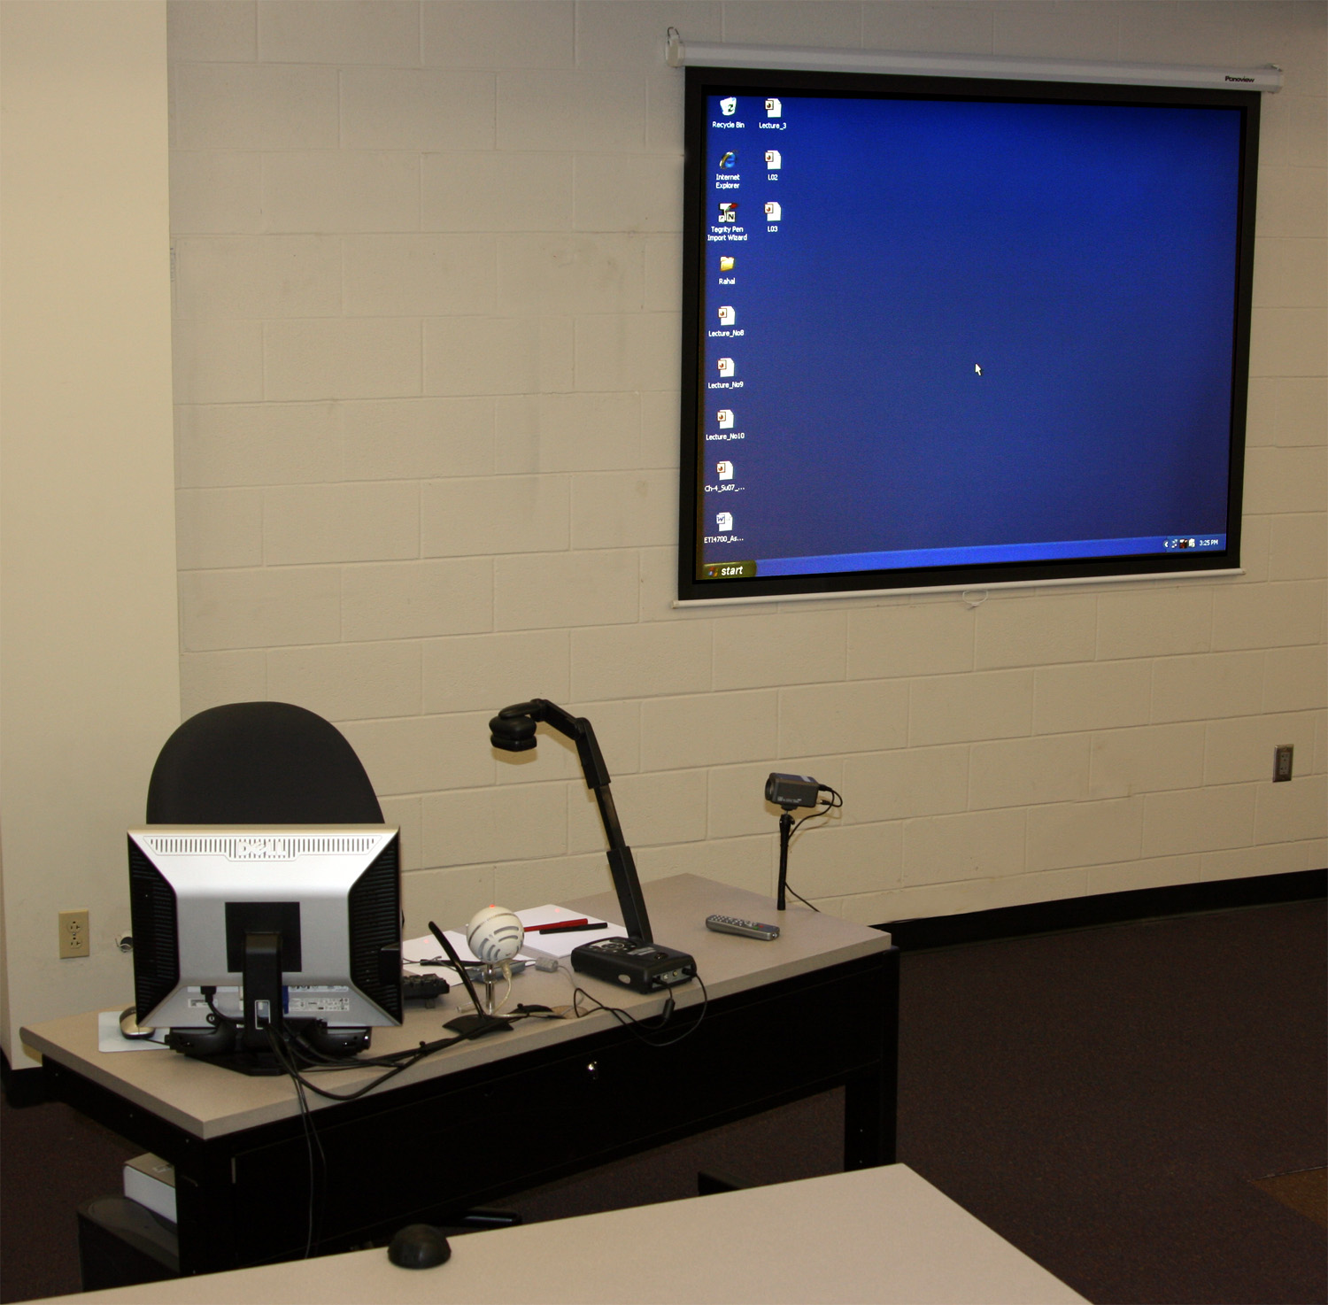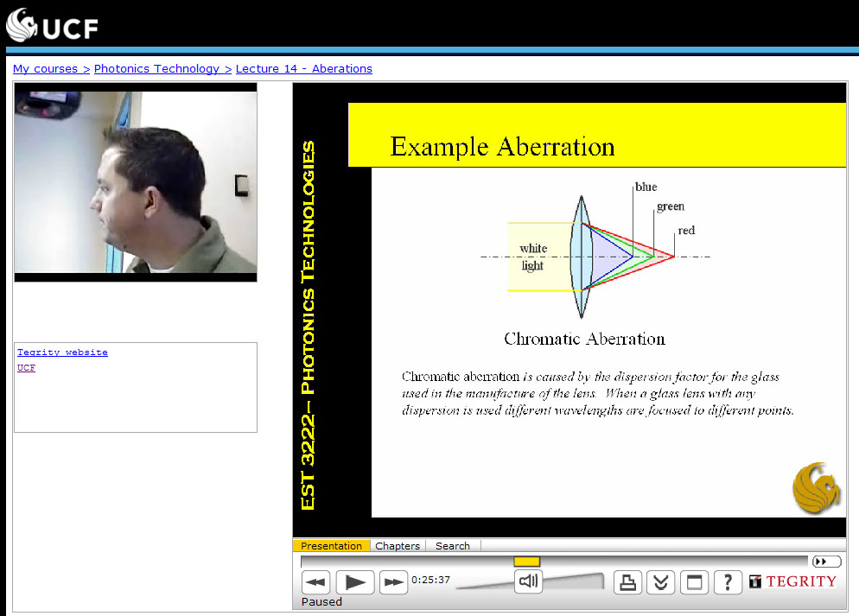

Fig. 1. Current recording hardware and streaming video delivery

Although the medium for lecture video delivery has changed it is important to note that the essential elements of instruction have not. Instructors lecture using digital white boards or document cameras. This information is captured as it is presented on the instructor’s computer. However, the use of digital slides or Power Point® slides has increased in the last decade.

Historically, engineering instructors prefer to use handwritten material generated as the lecture unfolds. Many see this as a fundamental method of teaching engineering related problems such as formulaic derivations. However, in the past few years handwritten lecturing has been replaced by slides completely in 45% of the UCF engineering courses.

With the advances in recording software many new tools are available for students and instructors. The new recording software creates an enhanced video recording of the classroom experience. Along with the video of the instructor and the instructional material displayed on their computer, additional information is recorded. All typed text is automatically captured from the computer and used to generate a searchable database. This allows students to locate vital information in any lecture using a search tool inherent in the video viewing application.

Instructors also have new available sign-ons to the new software system. The most important of these is the ability to generate viewing reports. This provides feedback on which students have watched the recorded lectures, for how long, and how many times. This can be used to access the clarity of particular lectures and allow instructors to gain valuable feedback for future lectures. The entire university included Tegrity as one of their modalities in Fall 2010.

Engineering online courses and enrollments are shown in Table 2. Data collection is not as extensive in engineering due to limited resources.

Table 2: College of Engineering and Computer Science course offerings and enrollments

 | Summer 09 | Fall 09 | Spring 2010
Graduate courses offered | 8 | 71 | 75
Graduate student enrollment | 292 | 1407 | 1494
Undergraduate courses offered | 10 | 29 | 25
Undergraduate student enrollment | 625 | 1267 | 1198

In 2008, 2009, 2010 the College of Engineering and Computer Science at UCF received the Tegrity Student Achievement Award for their use of Tegrity.

3. Evaluation

An evaluation of web and Web-enhanced courses has been ongoing at UCF since the inception of the Distributed Learning Initiative in fall 1996. These evaluations by the Center of Distance Learning typically do not include the engineering courses, students, or faculty. Based on anecdotal evidence and some surveys, the engineering evaluations would be similar. Below are some of the findings.

- Roughly half of students who take fully online courses are working full-time.
- The majority of students (79%) take fully online courses because of the convenience of not coming to campus.
- The majority of students in fully online courses report that they are satisfied with their experience (85%),
- Faculty overwhelmingly indicate that a course with Web components requires more time in both development and in weekly administrative duties than a similar course delivered face-to-face.
- Positive aspects of Web teaching cited by faculty include structure and time convenience, increased student outreach and contact, personal satisfaction, availability of expanded research tools, improved course management, and the ability to learn new technologies.

4. Opportunities for improvement

The UCF online program, called distributed learning, and the engineering distance program need to work more collaboratively. More evaluations need to be made of engineering students and their faculty. Also a method to collect statistics that enables engineering data to be extracted needs to be developed. Testing continues to be a problem, not only the method, but also the length of time the online exams are offered. These problems/opportunities are happening in this one institution (UCF), which receives many awards for their distance program. If they are happening there, they must be elsewhere and will need to be addressed.

Even though engineering was at the forefront at what we know as distance education today, many professors have just adopted the same techniques used in face-to-face classes for their distance presentations. Although no ideal model of distance education exists, several models are innovative for very different reasons. Some researchers and practitioners feel that to be successful, distance education must replicate face to face classroom interaction. Others assert that learner characteristics diminish the need for real-time interaction. In delivering any course the faculty member is the key for the content presentation. Communication, interactivity with students, and removing obstacles to the student’s learning may be the responsibility of the faculty member or of the delivery system, which is the pipeline for presenting the instruction, and good instruction can be designed for any delivery system.

5. Acknowledgements

Special thanks to Naomi Morris and Al Ducharme of the College of Engineering and Computer Science and Bob Reed of the Center of Distributed Learning at UCF for finding and sharing the statistics of enrollments with me.

References

1.Beyond Chalk: Teaching with Technology. Lucy C. Morse,Co-Executive Producer, 1997. Thirteen copyrights for videos. Distributed by national Public Broadcasting System. 1998-2003.

2.Morse, Lucy C., Editor. Beyond Chalk: Teaching with Technology - A Resource Manual, 1997.

3.Morse, Lucy C. et al. Reach Out and Teach: Designing Distance Education, An Introductory Manual, 1998. Distributed by national Public Broadcasting System. 1998-2001.

4.Reach Out and Teach: Designing Distance Education. Lucy C. Morse, Executive Producer, 1998. Eight copyrights for videos.

5.Websites: http://cdl.ucf.edu/research/rite/dl-impact-evaluation/, April 2011
http://today.ucf.edu/about/, April 2011.
http://cdl.ucf.edu/, May 2011.

