Nanotechnology Education with Remote Control Scanning Electron Microscope in Taiwan

¹H.Y. Tsai, ²J.J. Kai, ³J.T. Yang, ⁴Z.Y. Wu, ⁵M.K. Yeh
Department of Power Mechanical Engineering, Hsinchu, Taiwan, E-mail¹: hytsai@pme.nthu.edu.tw;
Department of Engineering and System Science, Hsinchu, Taiwan, E-mail²: jjkai@ess.nthu.edu.tw;
Department of Mechanical Engineering, Taipei, Taiwan, E-mail³: jtyang@ntu.edu.tw;
Department of Engineering and System Science, Hsinchu City, Taiwan, E-mail⁴: d937120@oz.nthu.edu.tw;
Department of Power Mechanical Engineering, Hsinchu City, Taiwan, E-mail⁵: mkyeh@pme.nthu.edu.tw;

Abstract
In order to establish the remote control Scanning Electron Microscope (SEM), the experimental equipment of the hardware and software has been set up at Department of Engineering and System Science in National Tsing Hua University (NTHU) in Taiwan. In this study, distance instructions for high school students have been implemented in Hsinchu, Taiwan. SEM image database in the website of K-12 human resource of nanotechnology supported by the Ministry of Education and the National Science Council in Taiwan has more than 150 samples, including different kinds of materials and biology samples. Students can learn by the Internet, and they can understand the changes and difference from macroscopic view to microscopic one. Cooperating with Department of Power Mechanical Engineering in NTHU, six “AFM/ SEM practical training course” workshops for teachers have been hosted, and participants are over 100. Seed teachers in Taiwan are invited to attend the operating training course; undergraduates and graduates also have been incubated to take SEM pictures of some samples for observing the nano properties.

1. Introduction
1.1 Background
Nanotechnology is one of the emerging technologies in the last decade. While the nanotechnology related industries have been developed, training the technicians to have high skills is an important issue.^{1,2} In order to train the related human resource for the nanotechnology, the Ministry of Education in Taiwan had provided a six-year (2003-2008) program which supported scientists and schools to develop some educational activities and teaching materials for nanotechnology education. This program named “Nanotechnology human resource development program”. In this program, the trained objects had been divided into two groups; one is K-12 teachers and students, and the other is university students. The purpose of this program is for continuously educating and training teachers.³ After the successful achievement of the six-year program, the National Science Council created social science researches on nanotechnology education in 2009.

Because of the extremely minute size of the nanotechnology materials or elements which could not be observed by the general optical microscope, it is necessary to use the advanced analysis equipment, such as the scanning electron microscope. Department of Engineering and System Science (ESS) in National Tsing Hua University (NTHU) in Taiwan has participated the Nanotechnology human resource development program constructively. ESS has supported K-12 teacher education and teaching K-12 students by using professional academic ability and technique in this significant program in the past few years.

Teachers have built up the basic abilities and concepts, and they are capable to teach the relative knowledge and concepts of nanotechnology for students in classes after the efforts in theses few years. However, each student still cannot have opportunities to operate expensive machines and experience practically. The learning achievement for K-12 students is not enough. The main reason is that schools do not provide the appropriate equipment for students to practice. If every school had set up the electron microscope equipment, not only the cost is expensive, but also there is not enough professional human resource to operate and repair the equipment. We hope that K-12 students can observe the magnified images of interesting samples and operate the scanning electron microscope themselves by the Internet. Therefore, we have built the central laboratory, e-learning instructional materials, and the wideband internet system. K-12 students can deeply understand the nanotechnology related materials and devices, and they are inspired to the learning courses, so that the learning achievement could be promoted soon.
1.2 Literature review
Integration of Information technology means integrating information technology to courses, teaching materials and instructions, so that the use of information technology is one important part in daily teaching activities in class. Teachers and students can dig out answers to questions anytime and anywhere. If teachers use information technology in class or ex-curriculum activities, students will have more possibility of self-thinking and resolving questions.⁴ Information technology integration has been an important trend nowadays; it goes from information literacy training, computer assisted instruction to information technology integration.¹ Kochtanek and Hein indicated that information technology integration creates the depth of learning, and learners’ mind and intelligence ability can be promoted.⁵ Using the multi-media by computers to teach students has some advantages, for examples, creating the opportunities for communication and for application of learning, increasing the learning motivation, and having students to learn by their willingness.⁶

We have built up the e-learning teaching material files in the Internet to let K-12 students have the opportunities to observe the magnified images and operate the SEM equipment in the current study. The purpose of this funded program is to inspire K-12 students to have interests in nanotechnology. In the coming future, these students will also have the interests toward the nanotechnology related industries based on the fundamental understanding if nanotechnology at a young age.

2. Method
2.1 Equipment of remote control SEM
For building up the equipment of remote control SEM, this program had obtained the remote control software set from JEOL. The type of operation panel is SM-77020. The operation panel is established to remotely control and to operate the experiment interface for clients. The type of the remote control Web-SEM Kit is SM-77010. Once the client set up this software, people can operate the SEM platform with high effectiveness and convenience through the Internet. Integrating and testing part is Digital Scan Converter, and its type is SM-77030. It transfers the image signals from the SEM platform, and transmits to the client through the Internet. At the same time, the software and the Internet passes instructions which the computer is given orders to the SEM platform by the Internet to control the hardware as shown in Figure 1.

Remotely operating the SEM equipment
In order to operate the instrument through the Internet, ESS has expanded the present website to set up the “image instructional website” for building up the SEM image instructional material files (http://cem.ess.nthu.edu.tw/K12/). As shown in Figure 2, there are document names of instruction files, explanations in Chinese and English, and many photographs with different magnifications in every material category. By setting up the image database and attaching the related information, K-12 students and beginners are inspired to the have the expectation of studying nanotechnology. After setting up the whole structure, our goal is to expand the image database and to train teachers and students to operate SEM equipment. Expanding the image database can show the diversity of the micro-world, such as the butterflies’ wings, the comparison of flies’ compound eyes and spiders’ single eye, and nano materials, etc. Moreover; these images are clear and excellent with detail explanations. We also take apart every detail of the complex samples. In addition, the website provides the discussion session on line; guiders in NTHU ESS provide the on-line consulting, and teachers and students can discuss and answer questions through the platform.

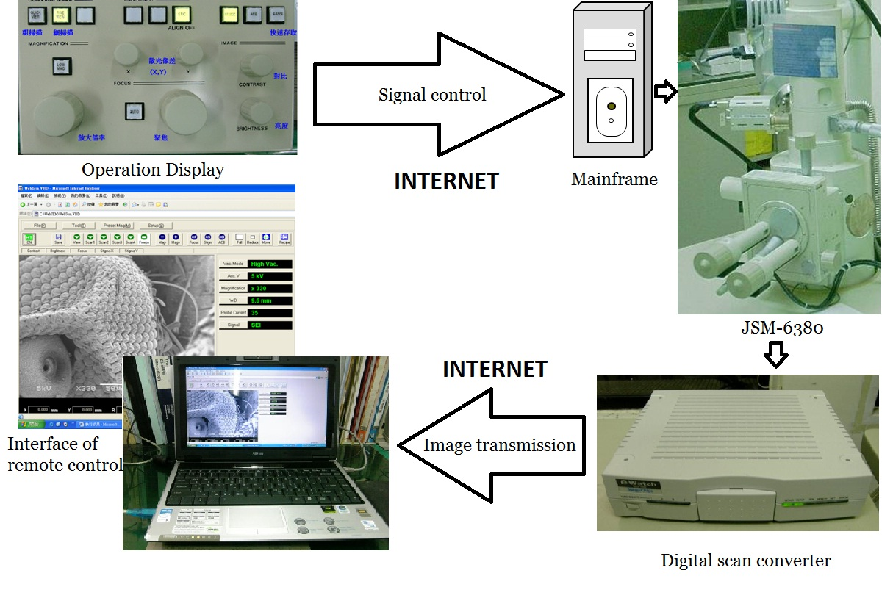
Figure 1. The hardware structure through the Internet remote control.

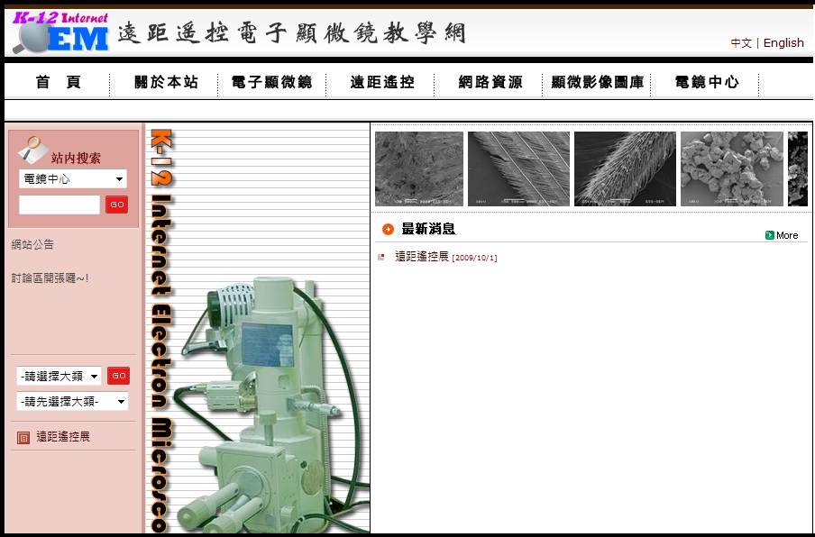
Figure 2. The index of the K-12 e-learning teaching materials.

Instructional files and image database in the Internet
The concept of building up the image database is to observe samples by scanning electron microscope from macroscopic view to microscopic one. Image builders chose a point in one picture as the original point to be enlarged, and then the shown image was taken from low to high magnification. In order to attract browsers’ eyes and to fulfill their curiosity about the enlarged nano-structure of samples, the images are demonstrated by the changes from macroscopic view to microscopic one. As shown in Figure 3, the SEM images of the spider silks are from 100x (a), 1000x (b), to 7000x (c). The more the magnification is, the smaller is the feature size one can observe. People can find how much different it is when enlarging the magnification of one sample.

The files in the image database are the samples made by professional techniques. The resources of the samples are some amusing topics which were searched in the Internet. Seed teachers also provide some suggested targets or images with their interests.

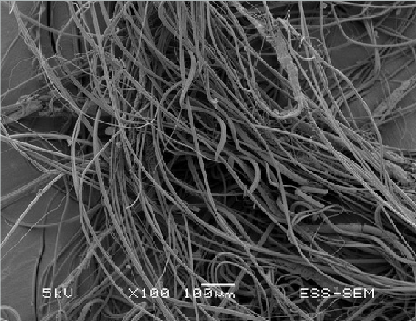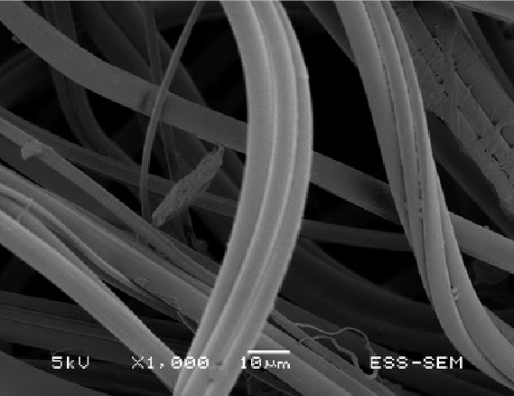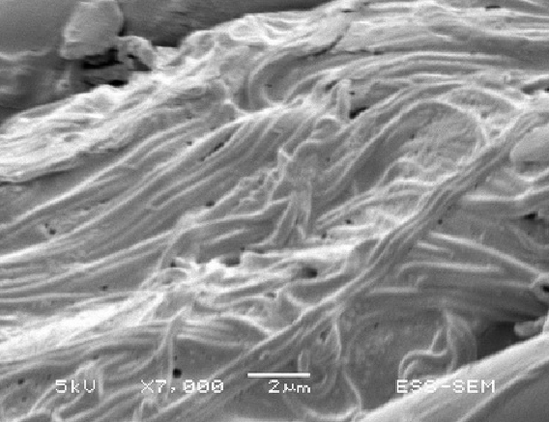
(a) (b) (c)
Figure 3. The spider silks from 100x(a), 1000x(b), to 7000x(c).

2.2 Training courses
There are two training parts: one is a serious training program for professionals to operate independently with high skills, to have the ability to maintain the whole facility and to have custom service for taking SEM images; the other is a common training program for general operator. For the second part, this training is short and the objective is to let the users have the basic skill to operate the SEM. The demanded ability is therefore simple.

The related machine testing, troubleshooting procedure, maintaining processes, and standard operating procedure have been set up after building the remote control SEM equipment. All these have been included as one part in the learners’ training course.

The training and workshop for seed teachers
ESS assigns a professional to give lessons to train seed teachers in the regular teachers’ workshop. Seed teachers can learn how to make samples for using the gold coating device on the stage of microscopes and they start to load samples and calibrate the SEM parameters according to the operating procedure. Every teacher is expected to have the ability of operating independently, and is capable of basic machine repairing and maintaining. The scene of training is shown in Figure 4.

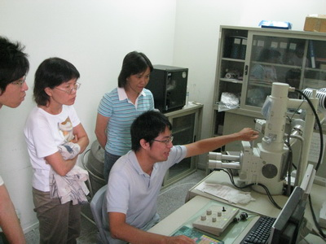
Figure 4. Teachers observed samples and professionals provided images.

The instruction of remote control SEM through the Internet
We accepted the invitation of the instruction of remote control SEM from Miss Liu in National Hsinchu Girls’ Senior High School (NHGSHS) in Taiwan. The SEM principle was given, the SEM images from the database in the website were shown, some experiments were done and SEM equipment was operated through the remote control operating for students and shown in Figures 5 and 6.

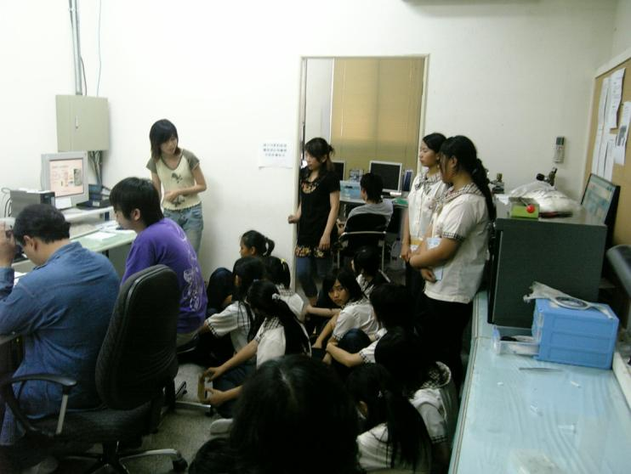
- At ESS with SEM equipment, NTHU

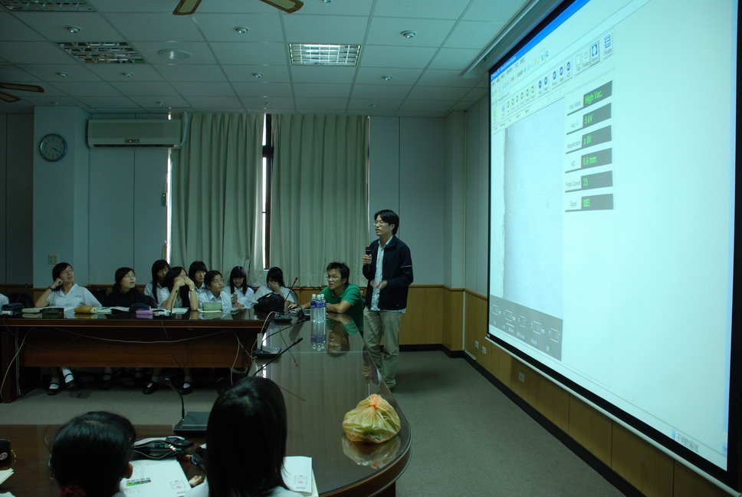
- At NHGSHS
Figure 5. The scene of instruction of remote control SEM through Internet

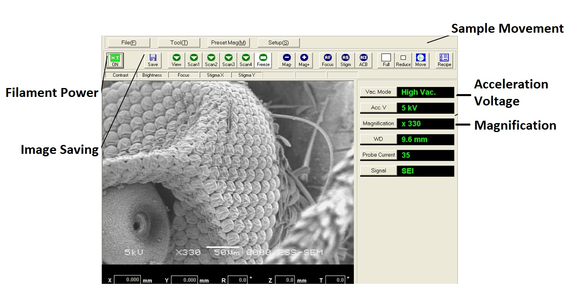
Figure 6. Interface of operating SEM on the panel by remote control

3. Results and conclusion
In order to establish the remote control SEM equipment, we have cooperated with Department of Power Mechanical Engineering in NTHU to host six “AFM/ SEM practical training course” workshops for teachers, and participants are over 100. Seed teachers in Taiwan are recommended to attend the training courses; undergraduates and graduates also have been trained to take pictures for samples with nano structure.

We will keep enlarging the image database to help those who use this website find more interesting images in the nano world in the coming future. Based on the well developed wideband internet, we hope that all teachers and students inside or outside Taiwan have more knowledge of nanotechnology.

4. Acknowledgements
The authors would like to thank the Ministry of Education for supporting the project under the contact No. MOE(奈)97-S-01_C and the National Science Council for supporting the research project under the contract No. NSC-99-2120-S-007-001-NM.

References
- F. O. Tsai. (2006). The Research of Teaching Nanotechnology through Information Technology Integrated Instruction in the Elementary School. Master’s thesis, National Taichung University of Education, Taiwan (in Chinese)
- C. C. Wu.(2004). The training of the nanotechnology education. Enews, Magazine Association of Taipei (in Chinese).
- C. K. Lee, et al. (2003). The development plan and prospect to the Nanotechnology human resource development program: from K-12 Nanotechnology human resource development testing program. Physics Bimonth, Vol. 25, No. 3, pp 435-443. (in Chinese)
- C. S. Wang. (2000). The meaning and content information technology integrating to instruction. Information and education Magazine, Vol. 80, pp 13-31. (in Chinese)
- T. R. Kochtanek, and K. K. Hein. (2000). Creating and nurturing distributed asynchronous learning environments. Online Information Review, Vol. 24, No. 4, pp 280-293.
- D. Santangelo, and M. Guy. (2004). The force of multimedia slideshows. Science and Children, Vol. 41, No. 7, pp 20-24.

