Online PBL: a route to sustainability education?

Bland Tomkinson, Ian Hutt
University of Manchester, Manchester, UK,
bland.tomkinson@manchester.ac.uk
ian.hutt@manchester.ac.uk

Abstract
The Royal Academy of Engineering sponsored project at Manchester; to foster education in sustainability through inter-disciplinary problem-based approaches, has since been extended to other groups and to a broader array of issues. One of the limiting factors is the ease with which this approach can be taken in the case of large numbers of students and a commensurate requirement for large numbers of facilitators. The University of Keele, together with partners from the universities of Manchester and Staffordshire, was awarded National Teaching Fellowship Scheme funding to explore further the use of blended or online approaches, in order to overcome these limitations.

In the case of the University of Manchester, the developments are being applied to a Masters-level course unit in Managing Humanitarian Aid Projects. This unit proceeds on the basis of five scenarios that students try to resolve in small groups and in the first pilot year one of these scenarios is being delivered on-line. The pilot unit already has a certain amount of support using the BlackBoard VLE but this scenario is supposed to rely entirely on online working. At the time of writing the evaluation of the pilot has not been completed but an online questionnaire has been devised to monitor students’ reactions to the online working and to ascertain whether they did in fact work entirely online or whether they chose to meet informally face-to-face. Difficulties encountered were both organizational (mostly relating to enrolment) and technical (this was a new version of BlackBoard and had a few teething troubles). The results of this pilot will be fed in to later stages including the possibility of distance learning modules.

1. Introduction
An inter-disciplinary, problem-based approach to education for sustainable development has been implemented in Manchester for a number of years and is already well documented ^{eg 1,2.} Initially this was across science and engineering but latterly more broadly across the university. However, this has been but one course unit in one university and the pioneers of the idea have sought to make the approach more widespread. One of the limitations, however, is the difficulty of using a problem-based approach with large numbers of students – each group of eight or nine students requires a post-doctoral or post-graduate facilitator. In order to try to resolve some of these issues, in 2009 Professor Pat Bailey of the University of Keele obtained a National Teaching Fellowship Scheme (NTFS) award to look at issues of implementing the ideas, through blended learning, at three universities. This paper looks at the developments in the University of Manchester. In this instance three course units are involved: at undergraduate and Masters level in Sustainable Development and at Masters level in Humanitarian Aid. The trial is initially confined to introducing blended learning to the Managing Humanitarian Aid Projects unit of the MSc in Project Management in the School of Mechanical, Aerospace and Civil Engineering.

The case for using problem-based learning as a basis stems from a number of origins. In a UNESCO report³, Arjen Wals suggests that the ‘nature of [education for sustainable development] demands new perspectives on matters like curriculum, teaching and learning. ESD and SD tend to focus on connections, feedback loops, relationships and interaction. Yet dominant educational structures are based on fragmentation rather than connections and synergy’. Sulaiman Yamin and Alias Masek⁴ suggest that ‘… PBL is seen potential[ly] as an effective learning approach to produce … graduates, who are technically competent, as well as aware on the issues [of] sustainable development’ and a report⁵ from Rosemary Tomkinson and colleagues, on a Delphi study, suggested that student-centred approaches were most relevant to embedding education for sustainable development.

The use of technology to support large classes has been widely explored but its application to student-centred, group-based learning is less widely recognised. For example, Hao-Chang Lo⁶ has looked at the implications of using publicly-available communications technology for a PBL-based medical course and Xun Ge and colleagues⁷ have studied the use of technology to scaffold the PBL learning processes. Rosman Ahmad⁸ explored online methods for a programme related to the one under study but this fell short of participative groupwork. A much fuller review of the available literature was undertaken in the bid document itself.

1.1 The trial
The NTFS project is over a three-year period and a phased approach is being taken. The Managing Humanitarian Aid Projects course unit employs four major scenarios, with a minor one as an introduction to the approach. Each scenario is designed as what Horst Rittel and Melvin Webber describe as a wicked⁹ problem, with no obvious answer. Each group of about eight students tackles each of the problem scenarios over a two-week period, producing a group report which may take several forms depending on the nature of the problem scenario. The unit seeks to develop specific transferable skills as well as to enhance knowledge and the methodology is in line with that described in more detail in an appendix to the report to the Royal Academy of Engineering¹⁰.

For the purpose of this latter study, the second of the major problem scenarios was chosen to be delivered entirely online. This particular problem scenario was looking at reconstruction in the aftermath of a recent Indonesian tsunami. The initial scenario (see Appendix) was posted to the BlackBoard site on controlled release, so that it could not be previewed. As well as the description of the problem, links were posted to news sites with more background material. Over the next two weeks each group was expected to collaborate online to define the aspects to be tackled, to carry out the background research and to formulate a response in the form of both a written report and also a set of PowerPoint slides to accompany an oral presentation. The result was submitted through BlackBoard and formative feedback was also given electronically.

The course unit is already well-supported online. At the time of the trial the university was introducing BlackBoard 9 and it was decided that this course unit would be one of the pilot modules mounted on that learning environment, partly because it was expected that the University of Keele would also be using BlackBoard 9 for the project. In the event, this did not happen at Keele. The Managing Humanitarian Aid Projects course unit was running for its second year, having been funded by an internal development grant for the first year. The BlackBoard 8 system had incorporated some online discussion tools – which had not been used by students – as well as providing a repository for much of the course information and copies of supporting handouts. In BlackBoard 9 the students also had access to an individual journal tool – an individual reflective report is an essential part of the assessment for the unit – as well as a wiki space that could be used for drafting the group report. Further asynchronous communication tools were provided, including group and general discussion forums and a file-sharing area. Unfortunately, due to some technical problems with the new platform, the usual synchronous communication tool, Wimba Pronto (an application similar in function to Skype), was not available. Assessment is primarily in two forms: a group project report and an individual reflective report. Group reports have to be submitted electronically through Turnitin®, but only the final two scenarios count formatively, and the results are modified by a peer assessment exercise, which is currently paper-based. In this case the groups were also required to submit their report in the form of a group wiki in the first instance, which was later packaged up for Turnitin® submission. Reflective reports should be derived from the individual journals, though not all students have used the electronic tool for this purpose, and are also submitted through Turnitin®.

In addition to project management students, students undertaking a Masters programme in international development policy and management were also able to enroll on the unit; in the event only one student did so. Enrolment proved something of a challenge since Masters students are allowed a three-week period to decide on which elective units they will pursue, after which they are formally registered on the unit, and this means a considerable number of changes in the student body at the beginning of the unit. Whilst not wishing to unduly restrict student choice, in this instance students were not allowed to enroll on the unit after the second week.

A major issue in a pilot scheme of this nature is the nature of the instructional design. In this instance the blended learning approach is being applied to an existing course unit and therefore models the previous face-to-face approach. Other modules may be designed ab initio and therefore take a different approach. In other cases, such as that considered by Richard Kenny and colleagues¹¹, this will incorporate the facility of monitoring student discussions in order to assess the processes of the student rather than merely the outcomes.

1.2 Evaluation
The evaluation of the online part of the course was undertaken using both an online questionnaire and also a nominal group exercise¹². Later, a second nominal group was conducted, covering the whole course unit and a short, paper-based, questionnaire was administered to the students also covering the whole course unit. The unit is also subject to a university-wide online student satisfaction questionnaire which is of dubious value in this context since it is constructed largely for a lecture-style format of teaching.

- Results
2.1 Online questionnaire
The twenty-three students undertaking the unit were asked to complete an online questionnaire about their experience and fifteen students (65%) responded. The questionnaire comprised thirteen statements plus a free-text area for general comments. Students were asked to rate their level of agreement with each statement on a five-point Likert scale ranging from “Strongly Disagree” to “Strongly Agree”.

Figures 1 and 2 show the results for questions related to technical and training issues that might have prevented effective access to the online systems (highlighted bars show median values).
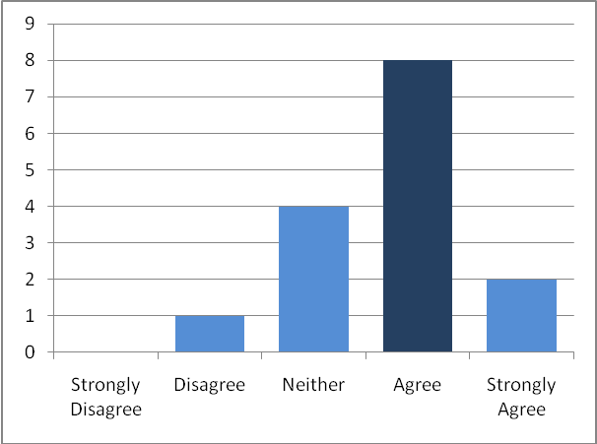
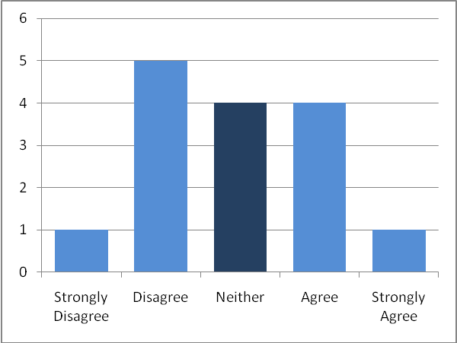
Figure 1: Q1. Technical problems prevented me from using Bb9 and the online tools effectively.

Figure 2: Q2. I received sufficient instruction to be able to use Bb9 and the online tools effectively.
The results of Q1 show that 5 of 15 students experienced technical problems. This probably

reflects some initial technical issues that arose at the very outset of the trial, though it should be noted that the number of support requests dropped to zero after these problems were resolved and no further support requests were received after the first 3 days of the trial. Pre-trial instruction was a 30-minute walkthrough of the Blackboard 9 platform and tools and from the results of Q2, appears to have been sufficient (1 of 15 students disagreed).

The first area of interest in the trial was the presentation of online briefing material. In addition to task instructions, this included links to relevant websites and a BBC documentary provided through the Box of Broadcasts service. The results shown in figure 3 suggest that this was well received (only 1 of 15 students disagreed).

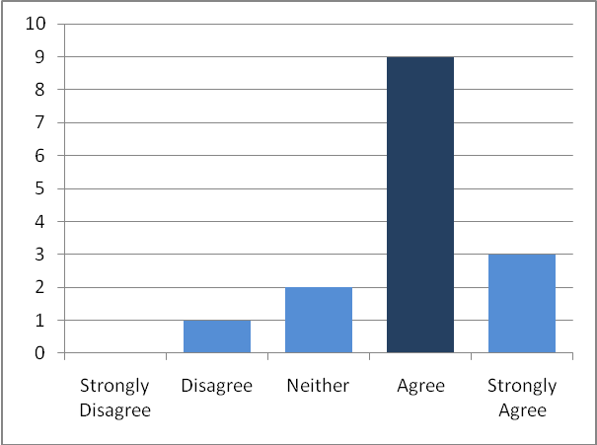

Figure 3: Q3. The websites and other online resources presented through Bb9 provided useful background to the scenario.

The next set of questions focussed on the groupwork experience. It appears that while the students generally felt that they were able to collaborate effectively as a group (figure 4 – 3 of 15 students disagree), they were less positive about their ability to engage with their group facilitator (figure 5). In at least one case the facilitator experienced technical difficulties in joining an online meeting and this may be reflected by the mixed responses shown in figure 5.

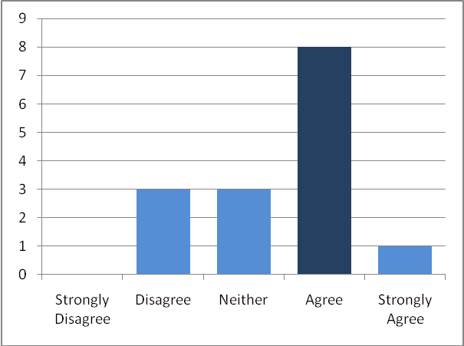
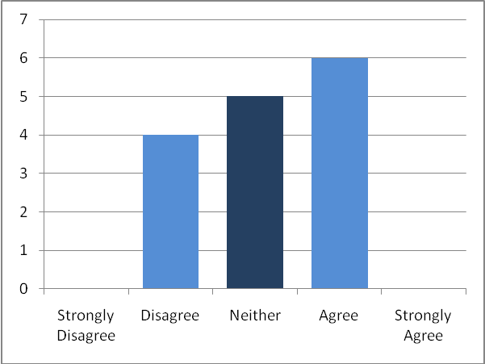

Figure 4: Q4. My group was able to collaborate effectively online.
Figure 5: Q8. I found that my group was able to engage effectively with the facilitator online.

As might be expected, results regarding the use of the communication tools showed a definite distinction between asynchronous collaboration, for which several tools were provided, and synchronous collaboration, for which no specific tools were included. Figure 6 shows that the majority of students (11 of 15) found the asynchronous tools effective, while only 5 of 15 agreed that the provided tools were sufficient for synchronous meetings (figure 7).

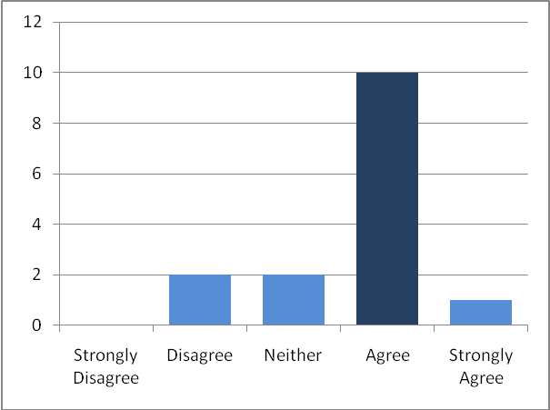
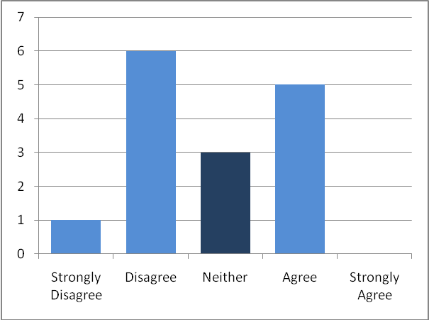

Figure 6: Q6. The discussion groups and similar tools enabled my group to communicate even when we were not all online.
Figure 7: Q5. The online tools provided enabled my group to hold effective online meetings.

The lack of provision of any specific synchronous collaboration tools clearly drove the students to seek solutions outside of the platform provided to them, as illustrated in figure 8 where 14 of the 15 students stated that they used additional tools for their meetings.

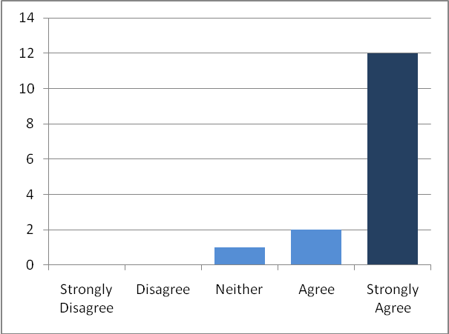

Figure 8: Q7. My group used additional online tools (e.g. Facebook) to collaborate online.

Observations of activity during and after the trial suggest that, while all student groups made extensive use of the discussion, file exchange and wiki tools within Blackboard 9 for sharing resources and providing progress updates, all online meetings tool place outside of Blackboard. Further investigation revealed that tools and services used were as follows (no of students who stated they used each tool shown in brackets):

Q14. If your group used any alternative tools for online collaboration beyond those provided within Bb9, please indicate which tools you used...
- Facebook (11)
- Skype (12)
- Email (12)
- Mobile phones (5)
- Google Docs (1)

The next set of questions focussed on the students’ preferences and their feelings about undertaking the task online. So far, with the exception of the particular issues of facilitator engagement and synchronous collaboration, the results presented have been reasonably positive, but figures 9 and 10 suggest that the students still prefer face-to-face meetings.

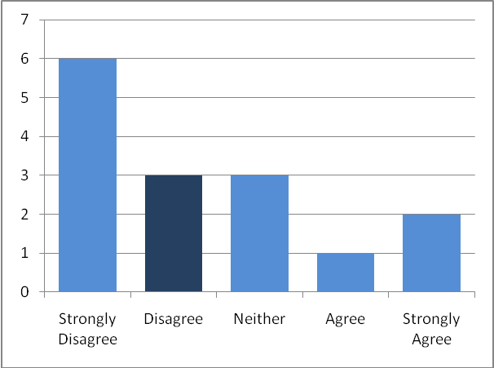
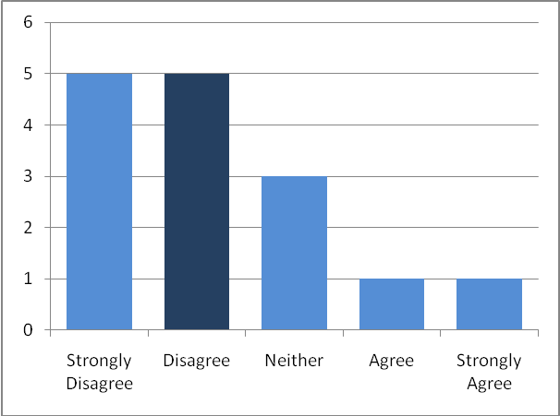

Figure 10: Q10. I contributed more to the online discussions than I would in a face-to-face meeting.
Figure 9: Q9. I prefer meeting online to meeting face-to-face.

In a similar vein, students also rated the creativity of their online group problem solving lower than in their face-to-face meetings (10 of 15 agreed). This is shown in figure 11.

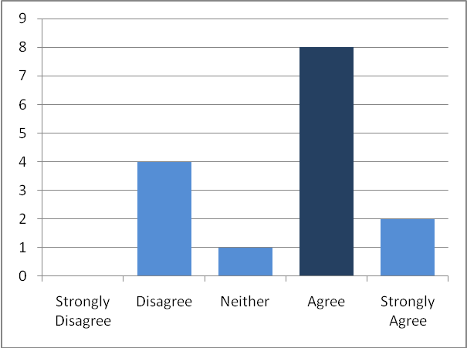

Figure 11: Q11. I feel that working online made our collaborations less creative.

This result is supported by some of the comments submitted in the general comments field – examples include:

Q15. Do you have any further comments you would like to add about your experiences of online group-working for Scenario 2?

- “I think It was a good experience, but a hard one.”
- “I found it hard to fulfil our commitment when collaborating online.”
- “Communicating through computer or other tools is time consuming.”

There is a general theme that while they found it possible to work effectively as a group online, students also found it more difficult. It is possible that the students were having to dedicate more time and effort to the use of the online system, which had an impact on their creativity and productivity. An assessment of the quality of the submitted solutions by the tutors may help to clarify whether this perceived reduction in creativity is borne out by the actual submitted work.
The final questions in the survey related to the group wiki that the students were asked to produce as their final report. Figures 12 and 13 show these results.

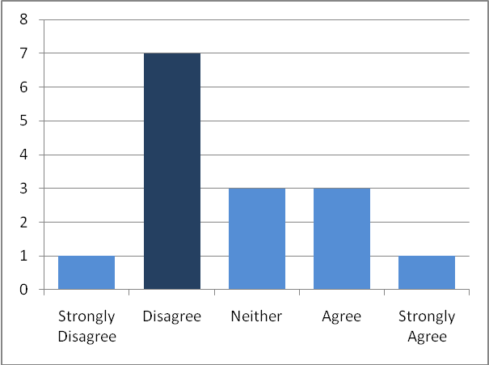
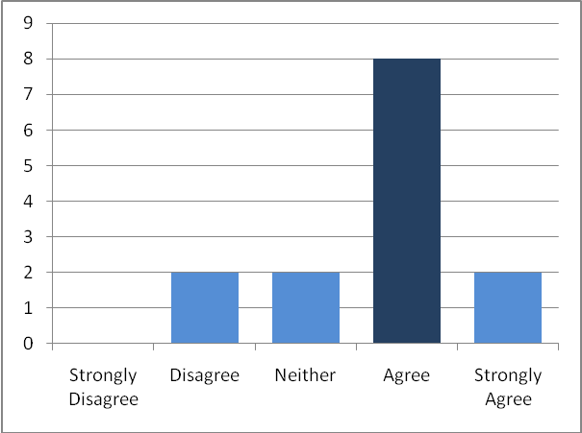
Figure 13: Q13. Everyone in my group contributed to the group wiki.

Figure 12: Q12. I found the wiki to be an easy to use and intuitive way to create a group report.

In general the wiki appears to have been an effective way to get all of the group members to contribute to the final report (figure 13), but the approach was not a popular one with the students (figure 12).

As with previous result related to perceived reductions in creativity, it is not yet possible to determine whether the difficulties in using the wiki are due to a lack of familiarity with the system or to an inherent lack of suitability of the tool to this task. Further investigation will be required to untangle this issue.

2.2 Nominal group
A nominal group exercise was carried out shortly after the second exercise had been completed. Each group of students was asked to individually list the positives and negatives of online PBL, based on their recent experience, and then to set those in order. They were asked to record the number of votes cast for each attribute, setting as infinity any with complete agreement of the group; one group failed to complete this latter stage. The results are summarised in Table 1. It will be noted that many of the positives are associated with group-based experiential learning but many of the negatives are associated with the online environment.

3. Conclusions
This pilot project has demonstrated that a blended approach to PBL is feasible but that it meets with a certain resistance from students. Some of the issues raised by the students can be resolved with greater familiarity with the VLE in use – in this instance the students were using two different versions of the BlackBoard system according to the individual course unit. One point of discussion is the extent to which online learning should take place through a university VLE: in this instance a variety of other electronic approaches was taken outside the formal structure. For the course unit in the pilot study the assessment was outcomes-driven rather than process-driven which meant that it was not necessary for the academic staff to have access to all the discussions. However, there were problems in facilitators having access to provide relevant support; in one case where much of the debate was through Facebook the facilitator concerned was not joined into the group until a very late stage. It should be noted that facilitators did not receive any training in the use of the systems beyond that received by students. In future trials, the inclusion of a dedicated synchronous communication tool, in the form of Pronto, and further instruction for facilitators should help to alleviate these problems. Equally of concern is the difficulty of remote access where firewalls have been installed and this could become a very real problem if the unit is extended to become available to part-time students working largely online.

The overall NTFS project is looking at the application of online PBL in sustainable development education and it could be argued that this pilot is somewhat peripheral to that. However, the field of global societal responsibility has a spectrum of approaches where humanitarian aid and disaster relief can be seen to overlap with sustainable development; indeed one of the scenarios used in the first year of the course unit was identical to one used in the parallel unit in sustainable development and others cover similar areas.

Table 1 – Results of nominal group exercise

Group 1 | Group 2 | Group 3
Positives
+ teamwork learning  + handling conflicts  + no exam  + dynamic nature  + commitment to work  + how to communicate  + handling challenges  + time management skills  + improving searching skills  + self-criticism  + learning more  + critical thinking  + how to read papers | + interactive effective communication  + taking up responsibility  + understanding cultural diversity  + different way of learning  + improve information searching skill  + self-adapting change skill  + improving team skill  + individual skills eg planning, organising  + people management skill | + enhancement of generic skills  + different cultures  + real-time case study  + encourage debate skills  + team development theory  + capability of communication  + improve logical thinking
Negatives
- unclear requirements  - is it practical?  - time consuming  - wiki not user friendly  - boring classes  - teams gathered coincidentally  - risk of losing commitment  - lack of time  - Not interesting topics  - Lots of conflicts  - internal usage  - prejudiced topics | - time consuming  - Blackboard  - lack of constant feedback  - difficult to manage a group  - not gain specific knowledge  - difficult to combine opinions | - unclear timetable and assessment  - Blackboard dysfunctionality  - ambiguity of feedback  - time consuming  - group size too big  - no interaction with other groups  - lack of basic methods
4. Acknowledgements
The authors wish to acknowledge the funding from the UK National Teaching Fellowship Scheme and the support of their colleagues at the University of Keele.

References
- B. Tomkinson, R. Tomkinson and H. Dobson, “Education for sustainable development – an inter-disciplinary pilot module for undergraduate engineers and scientists”, International Journal of Sustainable Engineering, Vol. 1, No.1, 2008.

- B. Tomkinson, H. Dobson, R. Tomkinson and C. Engel, “An Inter-Disciplinary, Problem-Based Approach to Educating Engineers in Sustainable Development”, International Conference on Engineering Education, Coimbra, Portugal, 2007.

- A. Wals, Learning for a Sustainable World – Review of Contexts and Structures for Education for Sustainable Development, Paris, UNESCO, 2009.

- S. Yamin and A. Masek, “Education for Sustainable Development through Problem Based Learning: A Review of the Monitoring and Assessment Strategy”, Proceedings of the ESD in TVET Conference. Manila, Philippines, 2010

- R.Tomkinson, C. Engel, B.Tomkinson and A. Lawson , Education for sustainable development in engineering: report of a Delphi consultation, Loughborough, Higher Education Academy Engineering Subject Centre, 2008. Available online at http://www.engsc.ac.uk/downloads/scholarart/delphi-consultation.pdf

- Lo H, “Utilizing computer-mediated communication tools for problem-based learning”, Educational Technology & Society, Vol. 12, No.1, 2009

- X. Ge, L.Planas, and N. Er, A Cognitive Support System to Scaffold Students’ Problem-based Learning in a Web-based Learning Environment, Interdisciplinary Journal of Problem-based Learning, Vol. 4, No.1, pp 30-56, 2010.

- R. Ahmad, R. Edwards and B. Tomkinson, “The Use of WebCT in a Distance Learning Course in the University of Manchester”, Turkish Online Journal of Distance Education, Vol. 7, No.2. 2006.

- H. Rittel and M. Webber, “Dilemmas in a General Theory of Planning”, Policy Sciences, Vol. 4, pp 155-169, 1973.

- B. Tomkinson (ed), Educating Engineers for Sustainable Development: Appendices to the Final report of a Royal Academy of Engineering pilot study. University of Manchester, 2009.
Available online at: http://www.tlc.eps.manchester.ac.uk/tlc/sd/raeng/March09_UoM_ISD_Appendices_RAEng.pdf

- R. Kenny, M. Bullen and J. Loftus, “Problem Formulation and Resolution in Online Problem-based learning”, International Review of Research in Open and Distance Learning,. Vol 7, No. 3, 2006.

- A. Delbecq, A. Van der Ven and D. Gustafson, Group techniques for program planning: A guide to nominal group and Delphi processes,. Scott Foresman, Glenview, 1975.

Appendix

Exercise 2 (Online)

You are a team of ‘facilitators’, working with international aid agency Building for Humanity, which encourages collaboration between architects, builders and designers and the humanitarian world.

Background
On 25th October 2010, eleven-year-old Amina was sitting in school. “When I noticed my pencil rattling on the desk I quickly ran outside,” recalls Amina. Some of her classmates were less fortunate and unable to save themselves. On the islands where the girl lives, schools suddenly ceased to exist or were seriously damaged. The earthquake triggered a tsunami that swamped coastal villages on the Mentawai Islands and swept away many of the buildings that the earthquake had left standing. With logistics provided by the military, much was done to save lives by the simple provision of tents and tarpaulins, but longer-term assistance is required to help the population rebuild their communities and infrastructure, whilst providing medium-term solid shelter (transitional accommodation).

Task
Immediately following this incident, as a multi-disciplinary team, your aim is to assess the situation on the ground and, with the help of the following:
-  Local community groups
- Local police and security forces
- Army and other military personnel
- Aid agencies and charities – both at organisational level and in the field
- Non-governmental organisations (UN, UNHCR, ICRC, etc.)
- Designers
- Manufacturers
- Other organisations (including health organisations and food charities)
….to develop a strategy to provide suitable transitional accommodation (housing, schools, clinics, etc). It is vitally important that all issues of sustainability are taken into account, and a realistic balance is achieved between emerging technologies and the constructional methodologies traditional in the area. Take account of potential transport difficulties, severe shortages of skilled labour and building expertise, as well as the availability of potentially suitable building materials. It is worthy of note, at this point, that many of the surviving buildings were of locally traditional construction.

You are to analyse possible alternative approaches and propose an environmentally sound and sustainable strategy for the construction of buildings, listed above. Achieve a realistic and workable balance between international aid and local skills and manpower. Make a reasoned proposal for a technological strategy which, if employed, would facilitate the creation of sustainable and safe buildings, and act as the building blocks of a longer-term rebuilding of communities. Present your analysis and proposals both as an A4 report of up to 1000 words and a set of PowerPoint Presentation slides that could be delivered in approximately 20 minutes. These must be submitted through BlackBoard.

Note: This is not a physical design exercise. Do not attempt to design any buildings. Instead, design an appropriate and workable strategy based on best current knowledge. Any such strategy must be workable, sustainable, affordable in both the short and longer terms, and should propose an appropriate project plan for all potential participants (local and international).

