Neuroscience and How the Brain Learns
An Introduction

Cynthia Norrgran USA and E. Dendy Sloan USA
BioEngineering and Life Science, Colorado School of Mines, Golden, CO. cnorrgra@mines.edu
Chemical and Biological Engineering, Colorado School of Mines, Golden, CO. esloan@mines.edu

ABSTRACT

With the new tools in neuroscience research in the last few decades, advances are now made regarding how the brain learns and retains information. Short term and long term memory, reverberating circuits, and the multi-layered aspect of the neocortex have helped to identify the requirements to take a learned idea and form it into the solid relation of micro-neuro-cellular networks. Once we understand how the brain learns, we will be able to incorporate that understanding into the teaching and education process in the university setting. In this paper, we review recognized theories of learning and layer them over the current anatomical format of the neocortex and its connections to the paleocortex and archicortex to provide a summary of current functional, structural, and theoretical models. A connection is shown to Cognitive Theory.

Physiological aspects of the brain during learning, reading, and problem solving can be seen in the functional magmatic resonance imaging [fMRI] and the magnetoencephalogram [MEG]. The microbiology of the six layered network of the cerebral gray matter gives an insight to the interconnections of the eight lobes of the brain to each other and to the architecturally more ancient parts of the brain. We now know that learning reacts to stress, emotion, and sleep as much as it does to study habits. Anatomy and physiology aside, it is the process modeling that gives us the most insight into the development of memory and idea integration. An idea must go from a thought process to a permanent interneural connection for memory retention and retrieval. Our formation of a scaffold of the structural, functional, and theoretical blueprint of the learning process will be paramount for teaching paradigms of the future.

Introduction

In 1979, Francis Crick wrote: “Reflecting on itself, the human brain has uncovered some marvelous facts. What appears to be needed for understanding how it works is new techniques for examining it and new ways of thinking about it.”¹ New imaging techniques such as fMRI have become available over the last two decades and are integrated into a fresh approach for interpreting how the brain functions. These new interpretations are replacing the earlier neuroscience concept of lesion based studies and of the modular brain made popular by Brodmann, yielding new concepts, such as distributed intelligence.

Ancient humans were interested in the workings of the brain. Evidence of trephination, or boring through the cranium, has been found in skulls from several early societies. The oldest trephinated skull dates from 7000 BC found in Peru; another example is a Sumerian skull from 3400 BC². Both show crude round holes made in the skull with evidence of healing of the bone. In other words, the patients survived! Egyptians practiced a different form of trephination in 2800 BC. Their incisions into the skull were made from four cuts, producing a square shaped opening. Studies of ancient hieroglyphic texts reveal the word “brain” written five times, as shown in Figure 1.
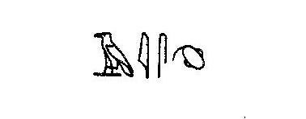
Figure 1. “Brain” written in hieroglyphic text²
Although the reason for the early trephinations is unknown, the physicians in the Dark Ages took to the procedure for the cure of insanity. The definition of insanity included psychopathies, seizures, dementias, and demon possession. The church often dictated the treatment plans for the mentally ill and the criminals of the state. The trephines were again circular with some skulls show evidence of healing after the surgery. These surgeries became more sophisticated throughout the Middle Ages, and not just in Europe but in the Incan community as well². Simple tooled devices were engineered to perform the successful craniotomies. Surgical tools and medical treatment developed rapidly as technology advanced. Sterile technique, dissection of human cadavers, understanding the process of infectious transmission, medical treatment in the war areas, and other advances made the brain more accessible for study. The living brain was studied in the ill, the injured, and those with tumors. The patients’ neurological deficits were extensively documented. Once the patient died, the brain was removed and studied for abnormalities. The anomalous areas were then assigned as the locality of the brain that controlled the neurological activity that was absent. Thus, the science of neurology and neurosurgery were initially developed as lesion-based studies resulting in the modular brain best described by Brodmann’s 44 human areas.

Phylogenetic Brain History

Studying animal brain progressions from reptiles, through birds, and finally to mammals, one can see the growth of the basal portions of the cerebrum, developing from olfactory bulbs, through balance control for flight, and finally to a folded cortex (about 2.5 sq ft in the human brain) to enable complex activity³.

Dated teaching about brain development used the catch-phrase - “Ontogeny recapitulates Phylogeny” - to suggest that as the human organism grows, earlier reptilian-like brains of the embryo evolve to the human brain cortex. This older concept has been discredited, and replaced with the concept that the reptilian brain, controlling basic functions, is overlain by increasingly sophisticated layers of the more complex evolved brain achieving a neocortical layer for executive function and learning.

A better analogy of brain development might be building a metropolitan subway system, with the earliest line being reptilian, or basic in function, and the latest being the neocortical line of executive function. Even if the newer lines wish for modernization of their lower, earlier neighbors, those same neighbors are unchangeable bases upon which the sophisticated development relies.

Sections of the Brain

The brain is subdivided according to the number of cellular layers it contains. The human cortex contains 3 to 6 cellular layers, depending on where it is positioned. The most ancient part of the brain is the paleocortex. This area includes the brainstem. It controls the automatic systems of the body, breathing, heart rate, blood pressure, digestion, and other homeostatic processes. We can control our breathing easily, but do not have much control over the other basic functions. Only with biofeedback and intense training can a person control their blood pressure and heart rate. The paleocortex contains three cellular layers and lies along the parahippocampal gyrus adjacent to the middle temporal lobe⁴.

The archicortex is closely related to the paleocortex, and is the next level of brain development with a higher degree of functioning. This area includes the amygdala and hippocampus proper and also contains three cellular layers. Memories start here as the reverberating circuits of short term retention. They shift to other areas of the brain to become “hard wired” for long term recall. The basic emotions of anger, fear, and dominance reside in the archicortex. This is the region for the instinctive behavior of most animals⁴. The ability to learn starts in this mix of the three layered microscopic structure of the paleo and archicortex.

The neocortex is the third and crowning stage of the brain. It is characterized as possessing executive function, which comprises intuition, logic, judgment, and the conscious recognition of self and identity. It is speculated that the neocortex first enabled the sophisticated functions of language, law, and worship. It permitted man to move outside the individual to form tribes or societies, both for protection and division of labor. The neocortex contains the most advanced processes, including adjusting to changes within seconds..

Layers of the Brain

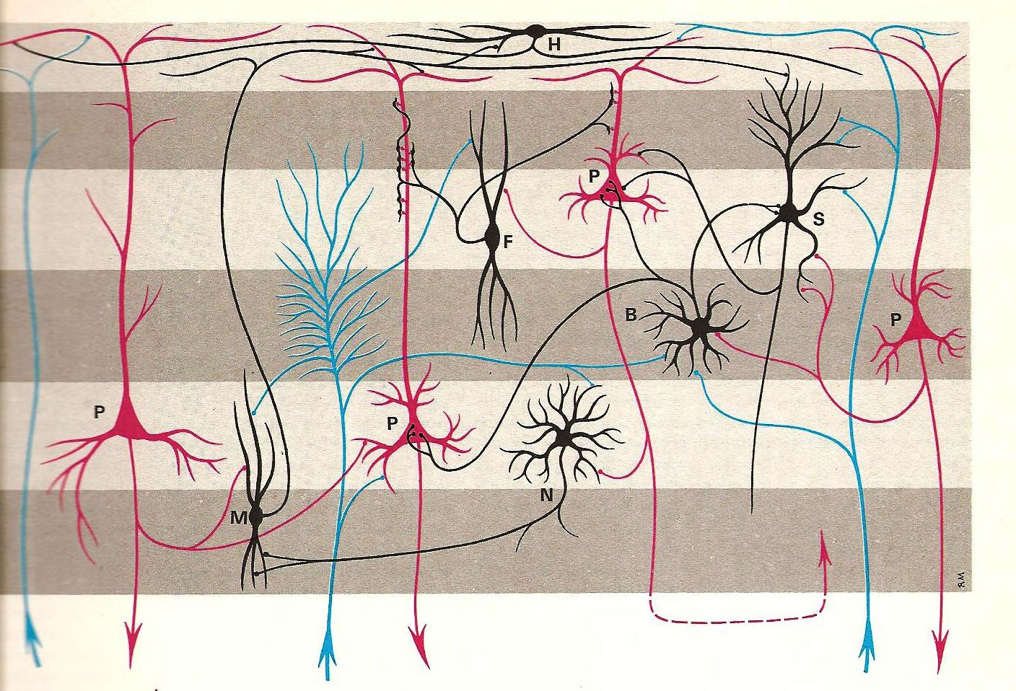

Figure 2 The cytoarchitectonics of the six layers of the brain showing the most common cells in each layer. P = pyramidal cell, M = the cell of Martinotti, H = horizontal cell, B = basket cell, S = stellate cell, F = fusiform cell, and N = the neuron cell. From Williams and Warwick⁵.

The six layered cytoarchitectonics of the neocortex are shown in Figure 2. The first layer [layer I] of the neocortex is the outermost layer and is called the plexiform or zonal layer. It contains a horizontal network of interconnected axons and dendrites with only a few cell bodies to spread impulses across the layer⁶. The second layer [layer II] contains small basket and pyramidal cells and is named the external granular layer. The third layer [layer III] contains medium sized pyramidal cells, large basket cells, and chandelier cells and is called the pyramidal lamina. Layer IV is a internal granular layer and contains closely packed small neurons. Layer V is known as the ganglionic layer and consists of large pyramidal cells. The deepest layer, layer VI, is the multiform layer containing differing size and shape cells.

Mountcastle claims that the cytoarchitectonic nature of the six layers of the brain interact in a columnar fashion, reaching between layers with both upward and downward extentions⁶. The pyramidal cells get their input from the web work of connections found in layer 1 and send them downward to other parts of the brain or back into another layer. Some cells in the lamina begin and end within the six layers but branch and intertwine with the dendrites of cells in the other layers. The complexities of this network, moving horizontally through the layers and vertically in columns, can only be surmised at present, but is the object of current research.

Examining the Living Brain

The most exciting current discoveries come from the study of the living and working brain. The anatomy of the brain in situ has only recently been imaged in computer tomography [CT] scans, magnetic resonance imaging [MRI] and neuroangiography. Recent imaging techniques called tractography have given us the first look at the white matter tracts involved in transmission of information to other areas of the brain. These imaging techniques can bring the brain into the realm of 3D images as seen in Figure 3. The functional MRI [fMRI] images the hemodynamic changes in the brain when the patient is asked to perform a specific task. Speech, hearing, vision, reading, and hand movement, have been mapped in the living cortex. This has moved the science of neurology and neurosurgery past the lesion based studies and the modular concept of the brain. These studies show that far more areas interacting in functional and task driven physiology than was previously thought. Brain anatomy has been reconstructed over the last decade by adding functional associations to the anatomical structures.

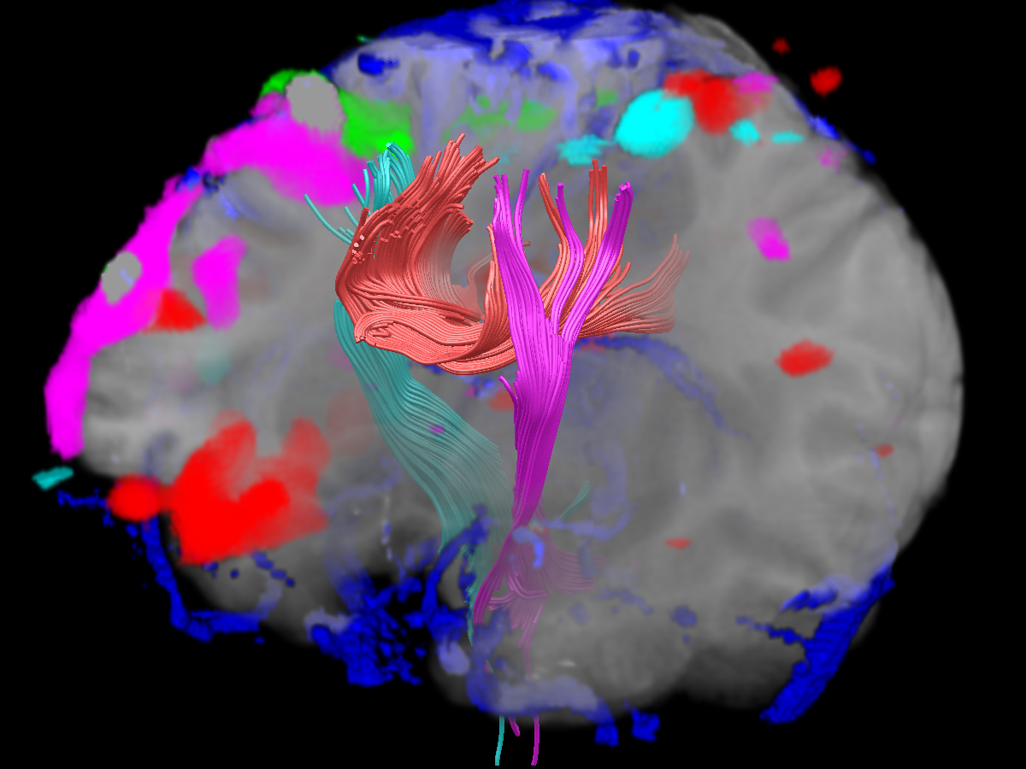

Figure 3. This picture is an integration of an fMRI and Diffusion Tensor Imaging [DTI] tractography into a 3D image for the visualization of multiple task driven areas of the brain and the white matter tracts that relay the information.⁷

Bringing in the older studies of the six layered and many column histological backgrounds with the new studies of multiple areas triggering for specific tasking of the fMRI, and the white matter tracts that send the information onward, we have begun to understand the brain in a new way.

How Learning is Related to the Brain

We consider the brain to be the organic substrate of the mind⁸. That is, the brain cytoarchitecture we described provides a physical basis upon which to place the framework for the function of the mind, particularly as related to pedagogy.

The investigation of mind function was initiated by philosophers like Plato and Descartes, progressing centuries later to methods of psychology/psychiatry of Freud and Jung. The new technologies of the last 40 years have enabled neuroscience to enter a new era, bringing molecular and cytological biology to brain applications, as a part of the transition from philosophy, to soft science, to a more definitive science.

In the past neuroscience used unwieldy tools to make slow, meticulous progress in macroscopic neuroscience. An example of this is the 1848 accident of Phineas Gage showing the functional relationship between the orbitofrontal cortex and social behavior. However, in the last two decades, tools such as fMRI and MEG allow neuroscientists to look at the physiology of the living brain. It appears there are connections of more specific portions the brain anatomy to brain function,connecting the brain to the mind, in an analogous way that the telescope connected astronomy to the heavens in the time of Copernicus and Galileo.

As professors we are concerned with the practical applications of this new science – in this case to the learning process. Such a development is also a natural progression of the application of the science areas initiated in the past; geology (18th century), chemistry (19th century), modern physics (first half of the 20th century), molecular biology (second half of the 20th century), and neuroscience (first portion of the 21st century).

However, in order to relate brain structure of the previous sections to learning, we must change directions, to consider first macroscopic hypotheses for how learning occurs in the neocortex. These macroscopic learning heuristics act as guides to the subsequent microscopic theory relating to neurons and synapses.

Macroscopic Heuristics of Learning

In engineering, a heuristic is a valuable, but somewhat inexact, guide to action - sometimes called a “rule-of-thumb.”⁹ To consider macroscopic concepts for how the brain learns, consider two heuristics, or hypotheses by Hawkins and Blakeslee¹⁰ and by Goldberg¹¹.

In the Hawkins and Blakeslee heuristic, cognitive intelligence is not defined by behavior, but by the ability to successfully predict the future. In turn, predictions of the future are enabled by extrapolation of memories from past experience. Past memories are established by progressively generalized patterns, upward and downward through the six neocortex layers. Building on the findings of Mountcastle⁶, Hawkins and Blakeslee consider neocortical columns responsible for executive function, with upward progression enabling meta-categories of pattern classification. As a crude example, the visual recognition of a famous person might progress from (a) recognition that an object is a face, to (b) recognizing it is a familiar face, to (c) recognition of a match in memory, to (d) adding knowledge about the person, to (e) recognizing the individual as Barack Obama. Because the brain has 10¹¹ neurons (more than the number of fundamental particles in the world) individual groups of neurons can be specifically assigned.

If memories and their retrieval are the hallmark of learning, one way to categorize memory is distinguished by explicit, declarative memory (facts, words, events, etc.) and implicit, non-declarative memory (motor, non-verbal habits). A distinguishing example from Wang and Aarmodt¹² is forgetting where you placed your car keys (explicit memory) but still recalling how to drive (implicitly). In education we’re usually concerned with explicit memory.

A second memory category has a temporal basis: working memory (lasting seconds to minutes, e.g. phone numbers), short-term memory (lasting hours to days, e.g. lectures), and long-term memory (years and longer, e.g. complex techniques and autobiographical stories). One way to consider education is the conversion of short-term memory to long-term memory to enable successful predictions of the future. Medina¹³ summarizes the evidence that consolidation from short- to long-term memory is time-dependent, as long as 2-10 years, and one of the major functions of sleep. In contrast, Squires and Kandel¹⁴ give examples to suggest that some degree of forgetting is a necessary part of memory, in order to abstract and retain major points.

The hypothesis of Goldberg¹⁰ suggests that innovations are associated with the right neocortex, but routines are embedded in the left neocortex. In childhood, when most things are new and/or innovative the right hemisphere is the most active, but with maturity the left hemisphere of the neocortex becomes the storehouse of knowledge, accumulating easy-to-recognize patterns. In Goldberg’s macroscopic learning hypothesis, the organism encounters a situation for which it has no ready-made response, but with repeated exposures to similar situations over time, response strategies are formulated. The length of time or number of exposures required to generate suitable responses is variable. So in the early stages the organism is faced with novelties which become routine as they are moved from the right to the left neocortex, crossing through the corpus callosum. Goldberg suggests this cycle, from novelty to routine and retrieval, as a universal process in learning.

Microscopic Theory

This section is a brief summary of the implicit memory research in Kandel¹⁵ and in Squire and Kandel¹⁴. Kandel, his colleagues, and associates studied the neurological connections of Aplysia (the California Sea Snail) for implicit memory, both short and long-term, and the spatial memories of genetically-modified mice. While only a brief synopsis of implicit Aplysia memory is provided here, some of the same principles form bases for extensions to explicit, spatial memory in mice.

When the syphon of the Aplysia snail is shocked, the snail will pull in its gills. Kandel demonstrated that with multiple shocks, the snail no longer attempts to protect it gills by withdrawal and will grow or produce a new synapse, which Kandel claims the snail develops new synapses as a product of learning. Of course it is not possible to summarize decades of painstaking, scholarly research in only a brief review. However, a principal can be demonstrated, using Figure 4, showing the conditioned, implicit, memory response of Aplysia gill withdrawal.

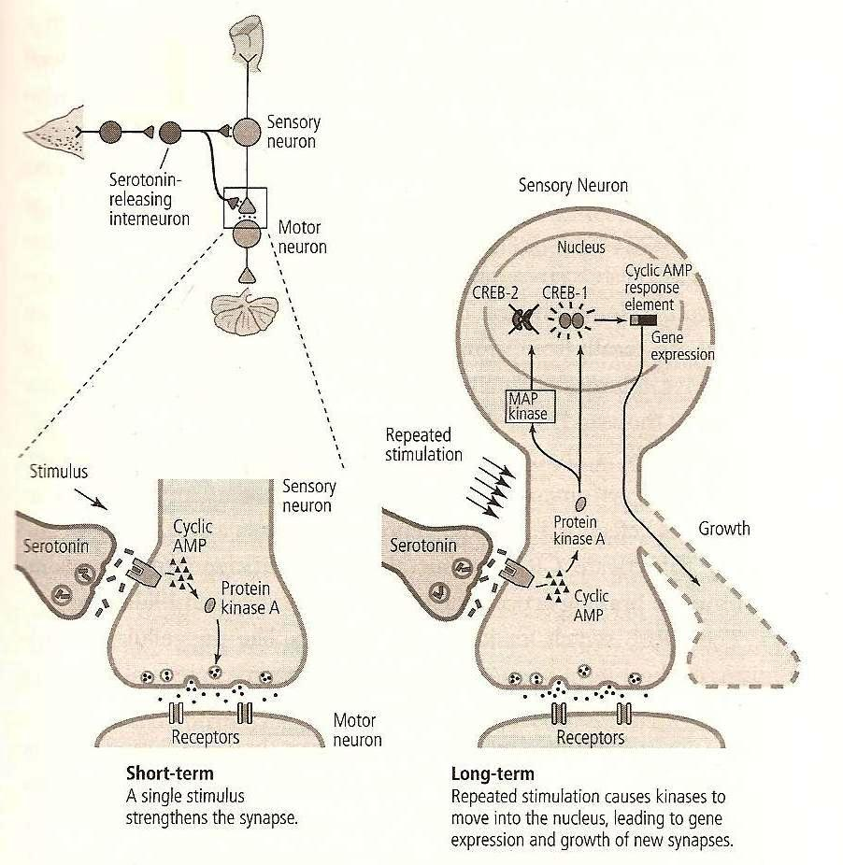

Figure 4 The short and long-term memory processes between neurons in Aplysia (Kandel¹⁴)
On the left in Figure 4, a single painful stimulus releases a moderate amount of neurotransmitter from the sensory neuron into the synapse of the motor neuron of the Aplysia gill. This correlates with short term memory. On the right in Figure 4, with multiple stimulations, the growth of new extensions are activated, leading to new synapses for a more complete neurotransmission, and thus longer memory. Wang and Aarmodt¹² describe this principle as, “The neurons that fire together, wire together.”

If one accepts the principle of new protein growth for long-term, implicit memory, then new, hitherto unknown variables are explicitly brought into reckoning. It no longer seems that repetition alone is sufficient to bring about these new synapses. Time and reiteration are the most important elements to grow new protein, along with proper diet and exercise for the both body and the brain. It is small comfort to recognize that these new microscopic variable may be related to experiential lessons from the history of pedagogy.

Connection to Pedagogical Theories

Neuroscience can complement and inform current pedagogical theories such as Cognitive Theory¹⁶, Active Learning ¹⁷, and Conceptual Change¹⁸, to extend two of the three foundational principles reviewed a decade ago by Bransford et al., ¹⁷: “1. Learning changes the physical structure of the brain, and 2. The structural changes alter the functional organization of the brain.” The concept of Michelene Chi’s ontological trees¹⁸ with parallel processing and higher level jumping of novel phenomenon fits almost perfectly into the Mountcastle view of columnar and layered sections of the neocortex.

Here we have only enough space to suggest one such connection. Cognitive Theory¹⁶ indicates new information is taken into short term memory, where it is compared with older, related information retrieved from long-term memory; if there is similarity, the new information is added to long term memory through either assimilation or accommodation. Current ideas in neuroscience indicate that long term memory is enhanced not only via such comparisons, but by repetition and the growth of new protein required for new synaptic connections.

Conclusion

New neuroscience tools and research are providing bases, extensions, and explanations for older experiential pedagogical ideas. In this work we briefly summarize new hypotheses of how long-term memory is related to learning, and to microscopic neuroscience research. Experience has taught learning theorists about the importance of exercise, diet, sleep, active brain use, as well as principles such as “Practice make permanent.”

Each of us has our own way of teaching. Some of us are dynamic, others rigorous, and still others are entertaining. We can each incorporate a reiterative and temporal concept into our own teaching method to ensure the growth of the proteins and the “hard wiring” of the knowledge we want to impart to the student. Taking the novel into the familiar range of the brain allows students to adapt to changes and to integrate the knowledge into their own background, perhaps to produce novel designs of their own.

In this exciting new science there are many challenges to establish the detailed biochemical bases of memory creation and retrieval. As these details are determined, there is the expectation to relate them to previous pedagogical knowledge, as well as the hope to extend the knowledge in ways yet unknown.

References

- F. Crick, “Thinking About the Brain”, Scientific American, 241, No. 3, 1979, pp. 219-232.
- S. Finger, Origins of Neuroscience, Oxford University Press, New York, 1994, pp. 3-15.
- R. Carter, The Human Brain Book, DK Press, London, 2009.
- D. Purvus, Neuroscience, 4th Edition, Sinauer Associates Inc., New York, 2007.
- P. L. Williams and R. Warwick, Functional Neuroanatomy of Man, W. B. Saunders, Philadelphia, 1975
- V. B. Mountcastle, Perceptual Neuroscience: the Cerebral Cortex, Harvard University Press, London, 1998.
- J. Hardenbergh, et al., Integrated 3D Visualization of fMRI and DTI tractography, poster at Visualization 2005 conference, Minneapolis, Minnesota
- J. Norden, Understanding the Brain, DVD Lecture Series, The Teaching Co., 2007.
- B. V. Koen, Discussion of the Method: Conducting the Engineer’s Approach to Problem Solving, Oxford University Press, New York, 2003.
- J. Hawkins and S. Blakeslee, On Intelligence, St. Martin’s Press, New York, 2004.
- E. Goldberg, The New Executive Brain: Frontal Lobes in a Complex World, Oxford University Press, USA, 2009.
- S. Wang and S, Aarmodt, Welcome to Your Brain, Bloomsbury, USA, 2008.
- J. Medina, Brain Rules, Pear Press, USA, 2009.
- L. R. Squire and E. R. Kandel, Memory: From Mind to Molecules, 2nd Ed., Roberts and Co., 2008
- E. R. Kandel, In Search of Memory, W.W. Norton, USA, 2007.
- M.D. Svinicki, Learning and Motivation in the Postsecondary Classroom, (Chapter 2) Anker Publishing Co., Inc., 2004
- M. Prince, “Does Active Learning Work? A Review of the Research,” J. Eng. Educ., 223, July 2004
- M.T.H. Chi, “Three Types of Conceptual Change: Belief Revision, Mental Model Transformation, and Categorical Shift” in S. Vosniadou (Ed.) Handbook of Research on Conceptual Change, pp 61-82, Erlbaum 2008
- J.D. Bransford, et al., How People Learn, (Chapter 5) National Academy Press, 2000

