Temporary City – Cooperation between universities of
European Capitals of Culture 2010

¹Tamás Molnár
Pollack Mihály Faculty of Engineering and Information Technology,
University of Pécs, Pécs, Hungary, tmolnar@pmmk.pte.hu¹;

Abstract
The program of Temporary City supplies the cooperation between the Universities of European Capitals of Culture 2010 (ECoC). In the course of the program students of Architecture, Environmental Planning and Settlement Design of the Technical Universities of Ruhr Area, Pécs and Istanbul worked together in workshops in the hosting locations.

1. Previous workshops
There were two previous stages of this series of workshop. The first has taken place in Düsseldorf at the Gustaf-Gründgens Square under the name of Temporary Architecture at special locations in 2004 and 2005. The participating schools were the FH Düsseldorf, the RWTH Aachen, the FH Münster and the Technical University of Dortmund. The objective was how the people will use again this square that is surrounded by great buildings as e.g. the Theater, because that time the Gustaf-Gründgens square was not used by the inhabitants of Düsseldorf. The winner was the project My Square, which was the work of Verena Gerdesmeier and Patrick Stührenberg from FH Münster (see Fig. 1).

The idea was that the square should be covered by wooden structure and every square meter of the place can be bought by anybody. So somebody put a tent over there or sold coffee. So the objective has been solved, because people used again the square [1].

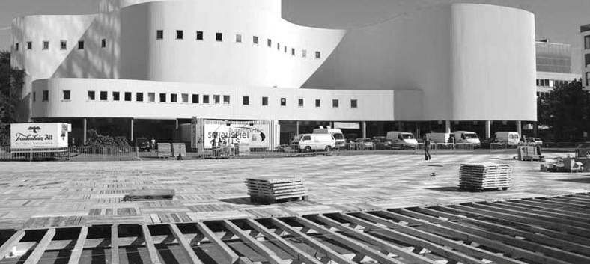

Fig. 1. The Gustaf-Gründgens Square

The second stage under the name Temporary City at special locations in 2006 and 2007 tackled the spatial connection of the Abteiberg Museum created by Hans Hollein to Mönchengladbach’s city center. The museum entrance with its bridge over the Abteistraße was originally designed as a direct connection to the pedestrian zone (Hindenbergstraße); this concept was, however, not realized. As a result the museum’s main entrance is quite concealed and is rarely used by the visitors. The winning students Moritz Gerigk, Thomas Herbert and Jens Paprotta from Bochum University of Applied Sciences proposed to create the previously planned connection in a new and spectacular way. They proposed a temporary stairs-bridge-construction over the roofs of two blocks of houses with the name stAIRWAYs (see Fig. 2).

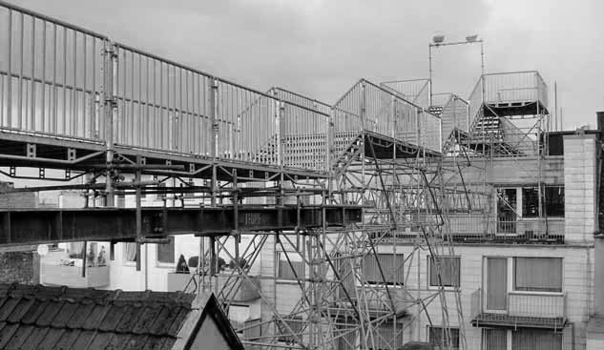

Fig. 2. The stairway in Mönchengladbach

The temporary air bridge not only created a completely new city space but also offered the possibility to the Mönchengladbach citizens to admire a new and previously unknown perspective of their city [2].

2. The system of the Temporary City workshop series
In the series of Temporary City workshop between 2008 and 2010 universities of three cities or areas are working together:
- the Ruhr-area with the RWTH Aachen;
- the Technical University Dortmund;
- the University of Siegen;
- Pécs with the University of Pécs;
- Istanbul with the Bilgi University;
- the Yildiz Technical University.

Through all three occasions an urban area is introduced to workshop participants. These sites have one in common: some sort of an intervention is imperative from one or another aspect. During the one-week's fieldwork students in mixed groups get acquainted with the area to make an analysis then. As a closing act of the workshop they represent their own ideas of intervention, they demonstrate their investigations from their different viewpoints. Later, when returning home, students draw up their proposals for the objective of the workshop, also as the competitive part of the program. The planned idea should be realizable from a fixed amount of money. The competitive designs will be evaluated and prized by an international jury. The prize-winning design will be accomplished as a temporary establishment in 2010 along with other ECoC related projects. [3]

3. Temporary City at the Ruhr area
The first stage of the Temporary City workshop series has taken place at the Ruhr area in Germany in the autumn of 2008. The students worked in the city of Gelsenkirchen at the Stadtbauraum. The Initiative of Stadtbaukultur NRW together with the TU Dortmund is the project leader of the whole workshop series. The problem to be analyzed was in the city of Duisburg. The area of the Inner Harbour is very near to the old city center with the town hall and the church. A little bit far away a new developing area is building up according to the masterplan of Sir Norman Foster. Today most of the people are walking in the new pedestrian zone next to the shopping mall. The objective of the workshop was to plan a temporary solution to connect the old downtown area to the new pedestrian zone those are divided by a street with heavy traffic. The winners of the workshop are Anne Lerch and Mavie Lakenbrink from the TU Dortmund. They planned a huge zebra crossing area onto the street with the title Wetterumschwung (see Fig. 3).
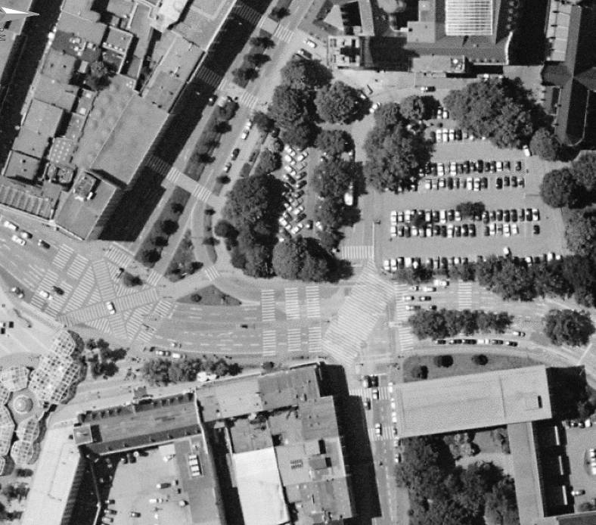
Fig. 3. Rendering of the winner project at the Ruhr area

Everybody knows that German drivers stop at zebra crossings to allow the pedestrians to cross the road. So with this solution it will be much easier to reach the old downtown area and the inner harbor from the direction of the pedestrian zone [4].

4. Temporary City in Pécs
The second stage of the workshop has taken place in Pécs in Hungary in the spring of 2009. In 2010 as an ECoC project a huge part of the old Zsolnay ceramics factory will be turned into the Zsolnay Cultural Quarter. The objective was for the students to plan a temporary installation or object that will connect this new cultural quarter to the end of the pedestrian street that comes from the main square of Pécs, because these two points are far away from each other. A lot of public spaces will be reconstructed for 2010 but between these areas there is a housing territory that should be crossed by the visitors of the cultural quarter. In the small streets it is not easy for foreign people to find the way to the cultural quarter. The winning project was planned by Sofia Rivadeneira and Daniel Spruth from RWTH Aachen. Their project has the name 2010 Chairs (see Fig. 4).
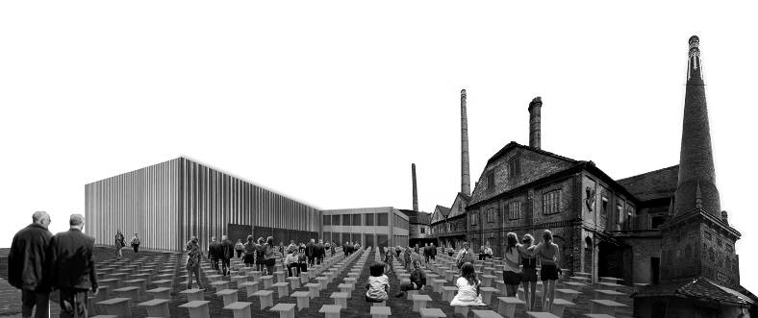
Fig. 4. Rendering of the winner project in Pecs

They planned a happening for the way between the main square and the Zsolnay Cultural quarter. At important public spaces these 2010 chairs will be placed there for a time shaping different forms. With these moving chairs they want to lead people to the cultural quarter, as they will see how the chairs are moving towards the cultural quarter [5].

5. Temporary City in Istanbul
The third stage has taken place in Istanbul, in the Turkey in the autumn of 2009. The problematic area was the Halic dockyard at the Golden Horn bay. Halic is a historical dockyard with three dry docks that is used for repairing ships. Nowadays this work is not as much important as it was before, because it is not easy to reach the dockyard. Two bridges divide the Halic dockyard from the Bosporus. The dockyard is surrounded by a high wall, so it is really hard for pedestrians to discover anything from the dockyard. In 2010 some parts of Halic will be used for different cultural activities. The objective was to plan a temporary installation that invites people of the metropolis to come to the dockyard for the cultural events. The first prize was awarded to the project Floating Surfaces designed by Ceyda Cihangir, Duygu Kinsoglu, Fazil Efe Ilgen and Müge Yorganci from the Yildiz and the Bilgi University (see Fig. 5).

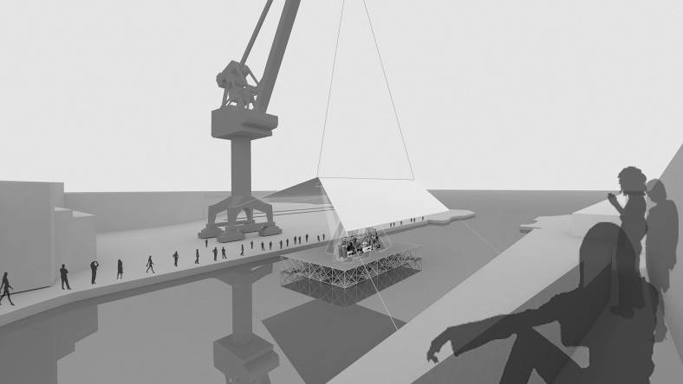
Fig. 5. Rendering of the winner project in Istanbul

The project suggests a floating surface that can be shipped into the dockyard and used as a stage for concerts. A tent hanging from the highest crane of the territory is used as roof over the stage [6].

6. The realization process in Pécs

The realization of the project 2010 chairs has taken place in the public spaces of Pécs between the 3rd and 10th October, in the autumn of 2010. The chairs shaped different forms on every public space. The chairs were produced in Italy, they are made of foldable plastic material and with this they are weatherproof. The material, the plates arrived to the Mihály Pollack Faculty of Engineering of the University of Pécs on pallets. On the first day the doctoral students of the Marcel Breuer Doctoral School and some professors started to fold the chairs. With mass-folding program the plastic plates are turning to chairs. The first installation was a blockade at one of the entrances of the faculty building.

In the next two days the students of the faculty has been participating at the mass-folding. Place of the happening was the entrance hall of the faculty and the courtyard in front of it. The students really liked the mass-folding program. They built a lot of things from the chairs, among them a large pyramid. At the end of the third day all of the chairs were folded. The program was so successful that in the afternoon of the last day a pallet of plates should be separated so that the students coming in the afternoon also had the possibility to fold some chairs. Also some volunteers from the Pécs2010 Management Center participated at the mass-folding. In the evening all of the chairs have been put in front of the faculty in rows. That was the time when one of the professors of the faculty said: “The new auditorium for 2000 people is ready!” In the evening of the same day all of the chairs were transported to the courtyard of the Lajos Nagy Grammar School, where the program started on the next day.

Exactly this day, so the 6th of October is the day of the yearly fire-alarm in the grammar school. As probably everybody knows at the fire-alarm all of the pupils have to leave the building of the school as soon as possible. So the idea of the director was that we should connect the two programs. Every student had to take two chairs with him/herself and bring them to the main square of Pécs, to the Széchenyi square. After this movement a flash mob has started with 750 pupils of the grammar school. At a flash mob a lot of people suddenly appear at a place and they are doing something together and after short while they disappear even so suddenly. In the 10 minutes long program the students had to make some movements with the chairs.

Also the inhabitants and the press were interested to see the appearance of the chairs and the opening of the program in the afternoon. The happenings of the afternoon and the evening were totally surprising. A lot of people came to the main square to build something of the chairs. There were families with young children, pupils of more secondary schools, students but also elder people. Some of the builders built the title of the program from the chairs.

Next day morning the chairs were still on the main square, the transport started in the afternoon. A huge arrow made of chairs showed the direction of the movement. Some of the chairs have been thrown from one hand to the other so that anybody could join the program. Most of the chairs were transported to the 48th square. The first form on the new public space was a huge chess table. Of course this form has been changed by the people passing by.

One of the most spectacular happening has taken place on the next day. 200 pupils of a primary school have played different games with the chairs. The last game was the tallest tower. Every group had to build a tower separately. The weather was really good that time so the pupils really enjoyed the afternoon program. At the end every pupil could bring a chair to home, to remember this program.

On Saturday the chairs has been transported to the newly opened South-Transdanubian Regional Library and Knowledge Center. At this place a part of the parking lot was occupied by the chairs. (see Fig 6.) In the evening the closing party has taken place here with the music of DJ Con.

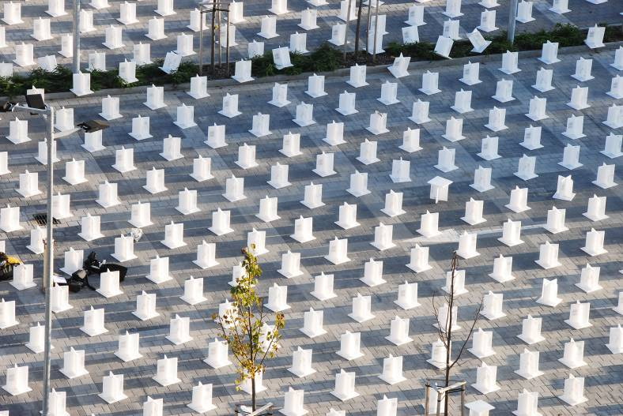

Fig. 6. 2010 Chairs at the parking lot

During the week there were some security people in the night not to steal all of the chairs. After the closing party it was allowed anybody to bring some chairs to home. For the next day there were ca. 500 chairs left. The other part of the originally 2010 chairs disappeared, they has been taken by the inhabitants and the visitors of Pécs.

The planners of Pécs2010chairs wanted that somehow, maybe in a symbolic way the chairs will reach the original destination, the Zsolnay Factory, which was that time still a construction site. So finally three chairs were thrown into the Balokány-lake on the way and one single chair finally reached the destination the Zsolnay Cultural Quarter. [7]

Some people said that this chair will be a really good stand for plants at home, other brought it with them to use as a chair in the workshop or by angling. Some of the chairs reached their final destination in the courtyard of a primary school or a kindergarten.

7. Conclusion
As a conclusion the author thinks that Temporary City is a really good workshop for the students. Temporary City is cooperation between universities of the European Capitals of Culture (see Fig. 7). For the students it is a good opportunity to see different working methods and point of views. The objectives and the places are interesting for anybody. For the student the most important point is that they can plan something that will be realized as a temporary object.

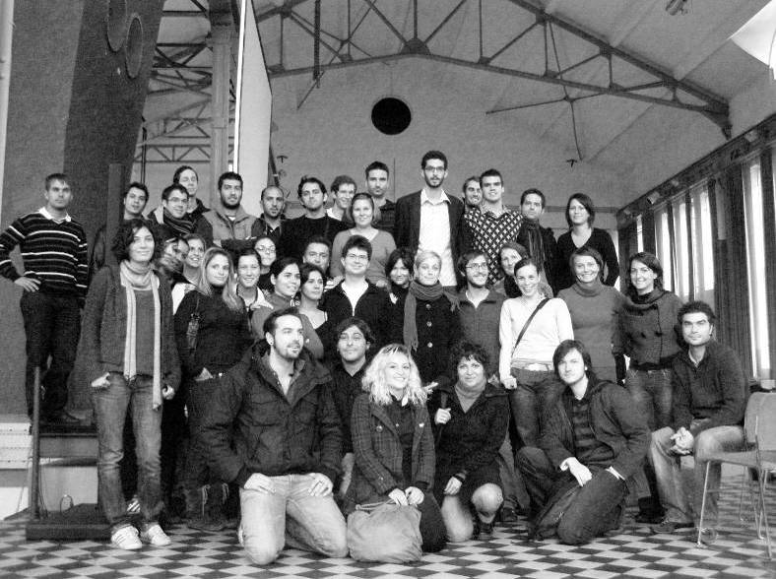
Fig. 7. The group of students at the workshop in Gelsenkirchen

References
- Temporary Architecture at special locations 2004, Initiative StadtBauKultur NRW, Gelsenkirchen, 2005.
- Temporary Architecture at special locations 2006-07, Europäisches Haus der Stadtkultur, Gelsenkirchen, 2008.
- http://uneecc.org/htmls/uneecc_conference_vilnius_presentations.html, last visited 12.12.2009
- http://www.temporaere-stadt.de/start.html, last visited 05.09.2010
- http://epitesz.pmmk.pte.hu/tc_workshop, last visited 05.09.2010
- http://www.temporarycityistanbul.org/, last visited 05.09.2010
- Molnár T. The Realization Process, ed: Erkol, I. Manisa, K. Yerliyurt, B. Temporary City Istanbul „2010 Avrupa Kültür Başkentleri Arasinda Diyalog” „Dialogue Between The European Capitals of Culture 2010”, Istanbul 2010 Avrupa Kültür Başkenti Ajansı Yayınları, Istanbul 2010. pp 246-270.

