WebLab of a DC Motor Speed Control Didactical Experiment

¹L. A. Mendes, ²K. Bauer
Production and Systems Engineering Post Graduation Program, Pontifical Catholic University of Parana, Curitiba, Brazil,
l.mendes@pucpr.br ¹, bauer.karine23@gmail.com ²

Abstract
Weblabs are an additional resource in the execution of experiments in control engineering education, making learning process more flexible both in time, by allowing extra class laboratory activities, and space, bringing the learning experience to remote locations where experimentation facilities would not be available. The present paper depicts a weblab project where the speed of a DC motor is controlled in closed loop, being the control system parameters set by the remote user (student). The engine control experiments are run and on-line transmitted by videoconference over the internet, from a didactical plant physically located at the Systems and Automation Laboratory of the Control and Automation Engineering department of the Pontifical Catholic University of Parana. The system response (transient motor speed) to the user’s choice of parameters is evaluated through performance indices (IAE, ITAE), which are used to qualify the ability of the student to tune PID and RTS control algorithms. There is an option to run experiments in open loop, so the student can perform preliminary analysis to identify the system dynamic model and then apply mathematical models and computational methods, learned in theoretical classes, to define best performance control parameters. Also, a simulation function was implemented, to further help the student in the problem solution. Virtual instrumentation resources were used to implement the Weblab, using the DC motor of a laboratory didactical plant. A local server runs a LabVIEWTM application, which can be remotely accessed in the client side through a web browser, where the system front panel is reproduced. This remote interface is directly originated at the LabVIEWTM application, through an embedded web server. At the user request, the control of the remote system is granted. The user interface is cognitive, with motor speed, control signal, set point and all the pertinent information displayed in evolving charts and indicators. Skype is used to establish a videoconference with the laboratory where the plant is located. Results of the user experiments are stored in local files, which can be emailed to the user at his command by the end of the session.

1. Introduction
The computing and networking technologies available nowadays can support the remote execution of experiments, in plants and systems existent in laboratories which can physically exist very far from the student who is operating it over the Internet. Naturally, fundamental engineering disciplines are expected to have hands-on laboratory activities, as to qualify undergraduate courses. Nevertheless, there are many situations in which the execution of experiments at distance can be the only available option. For example, let’s consider the situation in which a specific experimental equipment is not offered by an institution for students use. Eventually, a similar one is available and idle in a second institution, which could grant its remote use to the first under proper agreements. Another example lies in the case of engineers working in companies settled in towns away from the main centers, who are likely to face difficulties in staying updated in their areas of actuation, having few options when willing to resume studies. The Distance Learning (DL) modality becomes attractive in this context, but the possibilities are limited in technical areas where laboratory experimentation makes the difference. In such cases, the remote, live operation of laboratories, through appropriated computer interfaces and videoconferencing resources, is to be considered a much better approach then purely theoretical classes. The distant execution of experiments can be seen as a modern and globally reaching solution for engineering education, optimizing the use of laboratory resources and reducing the need to move people to the facilities location, therefore in accordance with sustainability ideas.

In the particular case of control engineering education, Weblabs have an important applicability. As a physical system is incremented and modified for remote operation, the use of closed loop control of variables has great educational purpose potential through the exploration of different control strategies and their optimization, defying students to design optimum sets of parameters which lead to the best performance. Control systems are intensively used throughout industrial processes automation, manufacturing machines, modern consumer products, energy efficient systems, security systems, and others.

In this paper, the control of a DC motor plant through a web browser and with live visualization by the user is presented. The performance of the system governed by a given set of user-defined controller parameters is measured through objective indicators. These indicators measure how quickly the system reaches and stabilizes in the new state commanded. As an experimentation session is completed, results are emailed to the user at his order.

The DC motor speed is the controlled variable. Two alternative control strategies were implemented – PID and RTS. The inertia moment of the rotational mass attached to the motor and the inherent frictions define the plant dynamics. From the combination of plant, sensor and control system dynamics results the system response. The user can modify the controller parameters only.

2. Control Systems and Performance Indices
The main objective of a control system is to bring a process variable (PV) to the desired set point (SP) by nulling the error e(t), which is defined as the instant difference between PV and SP. For control systems analysis and design purposes, processes, controllers and sensors have their characteristic dynamic behavior mathematically expressed in the s-space, as the Laplace transform of a time domain differential equation, known as transfer function. In a closed-loop control system, the block diagram of transfer functions has the classical form shown in Figure 1.

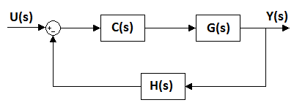
Figure 1: General control system structure.

The PV is controlled through the continuous modification of another variable that affects it, the so called manipulated variable (MV), whose value is computed by the controller. Usually, the process block includes the dynamics of the actuation system that varies MV. The controller, process and sensor transfer functions are named C(s), G(s) and H(s), respectively. The (process + controller + sensor) combined behavior can be designed by asserting certain properties to its closed-loop transfer function [Ogata 2003], shown in equation (1).

$\frac{Y(s)}{U(s)}=\frac{\text{CG}}{1+\text{CGH}}$ (1)

Considering G(s) and H(s) as the representation of an existent system, the engineer can design an optimum C(s) which will result in the best overall performance, i. e., that minimizes the PV settling time and transient overshoot. Additionally, stability analysis can also be performed.

The PID (proportional – integral – derivative) controller architecture is by far the most broadly used, being responsible for the major part (90 - 95%) of the solutions to industrial control problems. It combines the advantages of PI (proportional – integral) and PD (proportional – derivative) controllers. The integral action is responsible for nulling the error in permanent regime, while the derivative one fastens the system stabilization due to its anticipation effect. Most of the controllers, nowadays, are implemented digitally. In the time domain, the PID controller equation (2) has three main parameters: Kp – proportional constant; Ti – integral time; Td – derivative time. u(t) is the controller output.

$u(t)=\text{Kp}\text{.}e(t)+\frac{\text{Kp}}{\text{Ti}}\int{e(t)\text{dt}}+\text{Kp}\text{.}\text{Td}\frac{\text{de}(t)}{\text{dt}}$ (2)

In equation (3), the discrete-time expression required for software implementation of the above equation:

$u(k)=u(k−1)+\left(\text{Kp}+\frac{\text{Kd}}{\text{dT}}\right)\text{.}e(k)−\left(\text{Kp}−\text{Ki}\text{.}\text{dT}+2\frac{\text{Kd}}{\text{dT}}\right)\text{.}e(k−1)+\frac{\text{Kd}}{\text{dT}}\text{.}e(k−2)$ (3)

An alternative controller architecture is known for R-S-T, shown in Figure 3. In this model, R, S and T are polynomials in the complex variable z, and SP, PV, MV are represented by w(z), y(z) and u(z), respectively.
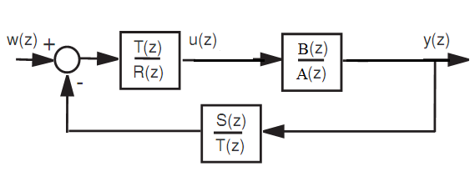
Figure 3: RTS controller structure.

The closed loop transfer function for this model is given by (4), where A and B are numerator and denominator of the process transfer function, respectively.

$G_{\text{cl}}=\frac{\text{BT}}{\text{AR}+\text{BS}}$ (4)

The discrete-time version for implementation of the RTS controller is given by (5)

$u(z)=\frac{T(z)}{R(z)}\left(w(z)−\frac{S(z)}{T(z)}\text{.}y(z)\right)$ (5)

Unlike the PID model, where the system error is controlled, RST control allows independent treatment of the controlled variable signal (PV) and of the reference signal [Campos 2003].
2.1 Performance Indices
In order to optimize the performance of the control system, the gains are adjusted to maximize or minimize a performance index, which is measured over a period of time, usually during the stabilization time. In this paper, two performance indices were used: IAE and ITAE [Mathworks 2011]. The Integral of Absolute Error (IAE) (6) considers the integral module of the error. This performance index is widely used in simulations studies and is easy to implement and understand, but does not impose any penalty if the system lasts a long time to settle to the set point value.

$\text{IAE}=\int{\left|e(t)\right|\text{dt}}$ (6)

The Integral of Time multiply Absolute Error (ITAE) (7) performance index is designed to improve the IAE criterion. The absolute error in ITAE is weighted by the time. Systems optimized for ITAE minimization settle quickly, with less oscillations and lower overshoot.

$\text{ITAE}=\int{\left|e(t)\right|\text{.}t\text{.}\text{dt}}$ (7)

3. The DC Motor Speed Plant Model
The dynamic model for the DC motor is given by a differential equation on the rotational speed ω (8), where J is the motor and attached rotating parts total moment of inertia, and B the equivalent viscous friction.

$J⋅\frac{dω}{\text{dt}}+B⋅ω=T(t)$ (8)

In this model, the torque T(t) is governed by the MV value output by the control system to the plant (9):

$T(t)=K_{1}⋅V_{\text{MV}}(t)$ (9)

The transfer function for this simple system is of the first order (10),

$\frac{ω(s)}{V_{\text{MV}}(s)}=\frac{K}{τ⋅s+1}$ (10)

where

$K=\frac{K_{1}}{B}$ (11)

and

$τ=\frac{J}{B}$ (12)

Rather than determining the values K and τ by measuring the motor system properties physically (or through estimation) and then applying formulae 10 and 11, the transfer function can be evaluated through the plant response to a step function.

4. The Weblab Architecture
The DC motor used in the project is component of laboratory didactical plant existent at the Systems and Automation Laboratory of the Control and Automation Engineering department of the Pontifical Catholic University of Parana (PUCPR). The motor can run, clockwise and counter-clockwise, up to ±800RPM. The linear control signal applied is in the range of ±10V, and the speed is acquired as a voltage level in that same range, which is converted into the motor speed also by a linear rule.

System components integration is shown in Figure 4. The motor speed plant is interfaced to the server computer through the external connector block of a multi-functional input/output PCI-standard DAQ board. This board is responsible for the analog signal acquisition and output used in the closed-loop control of the plant’s DC servo-motor. LabVIEW (Laboratory Virtual Instrument Engineering Workbench), [National Instruments 2011] was used as a software platform for interface development and internet / computer / hardware / plant integration. Weblabs interfaces can be designed in any language, as long as the resulting system can be made available on the internet to the end user as a (safe) web server. [Ngolo 2009] uses the concept of Web Services in weblabs design. However, the integration of a high level, user-friendly interface with the physical system requires physical input/output involving signal conditioning and communication interfaces [Sumathi 2007], and this is where solutions which can handle this transport of information between the real world and the computer, keeping high level programming and easier interface design capabilities, become attractive. The LabVIEW platform has been used in several weblabs projects [FEUP 2010] [Cox 2010].

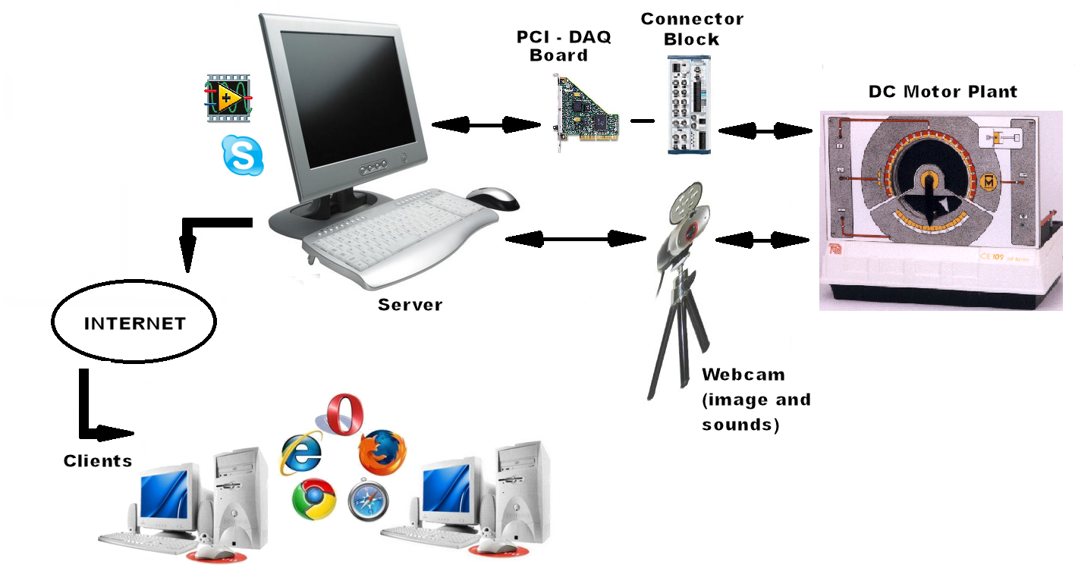
Figure 4: WebLab components integration.

In the server computer, the LabVIEW application displays the user interface, where the available functionalities are accessed, and performs the controller calculations during the experiments. With an Internet connection of enough speed, network latency is not a problem and the user interface in the remote client’s web-browser has responsiveness very close to that verified when running the system in local mode. The web server is a built-in feature available in the LabVIEW platform, configured through the ‘Web Publishing Tool’, which generates a high quality webpage of the application front panel. Multiple clients can access the interface simultaneously and watch the experiments, but only one at a time can be granted the system control. The need for a specific web browser plug-in in the remote computer to run LabVIEW based solutions should be considered a minor problem, since the plug-in is freely downloadable in the internet and the benefits of having an integrated web server easily configured and running are a considerable advantage.

The videoconference system can be embedded in the main software application, or be implemented through a dedicated application in an internet language, such as Java [Yeung 2003]. Nevertheless, modern programs for internet personal communication are another source of solution. One popular program of this kind is Skype [Skype 2011], an application originally created for VOIP (Voice Over IP) calls that was enhanced with video transmission between users with enabled webcams. In this project, Skype was selected to provide the videoconference functionalities.

The users demand can be managed in the local LabVIEW environment by the system administrator.

5. User Interactivity with the WebLab
In Figure 5, the functionalities available in the weblab are shown in a schematic tree. The main modules are: Videoconference, DC Motor Control, Simulation. The user observes the experiment directly on the plant through the live image and sound transmitted through the Skype audio/video call between the user and the plant (a Skype user has been specially created for the plant).

Ideally, on the user computer, two monitors are connected and full-screen enabled: one for the weblab interface and another for the Skype transmission. Alternatively, a side or corner screen position for Skype can be adopted, only that with a reduced image of the plant. The first option provides better ergonomics.

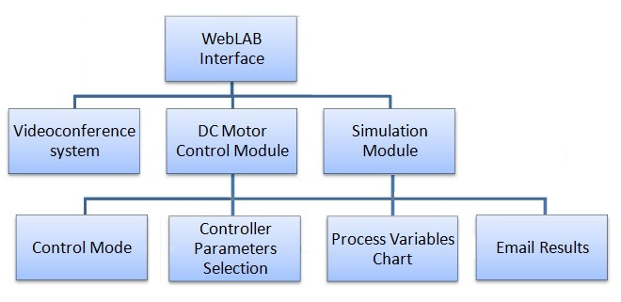
Figure 5: System functionalities.

When operating the developed weblab, the user has as objective to tune the DC motor speed control system to the best performance level. In practice, this means that at the order to go to a specific speed, the motor should do it quickly and with minimum oscillations. By watching the variables’ chart, it is possible to make a first idea of how well the control system parameters have been chosen, either with PID or RST control enabled. The updated ITA and ITAE indexes are continuously displayed to the user, in real or simulated operation mode.

From control theory, it’s known that prior to the design of a good control system it is necessary to know the system dynamic model. One way to accomplish this is through an open-loop response test, which can be done by the user through the ‘Manual’ mode of operation. In this test, the system is submitted to a step function and then the process variable evolution is examined for the determination of the system’s dynamic parameters (motor system model).

Once the system model is determined, the user can propose different control parameters sets based on his control engineering theoretical knowledge. Also, the parameters can be entered in the simulation module, and then compared to the results returned by the real system. All data produced during the test is locally saved and, at the user order, sent to the user input email address in an attached text file.

6. Results and Discussion
In Figure 6, the remote computer from which the system was being operated during a session is presented. For the live transmission of the plant, the camera / microphone unit is appropriately positioned to provide a close view and hearing to the user.

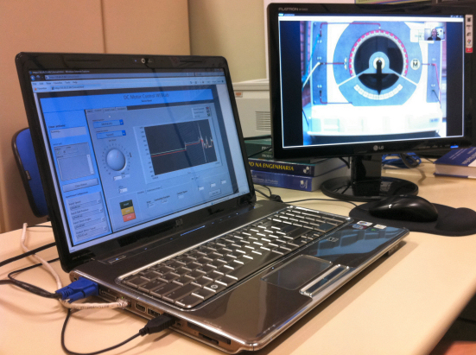

Figure 6: Side-by-side monitors improve ergonomy.

Figure 7 contains a picture of the system running, with both interface and plant displayed for the user in separate monitors, in the Microsoft Internet Explorer (IE) web browser and in Skype, respectively.

Figure 7: Weblab in the remote client - web browser and plant observation screens.
The triple chart in the interface displays PV (rotation ω), MV (output signal V_{MV}) and SP (rotation ω), and has been edited into a clear picture in Figure 8, using for plots colors red, black and green, respectively. A prevalent superposition of the red and green curves means the PID parameters choice is of good quality. The MV curve shows the system maneuvers to apply variable torque to the motor, as to keep PV tracking SP. This control action is more intense when changes applied to the SP value are higher.

Figure 8: Plots of the variables PV, MV (not in scale) and SP.

The experiment results are saved in a ‘.dat’ text file data format, headed with session identification and data acquisition timing information. The file is given a name by the system automatically, and at user order is emailed. The user can then use the data to make further analysis and to generate reports with his drawn conclusions.

Laboratory activities are an opportunity for students to verify theoretical concepts in practical experimentation. The present weblab provides that experience to a limited extent, since the hands-on activities do not involve the general preparation of the plant, connections of plugs / cables and their verification. On the other hand, it provides the same base of results to be analyzed, i. e., the same conditions for the development of abilities to criticize and evaluate the results, and use to feedback improvements in the controller performance.

The depicted system can be situated between a proof-of-concept and a fully-functional system, as there are evident requirements [Mendes 2010] yet to be attended before having it on-line. The improvements to be implemented include: login control, users scheduling, a communication channel with the system administrator, safe operation assurance (e. g. soft rotation inversion) and remote plant dynamics modification. The latter will require direct intervention on the original plant system, with the design of specific actuators, that must be integrated with the system.

The system was developed with scalable software architecture [Blume 2007], using a producer-consumer code design pattern to coordinate the user inputs with the execution of sub-routines. If additional functionalities are to be implemented, e. g. new control strategies and analysis functions, they shall not require deep modifications in the software structure.

Finally, in order to access the weblab from outside the university network, it was required an IT department permission, due to internet safety reasons. Actually, this is another important point to be managed when designing such systems.

7. Conclusions
A weblab for a DC motor speed plant has been implemented on the basis of a LabVIEW and Skype combined solution for over-the-internet interfacing and videoconferencing. As a traditional virtual instrumentation solution with readily available resources for communications with data acquisition systems and advanced connectivity resources, the LabVIEW platform is a very suitable solution for the necessary software/hardware integration in weblabs projects. On the other hand, Skype is a popular solution for video calls that proved to be very efficient in establishing a videoconferencing environment, avoiding the need for the development of rather complicated software codes in internet languages. The developed system is a useful tool for teaching practical control engineering concepts, and can return to the student the performance achieved by the controlled system as a consequence of his abilities to determine the controller parameters. With some further effort, the system might be upgraded with user login control, so that results can be submitted to the class teacher as serve as a learning evaluation instrument.

References
1. P. A. Blume, The LabVIEW Style Book, 3ª Ed. Prentice Hall, 2007.
2. A. R. C. R., Campos, Projeto e Análise de Controladores a partir da Identificação em Malha Fechada: Estudo de Casos, Master Degree Dissertation, Universidade Federal de Minas Gerais, 2003. Available at: <http://cpdee.ufmg.br/defesas/398M.PDF>. Accessed April 15, 2011.
3. D. Cox, Z. Meric, R. Bartz, C. Ctistis, “Complementary Simulation and Remote Laboratory Experiences to Hands-on Control Systems Curriculum”, Proceedings of 2010 International Conference on Engineering Education, ICEE-2010, Paper No. 967, Gliwice, Poland, 2010.
4. L. A. Mendes, M. Debner and M. Siqueira, “Systematization of the WebLabs Development Process: Towards an Approach Proposal”, Proceedings of 2003 International Conference on Engineering Education, ICEE-2010, Paper No. 1052, Gliwice, Poland, 2010.
5. M. A. F. Ngolo, “Arquitetura Orientada a Serviços REST para Laboratórios Remotos”, Master Degree Dissertation, Universidade Nova de Lisboa, July 2009.
6. National Instruments. Virtual Instrumentation and Traditional Instruments, http://zone.ni.com/devzone/cda/tut/p/id/4757, Accessed May 15, 2011.
7. RemoteLab FEUP – Porto University, http://remotelab.fe.up.pt, accessed May 02, 2010.
8. Skype Limited, <http://www.skype.com>, 2011.
9. S. Sumathi, P., Surekha, “LabVIEW based advanced instrumentation systems.”, Berlin, Springer, 2007.
10. The Mathworks, Inc., Learning PID Tuning III: Performance Index Optimization, available at http://www.mathworks.com/matlabcentral/fx_files/18674/1/content/html/optimalpidtuning.html. Accessed April 15, 2011.
11. K. Ogata, Modern Control Systems, 4 ª Ed. Prentice Hall, 2003.
12. K. Yeung, J. Huang, “Development of a remote-access laboratory: a dc motor control experiment” - Computers in Industry, 52, 2003, pp. 305–311.

