Physics and Chemistry Courses in Mechanical Engineering Curriculum

Dr. Murat Sönmez
Middle East Technical University
Northern Cyprus Campus Mechanical Engineering Program
Güzelyurt KKTC ^{sonmez@metu.edu.tr}

Abstract
In the restructuring process commenced after the Bologna Declaration, the Turkish Engineering Education System is to be scrutinized in detail considering the demands of the labor market. In this paper, the curriculum of mechanical engineering education in two of the tiers is discussed and the classical physics and chemistry courses are proposed to be replaced with some advanced level 1 or 2 credits science courses in mechanical engineering curriculum.

1. Introduction
When the increasing complexity of engineering systems, the expectations and demands of job market from engineers and the status quo of engineering faculties are considered, it is obviously seen that engineers need broader training to adapt to the technological innovation and global competition in industries and therefore the engineering education system should be restructured.

This necessity has occasioned to the Sorbonne and the Bologna Declarations and new debates about the competencies of the graduates of university were started, and the studies for restructuring the education systems were speeded up. The Sorbonne Declaration, signed in 1998, recommended that university education should be organized in an undergraduate and a graduate cycle, but did not provide an indication of their duration. The Bologna Declaration, signed in 1999 by 30 European Ministers of education, on the other hand, is a remarkable document containing an action plan and implementation process. One of the objectives defined in this Declaration is the adoption of a system essentially based on two main cycles, as it is mentioned in the Sorbonne Declaration, requiring successful completion of the first cycle, lasting a minimum of three years, for the access to the second cycle. In this system the degree awarded after the first cycle shall also be relevant to the European labor market as an appropriate level of qualification [1].

There are examples of two-tier structures in all branches of engineering. However in many countries, contrary to the expectation mentioned in the Bologna Declaration, the Bachelor/ Master structure does not concern certain professional curricula. Therefore, unfortunately, trial- error is a widely used method in applications by young, non-professional technical staff due to insufficient application knowledge and skill. This causes economic losses, and undermines occupational safety and health at work. For being a professional engineer, the correct method is graduating from master of engineering program with a curriculum that teaches the bases of application, which do not change in time and participating short-term courses offered by lifelong learning centers to learn the details of application. In the following part of this paper the structure of engineering education in Turkey is taken into consideration from the perspective of the Declarations mentioned above:

The structure of Turkish higher education is a two-tier system as undergraduate and graduate level of study. Undergraduate structure consists of the Vocational Associate’s Degree and the Bachelor’s degree. Associate’s degree is awarded after the successful completion of a two-year education and training by vocational schools of higher education. The graduate of a technical program of such a school is awarded with engineering technician title. Bachelor’s degree education does not concern certain professional curriculum. Since the entrance of the graduates of technical high schools to engineering programs is hindered, in application, the graduates of general or science high schools only are accepted to engineering education. For these students, four years are not sufficient to teach the basic and the related application courses of the profession. Looking at the existing curriculum of mechanical engineering, it can be seen that in the 1st Year, the physics and chemistry courses repeat the content of the ones given in high school education. The current approach considers the students as they come to university with inadequate and incomplete knowledge and therefore not ready to follow the engineering science courses. This approach underestimates and denies the high school education contrary to the main objective of its curriculum. The main objective of high schools (secondary schools) is expressed in the Laws and Regulations with such a statement [4]: “General high schools do not prepare students for a specific profession but rather for higher education”. Today, the existing curriculum of Mechanical Engineering is to be renewed by some new science and application courses to satisfy the demands of labor market. However, the total course credit limit prevents such a renewal. In the face of this dilemma, the answer to this question becomes important: Should the university really repeat high school physics and chemistry? The ones who may answer this question positively with such a statement “13% of engineering curricula is to be formed by science courses [2]” do not consider the content. Yes, there should be some science courses in engineering curricula, but with which content? The correct answer requires making a review on the role of an engineer and engineering education:

2. Education for Engineering

The profession of engineering takes the knowledge of mathematics and natural sciences gained through study, experience and practice and apply this knowledge with judgment to develop ways to utilize the materials and sources of nature for the benefit of all humans. An engineer is a person who possesses knowledge of mathematics and natural sciences and through the principles of analysis and design applies this knowledge to the solution of problems and the development of devices, processes, structures, and systems. Scientists primarily use their knowledge to acquire new knowledge on laws of nature, whereas the engineers apply the knowledge to design and develop usable devices, structures, and processes. Although in general engineers use the knowledge introduced by scientists in some cases scientists learn great deal from the work of engineers, for example the science of thermodynamics was developed by a physicist from studies of practical steam engines built by engineers. An engineer may become involved in research, in developing a functional device, structure or process, in design work, in production and testing, in sales, in management, in consulting and in teaching [2], [3]. A successful research is necessary for starting development and design activities for a new product. Using existing knowledge and new discoveries from research, the development engineer attempts to produce a functional device, structure or process. Development engineers produce concepts or models and design engineers determine the shape and size of the product considering the cost of manufacture, ease of production, availability of materials, and performance requirements. Duties and responsibilities of engineers require very adequate education.

Today the quality of engineering programs of universities are accredited by some boards, ABET, CEAB, MUDEK etc. The Accreditation Board for Engineering and Technology is the most common organization responsible for accrediting the educational programs that grant engineering degrees. The board has identified a set of skills that new engineering graduates are expected to have. These skills also frame the curricula of engineering programs. Engineering programs must demonstrate that their students attain the following outcomes:
- An ability to apply knowledge of mathematics, science, and engineering,
- An ability to design and conduct experiments, as well as to analyze and interpret data,
- An ability to design a system, component, or process to meet desired needs,
- An ability to function on multidisciplinary teams,
- An ability to identify, formulate, and solve engineering problems,
- An understanding of professional and ethical responsibility,
- An ability to communicate effectively,
- The broad education necessary to understand the impact of engineering solutions in a global, economic, environmental, and societal context,
- A recognition of the need for and an ability to engage in lifelong learning,
- A knowledge of contemporary issues,
- An ability to use the techniques, skills, and modern engineering tools necessary for engineering practice.

3. Discussion on Mechanical Engineering Curriculum and Conclusion

According to the frame described in the preceding part, the courses of an engineering curriculum can be grouped in some main areas and the approximate percentage of time spent on each group can be determined (Fig. 1, [2]).

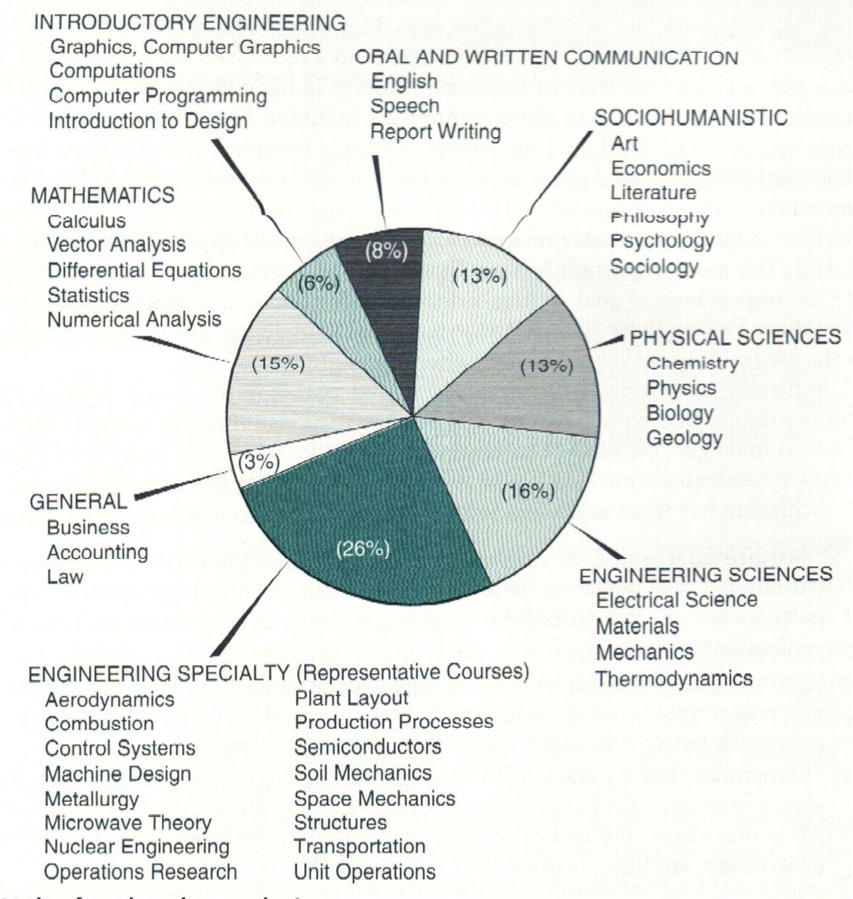

Fig.1. Elements of Engineering Curricula [2].

As it is shown from this figure approximately 13% of engineering curricula is to be formed by science courses. The physics and chemistry are fundamental to the study of engineering science. Unfortunately this part of the frame has been interpreted wrongly by some universities:
For instance, in Turkish education structure secondary (high school) education follows eight years of primary education and covers general, science and vocational and technical high schools that provide four years of education General and science high schools do not prepare students for a specific profession but rather for higher education, as it is stated in Basic Law of National Education. In general high schools, in their second year, students may choose to attend branches which specialize in the natural sciences, literature and mathematics, the social sciences, foreign languages, art or physical education. Engineering programs admit the graduates of science high schools and the graduates of general high schools who have chosen science branch. In science high schools and in science branch of general high schools the science and mathematics courses have the major importance. The students are well educated on physics, chemistry, biology and mathematics. They are provided with the necessary science and mathematics background that is required in engineering education. Although only the well educated graduates of science and general high schools are admitted to engineering programs and the students are already ready to follow the engineering science courses thanks to their high school background, unfortunately in some universities (in Turkey in all) science courses part of engineering curricula is filled by physics and chemistry courses with the same content of the ones taught in high school. In a typical mechanical engineering curriculum (Table 1 [5]) to

Table 1. A Typical Mechanical Engineering Curriculum in Turkey [4]

First Semester
MAT 119 | Calculus with Analytic Geometry | (4-2) 5
PHY 105 | General Physics - I | (3-2) 4
CHM 107 | General Chemistry | (3-2) 4
MECH 113 | Computer Aided Engineering Drawing - I | (2-2) 3
ENGL 101 | Development of Reading and Writing Skills I | (4-0) 4
CNG 100 | Intro. to Information Technologies and Appl. | (2-0)NC
Second Semester
MAT 120 | Calculus for Functions of Several Variables | (4-2) 5
PHY 106 | General Physics - II | (3-2) 4
CNG 230 | Introduction to C Programming | (2-2) 3
MECH 114 | Computer Aided Engineering Drawing - II | (2-2) 3
ENGL 102 | Development of Reading and Writing Skills II | (4-0) 4
MECH 100 | Introduction to Mechanical Engineering | (1-1)NC
Third Semester
MAT 219 | Introduction to Differential Equations | (4-0) 4
MECH 202 | Manufacturing Technologies | (3-2) 4
MECH 203 | Thermodynamics | (4-0) 4
MECH 205 | Statics | (3-0) 3
MECH 227 | Engineering Materials | (3-0) 3
TUR 101 (a) | Turkish I | (2-0)NC
Fourth Semester
MAT 210 | Applied Mathemetics For Engineers | (4-0) 4
MECH 206 | Strength of Materials | (4-0) 4
MECH 208 | Dynamics | (3-0) 3
MECH 220 | Mechanical Engineering Laboratory - I | (1-2) 2
EEE 209 | Fund. of Electrical and Electron. Engr. | (3-0) 3
ENGL 211 | Academic Oral Presentation Skills | (3-0) 3
TUR 102 (a) | Turkish - II | (2-0)NC
Fifth Semester
MECH 301 | Theory of Machines | (4-0) 4
MECH 305 | Fluid Mechanics | (4-0) 4
MECH 311 | Heat Transfer | (4-0) 4
ECO 280 | Engineering Economy | (3-0) 3
 | Non-Technical Elective | (3-0) 3
HST 201 (b) | Principles of Kemal Atatürk I | (2-0) NC
MECH 300 (c) | Summer Practice - I | NC
Sixth Semester
MECH 303 | Manufacturing Engineering | (3-0) 3
MECH 304 | Control Systems | (3-0) 3
MECH 307 | Mechanical Engineering Design | (4-0) 4
MECH 320 | Mechanical Engineering Laboratory - II | (1-2) 2
 | Non-Technical Elective | (3-0) 3
HST 202 (b) | Principles of Kemal Atatürk II | (2-0)NC
Seventh Semester
MECH 420 | Mechanical Engineering Laboratory - III | (0-4) 2
MECH xxx | Elective | (3-0) 3
MECH xxx | Elective | (3-0) 3
MECH xxx | Elective | (3-0) 3
ENGL 311 | Advanced Communication Skills | (3-0) 3
MECH 400 (c) | Summer Practice - II | NC
Eight Semester
MECH 458 | Graduation Design Project | (0-6) 3
MECH xxx | Elective | (3-0) 3
MECH xxx | Elective | (3-0) 3
MECH xxx | Elective | (3-0) 3
 | Free Elective | (3-0) 3

each of the chapters contented in such a physics course different one- semester engineering science courses correspond. In the Middle East Technical University, which is the top ranked university in Turkey, there are two physics courses and one chemistry course in mechanical engineering program, PHY 105 General Physics I (3-2) 4, PHY 106 General Physics II (3-2) 4, CHM 107 General Chemistry (3-2) 4. In the catalog description the contents of these courses are briefly given as:
“PHY 105 General Physics I (3-2)4
Vectors, equilibrium; kinematics; particle dynamics, work and energy; conservation of energy; system of particles; collisions; rotational motion; oscillations.
PHY 106 General Physics II (3-2)4
Electric charge; electric field; Gauss' law, electric potential; capacitance; current and resistance; circuits; magnetic field; Ampere's law; Faraday's law of induction; electro-magnetic oscillations; alternating currents.

CHM107 - General Chemistry (3-2) 4
Introduction to atomic and electronic structure, chemical bonding, molecular structure and bonding theories, properties of liquids, solids and solutions, chemical equilibrium, kinetics, thermodynamics, metal complexes, organic compounds and nuclear chemistry.

The content of PHY 105 is fully covered, in much broader detail, by some engineering science courses to be taken in second year, Statics, Dynamics, Thermodynamics and by some other 3rd and 4th year courses, such as Mechanical Vibrations, Theory of Machines, Acoustic and Noise Control etc. The catalog description of the content of basic engineering science courses are shown in Table 2.

Table 2. Science courses in mechanical engineering curriculum (METU NCC )

Science Courses | Course Content
MECH205 - Statics  (3-0) 3 | Idealizations and principles of mechanics. Important vector quantities, classification and equivalence of force systems. State of equilibrium. Elements of structures; trusses, beams, cables and chains. Friction. Elements of statics of fluids. Variational methods
MECH208 - Dynamics (3-0) 3 | Kinematics and kinetics of particles and system of particles. Plane kinematics and kinetics of rigid bodies. Newton’s second law of motion. Methods of work-energy and impulse-momentum.
MECH203 Thermodynamics  (4-0) 4 | Basic concepts and definitions. Properties of a pure substance. Equations of state. Work and heat. First and second laws of thermodynamics. Internal energy and enthalpy. Second law of thermodynamics. Availability. Power and refrigeration cycles. Gas and vapor mixtures. Thermodynamic relations.
MECH227  Engineering Materials (3-0) 3 | Structure of engineering materials. Bonding, crystals, grains, imperfections. Mechanical properties. Tensile testing, impact testing, hardness. Plastic deformation, strain hardening, solution hardening, grain size effect, re-crystallization. Failure of materials, fracture, fatigue, creep. Phase and phase diagrams. Fe-C phase diagram. Steels. Heat treatment of steels. Alloy steels. Cast iron. Non-ferrous alloys. Ceramics. Polymers. Composites. Some laboratory experiments will be carried out.
MECH220 - Mechanical Engineering Laboratory I (1-2) 2 | Laboratory work and its guidelines. Laboratory safety issues. Laboratory notebook keeping, report writing. Basic concepts in measurements, experiment planning, calibration, standards, experimental error and its analysis, uncertainty analysis. Data acquisition and processing. Analysis of experimental data. Displacement and area measurements. Pressure measurement. Flow measurement. Temperature measurement. Force, torque and strain measurements. The concepts of teamwork and leadership.
EEE209 - Fundamentals of Electrical and Electronics Engineering (3-0) 3 | Fundamental circuit laws. Resistive circuit analysis. Sinusoidal steady-state response of circuits. Three-phase circuits. Magnetic circuits and transformers. Electromechanical energy conversion.
MECH305 Fluid Mechanics (4-0) 4 | Introduction. Fluid statics. Kinematics of fluid flow. Integral formulation of basic equations. Bernoulli equation. Similarity. Viscous flow. Introduction to Compressible fluid flow. Some laboratory experiments will be carried out. Introduction to turbo-machinery.
MECH311 Heat Transfer (4-0) 4 | 1-D and 2-D steady heat conduction, extended surfaces. 1-D transient conduction. Dimensionless parameters, Reynolds analogy. External flow, empirical correlations. Internal flow correlations. Free convection. Forced convection. Heat exchangers. Radiative heat transfer. Boiling and Evaporation.
MECH301 - Theory of Machines (4-0) 4 | Basic concepts, mobility, basic types of mechanisms. Position, velocity and acceleration analysis of linkages. Gear trains. Static and dynamic force analysis of mechanisms. Virtual work method. Modeling and elements of vibratory systems. Free and forced vibrations of single degree-of-freedom systems.
MECH 429  Mechanical Vibration  (3-0) 3 | Coulomb and structural damping, response of single degree of freedom systems to periodic and non periodic excitation, vibration measuring devices, vibration criteria, diagnostics, Lagrange equations, multi degree of freedom systems, modal analysis, harmonic excitation.
MECH 432 Acoustics and Noise Control Engineering (3-0) 3 | Wave motion, wave equation, plane waves, spherical waves, sound transmission, mechanism of hearing, noise limits and legislation, noise control.

As it can be seen from the catalog descriptions, the part of the content of Physics 105 on vectors, vector mathematics, Newton’s Laws, equilibrium of particles and rigid bodies are fully and in detail is covered by MECH 205 Statics, the part of the physics on dynamics similarly is subjected in MECH 208 Dynamics, fully and in more detail. MECH 203 Thermodynamics and MECH 305 Fluid Mechanics and MECH 311 Heat Transfer cover the remaining part of the content of PHY 105, in much broader meaning. Some high level, advanced topics of physics, which are not contended in PHY 105, are subjected in the other engineering science courses, such as MECH 301, 429, 432…

Similarly, the content of PHY 106 is mainly subjected by EEE209 Fundamentals of Electrical and Electronics Engineering.

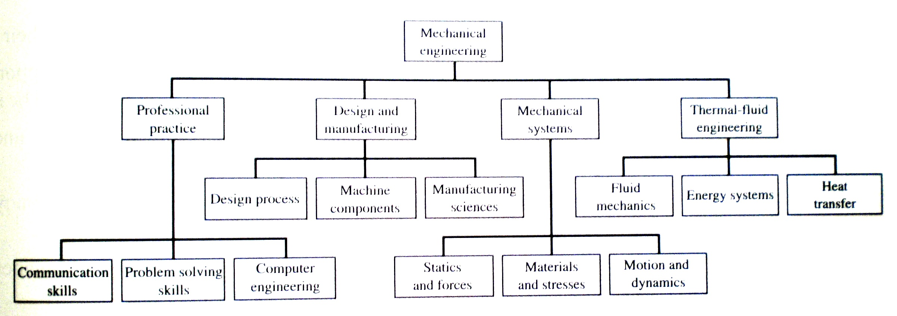

Figure 2. Hierarchy of topics and courses that are studied in a typical mechanical engineering curriculum [3].

In mechanical engineering education in some applied courses, such as internal combustion engines, heating-ventilation-air conditioning, theory of combustion, steam generator design, and in engineering materials course the basic principles of chemistry are referenced, such as atomic model, periodic table of elements, chemical equilibrium, expressing chemical reactions by using symbols, chemical properties of matter, etc.. The necessary back ground to be able to follow the content of such courses, actually is provided sufficiently in high school education. The review on the basic part of chemistry that may be required by the students is normally done at the introductory part of such courses.

Since there is a limit for total credits of the engineering programs, due to the existence of such courses, which repeat the content of the courses taught in high school, although today it is necessary to increase the credit of some engineering courses, such as thermodynamics, computer aided design and drawing, machine elements, machine design, etc. to be able to add the new issues introduced by technological developments to their contents and also it is necessary to add new theoretical and applied courses demanded by professional life to the curricula, these cannot be realized. And therefore, the expectation stated in Bologna Declaration, “the degree awarded after the first cycle should also be relevant to labor market as an appropriate level of qualification” cannot be satisfied. The graduates cannot be competent at profession. Although they are awarded to engineer title with all the privileges connected thereunto in Turkey, they cannot be relevant to labor market as an appropriate level of qualification. Additionally, inadequate engineering education negatively affects the master of engineering education.

In this situation, when the problems mentioned above are considered, the necessity of physics and chemistry courses is to be questioned. Is it really necessary to oblige the students to repeat high school level physics and chemistry courses? Today, instead of insisting on forcing the students to repeat high school physics and chemistry courses by denying the outcomes of high school education, some new elective physics and chemistry courses with contemporary content; such as Modern Physics, which may content quantum mechanics, nuclear structure and radioactivity, Semiconductor Physics, Nuclear Physics, Laser Physics, Biochemistry, Solid State Chemistry, Environmental Organic Chemistry etc. should be offered to the students who plan to be positioned as research engineer. In the curriculum of the Mechanical Engineering Program of MIT, the content of physics course covers the content of Statics and Dynamics, its objective is not repeating high school physics. And it offers some elective courses; e.g. Astrophysics, Solid State Chemistry [6].

The discussion on the subject of this article, to full agreement, can be concluded with Dr. Sandler’s opinion [7]: In the preface of his book “Chemical, Biochemical, and Engineering Thermodynamics” Professor Sandler says: “Chemical engineering faculties are increasingly examining their curricula to find space to add new subjects, such as biochemical engineering, and at the same time to meet institutional requirements of reduced credit hours. I believe that breadth is more important than redundancy, especially when redundancy has little positive effect. It is very important that we keep the right balance between breadth and depth, and critically examine the need for redundancy in our core program. If we omit introducing our students to some area, we make it much more difficult for them to independently learn about this subject later in their careers, since they will start without any basic knowledge, or without even knowing the nomenclature. Thermodynamics, in some form, is typically presented to students in general chemistry, physical chemistry, and physics courses, before the chemical engineering course. I believe this redundancy has had little positive, and perhaps even a negative, effect. Because of the types of systems considered, and frequently the use of quite different notation among different subject areas. I find that chemical engineering students are more confused by this redundancy than aided by it. Therefore, when I teach undergraduates I begin by telling them to forget what they have been taught about thermodynamics elsewhere. Consequently, I suggest that thermodynamics should be studied only in a chemical engineering thermodynamics course, eliminating the physical chemistry and physics exposures. I suggest eliminating the one- semester course of the physical chemistry program (retaining the course on statistical mechanics and quantum mechanics), and perhaps reducing by one credit the physics course”. Yes, adopting Dr. Sandler’s opinion to mechanical engineering curriculum, in this article, it is suggested that university should give up denying high school education and instead of insisting on repeating high school courses should increase the credits of engineering science courses and offer new contemporary courses for satisfying the demands of professional life.

References
[1] M. Sönmez. “Master of Engineering- Life Long Learning”, Proceedings of the 7thWFEO World Congress on Engineering Education, Budapest, Hungary, pp. 216-220, March 2006.
[2] A. R. Eide, at. al., Engineering Fundamentals and Problem Solving, McGraw-Hill, NY, 6th Ed., 2008, pp.1-51.
[3] J. Wickert, An Introduction to Mechanical Engineering, Thomson, USA, 2nd Ed. 2006, pp.1-25.
[4] Basic Law of National Education No. 1739 Year: 1973
[5] http://mech.ncc.metu.edu/content/program/curr/
[6] http://student.mit.edu/catalog/index.cgi
[7] S. Sandler, Chemical, Biochemical, and Engineering Thermodynamics, John Wiley & Sons
Inc. 4th Ed., 2006.

