Development of Integrated Learning Materials to Teach Energy Engineering Concepts for a Deep Approach to Learning

¹E. Montero, ²M. J. González-Fernández, ³F. Aguilar, ⁴F. E. M. Alaoui
Department of Electromechanical Engineering, University of Burgos, Spain emontero@ubu.es¹, mjgf@ubu.es², faguilar@ubu.es³, falaoui@beca.ubu.es⁴

Abstract
Rapidly changing technology means that graduates of engineering programs need to acquire important qualities of lifelong learning and self-learning to support a through-life ability to respond to advances in technology. Research has shown that the approach that the students take to learn a particular task is an important factor in determining learning outcomes. A surface approach focuses on discrete pieces of knowledge, without attempt to integrate them, learning just the unrelated facts. In contrast, in a deep approach to learning, the student looks for underlying meaning and structure, taking a holistic view. This paper presents a case study of introducing the fundamentals of energy engineering concepts through an integrated and meaningful engineering context, following the basis of deep approach to learning. Basic energy concepts and magnitudes such as pressure, temperature, heat, energy, power, voltage, current, etc. are well treated in modern engineering textbooks from the point of view of logical and mathematical development of concepts. The role of the teacher in helping the engineering students to construct these concepts for themselves is not to repeat the same scheme of the textbook but in presenting them within the engineering context that many of these concepts are useful now. The paper presents one example of material elaborated on energy concepts that, based in a deep approach to learning, can be used in traditional lectures (posters, documents, …) as well as in Learning Content Management Systems LCMS (multimedia, e-materials, …) for e-learning and b-learning in introductory engineering sciences courses. The material includes historical and modern aspects of the use of the concepts, transversal links with other engineering topics and the utmost importance of engineering evolution in creating new scientific developments. The material has been developed to be used in introductory courses of mechanical and electrical engineering at the University of Burgos, but can be also transferred to any other Faculty of Engineering.
1. Introduction
Research has shown that the approach that the students take to learn a particular task is an important factor in determining learning outcomes [1]. A surface approach focuses on discrete pieces of knowledge, without attempt to integrate them, learning just the unrelated facts. Students who see learning as increasing knowledge or memorization, that is, who see the process of learning as external to themselves, tend to use surface approaches and their focus is on satisfying assessment requirements. In contrast, in a deep approach to learning, the student looks for underlying meaning and structure, taking a holistic view. Such students see learning as an internal process, one that involves them acting upon the material in order to give it some meaning to themselves, learning the facts in relation to the concepts. That means that learning involves the construction of knowledge and that learners must actively seek to make meaning from their experiences by relating new information to what they already know. An important thing to note here is that the approach to learning is not a fixed characteristic of an individual [2], thus it is incorrect to speak of deep and surface learners. Rather, all learners are capable of using both deep and surface approaches, and it is their perception of the demands of a task that largely determines which approach they actually use. Rapidly changing technology means that graduates of engineering programs need to acquire important qualities of lifelong learning and self-learning to support a through-life ability to respond to advances in technology.
By the way, some studies in the field of engineering education [3, 4] point out that one of the future trends will be the greater utilization of information and communication technologies (ICT) in ways that improve teaching and learning. It is expected that such ICT will increase accessibility of students to engineering programs and allow students greater flexibility in terms of how, when and where they study. These ICT would be used in undergraduate programs as well as in postgraduate programs and engineering lifelong learning, as long as this technology can be used to accomplish pedagogical goals. The only theoretical presumption is that educational outcomes would determine the selection of teaching delivery media.
This paper presents a case study of introducing the fundamentals of energy engineering concepts through an integrated and meaningful engineering context, following the basis of deep approach to learning. Basic energy concepts and magnitudes such as pressure, temperature, heat, energy, power, voltage, current, etc. are well treated in modern engineering textbooks of Thermodynamics, Heat Transfer or Electrical Circuits from the point of view of logical and mathematical development of concepts. The role of the teacher in helping the engineering students to construct these concepts for themselves is not to repeat the same scheme of the textbook but in presenting them within the engineering context that many of these concepts are useful now.
The paper presents one example of material elaborated on energy concepts that, based in a deep approach to learning, can be used in traditional lectures (posters, documents, …) as well as in Learning Content Management Systems LCMS (multimedia, e-materials, …) for e-learning and b-learning in introductory engineering sciences courses. The material includes historical and modern aspects of the use of the concepts, transversal links with other engineering topics and the utmost importance of engineering evolution in creating new scientific developments. Materials have been developed to be used in introductory courses of mechanical and electrical engineering at the University of Burgos, but can be also transferred to any other Faculty of Engineering.
2. Units in energy engineering
Figure 1 shows the appearance of the introduction section to SI Units one can find in any engineering textbook of physics, mechanics, electricity, fluid mechanics or thermodynamics. This typical section uses to be placed in the first chapter of any of these textbooks. Presented in this way, Units seem to be created by an international board of experts which lay down rules for the base units, the derived units, the prefixes and other matters. The base units are a choice of a set of well-defined units which by convention are regarded as dimensionally independent. Derived units are those formed by combining base units according to the algebraic relations linking the corresponding quantities.
Therefore, engineering students usually think that the SI system and the decimal metric system have only to do with the fundamentals of physics, weakly linked in their memories with two platinum standards representing the metre and the kilogram, which can be seen in Paris. Many often, Unit analysis is only used to evaluate equations to determine whether they are physically sensible, having the same units for each term.

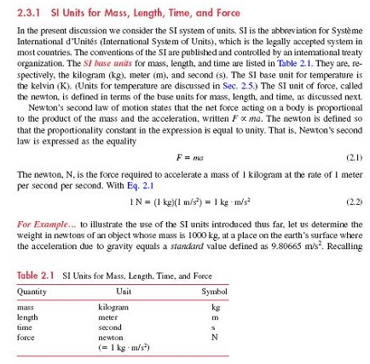
Figure 1. Traditional SI Units introduction section

In early stage energy engineering and related courses (Thermodynamics, Heat Transfer, Electricity, …) derived magnitudes such as pressure, temperature, heat, energy, power, voltage, current, etc. are also introduced following this scientific criteria, even in advanced lessons on the corresponding topic. Very rarely, there is a footnote to introduce some historical aspect of the unit, as for example the reference of the scientist in which honour the unit was named. This method has nothing to do directly with engineering concepts and developments, or with professional tasks that deal with measurement techniques.
For example, think about the power SI unit, the watt. At least some students will recognise that the name of the unit corresponds with the name of James Watt. Was really James Watt the scientist who defined the unit? Where was he from? If you ask your students how old is the definition of the unit, the most you could get as response is the age of the Industrial Revolution. Another hidden question for the student is the reason why there are so many unit options for the same magnitude, and the difficulty he founds to perform unit conversion (kcal/h, hp, etc.). Finally, from time to time, the teacher states that the SI unit is not used very often at industry, because its size does not fit very well real size of power devices…
In fact, we are losing the opportunity to introduce relevant engineering concepts and practices when teaching units only from this point of view. The systems of measurement that were born close to experience were deeply significant, because by means of the measure they established a dialogue between the man and the nature. The significance of the traditional measures, that constitutes one of his more outstanding virtues, was also the reason for the metric chaos, since the significance means comports the multiplicity of units. The pattern of measurement can be established into two forms. One, from the man or the human activity, which gives origin to the functional units (example: foot). Another option is by means of abstraction, designing the unit by the community agreement. In this case, we are in front of a conventional unit (example: metre). With the aid of the ICT and the Internet, and following with the example of the power unit, we propose to introduce first the definition of horsepower as significant unit with the aid of an interactive multimedia tutorial. After, the link with the SI power unit, the watt, will be established following the historical sequence:
- J. Watt defined in 1809 the horsepower unit with commercial purposes.
- C. W. Siemens defined in 1882 the watt as the electrical measure of power (1 watt = 1 ampere x 1 volt)
- Only from 1948, the definition of the watt as SI unit was adopted by the Bureau International des Poids et Mesures ( 1 watt = 1 joule/second)
This integrated approach has some early advantages for engineering students:
- It integrates from the beginning the teaching of scientific topics with engineering development of science.
- It allows the teacher to teach the scientific topic more closely to reality of engineering context.
- The ICT and the Internet allows the teacher to link easily the specific topic with other related topics of engineering curricula.
The integrated approach described in the previous paragraphs has been taken to develop some multimedia tutorials in the field of energy engineering. The initially selected magnitudes have been: pressure, temperature, heat, energy, power, voltage and current. All of them have some common features:
- Their origin is related directly to energy concepts (science)
- Their origin is directly linked with energy devices and engines, engineers and scientist.
- Historical aspects of its development are nowadays very well founded and easy to access through the Internet
- Energy consumption (heat, electricity) is a critical factor for industry development and sustainability
- Its measure (uncertainty) is very often related to industrial quality control and management systems.
3. The integrated multimedia tutorial on power units
In this section we present as example the multimedia tutorial on the power unit, the horsepower. The multimedia tutorial on power units was conceived as a helping learning task. The editor of this tutorial (exe.exe, eLearning XHTML editor) is a desktop authoring environment to assist teachers and academics in the creation of web content. The editor includes a range of pedagogical forms, e.g. objectives, advance organizers, and learning activities (text, videos, questionnaires, wikis, etc.), which constitute the equivalent of the 'teacher talk' in content resources designed for online learning.
As any other multimedia, it can be used for e-learning and b-learning through any Learning Content Management System that provides a framework for learning and teaching. The previous experience of the authors in international e-learning training actions [5] has been very profitable for this new project. Figures 2 and 3 present some screens of the multimedia tutorial.

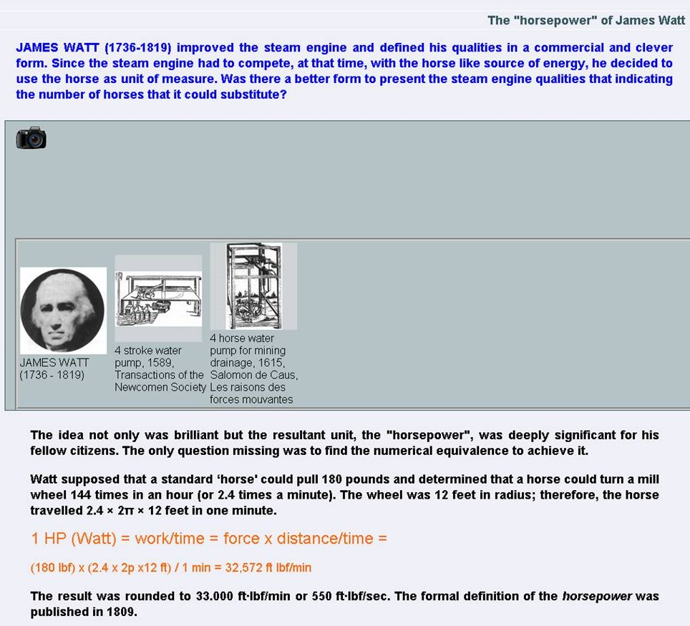  (a) | 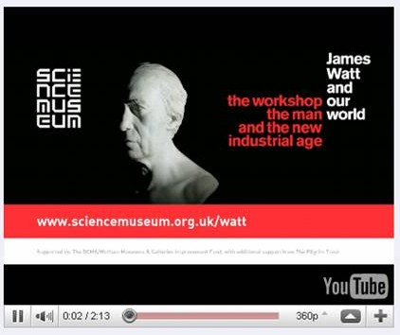  (b)
Figure 2. Multimedia tutorial on power units (I). (a) Watt’s definition of horsepower unit with historical pictures. (b) link to YouTube screaming video of James Watt.

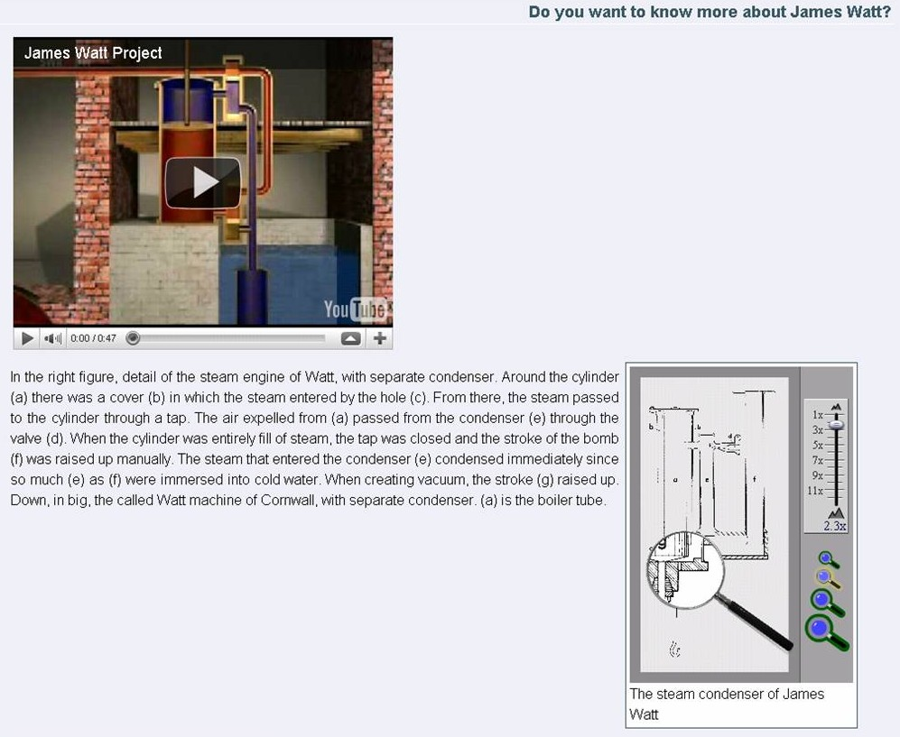  (a) | 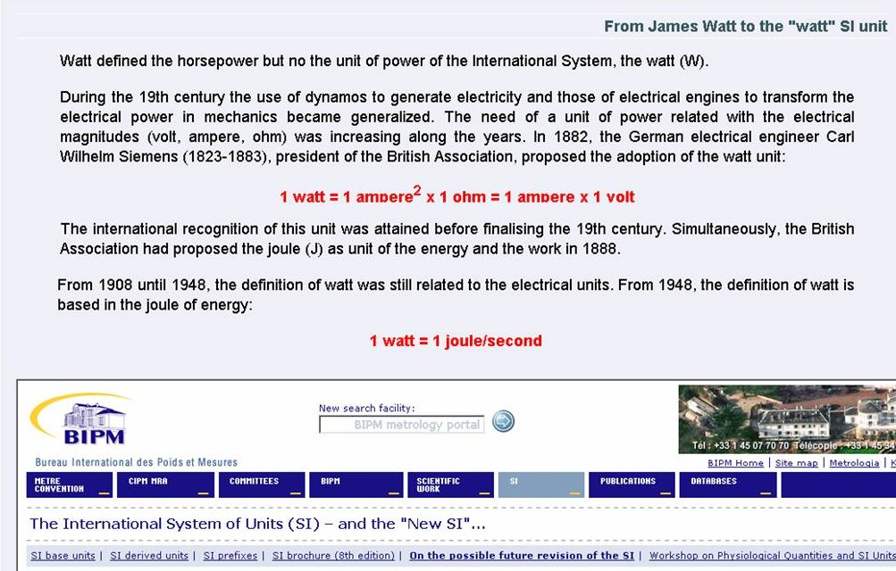  (b)
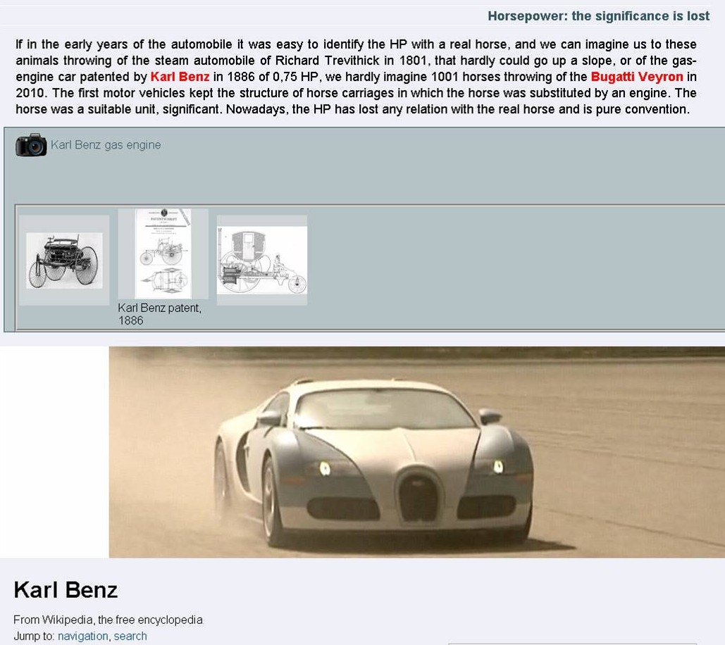  (c) | 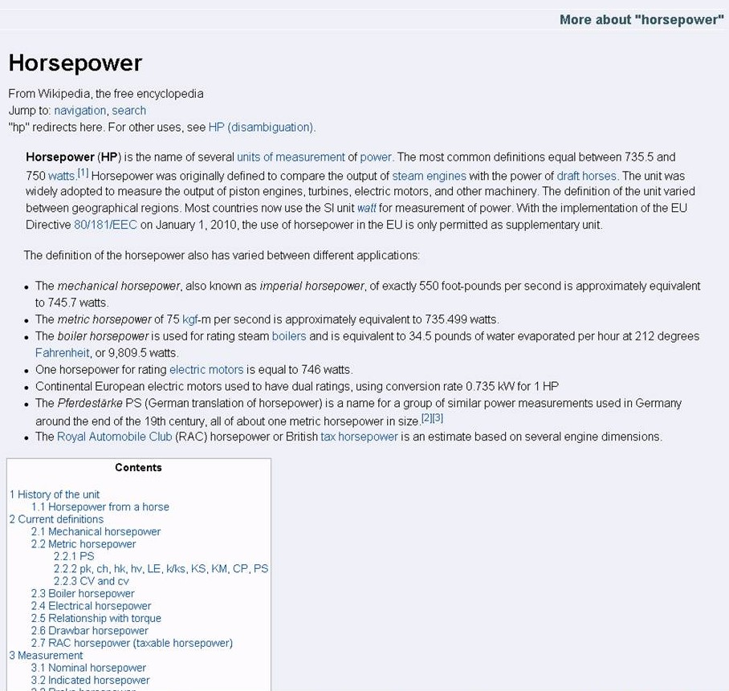  (d)
Figure 3. Multimedia tutorial on power units (II). (a) link to YouTube screaming video of Watt’s steam engine and interactive picture of the condenser (b) definition of watt unit by C. W. Siemens and link to the Bureau International of Poids et Measures website (c) comparison of the unit significance with respect Karl Benz patent (1886) and Bugatti Veyron (2010), including wiki of K. Benz (d) wiki of the horsepower unit with related links and literature references.

The learning objective of this multimedia tutorial was to broad the scope of energy and power topics content and to present the information in an attractive and interactive way, in order to engage the student with the topics. Though the relevant engineering content of the course will be included within the corresponding text of reference, the multimedia tutorial is intended to allow students to go more deeply into the specific topic and to integrate scientific concepts with engineering practice. Links to very well known free Wikipedia articles on power units provided suitable further reading on the topic, the use of them depending on the previous background of the student. Available technical or scientific video on steam and internal combustion engines were included to foster the interest of students in energy systems. Tests and quizzes were intended to promote self assessment.
4. Acknowledgements
The authors thank the Vicerrectorado de Profesorado of the Universidad de Burgos, for the funding of this project within its Educational Innovation Program, 2011
References
- P. Ramsden, Learning to Teach in Higher Education, Routledge, London, 1992.
- A. K. Ditcher, “Effective Teaching and Learning in Higher Education, with Particular Reference to the Undergraduate Education of Professional Engineers”, International Journal of Engineering Education, Vol. 17, No. 1, 2001, pp.24-29.
- M. A. Rosen, “Future Trends in Engineering Education”, Innovations 2007: World Innovations in Engineering Education and Research, Win Aung et al. eds., International Network for Engineering Education and Research/Begell House Publishing, Arlington, VA, USA, 2007. pp. 1-11.
- M. Drozdova, M. Dado, “Innovation in engineering education based on the implementation of e-education”, European Journal of Engineering Education, Vol.32, No. 2, 2007, pp. 193-202.
- E. Montero, M. Díez, M.J. González, R. Pizarro, M. Ortega, “Teaching a Postgraduate Engineering Programme on renewable Energy in the Building Sector as part of an International Project”, Innovations 2007: World Innovations in Engineering Education and Research, Win Aung et al. eds., International Network for Engineering Education and Research/Begell House Publishing, Arlington, VA, USA, 2007, pp. 87-98.

