Oslo Fjord Technology Education, on the road to becoming the Norwegian leading provider of technological knowledge relevant to industry.

¹Anne Kari Botnmark, ²Jørn Kragh and ²Duy-Tho Do
¹Vestfold University College, Oslofjordalliansen, Horten, Norway. E-mail anne.kari.botnmark@hive.no ; ² Vestfold University College, Faculty of Technology and Maritime, Dept of Maritime Technology and Innovation Sciences, Horten, Norway. E-mail jorn.kragh@hive.no ; ²Vestfold University College, Faculty of Technology and Maritime Sciences, Horten, Norway, E-mail: duy.t.do@hive.no

Abstract
The Oslo Fjord Alliance is a Norwegian educational and research alliance between the Norwegian University of Life Sciences (UMB) and the University colleges in Buskerud, Vestfold and Østfold. The main areas in the pilot project in technology are education, research and industry affiliation. The goal is to become the leading provider of knowledge in technology that is characterised by quality, flexibility and industrial relevance throughout the alliance. This involves establishing a united/coordinated technology education and a common research strategy in collaboration with the private sector in our region. This paper describes efforts to promote co-operation, division of labour and concentration throughout the pilot project's first phase (2008-2011) including the efforts to establish a joint strategy for education and research portfolio before continuing to a phase of operation.

- Introduction

The Oslo Fjord Alliance is a Norwegian educational and research alliance between the Norwegian University of Life Sciences (UMB) and the University colleges in Buskerud, Vestfold and Østfold. The pilot project in technology has the working title Oslofjord technology education and organises the Faculty of Engineering and maritime studies in Vestfold, Faculty of Engineering, Buskerud, Department of Engineering in Østfold and Institute of Mathematical Sciences and Technology at UMB. The main areas in the pilot project in technology are education, research and industry affiliation. The goal is to become the leading provider of knowledge in technology that is characterised by quality, flexibility and industrial relevance throughout the alliance. By focusing on education and knowledge in collaboration with the private sector the Oslo Fjord Alliance will be attractive to students, staff and partners in Norway’s most populous region of approximately 2 million inhabitants.
From the Norwegian authorities (The Ministry of Education and Research and The Ministry of Trade and Industry), emphasis is placed on stimulating increased research and new regional initiatives through co-operation, division of labour and specific subject matter, known in Norwegian as SAK.
This involves establishing a united/co-coordinated technology education and a common research strategy in collaboration with the private sector in our region. Three Norwegian Centres of Expertise (NCE) are also involved in the collaboration. These are among the twelve business clusters identified by the Norwegian Government as world-class clusters in their fields. Co-operation with these clusters is a prerequisite for further development of the Oslo Fjord Alliance. An Advisory Board comprised of top businesses in our region functions as our main arena for SAK-operation as described here.
This paper describes efforts to promote co-operation, division of labour and concentration throughout the pilot project's first phase (2008-2011) including the efforts to establish a joint strategy for education and research portfolio before continuing to a phase of operation.

  - International research methods, globalisation, internationalisation and competition.

Universities and Colleges of Further Education compete for students, research talent, resources and prestige in an educational landscape that is increasingly becoming more global. This form of competition induces quality but can also unintentionally prevent national collaboration and the good use of research across institutions.
The ”logic of massification” is an irreversible development process from a selective further education system where higher education becomes normal.
Globalisation, massification and competition results in universities and colleges of further education having to position themselves in a continually demanding market in order to secure resources in the form of students, qualified personnel and income from external collaborative partnerships and the public sector.
The Bologna process and the implementation of a European qualification framework with clear goals of teaching, and expected use of learning, is part of the European harmonisation process.
The last notion of globalisation lies in the increased importance of further education and research as a product driven force i.e. the desire to integrate universities and colleges in a nationally innovative and valued way. This is also made clear in the Stjernø committee¹.
”OECD, EU and national authorities are placing increased importance on creating a tighter bond between fundamental research and the commercial use of research results, the market and work related education and strengthen the elements of market mechanisms.”
All countries assist in structuring the landscape for increasing the quality of top research environments around the best research communities. Some countries change their structure of their institutions. In Denmark the research institutes and universities have carried out a comprehensive fusion process, which has resulted in the country only having three small-specialised universities and three diverse universities. This was the most comprehensive political structural reform in the Northern countries to date. The processes in Sweden and Norway are not as a result of a politically driven structural reform. The few institutions that have started collaborative sessions have also received assistance with the fusion processes.

1.2 Structural changes within Norwegian Higher Education

The growth and development of the higher education sector in Norway has been largely similar to the rest of West Europe. Change happened in the 1960s where a university-dominated environment was split in two, and the establishment of a binary system introduced in the higher education reform in 1994². More recently the Norwegian agenda has been to merge all laws and regulations, common levels of employment, common grading system, common financing system, common advice and flexible methods of student mobility, hence to reduce the division between universities and colleges of further education.

The Stjernø-commeitee’s evaluation¹ summarised the challenges faced by the Norwegian universities and colleges of further education as quality enhancements, work delegation, diversity and collaboration, internationalisation, contributions of regional development and effective management.

The committee's recommendationshave generated the basis for the voluntary processes, which are now implemented within higher education. The government are in agreement with the Stjernø Paper in that there is need for clarification within work sharing and more binding collaboration within the sector. Collaboration for the time being is not going to be developed through a politically managed structure. The structural challenges are to resolved with voluntary processes as a result of the subject areas and institution leaders seeking frameworks within sharing, collaboration, work delegation and concentration. The governmental role is to stimulate and contribute to these voluntary processes and ensure that they reach the higher educational facilities.
The university’s regional role has mainly been that of conducting research and producing competent labour. Nordic universities’ traditional missions of research and teaching were during the 1990s supplemented by a ‘third mission’ of contributing to regional economic development³.
One of the voluntary institution collaborations that are happening today is the Olsofjord Alliance. To begin with focus was put on to find areas of subject collaboration. The first pilot project was within technology, the other within teaching education. Both pilot projects reported a successful outcome. The three colleges of further education are now implementing fusion within the multi-campus model. The inauguration of this fusion will be declared in December 2011.

- The regions demographics

2.1 The member Institutes of the Oslofjord Alliance.

The three University Colleges in Østfold, Buskerud and Vestfold are medium-sized Norwegian university colleges. The Høgskolenes main profile offers practically based, well proven and attractive courses all of which are professionally orientated, community and working life orientated study programs.The Norwegian University of Life Sciences (UMB) was established in 2005 when it received full university accreditation. It is one of the 8 accredited universities in Norway. UMB is recognised as a leading international centre of knowledge, focused on higher education and research within environmental and biosciences.

Table 1. Facts at a glance of the four institutions

2.2 Norwegian Centres of Expertise
There are 12 Norwegian Centres of Expertise, strong clusters with business links which are amongst the best in the world in their fields.
They were chosen under fierce competition between Norway’s leading businesses. The NCE program is to enhance innovative activity in the most internationally orientated business clusters. The purpose is to contribute to new developments and increase international growth within the businesses connected to the clusters. The program is being organised in collaboration between Innovation Norway, SIVA and the Research Council.

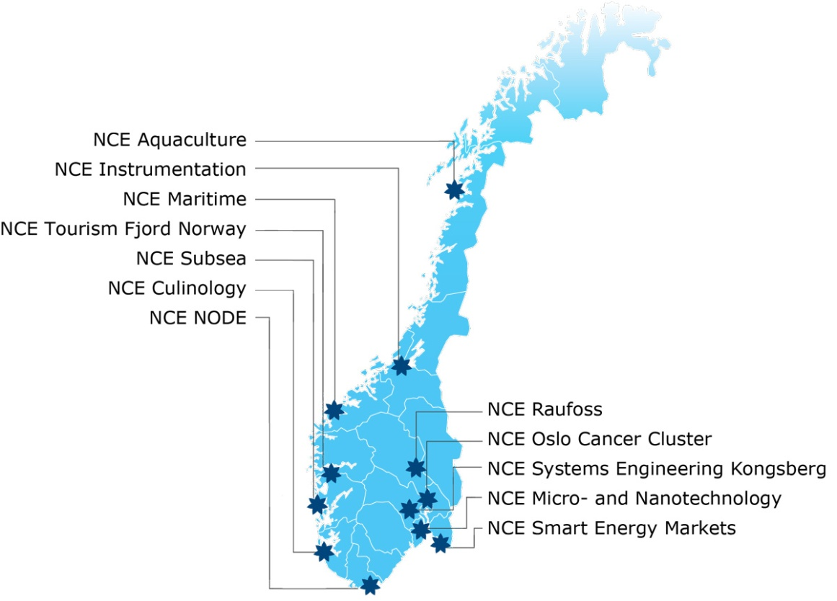
Maritime Centres - Oslofjord

Figure 1. Norwegian Centres of Expertise⁴

In the Oslo fjord Alliance there are three NCE’s that the college of further education and the UMB are collaborating with.

A Norwegian national collaboration has been set up within maritime technology where the government is committed to the development of competence throughout as in the ”GO STEADY” message.

The interesting thing that is special about maritime business is that it bears no relation to natural resources, but only on human competence. It relies on experience and the knowledge of seafarers that have been passed on through generations; Norway has used this to its advantage and to build its success and competence. The maritime cluster is today known as the countries largest knowledge base with the most innovative businesses and contributes to 11% of all the business wealth in Norway with oil and gas companies excluded.

3. Technology pilot project and the project role in SAK

3.1 Co-operation, Work Sharing, Concentration

From the Ministry of Education and the Department of Industry and Commerce emphasis is put on stimulating increased research, prioritising regional ventures through collaborative measures, work sharing and academic concentration. The goal is that these processes should result in better quality education and research. The Norwegian universities and colleges wish to become academically stronger which is why they are striving for increased activity in more collaborative activities, work sharing and academic concentration.
So that the institutes are to become more robust, the institutions have to work together more, looking after each other and pay attention to the culture of the nation when prioritising and forming its strategies. Collaboration is to work itself out through voluntary processes and not through political structures.

3.2 Introduction of the technology pilot project
The main areas of the pilot project in the Oslo fjord Alliance within technology are education, research and business relationships. The goal is to become the foremost industrialised offerer of knowledge within technology, which is recognised by quality, flexibility, and to encompass a close relationship with industry.
By incorporating the collaboration of business and placing emphasis on education and knowledge development, the institutions will become attractive to students, staff and partners in Norway’s most populated region (approx 2 million inhabitants).
The pilot project is to contribute to the three colleges and UMB under the same roof developing their technological competence and their organisations such that they are more attractive than business, and that business can draw upon expertise from the Oslo fjord Alliance services as a component part of their growth and innovation.
In order to become Norway’s most foremost offerer of knowledge, businesses have to believe and trust the organisation. To achieve its goals, focus on finding industrial partners, who are driven by technology in the region to develop initiatives, will become nationally first choice competence partners.
The pilot project is established to work together on educational frameworks, research and the exchange of information of subject and administrative competence. The pilot project of technology seeks to establish a common technology education within the Oslofjord Alliance. The co-ordination of the development of Masters and common research strategies lie at the heart of the alliance.

3.3 Organisation of the technology pilot project.

The Management group comprises of Engineering Deans from the HiØ, HiBu, HVE, the institute leader of the IMT of the UMB and two student representatives.
A reference group has been set up within the Advisory Board with representatives from business areas (NHO, LO, company directors from collaborative businesses in all four regions) to contribute to visions, strategy, subject fields and other support for technology education in the Oslo fjord. The refererence group report to the management team.
A working group within education with four co-ordinators has been set up to deal with student offers, organisation and the implementation of studies.
The participation processes with organisations and students is the Principals formal assignment and responsibility. Every idea or resolution is put to the managers of the college and UMB. The organisation and students have an influence on the formal decisions made. Managers and the working groups represent students with two participants from both places, as well as in the management teams.
The directors are planning and carry out the support projects from the pilot project. These will be decisive in the execution of common (general) engineer education and are important to success.

Figure 2. Organisation of OFA technology pilot project.

The management group comprises of the Deans from the four institutions. The management group sets the projects mandates and takes strategic conclusions. They evaluate the project delivery and provide feedback towards the next level. The management ensure that overall consensus decisions across the board are followed and implemented. Amongst other things this also includes the implementation and interpretation of the SAK principles. They have approximately one meeting per month and utilise both video and face-to-face meetings.

Project leader
The project leader leads all the processes in all the sub projects within OFA technology. They are linked between the sub team below them and participate in all meetings. Other sub projects other than education are researched with their own mandates and process leaders.

Working group
The working groups are lead by process leaders. The mandate is to work out a common education offer within the bachelor engineering degree. When institutions maintain a common program the challenge lies in organising these equally – i.e. covering the same topics. It is desirable to create different program profiles within each program to increase the offer available generally. The working group has regular weekly video meetings and meet face to face approximately every six weeks. They lead common sessions with the subject groups.

Subject Groups
Subject groups which are put together as a result of the collaboration of the institutions and generally don’t have an appointed leader. The goal is that the subject groups work closely together towards common goals. The subject groups meet at general meetings, have individual face-to-face meetings and tele-video conferences.

Advisory Board
This comprises a gathering of business representatives in the region together with the management committee and project leaders. They will give advice on the development and be key support in the strategic work.

Large collective meetings.
Large collective meetings have been regularly scheduled to enable all those involved with the working groups to become acquainted with one another so that notions can be discussed and followed through. The meetings have been held outside of the campus and have often entailed overnight stays in Hotels in Strømstad and Sweden.

Short Collective Meetings
These short meetings have been held for the duration of one day often on campus at one of the institutions. Here, individual themes have been on the agenda, but they have also been to bring individuals together in order that they become acquainted.

3.4 Collaboration, work sharing and subject concentration in the technology pilot project.

The concept concerns the development of collaboration and work delegation of ventures with the basis in already existing and established ventures in the departments/faculties/institutes. Figure 3 shows how the college and universities ambitions are prioritised by these ventures. One combines the roles as regional developmentor with the role as a university participant. It is necessary with internal prioritising in each individual institution to build up chosen ventures within the individual institution. This means that business get to collaborate with the strategic ventures as a result of the institutions working together. Masters and PhD studies are developed with basis in the subject environment of the chosen areas of venture. This means that the institutions can form the viewpoint of wishing to collaborate by building up strategic areas of venture with strong subject competence and education.
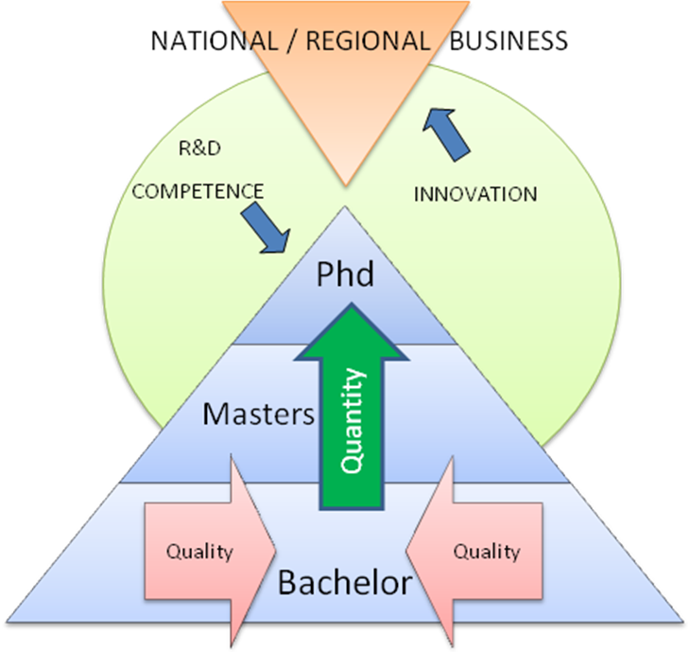
Figure 3. The principle of SAK.

Through collaboration, work sharing and concentration, the OFA technology education wishes to develop subject areas as in figure 3 (for each area).
The way in which SAK is interpreted depends on many factors and is a strategic decision which the Norwegian institutes can base themselves upon, such as geographical proximity, subject cohesion, size, economy, fusion and industrial structure and demography.

SAK – Collaboration in the Oslo fjord technology education contains the following:

Collaboration within Bachelor degree to increase quality of the education
- Common structure in the degree
- Common topic descriptions in the first year of study, with some common areas in year 2

Work Sharing
- The college will profile their bachelor degrees and tailor them towards business
- Common use of laboratories within the Alliance

Work Sharing and Concentration
This is carried out at a higher level of education i.e. Masters and PhD by increasing the involvement of businesses
Individual institutions take responsibility for their own subject areas. Initiatives are generated to encourage research projects built towards new ventures. Applications for research projects are sent to the regional research funds. Criteria for subject areas within the Masters and PhD courses are based on NOKUT criteria.
The ventures are related to the industries need for competence. The Advisory Board has been given orientation about the work in all institutions within technology and supports the concept and subject areas. The research profile is based on the institutions relation to the business environment and which areas the institute can be good in common together. Within each area of venture a subject area is linked to business. The subject area will thereafter offer a high standard of education. Four subject areas have been chosen for research, which in the future will build on work sharing within the Masters and PhD studies. These are chosen with reference to the NOKUT demands for subject content which can lead to a higher qualification.
- Environment – climate and energy technology (NCE Østfold)
- Micro and Nano technology (NCE-MNT)
- Maritime Management
- Systems Engineering (NCE – Systems Engineering)
There are several subject areas, which are relevant as well as the areas of venture. These must be built up such that NOKUTs demands for subject fields, before they enter the universities portfolio, are freed up.

3.5 Collaboration, Work sharing and subject concentration process
The process in the technology pilot follows the SAK principle. We use the model (figure 4)³ to illustrate the flow from tasks to implementation of the mechanism used in the bachelor degree. S and A processes are of particular strength as illustrated in the figure.
Had we included the process surrounding both Masters and PHD qualifications in the model we would have had a stronger inclination to the K processes.
The mechanisms are groups, which are central to achieving goals and are retrieved directly from the OFA structure (Figure 4). The active mechanisms drive the project forward by the chosen individuals of the task. The collaboration is representative of the four collaborative institutions in all the mechanisms. Even representation ensures that special circumstances within the institution are brought forward and that joint ownership is achieved.

Figure 4. Flowchart through the SAK principle³
Processes
Under the processes are the categories that SAK is split into and are goals themselves. S expresses the collaborative goal. It is desirable that the institutions work more closely with their activities and organisation of studies. A concerns the sharing of the workload between the collaborative institutions. To share this work can lead to more effective use of resources. But not necessarily. Work sharing demands administrative co-ordination, which also puts pressure on resources. Hence A is not linked to Output with effectiveness as a goal. S and A are currently closely linked to one another. The subject areas collaborate about work sharing. This cohesion creates a wider scope of contact between similar subject areas and strengthens individual subject communities. The model does not take into account what work is natural to share. Specialists will have to be active in sharing assignments. K expresses its wish or goal to be subject concentration. K is resistance to redundancy. K is central to the subject basis in the Masters and PhD arena. At bachelor level K is also taken into account. Each program develops its own individual program profile supported by individual topics. Each institution will gather their own specialities and will be defined by a concentration.

3.6 Output (Aim) Result

The three SAK categories also provide a framework for three processes. Each process contributes in an individual way to achieve goals (result – Output). The model shows which mechanisms through the SAK processes result in defined goals. Not all categories contribute equally to many of the goals.

Stronger and wider community of professionals
S and A processes contribute to fulfil the goal of social communities where one of the results will be to generate a stronger and closer subject area. K contributes little to this end. K will ensure a stronger subject base for an institution because the resources are collected surrounding a smaller subject area. There are no definite goals at bachelor level. K is seen as expedient to higher education due to less applicants to courses and higher competition for student entries, but also because Masters and PHD demands higher qualified personnel with specialised competence.

Improved quality of study programs
All the SAK categories contribute to improve the quality of the student programs within the bachelor degree. We observe that S results in topics, which get more attention with several qualified individuals checking that the content leads to improvements. This was specifically observed by a group meeting where the discussions were open and constructive. When a group of individuals work together on a specific subject area there is a clear improvement in quality and the same competent people assess ideas on the content and methodology. More consistency seems to be generated. We believe that the improved quality will eventually lead to better streaming of students.

More efficient management
There lies a great challenge in leading students, programs or topics, which are made available by various institutions. Geographical distance also means distance in terms of processes. K will therefore be one of the greater contributions to effective leadership because the concentration in itself allows closer proximity between leadership and process. Close proximity will also provide a better oversight. Better oversight and greater concentration will provide ground to generate the right strategies for subject development, business alliance and research association.
The bachelor programs have for the time being their own profiles and specialisations, which can be described as subject concentration. Specialised topics will be lead by individual institutions. Effective leadership is directly bound to the cost of running the studies.

Stronger market position
Small individual institutions have a weaker position in the market than larger and stronger ones. In order to win the attention of the applicant, trust is of foremost importance. A goal within the Alliance is to show strength in providing a wider scope of opportunity and further possibilities to take their studies to PHD level. The collaboration is now being driven towards the bachelor degree. K will also stimulate further offers to incorporate Masters and PhD studies within the Alliance. This will result in more applicants applying for places and therefore a better economy. Increased market awareness and position are linked. With this is mind the possibilities for better co-operation in the Alliance environment are better regionally, nationally and internationally.

3.7 Alternating loyalty between institutional and inter-institutional decisions
There will naturally be disagreements in any project development. Disagreements can be resolved in many ways, one of which carries a majority vote. The leaders in the mean time will attempt to reach a consensus amongst their participants. The participants will have to adopt a ”give and take” approach in order to reach this consensus. This will also include that representatives from time to time will have to accept that some things will have to be sacrificed in order to achieve greater things. A ”representative” is seen as someone who does not include their own personal goals but someone who looks to the bigger picture for their institution or the subject behalf.

Figure 5 - Loyalty alternating states

The project utilises meetings as its most important form of mechanism to drive the process. The meetings include participants and the OFA leaders. Frequent meetings have allowed all concerned to become frequented with one another. With a ”good tone’ amongst everyone, the loyalty bond between everyone has been built up. It has been possible to reach consensus decisions amongst all concerned without the need for heated disputes. But it has taken longer than putting it to the vote.
It can be observed that the participants are torn between two roads of loyalty, one for the institutions, for example subject areas and colleges, and secondly to common project requirements which includes other inter-institutional participants. Two lines of loyalty are not a problem as long as there is common ground between the institution and their colleges. However such common ground is not always found and disagreements result in a weakening or strengthening of loyalty dependent upon where the participant find themselves. An attempt to clarify this situation is illustrated by figure 5. It is important to underline the fact that a loyalty strength or weakness is observed indifferently between cases and participants and that it is uncommon for direct disloyalty. For the project this has meant that cases with a consensus vote has been injected with new information from the participants and has had to be taken up anew with increased use of time and resources.
We observe that loyalty is strongest in the environment where one sometimes finds oneself. The observations are interesting, and suggests further empirical research to investigate further.

4. Discussion

SAK is the most important principle defined and given by Norwegian authorities. This pilot project has attempted to utilize this principle in order to systemize it´s processes and gain more output quality. The outcome of this effort is defined in figure 4. This section consists of some selected topics regarding SAK for discussions.

Does K have greater importance in Bachelor degrees?
K seems to be undesirable at Bachelor degree level. Concentration is seen as a process, which splits rather than uniting education at this level. The three educational institutes HiBu, HiØ and HiVe have traditionally only offered Bachelor degrees. In order to gain more applicants for bachelor studies a typical strategy has been to not concentrate but to broaden offers, On the other hand Masters programs have now become available to these institutions. Masters programs are expensive offers and should therefore not be competing with each other internally in OFA hence be concentrated. A particular masters program should only be present at one institute and not be replicated. All Bachelor degrees accept some concentration (K) in the form of specialised subjects but no overlap is accepted allowing greater individual identity to each program in the OFA.
The figure 3 suggests Bachelor degrees in the lowest part of the triangle as the wider base of educational knowledge which higher education utilises as a platform. The offers support strategically chosen Masters degrees. At the top of the triangle lie the PhD courses, which have the highest concentration (K). If one follows this logic then bachelor degrees should have no or little association with K.

SAK processes and Output
The project mandate has been to encourage work sharing and collaboration for bachelor degrees within the four institutes, in order to create a common and more comprehensive bachelor degree offer in the market. The SAK principle has been the method for division of labour in different processes, which can be seen as serial or step-by-step processes. S was the first process that was carried out. How does one motivate collaboration? During group meetings over two days most of the participants became acquainted and surprisingly advocated a positive attitude for collaboration. One could have expected a sceptical approach hence a possible competitive situation. Firstly gaining trust is of utmost importance in order to motivate a collaborative effort.
Output is hard to evaluate at this point. It has to be measured after some period of time. For example the tactics, which have meaning for better student results, will not be known for at least a year’s time after they have been collated. Likewise the permanently strengthened relationships of the collaboration of colleagues will have to be seen and the effects on business over time.
It also remains to be seen if the project has been successful in creating a better and more effective method of leading studies. At this point in time there is a lack of clarification surrounding the follow up of the project. The projects administrative follow up is a key factor in whether the projects’ results lead to continuation or are weakened.

5. Recommendations to future work
Based on our experience within the project, we recommend these topic to be further investigated in future works :
- Is SAK applicable in other merging processes both in academic and business environments, and how does SAK compare to other comparable principles?
- Does SAK as a promising process really promote quality and efficiency in engineering educations? Does it promote lasting collaboration between involved parties?
- Since the cooperative institutes are preparing themselves for a merge, an interesting aspect after a merging is in which direction the new organization are heading with SAK as a guiding principle.

6. References
- Stjernoe et al: ”Sett under ett”, NOU 2008:3, Kunnskapsdepartementet, Norway ISBN 978-82-583-0953-3
- Kyvik, S.: The Dynamics of Change in Higher Education. Expansion and Contraction in an Organisational Field. Dordrecht: Springer. 2009.

- Gausdal, Anne H, Network Reflection- a road to regional learning, trust and innovation, Handelshøgskolen i Bodø ISBN: 978-82-92893-04-3 2008.

- Norwegian Centre of Expertice www.nce.no; http://ekstranett.innovasjonnorge.no/NCE_fs/09310NCE_16.%20mars%20endelig.pdf

- Do, Duy-Tho, dean, Vestfold University College, Faculty of Technology and Maritime, Horten, Norway 2010.

