E-learning Course Development for M.Sc. Engineering Students at Széchenyi István University

¹Zoltán Létray, ²László T. Kóczy
Faculty of Engineering Sciences, Széchenyi István University, Győr, Hungary, letray@sze.hu¹;
Faculty of Engineering Sciences, Széchenyi István University, Győr, Hungary, koczy@sze.hu²;

Abstract
Our Faculty of Engineering Sciences, the second largest technical faculty in Hungary, has been developing an e-learning course for M.Sc. engineering students for more than a year. Last year grants of 136 million Euros from the European Union were used to develop the most up-to-date learning material for universities in order to raise the level of the technical knowledge and to make up for deficiencies of e-learning materials for M.Sc. engineering students. Our management has decided to develop twenty different technical courses, including “Computational Intelligence,” “Applied Mechanics” and “Environment Management” in a unified structure shaped by a team of experts from our Department for Technical Teacher Training. This team has been developing e-learning materials for nearly ten years and possesses the necessary expertise for the methodology support.
The whole e-learning material production was established in a unified system. This is a “patent” of our institution and for the first time has been applied in Hungary. The main points are:
- Common goal and individual objectives, guide-lines for implementation
- Steps for learning material development
- Model structure of the e-learning material (a “skeleton” for requirements, modules and lessons) applying different checklists for validation
- Prescriptions for multimedia, interactive learning objects and knowledge measuring tools
- Strictly defined production process in teamwork (author, methodology expert, editor, digitizing support personal) using the widely proven “Moodle” Virtual Learning and Collaborating Environment
- Unified standard “SCORM” and HTML output materials
Recently, a number of courses are ready and have been accepted by the tendering authorities. This paper will present details of the model structure and of the production process, and will give a live demonstration of selected materials, for the discussion.

1. Introduction
Recently, the development of learning materials is often done in a new way, namely e-learning, which allows for it to spread rapidly. Our faculty of engineering sciences has been developing e-learning courses for M.Sc. engineering students. This development is supported by the European Union and is financed from grants of more than 100 million Euros. Twenty different technical courses including “Computational Intelligence,” “Applied Mechanics” and “Environment Management” will help students gain up-to-date knowledge from brand new e-learning material. This work has been done by colleagues of the university and is supported by an e-learning expert team gathered from members of the Department for Technical Teacher Training.
This team has been developing e-learning materials for nearly ten years, and possesses the necessary expertise for the methodology support. The learning material – say a course – is firstly prepared in a Word editor and includes all the figures, tables and multimedia elements (photos, diagrams, flash animations video clips, etc.) This material has been “digitalized” or it is better to say converted to e-learning form that complies with and conforms to standards like SCORM. The final result can be uploaded into some Learning Management System (LMS e.g., Moodle) and provided for students in a virtual learning environment, as well as in HTML format.

2. A unified structure
The on-line access of web-based learning material is a reality today. Pedagogical technology changes permanently and is determined by several elements, aspects and methods of Information and Communication Technology (ICT). Based upon former research and experience, our e-learning methodology team has decided the form of a unified structure of e-learning courses to be developed. This structure complies with the requirements stated in the tender documents too. The main guideline of the e-learning development is to produce such e-learning material that can be learned unaided as well. This requires the application of the well-known “individual learning methods”. Inclusion of multimedia and interactive learning objects in the course to be compiled is a must in order to achieve our goals.

A course is made of so-called modules and modules are compiled of lessons, as shown in figure 1:

Figure 1. The simple tree structure of a course

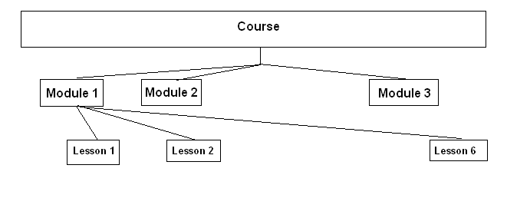
This simple structure has been refined defining the requirements for the lessons and the modules.

3. A possible way of e-learning course development
For the development of e-learning courses for M.Sc. engineering students, teams have been formed consisting of experts. Authors, methodological experts, editors and programmers have been working together. Communication is mainly performed via a special Moodle interface (schedule of contact meeting, messaging, file exchange, etc.). Authors and methodological experts work in a close contact in continuous interaction. They exchange information and files, and negotiate possible solutions also via face-to-face consultations. The learning content provided by the authors has been first examined by a methodological expert from the viewpoint of a student:
- Is the style proper for the students?
- Is the text really understandable?
- Does the course comply with the unified structure?
- Are there enough multimedia and interactive learning objects embedded in the textual content?
- Are there adequate tests and questions after the lessons and the modules?
- Are there proper questions, exercises and problems to be solved during the examination?
The course material compiled is controlled by a lector. After the necessary corrections, which are done by iteration, based upon the final world file, programmers (digitizing support personal) transform the course into an e-learning form. They use usually some “authoring” editor system like eXe, WBT Express, Thesys, etc. The output complies with the SCORM standards and is also available in HTML form. In some cases, where authors are not able to produce high quality pictures, diagrams, flash animations or video clips, programmers with special knowledge and tools can help to develop those multimedia elements.

4. What are the key points?
During the compilation of the learning material and the requirements for the students, authors need to continuously pay attention, how they can comply with the curriculum documents accepted by the University Board. Only those learning objects should be included in the content which are needed for students during their future study or are required to comply with the requirements demanded by their following place of employment.

Authors should unambiguously put into words how and what students should perform after having learned the given learning material. These are the exact requirements that are elaborated on more deeply in order to achieve the goals and objectives of the given course.

The author of the course should formulate and suggest certain activities for the students in the learning material. By performing these small exercises students are better motivated and can more easily understand the content.

Self-controlling exercises play a very important role in the learning procedure. Students are able to control continuously how they are advancing in a subject. Through this they can compare their knowledge with the exact requirements given. Authors should provide in the course enough tests, questions and exercises and place them properly after the lessons or the modules.

5. Refining the structure of an e-learning course
One M.Sc. subject is realized in one e-learning course. The course is the main objective and its content is divided into modules and lessons. Let us start with the detailed description of the smallest unit, the lesson. Students can learn a lesson generally between 0.5-1.5 hours. One module consists of practically 2-6 lessons.

The number of credits that student can get for a course completed in the case of an M.Sc. subject ranges from 2-4. Considering a course with 4 credits, it is about 180 pages, say around 300 screens on the computer’s monitor.

At the very beginning of a lesson important information should be listed as follows:
- What is the goal of the lesson? (From where we start and where are we going to.)
- Detailed requirements (after having finished the lesson, what kinds of activities will the students be able to perform).
- Listing of keywords.
- An estimation of the time that is necessary to learn the lesson and answer the questions,

After this the authors need to include the content. Lessons may consist of more subchapters. At the beginning of such a subchapter authors should specify:
- Suggestions, how to advance in the learning material (“read it”, “remark”, “collect”, “draw”, “depict”, etc.)
- Call attention to the included multimedia and interactive elements.

At the end of the lesson authors should insert the test section. These questions (generally multiply choice tests, which can be evaluated in an automatic way by the e-learning program) may give a feedback to the student on how they meet the requirements of the lessons.

Modules contain more lessons and always have an introductory part at the beginning. This can be an interesting example from practical life, a characteristic short story in connection with the content, or a short pre-summary of the lesson. At the end of each module the references are listed and more complex questions and exercises should be included. Solving of these exercises often requires knowledge gained from more lessons. Generally, these are “open-ended” tests and in this way only the tutor can evaluate the solutions. Most of the courses produced in the frame of the given tender will be used in a “blended learning” fashion. Face-to-face in a learning group led by a tutor, where problems can be negotiated and students can get direct oral feedback too.

At the end of the whole course a trial exam is shown, which serves as an example in order to help students to prepare for the real exam.

6. Requirements for multimedia
E-learning courses are typically suitable for the inclusion of multimedia as interactive elements or learning objects. Colourful pictures, motivating, illustrative and explanatory photos, flash-animation can help students’ understanding. Computer aided simulation can be especially attractive and useful if they are used in an interactive way. For example, students can vary different parameters and experience the answer of the system. Here is an example of the modelling of an electric circuit (see figure 2).

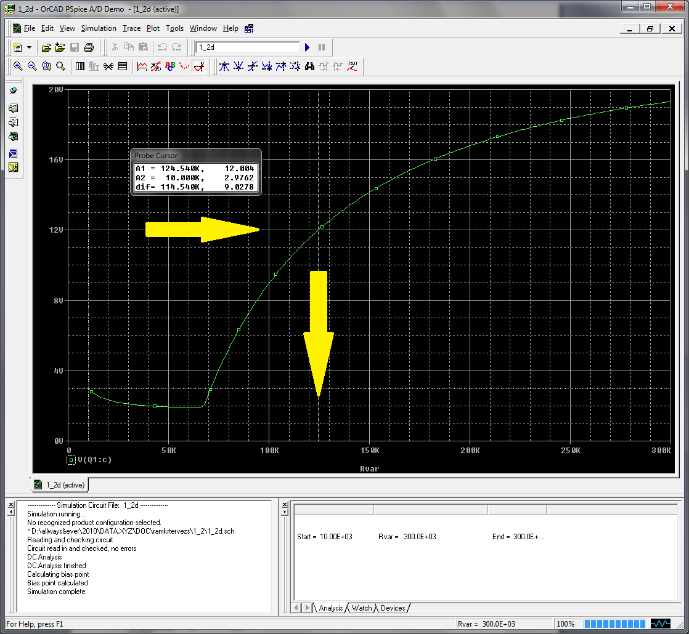
Figure 2. Simulation of an electric circuit

In each lesson, depending on the content, minimal requirements had been defined: each lesson should contain at least 5 pictures and each module should be equipped with at least with one interactive animation (simulation) or video clip.

7. Summary
According to our experience, high quality e-learning material can be produced only in a team that has sufficient financial support. Recently, it has become inevitable to provide M.Sc. students with e-learning materials. Production charges are higher than in case of traditional paper-based learning material but the efficiency of the e-learning courses is significantly greater.

The inclusion of e-learning methodology experts into the developing team is very important because the authors generally lack the necessary knowledge in this field. In the frame of the current tender the Department for Technical Teacher Training has organized e-learning development trainings for author colleagues. During these trainings authors could see the possibilities of applying multimedia and interactive elements and during the compilation of the course they could use the most up-to-date solutions as an alternative. E-learning development requires its own methodology that is why our research at the faculty also focuses on this field.

Final e-learning materials are evaluated using a checklist as follows (see table 1):

Table 1. Evaluation matrix for final e-learning courses

 | Considerations | Yes | No
1 | Deadline met
2 | Unified structure
3 | Separating main and supplementary material
4 | Formulating learning goals
5 | Formulating more exact requirements
6 | Time estimation for the learning of each lesson
7 | Suggestions for the learning methods
8 | Proper textual content
9 | Keywords in each lesson
10 | Visual illustrations (4-6 / lessons)
11 | Illustrating animation (1-2 / modules)
12 | Illustrating videos (1-2 / modules)
13 | Tests at the end of the lessons
14 | Questions, exercises at the end of the modules
15 | Simultaneous communication with the team members
16 | Trial exam
17 | Others

Although production of all e-learning materials are not yet ready, some of them have been proven very useful during the tests and are accepted by the tender authorities.

References
1. Z. Letray, L.T. Koczy, “Preparing Students for Lifelong Learning Technologies at Széchenyi István University” Proceedings of 2010, International Conference of ICEE
2. Z. Foldes, M. Kovacs, T. Nagy, „The Main Principle of the E-learning Development, Methodological issues and Problems”, TAMOP 4.1.2. tender documents, 2010.
3. G. Borbely, „The Design of Electrical Circuits”, TAMOP 4.1.2. tender documents, 2010.
4. Letray, Z., Kovacs, M., Nyeki, L., “E-learning based distance Education at Széchenyi István University”, Innovations in E-learning, Instruction Technology, Assessment and Engineering Education, Springer, University of Bridgeport, 2006.
5. Schramm, W. L., “Big media, Little Media: Tools and Technologies for Instruction”, Beverly Hills: Sage Publications, 1977.
6. L. T. Koczy, L. Keviczky, A. Horváth, J. Egert, J., “Establishing a multidisciplinary engineering faculty and a doctoral school in Gyoer, Hungary, ICEER Journal, pages 7, 2009.
7. L. T. Koczy, J. Egert, “Academic Experience of the Bologna Process at the Faculty of Engineering Sciences, Szechenyi Istvan University”, Int. Conf. on Engineering Education 2008, Hungary, Pecs and Budapest, 28th – 31st July 2008, pages 5.
8. F. A. Korthagen, “In search of the Essence of a Good Teacher: Towards a More Holistic Approach in Teacher Education. Teaching and Teacher Education, 20. no. 1, pages 77-79, 2004.

