Effective Learning Activities and Assessments in a First Year Engineering Mechanics Course

¹B.G. Prusty, ²N.J. Kessissoglou
The University of New South Wales, Sydney, Australia, g.prusty@unsw.edu.au¹
The University of New South Wales, Sydney, Australia, n.kessissoglou@unsw.edu.au²

Abstract
The lecturers of a first year mechanics course in engineering at a university in Australia aim to provide an effective learning experience for students using a range of assessment activities. The range of assessments correspond to the use of a web-based online tutorial system, a variety of group projects tasks, and individual laboratory projects which were conducted by students independent from supervision. These assessments were in addition to regular on-course tests and the final examination. The assessments aimed to reinforce the fundamental concepts of the lecture material and expose students to solving real world examples. The various assessments were delivered at a well-paced rate, so as not to overload students. By the end of the course, the majority of students had developed a clear understanding of the fundamentals of mechanics and its practical application in industry. The activities and assessments were shown to have a positive impact on motivation and participation of students, and improved student performance compared to previous years. Furthermore, feedback comments from the institutional student survey showed that the students were very receptive to the teaching approach and activities in the mechanics course.
1. Introduction
Engineering mechanics should provide an exciting challenge as students develop the fundamental insights and problem solving abilities in mechanics that assist them throughout their mechanical engineering degree and professional careers. Unfortunately, for many students mechanics is one of the hardest courses and can be a difficult and unpleasant hurdle. Pass rates are often low and the result satisfies neither students nor staff. At the University of New South Wales, the first-year mechanics course moves at a fast pace and covers a huge amount of material in two subject areas: statics and dynamics. Within each subject many topics are covered with a compounding effect, where a new topic draws upon the fundamentals of preceding topics. In past years, first year mechanics students would rapidly lose interest and fall behind, resulting in poor attendance to classes, large failure rates, student disatisfaction and lack of enthusiasm for students to willingly participate in future mechanics courses.

The objective of two lecturers sharing a first year mechanics course in mechanical engineering at the University of New South Wales, Australia, was to implement strategies to keep students interest and improve student performance. The lecturers (and authors of this paper) commenced teaching the first year mechanics course titled MMAN1300 Engineering Mechanics 1 in 2007. Their objectives were achieved by taking the following action: (1) introducing a web-based on-line tutorial system with weekly exercises and assessment, (2) introduction of variety of group project tasks for better interaction among the students, and (3) a range of laboratory projects which were conducted by students independent from supervision. These assessments were in addition to regular tests to reinforce lecture material. The various on-course activities and assessments were delivered in a well balanced time schedule to keep the students motivated and maintain their interest in the course.
2. Course content
The lecture material in the first year mechanics course is delivered in 12 weeks – the first six weeks covers statics and the second six weeks covers dynamics. The topics covered in both the components are: Statics (free body diagrams, moments, force, vectors, dot product, equilibrium of single objects, trusses, friction and equilibrium, machines, distributed forces, shear force and bending moment at a section, shear force / bending moment diagrams and second moment of area) and Dynamics (kinematics of particles, kinetics of particles, plane kinematics of rigid bodies, mass moment of inertia and plane kinetics of rigid bodies). The topics within both the statics and dynamics content have a compounding effect, where each subsequent topic draws upon the fundamentals of the preceding topics.
3. Course assessment
In order to reinforce the material taught in class, as well as to maximise student participation and performance, the assessments for the course are divided into a range of activities. The various assessments and corresponding weighting are given in Table 1. The wide range of assessments for the course were delivered in a well balanced time schedule to keep the students motivated and maintain their interest in the course. In addition to three on-course tests and the final formal examination, there was continuous tutorial and laboratory assessment by:
- Using of a web-based online tutorial system
- Group project on a truss structure
- Group project on shear force and bending moment
- Group project on a lawnmower dismantling activity
- Individual laboratory exercises
- Adaptive Tutorials (AT) using an Adaptive e-Learning Platform (AeLP).
The assessments corresponding to the laboratory exercises, group projects and web-based tutorial system are decided on yearly basis such that the focus is primarily on enabling a greater component of in-course assessment followed with a rigorous final examination to challenge the student ability. These assessments activities are described in more detail in the proceeding section.

Table 1. Assessments and corresponding weighting for the first year engineering mechanics course
Type of Assessment | Rationale for Assessment | % Weighting
Tests (x3 @ 5% each) | Three tests to assess basic knowledge in statics and dynamics | 15
Weekly tutorial exercises | Web-based assessment based on material learned each week | 15
Group projects | Developing and improving team work, communication and problem solving skills | 10
Laboratory exercises | Individual laboratory exercises with an experimental rig | 10
Final exam | Harder questions on the entire course | 50
Total marks |  | 100
4. Assessment activities
In the statics component of the course, the lecturer uses a blend of online and face-to-face teaching to help the student learn key concepts needed to progress in their studies. A combination of assessment activities that include group work, laboratory exercises and a new online teaching tool – Adaptive Tutorials using the AeLP is used to engage and stimulate the students to learn and achieve. In this paper, emphasis is made in presenting the unique group projects activities and the on-line tutorial system, whereas elaborate discussion on the use and their effectiveness of ATs are discussed separately (Prusty, 2010).
4.1 Group project on a truss structure (Statics)
A project was introduced in the course to elevate the students’ understanding and ability to analyse trusses, which are commonly used in many engineering applications including bridges, roof trusses, equipment on industrial sites, and floor decking. The three part project has group and individual components as described in what follows. The entire project was introduced early in the session which gave ample opportunity for the students to work both in a group and individually.

Part 1 of the project is a group task in which students are required to explore two applications of trusses. This task is assigned to each student to work in a group allocated by the lecturer. In each group, students are assigned to find two suitable trusses, take photographs of them and discuss the following:

- What are the loads on each truss?
- What types of supports are provided for each truss?
- What types of joints are used in each truss (welded, riveted, pins)?
- Which members in each truss are likely to be in compression and which in tension?

The overall objectives of the group based project are:

- to introduce students to real engineering problems early in their engineering education;
- to develop student skills in problem solving large, real engineering problems;
- to develop student teaming and communication skills;
- to motivate students to become involved in mechanics and engineering in general.

Part 2 of the project is the analysis of a truss structure and is an individual task. The individual component of the truss project is written in such a way that every student experiences a new example due to the parameters being set based on their student number. The truss shown in Figure 2 is created using the typical student number which has 7 digits. Starting from the first digit, each digit in the 7 digit student number is labelled a, b, c, d, e, f, g. Dimensions and loads for each student are configured as per Table 1. Students are advised to assume that the connections can be represented by pins. Students are instructed to use the method of joints or the method of sections for the truss analysis to do the following:

- List the forces in each member,
- Identify any zero force members,
- Draw the force diagram showing compressive and tensile members.

Table 2. Typical parameters for the truss for each student

L₁ | L₂ | L₃ | P₁ | P₂ | P₃ | P₄
a | 2+2*b/10 | 1+c/10 | d | e | f | g

The unique way of evaluating a student’s answer was through the development of an automated spreadsheet using macros in Microsoft Excel. This enabled the saving of a huge amount of tutor resources for correcting the project submission of large number of students. The entire project enabled the students to work independently as well as work together with the allocated working groups for students using the university web-based learning management system.

In the third part of the project, each student is asked to comment on the following questions:

  - How easy was it to learn this material for yourself, indicating any difficulties you had with the analysis of Part 1?
  - What you learnt from exploring the applications of trusses in Part 3, including whether you found it a good use of your time?

P₁ kN
P₂ kN
P₃ kN
P₄ kN
L₁ metres
L₃ metres
L₂ metres
A
B
C
D
E
F

Figure 1: Typical truss diagram used for the individual project
4.2 Group project for Shear Force and Bending Moment (Statics)
Laboratory experiments to target the concepts of shear force and bending moment are developed for the students to do as a group work activity. To perform experiments in a small group, the students’ have all been selected into small teams of three members. Four experiments each as shown in Figure 2 for shear force and bending moment evaluation are developed using the test rig supplied by TecQuipment.

W₁
a
l = 440mm
C
R_{A}
R_{B}
W
a = 260mm
l = 440mm
C
R_{A}
R_{B}
W₁
a
l = 440mm
b
W₂
C

W₁
a
l = 440mm
b
W₂
C
R_{A}
R_{A}
R_{B}
R_{B}

Figure 2: Shear Force and Bending Moment variation for four possible load cases
The experiments for all the groups are developed in such a way that the variables are parameterized and each individual student has a different set of variables, due to the parameters being set based on their student number. Necessary laboratory instructions using video demonstrations are made to assist the students in familiarising with the experimental rig and the tasks to do, saving substantial tutor resources.

The range of experiments for the Shear Force and Bending Moment achieve the following: (i) allow the students to do all the experiments in a team environment, enabling them to unravel their fundamental concepts required for the topic and (ii) making it mandatory that each student perform all the required calculations for each case and plot the required graphs individually for submission, ensuring the students have confidence in understanding the theory discussed in the lectures.
4.3 Group project on a lawnmower (Statics)
In the lawnmower project, students are required to participate in a collection of manual and theoretical exercises involving a lawnmower. Components of the lawnmower are shown in Figure 3. The exercises included calculating the forces and torque generated by the combustion pressure in the engine, which is measured using a piezoelectric pressure transducer. A group project was developed which involved using mechanics principles to calculate and analyse the friction, gravity and dynamic forces associated with the operation of the lawnmower. Students were instructed to calculate the (1) force on the cylinder wall, (2) force on the connecting rod, and (3) torque on the crankshaft from the connecting rod.

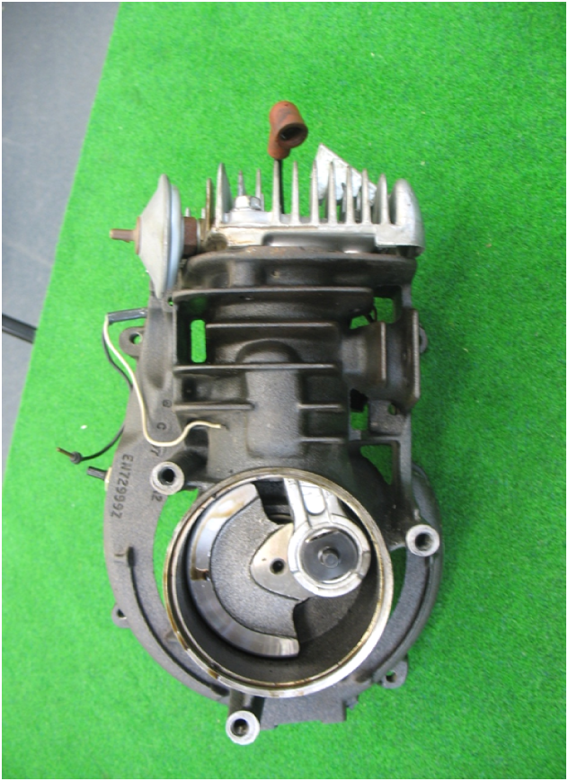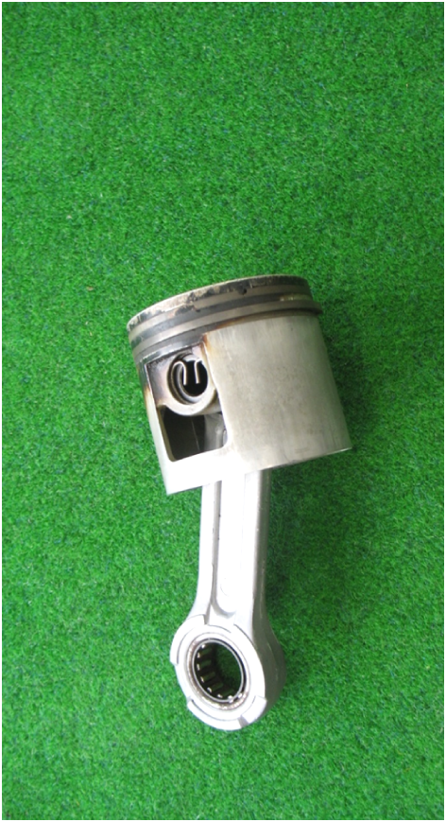
A lawnmower
Crankcase/cylinder casting with cover removed to show end view of crankshaft, crank pin and part of connecting rod

Figure 3: Components of the lawnmower
4.4 Individual laboratory exercises (Dynamics)
In the dynamics component of the course, a range of hands-on laboratory exercises are conducted by students. Students are able to access the experimental rig and take measurements without supervision, which saves substantial tutor resource time. Students are able to conduct the laboratory exercises in groups, although they were required to submit individual reports. Students are given guidelines on the format of their individual practical reports and given substantial feedback on their reports, with the aim to develop their technical writing skills as engineers. The various laboratory exercises are described in what follows.

Laboratory exercise 1: Motion of a rolling disk down an incline
A schematic diagram of the project to predict the motion of a rolling disk down an incline is shown in Figure 4. The project consists of three parts; (i) the experimental component in which the students are required to take measurements, (ii) an analytical component in which the students are guided on derivation of an expression for the time it took the rigid body disk to roll a certain distance down the incline, and (iii) a computational component in which the students are instructed to use either Excel or MatLab to graphically present their results.
x
r

Figure 4: Schematic diagram of a disk rolling down an incline.

Laboratory exercise 2: Coefficient of restitution rig
Impulse, momentum and the coefficient of restitution are important concepts to the field of dynamics. These concepts define the kinetics that occurs between moving bodies when they collide with each other. The coefficient of restitution is a property of collisions and depends upon the materials that are colliding. Students are required to determine the coefficient of restitution between two projectiles, a glass marble and a steel ball bearing, and the apparatus it is colliding with. The laboratory exercise is broken into two parts, experimental and analytical. In the experimental section, students are required to take measurements of the distance the projectile travels and the height from which it is dropped. The analytical section uses these measurements to calculate the coefficient of restitution. A schematic diagram of the rig is shown in Figure 5.

Figure 5: Schematic diagram of the impulse-momentum test rig.

Laboratory exercise 3: Moment of inertia of a pendulum
Moment of inertia is a measure of an object's resistance to changes to its rotation. It is the inertia of a rotating body with respect to its rotation. The moment of inertia plays much the same role in rotational dynamics as mass does in linear dynamics, describing the relationship between torque and angular acceleration. The moment of inertia of a body can be calculated directly knowing the geometry and the density of the body. The laboratory exercise involves calculating the moment of inertia of a pendulum, which consists of a swinging rigid body around a pivot point. When a pendulum is displaced from its resting equilibrium, it is subject to a restoring force due to gravity force that will accelerate it back toward the equilibrium position. When released, the restoring force combined with the pendulum's mass causes it to oscillate about the equilibrium position, swinging back and forth. The time for one complete cycle, a left swing and a right swing, is called the period. Students are required to calculate the moment of inertia of an H-beam suspended as a pendulum at a pivot point, by measuring of oscillation of the pendulum.
4.4 Web-based tutorial system
In 2007, an innovative computer based tutorial system (Scott and Stone, 1998) was introduced for the first-year mechanics course taught in the School of Mechanical and Manufacturing Engineering at the University of New South Wales. The online system was an effective tool for management and assessment of tutorial exercises for large class sizes. Furthermore, the system is web-based and interactive, providing integration of technology into the course and a fun means of delivery of the tutorial exercises. Using this system, students are required to conduct and submit online answers to the practice and assessed tutorial questions on a weekly basis. Each student has identical questions but with different numbers. Solutions to the practice questions are available immediately. Solutions to the assessed questions become available after a due date. The students could attempt the assessed questions as often as they wished before the due date without loss of marks if their answer was incorrect. The online tutorial system was also an excellent means to foster independent student problem-based learning, as students were able to work through the weekly exercises both in and outside of structured tutorial sessions (Brodie and Porter, 2008).
5. Student performance
The impact of implementing learning and teaching strategies in the first year mechanics course by using a variety of assessments has resulted in a significant improvement in student performance. This is evidenced by both the vast improvement in pass percentages as well as an increase in the average grade since 2007, the year in which the lecturers took over the delivery of the course. Figure 6 shows the percentage pass rates and grades for MMAN1300 Engineering Mechanics 1 from 2002 until 2010. Data is not presented for 2009 since both lecturers were on leave in this year. With the exception of 2009, since 2007 there has been a dramatic decrease in the failure rate as well as an increase in the average grade.

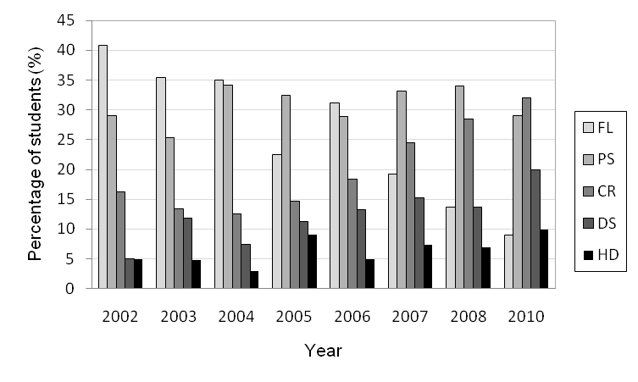
Figure 6: Percentage pass rates and grades for MMAN1300 Engineering Mechanics 1 students. FL=Fail, PS=Pass, CR=Credit, DS=Distinction, HD=Higher Distinction.

6. Student survey
The formal student evaluation instrument of the University of New South Wales is the Course and Teaching Evaluation and Improvement (CATEI) survey. In the CATEI survey, student satisfaction with the course is rated. Students are also given the opportunity to provide comments on what they like about the course and how the course can be improved. Selected student feedback comments from the CATEI survey in 2007 for the MMAN Engineering Mechanics 1 course are quoted in what follows.

- The course was well organised and set out. There was a clear assessment schedule at the beginning of session and information was regularly posted online to keep students up to date on events and on their marks.
- The engineering week lawn mower exercise was a fun learning experience. The follow up tutorial task was good because it connected the theory with practical applications. This helped me understand why we were studying this course, which makes studying much easier.
- Practical Applications of Statics and Dynamics were useful because the course is not just theoretical; it had some kind of use to the physical world.
- The best feature of this course was the labs.
- I loved the online tutorial problems. They formed the majority of my study and homework time and so overall I found them a fantastic way to consolidate the material.
- The online tutorial questions were of extreme benefit. Had they been set from a textbook, I wouldn’t have done them, but because they were online, I did. The online tutorial system was an effective way of reinforcing the material learnt in class.
7. Conclusions
The objectives of two lecturers sharing a mechanics course in first year engineering for the first time was to implement a variety of learning strategies to keep students interest and improve student performance. The range of assessments and activities was shown to directly impact on the students’ perception of the course, encourage student participation and provide a better student experience. The assessments were selected in an attempt to integrate the topics covered by students in their maths, science and engineering courses. Problem solving exercises as well as individual and group laboratory projects were chosen to improve student understanding of the fundamentals in mechanics and its application to real engineering problems. The method of delivery of the assessments and activities were also selected to cater for the different levels of motivation, different attitudes towards teaching and learning, as well as foster independent student learning. Independent student learning was promoted by instructing students to conduct both individual and group based projects as well as tutorial questions without direct assistance from tutors. By the end of the course, the majority of students had developed a clear understanding of the fundamentals of engineering mechanics in practical real-life examples. The various actitivities and assessments were shown to have a positive impact on (a) motivation and participation of students in the first year mechanics course, (b) verbal and written, both formal and informal student communication skills, and (c) improved student performance compared to previous years. Feedback comments from the formal student survey showed that the students were very receptive to the teaching approach and activities in the first-year mechanics course.
References
- L.M. Brodie and M. Porter, M., “Engaging distance and on-campus students in problem-based learning”, European Journal of Engineering Education, Vol. 33, No. 4, 2008, pp. 433-443.
- B.G. Prusty; “Teaching and assessment of mechanics courses in engineering, which encourage and motivate students to learn threshold concepts effectively”, Proceedings of the 3rd Biennial Threshold Concepts Symposium: Exploring transformative dimensions of threshold concepts, July 1-2, 2010, Sydney, Australia.

- N.W. Scott and B.J. Stone, “A flexible web-based tutorial system for engineering, maths and science subjects”, Global Journal of Engineering Education, Vol. 2, No. 1, 1998, pp. 7-16.

