Education to Promote Concurrent Manufacturing in the Composite Industry

E. Archer, A.T McIlhagger, J.P. Quinn
Engineering Composites Research Centre, Faculty of Computing and Engineering, University of Ulster, Shore Road, Newtownabbey, Co. Antrim, BT37 OQB.
e.archer@ulster.ac.uk

Abstract

Recent high profile events in the aerospace and wind energy sector have highlighted the potential for even the most established companies to incur costly programme delays, rework or component in-service failure by the inappropriate use of composite materials. These events will invariably tarnish the reputation of the composite industry as a whole and may affect the composite industry’s continued growth and competitiveness.

Recently in the US there have been moves to standardise a composites education curriculum and skills development. It has been argued however, that due to the proprietary nature of many of the emerging technologies, the development of a standard education programme will be difficult. This paper examines how organisations and the economy can benefit from a structured training programme targeting staff at all levels within a company’s structure.

The paper will outline the current events that have demonstrated the need for an in-depth review of the training of Engineers and technicians for the manufacture of composite components and systems. Furthermore, it will draw on the experience of the authors gained in both an industrial and tertiary environment to present the case for increased and coordinated composites education to satisfy not only the current need, but to lay the foundations for the rapid development of composites in many industrial sectors.

1. Introduction

Effective design with composite materials requires knowledge of a greater number of variables than designing with metals. With composites, we are designing a material as well as a part. Also, an understanding of how the part will be fabricated is vital; without this knowledge, the designer has almost no hope of meeting the performance criteria. It is therefore imperative that we change from a sequential to simultaneous involvement of the disciplines and develop an environment where stakeholders in a project are in communication from the start. By bring all disciplines into the design process at the beginning, they can evaluate developments and each discipline can measure the impact of a change on their area of expertise. As 70% of product cost can be determined in the first 5% of the design process (1) we must ensure that the need for costly programme delays, rework or in service failure is minimised.

The polymer composites sector is central to the economy and to meeting demand from a wide range of major industrial sectors. A skilled workforce is essential therefore, for companies wishing to compete in globally competitive markets using composite materials. Retraining will be required in companies which have gained expertise in manufacturing which use metals but are now increasingly using composite materials. It is unlikely that the use of composites materials will achieve widespread adoption without a viable education and training infrastructure. We must consider then what this training infrastructure will look like and how we will ensure that it provides useful education. As is often the case the aerospace industry is helping to lead the charge and in the USA the FAA, in collaboration with twelve schools participating in the FAA’s Joint Advanced Materials & Structures Centre of Excellence, is proposing an education strategy for transferring composite technology practice and knowledge to practitioners and others interfacing with composite materials (2). In a recent publication, Charles Seaton from Wichita State University remarked that training should involve three different but complementary concepts:
Level 1-Introductory courses
Level 2-Awareness of technology and safety issues
Level 3-Specialised training and skill building in specific areas of interest

Several initiatives in the USA have been implemented and are in various stages of development for Level I and II training which are directly related to this proposed education strategy. Seaton states, however, that while courses do exist at Level I and Level II, there remains a gap between the needs of industry and the capability of educators to satisfy those needs. For example, many education institutions provide worthwhile educational resources, but there is often limited industry input in the development of course content, resulting in inadequate source content in important topic areas and a lack of sufficient discussion of regulatory issues and guidance from regulatory agencies. For classroom delivery of courses, the availability of subject matter experts can be a challenge, but it is proposed that asynchronous online education allows experts to be much more available and effectively involved.

Figure 1. Layered or pyramid approach that has been proposed.

One area where a greater challenge could be encountered is with the proprietary nature of composites which will limit potentially the effectiveness of educational organisations. Proprietary protection is in direct conflict with the adoption of standardised practices. For example, if a company develops a new manufacturing process which is not used elsewhere, the organisation would undoubtedly benefit from an upskilling of their staff to properly implement the process, but the difficulty arises from the lack of external training agencies able to offer an off the shelf package. Also, in many cases the people within the company’s R&D section who truly understand the new process may be unable to disseminate the information in a structured way due to lack of either time or experience in delivering professional development education.

This FAA strategy outlined above clearly is applicable only for the aerospace sector. With a more general industry-wide view in mind, the American Composites Manufacturers’ Association (ACMA) believes that composites education will advance more quickly if the industry moves toward consistent, standardized curricula for basic and advanced training, developed through best practices and industrial collaboration. The purpose of the CCT standardized curricula is to establish the baseline skills required for composites industry employees to perform their jobs and should support best practices endorsed by the industry at large. In the case of composites technicians specifically, it should promote skills that lead to the manufacture of high-quality products. The qualification is called Certified Composites Technician and has been developed across all composite industries. Once one a candidate has achieved the CCT they can move up to achieve the CCM Composites Certified Manager qualification.

In an article from Composites Technology, Andre Cocquyt (3) concluded that a standardized training scheme for composites technicians in the US would not only help address competition from overseas, but would also reassures end-users that composites are the material of choice over more traditional materials. His vision of a training scheme for composites technicians would include fundamental knowledge and the following:
The history of composites
Basic terminology
Standard manufacturing processes
Material properties
Plant safety

He also considered the process of updating the curricula as an ongoing task which should also include a hands-on element. In a similar article Cocquyt (4) discussed how a national training programme in the USA should be established; he concluded that a cohort of potential trainers should initially be trained, who can then disseminate information in areas such:
The physics of composites
Chemistry
Tools and tooling
Manufacturing methods
Lean manufacturing
Other aspects that make our trade unique and challenging

Another advocate of standardized training is Bob Lacovara of Convergent Composites (4) who explains that Standardised training is the most productive path to indoctrinate new employees. On-the-job training (learning by example) is the least effective method. The authors of this article have observed anecdotal evidence that on-the-job training can actually perpetuate bad practice and lazy methodology and a loss of sight of the importance of following prescribed sequence of events. Lacovaor believes that training should begin with a macro overview and introduction of basic terms, followed by an understandable explanation of the task objectives. Once the basic premise is formed, specific how-to information can be introduced. It is not enough to know how to do a job. A worker must know why he/she is performing it in order to appreciate the proper context for the task sequence, explained first in the classroom, followed by the students taking these ideas to the lab to build laminates to test these theories. He suggests a programme as follows:
-Basics of composite materials and processes
-Fibre and matrix properties
-Simple design theories
-Performance and/or the dimensional stability of the composite structure

Although it is clear that there is a will to upskill the technicians and operators, it is important that we do not overlook Engineers and Designers. They are expected somehow, to understand the concepts but comprehensive programs are not widely available, and Engineers/Designers who are already employed will rarely do more than attend a few seminars and maybe purchase a book or two. Louis Dorworth from Abaris Training Resources (4) notes that when a designer actually has to build a laminate with a complex configuration, they quickly learn that designing with manufacturability in mind will not only improve the end product, but make it easier to build and, perhaps, require less time and effort, thus making the product more cost-effective. He postulates that all designers should be required to take a hands-on class to really understand manufacturability. As well as Abaris Training Resources there are a growing number of non-governmental organisations offering composites skills training in various locations throughout the world.
In the UK there have been some recent developments to enhance strategies for composites skills training. In October 2010 the Advanced Composite Training and Development Centre, located in the Hawarden Industrial Park in Broughton, was officially opened. The centre is partially funded by the Government of the Welsh Assembly to improve and teach composite skills and will help thousands of Airbus UK apprentices and employees develop and improve their composite manufacturing skills (5).
The UK Composites industry has also recently received a boost with the announcement of a new National Skills Academy (NSA) for Composites and Biotechnology. The Academy, which will form part of the National Skills Academy for Process Industries, will receive up to 1.98m of funding over 3 years, a sum of money to be matched by employers (6) Also, Semta, the Sector Skills Council for Science, Engineering and Manufacturing Technologies (Semta recently took responsibility for composites from Cogent in the UK) also announced a series of measures to give better support to businesses operating in the composites sector. Semta has developed a new National Occupational Standard for composites engineers up to NVQ Level 3. Occupational Standards provide a description of the skills, knowledge and understanding needed to undertake a particular task or job to a nationally recognised level of competence, helping formalise training requirements for employers and employees (7).
Another aspect of the overall strategy which must be addressed is how to develop a pool of graduates ready to take on careers in composites manufacturing. Bob Lacovara (4) considered that an initiative should be introduced to enhance the level of practical training and knowledge at the university level, aimed at structural engineering students. The authors of this paper have noted that many recent graduates of structural or mechanical and aerospace Engineering might struggle to solve a simple problem using laminate plate theory. When shown however, that it was derived from Mohr’s circle, something which they were familiar with from structural calculations with isotropic materials taught in undergraduate courses, they could quickly understand and use the concepts.
There are some Universities which specialise in this area at the undergraduate level, Plymouth (UK) being one. In the UK at MSc level, Composite Materials by Research exists at Manchester University. An MSc course in composites also exists at Imperial College London. Both the Universities of Cranfield and Surrey have an MSc in Advanced Materials and the University of Plymouth has an MSc in Mechanical Engineering with composites content. The University of Ulster now offers a PgDip and MSc in Advanced Composites and Polymers.
2. Case study
It is clearly recognized that the development of a new composites commercial transport aircraft has been more challenging than many would have predicted. Apart from supply chain management, there have undoubtedly been some technical challenges which could not have easily been anticipated. Lightning strike, hidden damage within the laminate, reparability, long-term fatigue behaviour, crash behaviour etc, have consumed more time and resources than airframe manufacturers might have allowed for.
Although many of these challenges can be overcome with extensive research, analysis and testing, there are several other examples of risk which could perhaps be mitigated by educating and training all stakeholders at an early stage in the project. One interesting example of this was a setback to a new aircraft programme which arose in 2009 during the static airframe test, revealing a structural flaw in the join between the centre fuselage and each wing. As a result, an already substantially delayed maiden flight planned for the commercial transport in question was further delayed.
The area of concern centres on points on each side of the aircraft where stringers in the centre wing box are bonded to partner stringers in the wing box. During wing flexing tests, stringer caps suffered damage including, according to reports, some laminate disbanding. The airframe manufacturer had to develop a repair and re-tested before the flight test aircraft could fly. According to Dominic Gates (8), excessive loads at stringer ends (known to Engineers as “runouts”) is not something that would have struck the airframer out of the blue as the problem with stringer runouts had been identified in the past and recognised as a problem having arisen as such on other composite airplanes. Indeed the stress point at the end of the stringers showed up as a “hot spot” in the computer models before the delamination in the wing bend test, but for some reason it was never addressed. It appears that in this example, the analytical experts in the stress office had a clear understanding of the issues surrounding through thickness (out-of-plane) tension, but by the time detailed drawings were then issued to manufacturing, some of this high level of understanding had been lost in communication. It is possible that with the implementation of a more in-depth training programme, some of the knowledge could have been disseminated from the stress department into other functions.
There are numerous other examples of composite components being damaged during manufacture or in service by the improper handling of laminated materials. Although some incidences are purely accidental, proper training of all involved in the composites supply chain is required to minimise delaminations resulting in rework, scrap or in-service issues. Consider an aircraft mechanic dropping a wrench on the top surface of a wing. If the wing is made of aluminium, the impact may leave a dent, essentially recording the impact and providing some rudimentary indication of the significance of the resultant damage. A composite component might show much less visible damage but could have internal delaminations. Inspection and maintenance staff therefore, also require significant training as service life will no longer be driven by fatigue and corrosion performance, as they are for metallic structures, because composites are not as susceptible to these failure mechanisms. Instead, accidental subsurface damage and subsequent failure progression will be more important.

3. Conclusions
The authors and the University of Ulster, with the support of Invest Northern Ireland have engaged with an aerospace OEM to provide a bespoke Level 1 and Level 2 training course, similar to the ones discussed by Seaton in the USA (2). This course was offered to various functions in the company from Design, Stress, Materials and Process, R&D, Tooling, Quality, and even some procurement staff. Experienced Engineers who participate in the basic course have commented on how much they have learned they can apply at the design level to improve manufacturability. Likewise manufacturing Engineers have gained an understanding and appreciation of the importance of ply orientation and placement and the minimisation of void contents and other unsatisfactory defects, from a stress point of view. By empowering each function with a greater understanding of the total process, cost, risk and time can be reduced from initial design right through to final inspection.
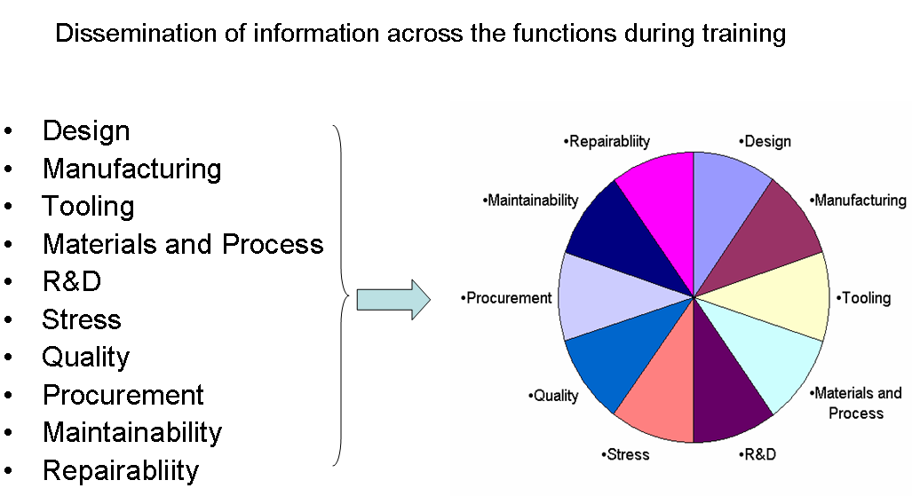
Figure 2. Shift from sequential to simultaneous involvement of the disciplines.
Although this is an important step, it is an example of the knowledge and expertise that are developed in large companies using composite materials; for a competitive composites industry as a whole, this type of information, or at least the non commercially sensitive aspects, needs to be transferred down the supply chain whilst recognising that industry needs to operate in an accredited quality scheme.
References
1. M. Niu, Composite Airframe Structures, Hong Kong Conmilit Press limited, Hong Kong, 1992, pp. 22-25.

2. C. Seaton, Proposed Education Strategy for Composite Technology, SAMPE 2010 - Seattle, WA May 17-20, 2010.
3. http://www.compositesworld.com/articles/composites-education-improvement-through-collaboration
4. http://www.compositesworld.com/articles/the-future-of-composites-education

5.http://www.glyndwr.ac.uk/en/Contactus/PressOffice/Pressreleases2010/FirstMinisterforWalesopensnewAdvancedCompositeTrainingandDevelopmentCentre/

6. http://www.netcomposites.com/newsitem.asp?id=6533
7.http://www.semta.org.uk/about_us/media_centre/news/semta_supports_composites_work.aspx
8. Dominic Gates, Boeing 787 may not fly this year, The Seattle Times, July 22, 2009.

