Design Thinking, a Pathway to Intentional Learning

¹Ruth E. Davis and ²Christopher A. Kitts

Santa Clara University, Santa Clara, California, USA, rdavis@scu.edu¹;

Santa Clara University, Santa Clara, California, USA, ckitts@engr.scu.edu²

ABSTRACT

Recognizing that today’s problems call for engineers who are globally engaged, ethical professionals, citizens, and individuals, we have redesigned our curriculum to encourage intentional, integrated learning, including more opportunities for interdisciplinary, experiential, entrepreneurial and civic education.[1] One unique aspect of our new core curriculum is the inclusion of pathways as a means to encourage intentional learning.

In this paper we describe the development of a Design Thinking pathway, extra-curricular activities associated with it, and plans to assess the effect it has had on the education of students who chose to declare this pathway.

1. Introduction

Santa Clara University is implementing a new core curriculum aimed at engaging students in the integration of their learning and preparing them to be engaged citizens of the world. Students are required to declare a pathway, a collection of courses addressing a common theme or issue from a variety of disciplinary perspectives.[2] This is quite different from a minor, which usually requires some depth in a given subject matter. Rather than delving deeply into a subject area, the pathway encourages students to recognize connections among different subjects by focusing on a particular issue or theme that can be addressed by all, but with different points of view defined by a range of disciplines.

There have been twenty-three pathways approved to date, the titles provide a clue to the issues or themes addressed within each:
- American Studies;
- Applied Ethics;
- Beauty;
- Children, Family, and Society;
- Cinema Studies;
- Democracy;
- Design Thinking;
- The Digital Age;
- Food, Hunger, Poverty, Environment;
- Gender, Sexuality, and the Body;
- Global Health;
- Human Rights in a Global World;
- Islamic Studies;
- Justice and the Arts;
- Law and Social Justice;
- Leading People, Organizations, and Social Change;
- Paradigm Shifts and the Nature of Human Knowing;
- Politics and Religion;
- Public Policy;
- Race, Place, and Social Inequalities;
- Sustainability;
- Values in Science and Technology; and
- Vocation.

A faculty facilitator proposes a pathway by providing a brief description of the pathway and a list of courses that might be included in the pathway. There is a minimum of ten courses for each pathway, as the students must have a sufficient set from which to choose the three or four courses they will take. In order to complete a declared pathway, a student must save and submit relevant assignments from each of the courses they chose to include, as well as a two-page paper that:
- describes connections among these courses and between their pathway and their major;
- analyzes a significant issue from at least two different disciplinary or methodological perspectives; and
- reflects on the learning process itself and on the past and future of their vocational and educational choices.

These papers are reviewed to see that the students have met each of these requirements, and if they have not, they will be given a chance to revise and resubmit.

2. The Design Thinking Pathway

Design Thinking provides a holistic approach to the development of new products and processes, emphasizing the creative, interdisciplinary synthesis of new systems that can lead to solutions for real problems. Important aspects of design thinking include the innovative application of technology as well as the need to harness such innovation in a sustainable enterprise. Design thinking may be applied to a vast range of problems, from designing a new consumer product, to adapting a device for low-cost and local production in the developing world, to solving global issues such as climate change and health care. This pathway is open to all students and invites them to discover the many elements of design thinking. The topic may be explored from a wide range of perspectives, such as those characteristic of the arts, humanities, natural sciences, social sciences, business, and engineering.

Courses included in the design thinking pathway come from departments all around the campus, including: Studio Art, Bioengineering, Biology, Business, Civil Engineering, Computer Engineering, Communication, Mathematics and Computer Science, Economics, Electrical Engineering, English, Environmental Science, History, Liberal Studies, Mechanical Engineering, Management, Operations and Management Information Systems, Philosophy, Political Science, Sociology, and Theology, Ethics and Spirituality. Each instructor of a course in a pathway must note the fact that the course is included in a pathway on the syllabus; however, it is up to the students to decide how the course relates to their individual set of courses and to choose the assignment to include in documentation of their pathway.

3. Design Challenges

In addition to identifying courses to be included in the Design Thinking pathway, we have provided several extra-curricular opportunities related to the pathway. We bring in speakers addressing Innovation and Entrepreneurship in our seminar series, and we continue the excitement they bring by following up with tours of their company sites. Whenever possible we tie these events in with a “Challenge” offered each term. For example, the first such challenge was the BMW Product Pitch.

This competition, held in February 2009, gave 6 teams of students only 22 hours to develop and present a new product concept, as challenged by BMW engineers. The product/service had to complement the BMW Mini brand through its use of a smartphone, GPS-based location data, and real-time information about the automobile's performance. The 6 teams competed for a Grand Prize of $500 and were composed of 34 students, including engineers, business students, and students from Arts and Sciences. The teams were presented their task at a Tuesday evening mentoring reception at the CREST facility in the NASA Research Park. They presented their concepts in 5-minute presentations 22 hours later at a Wednesday afternoon Innovation Seminar; judges included BMW engineers and local venture capitalists. The winners were announced the following evening at the School of Engineering Awards ceremony.

The next challenge was inspired by our collaborations with NASA. For the NASA Aerospace Challenge, held in October 2009, teams of students took part in a 3-week event in which they completed three challenges. The first was to develop an antenna pointing jig/process in order to hand-track the NASA GeneSat-1 spacecraft and decode data from its amateur radio beacon. The second was to develop a YouTube marketing video for NASA. And the third was to develop an egg launch and re-entry system.

More recently, in January/February 2011, the Centennial SWAG Competition challenged teams of students to develop SWAG (Stuff We All Get - giveaway trinkets) for the upcoming 100 Year Anniversary of the School of Engineering. The winning team developed a mini LEGO Mission model. This entry was selected due to its relevance to the university, its novelty and creativity, and its price-point. An honorable mention was given to the 2nd place team, of freshman students, which developed a mini-electronic tic-tac-toe game.

Capitalizing again on the connection between our Robotics Systems Lab and NASA, the next competition involved the design of a logo and patch for the NASA NanoSail-D mission. In November 2010, the NASA NanoSail-D spacecraft was launched into orbit by a Minotaur IV rocket that lifted off from Kodiak Alaska. In January 2011, NanoSail-D unfurled its primary payload, a solar sail, in order to demonstrate critical mechanisms required to store and deploy such sails for future space missions. NanoSail-D is the first Earth orbiting spacecraft to successfully deploy a solar sail.

The NanoSail-D mission was developed by NASA Marshall Space Flight Center, NASA Ames Research Center, and a variety of other partners. Students at Santa Clara University served as the mission controllers for the spacecraft by collecting satellite telemetry, performing S-Band command operations, and archiving beacon data collected by amateur radio operators throughout the world.

Because of its very low cost and rapid development pace, the NanoSail-D mission team never had the opportunity to develop an official mission logo or patch. For space missions, the mission logo and patch often play a significant role in marketing and commemorating the mission. Logos and patches do this by performing many functions, such as representing key elements of the mission architecture, highlighting noteworthy science or technical achievements, and recognizing team members and organizations.

This challenge was to develop both a mission logo and a patch for the NanoSail-D mission, as well as a brief narrative (no longer than 1 page) describing the logo/patch, pointing out the significance of the primary visual elements and why they are relevant to the NanoSail-D mission, and a cost estimate/quote for 100 patches given the size and colors used, assuming no more than a 1 month delivery. A panel of judges from NASA Marshall Space Flight Center selected the winning design, pictured in Figure 1.

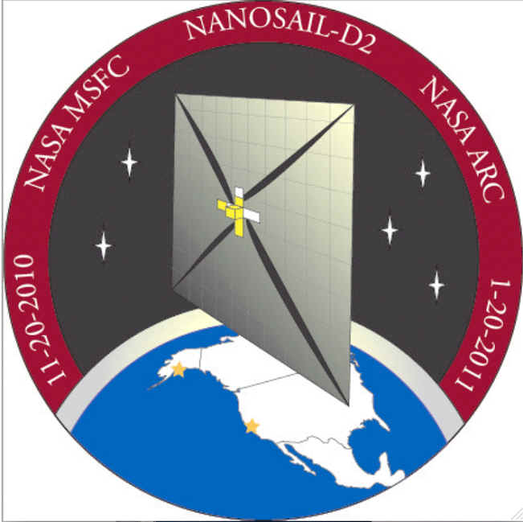

Figure 1.
Key symbols included in this design included SCU maroon around the border, stars in Alaska and at SCU for the launch and operations sites, 5 stars representing the 5 second deployment timer, and an atmospheric band representing the drag sail functionality of the spacecraft.

In Winter 2011 we hosted an invited speaker from NVIDIA for a seminar, which was followed a couple of weeks later by a lab tour of NVIDIA, and in the spring term we introduced a competition to design a new product using NVIDIA parallel processing technology. The challenge is to develop a socially beneficial service using smart phones and NVIDIA technology. We have found that the sequencing of these events (speaker, lab tour, competition) with a common theme encourages students to maintain interest.

All of the competitions mentioned above offer students to opportunity to actively engage in Design Thinking, beyond the classes they take as part of the pathway. We hope that such opportunities will enable students to keep the Design Thinking theme in mind when planning the courses they will take to satisfy other core curriculum requirements.

3. Study Groups

We introduced the first cohort of students to the new curriculum and pathways in fall 2009, through the Introduction to Engineering course taken by all freshmen in engineering. We introduced these students to the concepts of innovation and entrepreneurial thinking with presentations in class and invitations to participate in activities beyond the classroom. We also taught these students how to represent related knowledge using concept maps.³ We set aside one section of the introductory course as our primary study group, and have requested additional concept maps from these students as they progress through their pathways.

Another study group will be composed of those students who participated in the competitions presented during their undergraduate career.

A third group consists of all students declaring the Design Thinking pathway. We know these groups will overlap in interesting ways, and we hope to learn the impact that each contributes. Our control group will be the engineering majors who were not in any of the three groups defined above, but in the same class cohort as the primary study group, and will be graduating at essentially the same time. (All groups are comprised of engineering students who entered as freshmen in the fall of 2009.)

3. Methods

We are tracking all of these students, documenting their choices of pathway and courses to satisfy various core requirements, and participation in extra-curricular competitions. We are also collecting concept maps created by the students in the primary study group to show the connections among the courses they chose. As all of these students prepare for graduation, in Spring of 2013, we will be able to compare the attitudes and learning expressed in their pathway reflections with the students in the other groups identified above as well as the control group. We hope that the concept maps encourage the students in the primary study group to make more intentional choices and reflect on them more frequently than the students who simply must complete a pathway sometime before graduation.

We will also track how many of the participants in the challenges we present choose the Design Thinking pathway, and whether this subgroup of those in the pathway exhibit different characteristics in their choices of core courses, compared with the primary study group and with other students. We will compare the choices of core courses, the timing of those choices, and the reflection papers required to complete the pathway. It will be interesting to see if the distance in time from the introductory engineering course will have an impact on the number of them choosing the Design Thinking pathway.

Our conclusions thus far are based on preliminary findings, as the students in our study groups will not be required to complete their pathways until the winter term of their senior year (March 2013). However, we can already see that some of these students are making more informed, intentional choices, considering ahead of time what they want to emphasize and choosing courses they think will fit within their pathways.

4. Results

We expected the Design Thinking pathway to be particularly attractive to engineering students, and have witnessed that this is the case. Our primary study group declared their pathways early, as they completed the Introduction to Engineering course. The rest of the students in the same cohort will be declaring their pathways in June, 2011. Of the thirty-nine students we identified as our primary study group, nine students (23%) declared the Design Thinking pathway. Of the 283 students in the university (engineering and elsewhere) who have declared a pathway (from twenty-three different pathways available) as of May 1, 2011, 50 (18%) have chosen Design Thinking.

Thus far, we have been encouraged by the engagement these students have exhibited in going beyond what is required in the curriculum to participate in activities of interest. Many students have participated in the optional "challenges" offered throughout the school year.

Although early in the process of tracking the students, we have some results that show some students are making more deliberate choices among the options presented to them. We have collected concept maps indicating an understanding of how the courses chosen for the pathway fit together and support the pathway theme. For example, in choosing among a wide variety of courses to satisfy core requirements in the humanities, we see students making choices that are related to the pathway, rather than simply taking any course that satisfies a requirement and is offered at a time they find convenient. For example, one of the students in the study group described the relationships among her chosen pathway courses with the concept map presented in Figure 2.

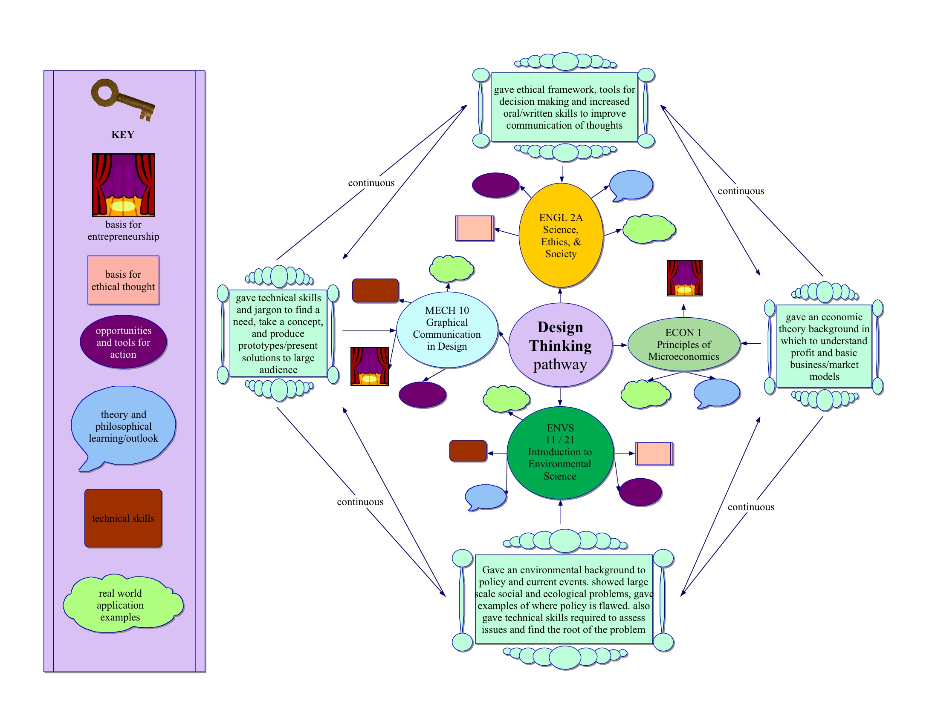

Figure 2.

She describes graphically the relationships among the courses she chose to include in the pathway, and annotates each class with the contribution she feels that it made toward her understanding of the whole. The key provided identifies the information represented by different graphical objects in her map that are in common with several courses. For example, she identifies with the oval, the fact that three of the four courses provided opportunities and tools for action, and all four courses contributed to her understanding of real world application examples.

4. Conclusions

It is really too early to make conclusions about this experiment. In Spring of 2013, we will have all the data we need to report thoroughly whether or not the repeated assignment of developing concept maps has had an impact on the students in the way they choose to reflect on their education and vocation. We will also be able to report quantitatively about the effects of participation in extra-curricular competitions on the students’ reflections on vocation and education. Early, anecdotal results are encouraging.

5. Acknowledgments

This work has been supported in part by National Science Foundation grant #0737110: “Pathways to Meaningful Learning”, as well as the Kern Family Foundation, through a KEEN (Kern Entrepreneurship Education Network) grant.

References:

1. Chang, Juliana, Paul Crowley, S.J., Michael Kevane, Leilani Miller, Chad Raphael, Michael Zampelli, S.J., and Alex Zecevic, “Proposal for the Santa Clara University Core Curriculum,” Santa Clara University, Santa Clara, CA, 2007. Available at:

http://www.scu.edu/core/upload/core-proposal-2007.pdf

2. Santa Clara University Core Curriculum, available at:

http://www.scu.edu/provost/ugst/core2009/

3. Novak, Joseph D. Learning, Creating, and Using Knowledge: Concept Maps as Facilitative Tools in Schools and Corporations. Lawrence Erlbaum Associates, Inc., New Jersey, 1998.

