Engineering better COSHH compliance in the lab or the workplace: A generic development Kit

¹Laura Newton and ²James Davis

Chemistry, Nottingham Trent University, Nottingham, UK, laura.newton@ntu.ac.uk¹;
School of Engineering, University of Ulster, Co. Antrim, UK, james.davis@ulster.ac.uk²

Abstract
Health and Safety education is a mandatory requirement for all educational and business organisations within the UK but there is often a negative perception regarding its implementation – especially with regard to the provision of information. This can often be ignored and is especially hazardous where everyday chemicals are used. The latent hazardous posed by these materials are often ignored on the basis of their familiarity but their misuse is invariably one of the major contributors to accidents within the workplace. There is a core need to have a more sustainable approach to imparting a greater awareness of the risk posed by chemicals – irrespective of their form. This has to start with school based activity and be built upon throughout the secondary and tertiary sectors. One approach from attacking the problem at the grass roots was to consider the engagement of the pupils and to stimulate curiosity such that they aware of hazards. An Origami kit was designed and tested to see if could be used to enhance the communication of the Control of Substances Hazardous to Health (COSHH) regulations and the associated hazard information within the home, workplace and not simply the lab. The system developed was found to be an engaging activity that delivered the intended information to a varied target audience covering all age groups across multiple curricula. The potential use of this model as a complementary aid to existing workplace COSHH training is also discussed.

1. Introduction

The Control of Substances Hazardous to Health (COSHH) is the legal framework within the UK that should be implemented and complied with by any business where hazardous substances are handled [1]. It is the employers responsibility to ensure that these laws are followed and this is normally achieved by provision of routine risk assessments, controlling user exposure to hazardous material and also by ensuring that all employees are provided with the appropriate training. Numerous training routes can be used [2], but in practice due to time and budget constraints the potential hazards are often communicated solely by word of mouth and supplemented by a deluge of forms that are seldom read - rather than a thorough explanation of the appropriate hazard literature. Sadly, this approach rarely reinforces the latent hazards and exacerbated through the employee assuming that there is a negligible risk associated with the use of certain everyday substances [3 and 4] combined with their lack interest in dissecting the wealth of complex paperwork that can accompany the appropriate COSHH documentation [5].

Even though it is mandatory for employers implement COSHH within the workplace, the number of accidents related to the handling hazardous substances was one of the main causes of work related injuries in 2009/10 [6] and so it is clear that a more effective means of communicating the significance of hazardous substances within the workplace needs to be developed. With the ideal route being one by which students is engaged at an early age. It was important that system could be adaptable to meet the needs of an unskilled work force such the existing employee is engaged or interacts with the subject material is a more useful manner such that the information is more likely to be retained for future use.

Origami can be used as a teaching aid providing a fun challenging learning activity but its actual implementation hasn’t been exploited fully [7]. There are a range of different models that can be used and varying tremendously in their levels of complexity (from the simplistic to the mind numbingly intricate artforms) but for our purposes a modular type puzzle system was chosen as these can be constructed simply making them accessible to a wide skill set and they can be modified easily so that they display the appropriate contextual information thus providing an interactive way of displaying the intended information during the construction of the model. They also provide a challenge which can create a sense of achievement such that the model is actively retained and thus could serve as a vital aide memoire.

The understanding of COSHH hazard symbols and the corresponding risk and safety phrases forms the basis of current COSHH training and lays the foundations for which more detailed information can be built upon. As such this information was chosen to give the contextual information that would be presented on our modular puzzle and so the main aim of this work was to develop a puzzle kit that could be linked to COSHH documentation providing a fun, engaging and hopefully more effective means at disseminating the key information when compared to conventional introductory/refresher COSHH training methods. The design and construction of the puzzle system is described and the results of a preliminary study evaluating its implementation are presented.

2. Puzzle Design

A modular cube puzzle consisting of 6 modules was chosen for the puzzle kit. This allowed 3 information snippets to be displayed on each page. Six everyday chemicals (along with an example of there consumer products), the hazard symbol associated with this chemical and the meaning/risk phrases corresponding to the hazard symbol were subsequently chosen as the 3 criteria for the information snippets as this subject matter highlights the basics of COSHH whilst reinforcing the need for constant vigilance when dealing with substances that may not normally be recognised as being hazardous. The snippet information used for the puzzle is listed in Table 1 and where selected such that a range of the more common hazard symbols and risk phrases could be highlighted. The puzzle itself consisted of six A4 sheets as illustrated in Figure 1.

Table 1: Puzzle Components and Respective Properties
Chemical | Application | Hazards
Butane | Hairspray | Flammable, R12
Ethylene Glycol | Antifreeze | Toxic, R23
Hydrogen Peroxide | Hair Dye | Corrosive,  Oxidising,  R5, R8, R35
Mercury | Fluorescent Lighting | Toxic, Danger to Environment  R23, R50/53
Sodium Carbonate | Washing Powder | Irritant, R36
Sodium Hydroxide | Drain Cleaner | Corrosive, R35

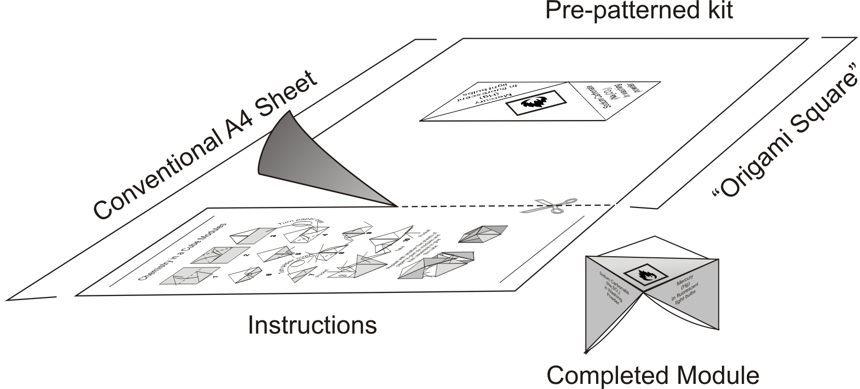

Figure 1: The Origami Kit

These were pre-printed with the snippet information as outlined previously and could be folded by following the folding instructions to give 6 completed modules which can then be combined to give the cube puzzle as illustrated in Figure 2.

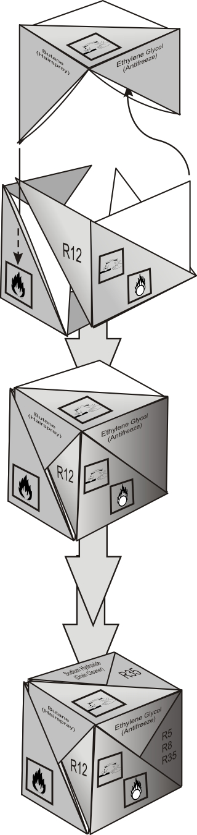
Figure 2: Assembly of the COSHH Cube

The assembly process can be performed using numerous combinations of the modules but for the puzzle to be completed correctly each face of the cube should have the correctly matched information snippets – the chemical name, the hazard symbol and the meaning of the hazard symbol/risk phrase.

3. Study

An initial trial was conducted with university undergraduates (N=23) and a section of the university cleaning staff (N=14) to assess the accessibility of the puzzle over a range of vocations, the clarity of the instructions provided, the general skill level needed and the time required to complete the puzzle along with the general response to the activity.

4. Results and Discussion

The results from this study were collected in terms of the user completing an anonymous participant questionnaire. The results from this questionnaire show that the puzzle was generally completed, by both groups, from the initial assembly of the modules to the final assembly of the cube, with the information snippets matching correctly within 20-30 minutes. It is therefore apparent that there was no real difference in terms of ability to construct the cube between the two different groups.

The majority of participants classified the activity as being informative and interesting (Figure 3A and 3B) confirming that the activity was accessible to both the young and old whilst confirming its ability to capture the curiosity of the individual, engaging them with the material and thus providing a route to introduce the basic concepts of COSHH.

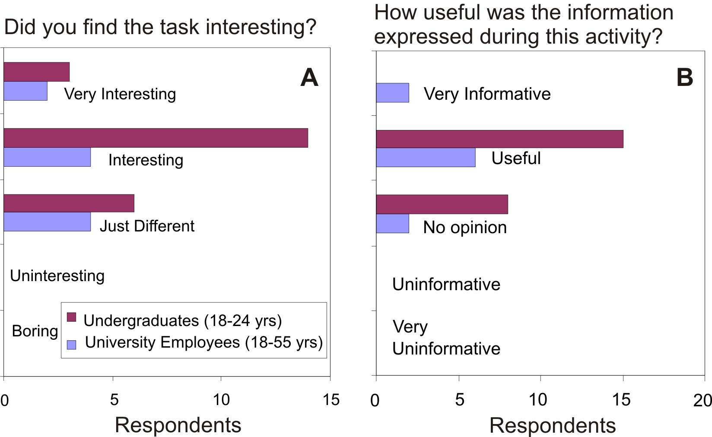

Figure 3A and 3B: Questionnaire Results

The study also found that over 90% of participants, from both study groups, retained the cube after the activity with the intention of showing it to and discussing it with friends and family. This can be viewed as a particularly positive outcome of the activity as it helps to disseminate the significance of hazard awareness to a broader audience whilst reinforcing the information within the participant and thus the working environment [5,8]. The retention of the cube also highlighted that the activity was regarded as being enjoyable giving the participant a sense of achievement.

A possible danger of this puzzle is that the participant can be disillusioned if the challenge appears too complex or if they are confused by the instructions [9]. The advantage of the puzzle developed is that the actual folding and assemble is not complex and the clarity of the instructions can be explained via a demonstration from the instructor or through watching a video clip of the entire assembly process as a means of reducing the cognitive load form one stage to another [9,10]. The correct assembly of the information snippets provides a challenge and although the correct assembly can require a degree of patience and perseverance it is unavoidable as there must be this challenge element to the puzzle in order to promote engagement within the task whilst instilling the sense of achievement at the end of the task.

The difficulty associated with the cube assembly can be altered to suit different ability cohorts through colour coding the information such that each side would be a specific colour upon successful completion of the cube thus having the correctly matched snippets of COSHH information which can subsequently be visualised and learnt. Without the colour coded sides the difficulty of the puzzle increases and it may be necessary for the participant to look at additional information sources so that they can confirm that the three snippets of information on a given face are in fact complementary. For the more complex puzzle approach it is possible that the cube could be assembled incorrectly thus the information on each of the cube faces is false, this creates an inherent danger if the system were to be deployed as a self learning aid without the correct answers being supplied. It does however have considerable merit in a test format where it can be used to encourage the participant to search for and use additional information sources such they can identify which symbol or risk phrases belongs to a particular chemical.

A primary advantage of the puzzle developed is the fact that the kit can be produced on demand and therefore allows for situations where there is regular staff turnover. The kit is produced in a PowerPoint® file which essentially serves as a template and its modification to update previous information, carry job specific information or to deliver other contextual examples can be easily achieved using simple cut and paste manipulation.

6. Conclusions

The puzzle kit developed is generic, transferable and simply requires access to a printer in order to generate the core components of the puzzle. As such, it provides a zero cost alternative that could significantly improve the appreciation of the COSHH to a wide audience: student, employee or even within the wider public. A vital component is that it can be easily adapted to suit the demands of an every changing regulatory landscape and, as such, represent a highly sustainable option for future adoption – especially with such minimal cost overheads.

7. Acknowledgements

The authors thanks the Engineering and Physical Sciences Research Council for supporting the pilot project

8. Supplementary Material

Templates and instructions for the assembly of the cube along with video clips detailing the actual folding of the cube are available from www.shapingscience.com.

9. References

- Health and Safety Executive Website. Available online at http://www.hse.gov.uk/coshh/basics/whatiscoshh.htm accessed 02/05/2011
- HSE, (2009), “Working with substances hazardous to health. What you need to know about COSHH”, Health and Safety Executive, HSE Books, UK Government Publications. Available online at http://www.hse.gov.uk/pubns/indg136.pdf accessed 02/05/2011
- C.A. Janicak, (1996) “Employers’ Knowledge of the Hazard Communication Standard Requirements and the Perceived Barriers to Compliance,” Journal of Safety Research, Vol. 27, pp. 233-239.
- M.A. McDonald, H.J. Lipscomb, J. Bondy & J. Glazner, (2009) “Safety is everyone's job: The key to safety on a large university construction site,” Journal of Safety Research. Vol. 40, pp. 53–61.
- C.C. Phillips, B.C. Wallace, C.B. Hamilton, R.T. Pursley, G.C. Petty & C.K. Bayne, (1999) “The Efficacy of Material Safety Data Sheets and Worker Acceptability,” Journal of Safety Research, Vol. 30, pp. 113–122.
- HSE, (2010), “The Health and Safety Executive Statistics 2009/10”, Health and Safety Executive, UK Government Publication. Available online at www.hse.gov.uk/statistics accessed 02/05/2011
- K. Chen, (2005) “Math in Motion: Origami math for students who are death and hard of hearing,” Journal of deaf studies and deaf education. Vol. 11, pp. 262-266.
- M.R. Lehto, (1998) “The Influence of Chemical Warning Label Content and Format on Information Retrieval Speed and Accuracy,” Journal of Safety Research. Vol. 29, pp. 43-56.
- N. Marcus, M. Cooper & J. Sweller, (1996) “Understanding instructions,” Journal of Educational Psychology, Vol. 88, pp. 49-93.
- L.R. Novick & D.L. Morse, (2000) “Folding a fish, making a mushroom: The role of diagrams in executing assembly procedures,” Memory and Cognition. Vol. 28, pp. 1242-1256.

