How to Encourage “Digital Natives” to “Analog Courses”?

K.Moscinska, J.Rutkowski, P. Jantos
Silesian University of Technology, Gliwice, Poland, Katarzyna.Moscinska@polsl.pl

Abstract
Twenty years ago, not many imagined buying a flight ticket or booking a hotel room would be available for people sitting in front of their computers. Nowadays world is progressively being digitalised and so are nowadays students. “Digital natives” require teaching methods different from ones suitable for their predecessors. In this paper, we present modifications to Circuit Theory course, making it “digital natives”-friendly. We focused on revising the course content and changes essential to deliver knowledge according to Gagne’s nine step of instruction. We have also presented Bloom’s taxonomy application in the Circuit Theory laboratory redesign. “Digital natives” handle e-sources, e.g. Internet, more naturally than books and they do not find “classical” methods of teaching appealing. Whilst changing the content of Circuit Theory course, we reached for the modern, computer-based teaching aids.
1. Introduction

“Digital natives” is the term created by Prensky [1] to describe today’s students who use computers whenever possible, spend much more time playing games than reading, want to receive information fast, and require frequent rewards. Tsividis [2] indicates that students taking technical courses, like electrical engineering, are devoted to software, and they don’t like hardware. The observation made by teachers at our faculty confirm this opinion. Moreover, our students are less and less prepared by high schools for taking technical courses – quite often their knowledge of mathematics and physics is unsatisfactory, and so is their ability of reasoning. Yet there are many basic, technical courses that we call “analog”, as opposite to “digital” generation preferences – these courses include difficult theory, require a lot of study to understand complex concepts and cannot be delivered without hardware. The exemplary courses are: Circuit Theory, Signals and Systems, Electronics. Students usually have no idea where the theory fits and want nothing but computers for simulations. Can we deliver these courses in the same way we did many years ago? Poor examination results, and dropping enrolment show that the teachers’ attitude to delivering the course must change drastically, if we still want to keep the students at the faculty.

Since 2005 at Silesian University of Technology (SUT), Gliwice, Poland, many courses have been fully or partially redesigned. In particular, we have modified Circuit Theory (CT) course according to the following guidelines:
1. Conversion of the course into „digital” form wherever possible.
CT course has been redesigned into blended e-learning version [3]. Learning Management System is applied for the coursework presentation, students’ work collection, formative and summative assessment and communication.
2. Revision of the course content.
The delivery method has been changed, in order to apply Gagne’s nine step of instruction [4]. Bloom’s taxonomy [5] has been applied while redesigning CT lab [6].
3. Provision of modern teaching aids.
Numerous circuit simulations are available for self-study (DC, AC circuits, transient state, transmission lines). Students can verify their knowledge and master their skills by solving computer tests. LabView simulation of exercises let the student learn equipment properties and expected exercise results.
4. Focus on practical aspects and interaction.
Each teaching unit includes examples of practical applications / correlation with future courses. Interaction with teacher, peers and content has been significantly improved, in order to increase retention rate.
5. Understanding of “digital natives” needs.
The material has been divided into chunks to avoid memory overload. Students can learn at their own pace (LabView simulations, computer tests).
In the paper we will focus on the following activities: revision of the course content and provision of modern teaching aids.

2. Revision of the course content
Circuit Theory course is an obligatory, two semester course delivered to the first and second year students of the Faculty of Automatic Control, Electronics and Computer Science. The course components include non-obligatory lecture, obligatory classroom tutorials and laboratory exercises. In 2005, we have initiated transformation of CT course into blended e-learning version [3]. Knowledge delivery is performed in a face-to-face manner, whereas Moodle-based Learning Management System is applied for the coursework presentation, students’ work collection, formative and summative assessment and communication. Fig.1 presents some links of the Circuit Theory course page (in Polish).

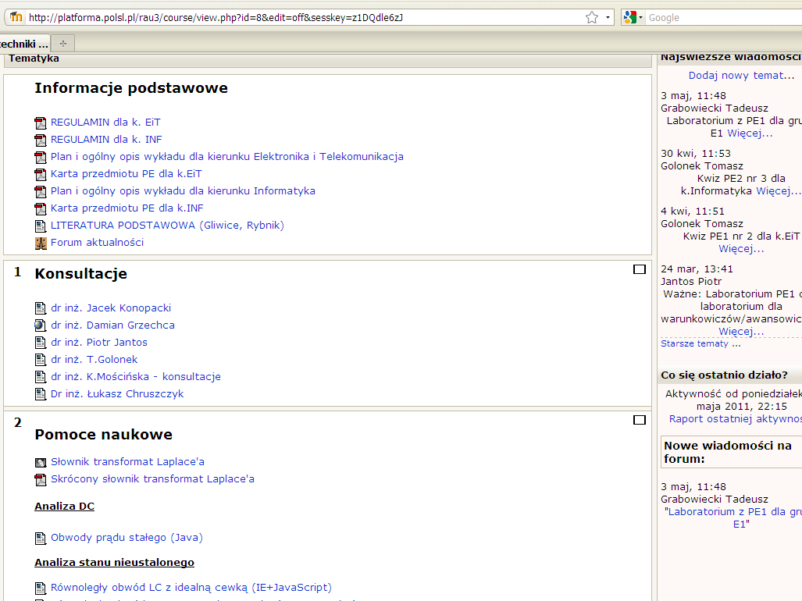

Fig.1 Circuit Theory course page (in Polish).

Circuit Theory belongs to the most difficult courses, with an average examination pass rate of 40% in each round. In order to improve learning efficiency and increase students’ interest we have changed the delivery method and have offered many options of self-study to the students.
2.1 Bloom’s taxonomy for revision of the laboratory program [6]
Recently, we have modified the program and the teaching method in the Circuit Theory laboratory. We were motivated by the fact that less and less students could successfully complete exercises – they either did not possess required knowledge (theory), which was verified by an introductory test, or could not perform their task or interpret its results.

At first, we have verified that the lecture material enables sufficient preparation for the laboratory work. Secondly, we have analysed the contents of the laboratory exercises and the pre-lab short tests in terms of Bloom’s taxonomy of learning outcomes [5], in order to find out which levels of knowledge they address. Bloom identified six levels within the cognitive domain, from the simple recall or recognition of facts, as the lowest level, through increasingly more complex and abstract mental levels, to the highest order which is classified as evaluation. Students cannot progress up the hierarchy unless they function at lower levels first, practising and mastering that level of activity, and then proceed up through more complex levels. Students of technical courses should achieve all lower level abilities (knowledge, understanding), as well as – depending on the year of study – most of higher level competences, for instance evaluation and synthesis (generate, assemble, design, compare, correct). In Circuit Theory laboratory students need to assemble simple circuits according to schematics prepared by the tutors, or use simple boards, which may be configured with a set of switches, see Fig.2. Except for carrying out measurements, during some exercises students perform oscilloscope observations. In some cases the goal of the exercise is to verify theoretical calculations, prepared by students beforehand. When there is no match between calculations and measurements, the exercise has to be repeated with a new configuration of the board. Most of exercises require medium levels of understanding - application and analysis. As Circuit Theory is delivered to the first and second year students, all the exercises are fully designed by tutors and require only limited amount of students’ creativity, which is assigned to the highest Bloom’s level – synthesis and evaluation [6].
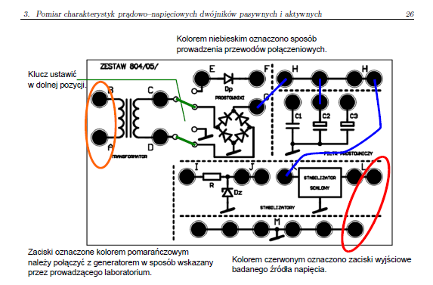

Fig.2 Schematics of exemplary board used in Circuit Theory laboratory.

Our findings were as follows: students possess insufficient knowledge, even though the theoretical context is fully covered by lecture. Many students cannot identify theoretical ideas which are relevant to the laboratory exercises. In particular, lack of basic knowledge components of Bloom’s taxonomy inhibits application of the medium level elements and therefore prevents successful execution of the laboratory exercises.

We decided to introduce weekly obligatory computer quizzes to be solved before attending laboratory exercises. In particular, we focused on the proper sequence of questions: firstly, the lower order, then the higher order questions [7]. This refers to the lower level (knowledge, understanding) and the medium level (application, analysis) of Blooms taxonomy. An example of created quiz structure is given below. The subject of the quiz is understanding and application of superposition method:
Q1 What is the main idea of superposition method? (knowledge),
Q2 Indicate circuits that cannot be solved by superposition method(knowledge),
Q3 How to suppress voltage/current sources(knowledge),
Q4 Choose the proper schematics for the subcircuit supplied by E₁ (understanding),
Q5-Q7 Calculate I_{R4} components contributed by E_{1,} E₂ and I₁ (application, analysis),
Q8 Which method is recommended for calculation of U₂ in the given complex circuit? (analysis),
Q9 Calculate increment of U_{R1} provided I₂ has increased by 10 mA (application, analysis).

Pre-laboratory quizzes of the graded difficulty have been accepted by both teachers and students. The adequate difficulty level of pre-lab tests (including the lower level cognitive categories – knowledge, comprehension) and focusing on practical issues have decreased students’ failure rate and changed their attitude to the course.
2.2 Modification of laboratory exercises
In the past years, the laboratory classes were mostly oriented on carrying various measurements. Finding the reason for them was left to our students. This attitude might have been suitable for “digital immigrants” who are used to acquiring knowledge from books, but appeared plain and boring to “digital native” students.
We decided to refresh and reorganise the laboratory in a way, that would encourage nowadays students to actively participate in them. For this purpose we started with a thorough check up of the laboratory content. As we reviewed we realised they addressed mainly medium levels of Bloom’s taxonomy, namely: apply, analyse and partially even the top level - evaluate. Effectively, going through laboratory classes might have been difficult and tedious. The aim of introduced changes was to cover, at first, the lower levels of Bloom taxonomy, especially remember, understand, and use it as a starting point to deepening their knowledge of circuit theory.

For this purpose we divided laboratory exercises into three blocks:
1. basic theorems and laws of circuit theory,
2. two-ports’ current-voltage characteristic measurements,
3. advanced theorems and principles of circuit theory.
The introduced division allowed us not only to present the course content starting with easy to understand basics and then move to more difficult, requiring more knowledge topics, but also to arrange tasks according to Bloom’s taxonomy order.

Each of the exercises is preceded by solving a set of tasks. As we deal with “digital natives”, we decided to mix-in some projects requiring electric circuits’ simulators, e.g. Spice OPUS or PSpice. The tasks expected to be solved before exercises in the first of the aforementioned groups cover mostly the lowest levels of Bloom’s taxonomy. Students are supposed to remember, understand and apply previously given equations allowing them to calculate currents and voltages across simple circuits. An exemplary task is to calculate a current in one of the parallel branches in the circuit. During the laboratory classes our students verify results of their calculations in hardware circuits, with the use of real measurement devices (volt- and ammeters). At this point we encourage them to analyse the origins of differences between analytical and practical results.

With the students’ advancement in the course, the difficulty level of laboratory tasks increases, considering both circuits and theory complexity and Bloom’s taxonomy levels. The second block of exercises requires not only understanding, but also application of circuits theory principles. After the exercise students have to carry out measurement errors discussion and find the main source of errors as well as to correct their results accordingly. This block of exercises covers middle levels of Bloom’s taxonomy. During the last exercises, our students are required to apply their knowledge to choose a method for analysing complex circuits at the preparation stage for their classes, carry the circuits’ analysis and evaluate its results. Moreover, they are supposed to design circuits and procedures allowing for measurements of the required electrical properties, therefore it covers the top levels of the Bloom’s taxonomy. An exemplary task is to measure a Zener diode current-voltage dependency (2nd block) and, secondly, to design proper polarisation circuit given the limit on the dissipated power.

While designing laboratory exercises we decided to introduce some circuit theory “riddles”, e.g. we asked our students to find a Thevenin’s equivalent of a linear circuit by means of measurement. We equipped them with analogue volt- and ammeters. Of course, we have prepared the circuits in a way that the measurement results are far from the analytical calculations. We explain our students that both results are correct and encourage them to find the reason for the differences. Discovering the answer, which is the serial resistance of ammeters, requires not only a thorough understanding of the basic principles of circuit theory, the philosophy and methodology of measurements, but also creativity. Apparently, applying their knowledge for solving a non-standard challenges was enough to “turn our students on circuit”.

2.3 Revision of delivery method based on Gagne’s nine step of instruction

According to Gagne, successful teaching requires the following sequence of events[4]:
- Gaining attention - stimulating learner to ensure reception of instruction; using some attractive method or device that grabs the learner’s attention, like demonstration,
- Informing the learner of the objective – describing the goals, learning outcomes, possible applications of the acquired knowledge,
- Stimulating recall of prior learning – reminding of prior knowledge relevant to current lesson, providing the framework that helps understanding,
- Presenting the material – using well-defined chunks, avoiding memory overload,
- Providing learner guidance, supplying organization and relevance to enhance understanding,
- Eliciting performance - asking learners to respond, demonstrating learning,
- Providing immediate feedback on learners performance, analyzing results and reasons,
- Assessing performance;
- Enhancing retention and transfer – providing additional practice, reviewing the lesson.

Gagne’s theory seems to be extremely suitable for modification of lecture content in order to satisfy the needs of “digital natives”. As the lecture is delivered in form of computer presentation, the first two steps are usually performed as a demonstration, PSpice, Java or LabView simulation, slide show etc. For example:
- The lecture on transmission lines starts with simulation of travelling waves in the line,
- Introduction of filters is preceded with slide show on practical application of filters – real devices,
- The lecture on modulation starts with practical experiments with real acoustic signals.
Students used to TV/cinema “teasers” are satisfied with the demonstrations and confirm that they really enable gaining learner’s attention.

In order to assure that students understand the relevance of prior knowledge to current lecture, we use verbal or graphical explanation, for example, the discussion on Fourier series and arbitrary periodic signals in linear systems is preceded by revision of symbolic method for sinusoid periodic signal in linear systems. We prefer plots or diagrams, as they are usually more appealing and better remembered, which is consistent with Dale’s cone of experience [8]. This revision can be easily performed with a computer-based lecture, as previously presented plots, charts and diagrams can be quickly repeated and in this way the students’ knowledge is recalled.

In order to make the lecture interesting and successful, both the content and the delivery method must be updated. “Digital natives” appreciate modern technologies, therefore they are satisfied with computer-based lectures. However, classical slide presentation may be ineffective, as it does not allow tracing a problem deduction, and then it is against interaction, To attract students’ attention and increase interaction, use of tablet PC seems to be necessary. Some parts of the lecture content, e.g. circuit diagrams, and data of exemplary problems, can be initially preset on slides. Then, all derivations and calculations may be added, hand written on a PC screen, the same way as it is done on a traditional blackboard. With the same approach it is possible to elicit students’ performance and provide feedback. Alternatively, we use ppt animation for presenting the solution – at first student present their answer; then the tutor shows successive steps of problem solution.

Providing learner guidance, assessing performance; enhancing retention, providing additional practice, can be only partially performed during the lecture; it is mainly the goal of classroom tutorials and formative assessment. Nevertheless, we try to interact with the audience as much as possible, asking questions, commenting on the answers and suggesting further work. Students can learn at their own pace and verify their knowledge solving numerous quizzes available in Learning Management System.

3. Provision of modern teaching aids

Theoretical ideas usually do not appeal to nowadays students - modern technologies enable to prepare computer-based teaching aids for visualisation of complex phenomena. “Digital natives” appreciate such teaching aids and experiment a lot on their own. A set of interactive demonstrations (Java simulations), concerning the most difficult Circuit Theory problems, like transmission lines and Fourier series expansion, is available in Learning Management System. The reason for preparing demonstration is twofold: firstly, it helps to understand the underlying theory; secondly, computer simulations serve as introductory exercise to laboratory practical experiments. Students who make simulations before entering the lab know what results are expected and work more efficiently. In this way we encourage students to practise with hardware. Simulations are also good source of feedback, as some problems with understanding/analysing the results were reported by the students and they were discussed during classroom tutorials. Fig.3 shows an exemplary simulation – travelling waves in transmission lines.

Fig.3 Transient analysis in transmission lines – exemplary simulation.

Since 2005 various forms of formative assessment have been offered to SUT students [3]. Computer quizzes are the leading form of formative assessment now. Preparing of pedagogically appropriate tests is a complicated task – there are many criterions that must be fulfilled so that students would benefit from solving tests. Gradation of difficulty level is one of the main issues. The tests should not only check students’ knowledge, they should also encourage to self-study and build up confidence. If the Bloom’s taxonomy is neglected, the tests become too complicated and the students’ interest drops immediately. Fig 4 presents an exemplary quiz task.

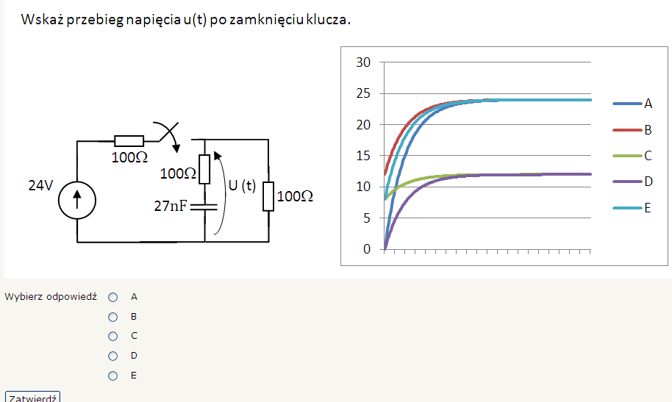

Fig.4 Transient analysis in first order circuits– exemplary quiz task.

As the main goal of the test is self-study, except for grades students get feedback (verbal comments) whenever possible. This feedback indicates possible source of errors or suggested modification of solution. “Digital natives” were not very enthusiastic towards computer tests few years ago [3]. At the moment the ratio of approval is quite satisfactory – approximately 50% students solve at least one test during semester. This form of assessment does not count for the final grade, however, in order to increase students’ interest some problems are repeated during final examination.

Recently we have prepared a new type of simulations, namely – LabView demonstrations of laboratory equipment. Many students have never tinkered and have never seen an oscilloscope or generator, so they often get very frustrated during first laboratory exercises as they cannot use the equipment properly. With this aid students simulate turning knobs, pressing buttons, and observe the influence on generated/observed signal. “Digital natives” may learn at their own pace, at preferred time, and may be better prepared for the laboratory.
4. Conclusion
This paper summarises a sequence of CT course’s modifications we applied to make the course “digital native”-friendly.
In the first stage of the course redesign, we focused on revising the course content and changing the knowledge delivering method according to Gagne’s nine step instruction.
During the following phase, we decided to dedicate ourselves to encouraging students to self-study by introducing several computer-aided teaching aids, e.g. visualisations, computer tests, etc.
The last stage of our work was devoted to turning “digital natives” on to analogue circuits. We redesigned the content and form of CT laboratory classes emphasising the correlation between theoretical calculations and practice. At this stage we decided to apply Bloom’s taxonomy which strongly affected the structure of laboratory.
After a few years, with the redesigned CT course, we observe that the students’ attitude to the course has improved and they are particularly satisfied with the laboratory modification, as confirmed by results of students’ survey. During the last 2 years the examination results have improved, too.
Students’ enthusiastic reactions to the CT course changes encouraged us to further studies and work, to fully adapt the course content to nowadays digital reality.

References
1. M. Prensky, “Digital Natives, Digital Immigrants”, On the Horizon, 9(5), 1-6, 2001.
2. Y. Tsividis, “Turning students on to Circuits”, IEEE Circuits and System Magazine, 9(1), 58-63, 2009.
3. J.Rutkowski, and K.Moscinska, “ICT supported engineering course – case study and guidelines”, Proc.12th Int. Conf. on Computers and Advanced Technology in Education (CATE), 129-136, 2009.
4. R. Gagne, The Conditions of Learning and the Theory of Instruction, New York: Holt, Rinehart, and Winston, 1985.
5. B.S Bloom, D.R.Krathwohl, “Taxonomy of Educational Objectives: The Classification of Educational Goals, by a committee of college and university examiners”, Handbook I: Cognitive Domain. NY, Longmans, Green, 1956.
6. J.Rutkowski, and K.Moscinska, “Application of Bloom’s taxonomy for increasing teaching efficiency – case study”, proc. ICEE 2010 conference.
7. A.Swart, "Evaluation of Final Examination Papers in Engineering: A Case Study Using Bloom’s Taxonomy", IEEE Trans. on Education, 53(2),257-264, 2010.
8. http://teacherworld.com/potdale.html

