A Global Engineering Experience to Undergraduate Students

¹M. A. L. Alves
Department of Mechanical Engineering, Polytechnic School, University of São Paulo, São Paulo, Brazil, malalves@usp.br ¹

Abstract
This article describes an experience with Global Engineering with undergraduate students from Brazil, Canada, Germany, India, South Korea and United States. Students formed a product development team to create a vehicle aimed for the emerging markets. More than the product itself, the main objective was to develop among the students the skills needed to work in cross-cultural teams, a characteristic demanded by business and government hiring new professional. Students applied up-to date product life-cycle management tools and techniques as well as communications tools. Faculty also interacted to make the project suitable to the academic objectives of each institution involved with the project.

1. Introduction
Global engineering has become a trend in engineering education from recent years [1-3]. This follows a trend from industry and it is recognized as an important part of the engineering education since working in cross-cultural teams is becoming more common [4]. Interchange programs are a very effective way to know a different culture and experience different approaches in terms of engineering education [5] but it may not be as much effective if the ability to work in groups, for specific tasks or projects, is the aim. If that is the objective, experiences as the one described in this article tend to be more effective as shown in some examples [6].
The experience described in this article is the PACE Global Project. PACE stands for Partners for the Advancement of Collaborative Engineering Education. It was created by a global car manufacturer and companies that provide hardware and software tools focused in product development [7]. It now congregates universities in Australia, Brazil, Canada, China, Germany, Italy, Mexico, South Korea, Sweden and USA. Among the activities of this program there is a Global Project in which a group of engineering students is tasked to work on the simulated development of a vehicle using engineering computational tools (CAD/CAE). For this particular project the vehicle was aimed for the emerging markets (Brazil, Russia, China and India).
During 2008-2010 the task of managing the project was passed to University of São Paulo after several years under the leadership of Brigham-Young University (USA) [8, 9]. The vehicle was divided in its several subsystems (Steering, transmission, body, etc.) and each university was able to choose one. Every university had a faculty advisor and mentors were assigned by the industry to provide professional advice for the students in highly specialized topics in vehicle design or linked to the software tools used. Integrating students with industry mentors was a secondary but also important objective of this project. This sort of integration was already identified as important in other similar contexts [10].
Apart from the development of the vehicle, the main objective of the project was to provide the students with an experience much close to the one faced by the engineer in its professional life. Vehicles are not a collection of parts and systems developed in isolation. Interactions between the different systems had to be dealt during the development and this lead to the collaboration among teams that were working in different time zones and with different levels of knowledge.
It must be also noticed that cultural differences also had to be dealt with starting with languages, ranging from Korean to Portuguese, with English not being the first language of some of the students. Communication and data sharing tools were extensively used and meetings were held to discuss the problems and issues faced by the students and faculty.
This article describes how the project was developed and the challenges to its full implementation. The conclusions and lessons learned from the experiment are also presented.
2. Project Development
In August 2008 University of São Paulo (USP) was tasked to lead the PACE global vehicle project after its implementation by Brigham-Young University since 2005 [8-9]. The new project theme was a vehicle for the emerging markets and several vehicle proposals were presented as a result of a design contest promoted by a global car manufacturer, the main supporter of the PACE Project. The idea was to provide the engineering student with an experience very close to what engineers face while working in companies with worldwide activities, i.e., to develop a product not only for the local market but for one that can be very different and sometimes not well-known, working with colleagues from different locations and cultures, with different practices in the work environment. The idea was not just to emphasize teamwork but to develop cross-cultural team work.
Vehicle specifications were defined based on benchmarking and proposals from the design brief provided by the car manufacturer. There were also specifications for the several subsystems as well as initial packaging studies to define the location and volume occupied by each subsystem. The subsystems division was done to provide opportunities for the different schools according to their preference and also to accommodate different sizes of teams based on the system complexity. At the end students from the various institutions would have to collaborate in order to make it possible to have all systems fully integrated.
For the first year (2008-2009) 14 institutions joined the project. As the project continued in 2009-2010 other institutions joined, some left, and eight took part during that final year (Figure 1). Each institution was free to choose one of the vehicle subsystems (Suspension, steering, body, etc). The choice was based on the academic objectives of each institution. It also allowed for different team sizes, ranging from three to seven students. Some institutions used the global vehicle project as a theme for final (capstone) project, others as part of a product development class, and another set of institutions offered it as an optional mentored activity to their students. The different approaches to the project lead to the first challenge that was how to deal with different levels of commitment from the students. In one side there were students that had to present a functional prototype of their subsystems in order to fulfill the requirements of the final graduation project in their schools and on the other hand there were students that joined the project as an extra-curricular activity. Commitment to the project had to be first obtained from the faculty involved. This was done by making sure that they would be also responsible for the performance of their students and that they shared the goals of the project. A basic set of deliverables was established and upon agreement with such deliverables each institution could define their own aims with the project. The basic deliverables were set as being:

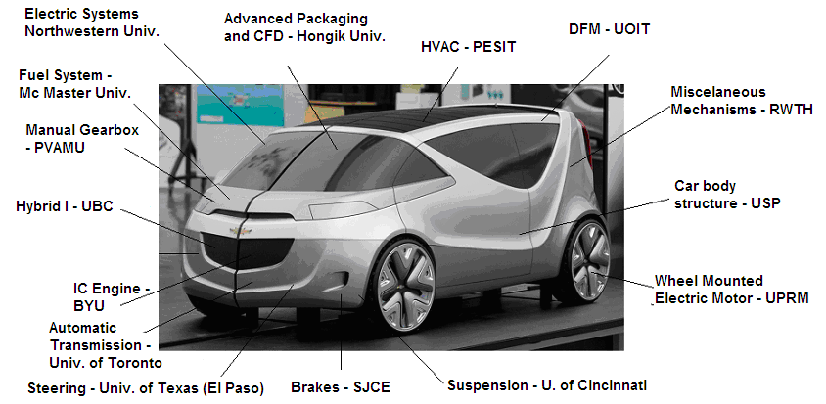
Figure 1 – Participant institutions and chosen subsystems
- A set of CAD drawings using a standard version of a common software used by all institutions and provides by the PACE Program.
- A written report detailing how the respective subsystem was developed
- A presentation about the subsystem and the team contribution to the project. The presentation was meant for the PACE program annual forum with attendance from faculty, students and representatives from the industry.
Another obstacle was the different schedules of the different universities. Some institutions have course units in quarters others in semesters. So, some of the participants joined the project later while others had to finish their activities earlier. Holidays, vacation periods, exam weeks also had to be taken into account as a single calendar was made. It had the main dates for the deliverables and schedule of the meetings between the teams. The meetings were meant to be opportunities to check how the project was developing. Students had the opportunity to schedule meetings with their colleagues from the other teams every time an issue was present.
Communications between teams were crucial for the project development. Vehicle subsystems interact with each other so they can not be developed independently without taking into account that they will need to be assembled and work together. The language of choice was English. It was the first language of the majority of the students. For the ones that had it as a second language the level of proficiency varied greatly. Table 1 show the location of the institutions and the first language of their students. The ability to speak a second language was important to solve specific problems between two teams. For instance, some of the Brazilian students used Spanish to communicate with their counterparts in Puerto Rico since communications were more effective.
The communication tools ranged from e-mail to video-conference. Each tool was used according to the number of participants in a single discussion and with the purpose of the communication. The most used tool was e-mail. It was readily accessible to all participants and also allowed for the sharing of files in different formats. VOIP (Voice over IP) was the main way to make small conferences and have conversations among teams. Video-conference was also used and provided the opportunity for the students to interact more closely and know each other. However, its effectiveness was deeply affected by the availability of bandwidth for the connections. The cost of equipment was also a problem to some institutions.
As shown on table 1, the teams were scattered in six countries across the globe and that allowed for work to be done continuously during the day. However, the time zone difference was a problem when issues had to be discussed and debated. Scheduling meetings with students separated by up to twelve times zones proved to be challenging. The overall meetings when everyone had to present a project report had to be scheduled in two sessions and documentation of such meetings were important to inform all parties involved of what was discussed in each session.
As in every major engineering project the flow of information is an important issue. Students were sharing CAD and CAE file and a single database was available. A project data management tool (Teamcenter Community) was used for that purpose and it was also applied as an important communications and information sharing tool. This was an important feature in order to provide the students with a very realistic product development environment.
Table 1 – Participant Institutions, their location and students languages
Institution | Country | Participation years | Number of students | Language
Brigham Young University | USA | 2008-2009 | 3 | English
Hongik University | South Korea | 2008-2009  2009-2010 | 8 | Korean
Mc Master University | Canada | 2008-2009 | 3 | English
Northwestern University | USA | 2008-2009  2009-2010 | 4 | English
P. E. S. Institute of Technology | India | 2008-2009  2009-2010 | 8 | English  Kannada  Hindi
Prairie View A&M University | USA | 2008-2009 | 3 | English
RWTH Aachen university | Germany | 2008-2009  2009-2010 | 6 | German
Sri Jayachamarajendra College of Engineering – Mysore | India | 2008-2009  2009-2010 | 6 | English  Kannada  Hindi
University of São Paulo | Brazil | 2008-2009  2009-2010 | 8 | Portuguese
University of British Columbia | Canada | 2008-2009 | 4 | English
University of Cincinnati | USA | 2008-2009 | 4 | English
University of Ontario Institute of Technology | Canada | 2008-2009 | 3 | English
University of Puerto Rico (Mayaguez) | USA  (Puerto Rico) | 2008-2009  2009-2010 | 5 | English  Spanish
University of Texas – El Paso | USA | 2008-2009 | 3 | English
University of Toronto | Canada | 2009-2010 | 4 | English

Students worked in their local institutions and each team had their schedule and academic goals as described earlier. To engineer their subsystems the students needed very specialized knowledge and information that normally is available in industry. Mentors were assigned to each team. They came from the automaker that sponsors the PACE program and provided information to help the students to accomplish the engineering of the vehicle. The relationship with the mentors was not uniform to all teams. In fact some of the teams did not contact the mentor and others developed a very close relationship with the mentor with visit to plants and frequent phone conferences. The reason for the different levels of mentoring can be traced to some factors. Mentors were volunteers and their availability in terms of time was not the same. The project was developed in a difficult period for car manufacturers, mostly in North America and Europe, the recession of late 2008. Some of the mentors were laid-off and took a few months to other people to volunteer their time to help the students.
At first it seemed that the cultural differences would create major difficulties for the students. However, more similarities than differences emerged during the project development. The fact that they had a common interest about engineering in general and vehicles in particular was decisive to put aside their differences. The students were familiar with the engineering tools used and the use of the internet for communications and data sharing was natural to all of them. One of the reasons for the easier than expected interaction between the students would be the reality of globalization in a world connected by the internet and its social networks. On the other hand the interaction between the students was mostly related to the project. This strictly professional-academic relationship did not give opportunity for prejudice to be displayed. The project had no incident of racism or xenophobia. Debate was about technical issues only.
Some teams had the tendency to work alone without much interaction with the others. One way to minimize this tendency was to focus on the assembly and interaction between systems. The project goals were not restricted to the development of the individual system. Systems and parts that do not assembled into the vehicle were not accepted. This was a driver to keep the students focused on their systems interaction with the rest of the vehicle.
Figures 2, 3 and 4 show some of the CAD and CAE data that was produced by the students. The project was closed with a presentation at the annual meeting of the PACE Program. The event was held in Seoul, S. Korea, and the students were able to present their work in person or by video-conference. This was also a way to show to the audience not only the results of the project but at least some of the processes involved.
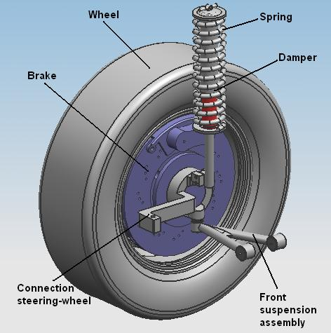
Figure 2 – Front suspension CAD model
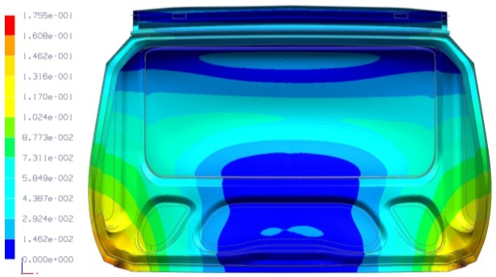
Figure 3 Finite Elements Analysis of a body panel
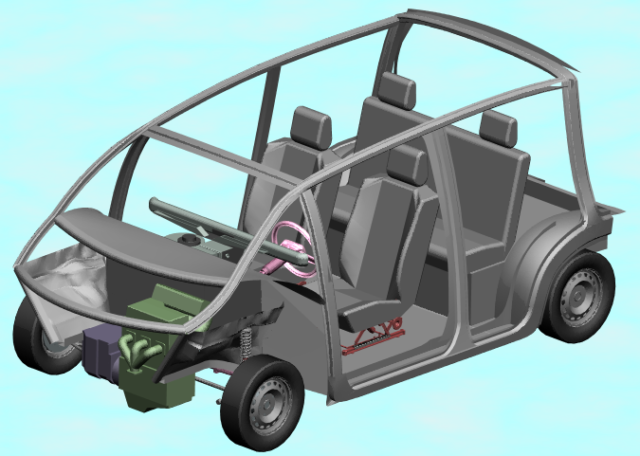
Figure 4 – Cutaway view of the assembled vehicle in CAD

3. Lessons learned and conclusions
The organization of activities such as the ones described has to be carefully planned. At first the participating institutions have to agree in a common set of objectives and deliverables for the project. From this base point each institution can apply the project to fulfil specific academic objectives. Turning this project as a possibility to achieve local academic goals was a key factor to have participation of a diverse group of institutions and make sure that the project was meaningful to all parties involved.
Planning also involves careful preparation of the schedule and calendar. The person leading this sort of project has to be open to make changes in its initial planning in order to make sure that all schools that want to be part will have the opportunity to fit the project according to their needs.
Communication between the faculty advisors of the teams is also very important to keep the project on track. Faculty must be in agreement with major project modification and the leader has to be open to suggestion from others. It is the work of the individual advisors that will help to keep the students focused on the project goals.
To make this project meaningful to the students, the leader has to make sure that communications between the teams is working and avoid the tendency of some teams to work isolated. Frequent meetings and design reviews are the occasions were miscommunication problems may be spotted. The project goals and deliverables can not be restricted to individual systems and parts. Each deliverable must require that parts join together and that subsystems really interact. In this particular case the assembly of the vehicle in a single CAD file was the main motivation to keep teams collaborating with each other since the project would not be accepted as complete until all subsystems could be assembled without flaws and within the specified tolerances.
It is also important to make sure that the participants share similar skills in using the main software tool used. In this particular case was the CAD system. If it is not possible to have all students at the same skill level then at least some time must be allocated for training.
Mentoring from industry professionals was significant when the person acting as mentor had knowledge of the project objectives. However, external factors to the project, such as the economic downturn of 2008, created difficulties to the mentoring activities. After the project was completed the students that developed a closer link with the industry mentor described the mentoring as one of the most significant aspect of the project and as an opportunity to learn in deep about some very specific subjects.
Although cultural differences do exist, the participants in this project focused on the professional relationship. The fact that contacts were made mostly on the internet, made it possible to keep them as much formal as possible. The communications between students were driven by the project needs. But language was still a problem because not all students had the same proficiency in English to make conversations to flow easily. In this case written communications proved to be more effective together with drawings and CAD models. It can be said that cultural differences played a minor role than expected at the beginning of the project.
4. Acknowledgements
The author would like to thank all faculty and students that worked in this project. Special thanks for the industry mentors and companies that supported the project through the PACE Program.
References
- H. Jackson, K. Tarhini, A. Zapalska, S. Zelmanowitz, “Strategies to infuse Global Perspectives and Industrial Collaboration in Engineering Education”, Proceedings of the 40th ASEE/IEEE Frontiers in Education Conference, ASEE/IEEE - 2010, Washington DC, 2010
- R. G. Qiu, “A Collaborative Model of Engineering Education for Complex Global Environments”, Proceedings of the 40th ASEE/IEEE Frontiers in Education Conference, ASEE/IEEE - 2010, Washington DC, 2010
- C. Vest, “Context and Challenge for Twenty-first Century Engineering Education", Journal of Engineering Education, July 2008, pp. 265-236
- National Academy of Engineering, "The Engineer of 2020: Visions of Engineering in the New Century", National Academies Press, 2004.
- J. H. Bohn, M. Hampe, "Study Abroad Programs in Mechanical Engineering", ASEE Annual Conference and Exposition Conference Proceedings, Chicago, IL, 2006
- S. Owusu-Ofori, D. Klett, D. Pai, K. Roberts, D. Obeng, E. Agbeko, "Global Engineering Education Project at North Carolina A&T State University", Proceedings of the 31st ASEE/IEEE Frontiers in Education Conference, ASEE/IEEE - 2001, Reno NV, 2001
- PACE Website, www.pacepartners.org, 2010
- M. Webster, D. Korth, O. Carlson, C. G. Jensen, "PACE Global Vehicle Collaboration", ASEE Annual Conference and Exposition Conference Proceedings, Honolulu, HI, 2007
- N. Giullian, C. G. Jensen, J. McCammon, B. Broks, "Hosting/Participating in global collaborative PACE Projects", ASEE Annual Conference and Exposition Conference Proceedings, Honolulu, HI, 2007
- E. Jestrab, C. Jahren, "Integrating Industry Experts into Engineering Education: Case Study", Journal of Professional Issues in Engineering and Practice, Vol. 135. No. 1, Jan. 1999, pp. 4-10.

