Exploiting the eSerialisation of Comic Pictograms to Enhance Undergraduate Health and Safety Lectures

Jolene Phair, Cliodhna McCormac¹, Graham R. Dale,
Kevin McHugh and James Davis

School of Engineering, University of Ulster, Jordanstown, Co. Antrim, BT37 0QB, UK

Abstract

The use of eSerialisation to encourage the proactive engagement of undergraduates in acquiring a greater appreciation of health and safety issues has been investigated. In contrast to the single event induction lectures and elearning systems, the work describes an innovative method of dissemination which employed the repetitive delivery of an email cartoon-caption competition to refresh and reinforce the safe working practice message. The strategy marries the emerging literary format of flash fiction with modern communication to foster a synergy that captures the imagination of the students and markedly contrasts conventional essay / assignments / induction material. The efficacy of the approach has been critically assessed and found to possess the advantage of being in a format that is both accessible to the student body and which can be readily delivered, through email, by the staff with minimal effort. The strategy is generic and could be applied across the life, physical and engineering disciplines.

¹To whom correspondence should be addressed. T: +44 (0) 28 903 68018, E:c.mccormac1@ulster.ac.uk

Introduction

Health and Safety induction programmes are a vital introduction to the hazards that can be faced in the laboratory sessions of many degree programmes [1-3] but there are always questions over the extent to which the students engage with the material [4-5]. In most cases, initial preparatory lectures will be supplemented by informal explanations and cautionary statements within the lab scripts such that particular hazards are identified [6]. There is always a concern that the retention of the key ethos that underpins safe practice is seldom achieved [2] and that the students, rather than being proactive in the identification of hazards and management of risk, become reliant upon the demonstrators to simply highlight the issues [7]. The aim of this pilot study has been to investigate a novel approach in which emerging literary methods are used to enhance the engagement of the students with hazard appreciation.

Interactive methods designed to enhance the significance of the H&S message such as those based on web/Flash animation components or through WebCT based collections have become increasingly common but the general approach has some critical limitations. Prime among those is the fact that they represent isolated events that, while initially interactive, are seldom retained or reinforced beyond the lecturer’s instruction to view them. Our rationale has been to provide a mechanism through which the periodic release (eSerialisation) of the messages through email distribution throughout the year will continue to reinforce the core tenets of the safe practice ethos and allow some reflective learning that embeds the significance of being proactive in the adoption of safety procedures within the memory of the student. A key ingredient has been to induce a component of interactivity that stimulates a desire to actually read the messages upon receipt of the email and not treat it like a spam message [8,9].

Methodology

Our approach was to rediscover and reintegrate the art of story telling as a means of conveying the significance of the health and safety message but in a way that would be easily digestible to the student and adapt its delivery such that it could be exploited as the basis of an interactive hook through which to capture the imagination of the student [10-12]. Rather than have the lecturer provide the stories, our approach was to have the students construct them [10,13]. The strategy was to provide a cartoon illustration of a prehistoric scene that had some resonance with a particular health and safety hazard (trip, fire, manual handling, COSHH etc) which would then be delivered to the students through email and a competition instituted for them to provide a brief caption – the story – that underpins the safety message but in a humorous light. The mailshot would be distributed post induction lecture and it was envisaged that the former would provide the interactivity needed to encourage reflective learning of the lecture material with the competitive element enhancing the quality of the submission but also, importantly, the drive to examine future releases of the best/winning entries delivered through the email [8,9]. It was anticipated that eSerialisation through email would be more appropriate than a blog, as the latter requires the student to actually visit the site hosting it, whereas email is delivered direct and requires little more than opening the message. The sample audience were mechanical engineering, sports technology and biomedical engineering students (Total N = 270). This covered both undergraduate (N = 254) and postgraduate cohorts (N = 26).

Results and Discussion

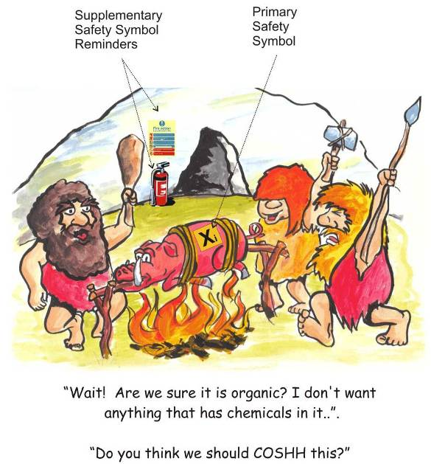
An example of the mailshot delivered to the students post induction lecture is detailed in Figure 1. A key feature of the setting is that while there can be a key theme – as set by the caption question – it still allows the more subtle embedding of health and safety messages within it and thus encourages subliminal uptake [14-16]. The email was tagged with delivery and read receipts in order to facilitate evaluation of the transfer and allow an estimate of the viewing figures. The number of read return replies and entries to the caption competition were then assessed. In general, the read return was 71% (based on a successful delivery notice of N = 270). Engagement of the students with the email message is clearly promising and can be attributed to: the competitive element, the humour and the fact that the work required to participate in the challenge is not too onerous. The caption embodies the spirit of nanofiction (limited to 69 words) and thus, in terms of student perception, is more easily accommodated within their time management plans than a traditional essay.
Figure 1. Typical example of an email cartoon-caption competition highlighting the placement of embedded reminders

Evaluation of the approach was done qualitatively through follow up questionnaire designed to extract feedback on their attitude towards the mailshot, their desire/ability to participate and the benefits that they thought accrued from it. The results are summarised in Figure 2. Assessing the long term assimilation of the health and safety message is beyond the scope of the present communication and would be the subject of follow-up investigations but it is clear that the eSerialisation represents a facile method for reinforcement of the core message which actively engages the student imagination [9].
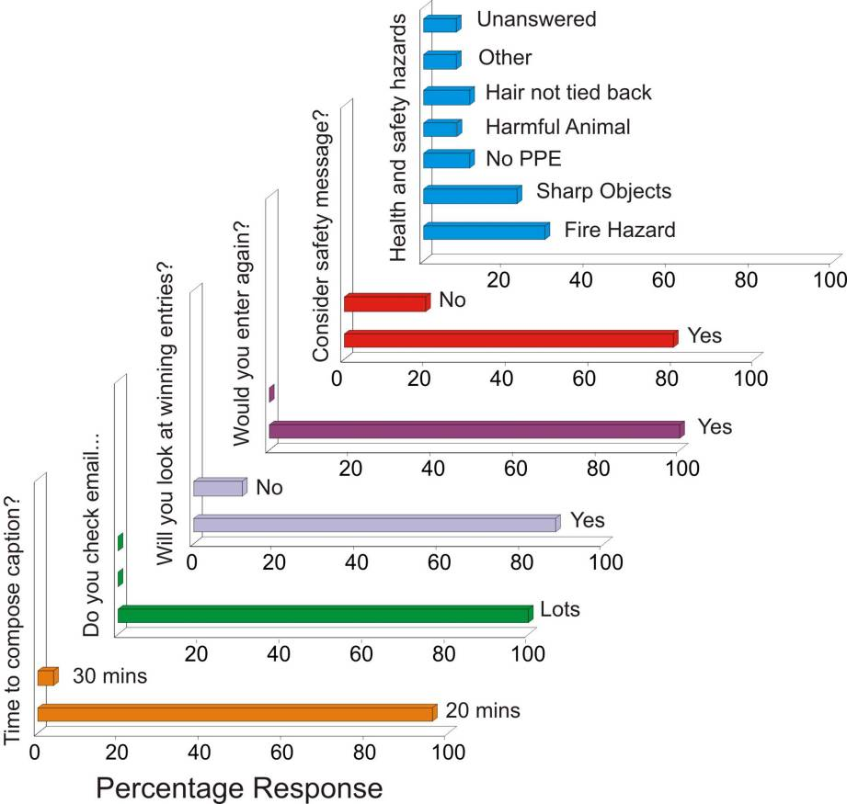
The central theme in the strategy adopted at Ulster has been to exploit humour as a means of making the material more accessible to the students. Health and Safety procedures are, in contrast to the academic disciplines, the storyteller’s ideal realm in that they contain all of the key ingredients (principally the presence of danger but with an added dusting of humour) necessary for the construction of stories that can capture the interest of the reader [11]. In this case the context (prehistoric) has been selected but the variety of storyline is dependent only on the imagination of the teller and it is capable of being moulded in an inexhaustible number of ways that can serve to emphasize specifics or generalities and can be tailored to any context. Rather than presenting isolated data or facts – the combination of cartoon and nanofiction offers a means of delivering the theme in an entertaining, accessible and reflective style that is more amenable to being embedded within deep memory [15-17]. There is an additional advantage in that it can tap into the imagination [17-18] in a way that conventional lecture material often fails to achieve and facilitates learning of the bigger picture (or in our case the ethos/process) and is much more effective than attempting to impart isolated facts about Health and Safety doctrine [9].
Figure 2. Feedback
summary

The exploitation of eSerialisation provides a drip feed throughout the year, thereby enabling a continual refresh of the memory [14,17]. While email is increasingly used as the principal form of communication between faculty and student, it presents an ideal route through which to disseminate the cartoon-captions, it is important to consider the fact that delivery of the email however does not necessarily mean that it will be read [9]. We are all adept at deleting mail perceived to be spam and of no interest to us but there is a safeguard. In the present case, the mail exploits the all too human traits of curiosity and competitiveness whereby the natural tendency of the student is to see what the latest cartoon is. Each email would contain the new competition and the winner(s) of the previous one which again serves to reinforce the core messages and exploits the student need to see who won and to compare the winning entry with their own. Importantly, the adoption of the nanofiction format also provides a concise text which is easily read but which has the capacity to provide the core tenets of the messages.

Fiction is often exploited in the construction of problem based learning materials and used by every lecturer at some point and is most clearly evidenced by the construction of context to support the presentation of what-if scenarios and tutorial/exam questions [10] – each a story in their own right. The great strength of this approach is that it reverses the roles and encourages the students to write the story. Once the central problem/hazard (i.e. trip, electrical, manual handling etc) is set, the students create the fictional account (the nanofiction caption) of a potential scenario to match the cartoon. This provides a number of advantages:

- In setting the scene the students are required to consider the likely cases where such hazards can arise and the risks involved. This involves the anticipation of the problem and thus they are more able to recognise the situation in the real environment.
- In supporting character development they are seeking a degree of emotional engagement – albeit through humour. It also serves to stimulate debate within their cohort and wider friends.
- The process promotes reflective learning associated with considering the implications of the hazard failing to be identified and resolved.

Through empowering the students to create the story, the time demands on the lecturer are lessened and it enhances the experience of the student through being proactive in the story process rather than relying on the passivity of reading [10,12,13]. The process also fulfils many of the learning outcomes associated with the pursuit of transferable skills. The strategy integrates the various forms of communication – oral, written and technological – which are key components of the “Professional Skills” required by engineers and thus embodies a more coherent/integrated approach than conventional essay assignments.

Conclusions

The strategy advocated here has sought to provide students with a more accessible and fun challenge (the concise format of the nanofiction caption combined with the competitive element) that promotes engagement. While more long term assessment of the degree of assimilation is required, the results from this preliminary study highlight the effectiveness of the approach in capturing the curiosity of the student. Moreover, it offers an imaginative alternative to the conventional writing assignments that typify the approaches taken within most engineering faculty. Most importantly, it offers a means of introducing and reinforcing health and safety issues in way that can be easily adopted irrespective of curricula, possesses a format that is complementary to existing modules and can be accommodated/delivered without any additional information technology outlay.

Acknowledgements

The authors thank the EPSRC for financial support and to Kevin McHugh for his time, effort and boundless creativity in preparing the illustrations used throughout the study.

References

1. BSC, (2010), Ensuring the safety and health of young workers, British Safety Council, http://www.britsafe.org/policy-and-campaigns/research/ensuring-the-safety-and-health-for-young-workers.aspx

2. HSE, (2008), “Health and Safety Statistics 2007/08”, Health and Safety Executive, UK Government Publication, www.hse.gov.uk/statistics

3. HSENI (2002), “Mind How you go”, Health and Safety Executive Northern Ireland, UK Government Publication, http://www.healthandsafetyworksni.gov.uk/content-newpage-4

4. M.R. Lehto, (1998), “The Influence of Chemical Warning Label Content and Format on Information Retrieval Speed and Accuracy”, J. Safety Research, 29, 43-56

5. C.A. Janicak, (1996) “Employers’ Knowledge of the Hazard Communication Standard Requirements and the Perceived Barriers to Compliance”, Journal of Safety Research, 27 233-239

6. C.C. Phillips, B.C. Wallace, C.B. Hamilton, R.T. Pursley, G.C. Petty, and C.K.Bayne, (1999), “The Efficacy of Material Safety Data Sheets and Worker Acceptability”, J. Safety Research, 30,113–122

7. M.A. McDonald, H.J. Lipscomb, J. Bondy, J.Glazner, (2009) “Safety is everyone's job: The key to safety on a large university construction site”, Journal of Safety Research 40,53–61

8. I. Yengin, D. Karahoca, A.Karahoca, and A. Yücel. (2010) “Roles of teachers in e-learning: How to engage students & how to get free e-learning and the future”, Procedia - Social and Behavioral Sciences, 2, 5775-5787

9. P-S.D. Chen, A.D. Lambert and, K.R.Guidry (2010) “Engaging online learners: The impact of Web-based learning technology on college student”, Computers & Education, 54,1222-1232

10. J. Moon, (2010), “Using Story in Higher Education and Professional Development”, Routledge, London

11. E.K. Diekhof, H.E. Kipshagen, P. Falkai, P. Dechent, J. Baudewig and O. Gruber, (2011) “The power of imagination — How anticipatory mental imagery alters perceptual processing of fearful facial expressions” . NeuroImage, 54, 1703-1714

12. M.J. Shank, (2006), “Teacher storytelling: A means for creating and learning within a collaborative space”, Teaching and Teacher Education, 22, 711-721

13. M. Gillard,(1996) “Story Teller, Story Teacher”, Stenhouse Publishers, Maine.

14. T. Watanabe, J.E. Nanez and Y. Saski, (2001) “Perceptual learning without perception”. Nature, 413, 844-848

15. R.E.Mayer, W. Bove, A. Bryman, R. Mars and L.Tapangco (1996) “When less is more: Meaningful learning from visual and verbal summaries of science textbook lessons”, Journal of Educational Psychology, 88, 64-73

16. R.E.Mayer and J.K. Gallini, (1990) “When is an illustration worth ten thousand words?”, Journal of Educational Psychology, 82, 715-726

17. D.R. Shaffer (1989) “Developmental Psychology (Childhood and adolescence)”, 6th edition, Wadsworth

18. C.M. Roebers and W. Schneider (2005) “The strategic regulation of children’s memory performance and suggestibility”, Journal of Experimental Child Psychology, 91, 24-44

