A Study of Students' attributes in Application of Engineering Principles and Design Management for Freshman Engineering Students

I.K. Dabipi, J. Bryan Burrows-McElwain and Chris Hartman

Abstract ⎯ Two groups of freshman engineering design students designed the layout of the basic components of a general aviation airport. Students were tasked with the design of the placement of the entrance road approach and exit, the parking area, drop-off and pick-up zones as well as the terminal building. Design criterion included human factors stipulations such as multi-lingual friendly signage, limited decision points, and the ability to be able to easily identify the major components (parking, arrival/departure pick-up points, and terminal building) from the roadside approach to the airport. The students were given a set of criteria which required them to employ engineering principles as well as leadership skills in team building and management. Teams were required to build a diorama to demonstrate their design. This paper examines the similarities and differences of the engineering principles and approaches the groups used in the final design product, the process in completing the assignment and leadership variables involved in project management..

Keywords ⎯ Design, Management, Leadership.

Introduction
Over the past four years, the Aviation faculty at the University of Maryland Eastern Shore (UMES) have been working in conjunction with the Engineering faculty within the department to develop a joint Freshman Engineering Design Experience aimed at a design course that is collaborative, multi-disciplined, hands on, aerospace industry focused, and helps students identify strengths and weaknesses they may have when working in team environments. While focusing on Aviation projects, the faculty from both the engineering and aviation programs seeks to address the issues faced by students in both programs in a way that benefits the students. Practical projects provide the students the understanding that their work is addressing an immediate need and it introduces them to the fact that their employment in industry will require them to work in a team. This paper examines the lessons learned during this collaboration and offers some insight into what challenges similar freshman engineering design courses may encounter.
Design Course Project Review
The Freshman Engineering Design Course at UMES has continued to operate in the same fashion since 2006. The engineering professor facilitates the course and introduces aspiring engineers to the knowledge, skills and abilities requisite for completing a design project. Jointly, Aviation Sciences faculties participate in the course by serving the role of both the client(s) and the users who provides the students with the aim, scope and constraints of the project. Both aviation faculty are Certified Flight Instructors with terminal graduate degrees in Aviation Sciences and serve as voluntary Federal Aviation Administration Safety Team (FAAST) Representatives. The aviation faculty, posing as clients, work with the course professor to guide team selection, answer student questions, and evaluate ongoing progress. The clients outline the expected deliverables and evaluate the final product at the end of the semester during the presentation portion of the course.
The theme of the course project subject varies from semester to semester; however, the topic does address current research areas in the Aerospace/Aviation fields. Current areas of interest include sUAS operations in the National Airspace System for commercial remote sensing purposes and how operators can mitigate related safety concerns. Due to restrictions on model aircraft usage for research purposes on campus (implemented by the Federal Aviation Administration in the United States), continued usage of powered model aircraft devices were prohibitive. In response, client centered projects turned to kite-based aerial platform design and other key aviation safety issues such as runway incursion.
The following is a list of past projects that freshman engineering students have participated in:

- Device to mitigate the negative transfer that occurs when training primary students how to taxi aircraft on the surface with rudder pedals instead of using the control yoke as in automobiles [1].
- Design and Construction of A Stereoscopic Aerial Imaging Platform: A Project-Based Platform for Teaching Freshman Engineering Students [2].
- Ballistic Parachute Design for sUAS operations.
- A Kite-Based Aerial Imaging as a Freshman
Engineering Design Project [3].
- Bungee Launch System for Kite-Based Aerial Systems.
- Low Cost Runway Incursion Detection System for General Aviation Airports [4].

Course Design Evolution
The course evaluation starts with an assessment of student leadership and cooperative skills which is extracted from an initial Team Formation Survey (TFS). Three approaches have been used to formulate teams for the project depending on the size of the class and the composition. In some semesters, the students after taking the TFS, form their own teams and select their leader while in other semesters, the leadership role is rotated weekly among the team members. A different approach is to divide the teams based on the survey results and assign the leadership role as well. In both team composition examples, each team executes the project from start to finish even when both groups have the same project constraints. Thus the assignments of individual student responsibilities are determined within the group structure. Current students enrolled in the Fall 2010 Freshman Engineering Design course are working on a three pronged project that requires three separate groups (vehicle attachment group, picavet design group, imaging platform and survivability group) to work together to design one complete imaging system that works with both aerial blimp and kite based platforms. Each group is assigned a sub-team leader who then reports to the student design project leader. As is the case in all projects, the interdependency of the teams provides the team dynamics which forms the basis of discussion in this paper.
Any change in design of one group is communicated to the other groups to determine it’s affect on their unit design constraints.
Leadership Selection
In general, our experience proved to highlight the negative consequences of student group/leader self-selection. That is, freshman students are generally poor judges of good team dynamics and often make poor leadership selection when asked to work on a team project. Since freshman engineering design occurs in the first semester, and students had not established sufficient relationships with each other through prolonged performance observation, they do not have the necessary information to select their own groups.
Faculty (engineering & aviation sciences) quickly observed that students possessing the technical skill and leadership ability would step into the leadership role later in the semester, often unprompted, in an effort to correct previous leadership decisions. Groups having a unified understanding of cohort skill were more successful in their design progress. Groups that struggled were those lacking basic design skill history and those who had weak leadership. The lesson learned was that in the freshman level design projects, strong leaders are needed to prolong group cohesion and participation.
Early problems included the sense of not belonging in a design group. If group members perceived they were not a part of the group, they would often express their lack of confidence in group skill. Students participating in groups that felt included in project design reported being highly confident of their abilities even in cases where in-group and out-group ability levels were comparable.
Client and course facilitators realized that defenses against these types of failures might be erected by ensuring that groups all had equal amounts of diverse talent as well as assigned leaders that reported confidently the requisite skills necessary for project leadership and management.
Current procedure included and early assessment of the following information:

- Engineering history – family, friends, and/or personal
- Living arrangements – on campus/off campus
- Team-work related attributes self-report items
- Technical ability self-report items

Additionally, faculty and clients currently ask students complete a leadership evaluation of their team leaders and compare those results to the team leader’s self-evaluation. The result of these assessments will be shared with future student team leaders to help them identify potential problem areas that may affect overall team performance while completing the course assignment. A modified version of the Multiple Leadership Questionnaire (MLQ) found in Northouse’s [5] leadership text is utilized in the class to complete this evaluation.

Benefits
Student(s)
These types of multidisciplinary activities help infuse technology into classroom and expose students to relevant real-world problems being addressed by contemporary researchers.
Students learned the value of planning ahead and the need to include determining site selection and availability for design construction and testing. Students discovered that they were able to meet the client’s project request with limited time and resources by working together. In their final report, students emphasized the need for good communication between team members and the client. Clear documentation of tasks needed to be completed and finished is the key to staying on schedule and having team accountability.
Additionally, the ability to be open minded to differing approaches to solve the same problem is a good characteristic of members working in a team environment.

Aviation Faculty
The aviation faculty at UMES benefit from the interaction with the Freshman Engineering Design course by finding alternative solutions to operational/training problems that arises as a result of integration of new technology into the National Airspace System (NAS). Students continue to develop diverse and thoughtful designs to address problems presented to them by the aviation faculty. Faculty continue to utilize the course to satisfy the need for multidisciplinary research on campus while identifying aspiring leaders for other aerospace related research opportunities on campus.
Student Airport Design Problem
During the Spring 2011 Modern Engineering Design course, freshman engineering students were asked to participate in the initial planning stages of a fictitious regional airport. Students were tasked with the design of the placement of the entrance road approach and exit, the parking area, drop-off and pick-up zones as well as the terminal building. Design criterion included human factors stipulations such as multi-lingual friendly signage, limited decision points, and the ability to be able to easily identify the major components (parking, arrival/departure pick-up points, and terminal building) from the roadside approach to the airport.
Constraints
The design was for a regional airport with one main terminal building with one main exit and entrance road consisting of single decision points for parking/drop off/pickup destinations. Symbols for airport signs had to be monochromatic and have a universal theme that did not require the use of alpha-numeric terminology.
Airport Layout
Faculty serving as clients observed the process of design idea development and modification. Students kept a log of these changes and included them in their final reports. The process of taking a group idea from paper to design layout to actual construction can be observed in the following figures ( Fig. 1-4). Figure 5 illustrates how the students tracked the problems and potential solutions.
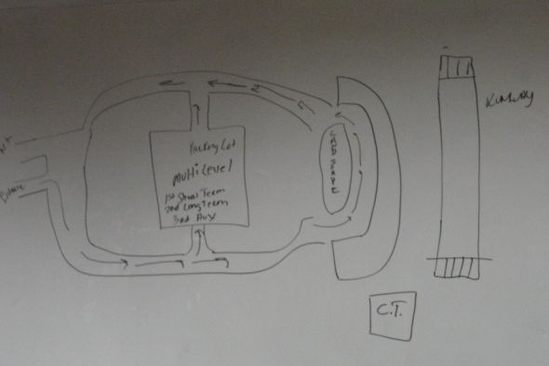
Fig. 1 Hand Sketch
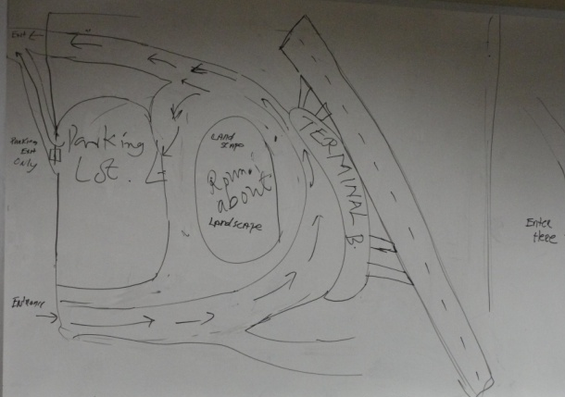
Fig. 2a Modified Sketch
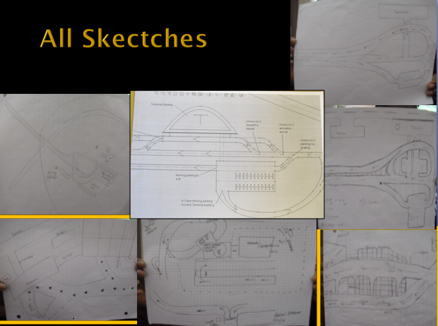
Fig. 2b Sketch compilation
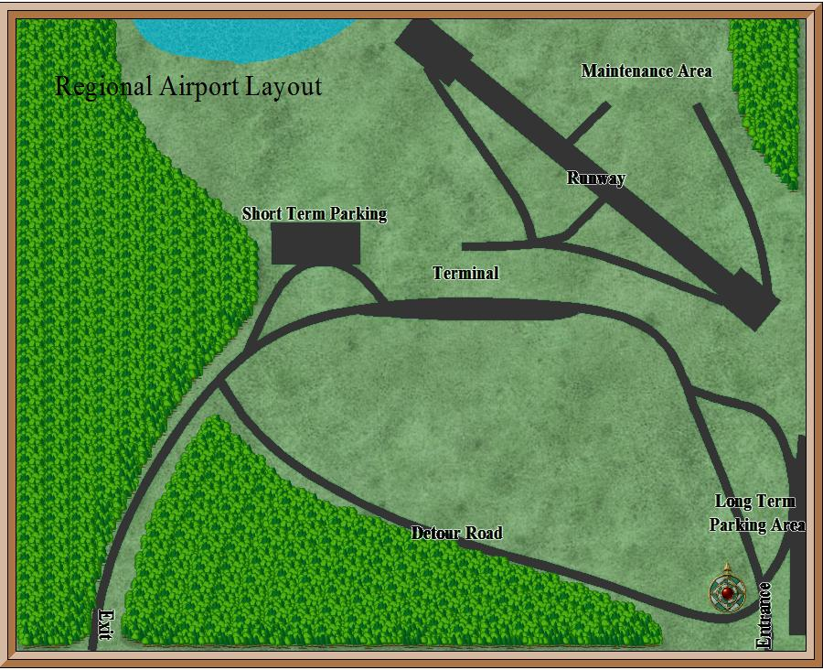
Fig. 3 Finalized conceptual Drawing
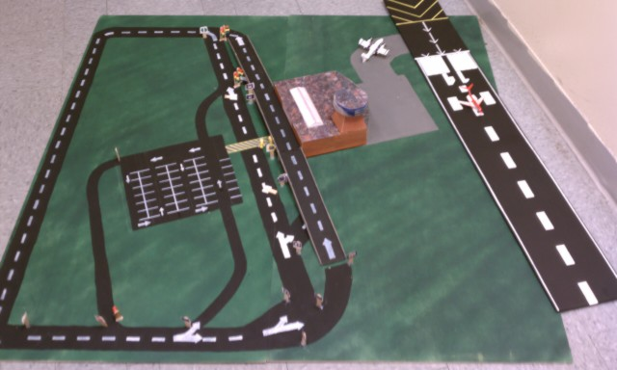
Fig. 4 Final Model Construction
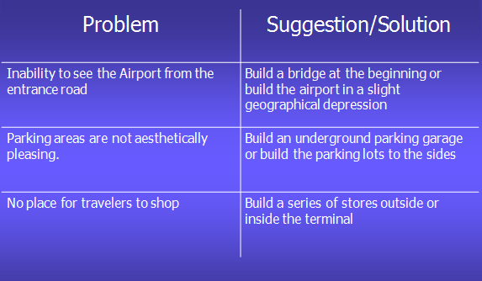
Fig. 5 Brainstorming Grid
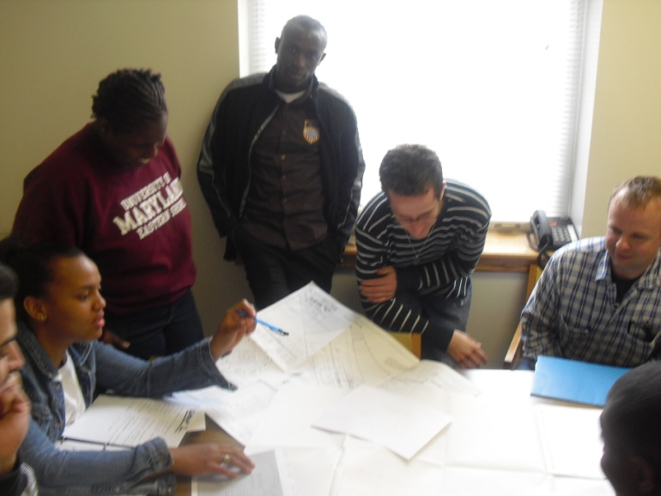
Fig. 6 Student brainstorming session
Students learned an important lesson on group consultation where many good ideas are presented but not all can be incorporated. Good teamwork dynamics allowed students to integrate as many concepts as possible and move forward on a combined group project and not one dominated by one input.
Signage Solutions
Students were able to devise the following symbols and incorporate them into the airport signage to reduce confusion and provide direction for non-English speaking travelers (Fig. 7).
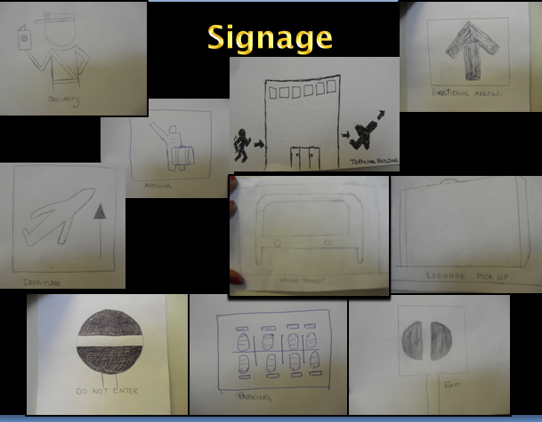
Fig. 7 Examples of airport signage
Project Challenges
Time Management
Students reported spending the majority of time on the physical construction of the model and meeting the design constraints (figure 8 & 9).
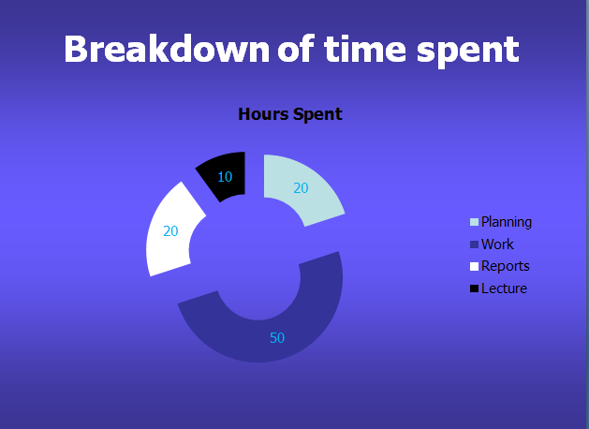
Fig. 8 Time breakdown Team 1
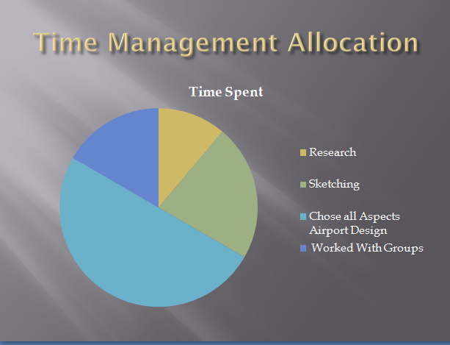
Fig. 9 Time breakdown Team 2
It is typical to observe that students struggle with time management issues on group projects such as this one which requires flexibility during a less than flexible academic schedule.
Key Attributes
Key attributes that have been identified by aviation and engineering faculty for successful completion of design projects have been identified through the collection of rich qualitative data. Sources of qualitative data in the Freshman Design course include: Presentation speeches and materials; individual and weekly logs and meetings with client(s); construction and other team work observation; final deliverable demonstration events; and class interaction. From these interactions, we have identified a few of the key attributes of successful students in the completion of the Freshman Engineering Design course. They include, but are not limited to:
- Involved- Regular reporting and querying of the client and faculty member. The emphasis here is timely communication with the client and faculty to address any perceived misconceptions on what the project entails.
- Experienced- Some previous design history. While all students do not enter the course with the same skill sets, it is necessary to establish the relative strengths of the students such that they can harness them collectively to achieve the desired objectives of the project.
- Social- Works well in a team environment. Is able to communicate his/her ideas effectively with others in his/her group. Understanding the fact that isolation or working on the entire project is not an option and to acquire the skills for integration and sharing of ideas even when the ideas are contentious
- Cultural Sensitivity – Considers that the group is made up of people of diverse backgrounds, ethics and values that must be considered an influencing part of the group dynamic. A lack of cultural sensitivity can create serious roadblocks to innovation and lead to a loss of group trust/respect.
- Follower- Great leaders learn to be great followers first. Followers know when to put the needs of the collective group before individual needs/desires to keep group unity and avoid conflict. Often, poor followers will deny the rest of the group the treasure of their abilities when their idea is not accepted by the rest of the group.
Acknowledgment
We would like to acknowledge the Chesapeake Information Based Aeronautics Consortium for continuing to support our educational efforts in the area of aviation/aerospace research.
References

[1] Dabipi, I.K, Arumala, J.O., Burrows-McElwain, J.B., “Advancing Aviation Sciences Education Through Industry Partnerships”, 9th International Conference on Engineering Education, Session R-1A, 2006.
[2] Dabipi, I.K., Hartman, C.E., Burrows-McElwain, J.B., Mohseni, S., " Design and Construction of A Stereoscopic Aerial Imaging Platform: A Project-Based Platform for Teaching Freshman Engineering Students ", 38th ASEE/IEEE Frontiers in Education Conference, Session F4C, 2008.
[3] Dabipi, I.K., Hartman, C.E., Burrows-McElwain, J.B.,"A Kite-Based Aerial Imaging as a Freshman Engineering Design Project ", 39th ASEE/IEEE Frontiers in Education Conference, Session M1C-1, 2009.
[4] Dabipi, I.K., Burrows-McElwain, J.B., Hartman, C.E, "Low Cost Runway Incursion Detection System for General Aviation Airports", 40th ASEE/IEEE Frontiers in Education Conference, Session T1C-1, 2010.
[5] Northouse, P. Leadership: Theory and Practice. Sage Publications, London, 2007. Pp. 69-79, 151-159.

I.K. Dabipi, Professor, Engineering & Aviation Sciences Department, University of Maryland Eastern Shore, Princess Anne, Maryland, USA, ikdabipi@umes.edu
James Bryan Burrows-McElwain, Lecturer, Engineering & Aviation Sciences Department, University of Maryland Eastern Shore, Princess Anne, Maryland, USA, jbburrowsmcelwain@umes.edu
Chris Hartman, Lecturer, Engineering & Aviation Sciences Department, University of Maryland Eastern Shore, Princess Anne, Maryland, USA, chartman@umes.edu

