Science Building in Pécs

¹Bálint Bachmann
Pollack Mihály Faculty of Engineering and Information Technology,
University of Pécs, Pécs, Hungary, bachmann@pmmk.pte.hu¹;

Abstract
The Science Building is an academic centre with state-of-the-art equipment that can prove all over the world how an excellent ‘racing stable’ could be for young scientists. The invitation of outstanding foreign scientists makes it possible that not only those few young scholars could have research opportunities that win a scholarship to abroad, but also those who stay at home, as a famous scientist could supervise several young candidates.

1. The Science Building
A building had to be designed for this purpose and this required a masterpiece. Several young people have also taken part in this work: Bálint Bachmann, Ákos Hutter, Csaba Rohoska, István Kistelegdi Jr., Klaudia Szösz, Tamás Molnár and Ágnes Borsos. Naturally this project is also a European Union project and the Science Building has won almost seven billion Hungarian Forints, of which about three billion can be spent on the house.

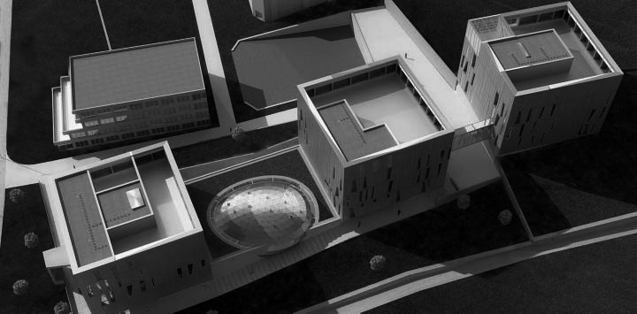
Fig. 1. Rendering of the Science Building

2. Functional, structural and energy concept of the building
The function requires three main bodies [1]: an office building, a building for informatics and another one including a ‘serious lab’ block. (see Fig. 2) The three buildings, having the shape of ‘stones’, are connected: between the first and the second buildings there is a ground floor with lecture rooms including a main hall, the shape of a pebble, seating three hundred people, while the second and the third buildings are connected with a ‘Bridge of Sighs’. The group created this way forms a strict body with some playfulness. The architects intended to coat the pebble-shaped lecture hall with a cladding material in the famous green-turquoise colour of Zsolnay to emphasise the Pécs character of the Science Building, but finally it had to be reverted to using Italian glass to recall the colourful world of Zsolnay. The building has a simple, monolith ferroconcrete structure with short spans. The façade of the building has a two-shell external wall structure that matches its character. Steel is used on the facade to act as sun-protection, which has a perforated structure. The technical equipment of the house runs between the two shells. It is only the southern façade of the first ‘stone’ that has been equipped with a glass solar-protection structure making it possible to utilize solar energy.

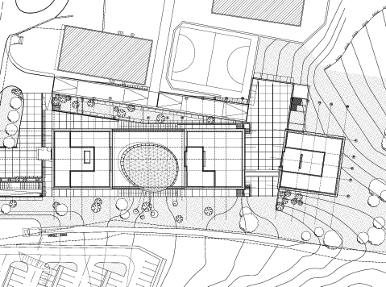
Fig. 2. Site-plan of the complex

Tibor Kukai had the idea, that everybody can hear a lot about renewable energy sources but no one has ever assessed whether solar energy, geothermic energy or other eco-architecture solutions are the best. The Science Building consists of three roughly uniform ‘stones’ (see Fig. 3), and the building is already equipped with modern building service systems. With this solution the various methods can be tested, the results can be recorded and the performances can be compared.

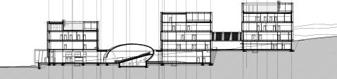
Fig. 3. Longitudinal section

3. Working method of a complex team
Several faculties of the University of Pécs have been involved in this project. The building was designed by the Marcel Breuer Doctoral School of the Mihály Pollack Faculty of Engineering. [2] Balázs Czibók, an economist, carried out the considerable work of preparing the application in a skilful and modest way and he was also responsible for the administrative and management tasks. Technology of the lab came from Dr. Ferenc Jakab who carried out his work with great precision. Considering the above mentioned list it becomes visible that the high technological level of the 21st century can only be achieved through the integration of various professions, and various faculties of a university. As the task was enormous and the period of time was really short György Stocker, a well-prepared architect, who knows a lot about construction and design, joined the team also.

In the field of architecture the Architects sought to achieve simplicity, clarity and almost obvious relationships among the various spaces. At the beginning a few sketches (see Fig. 4) had to be done to clarify the connection between the entrance hall and the ‘pebble’ conference hall. These sketches have been sent to György Stocker who instantly understood everything and responded with some sketches of his own.

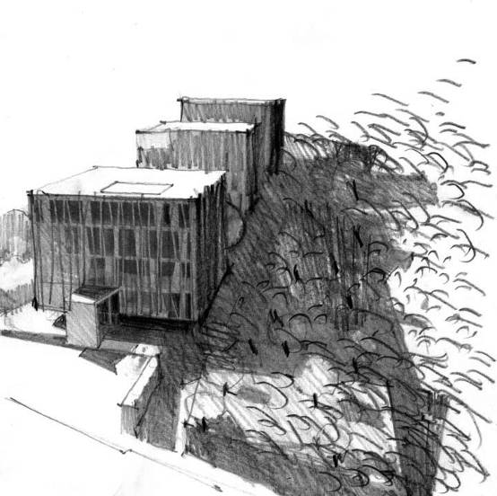
Fig. 4. Sketch from outside

A part of the consultation concerning the concept was done. What remained was the design of the façade’s structure (see Fig. 5) At this point Csaba Rohoska introduced the proposal of the architects that made simpler by the strict engineers: Gábor Szigyártó and György Stocker.

This was the method used when designing the building. It was a real challenge to meet the requirements set by the authorities, to correct the designs here and there. Bálint Bachmann, who is quite experienced in the field of consultation and his young colleague, Tamás Molnár carried out this work. This division of labour has been devised because otherwise the tight deadlines could not have been met and also the architects had to meet so many requirements that one person could not comprehend and meet all of them. It was a feat of daring stunt that the authorization procedure took a record setting short time thanks to Ervin Winkler, a former student of the Faculty, who also has a degree in law and having spent some years in public administration, had excellent knowledge and the necessary connections.

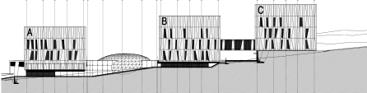
Fig. 5. Façade of the Science Building

In the meantime Balázs Czibók was struggling with the tricky traps of writing the application. In the increasingly complicated world everyone should know how important it is to receive authorization fast. This can only be achieved through quick and skilful consultations that have an impact on the house, including even its basic concept. There must be one in the team who can see this. In the case of the ‘pebble’, for instance, the original design was a ferroconcrete structure (see Fig. 6)

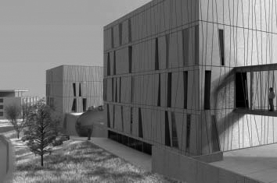
Fig. 6. Rendering from outside

Then, having considered the structure from the perspective of construction and finances it has been recognized that the two-shell, double formwork would not be acceptable to the contractor. A steel structure was considered which one would not pass the fire regulations. Finally the architects came up with the idea of underpinning the entrance hall with several ‘staggering’ pillars, creating the atmosphere of a forest. This way an oval hole can be cut into the slabs. A glass and steel structure, a ‘skylight’ dome can be placed above it, so confining the space of the lecture hall vertically can be anything as it must meet only the standards of space confinement and not those of the superstructure. [3] The working style of the team was able to follow this perfectly.
4. Conclusion
The building of the Science Building is able to play its role determined by the academic, local, regional and international expectations. The entrance hall and the adjoining lecture rooms (see Fig. 8), which inform the students and those interested about the results of the researches have another role, too: they serve as a forum for scholars arriving from abroad because owing to the labs and the computer system it can provide them with everything they need for their scientific research.

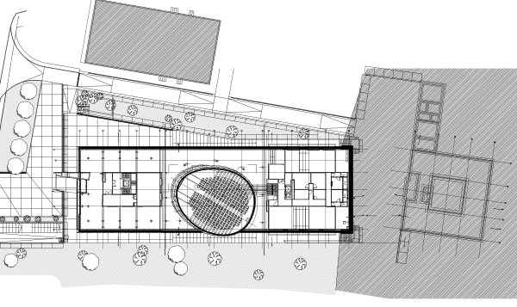
Fig. 7. Ground floor plan of the Science Building

The architects have great hopes concerning the research carried out through assessing the ecological aspects of the building. The laboratory technology has been served by the architects with the greatest possible respect. In return the engineers gave a completely free hand in the field of forms and aesthetics, and sometime they even appreciated the different ideas of the architects.

References
- Bachman Z. Bachman Zoltán, Vince Kiadó, Budapest, 2010. pp 277-291.
- Bachmann B. “Challenge of changes, Architectural education in atelier”, Pollack Periodica, Vol. 3, No. 3, 2008, pp. 3−17.
- Bachmann, B. Bachman, Z. “Science Building in Pécs”, Pollack Periodica, Vol. 5. No. 3, 2010, pp. 3-8.

