Answer evaluation in competence based learning

¹K. Umbleja, ¹V. Kukk, ¹M. Jaanus
Tallinn University of Technology, Tallinn, Estonia, kadri.umbleja@dcc.ttu.ee¹

Abstract
This paper describes competence based approach to measure students’ learning results to be used in control of learning process. Most important outcome of studying is acquired knowledge. To get clear and accurate data of student’s abilities and gained knowledge, exercises have been divided into elementary tasks that checks small part of knowledge. All tasks are connected to competences and analysis of answer changes the levels of abilities related to corresponding competences. Student provided answer is not only checked against teacher’s provided correct answer, but the reason why student has made a mistake is analyzed. By being able to detect places and types of errors in provided answers typos can be eliminated, influence of repeated mistakes can be reduced, appropriate feedback signal can be produced and study materials can be recommended according to mistakes made. Using algorithm to mimic process of finding answers for tasks with multiple correct outcomes can be evaluated. Also, in many cases, part of answer depends on previous actions and mistake in the beginning of the answer can be avoided to be carried over to other parts of mistakes even if those parts were processed correctly. By using memory models and lowering students’ ability levels by implementing forgetting model forcing students to retake tasks, learning has been personalized and moved from temporary knowledge toward long term attainments. Competence based approach enables to point student toward the certain tasks he/she needs to retake in order to fix knowledge. The process is repeated until system confirms required level of skills. Students get instant response to experiment and can repeat exercises as many times as they wish.

1. Introduction
To measure studying outcomes and have a full and accurate overview of student knowledge classical “topic -based” learning is not sufficient. Competence based learning with grading skills separately can give much clearer picture. With new kind of approach to grading tasks, different way to analyze and evaluate answers is also required.

1.1 Background: learning environment ISC
ISC is e-learning environment used in Department of Computer Control, Tallinn University of Technology from the end of 1990-s [1].

This system is used to teach many different courses with some courses having overlapping material. Every course has poll of tasks and lab experiments. They were divided into topics (etc “Two-ports” in “Circuits, Systems, Signals” course) and every topic had large number of different variation of tasks connected to it. Tasks and lab experiments are designed to be small concentrating only in small portion of theory.

Every topic has state what is like grade showing the progress made in that field. Instead of using commonly practiced system with 5-6 grades, 128 different ability levels are used in order to avoid discretization effects and have more effective feedback control [1]. When student decides to solve some topic, a task or lab experiment is chosen for student according to topic, level and frequency of task taken. The goal is to use all possible tasks in topic’s pool, try to avoid student getting the same version of certain task more than once and get task closest in its level to student’s state on topic.

System is fully web based, giving students the possibility to solve tasks when and where they wish not being bound to campus. Also, the system supports HomeLabKits – portable lab equipment what gives students the possibility to complete entire course in web on time and place of their own choosing [2,3].

ISC takes “authentic“ student input meaning that even if there are some multiple choice items, majority of tasks need student to fill in the answer [4]. It also has automatic evaluation in tasks and lab exercises therefore; no teacher interference is needed for solving exercises. Students get instant response thanks to algorithms used for processing answers. Those algorithms give feedback and calculate results.

2. Competence-driven learning
Most important outcome of learning is acquired knowledge what is hard to measure even if there exists many proposed metrics, they may not give proper picture [5]. Problem with one number representing the knowledge on some wider topic is that it is not measurement of elementary skill or competence rather than summation of elementary competences (summative grading). In order to give proper picture of student’s abilities every task and lab evaluation should not measure the summed or averaged levels of skills but be able to see different competences within tasks. That kind of approach can result in personalization, better task and lab evaluation, clearer picture of student abilities and it can give to teacher a view of current students’ abilities and learned skills. That would give teacher a better understanding of class level, what they already know and where gaps in their knowledge are. That would save time, avoid repeating material student already know (but what sadly happens quite often) and gives teacher better idea how to plan course material between lectures. To achieve more detail and clearer picture of student abilities we replaced classical topic based learning approach by skill based competence learning.

Competence learning is knowledge base methodology, what concentrates on what person can actually do as a result of learning [6,7,8]. Instead of evaluating one result for a task, every exercise is analyzed to extract smaller parts of skills what the task uses checks or requires [9]. For example, task in which the following is to be evaluated x=40/2*5+1 not only checks student’s ability to solve mathematical equations but makes sure student can multiply, divide and add. Analysis performed before changing over to competence learning showed that in average for every task about 4 competences could be extracted [1].

Answer evaluation in competence learning differs from answer evaluation in topic based learning. As every task is related to multiple competences, answer evaluation will not give one result for whole task but results for every competence that are present in completed task. All competences and results are independent and therefore some competence levels can go up and other go down at the same time. That solves previous problem with topic based learning and answer evaluation where summative grading is difficult and can be misleading [1].

Competence learning and evaluating answers within that kind of method goes into details. Instead of huge experiments taking hours, exercises have been divided into elementary tasks that check small part of theory enabling competences to be acquired easily and reduces the amount of information acquired at the same time allowing significant increase in the total number of individual tasks [1].

With competence learning we will no longer have topic field where student chooses topic and task is chosen for him/her. Instead now student chooses a competence wishing to improve. In ISC, three levels of granularity are implemented where in 1st level every competence can be seen and accessed. On 2nd level similar competences have been assembled and 3rd level is most general but less than a course. Also, in case when students do not wish to make decision themselves, their current level of knowledge and previously solved tasks are used to recommend next competence and task with it to solve. Competence learning gives us ability to personalize learning as student has to repeat and retake tasks with competences and parts of theory he or she has not yet acquired with sufficient level [9]. With forgetting model personalization can be taken even further.

3. Processing answers
Answer evaluation the most important part of competence learning providing valuable information to both student and teacher [4]. The simplest answer evaluation is comparing student’s submitted answer with teacher’s provided correct answer. That gives two possibilities: the answers are the same and therefore it is presumed that student has submitted correct answer and knows how to solve the problem. The alternative is that the answers are not the same and student did not solve the problem correctly. In most cases that kind of black-and-white approach of answer analyze is not enough as tasks may contain many different competences, consist of many intermediate steps and intermediate sub-results influence final answer. When analyzing wrong answers from log files one can first determine possible errors and from that define competences that may consist in correct answer.

Perfect algorithm for answer analysis would be able to find places of mistakes, understand reasons why mistakes were made and find associated competences. It will also be able to alter given correct answer according to made mistake. Therefore one mistake made would not make rest of the answer fully wrong even if it depends on earlier calculations. There are types of tasks where more than one way to solve exists. Those tasks cannot be checked with black-and-white approach as student has more than one possibility to submit correct answer. One alternative is to have more than one correct answer provided by teacher and student provided answer is compared with all of them. That becomes inefficient if the number of possible answer increases. Therefore algorithm that mimic the answering process following the path student has used is preferred as it should be able to adapt to any path student chooses to give the correct answer.

We are particularly interested in student's incorrect answers as there is much to learn from them – what went wrong, why went wrong, where the answer went wrong, what competence should be more focused on teaching etc.

3.1 Case study
In the course(s) “Operating Systems” there is a set of tasks where students have to mimic process scheduling in CPU. They are given description of three processes with time spent in CPU and resources declared. Correspondingly to scheduling strategy given, student has to fill table and show in which moment of time where certain process is.

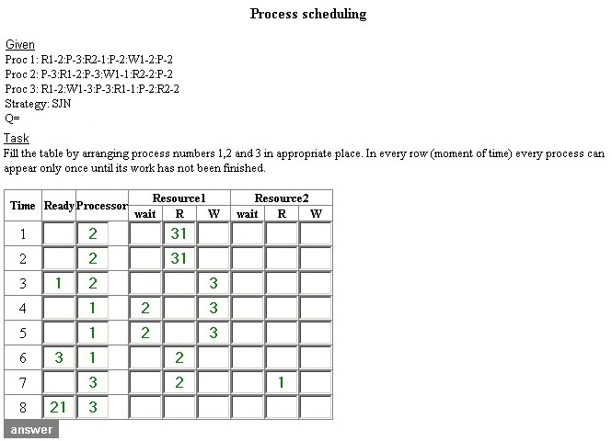
Figure 1: Process scheduling task with filled in answer

Originally the task had control algorithm what compared input string with teacher’s provided correct answer string until the first difference. Then the percentage of the answer what matched was used to calculate the result. With that kind of analysis a mistake meant end of answer evaluation. It did not matter how serious the mistake was. Even typos or carelessness mistakes like forgetting to assign an action to process in every moment of time were as crucial as misunderstanding the task or making mistakes in interpreting scheduling strategy.

That control worked efficiently if there were no mistakes or mistakes were made in the later part of the answer. Sadly, that kind of approach did not allow any proper feedback or identification of mistake made. In order to give students proper comments to their answer, understand mistakes and suggest materials according to gaps in student’s knowledge, a different approach was needed. The first phase of new algorithm development contained analyzing previous answers as the only source showing where and why mistakes are made. It was learned that majority of mistakes where done with 1) process priorities, 2) resource management (many students failed to understand that one file can be read by many processes but only one process can write a file and writing is preclusive for reading and vice versa), and surprisingly 3) many typos.

The first priority was to reduce the impact of typos. All processes can be in CPU, in waiting list or performing resource action in any given time. Many students had assigned process in one moment of time for more than one action. Therefore a pre-submitting control to answer input table was added what raised an error message when a process was added more than once and removed lastly added process. That lowered typos and carelessness mistakes almost by half.

The main part of algorithm is analysis of mistakes. First, the moment where student’s answer and provided correct answer start to differ. Then the line where the mistake was made is thoroughly examined. Mistakes with resource are easily determined. Types of mistakes are numbered and number of occurrences is stored in array. Every time when a certain mistake is made, that number in array is increased. So, every moment of answer evaluation, the number of different mistakes and total mistakes are known. With every type of mistake a proper comment is added to global comment variable.

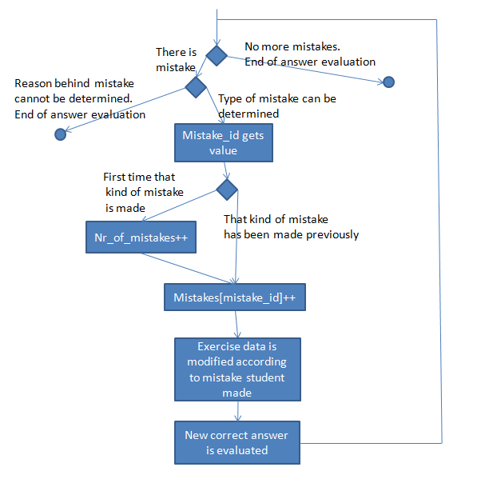
Figure 2: Answer evaluation process

For example, if it is detected that when t=4 there are processes reading and writing the same resource, it is determined that competence “Process scheduling: Can only read or write” is not followed. For example that is error type nr 3. Array for error counting is increased in proper place and comment “Line 4: Currently processes are reading and writing to the same resource at the same time. “Processes can only read simultaneously or write exclusively” is added to global message what will be printed to the screen after the answer evaluation has ended.

When mistake is determined it is recorded and that line is, in answer evaluation purpose, considered correct. Therefore the “global” correct or teacher provided correct answer cannot be used anymore and new correct answer has to be evaluated. It is sure, that the parts of correct and student provided answer to the start of the line where mistake was made are correct. The line where mistake was made is considered “correct” in student provided answer. The rest of the correct answer has to be evaluated for further analysis.

To obtain rest of new correct answer, the algorithm that is used by student for answering has to be implemented. With process scheduling that is easy as students have to follow certain rules and scheduling algorithm. That process just has to be coded and the description of processes on the time moment where mistake was made has to be known. Therefore, at every time step, the description of processes has to be altered according to the steps made. With known description of processes, number of moments known to the end of the task and algorithm to mimic answering process, new correct answer can be calculated.

With new correct answer that takes into account the data student had after the mistake was made, the process of analyzing “new correct” answer with student provided answer continues until the end of the answer is reached. When new mistake is found, new comment is added to global comment variable, amount of mistakes is increased and correct answer re-evaluated. When the end of answer evaluation is reached, global comment is printed and result is calculated. Final result is not one number for the task as every task is related to many competences. In that example, up to 31 different types of mistakes can be determined and 12 different competences have been evaluated. Many different types of mistakes can affect one competence or one type of mistake can affect many competences. For example, concerning reading and writing at same time, affects competence “Process scheduling: Can only read or write” but it also has smaller effect on competence “Process scheduling: Resources”. Also, every mistake and total number of different mistakes is used to calculate outcome for competence “Processes” and the competence corresponding to the algorithm used for process scheduling.

Changes in every competence levels (abilities) are calculated separately using common algorithm and therefore some competences can go up and others can go down. That gives flexibility to measure different aspects of tasks and to consider the mistakes made. It is possible that student can understand the strategy used for process scheduling but does not understand that this algorithm only applies to CPU and not to the resources. So as the result ‘scheduling strategy’ knowledge competence will go up but understanding resource management will go down. That kind of new algorithm gives us possibility to find and understand the mistakes students have made, compile proper feedback signals, give proper comments, and according to mistakes (or competences) direct student to associated learning materials. Answer evaluation is automatic and enabling real-time feedback. (It is possible to engage a teacher as part of evaluation however this may cause extra delays – unwanted in feedback control). Students can solve their tasks any time and place, get real-time comments about their answers, and adopt their knowledge of the problem according to feedback. They are not limited how many times they can try to solve the task and extra tries will not raise teacher’s workload.

4. Forgetting model
Human forgetting has been studied carefully over long time and H. Ebbinghaus was first to show with his experiments that retention is very fast in the beginning and quite slow later and repeating is important to memorization [10]. When student solves some task and gets to the higher competence level, the new knowledge goes to short term memory. To achieve long term memory of certain knowledge, student has to repeat the tasks connected to that knowledge competence. As the number of times one type of task is taken rises, it is important to have many variations of the same task as students strongly oppose getting the same task they have already solved.

As answer evaluation is done automatically there is no new stress for teacher with repeated taking of task and memory model can be used for further personalization. The purpose of memory model is to lower the overall result of certain competence over time in order to mimic forgetting. The level of forgetting depends on student previous behavior and the correctness of student’s answers. When student result is lowered by forgetting model over time after first time taking task with previously unsolved competence and student retakes task with the competence and answers correctly, it is assumed he has lower threshold of forgetting than when making mistake in repeated attempt.

5. Conclusions
When forgetting model attached to old “topic based” learning was introduced in 2007 the amount of tasks taken increased 50%. Changing over to competence based learning with forgetting model in 2010, the number of tasks taken by students increased remarkably. Before introducing competence based learning, in 2009 and 2010 spring, students solved 140 tasks on average. After competence based learning was introduced in 2010 fall and 2011 spring average number of tasks solved by student raised to 507. At the same time tasks were divided into smaller units and whole number of tasks available increased too. It was also visible that students’ later attempts were usually much better than their first attempts. In student’s first five tries with new competence the average result was 0.16 and on their last five tries the average result was 0.58 (with result in [-1.0, 1.0]). That proves that forcing students to retake exercises their knowledge gets more long-term one and they get better understanding of material.

With improved answer evaluation and generated correct answers by algorithm, rather than just checking answer against correct one, in 71% of cases student got better result value due removing typos and lowering influence of repetitive mistakes. In 27% the result remained the same and in only 2% the new algorithm graded answer with lower result value. This proved that generated correct answers and evaluating them based on competences is more efficient in reflecting student’s real progress. All that has proved that with competence learning, forgetting model, and complex answer evaluation more information for both student and teacher can be collected, better feedback can be obtained, studying can be personalized and proper picture of student abilities can be drawn.

References
1. V. Kukk, M. Jaanus, K. Umbleja and O. Shvets “Developing integrated learning environment – analysis, ” Proceedings of International Conference on Engineering Education ICEE-2010, Gliwice, Poland, 2010.
2. M. Jaanus, V. Kukk and K. Umbleja, “Integrating Labs into Learning Environment, ” Electronics and Electrical Engineering, Vol. 6, 2010, pp 27 - 30.
3. O. Švets, V. Kukk, M. Jaanus and K. Umbleja, “Remote laboratories and methods of their aplication in study procsess”. Journal of International Scientific Publications: Materials,Methods & Technologies, Vol. 4, No. 2, 2010.
4. K. Scalise,D.J. Bernbaum, M. Timms, S.V. Harrell, K. Burmester, C.A. Kennedy and M. Wilson, “Assessment for e-Learning: Case studies of an emerging field”, Proceedings of International Objective Measurement Workshop, Berkeley, CA , 2006.
5. J. Liebowitz, and C.Y. Suen, “Developing knowledge managment metrics for measuing intellectual capital”, Journal of Intellectual Capital, Vol. 1, No. 1, 2000, pp. 54-67.
6. H. W. Van der Broeck and H. C. Skudelny, “Analysis and realization a pulse width modulator based on a voltage space vector”, IEEE Trans. Industry Applications, Vol. IA-24, No. 1, 1988, pp. 142-150.
7. D. A. Grant, M. Stevens and J. A. Houldsworth, “The effect of word length on the harmonic content of microprocessor-based waveform generators”. IEEE Trans. Industry Application, Vol. IA-21, No. 1, 1985, pp. 218-225.
8. P. Horowitz and W. Hill The art of Electronics 2. edition, Cambridge University Press, Cambridge, 1998.
9. C. Hockemeyer, O. Conlan, V. Wade and D. Albert, “Applying Competence Prerequisite Structures for eLearning and Skill Management”, Journal of Universal Computer Science, Vol. 9, No.12, 2003, pp. 1428-1436.
10. C. Ostyn, Competency Data for Training Automation. [Online] [Cited: 04 12, 2011.] http://www.ostyn.com/standardswork/competency/CompetencyDataForTrainingAutomation.htm.

