Learning Styles amongst Engineering Students in Malaysia, South Africa and Finland
¹Azizan Zainal Abidin, ²Rosetta Ziegler,³Raija Tuohi
UniversitiTeknologi PETRONAS, Malaysia,
azizan_zainalabidin@petronas.com.my¹;
Cape Peninsula University of Technology, Cape Town, South Africa, zieglerr@cput.ac.za²;
Turku University of Applied Sciences, Turku, Finland,
raija.tuohi@turkuamk.fi³

Abstract
Student learning styles play an important role in the process of teaching and learning. Many students are unaware of their personal learning styles let alone their study styles. Research has shown that students learn faster and perform better academically if their study styles fit their personal learning styles. Thus, the need for students to know what their learning styles are and to understand how these may influence their learning is emphasized. It is also important for the faculty to be aware of their students’ learning styles, in order to design and strategize appropriate, effective, delivery approaches and minimize mismatches of teaching and learning. The objective of this research is to discover and compare the learning styles of engineering undergraduates in three different parts of the world; Malaysia, South Africa and Finland. Three universities are involved in the study: UniversitiTeknologi PETRONAS (Malaysia), Cape Peninsula University of Technology (South Africa) and Turku University of Applied Sciences (Finland). At least one hundred first year engineering undergraduates from each locality are involved in this study. The instrument used for data collection is the Memletics Styles Quiz containing seventy items. Microsoft Excel and Statistical Package for Social Sciences are used for the analysis of results and graphical representation of the findings. It is anticipated that these findings will be significant for future work in establishing a basis for discovering the factors contributing to the significant differences (or similarities) in students’ learning styles. In addition, it is hoped that the findings will be beneficial to students and faculty in enhancing and improving student learning.
1. Introduction
A critical awareness and understanding of student learning styles by both engineering students and educators is important as it could provide valuable insight into what is needed to create meaningful learning experiences, and more effective teaching. Learning styles are essential in understanding how students learn (Cropley and Sitnikova, 2005). There is an inextricable link between teaching and learning. An acknowledgement that students learn in different ways and that they may not always find themselves in a learning environment that considers and incorporates this diversity into teaching, is important. Drop-out rates and poor throughput rates are consequences of ineffective teaching and learning. Mismatches between student learning styles and traditional teaching styles, as referred to by Felder and Silverman (1988), are amongst several factors that contribute to ineffective teaching and learning. Student disengagement and boredom may also be attributed to such mismatches (Felder and Silverman, 1988; Austin, 2004). Engineering students who lean towards an active learning style may be lost to the system if presented with the “old paradigm” pervasive in engineering courses where students are viewed as “passive recipients of knowledge transferred by master teachers” (Anson, Bernold, Crossland, Spurlin, McDermott and Weiss, 2003:146). Given the uniqueness of individuals and the concomitant diversity and complexity of learning needs, it stands to reason that the provision of absolute matching of learning styles to teaching styles may be problematic. However, efforts should be made to understand how students learn in order to provide more effective learning experiences. Anson, et al. (2003) see a solution to the mismatches between student learning styles and the teaching styles of their lecturers in the form of a symbiotic relationship between student and teacher “beliefs and practices” (146).

According to Felder and Brent (2005), learning styles are characteristic ways of taking in and processing information. One learning style is neither preferable nor inferior to another, but is simply different, with different characteristic strengths and weaknesses. Students typically focus on different types of information, for example visual or aural. They operate on perceived information in different ways. Students may interact in group discussions and co-operate with other students or reflect on their own thoughts and feelings. Felder (1993) states that students whose learning styles are compatible with the teaching style of a course instructor tend to retain information longer, apply it more effectively, and have more positive post-course attitudes toward the subject than their counterparts who experience learning/teaching style mismatches.

This paper presents an investigation into the learning styles of engineering students and provides a comparison of the distributions of learning styles amongst engineering undergraduates at three different universities, in three different countries, namely, Universiti Teknologi PETRONAS (UTP) in Malaysia, Cape Peninsula University of Technology (CPUT) in South Africa and Turku University of Applied Sciences (TUAS) in Finland. It is anticipated that the findings presented here will be significant for future work in establishing a basis for discovering the factors contributing to the significant differences (or similarities) in students’ learning styles. It is also hoped that the findings will be beneficial to students and faculty in enhancing and improving student learning.

2. Related Literature
The literature on learning styles is vast and exhaustive. Learning styles have been studied over a number of decades and it is claimed that the term was first encountered in literature on learning in the 1970s. Learning styles theories and concepts stem from the disciplinary home of psychology, but have over the years been incorporated into various other disciplines (Cassidy, 2004). During the last ten years, attempts have been made to try and match learning styles, study styles and teaching styles in order to achieve better results in learning (Oulujärvi, 2010) as improved academic performance has been linked to instruction where student learning styles are taken into account (Khan, 2009; Aripin, Mahmood, Rohaizad, Yeop and Anuar, 2008). Different studies have revealed different results in this regard. In their study, Aripin, et al. (2008) looked at dominant learning styles in relation to academic performance of first semester students and concluded that there was not a strong correlation between learning style and academic performance. Studies highlighted by Pashler et al. (2008) show results that concur with Aripin, et al. (2008). However, a study by Kvan and Yunyan (2005) suggested a significant correlation between learning styles and academic performance.

There are various definitions of learning styles. Cassidy (2004) refers to Hartley’s definition of learning styles which says that “learning styles are the ways in which individuals characteristically approach different learning tasks” (421). Mohamad and Mohamad (2005) refer to Honey and Mumford who define learning styles as “a group of attributes and behavior that determine the way or approach of learning preferred by an individual” (1). The term learning styles, according to Pashler et al. (2008), is relevant to “the view that different people learn information in different ways” (106). According to Zywno and Waalen (2002), learning styles involve “receiving and processing information within a learning environment” (35).

Coffield, Moseley, Hall and Ecclestone (2004), have established that there are approximately seventy one different models for learning styles and that extensive research has been done in this area. Some criticism has been given to the lack of consensus around the concept of learning styles (Cassidy, 2004; Pashler et al., 2008). In addition, terms relating to learning styles are, in some instances, used interchangeably in an imprecise manner and in other instances used very distinctly (Cassidy, 2004; Pashler, et al., 2008). Examples of terms that are sometimes imprecisely used in the literature include: “learning style”, “cognitive style” and “learning strategy” (Cassidy, 2004: 420). In Cassidy’s view (2004) cognitive style is distinctly different to, but an important element of, learning style. Pashler, et al. (2008) make the distinction between “learning style as a set of preferences” and “learning style as a specific aptitude” (109). They point out that the two are sometimes incorrectly conflated in the learning styles literature.

Felder and Silverman (1988) describe the concept of a learning-style model as a classification of students “according to where they fit on a number of scales pertaining to the ways they receive and process information” (674). It would appear that the most widely referred to models are those of Kolb, Dunn and Dunn, and Felder and Silverman. According to Zywno and Waalen (2002), Felder’s Learning Model has become popular with engineering educators and it presents learning styles that are more relevant to Engineering Education compared to other models. Felder and Silverman (1988) look at learning and teaching styles and propose a learning-style model that consists of the following dimensions: Sensing/Intuition (how information is perceived), Visual/Verbal (how information is presented), Active/Reflective (how information is processed) and the Sequential/Global dimension (relates to understanding).

Learning styles are shaped by different influencing factors and students may enter a university with an existing learning style or preferred learning style, which may be reshaped according to the requirements of the particular educational programme and the profession it is preparing students for. Professional orientation contributes to shaping learning styles (Csapo and Hayen, 2006). A study by Khan (2009) concluded that students from different professional courses have different learning styles. Learning styles are also shaped and reshaped by the constant evolution of technologies and their incorporation into curriculum activities. Here the role of “neomillennial learning styles”, as discussed by Dede (2005:7) is an important aspect to bear in mind. Felder, Felder and Dietz (2002) are of the view that it would be advantageous for engineering students who wish to function optimally in any sphere, to develop skills in all learning styles.

3. Methodology

Undergraduate Engineering students from three universities, UTP (Malaysia), CPUT (South Africa) and TUAS (Finland) participated in this study. The objectives of the study were explained to all the participants. A total of 529 students participated. This number comprises: UTP, 202 (82 female) first year engineering undergraduates, of a total not more than 400; CPUT, 161 (13 female) first semester Mechanical Engineering undergraduates, of a total not more than 300 and TUAS, a total of 165 (119 first year Information Technology and Electronic students and 46 second year Information Technology students) of which 14 were female. The participants’ ages ranged from 19 to 21. It may be of interest to note that the language of instruction at both UTP and CPUT is English. However, all the participants do not have English as their first language. At TUAS the instruction language is Finnish, but the participants of TUAS answered the same English questionnaire as participants at UTP and CPUT. Students in TUAS were able to utilize a Finnish translation of questions.

All the participants completed the 70-question Memletic Styles Quiz (MSQ) electronically. The MSQ is a learning styles instrument which aims to assist those who complete it to identify their preferred learning styles. It is in the form of an Excel workbook which makes electronic completion possible. The participants were required to rate 70 statements by using the following score ratings: 0 – the statement is nothing like me, 1 – the statement is partially like me or 2 – the statement is very much like me. Once all 70 items were rated, a learning styles graph was generated with seven learning styles indicated. The styles included are: Visual, Aural, Verbal, Physical, Logical, Social and Solitary. Advanogy.com (2004) provides a brief description of each style as follows:
- Visual - preference in using pictures, images and spatial understanding
- Aural - preference in using sound and music
- Verbal - preference in using words in writing and speech
- Physical - preference in using body, hands and sense of touch
- Logical - preference in using logic, reasoning and systems
- Social - prefer to learn in groups or with other people
- Solitary - prefer to work alone or use self study

This MSQ was chosen for this study because it is user-friendly.

At UTP, the Engineering undergraduates doing Electrical and Electronics, Civil and Chemical disciplines taking the Ordinary Differential Equations course were required to complete the MSQ and to confirm their names on an attendance list. However, since the questionnaire was posted on the e-learning for the course, other undergraduates from other disciplines also responded out of curiosity. Participants responded to the MSQ posted on electronic learning using Moodle, the UTP learning portal. The completed questionnaires were mailed to the instructor via yahoo electronic mailing system. Data collection began at the onset of the January 2011 semester. At CPUT, the participants completed the MSQ which was made available on a departmental, shared drive, which both the participants and the researcher could access. The completed MSQ was saved by each participant in a folder on this drive. This process was started in the first week of the first term, in February of 2011, with volunteer participants. Not all the students were keen and some of the volunteers were reluctant when confronted with 70 questions. However, once the graph was generated for each participant, there was interest in the interpretation of what these revealed about each individual. In TUAS all first year students in degree programmes in Information Technology and Electronics and second year students in Information Technology were asked to find out their learning style by completing MSQ and saving it on the electric platform OPTIMA. This took place at the beginning of the study year 2010-2011.

Once participants completed the MSQ, they could see their results as a spreadsheet and the overall totals (see Table 1 below). A student can type lots of two’s and one’s, or lots of zero’s. So, the sum of total points can differ.

Table 1: An example of a student’s results
Visual | Verbal | Aural | Physical | Logical | Social | Solitary
15 | 7 | 9 | 8 | 15 | 13 | 7

The data was captured in Microsoft Excel and transported to Statistical Package for Social Sciences (SPSS).

4. Results
The results of the study are presented below. Reliability test for the MSQ was made by SPSS giving the value 0,727 for Cronbach’s Alpha.

4.1 Results from UniversitiTeknologi Petronas

Table 2 shows the overall results (male and female students, combined) as well as the results shown by gender. It can be seen from the overall results that the most preferred learning style is social style, followed by logical, physical and visual styles. Verbal style is the least preferred style. The differences are statistically significant (paired samples t-tests, P-values at most 0,006) except for pairs visual – aural (P-value 0,140), visual – physical (P-value 0,957), aural – physical (P-value 0,071), aural - solitary (P-value 0,343) and logical – social (P-value 0,374).

Table 2: Mean values and standard deviations of students’ learning style results in UTP
 | Gender | n | Visual | Verbal | Aural | Physical | Logical | Social | Solitary
Mean | Male | 120 | 11,50 | 9,79 | 11,23 | 11,83 | 13,19 | 13,67 | 10,79
Mean | Female | 82 | 12,37 | 10,85 | 11,51 | 11,91 | 13,15 | 13,06 | 11,33
St. dev. | Male | 120 | 3,524 | 3,178 | 3,712 | 3,275 | 2,888 | 2,658 | 3,302
St. dev. | Female | 82 | 2,938 | 3,003 | 4,194 | 2,924 | 2,667 | 3,248 | 3,403
Mean | All | 202 | 11,85 | 10,22 | 11,35 | 11,87 | 13,17 | 13,42 | 11,01
St. dev | All | 202 | 3,319 | 3,144 | 3,907 | 3,130 | 2,794 | 2,920 | 3,346

The mean values of female and male students are shown in Figure 1. The differences between male and female results are small. In relation to the verbal style the difference is statistically significant at the level of 0,05 (P-value is 0,018). Other differences of mean values between male and female students are not statistically significant.

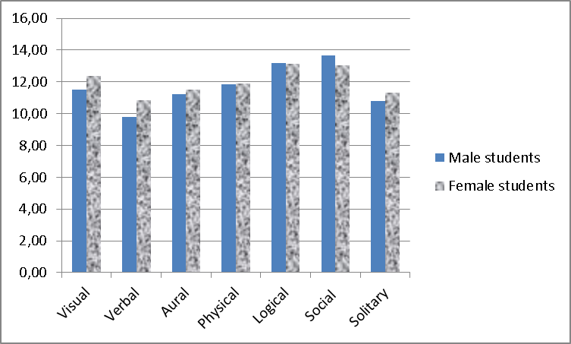

Figure 1: Mean values of male and female students’ learning style results at UTP

4.2 Results from Cape Peninsula University of Technology

At CPUT 148 male and 13 female students completed the MSQ. The overall results are given in Table 3.

Table 3: Mean values and standard deviations of students’ learning style results at CPUT
 | Gender | n | Visual | Verbal | Aural | Physical | Logical | Social | Solitary
Mean | Male | 148 | 12,86 | 10,51 | 11,74 | 13,43 | 13,66 | 14,20 | 11,32
Mean | Female | 13 | 12,92 | 13,54 | 13,15 | 13,92 | 14,69 | 13,92 | 12,77
St. dev. | Male | 148 | 3,392 | 3,263 | 3,195 | 2,728 | 3,159 | 2,750 | 3,305
St. dev. | Female | 13 | 4,071 | 3,126 | 4,140 | 3,499 | 4,008 | 4,232 | 3,140
Mean | All | 161 | 12,87 | 10,76 | 11,86 | 13,47 | 13,75 | 14,17 | 11,43
St. dev | All | 161 | 3,437 | 3,346 | 3,288 | 2,788 | 3,233 | 2,880 | 3,307

The overall results show that the most preferred learning style for the CPUT participants is the social style. This is followed by logical, physical and visual styles. The verbal style is the least preferred style. The results are quite similar to that of UTP. The differences are statistically significant (paired samples t-tests, P-values at most 0,024) except for pairs aural –solitary (P-value 0,180), physical- logical (P-value 0,363) and logical –social (P-value 0,126).

The mean values for female and male students are shown in Figure 2 below. The differences between male and female results are small. In relation to the verbal style, the difference is statistically significant at the level of 0,05 (P-value is 0,002). Other differences of mean values between male and female students are not statistically significant. The results are similar to the results of UTP in this respect also.

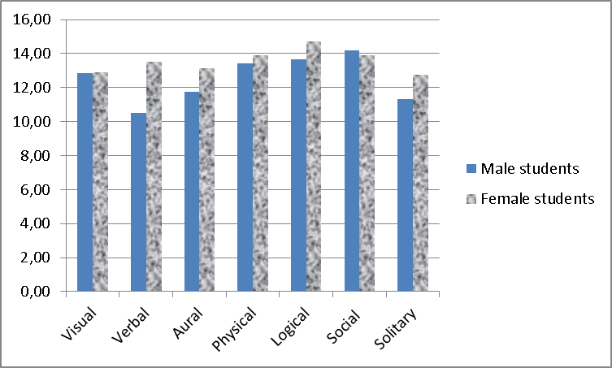
Figure 2: Mean values of male and female students’ learning style results at CPUT

4.3 Results from Turku University of Applied Sciences

The percentage of students who saved their results is 68,75 %. The overall results are given in the Table 4.

Table 4: Mean values and standard deviations of students’ learning style results at TUAS
 | Gender | n | Visual | Verbal | Aural | Physical | Logical | Social | Solitary
Mean | Male | 151 | 10,36 | 9,45 | 11,00 | 10,32 | 11,18 | 12,42 | 10,25
Mean | Female | 14 | 12,21 | 11,14 | 12,36 | 11,79 | 10,21 | 13,71 | 10,07
St. dev. | Male | 151 | 3,582 | 3,296 | 3,802 | 3,234 | 3,007 | 3,658 | 2,740
St. dev. | Female | 14 | 3,965 | 3,134 | 3,692 | 3,191 | 3,786 | 4,214 | 3,647
Mean | All | 165 | 10,52 | 9,59 | 11,12 | 10,44 | 11,10 | 12,53 | 10,24
St. dev | All | 165 | 3,640 | 3,307 | 3,801 | 3,247 | 3,079 | 3,711 | 2,815

The results show that the most preferred learning style is social style, followed by aural, logical and visual styles. Verbal style is the least preferred style. The results differ from the results of UTP and CPUT in that physical style is not as preferred by the TUAS participants compared to UTP and CPUT. Instead of physical style, aural style is preferred by TUAS participants. The differences are statistically significant (paired samples t-tests, P-values at most 0,048) except for pairs visual – aural (P-value 0,093), visual – physical (P-value 0,781), visual –logical (P-value 0,094), visual - solitary (P-value 0,323), aural – logical (P-value 0,960) and physical – solitary (P-value 0,507).

The mean values for female and male students are shown in Figure 3 below. The differences between male and female results are small and not statistically significant.

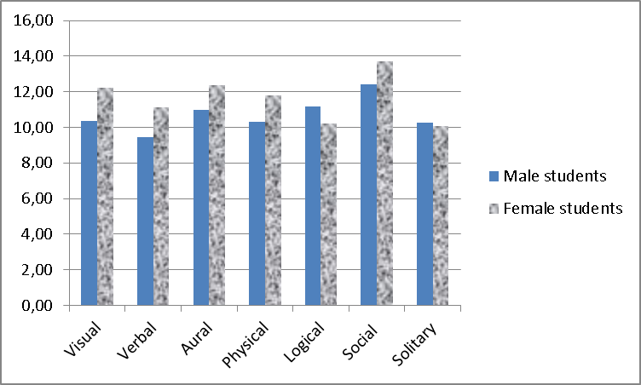
Figure 3: Mean values of male and female students’ learning style results at TUAS

4.4 Combined results

Figure 4 shows the combined results of learning styles from the three different institutions.

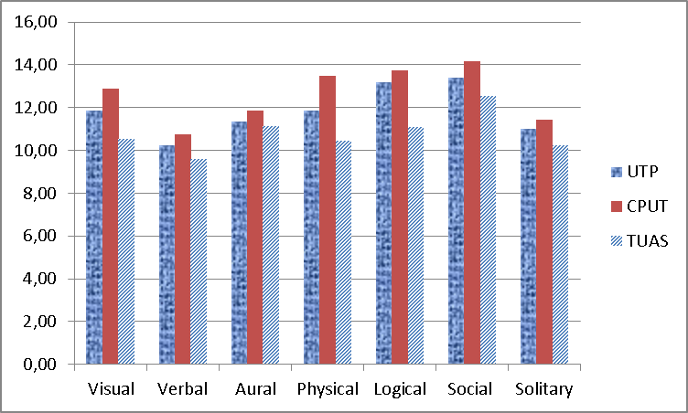
Figure 4: Mean values of students’ learning style results at UTP, CPUT and TUAS

At CPUT the students have given more “the statement is partially / very much like me” – answers than at UTP and TUAS. The differences in overall results of CPUT and TUAS are significant in all learning styles (P-values at most 0,002) except for aural style (P-value 0,061). The differences in overall results of UTP and TUAS are significant in all learning styles (P-values at most 0,019) except for verbal style (P-value 0,063) and aural style (P-value 0,568). The differences in overall results of CPUT and UTP are significant only in visual style (P-value 0,005), physical style (P-value 0,000) and social style (P-value 0,015).

Figure 5 shows the results of learning styles from the three different institutions separately for female and male students. It can be seen that mean values of female students are higher than mean values of male students in many cases. If female mean values from all three institutions are compared to male mean values of all three institutions, the results show that female means are greater than male means in all styles except the social style. The differences are significant only in relation to visual style (P-value 0,029) and verbal style (P-value 0,000).

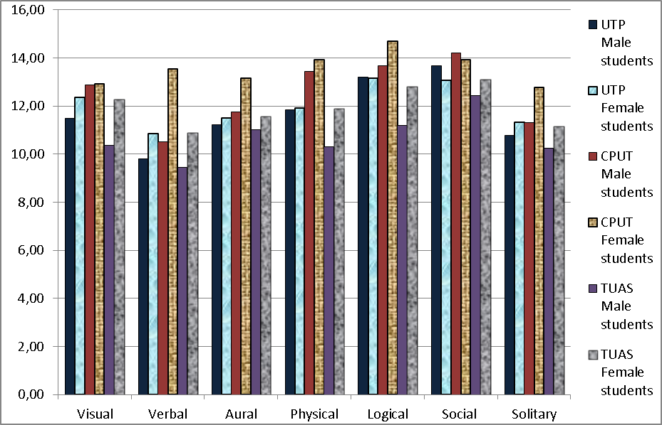
Figure 5: Mean values for UTP, CPUT and TUAS male and female learning styles

4. Discussion and Conclusion

This paper has shown the preferred learning styles amongst the participants from three different parts of the world; UTP in Malaysia, CPUT in South Africa and TUAS in Finland. It was found that the most favored learning styles amongst these engineering and technology undergraduates is social learning style and the least being verbal learning style. Results for UTP and CPUT show exactly the same order of learning preferences; social, logical, physical, visual, aural, solitary and verbal, whilst those from TUAS learning preferences show a close similarity, except that those at TUAS prefer aural to physical. Compared to UTP and TUAS, respondents at CPUT tend to agree much more with the descriptions given in the MSQ. This is attributed to the fact that CPUT recorded higher learning style means compared to UTP and TUAS. Further observation shows that the means for each learning style at TUAS are lower than those of UTP and CPUT. At this point in time, the researchers are of the opinion that perhaps the language used (English) could be a contributing factor. However, further studies could be done to investigate the reason(s) behind this phenomenon. With the exception of aural, there are significant differences in all learning styles where CPUT and TUAS are concerned. For UTP and TUAS, there are significant differences in all, but verbal and aural learning styles. Both UTP and CPUT have a common set of preferred learning styles except for visual, physical and social. For both UTP and CPUT, the only significant difference between male and female respondents is where verbal learning style is concerned, whilst in the case of TUAS, no significant differences between male and female learning preferences are noted.

With social learning style being most preferred and verbal least preferred, it implies that for these engineering students, team-based tasks are favorable. However, expressing themselves in writing and speech, which means written and verbal communication, is least favorable. It seems rather strange that there is a strong preference for teamwork, yet a disfavor for verbal communication. One would think that for teamwork to happen, it would require good verbal communication amongst team members.

For future work, studies could be done to discover the reason(s) for the verbal learning style being the least preferred and how it can be improved. The limitation of this research is that it was done at only three institutions dealing with engineering and technology students. This could be further extended for future work, to other institutions in other parts of the world, perhaps dealing with undergraduates of other programs as well.

5. Acknowledgment
The authors from the three Institutions of Higher Learning would like to extend their appreciation to all the three universities concerned in the study for all the support that have been granted to them in making the study successful in achieving its objective.
References
1. D. Cropley and E. Sitnikova. “Teaching and Learning in Engineering Education: Constructive Alignment,” Proceedings of the 2005 ASEE/AaeE4th Global Colloquium on Engineering Education, 2005.
2. R. M. Felder & L. K. Silverman, ”Learning and Teaching Styles in Engineering Education”, Engr. Education, 78(7), 1988, pp. 674-68.
3. Z. Austin. “Development and Validation of the Pharmicists’ Inventory of Learning Styles (PILS),” American Journal of Pharmaceutical Education, Vol. 68, No. 2, Article 37, 2004, pp.1-8.
4. C. Anson, L. Bernold, C, Crossland, J. Spurlin, M. McDermott and S. Weiss. “Empowerment to Learn in Engineering: Preparation for an Urgently-Needed Paradigm Shift,” Global Journal of Engineering Education, Vol. 7, No. 2, 2003, pp.145-155.
5. R. M. Felder & R. Brent, “Understanding Student Differences”, Journal of Engineering Education, 94 (1), 2005, pp. 57-72.
6. R. M. Felder, “Reaching the Second Tier: Learning and Teaching Styles in College Science Education”,J. College Science Teaching, 23(5), 1993,pp. 286-290.
7. S. Cassidy. “Learning Styles: An Overview of Theories, Models, and Measures,” Educational Psychology, Vol. 24,No. 4, 2004, pp. 421- 444.
8. J. Oulujärvi, “Opi tyylikkäästi – ponnista”, Educode, 1, 2010, pp. 8-9.
9. Z. Khan. 2009. “Differences between Learning Styles in Professional Courses at University Level,” Journal of Social Sciences,Vol.5, No. 3, 2009, pp.236-238.
10. R. Aripin, Z. Mahmood, R. Rohaizad, U. Yeop and M. Anuar. “Students’ Learning Styles and Academic Performance,” 22nd Annual SAS Malaysia Forum, Kuala Lumpur, 2008.
11. H. Pashler, M. McDaniel, D. Rohrer and R. Bjork. “Learning Styles: Concepts and Evidence,” Journal of the Association for Psychological Science”, Vol. 9, No. 3, 2008, pp.105-119.
12. T. Kvan and J. Yunyan. “Students’ Learning Styles and their correlation with Performance in Architectural Design Studio,” Design Studies, Vol. 26, No. 1, 2005.
13. S. Mohamad and A. Mohamad. “An Analysis of Learning Styles of Distance Learners at the Institute of Education Development, UniversitiTeknologi Mara, Malaysia,” ICDE International Conference, New Delhi, 2005.
14. M. Zywno and J. Waalen. “The Effect of Individual Learning Styles on Student Outcomes in Technology-enabled Education,” Global Journal of Engineering Education, Vol.6, No. 1, 2002, pp.35-44.
15. F. Coffield, D. Moseley, E. Hall & K. Ecclestone, “Learning styles and pedagogy in post-16 learning, A systematic and critical review”, Learning and Skills Research Centre, Cromwell Press Ltd, 2004.
16. N. Csapo and R. Hayen. The role of learning styles in the teaching/learning process. Issues in Information Systems, Volume VII, No. 1.
17. C. Dede. “Planning for Neomillenial Learning Styles,” Educause Quarterly, No. 1, 2005.
18. R.M. Felder, G.N. Felder, E.J. Dietz. “The Effects of Personality of Personality Type on
Engineering Student Performance and Attitudes,” Journal of Engineering Education, 91(1), 3–17 (2002).
19. Adapt your learning with Memletics ® Learning Styles Inventory, pp.3© Advanogy.com (2004),available online at http://www.ronniejohnson.info/files/Creative%20Teaching/Memletics-Learning-Styles-inventory.pdf

