A Hands-on Graduate Real-time Control Course:
Development and Experience

Timothy Chang¹ and Daphne Chang²
¹ Department of Electrical & Computer Engineering, New Jersey Institute of Technology
² Counseling Department, Passaic County Community College, NJ

Keywords: Real-time Control, digital signal processor, Myers-Briggs type indicator, computer control

Abstract: In this paper, the development and courseware analysis of a graduate electrical engineering course titled “Real-Time Control Systems Design” are reported. This course comprises of a lecture and laboratory component where the students are expected to transform their theoretical knowledge into a viable team laboratory design and present the results to the entire class. Course contents, digital signal processing system, and some typical experimental results are discussed. This is followed by the use of Myers-Briggs Type Indicator to analyze the noticeable decorrelation between lecture and laboratory performances. A number of recommendations are made to improve the learning environment as well as student assessment criteria.

(I) Introduction
Engineering differs from most other education fields in that the graduates are expected to be able to transform their classroom experience into the industrial environment which requires critical thinking, design abilities, team-work, management skills; in additional to fundamental scientific/engineering knowledge. The definition of a qualified graduate, from the educational institute’s perspective, should reflect the student’s ability to thrive in the industry. Standard classroom evaluation is heavily based on individual paper accomplishments: assignments, quizzes, exams, term projects, etc. While these are effective measures, a serious gap remains in assessing the student’s ability with respect to the abovementioned industrial criteria. Traditionally, graduate engineering education appeals to a focused group of candidates: those who wish to pursue an R&D career. However, with the changes in technological integration, a master's degree is now almost a necessary requirement for professional competitiveness and growth across all electrical engineering (EE) subfields. The influx of “non-traditional students” into the EE Master degree program poses special challenge to the curriculum design and student assessment processes which are further affected by the following conditions:

- EE graduate level courses are theoretically oriented with little or no experimental work.
- Assessment is dominantly based on assignments, examinations, and "paper" projects.
- Thesis is no loner required and most students choose the course-only option.
- Part-time students constitute a majority of the student body.

Over the past decade, many observations and comments about the changing demographics of graduate students, especially at the master's level, have been made. Specifically, it is generally considered that the students are not as "good" as they used to be. However, It has also been observed that the best students, in terms of indicators such as GPA, are not always the ones to excel in their careers.

The central issues facing academic institutions are then:
- How to assess student performance with respect to a broad-spectrum academic/industry benchmark.
- How to provide a learning environment so that the students can realize their full career potential.
- How to improve team-work and communication skills.

This paper discusses the summary analysis of an electrical engineering graduate course titled "Real-time Control Systems". This course has been offered to graduate students from electrical engineering, mechanical engineering, and computer science since 1992. Although control systems have a wide range of engineering applications, e.g. aerospace, chemical, civil & transportation, manufacturing, mechanical, power, etc., graduate level control systems courses are usually presented in a highly mathematical and theoretical manner; thereby filtering out a large population of students who are more experiment oriented. "Real-time Control Systems ", on the other hand, comprises of a theoretical component and an experimental component: the students are required to team-up, design/construct a motion control experiment, and apply control systems theory knowledge from the lectures so as to meet the performance specifications of the experiment. Finally, the students are evaluated on their knowledge of theory (assignments and exams) and experimental projects.

Over the years, a widening decorrelation between theoretical and experimental performances is observed with the class grades resulting in a bimodal distribution.
Preliminary analysis quickly revealed that this decorrelation trend has less to do with gender, ethnicity, or the average GPA of the class. Rather, the trend is a result of a diversifying graduate student body whose profile bears closer resemblance to undergraduate cohorts than to the traditional graduate ones.

In order to further analyze this trend, a number of psychological test instruments have been considered and it was determined that the Myers-Briggs Type Indicator (MBTI) was the most appropriate. A brief discussion of the MBTI is given in Section 3 of this paper.

A number of results describing the role of MBTI in engineering education have been reported. For example, the use of MBTI in curriculum analysis and design was discussed in [1]. In [2] experimental confirmation of the relationship between MBTI, various psychometric factors, and categories of cognitive activities was obtained. MBTI was also used as a part of a profile analysis to predict student performance in a first year chemical engineering course [3]. In [4] the use of MBTI for team formation was discussed.
In [5] a group problem-solving model, based on MBTI, was introduced to address student deficiencies in problem solving skills and teamwork. MBTI was used to predict academic success and subsequent career satisfaction for engineering students in [6]. In [7], the authors used MBTI as part of a student portfolio for biological engineering students to initiate student-centered learning.

(II) Course description
EE664 “Real-time Control Systems” is a multidisciplinary first year graduate level course intended for a broad range of students including those from electrical\computer engineering, mechanical engineering, computer science, and applied physics. As with other electrical engineering graduate courses, real-time control deals with application of theory to real world problems. Although the common approach is classroom dissemination, this course is designed with an experimental component for the following reasons:
- To provide the students with better understanding of the application through hands-on experience.
- To motivate the students by challenging them to compete with each other.
- To improve teamwork and communication skills.

The experiment is free-structured where each team, consisting of two to three students, is given an Airpax DC motor, an LM675 high current operational amplifier, and small machine tools. The goal is to design, build, and control a single link robot arm to rotate a
50 gram load with a radius of 10cm to 90 degrees +/- 1 degree with less than 25% overshoot and in minimum time, while holding the load in that position for at least two minutes. Block diagram of the single link robot arm system is show in Figure 1 whereas the control system block diagram is shown in Figure 2. The students are free to design and implement the hardware platform, sensors, and control software.

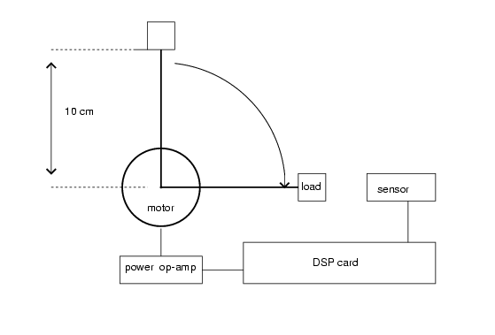
Figure 1: Block Diagram of the Single Link Robot Arm.

Single Link Robot
Dynamics
Sensor(s)
Power
Electronics

TMS320C25
DSP
A/D

D/A

PC

Figure 2: Block Diagram of the Experimental Control Systems

Since its initial offering in 1992, this course has undergone a number of revisions to reach the present format. The initial experiments are standardized kits (DC servomotor/Heat exchanger), which are simple to operate but do not adequately challenge the students. The revised experimental format provides a great deal of technical freedom to the students who are responsible for the design, build, and control of the system. With the same motor and power amplifier, the students compete on a fairly leveled playing field. They are evaluated according to the following

20% Hardware design and build quality
25% Experimentation and data
10% Innovation and creativity
30% Analysis and discussions
10% Presentation and communication skills
5% Documentation

At the end of the semester, each team is allocated a 20 minutes time slot to present their project and an additional 5 minutes for Q&A. Each team member is evaluated separately, although the grades are generally correlated within each team.

The lecture materials are designed to mesh with the experiment. An outline of the course is shown below:

Week Topics

1 Introduction to real-time control systems
2 Architecture of DSP systems: the TMS320C25
3 Programming the C25
4 Properties of sampled data systems, review of Z transform
5 Solutions to matrix difference equations, reachability, observability
6 Pole placement, observer design, and separation principle
7 Mid-term Examination
8 Controller design I: Parameter optimized controllers-PID controllers
9 Controller design II: State controllers-LQR and industrial regulators
10 Controller design III: Feedforward, command shaping, and deadbeat controllers
11 Experimental issues: plant identification, sampling rate selection
12 Implementation and numerical issues: scaling, modular realizations
13 Practical issues: saturation, delay, reset windup
14 Experiment/project presentation, review
15 Final Exam

The lecture grading scheme is based on homework, a mid-term and a final examination.

(III) Myers-Briggs Type Indicator and its applications in engineering education
The MBTI Personality Inventory is based on Jung’s theory indicating how the interactions among the preferences of perception and judgment (mental functions) and attitudes of orientation toward external world would result in 16 distinctive personality types. The MBTI is most often used by educators to identify students’ learning styles and by Student Affairs professionals to provide career guidance and to improve student retention. Management consultants utilize the instrument to develop leadership and group dynamic/ teamwork training among employees.

The MBTI Personality Inventory identifies two opposite preferences for each of the four scales. 1) the EI scale, where does one prefers to focus one’s attention? People who prefer extraversion tend to direct their energy in the outer world, communicate more by talking, like action and variety. People who prefer introversion tend to be the reflective observational learning type, like lecture format. 2) the SN scale, how does one acquire information? Sensing type tends to have concrete experiential learning and/or abstract sequential learning styles with high factual retention. Intuitive type, on the other hand tends to be abstract conceptual learner, high in academic comfort, reflective judgment and likes self directed learning. 3) the TF scale, how does one make decisions or draw conclusions? Thinking types tend to be both abstract conceptual and sequential learner and have a talent for analyzing a problem or situation. Feeling types tend to be concrete experiential learner and/or abstract random learner. 4) the JP scale, how does one orient toward the external world? Those who prefer judging tend to be abstract conceptual learner, like structure and seek motivation in learning, high in fact retention and academic comfort. Those who prefer perceiving are more likely to show concrete experiential learning style, active experiential learning and collaborative learning.
According to [9], the SPs and the SJs each comprise roughly 38 percent of the population in the United States, while the NTs and the NFs comprise 12 percent of the population respectively. In this study sample, there are 6 NTs, 1 NF, 15 SJs and 5 SPs. SJ types (55% of this study) are often labeled as “good student” in academic setting because they valued hard work and demonstrated dependability. They do better in theory class when they can follow outlines and if the teacher pointed out how the theory applies to the real world before class. The research indicates that as long as what they are studying are facts or procedures, they are comfortable. On the other hand, if the SJs are expected to speculate, invent, or improve, they often fail to deliver satisfactory performance despite their studious dependability. SP types (19% of this study, despite its 38% representation in general population) are least represented in higher education and tend to have lowest correlation between academic ability and GPA. This low survival rate at the rigorous academic environment is resulted from their inclinations to search for options and to leave tasks unfinished until the very last minute. NT types (22% of this study) are largely represented in science and engineering fields.

Aforementioned, a successful engineering professional in the twenty-first century requires a commitment for life long learning, quality of teamwork spirit and ability for project management. MBTI typology provides individuals with avenues for self-awareness and possibilities for human growth as well as professional development. On responding to the demand for accountability in higher education and partnerships with business community the graduate engineering programs are compelled to design curriculum that would address these concerns. The MBTI Inventory could be one of the instruments that the educators can adopt to better prepare future engineers with technical skills, knowledge and professional qualities.

Applying the MBTI typology in graduate engineering classes will enable educators to accomplish the following benefits:
- Develop curriculum to support and challenge all types.
- Facilitate the learning process of team project by recognizing individual strengths and introducing the elements of complementary working styles among opposite types.
- Adopt desirable assessments, a holistic approach, that warrants adequate evaluations of student performance.

As for engineering students, they would be made aware of various learning styles and obtain optimum learning outcomes. Furthermore, they are able to develop competencies in the areas that are perceived as their weaknesses. Through the introduction of MBTI typology, the authors hope to instill self-confidence among engineering students and to intentionally challenge students developing those skills that are identified as “inferior”. Last but not least, we think that one of the strategies to address issues on academic persistence and student retention in engineering program is to administer MBTI Inventory early in college education. Any effort in acknowledging individual differences and in providing supports for diverse learning types will definitely enhance academic comfort among at risk students and hence increase college retention.

(IV) Hardware considerations
To encourage innovativeness and sense of responsibility, each team is required to design, build, and integrate the front-end electronics, mechanical system, and the digital signal processing unit. The interface electronics consists of a pre-amp filter for the sensor signal and a power amplifier based on the LM675. Aside from a few occasional grounding errors, the interface electronics task is fairly straightforward and is typically completed within 1-2 weeks. The mechanical system is more challenging since majority of the students do not have machine tool experience. This is especially problematic with some international students who underwent a traditional blackboard curriculum. However, this task is also among of the most beneficial in that the students are exposed to standard engineering prototyping cycle: planning, component selection, design, build, and improvements. The students also learn one important lesson: the mechanical system must be well designed and well built in order to have a consistent, linear model for control system design. The most popular sensor is a precision potentiometer with ball bearings and linear resistance. The second choice is an optical encoder, which has better resolution but requires further digital interface. The motor shaft and sensor alignment as well as the rigidity of the mount are the two most important factors affecting the degree of linearity and time-invariance of the plant. Assembly of the mechanical system takes 4-5 about weeks to complete. Some typical designs are shown in Figure 3 (with top support plate) and Figure 4 (with axial mount). Depending on the type of sensors, the material cost of the mechanical system is around $40.

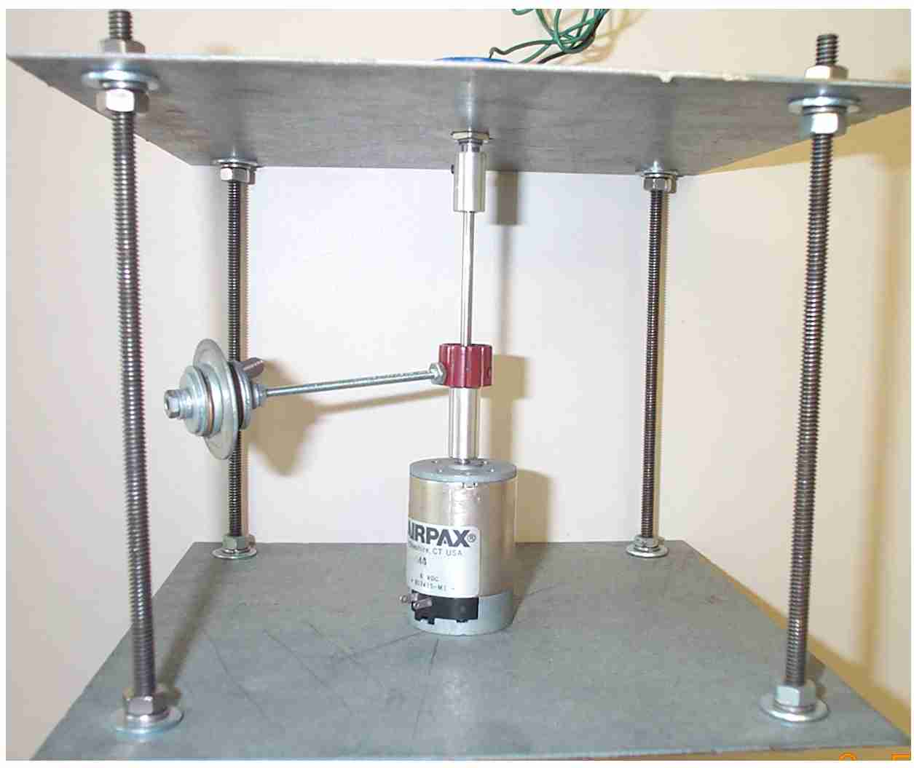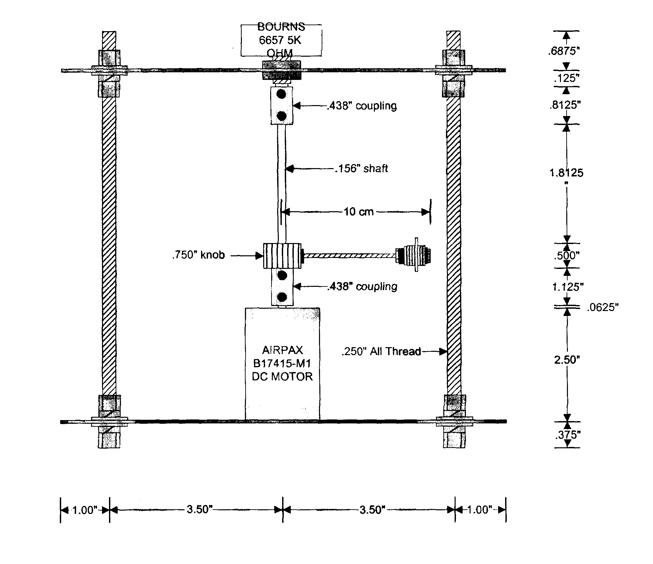
Figure 3: Single link robot mechanical system with top support plate
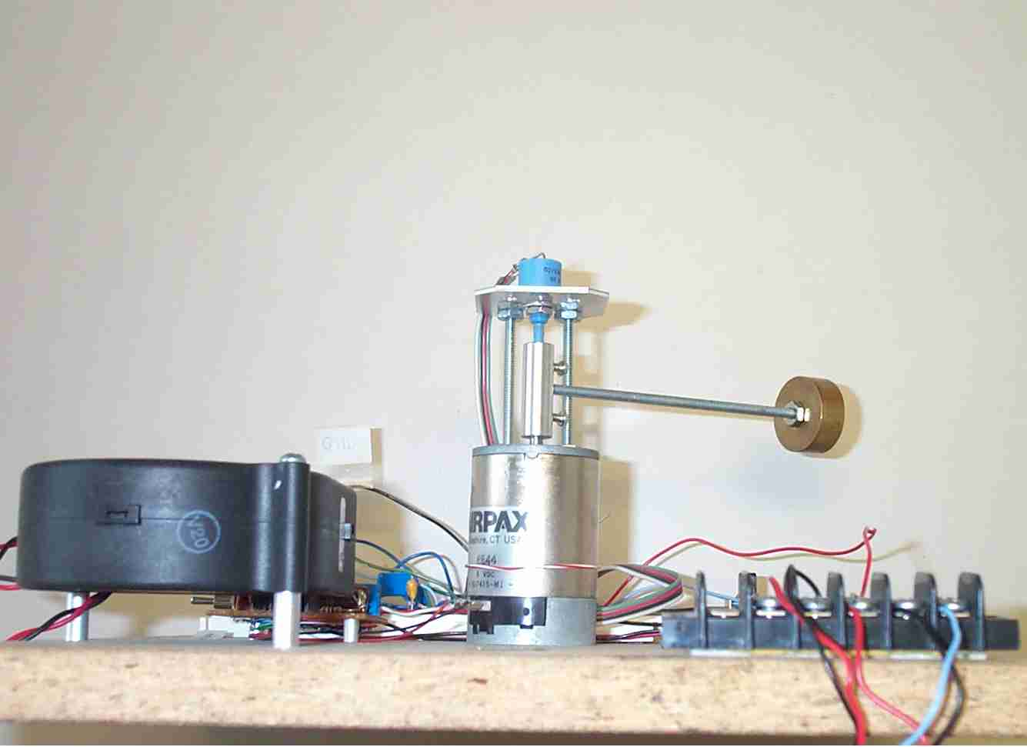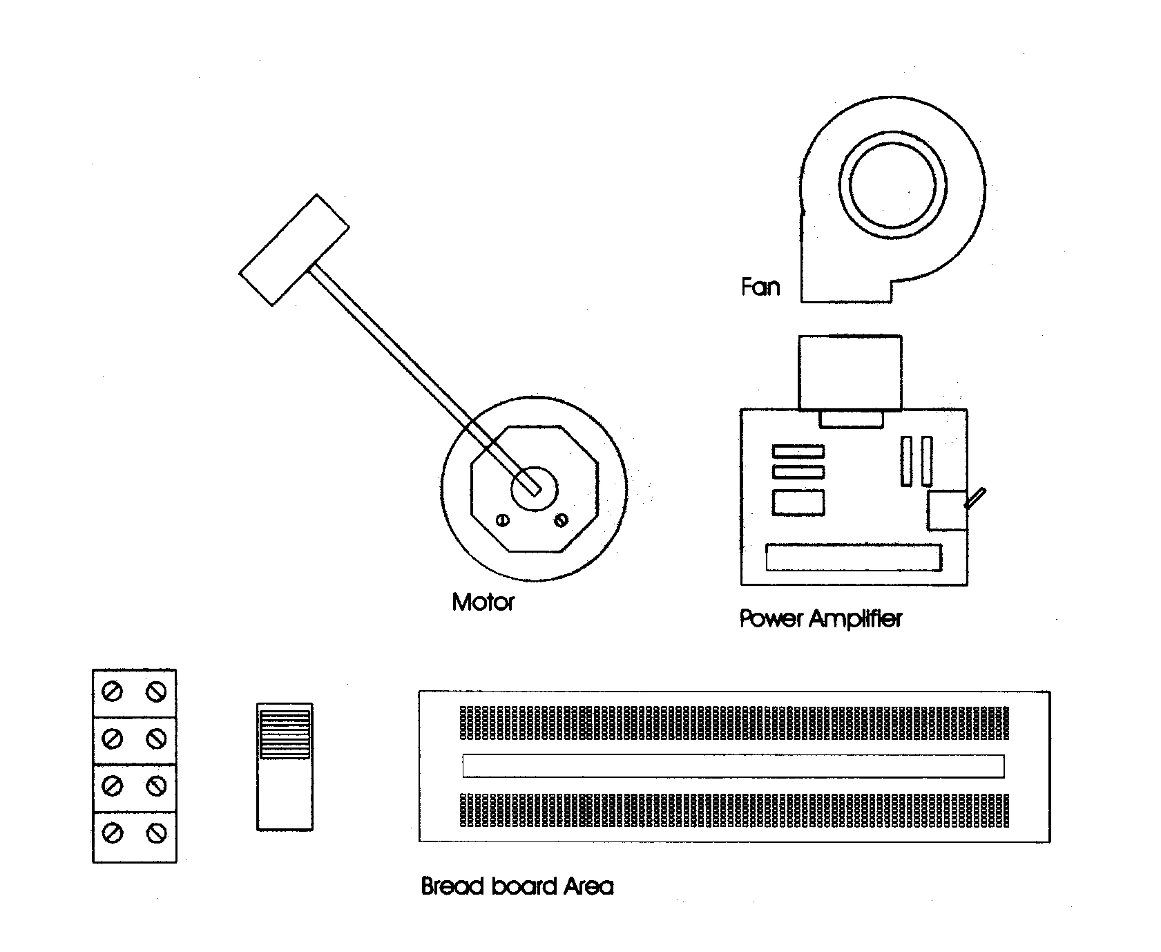
Figure 4: Single link robot mechanical system with axial mount

(V) Software considerations

Software is implemented on the TMS320C25 fixed point digital signal processor. While a floating point processor may be more convenient for code development, the fixed point processor offers a number of pedagogical advantages:

Fixed point DSP architecture is simpler and can be properly covered in 3 lectures

Issues such as word-length, resolution, etc. are more pronounced in fixed point processors and the students are therefore motivated to apply scaling, modular programming, and proper documentation.

The TMS320C25, shown in Figure 5, is a second generation fixed point DSP with a modified Harvard architecture and the following features:
- 80-ns Instruction Cycle Time (50MHz Clock)
- 4K Words of On-Chip Program ROM
- 544 Words of On-Chip RAM
- 128K Words of Total Program/Data
- Vectored interrupt
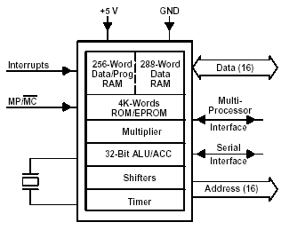
Figure 5: TMS320C25 Architecture

The TMS320C25 is packaged in a Dalanco-Spry Model 250 DSP Board with 128K words of dual ported memory, 16 channel analog inputs and 2 channel analog outputs. Such features are adequate for most mechatronics projects. The software toolkit includes a debugger, an assembler, and a run time library. A typical real-time control program consists of the steps shown in Figure 6. A template assembler program provides the students with the initialization, interrupt jump table, and overall program structure. An on board, 5 MHz, 16-bit counter regulates the analog/digital conversion (sampling) rate. Completion of the conversion triggers an external interrupt (), which is handled by an interrupt service routine (ISR) shown below. In fact, the ISR executes the control codes while the main program is primarily an idle loop.

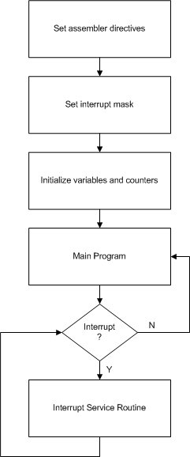
Figure 6: Interrupt service routine based sampled data system

The skeleton code assembler fragment for the interrupt service routine is shown below. This interrupt service routine (ISR) and various house keeping codes are given to the students who are then expected to insert their control algorithms into the ISR.

; interrupt 1 handler
int1_ser:
in temp,ADPort; reads data from A/D converter
; insert user control codes here
out temp,DAPort; outputs the control to D/A converter
; stores data in dual ported memory pointed to by auxiliary register 1
; data length is stored in auxiliary register 0
lac temp
larp 1
sacl *+
larp 0
banz next
done b done
next nop
eint
ret

(VI) Course data and analysis
The students are evaluated by both written tests and experiment performance. This combination is found to be particularly helpful to provide a broad-spectrum assessment of engineering abilities. Furthermore, the need to apply lecture materials to a real experiment and to compete with other groups tends to motivate the students (the so-called “Motivation-by-Challenge” approach).

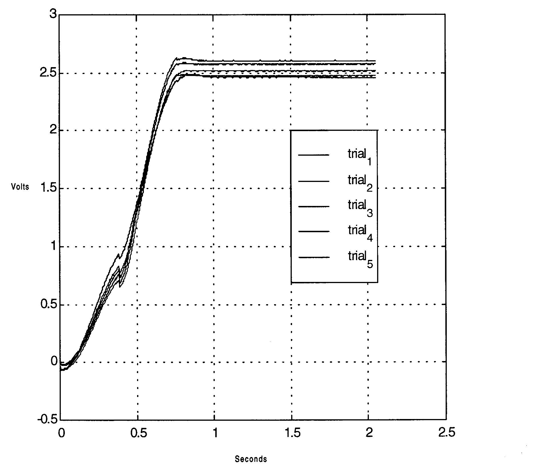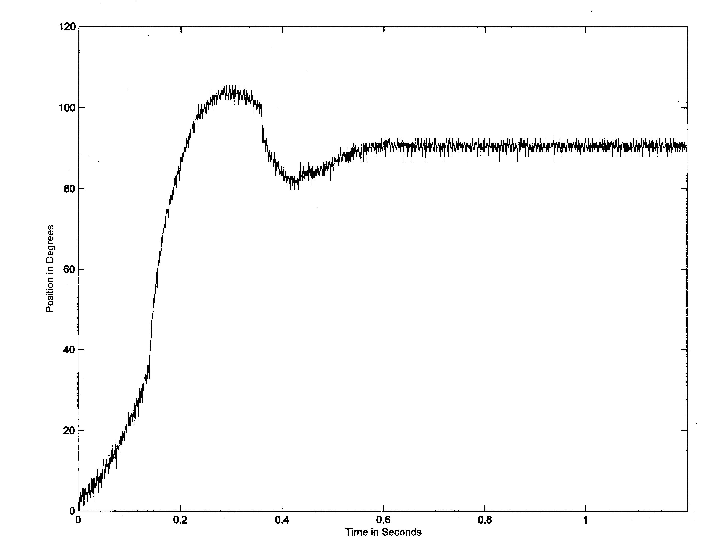
Figure 7: Experimental response: left (good design) and right (bad design)

Two typical experimental responses are shown in Figure 7: the graph on the left is obtained from a group with good hardware/control design whereas the graph on the right resulted from sloppy hardware and software. Since 1992, EE664 Real-time Control Systems is given at every fall semester with environment restricted to 15. For a limited trail, MBTI was administered in two consecutive years to the class (Set1 and Set2) for detailed analysis. Along with the MBTI, other relevant data include: theory grades (based on written tests), experiment grades, and individual GPA.

- MBTI type distribution
The distribution is summarized in Table 1 below where the 16 types are arranged in a 4-by-4 matrix. Three sets of data are listed: CAPT/MBTI, Set1/EE664, and Set2/EE664. CAPT/MBTI represents data from Center for Applications of Psychological Type-MBTI data Bank for undergraduate electrical/electronics engineering students. Set1/EE664 and Set2/EE664 are the data collected from the Set1 and Set2 classes respectively. It is observed the type distributions of the Set1 and Set2 classes correlate well with the CAPT/MBTI data. It is further noted that, for the two classes:

- S_J types constitute the most significant core of the student body (38% for Set1 and 69% for Set2).
- I to E ratio varies from 3.8 for Set1 to 2.1 for Set2.
- The students are dominantly T type.

Table 1. MBTI Distributions
ISTJ  CAPT/MBTI: 17%  Set1/EE664: 18%  Set2/EE664: 31% | ISFJ  CAPT/MBTI: 9%  Set1/EE664: 14%  Set2/EE664: 15% | INFJ  CAPT/MBTI: 2%  Set1/EE664: 0%  Set2/EE664: 0% | INTJ  CAPT/MBTI: 13%  Set1/EE664: 14%  Set2/EE664: 8%
ISTP  CAPT/MBTI: 10%  Set1/EE664: 21%  Set2/EE664: 0% | ISFP  CAPT/MBTI: 2%  Set1/EE664: 0%  Set2/EE664: 0% | INFP  CAPT/MBTI: 6%  Set1/EE664: 7%  Set2/EE664: 0% | INTP  CAPT/MBTI: 6%  Set1/EE664: 7%  Set2/EE664: 15%
ESTP  CAPT/MBTI: 0%  Set1/EE664: 7%  Set2/EE664: 8% | ESFP  CAPT/MBTI: 2%  Set1/EE664: 0%  Set2/EE664: 0% | ENFP  CAPT/MBTI: 7%  Set1/EE664: 0%  Set2/EE664: 0% | ENTP  CAPT/MBTI: 6%  Set1/EE664: 0%  Set2/EE664: 0%
ESTJ  CAPT/MBTI: 9%  Set1/EE664: 14%  Set2/EE664: 15% | ESFJ  CAPT/MBTI: 4%  Set1/EE664: 0%  Set2/EE664: 8% | ENFJ  CAPT/MBTI: 2%  Set1/EE664: 0%  Set2/EE664: 0% | ENTJ  CAPT/MBTI: 7%  Set1/EE664: 0%  Set2/EE664: 0%

- Class data
Four sets of data are compiled: theory grades, experimental grades, combined grades (using a 60-40 weighting for theory and experiment), and cumulative GPA. All scores are normalized to 100%. For the Set1 class, the bar graphs and the composite plots (with GPA) are shown in Figures 8-9. Similarly, for the class of Set2, the bar graphs and the composite plots (with GPA) are shown in Figures 10-11. Plotting the GPA curve along with theory, experimental, and combined curves obtain a visual indication of the correlation of the curves.
For the Set1 class, it is observed that:

- The best theory grades are predominantly scored by SJ types.
- The best experimental grades are mostly scored by the teams with iNtuitive type members.
- The lowest theory grades are scored by P type students while the lowest experimental grades scored by Sensing type students.
- From Figure 4, it is noted that the GPA curve correlates very well with the Theory curve (correlation coefficient = 0.63). On the other hand, the experimental grades correlate poorly with the GPA curve (correlation coefficient =0.1). This is perhaps not surprising since the GPA reflects mostly structured, classroom performance.
- As a result of combining theory grades (60%) and Experiment grades (40%), two “theorists” (ISTP, ISFJ) suffer overall grade reduction (from using theory grades alone) while two N type students obtain grade boost.
- E type students tend to be more visible and vocal in class. However, this stronger classroom participation does not translate into noticeable performance gain in either theory or experiment.

For the Set2 class, similar observations are made:

- Best Theory grades: ESTJ, INTJ, ISFJ ISTJ.
- Best experimental grades: teams with INTP, ISTJ, INTJ members.
- Lowest Theory grades: ESFJ, ESTJ, INTP. Lowest experiment grades: Teams with ISTJ members.
- From Figure 7, correlation between the GPA curve and Theory Curve is high (correlation coefficient 0.74) while correlation with experiment is lower (correlation coefficient=0.48).
- As a result of combining Theory and Experiment grades, one student (ESTJ) suffer from grade reduction while three others (INTP, ESFJ, ESTJ) receive grade boost. It should be mentioned that the INTP student performs the best experiment and therefore receives the biggest boost. The two ES_J students have low grades to begin with and have benefited from the team nature of the experimental work.
- Performance slightly correlates with I type instead of the more “active” E type.

- Discussions and Recommendations
From the above data, it is observed that the two classes exhibit similar characteristics in terms of MBTI distributions, GPA, Theory and Experiment performances. The most notable feature is that Experimental abilities (for free-structure experiments that require innovation and creativity), the N-type students consistently outperform the other types. However, this ability is not reflected in their GPAs since almost all graduate EE courses are theory-based. The S_J type students thrive in a highly structured environment (i.e. good standard classroom performance) but are less apt to doing a “real” engineering project. The P type is more problematic (with respect to the EE curriculum) in that they tend to procrastinate and leave many loose ends. Finally, it is further observed that team with a mix of N type and S_J tend produce the best experimental results as they are complementary to each other.

Even though the statistics in this paper is limited, the consistency of data trend nevertheless warrants the following recommendations:

- Reconsider assessment criteria for Master level EE students. More emphasis should be placed on experimental projects, team-work, and communication skills.
- MBTI should be used in helping students to modify their work habit and to form teams with complementary types.
- Particular attention should be paid to the F and P type students who tend to experience difficulties in EE program.
- Design curriculum and program to accommodate and challenge students of different types.

The experience of this work demonstrates that students benefit from the concept of MBTI typology and perceive the individual differences more in light of working styles than on a personal level. Furthermore, the acknowledgement of one’s strength & weaknesses empowers students to overcome their academic difficulties by focusing on skill building and ultimately to develop competencies required for their engineering profession.
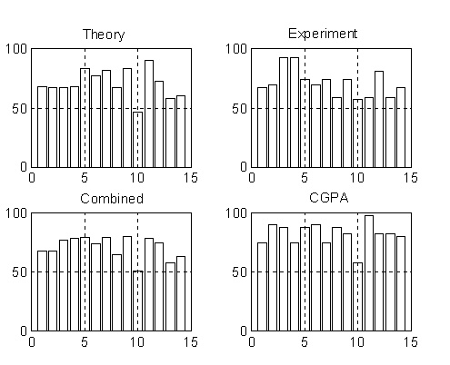

Figure 8: Bar Graph of Set1/EE664 Data

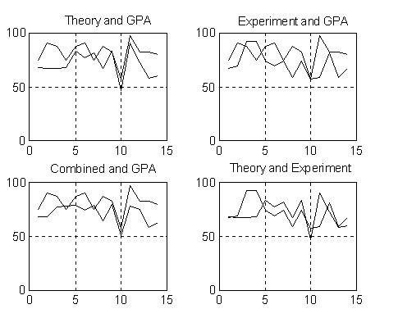

Figure 9: Composite Plot for Set1/EE664 Class

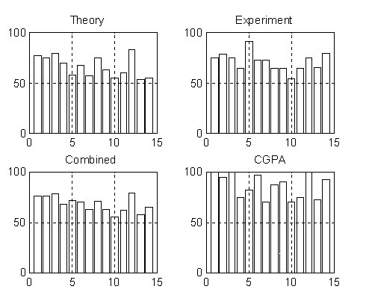

Figure 10: Bar Graph of Set1/EE664 Data

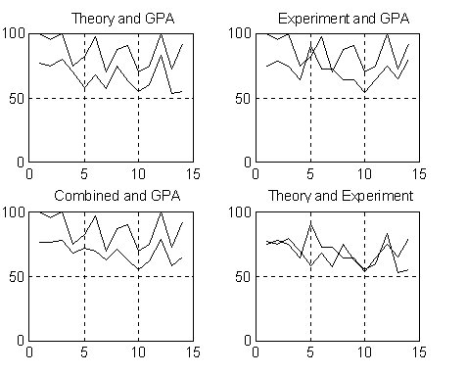

Figure 11: Composite Plots of Set2/EE664 Data

(VII) Conclusions
This paper describes the development and performance assessment for a master level electrical engineering course titled: “Real-time Control Systems”. This course adopts the “motivation-by-challenge” approach by incorporating an experimental design module. This team project has consistently been rated by the students as the best features of the course. However, it is frequently noted that the theory and experiment grades did not correlate well. In order to help analyze this discrepancy, the Myers-Briggs Type Indicator inventory was administered to the class of Set1 and Set2. The results provided an extra analytic dimension and led to the conclusion that personality types/learning styles play an important role in student “performance” in (1) a highly structured classroom environment and (2) a free-structure experimental project. Traditional graduate assessment criteria heavily biased towards the classroom environment so that students with excellent hands-on and creative skills are not evaluated adequately. Given that a master degree is becoming a necessary requirement for practicing engineers, a broad based assessment mechanism that include analytic ability, creativity, hands-on ability, and communication skills should be devised and implemented.

References
[1] Staiger, Eugene H., "Curriculum redesign: psychological factors worth," Frontiers in Education Conference Oct 15-17 1989 1989, pp 140-144.

[2] Carpenter, Raymond A.; Bishu, Ram R.; Riley, Michael W., "User characteristics. Are personality types and psychometric factors good predictors?" Proceedings of the Human Factors Society 34th Annual Meeting - Orlando '90 Oct 8-12 1990, pp 351-355.

[3] Felder, Richard M.; Forrest, Krista D.; Baker-Ward, Lynne; Dietz, E. Jacquelin; Mohr, Phyllis H., "Longitudinal study of engineering student performance and retention: i. success and failure in the introductory course," Journal of Engineering Education v 82 n 1 Jan 1993 pp. 15-21.

[4] Parsons, J. Roger; Klukken, P. Gary, "Introductory design and innovation course at the university of tennessee," Proceedings of the 1995 25th Annual Conference on Frontiers in Education. Part 1 (of 2) Nov 1-4 1995 v1 1995 Atlanta, GA, , USA, pp. 442-444 .

[5] Daigle, R.J.; Doran, Michael V.; Pardue, J. Harold, "Integrating collaborative problem solving throughout the curriculum," Proceedings of the 1996 27th SIGCSE Technical Symposium on Computer Science Education Feb 15-18 1996 1996 Philadelphia, PA, USA, pp. 237-241.

[6] Rosati, Peter, "Students' psychological type and success in different engineering programs," Proceedings of the Set1 27th Annual Conference on Frontiers in Education. Part 2 (of 3) Nov 5-8 Set1 v2 Set1 Pittsburgh, PA, USA, pp. 781-784.
[7] Christy, Ann D.; Lima, Marybeth, "Use of student portfolios in engineering instruction," Journal of Engineering Education v 87 n 2 Apr Set2 ASEE Washington DC, USA, pp. 143-148.

[8] Jensen, Daniel D.; Murphy, Michael D.; Wood, Kristen L, "Evaluation and
refinement of a restructured introduction to engineering design course using student surveys and mbti data," Proceedings Proceedings of the Set2 Annual ASEE Conference Jun 28-Jul 1 Set2 Set2 Seattle, WA, USA, pp 1049-1052.

[9] Keirsey, D.; Bates, M. (1984), “Please Understand Me: Character & Temperament Types”. Del Mar, CA: Prometheus Nemesis Book Company.

