PHYSICS-BASED VIRTUAL MACHINES
DISSEMINATION OF A NEW
MECHANICAL ENGINEERING COURSE

The authors will present a new curriculum funded with a $370,000.00 grant from the US Department of Education. The funding allows the authors to invite participants to SDSU to learn this approach. Funding for these workshops will be provided by the grant.
One author has parlayed this education effort into a research effort and has also been awarded at 300K NSF grant and a $200K DARPA grant. The author will discuss funding opportunities for both education and research at this new intersection between mechanical engineering and computer science.

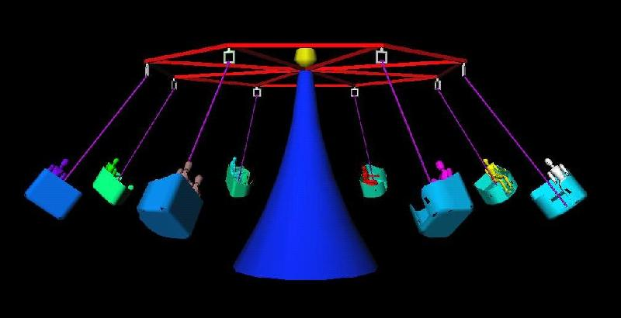

This effort refines, assesses and disseminates a series of new SDSU courses in mechanical engineering. The new courses culminate in a lower division capstone project in which students must write original software to create their own internet-distributed, physics-based virtual machines such as the amusement park ride shown here.
First, students select a real machine from the world around them and reproduce it as 3D CAD model. Selected machines have included all of the following: amusement park rides, machining centers, stress testing machines, cranes/bridges, ski-lifts, diesel trains, a city in an earthquake, mechanics of an opera set, and the biomechanics of an human elbow joint.
Second, students create 3D free body diagrams of their selected machine to demonstrate their understanding of the mechanics that describes the operation of the machine. The figure above shows a free body diagram for one of the cars of the rotor. The diagram relates the angular velocity of the ride and the lift of the cable cars and the analysis produces a descriptive equation. This 3D free body diagram brings mechanics textbook figures to life; more importantly, students created it.
Third, students create the data acquisition control panel for their machine. An example is shown in the figure on the right. LabView enables users to input the material properties of the ride, the weight of the people in each ride, and the angular velocity of the ride. At this point, students have created one CAD model, and three separate computer programs: 1) visualization program, 2) physics program, 3) data-acquisition program. Next, students convert the physics program into a generalized physics server, using the standard socket libraries as an interface to the network transmission control protocols that drive the Internet. This server initiates the basic calls to open a socket and receive connections over the Internet from the two client programs: the visualization client (3D VR CAD model) and the data-acquisition client (LabView).

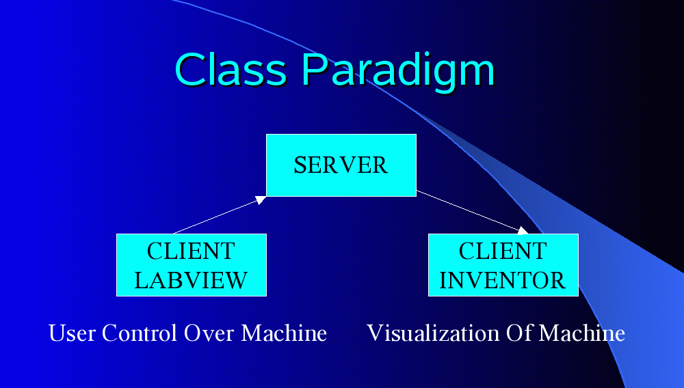

The three codes (visualization, physics, data acquisition) can be run from different locations. There is a reason the codes are split like this: it fosters student-to-student collaboration. Students are compelled to distinguish between the nature of input and output data. Students group similar data (i.e.: geometric properties vs. boundary conditions vs. material properties) in organized data frames for efficient transmission. Students are more motivated to communicate with each other and agree on the protocols of data transmission. A key-motivating factor in the success of this curriculum is its experiential nature and the fact that students learn the principles of mechanics and computer controlled machines, by writing their own simulation software, rather than by using commercial simulation software written by others.
The authors hope to present a paper, and a poster session and provide the hardware to put on a demonstration.

