Haptics-Augmented Undergraduate Engineering Education

Robert L. Williams II, Xingxi He, Teresa Franklin, and Shuyan Wang
williar4@ohio.edu
Ohio University

Abstract ⎯ We have developed a unique set of software activities and tutorials to augment teaching and learning in standard required undergraduate engineering courses. With our products students are able to change parameters, predict answers and compare, interact with animations, and feel the results. Two sample software interaction screens are given in the figures below. This is possible via economical haptic interfaces, giving forces to the user’s hand from our virtual PC activities. Teaching and learning can be more compelling, fun, and engaging, with deeper learning: “feeling is believing”; reduced student attrition may result, including those underrepresented in engineering. In a proof-of-concept project funded by NSF, we developed haptics-augmented educational software products for physics, statics, and dynamics. Our software design evaluations at Ohio University have shown potential for our products to enhance undergraduate engineering courses by adding force feedback and the human sense of touch to learning. This paper describes our project, along with our educational philosophy, followed by a description of our haptics-augmented undergraduate engineering educational products and software design evaluations with students enrolled in target courses at Ohio University.

Index Terms ⎯ engineering mechanics education, haptics, haptic interface, haptics-augmented education

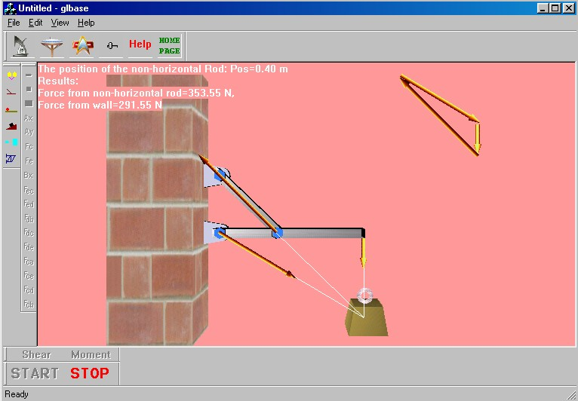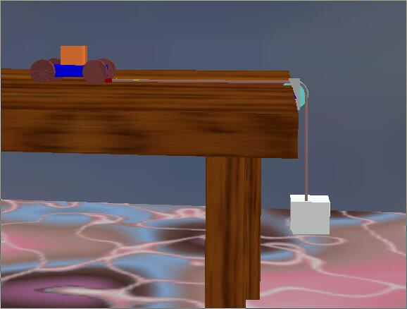
Three-Force Member (Concurrent Forces) Newton’s Second Law

