Low-Cost Interfaces for Learning Programming

Anjali Kulkarni, Center for Mechatronics, IIT Kanpur, anjalik@iitk.ac.in
Sarala Verma, Centre for Mechatronics, IIT Kanpur, saralav@iitk.ac.in
Rituraj Singh, Eectrical Engineering Dept., IIT Kanpur, rituraj@iitk.ac.in
Abhaya Agarwal, Computer Science and Engineering Dept., IIT Kanpur, abhayag@iitk.ac.in
Amitabha Mukerjee, Computer Science and Engineering Dept., IIT Kanpur, amit@iitk.ac.in

ABSTRACT ⎯This work describes an effort to introduce hands-on learning in schools. Generally for learning programming, computers are needed. However access to computers at school level is limited. This work emphasizes the development of low cost interfaces for learning programming without the use of otherwise expensive computers. In this context, we are working in the "Build Robots Create Science" (BriCS) program to introduce tools that can be interfaced easily with computers to provide school children with a tangible programming experience. In this paper, we describe three tools that are being used for this purpose, two of which do not require computers.
A. P-Blocks: These are a set of stackable blocks containing simple low-cost electronic devices. Each block represents a particular command and a flowchart of a program is implemented by physical stacking of these block .These blocks can be used to control any motorized device. Block functions include Move Forward, Move Backward,Turn Left, Turn Right, IF Sensor etc which take care of motor direction, duration and light and touch sensor modules.
B. PrISM (Programmable Interface for Sensors and Motors): This implements a simple set of programming constructs on a set of keys.
C. A programming GUI providing visual programming interfaces as well as direct Java coding.
As an example, consider the program to move a mobile robot in a square path:
It can be implemented in P-Blocks as the stack built with physical blocks performing following functions.
- Repeat Start four times
- Move forward for 1.5 secs.
- Turn Left for 3.5 secs.
- Repeat end
Stacked on a bigger base bloc containing motor driver and controller block as shown in Figure 1.

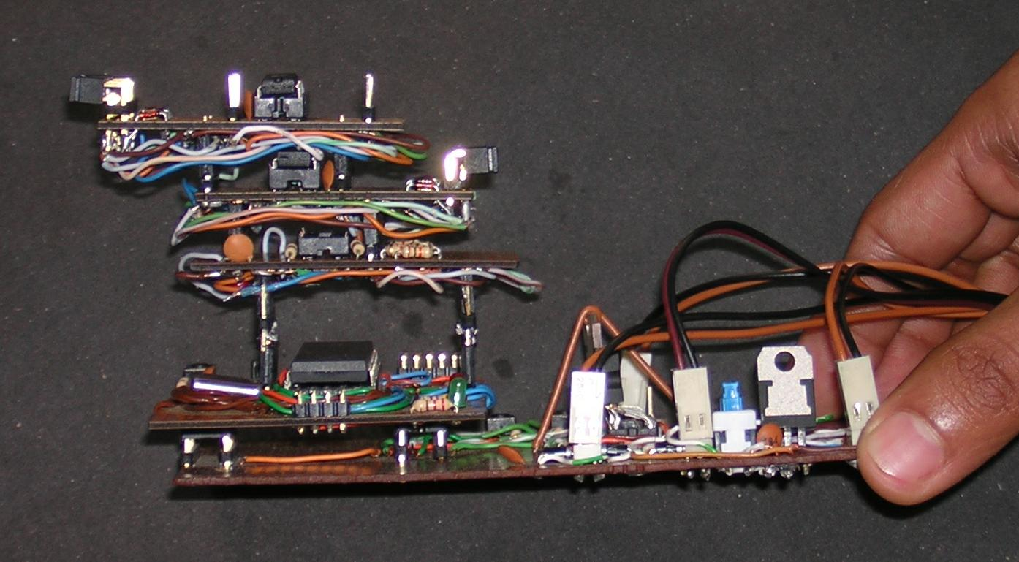

Figure 1. Stack of programmable blocks to move a robot in a square path.

The same program can also be implemented on PrISM as the following set of keystrokes:

START PROG
FOR 04 ((MB -> 10)(M1 -> 03))
STOP PROG
And written in the scripting language with GUI that we are developing will look like
{
M{1,3};
}
main{
while(){
M{1,3} power 2;
M{1,3} on 1000;
M{1,3} off;
M{1,3} power 2;
M{1,3} dir {CLK,ACLK}
M{1,3} on 1000;
M{1,3} off;
}

We describe our experiences in deploying these tools in a number of schools.
Index Terms⎯Educational tool, Hands on learning, PrISM, Programming block, Scripting language GUI

