Cooperative Distance-Education Paradigm for a Networked Application Course

Authors:

Jiann-Liang Chen, Department of Computer Science, National Dong Hwa University, Huailen, Taiwan Lchen@mail.ndhu.edu.tw
Ren-Hung Hwang, Department of Communications Engineering, National Chung-Cheng University, Chyayi, Taiwan rhhwang@cs.ccu.edu.tw

Abstract

Internet technologies recently have developed extremely fast. The development of WWW applications has increased the accessibility of the Internet. New information and communication technologies are developing and playing a growing role in engineering education. Based on these technologies and new teaching methodologies, this study designed a cooperative distance-education paradigm for engineering education. From the team teaching perspective, classroom teachers collaborate on distance teaching with other teacher-librarians simultaneously in different scenes. Each teacher in this teaching team can hear /present critical information to learners and other teachers. Three modules are designed in this paradigm, namely: web-oriented curriculum, SCORM-based e-book and Access Grid cooperative distance-education (see Fig. 1).

In the web-oriented curriculum module, a curriculum website was designed and reposed on several teaching resources, including teaching materials, teaching programs, and experimental handouts (see Fig. 2). Teachers and students can obtain the teaching/learning guidelines from the website in advance. Implementing this module will produce an interface for web-based distance education that is innovative in terms of student characteristics and teaching/learning process evaluation.

To provide ubiquitous learning environments, this paradigm included an e-book module based on the learning technology standards, SCORM (Sharable Content Object Reference Model), which provides a standardized communication interface between the LMS (Learning Management System) and learning content (courseware) for tracking learner profile and supporting the reusability of learning objects. Based on the wireless communication and Bluetooth technologies, we also make teaching materials and resources accessible to mobile learners at anytime, anywhere.

The cooperative distance-education module integrates distributed resources from different networks/sites into a shared platform where learners can easily fulfill cooperative learning (see Fig. 3). Access Grid technology provides interactive network services and supports multimedia applications via a high-speed backbone network. Because it comprises communication systems linking individual clients with servers, Access Grid technology eliminates the limitations of traditional distance-learning operations. Constructing a cooperative learning network using the Access Grid system is more flexible, scalable and economical than when using the existing system. Every Access Grid node can select which of the videos of the other nodes they wish to view and then project them onto the wall. Access Grid Systems communicate with one another on IP-based networks, thus reducing the expenses associated with least-line connection and equipments.

This cooperative distance-education paradigm establishes the Access Grid node at every participating university by installing the Access Grid via a room node, desktop computer, or notebook. The Access Grid requires the IP-based (or application-based) multicast support and an authorized server. Every university in the system can enter the venues built into the Access Grid server node and share the video, audio and text. To examine the feasibility of the cooperative distance-education paradigm, a novel course, next-generation networked multimedia application (the curriculum website: http://134.208.27.212/internet), is taught at three Taiwanese universities (see Fig. 4). Each teacher in the teaching team is responsible for teaching particular technologies and specific skills from one of the topics/chapters in the courseware which were collaboratively designed in last year (2003). From the trial teaching results, the Average grade of the learners exceeds that of learners in traditional pedagogy and traditional distance-learning (one teacher-to-whole-class methodology) at 5% and 3%, respectively. Furthermore, the learning efficiency using the proposed approach is around 5% higher than for traditional methods. The author thus believes that the cooperative distance-education paradigm can improve the educational quality by sharing teacher expertise and promoting better learning.

Keywords: Cooperative Distance-Education, Access Grid, E-learning, E-book, SCORM

References
[1] R.C. Schank, Designing World-Class E-Learning, McGraw Hill, 2002.
[2] L. MacLaren, “NewTrend in Web-based Learning: Objects, Repositories and Learner Engagement,” European Journal of Engineering Education, Vol.29, No.1, pp.65-71, 2004.
[3] O. Bohl, J. Scheuhase, R. Sengler and U. Winand, “The Sharable Content Object Reference Model (SCORM)- a Critical Review,” Proceedings of International Conference on Computers in Education, pp.950-951, 2002.
[4] D.P. Siewiorek, S. Finger and A. Smailagic, “Team-based Design: Collaborative Learning across Time and Space,” Proceedings of the 7th International Conference on Computer Supported Cooperative Work in Design, pp.25-27, 2002.
[5] F.C. Berry, P.S. Dipiazza and S.L. Sauer, “The Future of Electrical and Computer Engineering Education,” IEEE Transactions on Education, Vol.46, No.4, pp.467-476, 2003.
[6] V.B. Devedzic, “Key Issues in Next-Generation Web-based Education,” IEEE Transactions on Systems, Man and Cybernetics, Part C, Vol.33, No.3, pp.339-349, Aug. 2003.
[7] S. Kariya, “Online Education Expands and Evolves,” IEEE Spectrum, Vol.40, No.5, pp.49-51, May 2003.
[8] F.A. Dorca, C.R. Lopes and M.A. Fernandes, “A Multiagent Architecture for Distance Education Systems,” Proceedings of the 3rd IEEE International Conference on Advanced Learning Technologies, pp.368-369, July 2003.

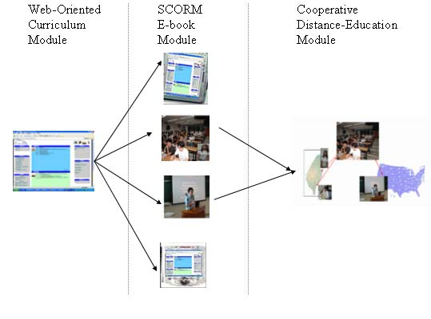
Figure 1: Three Modules Of Cooperative Distance-Education Paradigm

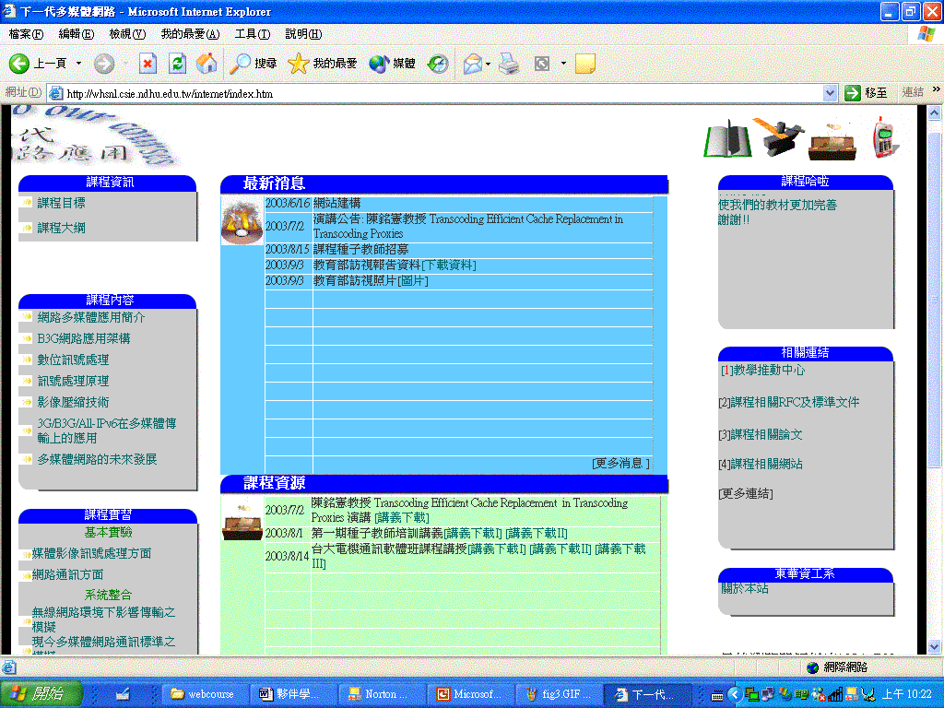
Figure 2: Web-Oriented Curriculum

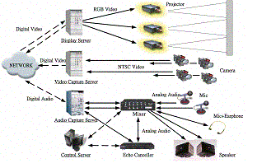
Figure 3: Access Grid Cooperative Distance-Learning Module

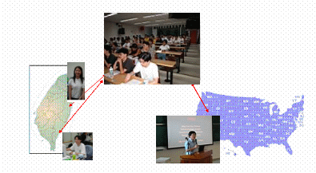
Figure 4: Trial Teaching

