Advanced Test Reactor National Scientific User Facility
¹F. M. Marshall, ²T. R. Allen, ³J. B. Benson, ⁴M. C. Thelen

¹Idaho National Laboratory, Idaho Falls, ID, USA, Frances.Marshall@inl.gov
²University of Wisconsin, Madison, WI, USA, allen@engr.wisc.edu
³Idaho National Laboratory, Idaho Falls, ID, USA, Jeff.Benson@inl.gov
⁴Idaho National Laboratory, Idaho Falls, ID, USA, Mary.Thelen@inl.gov

Abstract
The Advanced Test Reactor (ATR), at the Idaho National Laboratory (INL), is a large test reactor for providing the capability for studying the effects of intense neutron and gamma radiation on reactor materials and fuels. The ATR is a pressurized, light-water, high flux test reactor with a maximum operating power of 250 MW_{th}. The INL also has several hot cells and other laboratories in which irradiated material can be examined to study material irradiation effects. In 2007 the US Department of Energy (DOE) designated the ATR as a National Scientific User Facility (NSUF) to facilitate greater access to the ATR and the associated INL laboratories for material testing research by a broader user community. This paper highlights the ATR NSUF research program and the associated educational initiatives.

1.0 Introduction

In 2007, the Advanced Test Reactor (ATR), located at Idaho National Laboratory (INL), was designated by the U. S. Department of Energy (DOE) as a National Scientific User Facility (NSUF). This designation made test space within the ATR and post-irradiation examination (PIE) equipment at INL available for use by approved researchers via a proposal and peer review process. The goal of the ATR NSUF is to provide those researchers with the best ideas access to the most advanced test capability, regardless of the proposer’s physical location.

Goals of the ATR NSUF are to define the cutting edge of nuclear technology research in high temperature and radiation environments, contribute to improved industry performance of current and future light water reactors, and stimulate cooperative research between user groups conducting basic and applied research. As part of meeting each of these three goals, the ATR NSUF has developed a broad educational program aimed at increasing the number of researchers knowledgeable about reactor experimentation, post irradiation examination techniques, and material radiation effect fundamentals. The educational program also includes a wide variety of internship opportunities, faculty/student research team projects, partnerships with other DOE laboratory and university experimental facilities, annual User Week, which includes several seminars on ATR and partner facility research, collaborative experiment projects, graduate research fellowships, and opportunities for postdoctoral researchers and visiting scientists.

Since 2007, the ATR NSUF has expanded its reactor test space, obtained access to additional PIE equipment, taken steps to ensure the most advanced post-irradiation analysis possible, and initiated an educational program and digital learning library to help potential users better understand the critical issues in reactor technology and how a test reactor facility could be used to address this critical research. This article describes these expanded capabilities and services so that researchers can take full advantage of this national resource.

Recognizing that INL may not have all the desired PIE equipment, or that some equipment may become oversubscribed, the ATR NSUF established a Partnership Program. This program invited universities to nominate their capability to become part of a broader user facility. Several universities and one national laboratory have been added to the ATR NSUF with capability that includes reactor-testing space, PIE equipment, and ion beam irradiation facilities.

2.0 Facility Capability Summary

Several facilities are available for the ATR NSUF user community. Some of these are at the INL and many more are available through the ATR NSUF partnership program.

2.1 Advanced Test Reactor

The ATR was designed to optimize fuel and material testing for the Navy’s nuclear propulsion program. It began operation in 1967, and has operated continuously since then, averaging about 250 operating days per year. Irradiation of material and fuel in the ATR can simulate many years of prototypical operation in a few months or years of testing. This capability is valuable for testing materials and fuels in support of light water reactors (LWRs) and more advanced reactor designs. Unlike U.S. commercial LWRs, the ATR has no established lifetime or shutdown date. all core internal components are removed and replaced every eight to ten years during a core internals changeout outage, which typically takes about six months.

The ATR is a pressurized, light-water moderated and cooled, beryllium-reflected, enriched uranium fueled reactor with a maximum operating power of 250 MW_{th}. The ATR core cross section, shown in Figure 1, consists of 40 curved aluminum plate fuel elements configured in a serpentine arrangement around a three-by-three array of large irradiation locations in the core or flux traps, where the peak thermal flux can reach 1.0 × 10¹⁵ n/cm²-sec, and peak fast flux (E>1.0 MeV) 5x10¹⁴ n/cm²-sec. This core configuration creates five main reactor power lobes (regions) that can be operated at different powers during the same operating cycle. Along with the nine flux traps, there are 68 irradiation test positions ranging in diameter from 1.27 to 12.7 cm and all 122 cm long, and the irradiation tanks outside the core reflector tank have 34 low-flux irradiation positions.

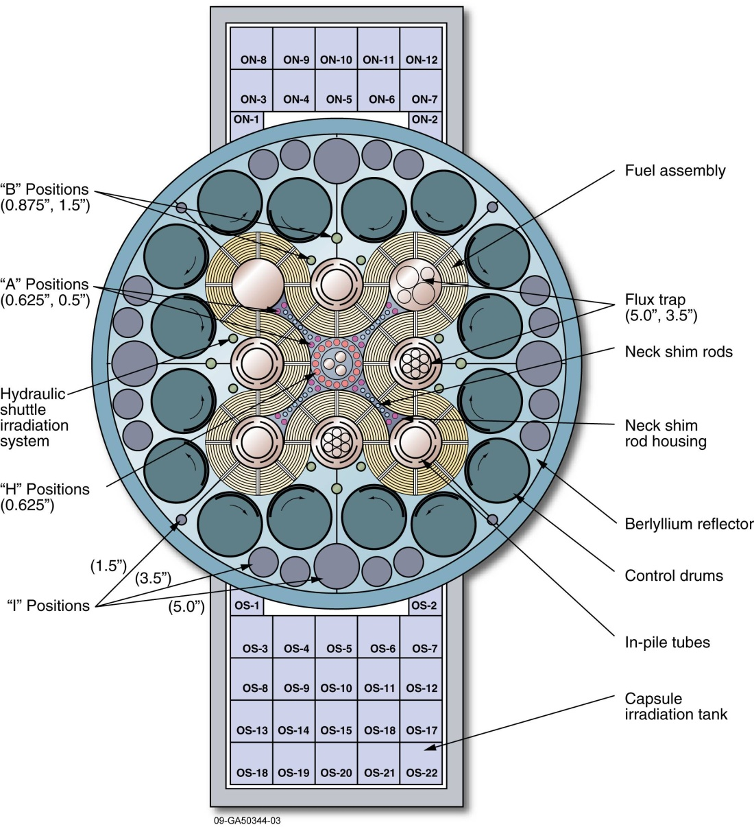
Figure 1. ATR core cross section.

General design information and operating characteristics for the ATR are presented in Table 1. The ATR can be operated with large power variations among its nine flux traps using a combination of control cylinders (drums) and neck shim rods. The beryllium control cylinders contain hafnium plates that can be rotated toward and away from the core, allowing for a symmetrical axial flux and eliminating axial variability among experiment specimens. This minimizes axial flux variations for experimenters.

Table 1. ATR design and operating data.
Reactor
Thermal Power (Maximum Design Power) | 250 MW_{th}
Power Density | 1.0 MW/L
Maximum Thermal Neutron Flux | 1.0 x10¹⁵ n/cm²-sec
Maximum Fast Flux | 5.0 x10¹⁴ n/cm²-sec
Primary Coolant System
Design Pressure | 390 psig (2.7 MPa)
Design Temperature | 240°F (115°C)
Maximum Coolant Flow Rate | 49,000 gpm (3.09 m³/sec)
Coolant Temperature (Operating) | <125°F (52°C) inlet  <160°F (71°C) outlet

There are three primary experiment configurations in the ATR - static capsule, instrumented lead, and pressurized water loop. Experiments must remain in the ATR for the entire duration of the operating cycle (average length of 49 days), except for experiments performed in the Hydraulic Shuttle Irradiation System (HSIS). The HSIS enables small volume, short duration, irradiations to be performed in the ATR, and can include up to 14 small shuttle capsules in a single shuttle operation.

The ATR building also houses the ATR Critical (ATRC) facility, which a full-size replica of the ATR, but operates at low power (5 kW maximum). It is used to evaluate an experiment’s potential impact on the ATR core, by measuring experiment control rod worths, reactivities, thermal and fast neutron distributions, gamma heat generation rates, and void/temperature reactivity coefficients before inserting an experiment into the ATR.

2.1.1 Static Capsule Experiments

static capsule experiments consist of tubing filled with material to be irradiated that is placed in the ATR. A test may consist of a single long capsule or a series of shorter capsules stacked on top of each other. Experiment materials that can come in contact with ATR primary coolant system (PCS) can be configured so the capsule is exposed to and cooled by the ATR primary coolant system. An example of this configuration is fuel plate testing in which the material contacting with the PCS is the same material as ATR fuel element cladding.

Static capsules have no instrumentation, but can include flux-monitor wires and temperature melt wires for examination following irradiation. Limited temperature controls can be designed into the capsule using an insulating gas gap between the test specimen and the outside capsule wall. The size of the gap is determined by analyzing the experiment temperature requirements. An appropriate insulating or conducting gas is then sealed into the capsule.

2.1.2 Instrumented Lead Experiments

Some experiments need specialized environments, such as an oxidized cover gas, or temperature control. A fueled experiment, for example, may need to be tested for fission gases, which could indicate a failure of the experiment specimen. The instrumented lead experiment establishes and monitors precise environmental conditions, thereby ensuring that the experiment’s data objectives are met. Temperatures can be controlled between 250-1200°C, within +/- 5°C. Instrumented lead experiments allow the experiment parameters to be displayed in real time on an operator control panel. Instruments can also be configured to alert operators and experimenters, if the experiment parameters exceed test limits. Instrumented lead experiments also have the capability of recording and archiving data for any monitored experiment parameter; data is typically saved for six months.

2.1.3 Pressurized Water Loop Experiments

Pressurized water loop experiments can be placed in ATR flux traps that have in-pile tubes. These in-pile tubes provide a barrier between the ATR PCS and a secondary pressurized water loop coolant system so that pressurized water loop experiments are isolated from the ATR PCS. The secondary cooling system uses pumps, coolers, ion exchangers, and heaters to control experiment temperature, pressure, chemistry, and flow. All of the secondary loop parameters are continuously monitored, and controlled to ensure precise testing conditions.

Loop tests can precisely represent conditions in a commercial pressurized water reactor. Operator control display stations for each loop continuously display information, which can be monitored by the ATR staff. Test sponsors receive preliminary irradiation data before the irradiations are completed, so there are opportunities to modify testing conditions if needed. The data from the experiment instruments are collected and archived similar to the data in the instrumented lead experiments.

2.2 Post-Irradiation Examination Capabilities

Post-irradiation examination (PIE) capabilities are available to ATR NSUF users at numerous facilities at the INL, including the Hot Fuel Examination Facility (HFEF), Analytical Laboratory (AL), Electron Microscopy Laboratory (EML), and Fuels and Applied Science Building (FASB). These facilities house equipment and processes used for nondestructive examination, sample preparation, chemical, isotope, and radiological analysis, mechanical and thermal property examination, and microstructure property analysis. Figure 2 is a photograph of the interior of the HFEF.

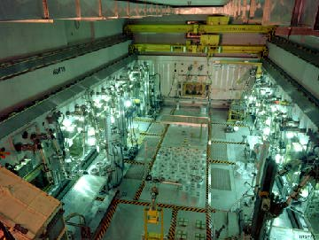
Figure 2. Hot Fuel Examination Facility.

2.2.1 Nondestructive Examinations

Nondestructive examination activities are available at the HFEF. Capabilities include neutron radiography using 250 kW TRIGA reactor, with two beam tubes and two separate radiography stations, precision gamma, dimensional inspections using a continuous contact profilometer, element/capsule bow and length examinations to measure distortion (bow) and length of fuel elements, visual exams, eddy current examinations to measures material defects, and high precision specific gravity measurements using pycnometer and immersion scales.

2.2.2 Sample Preparation

Samples preparation capabilities include solid metallography, which consists of sectioning and cutting, mounting into metallographic bases, and grinding and polishing processes and equipment, and gas sampling using laser puncture and gas collection processes.

2.2.3 Chemical, Isotopic, and Radiological Analysis

Chemical, isotopic, and radiological analysis of irradiated fuel and material meeting National Institute of Standards and Technology traceability standards capabilities include inductively coupled plasma mass spectrometry with dynamic reaction cell, inductively coupled plasma atomic emission spectroscopy, atomic absorption analysis, thermal ionization mass spectrometry, gas mass analysis, isotope mass separator, gross and isotopic radiological analysis, gross alpha/beta analysis, alpha, beta, and gamma spectroscopy analysis.

2.2.4 Mechanical Property Examination

Mechanical property examination activities are available for high radiation samples in the EML, HFEF Main Cell, and the lower-dose, contact-handled FASB. Capabilities include metallography, microhardness testing, tensile testing, and shear punch testing.

2.2.5 Thermal Property Examinations

Thermal property examination instruments and processes are available at the INL Materials and Fuels Complex. Capabilities include: thermal diffusivity (laser flash method and scanning diffusivity analysis), differential scanning calorimitry, and high temperature furnace for accident testing of high temperature gas-cooled reactor fuel.

2.2.6 Microstructure Property Analysis

State-of-the-art microstructure property analysis instruments capable of micro and nanoscale characterization are available at INL. Capabilities include scanning transmission electron microscope (STEM) with energy dispersive x-ray spectrometer, scanning electron microscope (SEM) with energy dispersive and wavelength dispersive x-ray spectrometers and electron back scatter diffraction detector, field emission gun (FEG) SEM, dual beam focused ion beam (FIB) that enables site specific sectioning of materials for 3D analysis or high resolution, TEM characterization, shielded electron microprobe to analyze elements from Be through Cm with full matrix correction, including fission gases on samples, and x-ray diffractometer to perform microscale phase identification, small-sample powder diffraction, and texture determination.

2.2.7 Instruments in the Center for Advanced Energy Studies (CAES)

the CAES facility located in Idaho Falls, supports the partnerships between INL and universities. It houses a newly installed nanoindenter, atomic force microscope, FIB, FEG-STEM, and local electron atom probe for characterization of low-level radioactive materials.

2.3 University Partner Capabilities

In addition to the capabilities of the INL facilities, the ATR NSUF has facilitated access to the facilities described below for the ATR NSUF user community.

2.3.1 Massachusetts Institute of Technology (MIT) Reactor

The MIT reactor is a 5 MW_{th} tank-type research reactor. It has three positions available for in-core fuel and materials experiments for water loops at pressurized water reactor/boiling water reactor conditions, high-temperature gas reactor environments at temperatures up to 1400°C and fuel tests at LWR temperatures have been operated and custom conditions can also be provided. Fast and thermal neutron fluxes are up to 1x10¹⁴ and 5x10¹⁴ n/cm²–s, respectively.

2.3.2 North Carolina State University (NCSU) PULSTAR Reactor

The PULSTAR reactor is a 1 MW_{th} research reactor, fueled by uranium dioxide pellets in zircaloy cladding. The fuel provides response characteristics that are similar to commercial LWRs, which allows teaching experiments to measure moderator temperature, power reactivity coefficients, and doppler feedback. In 2007, the PULSTAR reactor produced the most intense low-energy positron beam with the highest positron rate of any comparable facility worldwide.

2.3.3 Nuclear Services Laboratories.

Nuclear Services laboratories at North Carolina State University (NC-State) offer neutron activation analysis, radiography, imaging, and positron spectrometry capabilities.

2.3.4 Irradiated Materials Complex (IMC) at University of Michigan (UM)

The UM IMC Complex houses laboratories and hot cells for conducting high-temperature mechanical property, corrosion and stress corrosion cracking experiments on neutron irradiated materials in an aqueous environment and for characterizing fracture surfaces after failure.

2.3.5 Harry Reid Center Radiochemistry Laboratories.

The Radiochemistry Laboratories at University of Nevada, Las Vegas (UNLV) offer metallographic microscopy, x-ray powder diffraction, Rietveld analysis, SEM and STEM, electron probe microanalysis, and x-ray fluorescence spectrometry.

2.3.6 Characterization Laboratory for Irradiated Materials.

The Characterization Laboratory for Irradiated Materials at the University of Wisconsin–Madison (UW-M) SEM and STEM on neutron-irradiated materials.

2.3.7 Michigan Ion Beam Laboratory.

The 1.7 MV Tandetron accelerator in the Michigan Ion Beam Laboratory at the University of Michigan (U-M) offers controlled temperature proton irradiation capabilities with energies up to 3.4 MeV as well as heavy ion irradiation.

2.3.8 Tandem Accelerator Ion Beam

A 1.7 MV terminal voltage tandem ion accelerator at UW-M features dual ion sources for producing negative ions with a sputtering source or using a radio frequency plasma source. The analysis beamline is capable of elastic recoil detection and nuclear reaction analysis.

2.3.9 Illinois Institute of Technology (IIT) Beamline

The MRCAT beamline at Argonne National Laboratory’s Advanced Photon Source (APS) offers synchrotron radiation experiment capabilities, including x-ray diffraction, x-ray absorption, x-ray fluorescence and 5 μm spot size fluorescence microscopy.

2.3.10 University of California at Berkeley (UCB)

At the UCB Nuclear Engineering laboratory, nanoindenter capabilities are available for testing on low radioactive samples.

2.3.11 High Flux Isotope Reactor (HFIR) at Oak Ridge National Laboratory (ORNL)

The HFIR provides a high flux (up to 5x10¹⁵ n/cm²-s thermal) material irradiation test capabilities are similar to those available at the ATR.

3. Proposal Options

Researchers can gain access to the ATR NSUF facilities described above through several proposal options. These have evolved over time to meet researcher requests and provide the maximum possible flexibility. All proposal submittals are completed through the web site at http://atrnsuf.inl.gov/. All proposals received against open calls and RTEs are subject to a peer-review process before selection. An accredited U.S. university or college must lead research proposals for irradiation/post-irradiation experiments. Collaborations with other national laboratories, federal agencies, non-U.S. universities, and industry are encouraged. Any U.S.-based entities, including universities, national laboratories, and industry can propose research that would use the MRCAT beamline at the APS or would be conducted as an RTE.

3.1 Open Calls

The annual open call for reactor irradiation or major PIE proposals is a continuously open rolling call with project selections twice a year, in the fall and in the spring. This gives researchers the flexibility of writing proposals at their leisure and allows ATR NSUF to make two sets of awards each year. Proposals for these calls focus on irradiation/post irradiation examination of materials and fuels and on post irradiation examination of previously irradiated materials or fuels from the ATR NSUF Sample Library. These calls also offer researchers the option to submit proposals for synchrotron radiation experiments through the ATR NSUF partnership with IIT.

3.2 Rapid-Turnaround Experiments (RTEs)

An experiment is considered an RTE if it can be completed in two months or less, such as PIE of previously irradiated fuels or materials, ion beam irradiation, and neutron scattering experiments. The call for RTEs is always open, allowing proposals to be submitted at any time. RTE proposals are reviewed within a month of submittal and awarded throughout the year based on ranking and the availability of funds.

3.3 New-User Experiment

in response to requests from university faculty members, ATR NSUF developed a New-User Experiment to provide an opportunity for university researchers to experience the intricacies of designing and conducting an in-reactor test. The ATR NSUF Director selects the materials to be irradiated and each university researcher involved in the project can work with INL staff to design an experiment that meets the data objectives. To participate, researchers submit a letter of interest through the web site.

4.0 Education Programs

The objective of the ATR NSUF education programs is to establish a cadre of nuclear energy researchers, facilitating the advancement of nuclear science and technology through reactor-based testing. It optimizes the value of these programs by developing strategic partnerships with universities and helps inform the academic user community of nuclear energy issues and tools available to address research questions. ATR NSUF uses focused internships, fellowships, and faculty/student exchanges to encourage faculty and student access to cutting-edge and one-of-a-kind tools for conducting reactor-based research in nuclear science and technology, fuels, and materials. Researchers gain access to key mentors, world-class facilities, and equipment. From these collaborations, a new text book on irradiation test planning and execution is in development. A major emphasis of all education programs is to allow for maximum interaction and access to the critical components of the nation’s experimental nuclear research infrastructure.

  - Internships

Internships are the direct mechanism by which undergraduate and graduate students can be introduced to mentors. Each year, approximately 23 interns are exposed to ATR NSUF research and gain experience with tools in reactor-based nuclear science and technology. Interns typically spend 10 to 12 weeks at the INL in the summer. Graduate students may use their intern experience to conduct thesis or dissertation research, in a more focused experience than the undergraduate internship, that can last for up to one year. Internships are also used to support the increased impact of the ATR NSUF on facility operations.

  - Fellowships

Post-doctoral fellowships give recent doctoral graduates an opportunity for a short (up to three years) duration appointment in areas that align with current or future ATR NSUF research.

  - Visiting Scientists

The ATR NSUF education program has two programs for visiting scientists and students. The Faculty and Student Research Team (FSRT) program awards faculty-led team contracts to partner with an INL mentor and work on building capability needed in the user facility. In addition, teams gain an understanding of INL, build technical knowledge, and establish relationships with INL researchers. The ATR NSUF also uses an INL program called the Faculty and Staff Exchange program, in which participants are sent to universities or other research facilities and university faculty can visit INL. Researchers are encouraged to spend time at a university/INL to teach, perform research, collaborate, and be involved in campus/laboratory life.

  - User Week.

Annually, the ATR NSUF hosts a User Week to provide a venue to inform the nuclear science and technology community of current issues and the tools and facilities available through the use of the ATR NSUF to address these issues. User Week is comprised of a research forum that discusses current nuclear technology research being conducted in the NSUF. Sessions are held to familiarize participants with the ATR NSUF research facilities and capabilities. Discussions are held to facilitate potential industry-laboratory-university collaborations. User Week offers extended courses on fuels and materials and how to plan and execute irradiation experiments. Up to 50 travel scholarships are available to faculty and student participants.

  - Short Courses/Workshops

Portions of courses from User Week have been available as short courses at universities, technical society meetings, or technical meetings. As examples, short courses are adapted from the Experimenters’ Course or the Fuels and Materials course.

5.0 Acknowledgements

This work was supported by the United States Department of Energy (DOE) under DOE Idaho Field Office Contract Number DE-AC07-05ID14517.

