Empowering science and technology exchanges for engineer’s formation in Brazil

**1K.C.Goes , 2A.F.Camarão, 3M.V.Pereira Presenting Author, 4G.F.Batalha**

Petrobras - Petróleo Brasileiro, Rio de Janeiro, Brazil, [keurrie@petrobras.com.br](mailto:keurrie@petrobras.com.br)1;

ArvinMeritor do Brasil, São Paulo, Brazil, [arnaldo.camarao@arvinmeritor.com](mailto:arnaldo.camarao@arvinmeritor.com)2

Catholic University of Rio de Janeiro, Rio de Janeiro, Brazil, [marcospe@puc-rio.br](mailto:marcospe@puc-rio.br)3

University of São Paulo – Escola Politecnica, São Paulo, Brazil, [gilmar.epusp@gmail.com](mailto:gilmar.epusp@gmail.com)4

Abstract

The ability to transform engineering basic sciences into technology and solving problems represents some of the main qualification requirements for an engineer, contributing to society development and sustainable economic growth. However, few universities and education institutions in Brazil can be considered efficient when working on projects focusing on society benefits and industry demands. This issue is related to the gap and lack of synergy between the engineering education institutions and the market, where a longer term collaborative work should be developed. The companies’ globalization also requires the 21st Century engineer to be prepared for the world. The aggressive product time to market launching requires high expertise, experienced and trained professionals, able to speed up the development cycle, doing right at the first time, with quality and competitive cost. The correct combination of human intellectual capital and technology infrastructure is the driving force to achieve these goals and the key element to the success of the engineer formation. Investments and partnership programs in applied science oriented to solve real engineering problems for the benefit of the society should be increased. High challenges should be overcome to address the lack of updated laboratories and practical knowledge of strategic engineering disciplines such as material and computational sciences, electronics, control systems, robotics, manufacturing processes, NVH (Noise, Vibration & Harshness) and fluid dynamics. Our aim is to study the main reasons for these gaps, evaluating the key steps, difficulties and opportunities during the engineer’s formation. Data collection has been conducted by interviews with a range of participants among graduate students, recently graduated engineers, professors, researchers, industry engineers and technical leaders. Finally, the results are discussed and compared with recent studies reviewed in the literature. It is expected to generate a guideline for education institutions, universities, technological centers and companies that contributes to the process of preparing the Engineer of the Future.

1. Introduction

Engineering is a profession that has been seducing people since the Middle Ages, becoming essential throughout the Industrial Revolution. Leonardo da Vinci, considered by many the first engineer, associated art with engineering in the early XVI Century. Thomas Young, a physician, studied several engineering concepts and developed the Young´s modulus around 1807. This is the engineer’s spirit that nowadays continues to attract professionals from every knowledge areas. However, it is important to know if the quality of the engineer formation is aligned with the market needs.

New world trends demand a new kind of professional, capable of thinking globally without losing the dimension of local peculiarities [1]; it is necessary to give an engineering student the capacity to adapt to the market, creating opportunities by the planned ability with creativity and flexibility and no longer merely reproducing known solutions [2], mainly in Brazil.

Engineering is a career of passion with high social content. Health, safety and human comfort depend on engineers and these professionals help the economic development due to their capability to value the production with technology incorporation [3].

1. The Engineer Formation in Brazil

The engineering education in Brazil evolved together with the Brazilian development. Figure 1 shows engineering courses evolution.

Since the 1980s, engineering courses in Brazil have experienced a sharp growth; however, the quality of technological resources did not have the same development, which requires further training. This training can be supported by the company or sometimes by the engineer himself/herself.

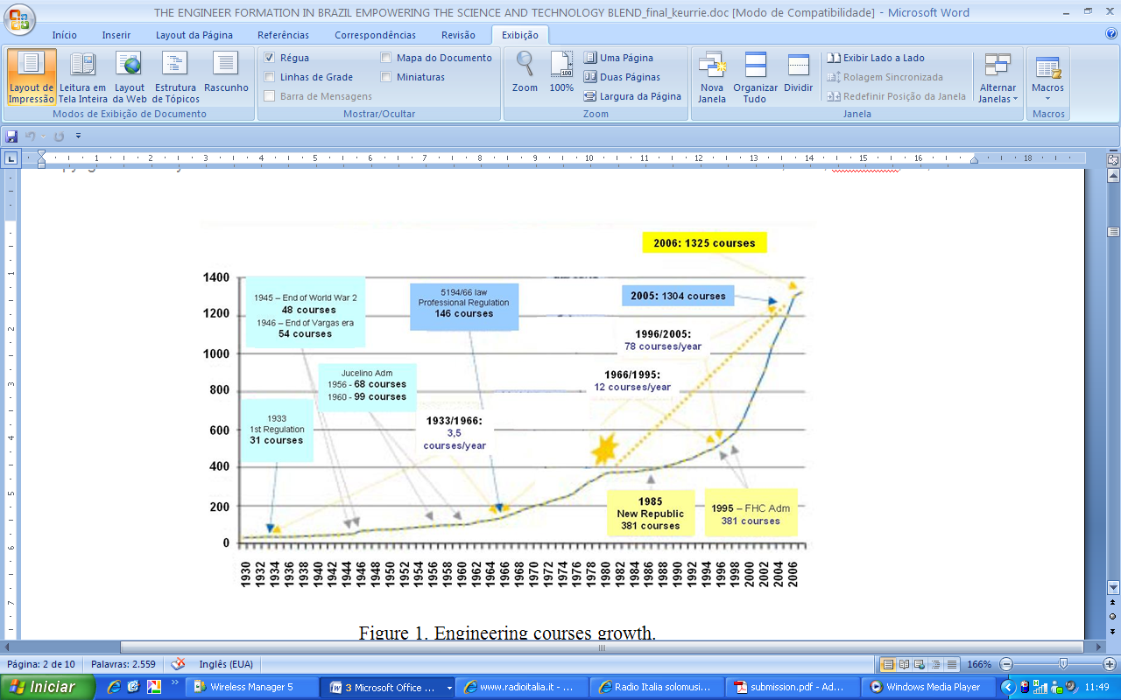

Figure 1. Engineering courses growth in Brazil.

1. Methodology

Companies and universities need to work together for the benefit of the society. It is well known that engineering and engineers play an important role in a developed society. Within the society-company-university triangle there are relations with students, engineers, professors and the market to achieve the best society development. Figure 2 illustrates these relations.

The aim of this work was to conduct a survey on the relation between university and the market, analyzing the resulting contribution to society, based on the impressions and opinions of students, recently graduated engineers, engineers, professors and the market.

Four surveys were built in a homepage (http) especially developed for this work. Only one answer was possible (automatically controlled by IP). The population size was 100 students or recently graduated engineers, 99 engineers, 20 market representatives and 17 professors.

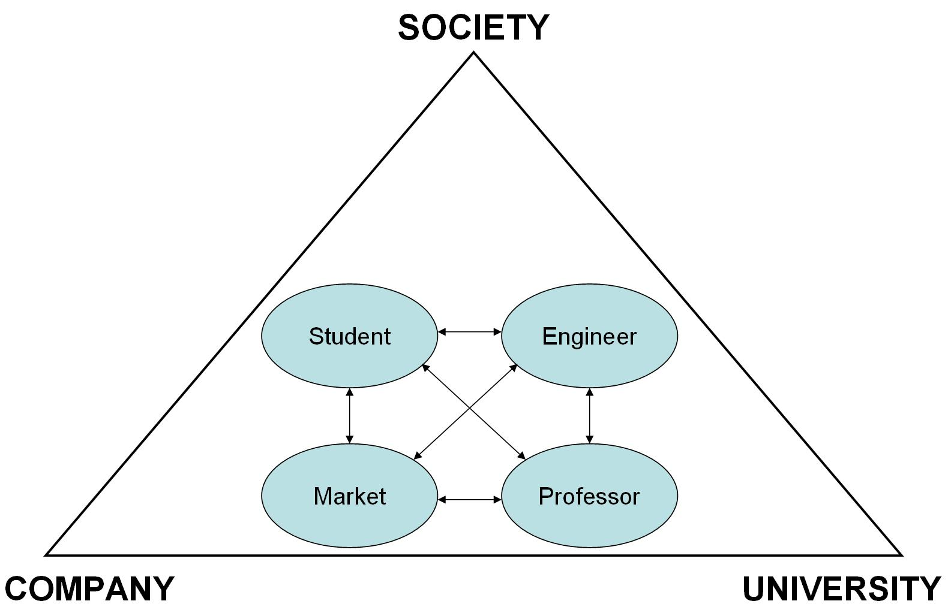

Figure 2. Relation between the society, company and university.

The survey was conducted independently of the institution; therefore, there were no specific questionnaires for each institution. The students are from various Brazilian universities, such as USP, Unesp, ITA, Mackenzie, Unicamp, IFET-MA, Unip, Uninove, FMU, FESP, IME, etc., at least one student from each of the universities listed.

The multiple choice questions followed the Mattar [4] guideline, in which the list of options considered possible answer and it is required that at least one of them be selected. Nevertheless, the option “other” could be chosen. The questions that cover a specific subject with a range of answers were limited to four possible choices preventing the respondent from selecting the middle option.

Data were compiled in an Excel spreadsheet. The result from each population survey was confronted with another one for comparison purposes.

The discussion of results was focused on the relation between university and market regarding their contributions to society and in the engineer’s technical development.

1. Results and discussion

The survey represents a sample view of this population. It is not intended to get a complete and statistical analysis of the engineering formation profile in Brazil, which should be the object of a further investigation.

Graphs presented from Figure 3 to Figure 6 showed questions addressed to students and to engineers. The first questions were focused on the point of view of the undergraduation course. The population analyzed allowed verifying a homogeneous answer distribution as compared to recently graduated engineers and engineers. The majority of the respondents chose excellent or good, but it is possible to verify some “regular” related to the technical lab, computational lab and professor didactics. The majority of recently graduated engineers and engineers pointed out the obsolescence of the technical lab as a weak point.

In Figure 5, it is possible to verify a balance between graduate students and engineers answers. While on the one hand the majority answered that they did not have enough contact with engineering problems, on the other hand professors show the real market problems.

The graph shown in Figure 6 indicates that the undergraduate activities performed during the course and offered by the university. The great difference between recently graduated engineers and engineers is related to the fact that the firsts had no opportunity to act in the field yet. presents a market point of view concerning the importance of the activities to be developed by recently graduated engineers / engineers.



Figure 3. Intellectual and physical resources.



Figure 4. Technical lab – gaps.

In the graph presented in Figure 7, two points very important to the market can be verified: foreign language courses and co-op student; however, the majority of the universities do not offer foreign language courses required for the graduation students’ need. They have to get this competence by themselves.

analyses the population opinion about the university-market relationship. It is possible to confirm that most consider this relation very good and that it benefits both the academy and the market. This relation provides better infrastructure to universities and, with improvements in the technical and computational labs and access to real engineering problems, it is possible to improve the results presented in Figure 3 and, consequently, the graphs shown in Figure 4 and Figure 5 have better results. Another conclusion from Figure 8 is that 100% of professors support the university-market relationship, recognizing its benefits.



Figure 5. Opportunity to solve real engineering problems.



Figure 6. Undergraduate activities by level of importance.

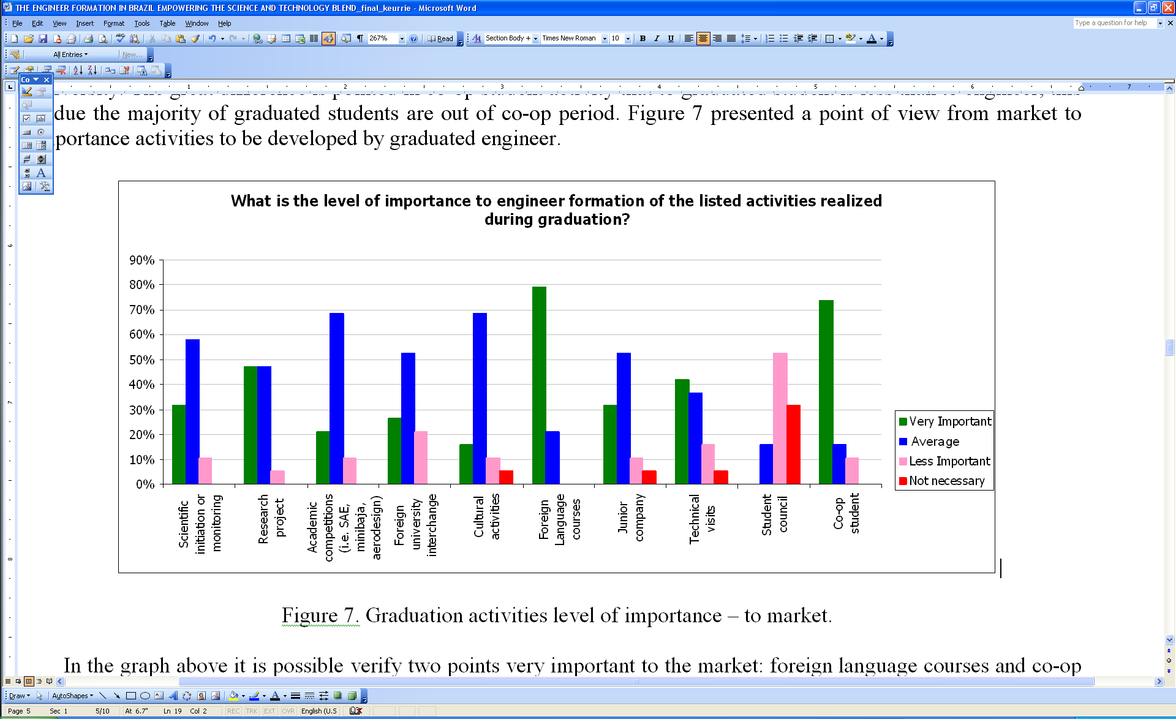

Figure 7. Undergraduate activities level of importance to the market.



Figure 8. Relationship between the university and market.

The graph presented in Figure 9 analyzed the graduate courses. Recently graduated engineers chose the graduate courses planned. Engineers and professors chose the courses that have completed and planned. Market chose the main graduate course to an engineer should be made. It is possible to conclude that professors are the best qualified, as was expected. Most engineers did courses sponsored by their companies or technical specializations. Half of the recently graduated students from the population analyzed opts to do a MBA while 40% intends to do an MSc, too. It can be concluded that most undergraduate students want to do a graduate course but, when the student becomes an engineer, and realizes the responsibilities that this profession requires, not everyone does or intends to do a graduate course. Students aimed at management courses because most elected MBA as a specialization course to do.



Figure 9. Graduate course.

The market seeks engineers with technical specialization or MSc. At the end of the questionnaire, the respondent had the opportunity to describe his/her personal impressions about the survey. An interesting comment about the specific question on specialization is reproduced by:

*“It is time the Brazilian industry eliminated the paradigm that an engineer doesn’t need technical knowledge and that being capable of leading people is enough. Let’s stop proliferating only “engineer managers”, who have no need of technical knowledge, to whom being a leader is the only requirement. Leadership and management are very important to the industry; however, there is not enough room for so many bosses. After all, if everyone is a leader, who will do the hard job?”*

The graph presented in Figure 10 shows the co-op student contribution. The majority of respondents chose the technical and professional growth with job experience. Being a co-op student is very important for an engineer to know the market and most of them are hired by the company where served their co-op time.



Figure 10. Co-op student contribution.

The majority of the professors, when asked about working in areas other than the university, answered that they worked in another sector in the past and recently on consulting, but the graph shown in Figure 11 demonstrates that most of the professor population analyzed has never worked in another sector (35% approximately), as it would be a great opportunity to better understand the market needs.



Figure 11. Working in areas other than the University (Professor).

In Figure 12, the professors conclude that the global market location should be focused on engineers’ formation.



Figure 12. Engineer formation to market area (Professor view).

For the market, the advantage of an entry level engineer is the eagerness to learn followed by the strong adaptability and the main disadvantage is the lack of experience to solve real engineering problems; this conclusion can be verified in Figures 13 and 14. From Figure 15 it is possible to note the opinion that to prepare an engineer for the market takes between 1 to 5 years to perform routine work, and between 4 to 8 years to prepare the engineer to be a technical leader. To hire a recently engineer, the market considers technical knowledge the major point and all other shown in the graph of Figure 16 are desirable.



Figure 13. Entry level engineer advantage (Market view).



Figure 14. Entry level engineer disadvantage (Market view).



Figure 15. Average time to prepare an engineer (Market view).



Figure 16. Key factors to hire a recently graduated engineer (Market view).

1. Conclusions

Technical and computational labs could be better and their main gap is become obsolete. Most recently graduated engineers and engineers do not have enough contact with engineering problems. However, a significant portion states the professors show real market problems during the classes; in other words, improving in contact with engineering problems is necessary. Another item to improve this is the contact with other experiences other than that at the university, which professors in this population do not usually have.

In the global market, to know a foreign language is a most important subject, yet, this is not well developed at most universities.

The co-op student period is very important for the professional development because it is a first contact between the engineering student and the market. The present research identifies a gap between the students’ needs and what is offered by the university.

The relationship between the university and the market is approved by the majority of this analyzed population. This relationship benefits both, the university and the market, including the recently graduated students student and engineer in this niche.

The graduate course is very important to the engineer’s professional development. The remaining question is what kind of course should be chosen. recently graduated students think of taking MBA; engineers want technical specialization or courses paid by the company, while the market seeks exactly engineers with technical specialization.

The main advantage of entry level engineers is eagerness to learn and the disadvantage is lack of experience to solve real engineering problems. This main disadvantage could be improved through university-market relationship.

Usually, the time to prepare a technical leader engineer is about 8 years, after finishing the undergraduation course. However, the market demands to reduce this time. In order to achieve this goal, the key engineer competences should be developed during the undergraduate course.

1. Acknowledgements

The authors acknowledge all collaborators who spend their time to contribute to this work.

References

1. C. R. Brito and M. M. Ciampi, “Action plan for the Engineer Formation: Guidelines for Seccess”, 38th Annual ASEE/IEEE Frontiers in Education Conference, Session T2E, pp. 19-23, Piscataway, NJ, 2008.
2. R. V. Belhot, *Reflexões e propostas sobre a ‘ensinar engenharia’ para o século XXI*. Tese livre docência, Escola de Engenharia de São Carlos – USP, São Paulo. 1193, 113p.
3. IEL (Instituto Euvaldo Lodi), 2006, “Inova engenharia: propostas para a modernização da engenharia no Brasil”, Brasilia, IEL.NC/SENAI.DN. 15 Jan. 2009, < <http://www.iel.org.br> >.
4. F. N. Mattar, *Pesquisa de Marketing*, 3rd edition, Ed. Atlas, São Paulo, 2001, 276p.