The Value of Collaborative Design Education for Structural Engineers and Architects

¹Clare Olsen, ²Sinead Mac Namara
Syracuse University, Syracuse, NY, USA, cjolsen@syr.edu ¹
Syracuse University, Syracuse, NY, USA, scmacnam@syr.edu²;

Abstract
Although architects and structural engineers collaborate closely in the professional world, in many curricula in the United States, students from the disciplines rarely mingle. This has partly been due to the fact that there are vastly different pedagogical approaches to teaching architecture and engineering: architectural educators value and promote creativity by assigning open-ended problems with numerous solutions, whereas structural engineering students, who must grapple with much more extensive technical knowledge, are rarely asked to push the limits of their discipline. Recognizing the importance of collaboration between architects and engineers, the authors co-taught two iterations of a National Science Foundation-funded course composed of architecture and engineering students with a focus on shell structures. The collaboration posed interesting challenges to teaching students with diverse skill sets. Over the course of the semester, we sought to develop students’ skills and confidence in approaching and discussing open-ended problems while promoting creativity and structural resolution in their design proposals. The instructors sought to achieve these goals by establishing common ground through two means: shared vocabulary and software-based design techniques. Through the development of these shared vocabularies and skills, the students’ design work evolved throughout the semester in structural, aesthetic and experiential complexity. In post-course interviews, architecture students reported that they felt they had tackled more ambitious design work than in previous courses, in part due to having more confidence in the technical resolution of innovative forms. Engineering students reported that the experience had improved their understanding of the potential and function of their technical knowledge, and that they had a better understanding of the role of the engineering professional in the design process.
1. Introduction
Contemporary architectural practice incorporates ever more technically complex engineering solutions in the pursuit of scale, form, sustainability, or just mere efficiency. In fact, it could be argued that it has been the speculative vision of the architect that has pushed innovation in building technologies of late. Architects are continually pushing the limits of construction through the use of advanced digital design techniques, thereby increasing the dependence on their structural engineering collaborators in order to realize their designs. Although architects and structural engineers collaborate closely in the professional world, in the United States, students from the disciplines rarely mingle. This has partly been due to the fact that there are vastly different pedagogical approaches to teaching architecture and engineering: architectural educators value and promote creativity by assigning open-ended problems with numerous possible solutions, whereas structural engineering students, who must grapple with much more extensive technical knowledge are rarely asked to push the limits of their discipline. Recognizing the importance of collaboration and feedback between architects and engineers, the authors (an architectural designer and engineer teaching at Syracuse University) co-taught a National Science Foundation-funded course composed of architecture and engineering students with a focus on shell structures. The course posed interesting challenges to teaching students with diverse skill sets. By recognizing and building upon the differences amongst the students’ expertise and understanding, we sought to establish a common ground for communication and design through a shared vocabulary and skill set.

In preparing for the course, many of the discussions between the two faculty members focused on understanding the differences in the educational systems of the two disciplines so that the lectures and design problems could be crafted to inform and not alienate one or the other group of students. Traditionally, in core engineering courses the same textbook is used for decades and the answers to homework problems are assuredly in the back of the book. The curricula result in a predictable and solid foundation for science and math knowledge, but this knowledge is derived from linear methods of thinking and resolution. Depending on the number of by-the-book engineering courses in the curriculum, it is very possible for students to graduate without having developed their creative problem-solving abilities, despite that the working world is full of open-ended, ambiguous problems.

On the other hand, it is because real-world problems are not clear-cut that architecture curricula emphasize research, investigation and innovation throughout the design education. The architecture design studio is the core of pedagogy at most schools of architecture (including Syracuse University). The studio joins faculty with students for 12 hours per week and utilizes a range of pedagogical strategies such as lectures, site visits, one-on-one critiques, group and individual presentations to enhance students’ creativity and technical skills, enabling them to address a wide range of design problems.
The opposite is true for engineering education in many Civil Engineering programs throughout the country (and also at Syracuse University), where there are few “design” opportunities for students except for a freshman design course and a final Capstone design course, which is required by the Accreditation Board for Engineering and Technology (ABET) for accreditation, saying: “Students must be prepared for engineering practice through a curriculum culminating in a major design experience based on the knowledge and skills acquired in earlier course work and incorporating appropriate engineering standards and multiple realistic constraints.” The Capstone is often 1-2 semesters long, consisting of about 5-7 hours of work per week with 3 hours or less in contact with advisor(s). The contact hours and number of occurrences in the curriculum demonstrate the marked differences in design education in architecture and engineering.

Additionally, the content of the design courses for the two disciplines differ in several ways: architecture studios (at least early in the core curriculum) often emphasize conceptual design and innovation without requiring full technical resolution, whereas the engineering design course is necessarily focused on codes and constraints, typically comprised of a normative design problem from the region i.e., a new highway overpass or a water supply system for a nearby suburb. Due to the emphasis on “realistic constraints” (more than 50% of projects come from Industry), architectural notions of creativity, such as aesthetics and ease of use, are not fore-grounded. Historically at Syracuse University, for example, the engineering capstone projects have not displayed a wide range of approaches or markedly innovative designs. The projects have, however, emphasized a high degree of technical resolution across a number of engineering sub-specialties.

The National Science Foundation Innovation in Engineering Education grant awarded to the Schools of Architecture and Engineering at Syracuse University provides an opportunity to address these fundamental differences in pedagogy pursued in the two Schools and to align them better with professional practice, which is becoming more and more dependent on collaborative modes of design as a means of resolving complex structural propositions. With support of the grant, the authors have co-taught two iterations of an elective seminar composed of around 20 students, half from each discipline. Each design problem assigned in the course was completed as a collaboration between two (or in the final projects where there were four) architecture and engineering students. Over the course of the semester, we sought to develop students’ skills and confidence in approaching (and discussing) open-ended problems, while promoting creativity and structural resolution in their design proposals. The instructors sought to achieve these goals by establishing common ground through two means: valuation and software-based design techniques. Through the development of these shared vocabularies and skills, the students’ design work evolved throughout the semester in structural, aesthetic and experiential complexity and innovation.

2. Interdisciplinary Approach and Course Content

The initial lectures and classroom discussions posed interesting pedagogical challenges: how does one communicate to half the class the principles of the other discipline without numbing the other group of students? This was attempted through lectures that combined both basic and advanced content about the values held by both disciplines in contemporary practice, emphasizing the importance of structural and material efficiency as well as experience and aesthetics. Shell structures throughout history, including recently completed projects, were described (by both instructors) in terms of structural conditions as well as their architectural effects that ranged from descriptions of program, circulation and contextual relationships to more theoretical discussions of aperture, articulation, aggregation and atmosphere. Although all of this was new for the engineering students, some of the architecture students were also surprisingly unfamiliar with concepts in contemporary architectural discourse. The engineering students were all in their third year; however, the architecture students ranged from second to fourth year students and seemed to be variously exposed to the vocabulary presented. Their experiences ranged from never having designed anything curvilinear to never having discussed voluptuousness or mood. Although both groups of students had basic levels of expertise in their fields, the relative newness of the vocabulary for both constituencies enabled an equal playing field.

Similarly, the mathematics and science behind shell structures was mostly new content for both the architecture and engineering students. In order to lay a foundation for design development, students were introduced to both mathematical principles of dome and shell design as well as structurally-guided form-finding techniques. We described the analog form-finding methodologies of engineers such as Heinz Isler and Antoni Gaudi. Although there was systematicity to their methods, mathematical parameters allowed for play and beauty in the development of form and aesthetic experience. As an example, the students were asked to repeat an experiment very much like Isler’s where they created “frozen forms” from fabric hung from a frame and manipulated (through pinching, folding, sewing, etc.) to create a form in pure tension and then sprayed with water (during winter in Syracuse, the fabric froze very quickly) and flipped to become a shell in pure compression.

In contemporary practice, many architects and engineers employ digital form-finding techniques to design and test complex curvilinear forms. When digital modeling first became widespread in architecture in the 1990s, architects were experimenting with digital form-finding for form’s sake, with little emphasis on material considerations and even less focus on constructability (see for example Paper Architecture promoted at Columbia University in the mid to late 1990s or Rahim (2009)). However, as more and more digital practitioners (meaning those that use software for design, not just production) gain an interest in constructability, structural parameters are being considered much earlier in the design process using both the capabilities of software and also bringing engineering collaborators into the discussion much earlier in the decision making process.

Figure 1. “Frozen Form” project showing Ekaterina Makarova and Jaeyun Kim, Spring 2011.
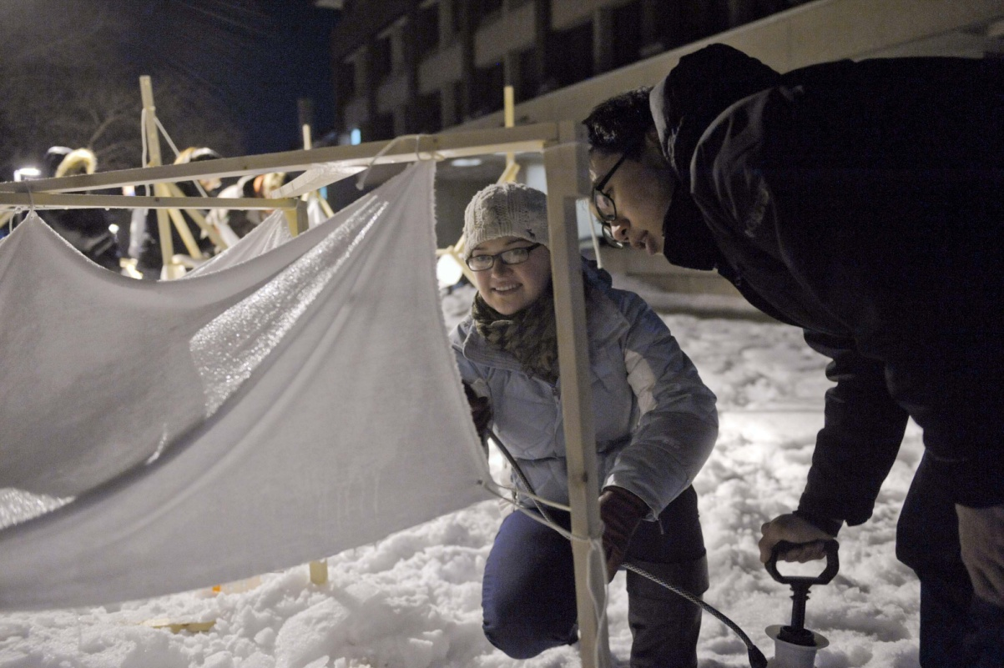

Following these exciting trends in contemporary practice while at the same time relating to the physical form-finding experiments of Isler and Gaudi, we endeavored in our coursework to emphasize the importance of establishing structural parameters to form-finding experiments within the digital environment. In order to design efficient shell structures virtually, students were introduced to specific geometric parameters in 3d modeling software, Rhinoceros (which will be elaborated upon later), and a Finite Element Analysis program (SAP2000), which when designing complex, doubly-curved structures is virtually required as a means to check and refine form and materiality. No students came into the course with a prior knowledge of techniques for modeling or analyzing shell structures. As a result, software instruction enabled all students to have an understanding of the capabilities and potentialities of the software, which not only helped them to push their designs but also aided in the communication during the collaborative design process.

Students were taught shell modeling parameters as means and basis for design and form-finding in Rhinoceros. Although the engineering students had never modeled in 3d, their knowledge of AutoCAD facilitated fast learning of Rhino. (Anecdotally, by the end of the semester, some of the engineers grew faster at modeling than some of the architecture students, which we hypothesize might be a result of the logic-based interface. If one would like to rotate and object, for example, one simply types “rotate” in the command line.) Algorithmically-based commands such as Parabola, Hyperbola, Sweep and Revolve were utilized to model shells with baseline structural efficiencies. These commands were, of course, new to the engineers, but also to many of the architecture students. Developing skills that were new to both groups proved helpful in the collective process for learning and instilling confidence.

In another project assigned mid- way through the semester during both course iterations, students were asked to design a minimum of three shell modules for aggregation. The Rhino models (developed collaboratively by an architecture and engineering student) were tested through both analysis and fabrication. The digital models were analyzed using SAP2000, and fabrication of doubly-curved surfaces was facilitated through CNC milling and vacuum-forming (It should be noted that the translation between the Rhino model and SAP was not self-evident. In some cases where models had been trimmed in Rhino, considerable rebuilding was required in the SAP environment in order to replicate the desired form. Recent developments in the Rhino plug-in Scan & Solve (currently in Beta form) may prove invaluable when this course is taught in the future). This process of creating milled molds allowed the students to abstractly replicate a possible means of construction with the use of formwork. In the review of this work, the students revealed to us that although the design process was initially linear, as they gained knowledge about the parameters to modeling, analysis and fabrication, these began to inform one another in a continuous feedback loop. Students began to recognize that through the process of design collaboration and analysis, communication and negotiation were required to refine the design proposal and to achieve the aesthetic and structural goals.

Figure 2. Eli Goldman and Jack Solomon, Apertures and Aggregations, Spring 2010.

3. Evaluation and Course Outcomes

As part of the NSF grant, the Office of Professional Research and Development in the School of Education at Syracuse University prepared an evaluation plan for the course consisting of surveys and focus groups conducted at the beginning, middle and end of the semester. Based on the information gathered through these means as well as students’ openness about the design and collaborative process throughout the semester, we have evaluated the 2010 course outcomes against the initial pedagogical goals, which helped to provide a framework for future iterations of the course. Happily, student enthusiasm for the course was very high. The course filled up very quickly and no student gave up his or her place. In initial interviews students expressed very specific reasons for taking the course with many of them citing career goals that would bring them into contact with the other profession and that a lack of understanding of the other profession was a deficit in their education so far.

In post-course interviews, architecture students reported that they felt they had tackled more ambitious design work than in previous courses, in part due to having more confidence in the technical resolution of innovative forms. Engineering students reported that the experience had improved their understanding of the potential and function of their technical knowledge, and that they had a better understanding of the role of the engineering professional in the design process. At the same time, engineering students observed that the course was more focused on architectural values than on engineering, and they would have appreciated more technical content. One way we attempted to address this in 2011 was to extend the schedule for the final project, which enabled more iterations reflecting the feedback between structural analysis and formal development.

Additionally, throughout both iterations of the course, it was evident through the types of design projects produced at the beginning and end of the course that there was marked growth amongst the students in tackling open-ended problems and providing a structurally-viable solution. For example, in the final project, a Regional Transportation Center for buses and trains designed by groups composed of three or four students of the two disciplines, one group utilized the stress curves found in the FEM analysis to determine aperture locations for an interior courtyard. The engineers on the team made the recommendation without solicitation from the architects, and the four worked together on the aesthetic and experiential qualities of the resulting structural enclosure.

Figure 3. Goldman, Ingersoll, Lipezker, Solomon. Final Project, Syracuse Regional Transportation Center, Spring 2010. 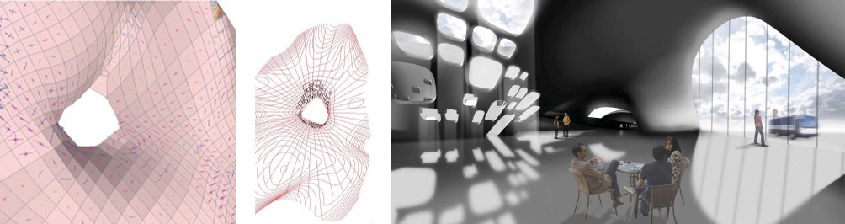

The interdisciplinary design partnerships were crucial to the success of the projects, and as a result, we believe that the students developed a greater appreciation of their own as well as the other discipline. Learning how to communicate with one another was an important process throughout the semester, which also affected students’ attitudes about the disciplines. The differences in vocabulary and expertise were discussed openly in the classroom to create an environment of mutual respect and support.

Additionally, through shared vocabulary and digital skills, both group of students showed a marked growth in confidence. The engineering students who were initially resistant to open-ended, multifaceted problems (with numerous acceptable design solutions) later embraced the challenges of complex design and analysis. In fact, in the first year, during the critique of the first assignment, which was to design five connected parabaloids of a certain square-footage, the engineering students commented that the assignment “frightened” them. They (and even some of the architecture students) wanted a program and site—as much information as possible--in order to develop the most logical solution. However, their architecture design partners helped them through the first assignment, and after we critiqued the projects in front of the whole class, there was a clear relief amongst the engineering students as they began to understand the process and the expectations. Throughout the semester and four assignments, there was an easily recognizable change among the attitudes of the engineering students, even in the way that they presented projects and carried themselves. This effect was observed both by the teaching faculty and the evaluation team Scott Shablak and Carolina Harris of the SU School of Education.

The architecture students also grew eager to create more efficient structures, and towards the end of the semester, it was difficult for the evaluation team visiting the class to distinguish between architecture and engineering students when they presented their designs. The skills and confidence gained through the course were especially evident during the final presentations. An architecture student commented that his group’s design proposal was the most radical form that he had ever attempted to design in architecture school, and yet he felt the most confident (he has ever fel) about the project due to the knowledge about its structural integrity achieved both through a geometrically defined digital model, as well as the collaboration with the two engineering students who were able to analyze the form and suggest revisions. One of his engineering partners also commented that she felt secure in her ability to contribute to the discussion about circulation, form and experience and was “proud of her capacity to tackle an open-ended problem”, a proposition that “scared” her at the beginning of the course.

4. Conclusion

Through the Shell Structures courses, engineering and architecture students learned the value in collaboration to work towards aesthetic and technical goals to produce beautiful, efficient structures. Group discussion of the design projects helped to foster an understanding amongst all students that a multiplicity of approaches exist and that the success of the proposals can be assessed using (equally important) aesthetic and technical criteria. Although the NSF grant that supported the courses (and will fund a third iteration) is particularly aimed at the engineering curriculum and the course proved to be new and exciting for the engineering students, the interdisciplinary approach has tremendous potential for architectural curricula as well. Where programs strive to develop the creativity and technical skills to produce innovative design proposals, it seems crucial to incorporate interdisciplinary collaboration to instill confidence in the formal project while placing importance on material efficiency as a consideration in sustainable design.

The Shell Structures course highlights the potential for similar interdisciplinary approaches in professional programs seeking to prepare students for meaningful cross-disciplinary design collaborations in the working world. By establishing common ground amongst the students, while highlighting the differences between the disciplines in an environment of respect and support, the students demonstrated remarkable growth in their abilities to communicate and design in interdisciplinary teams; skills that will prove invaluable upon completion of the professional degree. By refining the approach to interdisciplinary design collaboration in these test courses, we hope the methodology will serve as a model for similar cross-professional courses at Syracuse University and elsewhere.

5. Acknowledgements

The Shell Structures course is made possible through the National Science Foundation Award Number 0935168 and the support of the Deans of both the College of Engineering and Computer Science and the School of Architecture.
References

S. R. Barley and J. E. Orr. Between Craft and Science: Technical Work in U.S. Settings. Cornell University Press: Ithaca, New York, 1997. p 214.
R. M. Felder. “Learning and Teaching Styles in Engineering Education.” Journal of Engineering Education, 1988. Vol. 78, No. 7, pp 674–681.
ABET Criteria for Accrediting Engineering Programs, 2010-2011. Criterion 5: Curriculum, p4
Todd et al. “Survey of Capstone Engineering Courses in North America.” Journal of Engineering Education. 1994, Vol 84, p165-174
Todd et al. “Survey of Capstone Engineering Courses in North America.” Journal of Engineering Education. 1994, Vol 84, p165-174
A. Rahim. “Uniformity and Variability in Architectural Practice” The Architecture of Variation Lars Spuybroek (ed.) Thames & Hudson: New York, 2009. p42
“The New Structuralism: Design, Engineering and Architectural Technologies” AD Magazine, 2010, Vol. 80, No. 4, pp 14-23.

