Addressing Engineering Teaching Issues in Online Distance Learning

¹B.M. Mulligan, ²S. Reid
Institute of Technology Sligo, Sligo, Ireland, mulligan.brian@itsligo.ie¹;
Institute of Technology Sligo, Sligo, Ireland, reid.stephen@itsligo.ie²

Abstract
Efforts by IT Sligo to transfer courses into an online distance learning format since 2002 ran into three significant obstacles, namely the expense of developing learning materials for niche areas, an inability to teach mathematical topics using asynchronous communication techniques, and a requirement to facilitate hands-on practical laboratory sessions. The first two of these obstacles were addressed relatively quickly by the use of existing learning materials and by the use of synchronous conferencing systems for live online teaching. This approach along with attendance at the Institute for practical laboratory sessions, led to rapid growth of online courses within the country, but restricted the recruitment of international students. This final obstacle is now being addressed through the EU funded project entitled Knowledge and Innovation Transfer in Engineering (KITE). The IT Sligo element of the project is to investigate, develop and invest in systems to deliver “practical” subjects online. To date this has resulted in the development of a facility to allow remote access to laboratories where students can both control and monitor physical equipment. Early testing with students has shown remote access to be extremely effective and popular, with students able to access equipment at any time during the day or night, and work is underway to increase the range of physical equipment available to distance learners.

- Background
In 2000 the Institute of Technology Sligo decided to deliver their full-time Honours B.Sc. in Quality Management as an online programme. This was a “top-up” degree programme suitable for students who had previously completed an ordinary degree in a range of areas. At this time, the full-time programme was becoming less popular, most likely because of the increase in the number of top-up and ab-initio 4 year programmes available to students. This was despite the fact that there was a shortage of Quality Management skills in industry and significant demand for private training in this area, and so it was believed that there would be significant demand for a part-time version of the programme that was easily accessible.

- Initial Design
As there was very little finance available to invest in the development of the online version of the programme it was decided to use the wrap-around approach described by Mason (1). The programme developed and launched in 2002, was essentially a self-study programme, based on existing resources such as books, lecturers’ notes and links to websites, with required learning activities (assignments) to be carried out with access to lecturer and peer support available through a Virtual Learning Environment (VLE). Students were also required to attend the Institute for laboratory practical classes a number of times per year. As this approach did not require the development of any content, the only investment required was for training of lecturers.

- Success of the initial approach
The approach described above was not fully successful. The programme consisted of three types of topics; management, technology and mathematics. At that point in time asynchronous discussion based learning had been shown to be quite effective in teaching topics in the humanities and indeed it was quite successful in this case in teaching management topics. Self-study in technology topics, with irregular attendance at practical laboratories worked relatively well, but both students and lecturers felt that this was less than was normally acceptable.

In the mathematical topics, self-study with asynchronous support proved to be wholly inadequate. Students found it difficult to study mathematical topics from a text-book alone. They regularly encountered problems of understanding, or application of techniques in their assignments and asynchronous queries seemed to be unsuitable as a support mechanism. In response to demand from the online students, monthly tutorials were arranged. This improved the situation somewhat but students still found it difficult to study these topics in this format.

- Modifications to initial approach
In 2003, weekly synchronous online classes for mathematical topics were introduced. These were delivered using a PC based conferencing system, where lecturers could speak live to the students, display slides and write on the board. Lecturers also had access to physical electronic whiteboards in classrooms, or small graphics tablets to make it possible for them to write easily on the conferencing system whiteboard. Students could stop the lecturer at any time to ask a question, either by typing in a chat area or by taking control of the microphone. These live classes were recorded and were made available through the Virtual Learning Environment (Learning Management System) for students who could not attend. These recordings also proved to be very valuable as revision resources.
This new approach proved to be very effective for the teaching of these mathematical topics. It also proved to be very popular with both students and lecturers and the facility was almost immediately taken up by all lecturers on the programme.

- The emergent learning model
Very quickly a standardised model of online learning emerged. Almost all modules on the programme consisted of a one-hour live class every week, access to web-hosted resources, independent-learning activities and peer and lecturer support. It was emphasised to lecturers that the independent-learning activities should still be considered as the core of the student’s learning experience and the live lectures (and recordings) should be considered to be just part of the resources supplied to enable these learning activities. This model, described in more detail by Mulligan (2) is illustrated in figure 1.

Fig 1: Online Learning Model.

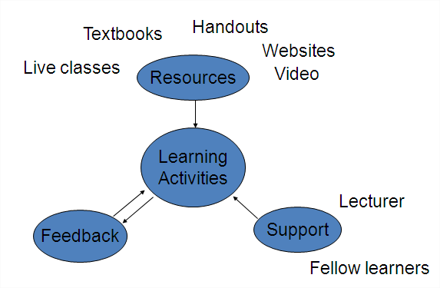

- Success and Growth
The Institute set out two criteria to measure the pedagogical success of this initiative;
- The level of achievement of the learning outcomes of the programme, and
- The level of student satisfaction with their learning experiences.

To determine the first, the online learners were required to sit the same written examinations as the full-time students. From the start, the online students’ performance in examinations, exceeded that of the full-time students. It was certainly admitted that, because of the work situations and motivation of these part-time students, this could certainly not be taken as evidence that the medium was superior, but did seem to indicate that the medium was not proving to be any barrier to their learning.

Indeed, it was felt that student surveys of student satisfaction would reveal if, despite the good examination results, the students felt that the medium was inadequate. As it emerged, the results from these surveys were excellent, with most students stating that the medium was effective and that they had a generally pleasant experience on the course.

The initial success of this online programme encouraged the School of Engineering to put a whole series of programmes online in the following few years. These included programmes in Mechatronics, Energy, Manufacturing Management as well as other programmes in Quality. The technique was also followed by two programmes in the School of Science. Enrollments grew steadily to almost 500 online students and fee income of over €2m in 2009 (see Fig 2). Analysis of costs indicated that these programmes were profitable and generated a surplus for the Institute.

Fig 2: Growth of Enrolment in Online Learning at IT Sligo
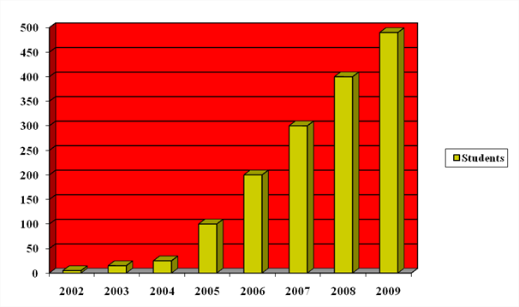

- Attendance requirements as a limit to growth.
The growth of these programmes indicated that there might be significant potential in selling online courses internationally. Indeed, the later online programmes offered in Mechatronics proved to be even more successful, but these programme had an even larger practical element to them and required attendance around 4 times per year. At this point, interest in our courses was being shown for potential overseas students and indeed we had a number of Irish students on our courses relocated overseas. However, attendance at the Institute was a problem for such students and generally we had to advise international students against enrollment and only a very small number chose to do so.

- Remote Access to Laboratories
During 2009 IT Sligo commenced work on the cross-border EU funded KITE project. The main aim of the IT Sligo element of KITE is focused on facilitating the delivery of practical classes online. To date the solution, described in detail by McAfee and Reid (2), has been to provide students with remote access to computers on campus. This remote access facilitates distance learning students with access to both software and purpose built physical equipment (Training Rigs) for both on-demand experimentation (24/7), and live interactive online classes on both training rigs and software.

8.1 On-demand access
As illustrated in figure 3 below, students access the software/ training rig in IT Sligo’s “remote access lab” from home, or wherever they happen to be, at a time that suits them. In this case the student can write, and test their PLC program by running the programme and viewing the operation of training rig through webcam.

Fig. 3: Illustration of student access to training rig.
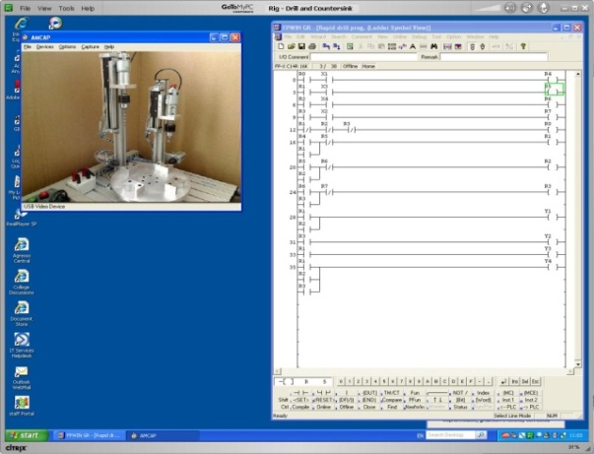
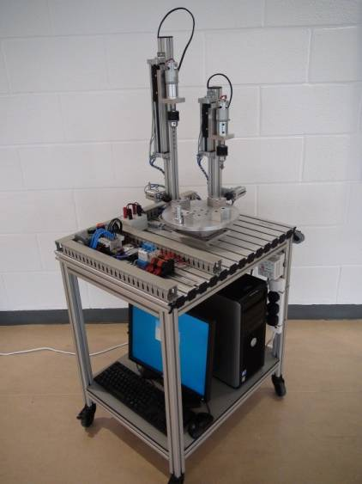

Online Student - Anywhere
Remote Access

8.2 Live Practical Classes
During a live online practical class, students remotely logon to PCs in the IT Sligo computer lab, while participating in an online meeting using a PC based conferencing system. This enables the instructor to monitor student progress, offer guidance through 2-way audio (VoIP) and take control of the “students” PC to demonstrate solutions when required (See figure 4).

Fig 4: Lecturer supervising remote classes.

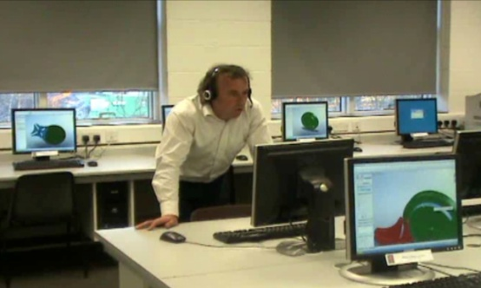
Students remotely control PCs in IT Sligo Computer Lab

Lecturer can take control of “student” PC, offering assistance

8.3 Success to date
The first of these live practical classes was delivered by the Institute between January and May 2010. Throughout this module in 3-D Computer Aided Design (CAD) and Modelling, students had remote access to the CAD software, removing the need for students to purchase and install the software on their own computers. In addition students had access to recorded video demonstrations through the VLE, and attended a 2-hour live practical class delivered each week. The main purpose of the live class was to focus on providing guidance and solutions to problems encountered by students during the previous week. Towards the end of the module students completed a questionnaire, and the final grades of the online students were compared to final grades of face-to-face students that took a similar CAD module in two previous years. Statistical analysis of the results indicated no significant difference between the results of all three modules and 80% of students indicated they would recommend CAD training delivered online.

For the moment, this has not decreased the requirements for attendance, but it does seemed to have improved student satisfaction and it is expected that when further work is completed on increasing the range of rigs that are available on a remote basis and the range of software that can be taught in live online laboratories, it should be possible to redesign attendance schedules to reduce the need for travel.

- Conclusion
It could be argued that in the delivery of higher education online, engineering may well be the most difficult place to start, and that many of the online pedagogical approaches, such as asynchronous discussion and self-paced multimedia, developed in the 1990’s because of the limitations of the Internet at that time, have limited applicability or serious cost implications in engineering education. However, IT Sligo’s success in developing financially viable online courses, with high student satisfaction and learning outcomes, may indicate that faster progress can be made using more traditional teaching techniques using communications technologies that allow us to replicate traditional teaching approaches for distributed groups of learners.

References

1. R. Mason, (1998) Models of online courses. Asynchronous Learning Networks Magazine, (http://www.sloanconsortium.org/publications/magazine/v2n2/mason.asp)
- B. Mulligan, “Back to the Future: The Power of Traditional Teaching with Modern Communication,” Proceedings of m-ICTE 2009 Conference, 22-24 April 2009, Lisbon, Portugal.
- M. McAfee, S. Reid, “Challenges in Providing Practical Labs Online to Distance Learning Students,” Proceedings of 3rd International Symposium for Engineering Education, University College Cork, Cork, Ireland, 2010.

