Teaching structural systems to novice architecture students through modeling and design representation techniques

¹P.F.N. Rodrigues, ²R.S. Mano, ³G. Lassance
Department of Structures, School of Architecture, Federal University of Rio de Janeiro, Rio de Janeiro, Brazil, pfnr@fau.ufrj.br¹;
Post-graduate Program in Architecture, Federal University of Rio Janeiro and Federal University of Tocantins, Palmas, Brazil, rafaelmanoarquiteto@gmail.com²
Post-graduate Program in Architecture, Federal University of Rio Janeiro, Brazil, lassance@ufrj.br³

Abstract
This paper deals with the teaching of structures to architecture students. The research presented here aims to improve the integration of knowledge concerning the structural design of buildings and the teaching of architectural design. this paper aims to show that the integration between structural design and architectural design can be facilitated by representing the structural behavior through the modes of representation of architectural design. The recent implementation of a curriculum reform in the architecture program at the Faculty of Architecture and Urbanism, Federal University of Rio de Janeiro, promoted the development of innovative pedagogical experiences in the first two academic years: one in the first semester that employs structural phenomenology, another in the fourth quarter through the creation of a new chair called 'structural design', associated with the integrated design studio. The analysis of student work allows us to observe an effective capacity for integration and incorporation of the structural phenomena in the design process.

1. Introduction
This paper deals with the teaching of structures to architecture students. The research presented here aims to improve the integration of knowledge concerning the structural design of buildings and the teaching of architectural design. Therefore, it faces a crucial problem that still persists in architectural education and impacts on a professional practice often submissive to conventional modes of construction and deprived of opportunities for innovation so necessary in the context of the new goals of sustainability and environmental impact of buildings.

The approach to this problem makes use of concepts from the research in design methodology, specially the distinction between solution driven and problem driven design [1] used to distinguish, respectively, the design behavior of architects and engineers [2].

The recent implementation of a curriculum reform in the architecture program at the Faculty of Architecture and Urbanism, Federal University of Rio de Janeiro, promoted the development of innovative pedagogical experiences in the first two academic years: one in the first semester that employs structural phenomenology, another in the fourth quarter through the creation of a new chair called 'structural design', associated with the integrated design studio. The pedagogical experience involves a total of 240 students each semester (120 in each level).
2. Modeling of Structural Systems
The study of structures is an important part of a student of architecture’s education. Therefore, the capacity to engage with information held in structures is vital to the study of architecture. In the Faculty of Architecture and Urbanism at Federal University of Rio de Janeiro (FAU/UFRJ), the introduction of this subject occurs with a discipline on modeling of structural systems for the simulation and testing of physical models, which seems to be a helpful approach for the comprehension of the engineering and design basic concepts (Figure 1).

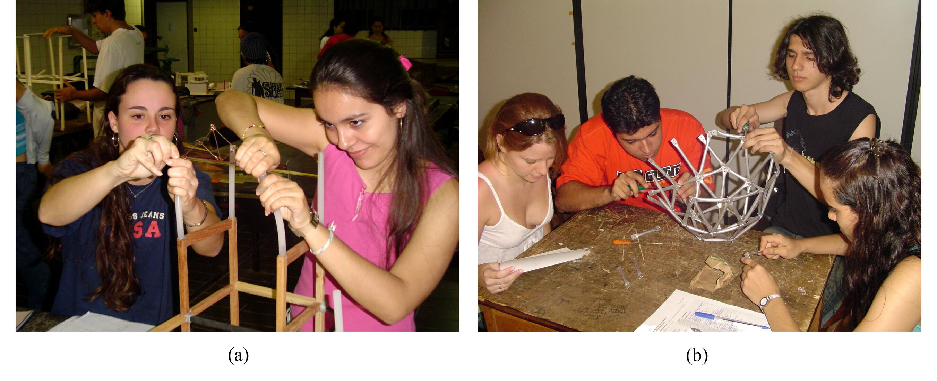Figure 1 – Students building qualitative models

At this stage, the most important characteristics and properties of basic elements along with the structural compositions are thoroughly studied. The main purposes are to allow the students to acquire the needed sensibility and motivate them, awakening the interest for the study of structural analysis in the following years. The most complete comprehension of basic concepts is considered as a prerequisite before getting into the analysis modules.

The use of physical reduced models made of relatively flexible materials, such as silicon, rubber, cardboard and polystyrene, in order to simulate the deflections of the structural members, was originally presented in the sixties by Salvadori & Tempel [1], being their illustrated teacher’s manual on why buildings stand up the first one to use the concept of a visual approach. The structural analysis executed with the help of models to enhance the visualization of the displacements due to the action of loads, provides an easy and efficient manner of understanding the basic engineering concepts, such as tension, compression, bending, buckling and torsion, employing the student’s feeling and intuition [2].

The methodology applied during the course period includes the use of intuition in the learning process by means of examples of structures found in nature, of the observation of structures from the past and present, their successes and failures, and of the responses to certain loads of reduced structural models made by students and teachers in the classroom. The intention is to show the pupils the structure’s functionality in architecture, its relevance in the design and building processes, introducing the structural systems knowledge in a qualitative way, including their properties and behavior when subjected to determined loads (Figure 2).

Then it’s possible to facilitate the understanding of basic concepts, such as tension, compression, buckling, torsion, among others, taking advantage of the fact that architectural students are visual learners. The subject becomes more attractive and fascinating, turning into a background for the structural analysis, without being superficial. As a matter of fact, the qualitative experimental analysis is an easy way of guiding the intuition through visualization and feeling.

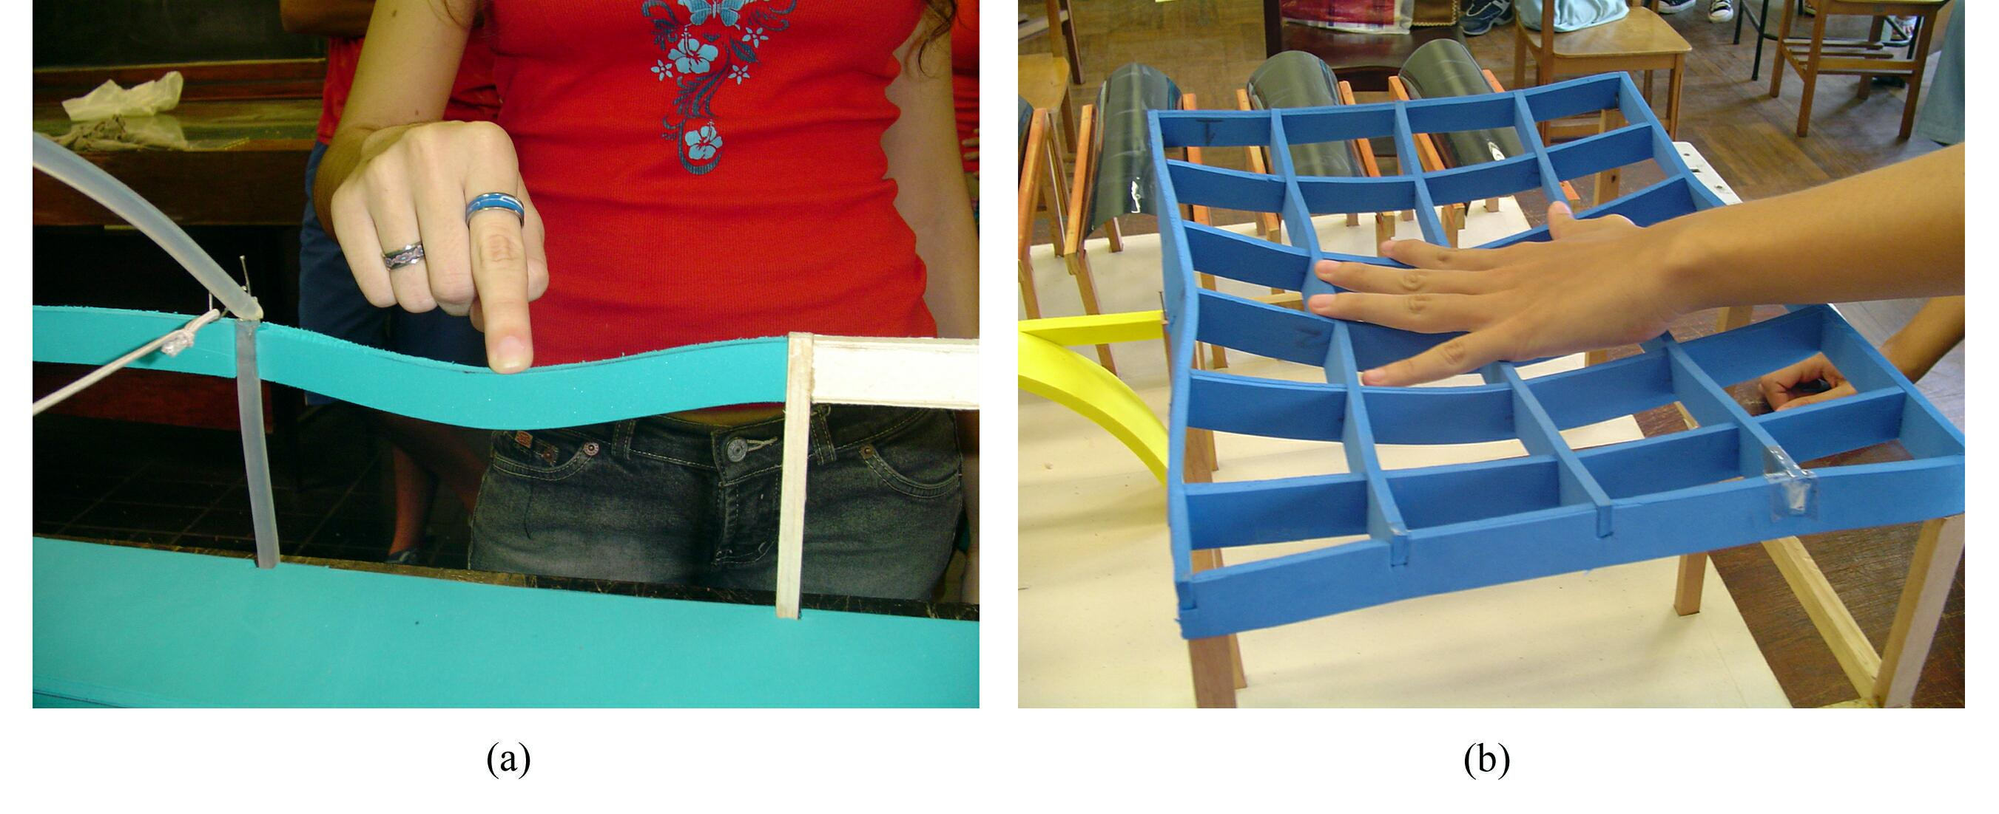
Figure 2 – Students manipulating physical structural models

The evolution of multimedia made the development of computer-aided tools for the interactive learning environment possible. The application of such tools is an important step to fulfill the needs of architecture students. Many contributions by researchers on this subject, applying some virtual reality techniques, were published during the last two decades ([3], [4], [5], [6], [7]). Two excellent tools for the architectural education with the aim of bypassing the structural systems teaching and learning difficulties that take place in the first years of architecture and engineering courses is the introduction of computer teaching software employing the Virtual Reality and Augmented Reality concepts ([8], [9]). Therefore, aplications of virtual reality, using the VRML language [10], and augmented reality, using the ARToolkit library ([11], [12]), were developed to enhance learning for novice students in architecture and engineering. Figure 3 shows students using the computational programs.

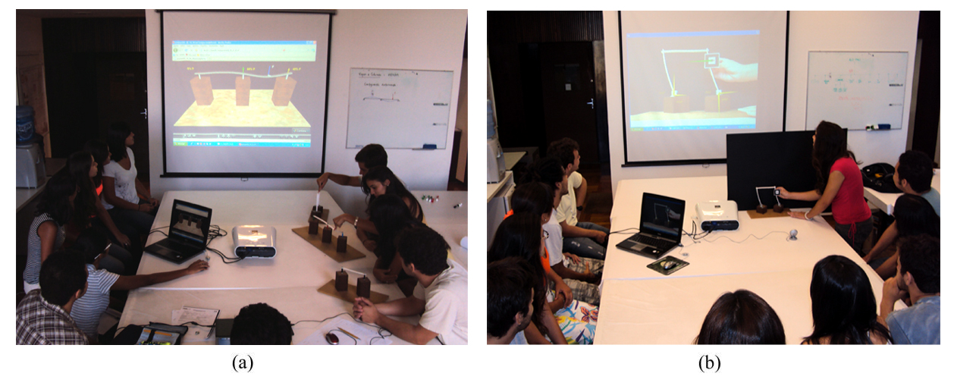
Figure 3 – Virtual (a) and augmented (b) reality applications

The application of these tools do allow the architectural student to develop the capacity for qualitative observation and to cultivate his feeling, perception, and intuition for structural behavior, enhanced by the following conclusions:

• The greater the applied load “P”, the greater the displacements.
• As the load “P” increases, the support reactions increase proportionally.
• The sum of the support reactions is equal to the applied load.
• The nearer the applied load is to the support, the greater its reaction.
• In the two-span beam, when the force is applied only to one of the spans, the other span tends to uplift, and its far end support reaction, distant from the central support, changes its direction.
• The deformed configuration and the stressed regions (where tension or compression occurs) are easily visible.

3. Structural Design
The structural design is the idealization of a structural system more suited to a particular architectural conception and therefore requires a prior knowledge of the various elements that comprise this system. It includes stages as the initial structural analysis of architectural design and preliminary structural design.

The increasing complexity of buildings, the use of innovative materials and technologies have introduced many challenges to the building industry and design profession as a whole and to the structural analysis teaching as well. The discipline Structural Design takes place on the second year of the architecture course. It is part of the “Integrated Work” and presents to the students the conceptual and practical underpinnings of basic structural design as an introduction to the design of both residencial and commercial small buildings. It aims to provide the essential concepts of the complete relationship of structural and architectural form and spatial organization, and also a better comprehension of the meaning of load configurations and its effects on the structures and other important factors of design. Students at this stage are able to choose appropriately the structural system to determine their architectural design's organization. The students perform structural drafting, structural design and structural detailing, including drawings and a technical report, and they make a presentation of their complete architectural design before an audience of teachers and students (Figure 4).

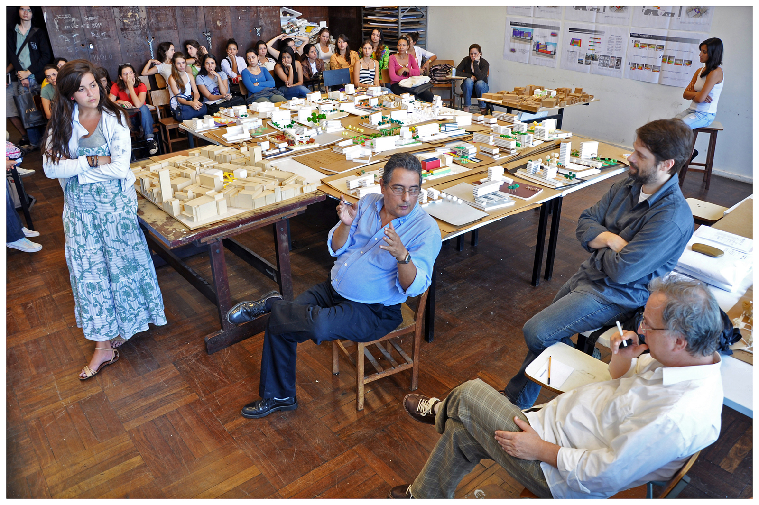

Figure 4 – Project presentation (photograph by Naylor Barbosa Vilas Boas)

The initial structural analysis and preliminary structural design processes encompass the conceptual stage, the preliminary design stage and the selection stage. The conceptual stage should bring forth a plan that maximizes the satisfaction of the stated objectives while minimizing any objectionable features of the project [13]. In order to do this, the preliminary design is based on approximate theories of structural analysis with the aim of minimizing the effort and time to be invested in this preliminary phase. These theories are studied during the course and the final product is shown by the presentation of the project’s structural drawings, which are converted into CAD drawings. The structural elements described in structural drawings are usually beams, slabs and columns The students must check that the designs conform to the relevant statutes and building codes. Figure 5 show the final structural design drawing presented by one of the students.

Figure 5 – Structural drawings (Structural design by Suzany Barros)

This experience of integration has thus the purpose of introducing the student to the diversity of the disciplinary field, involving the main issues that constitute the complexity of the spatial phenomenon. It also seeks to relate the different scales of operation, showing the different dimensions of professional practice to the student. The evaluation times, seem to allow for fruitful argumentative defenses. In addition to oxygenate ideas and visions naturalized by years of teaching and individual professional practice, such moments often refer to the focus of discussion between the content integration, promoting learning through exchange of information and views among teachers.

Very illustrative of this issue, is the case of a student who has proposed a tilted prism (Figure 6) without, however, at first, to offer argument, analysis, and no possibility of asolution to the materiality of this proposal. Until the first valuation, no preview of meetings between the disciplines of Structural Design, Construction Processes and design workshops. The interaction of actors sensitive to these disciplines (in this case structure, construction and shape), until the time of release of the design, despite some extent undermine the teacher project in his role as architect and general consultant of the whole, seems to implicitly remain delegated to the synthetic quality of the student.
In this sense, it would be the professor of design responsibility to instruct the student, philosophically and technically, with respect to the contingencies of his proposal, since the students' projects were not yet present in the classes of specific disciplines.

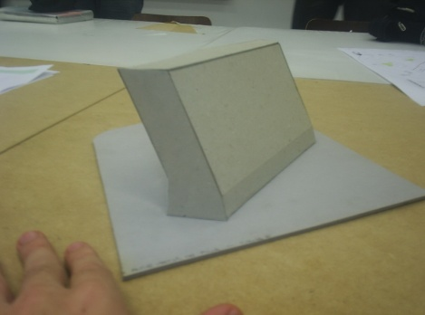 | 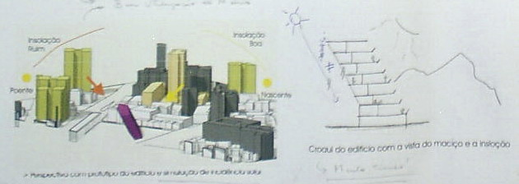

Figura 6 – The inclined parti – strcture-construction-shape (work of Alice Pina).

Thus, guidance for a case like this would happen as in a traditional course in which students would be up to the initiative to get teachers in matters of structure and construction, it will then possibly offer a prompt and specific technical solution for the case. In one possible design omission of the teacher, the material dimension (structure-building) that architectural design could not be suggested, and the student would be deprived of the opportunity to learn about structure and construction, as essential components of architectural design knowledge, from its initial stage.

At the time of evaluation, and in the case of this student, the collectivization may have contributed in a fundamental way to projective student learning, and potentially also a thinning of teaching practices from the perspective of integration within the project,regarding the consideration of constraints on to the specific disciplines.
The student based his arguments mainly on design of architectural form such as "brokeup with the signs of the basic structural building aimed at ensuring that a formal identity revitalize the place of insertion of the project, "including transcripts of Jacques Derrida to support the proposal. It also appeared an argument of habitability, but built on a seemingly superficial and inaccurate analysis of solar geometry, which in turn, making amistake a few degrees, can also fundamentally invalidate an argument. At this point, despite apparently miss the opportunity to promote learning, the pedagogical integration established itself as a potential promoter of critical evaluation, it does minimize the perception of student opinion in relation to pure taste.

First presentation mainly evaluates the ability of the student's argument about the launch of its architectural design. However, in this particular case, the student seems to argue to the edge of the tooling (enunciable specific content) that had set the course, since the classes of structures went further introduction, illustrating the issue of temporal connection between the teaching of design and specific content of other disciplines.
The opportunity to consult with several teachers on specific questions is whether orobligation to any student apparently teaching model, as mentioned previously. However, this condition remains in integration environments despite reinforce the need for reflection about an effective transformation in the teaching procedures.
However, from this particular case, we emphasize once more the possibility of contact and intensity of the engineering professors with the arguments of the decisions and projective assessments. Moreover, the presence of the engineer to the debate within the ratings of the project seems to somehow curb his passivity in relation to design decisions.

References
- Salvadori, M. G., and Tempel, M., Architecture and Engineering: An Illustrated Teacher’s Manual On Why Buildings Stand Up, Salvadori Educational Center On The Built Environment (SECBE), 3rd edition, New York, 1983.

- Rodrigues, C. S. C., Rodrigues, P. F. N.,Werner, C. M.L., “An Application of Augmented Reality in Architectural Education for Understanding Structural Behavior through Models”. In: Proceedings of the X Symposium of Virtual and Augmented Reality, João Pessoa: Universidade Federal da Paraíba, pp. 163-166, 2008

- M. Piccolotto, and O. Rio, “Structural Design Education With Computers”, Proceedings of ACADIA 95: Computing in Design, University of Washington, Seattle, USA, Oct., 1995, pp. 285-299.

- S. Vassigh, “Structures E-Book. ACADIA Quarterly”. V. 18, No. 3, Association for Computer Aided Design in Architecture, Salt Lake City, Utah, USA, Oct., 1999, pp. 14- 15.

- S. G. Guidera, “Exploring the Architecture of Structure: Integrating Structures into Design Studio Using Objectoriented”, CAD 2003 ASEE Annual Conference & Exposition: Staying in Tune with Engineering Education, Nashville, TN, USA, Jun., 2003, pp. 22-25.

- I. L. Kim, O. L. Weck, W. Nadir, P. Young, and D. Wallace, “Innovative Modern Engineering Design and Rapid Prototyping Course: A Rewarding CAD/CAE/CAM Experience for Undergraduates”, American Society of Engineering Education (ASEE) 2004 Annual Conference & Exposition, Salt Lake City, Utah, USA, Jun. 20-23, 2004.

- S. G. Millard, “Computer Aided Learning (CAL) and Computer Aided Assessment (CAA) in Civil Engineering”, Proceedings of the 3rd International CDIO Conference, MIT, Cambridge, Massachusetts, USA, Jun. 11-14, 2007.

- R. T. Azuma, “A Survey of Augmented Reality”, Presence: Teleoperators and Virtual Environments, V. 6, No. 4, 1997, pp. 355-385.

- R. T. Azuma, Y. Baillot, R. Behringer, S. Feiner, S. Julier, and B. MacIntyre, “Recent Advances in Augmented Reality”, IEEE Computer Graphics and Applications, V. 21, No. 6, Nov./Dec., 2001, pp. 34-47.

- Carey, R. & Bell, G., “The Annotated VRML 2.0 Reference Manual”, Addison-Wesley Professional, Indianapolis, 1997.

- H. Kato, “ARToolkit”, Human Interface Technology Laboratory, University of Washington, Available in: <http://www.hitl.washington.edu/artoolkit>, Acessed in: May 02, 2007.

- H. Kato, and M. Billinghurst, “Marker Tracking and HMD Calibration for a Video-based Augmented Reality Conferencing System”, Proc. IWAR99, San Francisco, CA, USA, Oct. 20-21, 1999, pp.85-94.

- West, H. H., Analysis of Structures: An Integration of Classical and Modern Methods, John Wiley & Sons, Inc., 2nd edition, New York, 1989.

