The Versatile Mobile Studio

Peter Bofah, Mohamed Chouikha
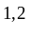Department of Electrical and Computer Engineering
Howard University, Washington, DC 20059
pbofah@howard.edu, mchouikha@howard.edu

Abstract
The mobile studio is a portable lab that can be adapted to suit several hands on experience in several scientific and engineering disciplines. The Department of Electrical and Computer Engineering has traditionally offered courses in several areas by separating course and labs. This approach has always presented difficulties to the average student bridging the gap between the course and the related lab even though the objectives are met. Our department has introduced the mobile studio approach that requires hands on and lectures simultaneously. The mobile studio is a lab on wheels. Lectures and labs become difficult to follow. Concerns about labs related to the theory may not be readily available. The lab instructor may be different from the course instructor. Thus further chaos is created for the student. Traditional labs are equipped with bulky expensive equipment that also occupations a lot of space. Thus few stations will be available to a group of students. Each station may accommodate 5 or 4 students per group creating calamities since very few of the students can actually conduct the experiment due to the limitation of space/workstations. Recently, the Department of Electrical and Computer Engineering at Howard University together with participating universities has introduced the mobile studio approach. It combines hands on and lectures simultaneously.

The mobile studio is a compact lab on “wheels”. Each student has his/her own work station. The studio consists of: (a) a Tablet-PC (lap top) with special software that mimics instrumentation and other features. (b) input/output I/O board that consists of dc power supplies, function generator and it can be used for analog or digital experiments. (c) A bread board that contains the hardware set up for the hands on approach. It is connected to the I/O board that is connected to the Tablet PC via a USB cable. The instructor also has a similar set-up for demonstration. It combines lectures, labs and demos in one package.

The mobile studio approach is being implemented several courses in our curriculum. The mobile studio concept is so versatile it is suitable for applications in several science and engineering areas by including appropriate transducers that will concert data of interest for the experimenter into electrical signals with calibration. Results can be obtained instantaneously with recorded data, pr graphing or on the scope screen that can be stored and retrieved any time. The studio has motivates students’ interest in their studies. Examples are provided using the mobile studio in several areas. It is also a great tool in recruiting undergraduate students during their summer outreach,.

1. Introduction

Traditionally, medium of instruction of courses with accompanied labs are offered separately. This approach creates problems for student as well as the instructors. Lectures and labs are taught at different times, on different days and even sometimes both are taken in different semesters, and most often by different instructors. Thus students find it difficult to understand theory as well as the separate lab hands on. In order for students to fully understand the lectures material and labs as proof of theories there is a great need to offer ‘hybrid ‘courses that consist of lectures, demonstrations and labs at the same time.

Additionally, traditional labs are equipped with bulky work benches and large expensive instruments and other equipment (such as large function generators, oscilloscopes and power supplies) sources that consume a lot of electric energy for operation at this time of the world’s crisis and dwindling energy sources. Due to limitation of space and bulky equipment, students work areas are limited and thus they forced to work in overcrowded groups. It contributes to a few students in a group who can actually participate in performing hands on the tasks required for the lab under investigation. The rest only act as recorders. They hardly participate or contribute to the success of the lab.

Due to recent advances in technology, such as nanotech and miniaturization, a great deal of work for miniature devices have been developed. Large size instruments have been reduced to palm sized computer notebooks. The miniature instrument (Tablet PC) is interfaced with input out I/O board that serves as source of power supply and function generators for analog and digital labs. The circuit under test is on a bread board and it is connected to I/O board. This unit (tablet PC, I/O board, bread board system) forms the mobile studio. Simply, the unit is known as the mobile studio. It occupies rather a small portable space (much less than a cubic foot). The cost is rather low, less tan $1000 per station. Thus a mobile studio is made available to each student in a course as well as one for the instructor. The mobile studio provides the functionality of a regular lab in a portable package. The instructor, as well as students, work in synchronism to provide lecture and hands on at the same time. Data collection at the PC is a synch. The PC acts as instrumentation (ammeter, voltmeter, oscilloscope with basic two-channels) as well as the control panel for the labs.

The mobile studio-based classes have been used in several courses (including circuits and electronics) in the department for over four years now. Initially, the department started with a few stations on experimental basis and as the students enthusiasm built up, the department acquired more units and expanded the concept to several courses at different levels freshman through senior levels. The concept has also been introduced in our ‘Smart Lighting Institute high school students summer outreach engineering programs with great success. The purpose of the program is to provide underrepresented students the motivation to pursue engineering profession in electrical and computer engineering. They are introduced to basic concepts in engineering, preparation to be an engineer and various (bachelor, masters and doctoral) levels. The program consists of lecture series in mathematics, electrical/computer engineering basics (analog and digital circuits. It is coupled with hands on approach since engineering involves data collection and analysis leading to evaluation. They do interesting projects (using smart lighting technology such as optical transmitter-recovers system) using the mobile studio. It is anticipated that through this paper, the mobile studio technology will be adopted by other institutions nations in their educational programs since the mobile studio is inexpensive safes space.

2.1 The Mobile Studio Concept

The mobile studio teaching concept that is normal a practice of other departments (such as architecture, arts) has been adopted by engineering departments due to advances in technology and miniaturization. It consists of Tablet-PC that acts as instrumentation and input/output I/O board that serves as computer interface via USB cable. Thus the usual old fashioned laboratory setup that includes separate oscilloscope, multi-meter, power supply, function generator and others (digital equipment) has been replaced with the ‘portable’ mobile studio setup that consists of a breadboard, Tablet PC (personal computer) and a Rensselaer I/O Board that is a small hardware platform. The entire setup occupies much less space than a notebook. It is so small it can fit in a backpack and carried home for more explorations of hands on. Its use by individual students has increased their participation including question and answer time combined with hands on verification of what has been learnt at the same time. The package shown in figure 1 allows individual participation since it occupies a small space and it is less expensive compared with bulky lab expensive lab equipment. It also consumes much less electric energy compared with the traditional lab equipment. It gives students individual access to the lab in progress and flexible interaction with the instructor as well as with other students
Figure. 1 also shows the I/O board instrumentation panel displayed on the tablet PC screen. The I/O board emulates a function generator, oscilloscope, voltmeter, Spectrum analyzer, ±4.5V supply.
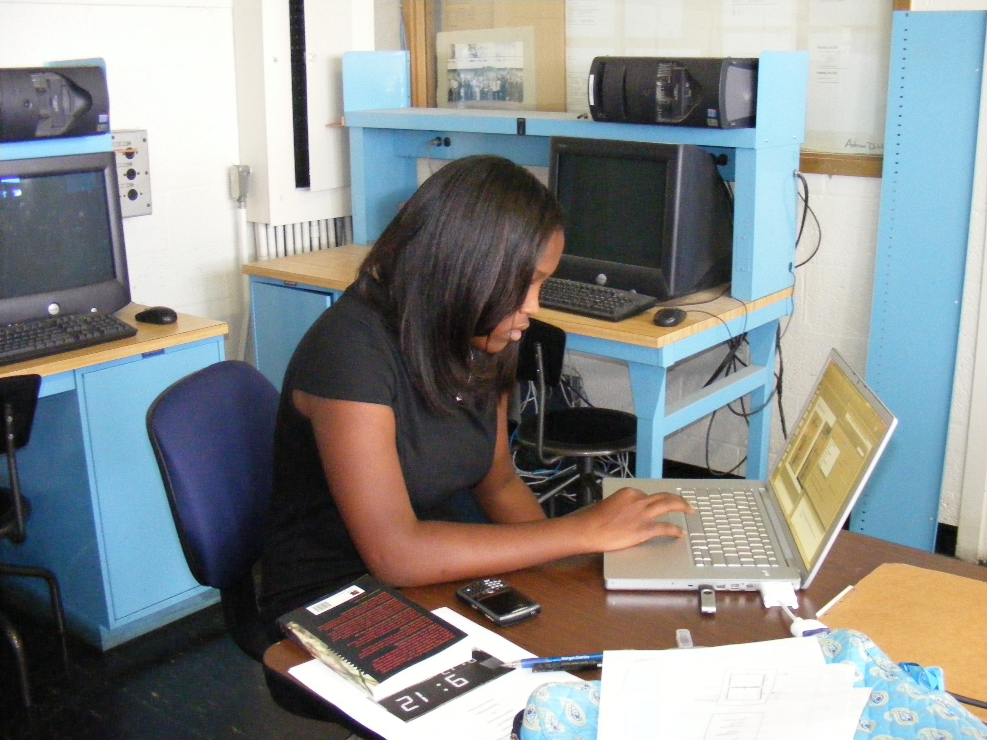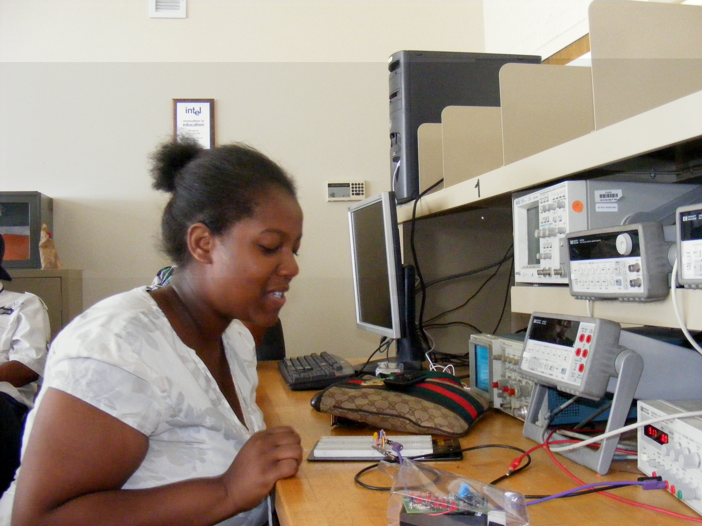

Compact Mobile studio lab Old Fashion Traditional Lab Concept-Bulky Equipment

It is capable digital operations. Thus the board output dc power supply lies within the range of -4.5V to +4.5V, and all of the experiments or designs have been built with this voltage range (constraint) in mind. The portable nature of the mobile studio setup means that there is far greater student interaction with the equipment since there is a workstation for each student. The instructor, and the teaching graduate assistants also have a similar set up. The students encouraged to individually explore the characteristics of the demonstrated circuit under several conditions. Occasionally, a graduate teaching assistant may contribute to monitoring the students’ progress and offer assistance to ensure that all of them understand the topic before resuming the lecture. They also use the studio for projects, homework, labs, and designs.

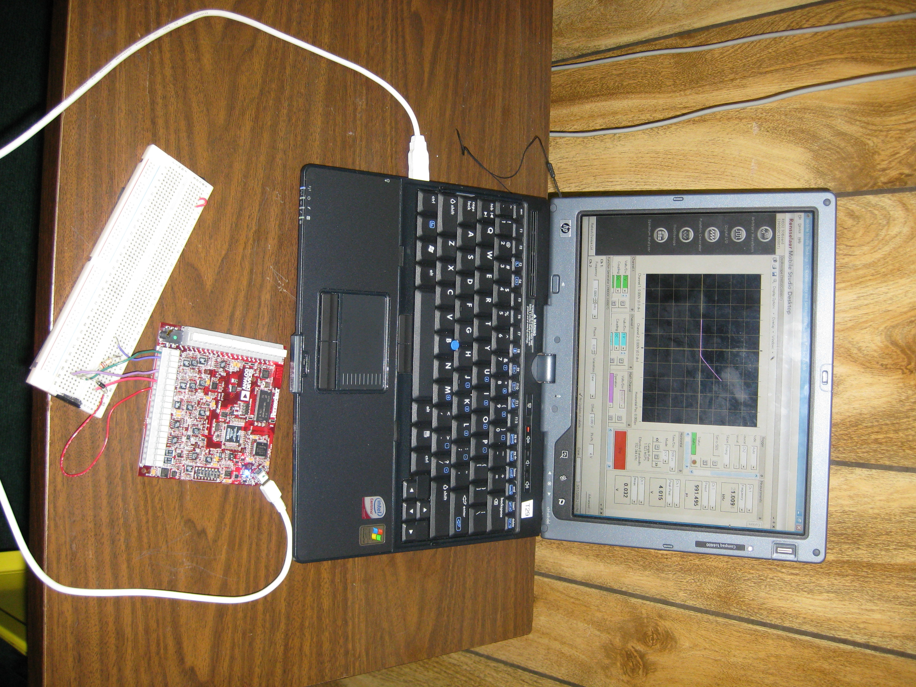
Tablet PC
I/O board
Breadboard
USB sync cable

Figure 1: Mobile Studio Station

2.2 Mobile Studio-Based Courses

The mobile studio concept has been in use for the past four years. The Department initially started with a small scale tablet-pcs (as a test bed) with circuits courses by combining lecture with labs at the sophomore level. It became a great success and students interest in electrical/computer engineering increased. Students could save data gathering time using the mobile studio. They could obtain plots instantly (instead of traditional write down data, and plot graphs on paper by hand or other means later. They could also correct bad data right away
The following year, additional tablet pcs were obtained, and the limited I/O board voltage supply had been improved from rather low voltage to 5.0 volts and more features had been added to the I/O board by Rensselaer Polytechnic Institute, RPI, the originator of the mobile studio concept. Thus due to flexibility of the mobile studio, the approach was extend to electronics courses at the junior level. Now, in addition to above course, the studio is being used in digital, circuits, and electronics courses, as well as in senior capstone design projects. It has also be introduce in freshman introduction to electrical and computer engineering courses, and high school outreach programs. We plan to extend the mobile studio system to other courses in the curriculum. Students are allowed to take home the ‘studio’ to complete assignments since the unit is portable (smaller than a note pad).

2.3 Experiences with the Mobile Studio

Unlike separate classes and labs, combining both lectures and labs has greatly improved the attention of our students through hands on approach. The student are able to discuss results with other students instantaneously. They correct each other. Students working on assignments with the mobile studio with serious concentration and overall enthusiasm.

The students obtain experience in experimentation, measurements also obtain direct plots instead of using paper and pencil for plot later when the experiment is completed. Instant plots allow for instant correction just in case of a wrong data set. Their mobile studio work coupled on the spot with comments from the instructor. It enhances the individual’s understanding of the subject both theory and practice (through experimentation). We have been running workshops with great success and enthusiasm from participants on how to use the Mobile studio in several fields.

3.1 Sample Mobile Studio Applications
Selected examples of the studio applications are represented below.

3.2. BIC-MOS Amplifier with Feedback Resistor

i. Summary
This experiment intended to study a BiC-MOS amplifier design. The design consists of 1 NPN and 1 NMOS transistors. The circuit is first simulated on PSPICE and the DC bias collector and drain currents and frequency response are obtained. The circuit is modified by changing the gate resistance and adding a coupling capacitor between the NMOS gate and NPN base to ground. Both simulation and experimental (mobile studio) match.

ii. Objectives
Obtain the DC Bias collector and drain currents, he mid-band gain, lower and upper 3dB frequencies and compare simulation and experimental results

iii. Introduction
The BiC-MOS amplifier is an amplifier created by combining NMOS and NPN transistors. This serves to combine the advantages of each transistor, high input resistance and high gain, respectively.

iv. Problem Statement
The purpose of this lab is to study the I-V characteristics of a Bi-CMOS amplifier with an added negative feedback bias resistor. The original setup will be analyzed along with a modified circuit involving the addition of a coupling capacitor between the NMOS gate and NPN base to ground. Figures 3. shows the circuit to be used for this purpose.

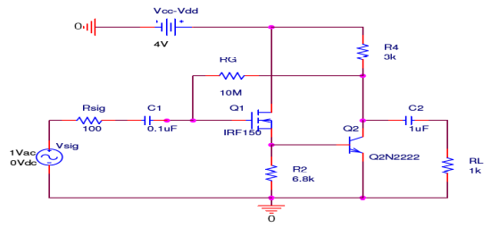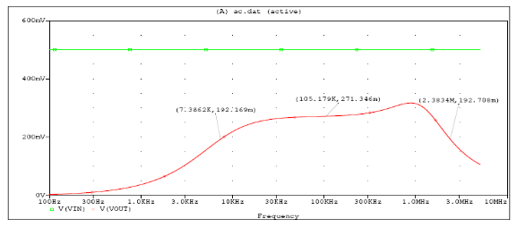
Figure 3.1 – BiC-MOS amplifier circuit diagram Figure 3.2. PSPICE frequency response
(R_{G} = 10MΩ, C_{SB} = 0F)
v. Simulation
The BIC-MOS amplifier circuit in Figure 3.1 was first set up in order to obtain the required bias collector current and voltage readings. Next, the input voltage source was set to 500 mV and an AC sweep was run to from 100 Hz to 5 MHz to obtain the frequency response of the circuit. The mid-band V_{O} was measured at 271.346 mV. The gain A =Vo/Vs=0.54 V/V
The 3dB frequencies correspond to a V_{O} value of: 0.707max. This results in lower and upper cut-off frequencies of 7.3862 kHz and 2.3834 MHz respectively. The experiment was then repeated after increasing R_{G} to 20MΩ and introducing a coupling capacitor C_{SB} of 5μF.

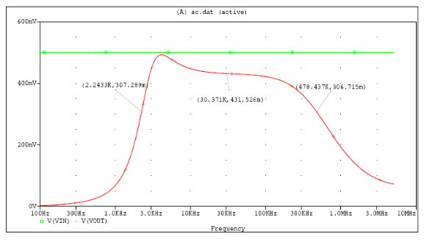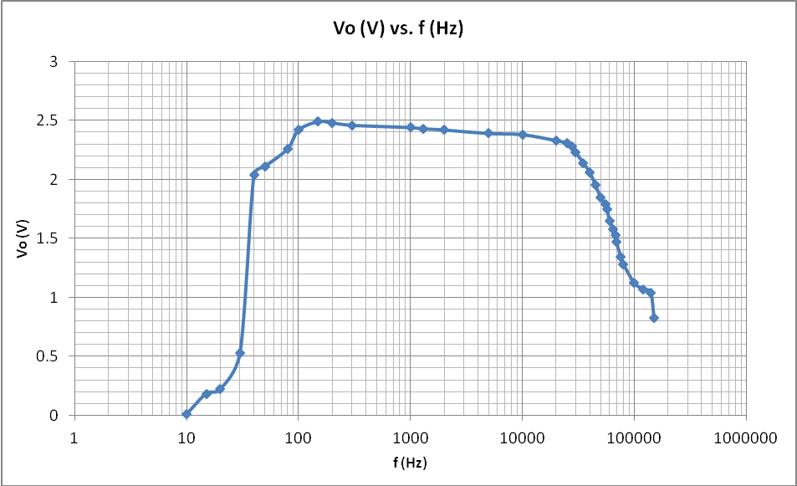
Figure 3.3. PSPICE frequency response Figure 3.4. Mobile Studio Frequency Response
(R_{G} = 20MΩ, C_{SB} = 5μF)

The mid-band V_{O} was measured at 271.346 mV. The gain is A= 0.86 V//V:
The 3dB frequencies correspond to a V_{O} value of 0.707Vmax. This results in lower and upper cut-off frequencies of 2.2433 kHz and 478.437 kHz respectively.

vi. Experiment
The following list of equipment was used in this experiment:
- Resistors: 1k, 3k, 6.8k, 10M, 20M Ω, Capacitors: 0.1, 1, 5 µF
- 1 BJT NPN Transistors (Q2N2222A), 1 NMOS Transistor (2N7000)
The DC bias version of the Bi-CMOS amplifier circuit in Figure 3.1 was set up and tested using Mobile Studio. The voltages and current were then measured as follows: Then the full circuit was set up and the input voltage was set to 500 mV p-p. Figure 6.2 displays the voltage readings at certain input signal frequencies and obtain the frequency response with the plot shown below.
The mid-band gain A = 4.85 V/V, The lower 3dB frequency corresponds to values of:

lower and upper cut-off frequencies of 38 Hz and 58 kHz respectively.
The experiment is then repeated after increasing R_{G} to 20MΩ and introducing a coupling capacitor C_{SB} of 5μF.We obtain similar results. Then the full circuit was set up and the input voltage was set to 500 mV p-p. The following table lists the measurement of V_{O} as the frequency of the input voltage was varied. In this case there was a much smaller bandwidth, in order to obtain the gain, the average of the 3 peak V_{O} values was obtained: 2.30 V.
The mid-band gain is A = 4.60 V/V, 3-db frequencies are lower and upper cut-off frequencies of 43 Hz and 500 Hz respectively. For a comparison between both results, we can plot the two frequency responses together. The modified with the higher resistance and addition of a capacitor at the Base-Source, the frequency response also changed. The entire frequency range is essentially shifted to the left and the bandwidth is reduced. The capacitor seemed to have introduced a smaller cutoff frequency.

vii. Conclusion
The results of the PSPICE simulation and Mobile Studio experiments do match. The upper cut-off frequency in the simulation is reduced when the circuit was modified in both cases.

3.3 Active Filters

i. Summary
This experiment serves as a study on active filter design. These are frequency selective circuits that can be modified for several different applications. Three circuits, band pass, all pass, and low pass filters, are designed using the Tow-Thomas Biquad filter design. The circuits are tested on PSPICE and the low pass filter is experimentally tested using the mobile studio. The results show the expected frequency responses.

ii. Objectives
In this experiment we will study three active selective frequency circuits: Band Pass (BP), b. All Pass (AP), c. Low Pass (LP), We obtain the frequency response of the filters and compared.

iii. Introduction
Filters are frequency selective circuits that are used for many electronics applications, including instrumentation and communications. They may be classified as passive whereby they do not require external power, or active ones that do require power. Passive filters use resistors, inductors, or capacitors to operate, while active filters may use transistors, op-amps, and passive elements. The advantage of using active filters lies in the fact that their gain can be varied to a value greater than unity.
A further classification of filters is their complexity. First order filters cannot be used to obtain band pass or notch filters, while second order filters are able to do so. The second order general transfer function is given as follows:
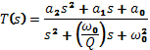
Q is the quality factor and ω₀ is the pole frequency. The zeros of the transfer function determine the type of filter
iv. Problem Statement
The purpose lab is to design different types of active filters using the Tow-Thomas Biquad Filter realization and the corresponding table of design data. Figure 1 shows the circuit to be used for each application.
v. Theory/Calculations

The component values to be used for each frequency response realization will be calculated using the Design Data table provided. We show the low pass design results.

Low Pass Filter Design Parameters: Q=10, 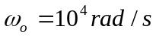, C = 1μF, 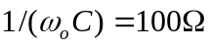
, , 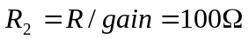,
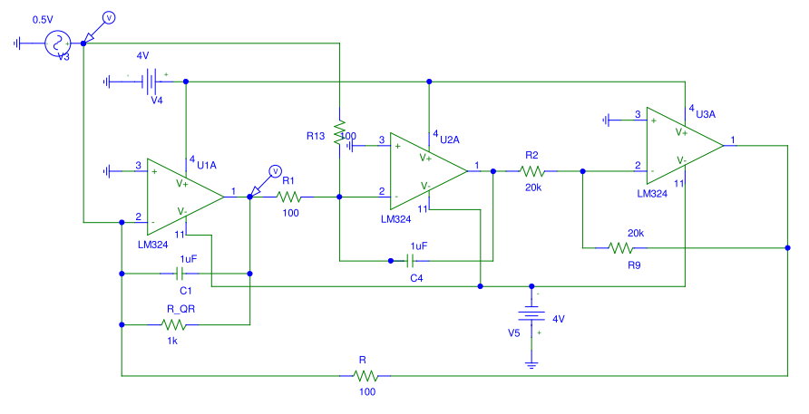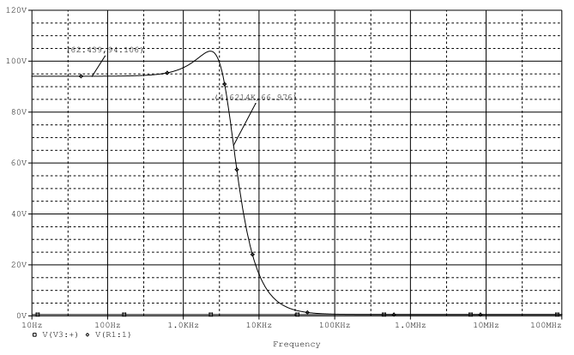
Figure 1 – Low Pass Filter Circuit Design Figure 2. Frequency Response of
(Using Tow-Thomas bi-quad Filter Design) Low Pass Filter

vi. Simulation
Each filter circuit from Figures 5.1-5.3 was set up in PSPICE in order to obtain the frequency response. An input voltage of 1 V was set and an AC sweep was run from 10 Hz to 100 MHz (100 kHz for band pass). Figures 6.1-6.3 display the results.

vii. Experiment (Mobile Studio)
List of experiment supplies: Resistors: 100, 1k, 20k Ω, Capacitor: 1 µF , Operational Amplifier IC (LM324). For actual experimental results, the low pass filter design yielded results. The circuit in Figure 1 was set up. The input V_{i} was set to 1 V p-p and the frequency of the signal was increased from 10 Hz to obtain the frequency response. Figure 7.1 displays the voltage readings at certain input signal frequencies. The 3dB frequency of about 2 kHz.

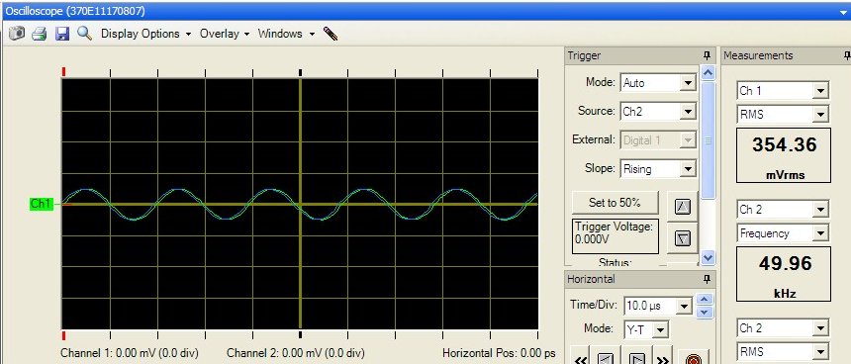

Figure 3. Voltage Waveforms at f = 50 kHz

ix. Conclusion
This lab shows the use of a single Tow-Thomas filter configuration to obtain different selective circuits. From both results, we obtain the identical low-pass filter response.
  - The Smart-Lighting Outreach Summer Program

The program emphasizes engineering and it is designed to provide an exciting, hands-on, design-centered using smart lighting projects and the mobile studio. Howard University is committed to providing an education environment that is accessible to all students.

Sample Project: Optical emitter-Receiver team project, .
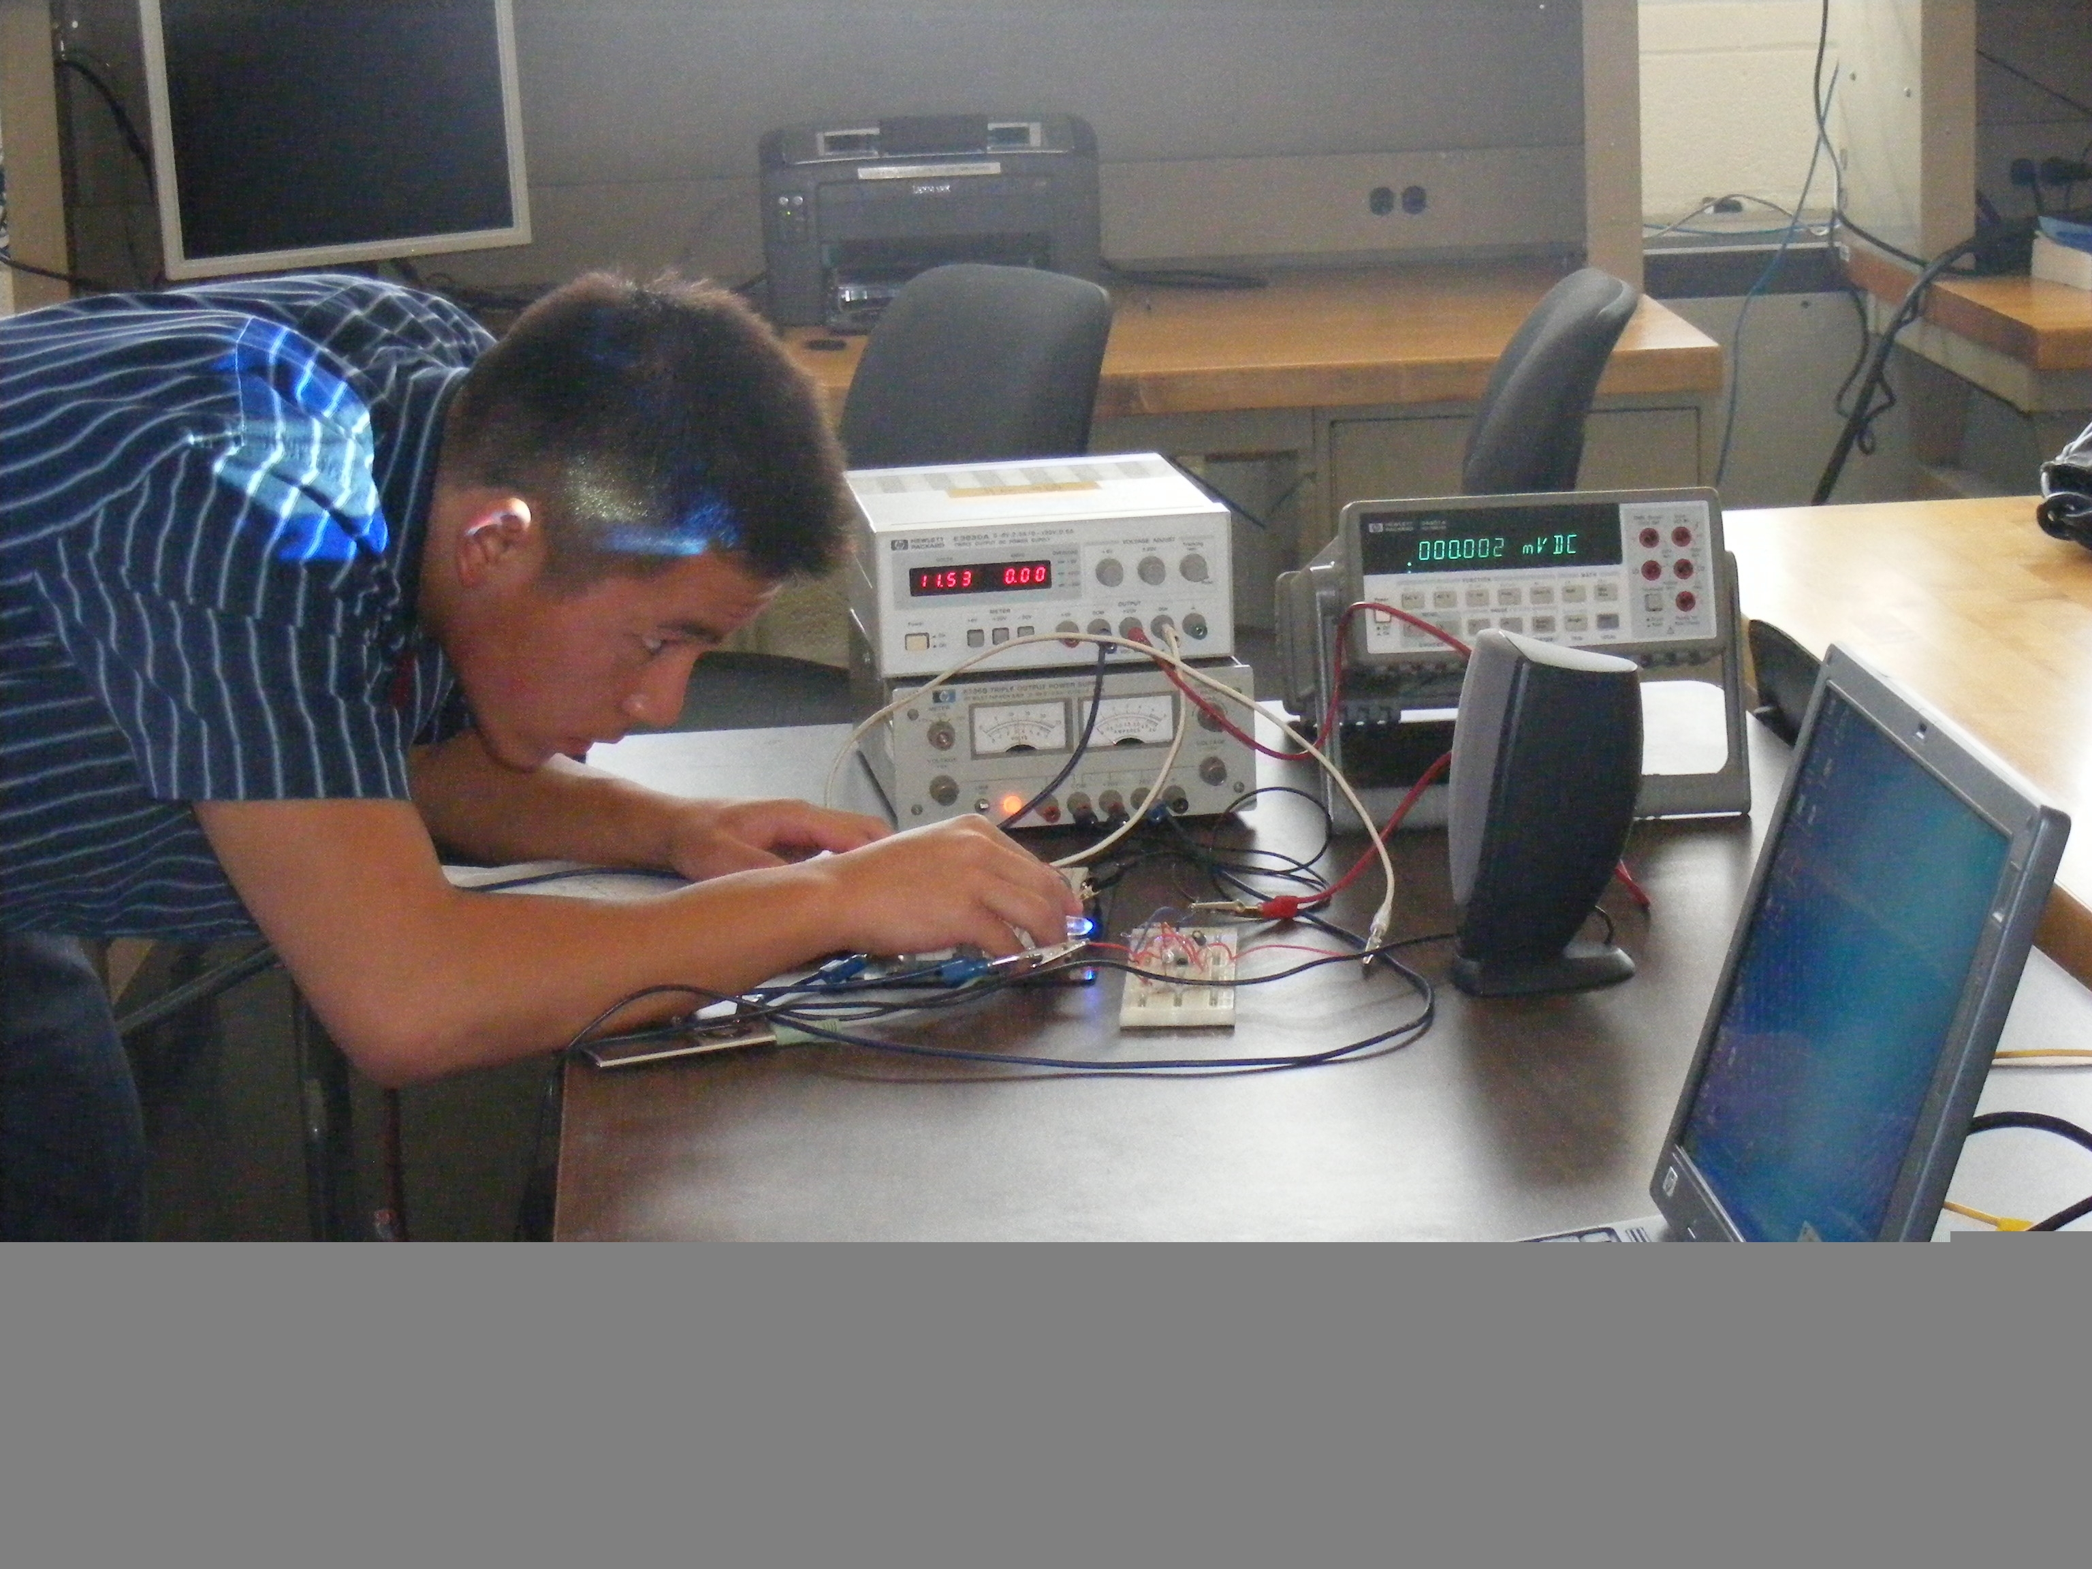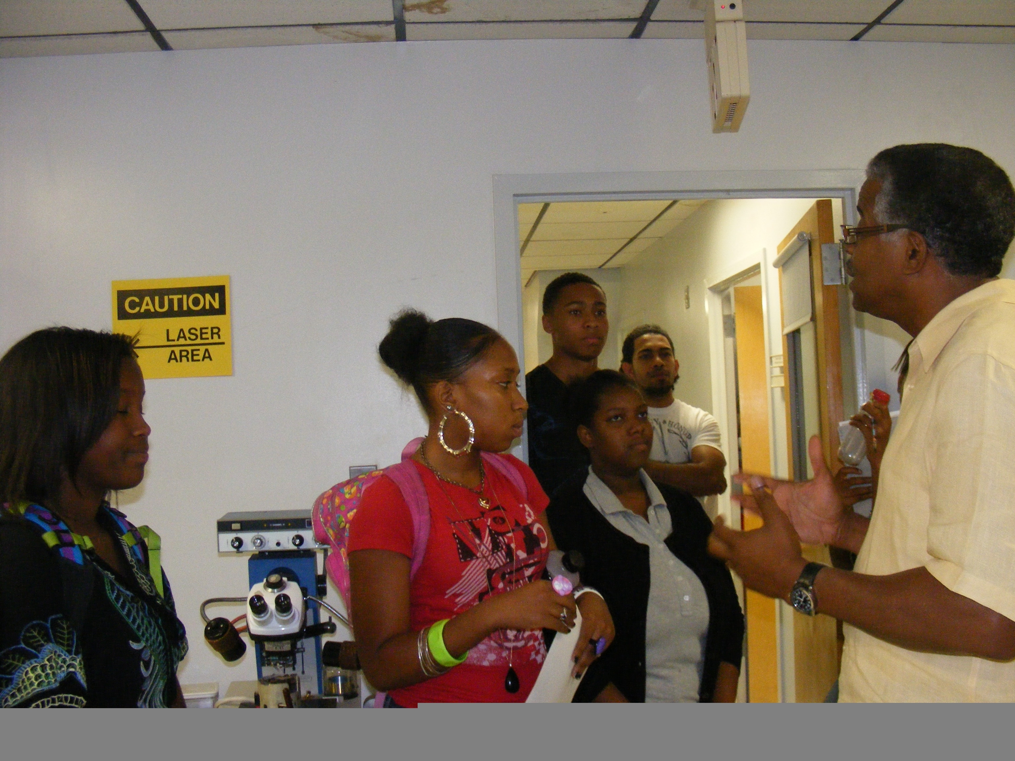

Right:: Smart Lighting outreach High school students listen to Prof. and Director Harris lecture on nanotechnology and the development of an optical sensor for the human eye retina at the Materials Science Research Center at Howard University. Left: A High School student demonstrates optical emitter/receiver project

4. Survey On the Use of The Mobile Studio

A survey of the students’ reaction to the use of the mobile studio that combines lectures and labs is conducted every semester based on the outline: Frequent use of I/O board in class, lab and homework, I/O board usage in course content, instructor and teaching assistant, format setting, supplementary material, use of I/O boards integration-development of students confidence, if engineering knowledge (follows ABET outcomes)-application of mathematics and science in solving/designing engineering problems, effective communications. Students unanimously approve the use of the mobile studio. Their attendance, attention and grades have also improved. However, they want to see the I/O board with improvements in increase of voltage supply above the available 4.5 volts, and function generator frequency be increased to the MHz range.

5. Conclusion

The department has successfully implemented the mobile studio approach in teaching combined lecture and labs. The new approach has improved students’ performance. Their teamwork skills have also gone up. Students participating in the High school summer outreach programs show great interest and appreciation in the use of the mobile studio. Students’ examples using the mobile studio are presented. Their confidence levels have increased unlike the earlier traditional methods (lectures separate from labs). The survey for assessment of the mobile studio concept. We hope colleges adopt the mobile studio concept. It saves money and space

- Acknowledgements

Thanks to the high school students participants, and
to the students and faculty who have contributed to the continuous improvement of the studio based courses.

References

[1] Peter Bofah, Mohamed Chouikha, Jan Jerry, “Mobile-Based Electronics Courses”, ICEE Proceedings, 2009, Seoul, Korea.
[2] Don L. Millard, “Expanding the benefits of Mobile Studio Classroom”, http://mobile studio.rpi.edu/Project.aspx, 2007.
[3] George C. Beakley, et. al., “Engineering, an Introduction to a Creative Profession”, 5th. Ed, NY, MacMillan Publishing Co., 1986.
[4] Adel S. Sedra & Kenneth C. Smith, “Microelectronics Circuits”, Holt, Rinehart and Winston, Saunders College Publication, Sixth Edition, 2010
[5] Peter Bofah, Mohamed Chouikha, ‘Integrating Lectures and abs Using the Mobile Studio”, International Conf. on Engineering Education, Procdings, Gliwice, Poland, Jul 18-22, 2010.
[6] Peter Bofah, Mohamed Chouikha, “Innovation in Engineering Education: The Mobile Studio”, 4th. International Conference on Engineering Education, Proceedings, Accra, Ghana, November 2010.

Biography
Peter Bofah obtained BS and MS both in electrical engineering from the University of Nebraska-Lincoln. He obtained PhD in controls from Howard University. Areas of interest : modeling, control of large structures, energy, electronics and power electronics, design and engineering education.
Mohamed Chouikha obtained MS and PhD degrees in electrical engineering from the University of Colorado. His areas of interest include image and signal processing, and electrical and computer engineering education. He is the Chair of the Department..

